DATA 624 - PROJECT 1

OMER OZEREN

Table of Contents

# Project 1

library(knitr)  
library(ggplot2)  
library(tidyr)  
library(dplyr)  
library(tseries)  
library(forecast)  
library(lubridate)  
library(tidyverse)  
library(gridExtra)  
library(kableExtra)

## Load Data

**Load all three data for the project.**

temp_file <- tempfile(fileext = ".xlsx")  
download.file(url = "https://github.com/omerozeren/DATA624/blob/master/Project1/ATM624Data.xlsx?raw=true",   
 destfile = temp_file,   
 mode = "wb",   
 quiet = TRUE)  
atm_data <- readxl::read_excel(temp_file,skip=0,col_types = c("date","text","numeric"))  
download.file(url = "https://github.com/omerozeren/DATA624/blob/master/Project1/ResidentialCustomerForecastLoad-624.xlsx?raw=true",   
 destfile = temp_file,   
 mode = "wb",   
 quiet = TRUE)  
power_data <- readxl::read_excel(temp_file,skip=0,col_types = c("numeric","text","numeric"))  
download.file(url = "https://github.com/omerozeren/DATA624/blob/master/Project1/Waterflow_Pipe1.xlsx?raw=true",   
 destfile = temp_file,   
 mode = "wb",   
 quiet = TRUE)  
water1_data <- readxl::read_excel(temp_file,skip=0,col_types = c("date","numeric"))  
download.file(url = "https://github.com/omerozeren/DATA624/blob/master/Project1/Waterflow_Pipe2.xlsx?raw=true",   
 destfile = temp_file,   
 mode = "wb",   
 quiet = TRUE)  
water2_data <- readxl::read_excel(temp_file,skip=0,col_types = c("date","numeric"))

## Part A - ATM Forecast

**In part A, I want you to forecast how much cash is taken out of 4 different ATM machines for May 2010. The data is given in a single file. The variable ‘Cash’ is provided in hundreds of dollars, other than that it is straight forward. I am being somewhat ambiguous on purpose to make this have a little more business feeling. Explain and demonstrate your process, techniques used and not used, and your actual forecast. I am giving you data via an excel file, please provide your written report on your findings, visuals, discussion and your R code via an RPubs link along with the actual.rmd file Also please submit the forecast which you will put in an Excel readable file.**

### ATM Data

df<-atm_data %>%  
 drop_na() %>%  
 spread(ATM, Cash) %>%   
 mutate(DATE = as.Date(DATE, origin = "1899-12-30"))   
atm_ts<-ts(df %>% select(-DATE))

df %>% gather(atm_data, Cash, -DATE) %>%   
 ggplot(aes(x = DATE, y = Cash, col = atm_data)) +  
 geom_line(show.legend = FALSE) +  
 facet_wrap(~ atm_data, ncol = 1, scales = "free_y") +  
 labs(title = "ATM Historical Cash withdraw Observastions", subtitle = "05/09 - 04/10", x = "Date") +  
 scale_y_continuous("Cash withdrawn ")

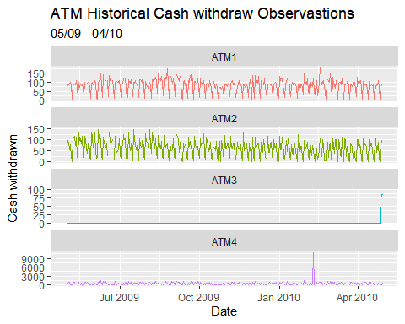

The plot shows each ATM’s historically cash withdraws.The ATM1 and ATM2 look solid Time series data where they have their own high and lows values. However, ATM3 data has most values zero, that is going to be challenging for building a model.I might need to take just mean valuers of data instead of building time series model.The ATM4 also has some challenges because it cointains some extreme values.

### ATM #1

#### Data Cleanup

There are only three missing values in atm_1 data. I will impute the missing values in order to create a timeseries data.

atm1 <- atm_data %>%  
 filter(ATM == "ATM1")

Here, I’d like to review the “atm1” timeseries data to determine whether there is a seosanality and ACF and PACF plots.

ATM1 <- atm_data[atm_data$ATM == "ATM1",]  
ATM1 <- ATM1[complete.cases(ATM1),]  
ATM1 <- ts(ATM1[c("Cash")],frequency = 7)  
ggtsdisplay(ATM1,   
 main = "RAW ATM1",  
 xlab = "DAY",  
 ylab = "CASH")

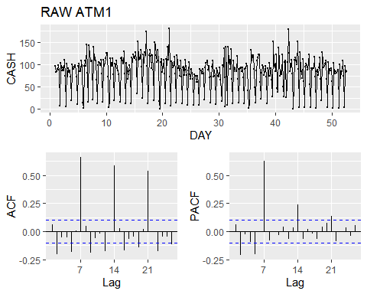

The ACF plot indicates that observations peak on every 7th lag.I will check Seasonality and Outlier for atm1 data.

#### Outlier and Seasonality

atm1$weekday <- factor(weekdays(as.Date(atm1$DATE)))  
atm1$weekday <- ordered(atm1$weekday,levels = c("Monday","Tuesday","Wednesday","Thursday","Friday","Saturday","Sunday"))  
#drop NaN values  
atm1 <- atm1[complete.cases(atm1),]  
ggplot(atm1[complete.cases(atm1),],aes(x=weekday,y=Cash,color=ATM))+  
 geom_boxplot()+  
 ggtitle("ATM Number 1 OUTLIER/SEASONALTY PLOT")

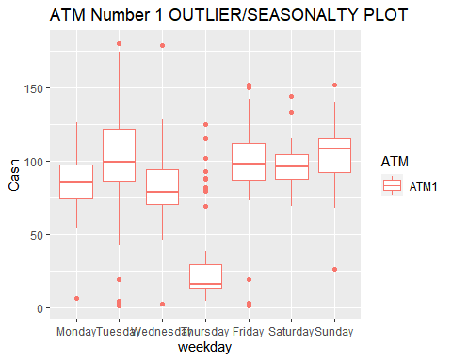

Box plots of the amount of cash is taken by customer in each of days from ATM1.As we can see on plot above, the Sunday has higher mean amount of cash is taken than rest of days.The thursday has the minumum mean of cash amount is taken.The weekdays Tuesdays and Wendsday hold some extreme values (greater than 150).The analysis above drops missing values.

#### Model Creation

I will use following forecating models on this time series and determine which one is better by estimatin error metric RMSE. I will use time series cross validation function to estimate RMSE for timeseries data.

* Seasonal and Trend decomposition (STL)
* Seasonal and Trend decomposition (STL) with ARIMA
* Holt-Winters
* Holt-Winters with Box Cox Adjustment
* ARIMA with Box Cox Adjustment

ATM1 <- atm_data[atm_data$ATM == "ATM1",]  
ATM1 <- ATM1[complete.cases(ATM1),]  
ATM1 <- ts(ATM1[c("Cash")],frequency = 7)  
Box.test(diff(ATM1,lag=7), type = "Ljung-Box")

##   
## Box-Ljung test  
##   
## data: diff(ATM1, lag = 7)  
## X-squared = 5.4172, df = 1, p-value = 0.01994

kpss.test(diff(ATM1,lag=7))

## Warning in kpss.test(diff(ATM1, lag = 7)): p-value greater than printed p-value

##   
## KPSS Test for Level Stationarity  
##   
## data: diff(ATM1, lag = 7)  
## KPSS Level = 0.021687, Truncation lag parameter = 5, p-value = 0.1

ggtsdisplay(diff(ATM1,lag=7),   
 main = "DIFFERENCED ATM1, Lag=7",  
 xlab = "DAY",  
 ylab = "")

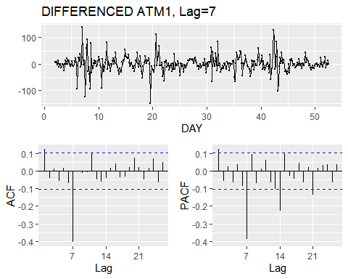

The result of KPSS and Box-Cox test indicates that atm1 timeseries is statioanry.

#### Seasonal and Trend decomposition (STL)

atm1_stl_fit <- ATM1 %>%  
 stlf(h = 31, s.window = 7, robust = TRUE)  
checkresiduals(atm1_stl_fit)

## Warning in checkresiduals(atm1_stl_fit): The fitted degrees of freedom is based  
## on the model used for the seasonally adjusted data.

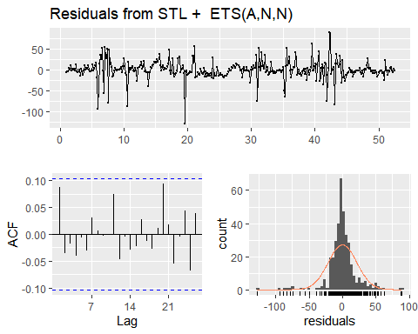

##   
## Ljung-Box test  
##   
## data: Residuals from STL + ETS(A,N,N)  
## Q* = 7.9258, df = 12, p-value = 0.7909  
##   
## Model df: 2. Total lags used: 14

checkresiduals(atm1_stl_fit)

## Warning in checkresiduals(atm1_stl_fit): The fitted degrees of freedom is based  
## on the model used for the seasonally adjusted data.



##   
## Ljung-Box test  
##   
## data: Residuals from STL + ETS(A,N,N)  
## Q* = 7.9258, df = 12, p-value = 0.7909  
##   
## Model df: 2. Total lags used: 14

atm1_stl_fit%>% forecast(h=31) %>% autoplot()

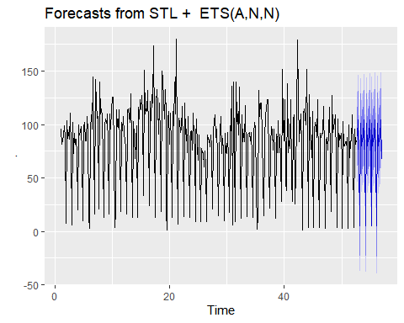

#### Seasonal and Trend decomposition (STL) with ARIMA

atm1_stl_arima_fit <- ATM1 %>%  
 stlf(h = 31, s.window = 7, robust = TRUE, method = "arima")  
checkresiduals(atm1_stl_arima_fit)

## Warning in checkresiduals(atm1_stl_arima_fit): The fitted degrees of freedom is  
## based on the model used for the seasonally adjusted data.

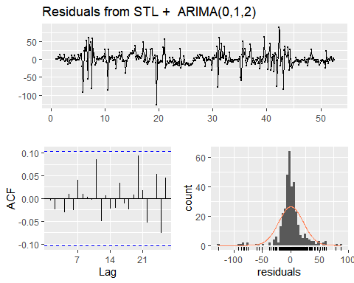

##   
## Ljung-Box test  
##   
## data: Residuals from STL + ARIMA(0,1,2)  
## Q* = 5.4248, df = 12, p-value = 0.9423  
##   
## Model df: 2. Total lags used: 14

atm1_stl_arima_fit%>% forecast(h=31) %>% autoplot()

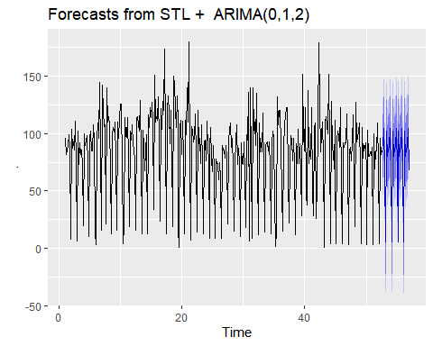

#### Holt-Winters

atm1_hw_fit <- hw(ATM1, h = 31)  
checkresiduals(atm1_hw_fit)

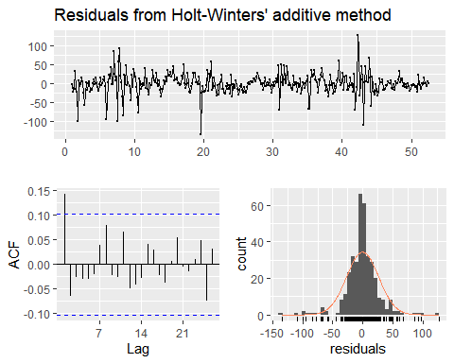

##   
## Ljung-Box test  
##   
## data: Residuals from Holt-Winters' additive method  
## Q* = 16.871, df = 3, p-value = 0.0007513  
##   
## Model df: 11. Total lags used: 14

atm1_hw_fit%>% forecast(h=31) %>% autoplot()

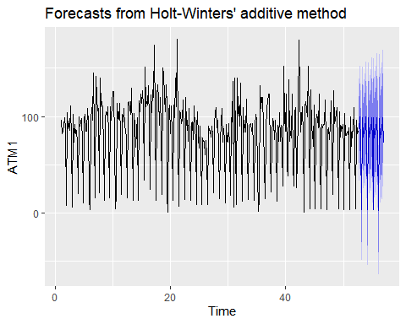

### Holt-Winters with Box Cox Adjustment

atm1_lambda <- BoxCox.lambda(ATM1)  
atm1_adj_hw_fit <- hw(ATM1, h = 31, lambda = atm1_lambda)  
checkresiduals(atm1_adj_hw_fit)

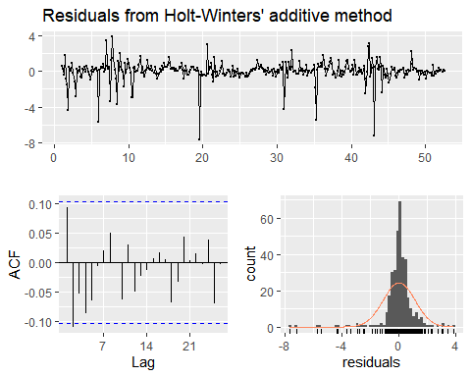

##   
## Ljung-Box test  
##   
## data: Residuals from Holt-Winters' additive method  
## Q* = 16.921, df = 3, p-value = 0.0007336  
##   
## Model df: 11. Total lags used: 14

atm1_adj_hw_fit%>% forecast(h=31) %>% autoplot()

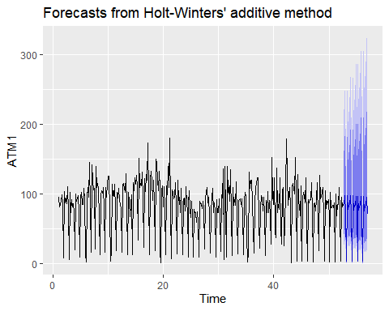

#### ARIMA

atm1_arima_fit <- auto.arima(ATM1)  
checkresiduals(atm1_arima_fit)

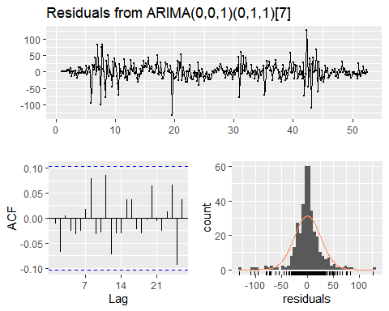

##   
## Ljung-Box test  
##   
## data: Residuals from ARIMA(0,0,1)(0,1,1)[7]  
## Q* = 11.267, df = 12, p-value = 0.5062  
##   
## Model df: 2. Total lags used: 14

atm1_arima_fit%>% forecast(h=31) %>% autoplot()

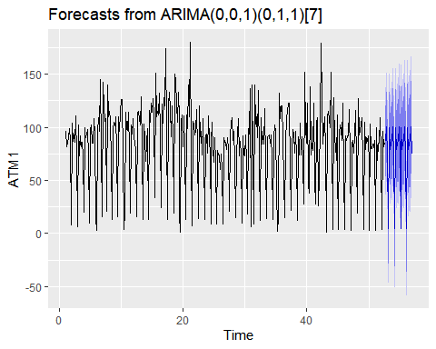

kpss.test(resid(atm1_arima_fit))

## Warning in kpss.test(resid(atm1_arima_fit)): p-value greater than printed p-  
## value

##   
## KPSS Test for Level Stationarity  
##   
## data: resid(atm1_arima_fit)  
## KPSS Level = 0.098551, Truncation lag parameter = 5, p-value = 0.1

### ARIMA with Box Cox Adjustment

atm1_lambda = BoxCox.lambda(ATM1)  
atm1_box_arima_fit <- Arima(ATM1, order = c(1, 0, 1), seasonal = c(0, 1, 1), lambda = atm1_lambda)  
checkresiduals(atm1_box_arima_fit)

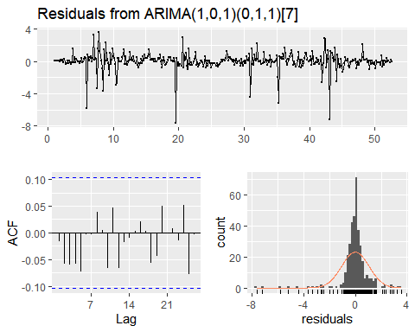

##   
## Ljung-Box test  
##   
## data: Residuals from ARIMA(1,0,1)(0,1,1)[7]  
## Q* = 10.658, df = 11, p-value = 0.4724  
##   
## Model df: 3. Total lags used: 14

atm1_box_arima_fit%>% forecast(h=31) %>% autoplot()

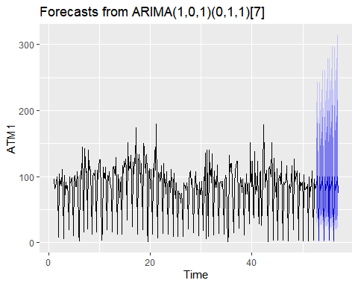

kpss.test(resid(atm1_box_arima_fit))

## Warning in kpss.test(resid(atm1_box_arima_fit)): p-value greater than printed p-  
## value

##   
## KPSS Test for Level Stationarity  
##   
## data: resid(atm1_box_arima_fit)  
## KPSS Level = 0.062513, Truncation lag parameter = 5, p-value = 0.1

### MODEL EVALUATION

I will use the tsCV function and evaluate the models.My goal is to find the model that produces minumum RMSE.

h <- 31  
get_rmse <- function(error) {  
 sqrt(mean(error^2, na.rm = TRUE))  
}  
atm1_arima_forecast <- function(x, h) {  
 forecast(Arima(x, order = c(0, 0, 1), seasonal = c(0, 1, 1)), h = h)  
}  
atm1_arima_box_forecast <- function(x, h) {  
 forecast(Arima(x, order = c(1, 0, 1), seasonal = c(0, 1, 1),lambda = atm1_lambda), h = h)  
}  
  
residuals_stl <- tsCV(ATM1, stlf, h = h, s.window = 7, robust = TRUE)  
residuals_stl_arima <- tsCV(ATM1, stlf, h = h, s.window = 7, robust = TRUE, method = "arima")  
residuals_hw <- tsCV(ATM1, hw, h = h)  
residuals_arima <- tsCV(ATM1, atm1_arima_forecast, h = h)  
residuals_arima_box <- tsCV(ATM1, atm1_arima_box_forecast, h = h)  
data.frame(Model_Name = c("STL", "STL & ARIMA", "Holt-Winters", "ARIMA","ARIMA-BOX_COX"),  
 RMSE = c(get_rmse(residuals_stl[, h]), get_rmse(residuals_stl_arima[, h]), get_rmse(residuals_hw[, h]), get_rmse(residuals_arima[, h]),  
 get_rmse(residuals_arima_box[, h]))) %>%  
 arrange(RMSE) %>%  
 kable() %>%  
 kable_styling()

Model_Name

RMSE

ARIMA

35.22610

ARIMA-BOX_COX

36.14111

STL & ARIMA

37.99406

STL

38.75113

Holt-Winters

46.03976

The ARIMA(0,0,1)(0,1,1) model gives the minumum RMSE among the other models.

### ATM #2

#### Data Cleanup

atm2 <- atm_data %>%  
 filter(ATM == "ATM2")

Here, I’d like to review the “atm2” timeseries data to determine whether there is a seosanality and ACF and PACF plots.

ATM2 <- atm_data[atm_data$ATM == "ATM2",]  
ATM2 <- ATM2[complete.cases(ATM2),]  
ATM2 <- ts(ATM2[c("Cash")],frequency = 7)  
ggtsdisplay(ATM2,   
 main = "RAW ATM2",  
 xlab = "DAY",  
 ylab = "CASH")

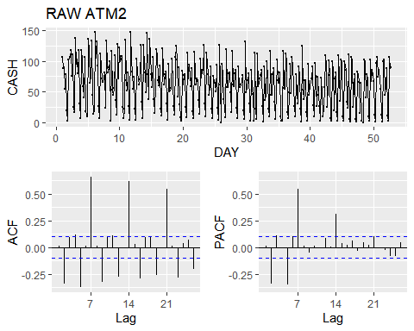

As above plots, the large spike at lag=2,5,7 suggests I=1,I will check Seasonality and Outlier for atm2 data.

#### Outlier and Seasonality

atm2$weekday <- factor(weekdays(as.Date(atm2$DATE)))  
atm2$weekday <- ordered(atm2$weekday,levels = c("Monday","Tuesday","Wednesday","Thursday","Friday","Saturday","Sunday"))  
#drop NaN values  
atm2 <- atm2[complete.cases(atm2),]  
ggplot(atm2[complete.cases(atm2),],aes(x=weekday,y=Cash,color=ATM))+  
 geom_boxplot()+  
 ggtitle("ATM #2 OUTLIER/SEASONALTY PLOT")

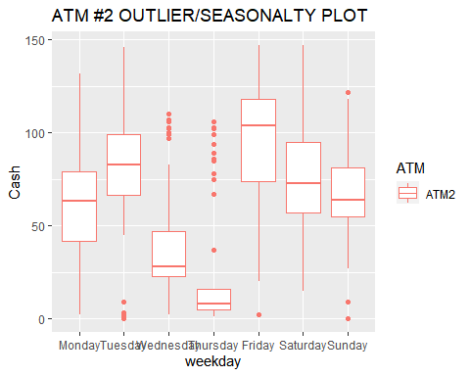

Box plots of the amount of cash is taken by customer in each of days from ATM2.As we can see on plot above, the Friday has higher mean amount of cash is taken than rest of days.The thursday has the minumum mean of cash amount is taken.

#### Model Creation

I will use following forecating models on this time series and determine which one is better by estimatin error metric RMSE. I will use time series cross validation function to estimate RMSE for timeseries data.

* Seasonal and Trend decomposition (STL)
* Seasonal and Trend decomposition (STL) with ARIMA
* Holt-Winters
* Holt-Winters with Box Cox Adjustment
* ARIMA
* ARIMA with Box Cox Adjustment

ATM2 <- atm_data[atm_data$ATM == "ATM2",]  
ATM2 <- ATM2[complete.cases(ATM2),]  
ATM2 <- ts(ATM2[c("Cash")],frequency = 7)  
Box.test(diff(ATM2,lag=7), type = "Ljung-Box")

##   
## Box-Ljung test  
##   
## data: diff(ATM2, lag = 7)  
## X-squared = 0.080312, df = 1, p-value = 0.7769

kpss.test(diff(ATM2,lag=7))

## Warning in kpss.test(diff(ATM2, lag = 7)): p-value greater than printed p-value

##   
## KPSS Test for Level Stationarity  
##   
## data: diff(ATM2, lag = 7)  
## KPSS Level = 0.017341, Truncation lag parameter = 5, p-value = 0.1

ggtsdisplay(diff(ATM2,lag=7),   
 main = "DIFFERENCED ATM2, Lag=7",  
 xlab = "DAY",  
 ylab = "")

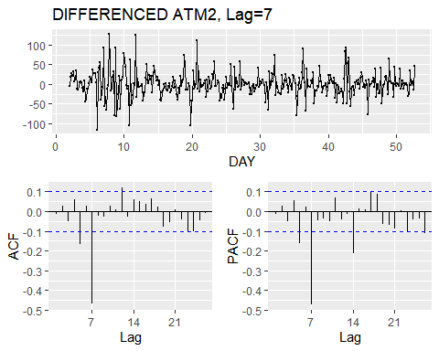

The result of KPSS and Box-Cox test indicates that atm1 timeseries is statioanry.

#### Seasonal and Trend decomposition (STL)

atm2_stl_fit <- ATM2 %>%  
 stlf(h = 31, s.window = 7, robust = TRUE)  
checkresiduals(atm2_stl_fit)

## Warning in checkresiduals(atm2_stl_fit): The fitted degrees of freedom is based  
## on the model used for the seasonally adjusted data.

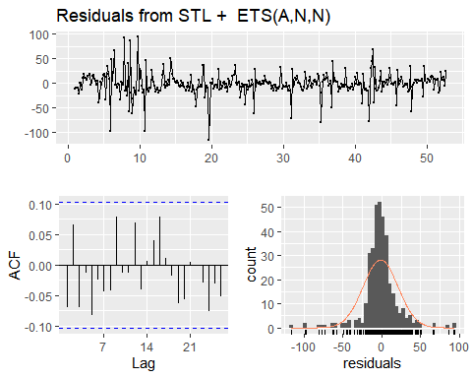

##   
## Ljung-Box test  
##   
## data: Residuals from STL + ETS(A,N,N)  
## Q* = 14.34, df = 12, p-value = 0.2795  
##   
## Model df: 2. Total lags used: 14

checkresiduals(atm2_stl_fit)

## Warning in checkresiduals(atm2_stl_fit): The fitted degrees of freedom is based  
## on the model used for the seasonally adjusted data.



##   
## Ljung-Box test  
##   
## data: Residuals from STL + ETS(A,N,N)  
## Q* = 14.34, df = 12, p-value = 0.2795  
##   
## Model df: 2. Total lags used: 14

atm2_stl_fit%>% forecast(h=31) %>% autoplot()

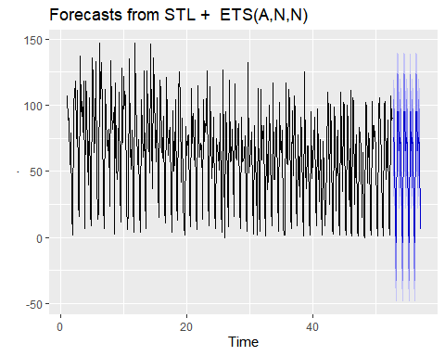

#### Seasonal and Trend decomposition (STL) with ARIMA

atm2_stl_arima_fit <- ATM2 %>%  
 stlf(h = 31, s.window = 7, robust = TRUE, method = "arima")  
checkresiduals(atm2_stl_arima_fit)

## Warning in checkresiduals(atm2_stl_arima_fit): The fitted degrees of freedom is  
## based on the model used for the seasonally adjusted data.

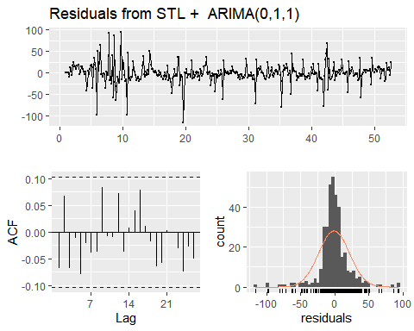

##   
## Ljung-Box test  
##   
## data: Residuals from STL + ARIMA(0,1,1)  
## Q* = 13.983, df = 13, p-value = 0.375  
##   
## Model df: 1. Total lags used: 14

atm2_stl_arima_fit%>% forecast(h=31) %>% autoplot()

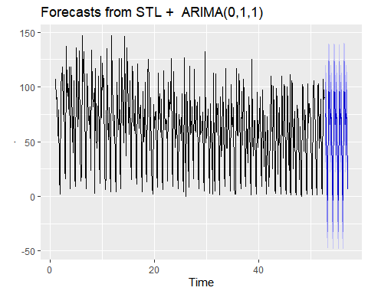

#### Holt-Winters

atm2_hw_fit <- hw(ATM2, h = 31)  
checkresiduals(atm2_hw_fit)

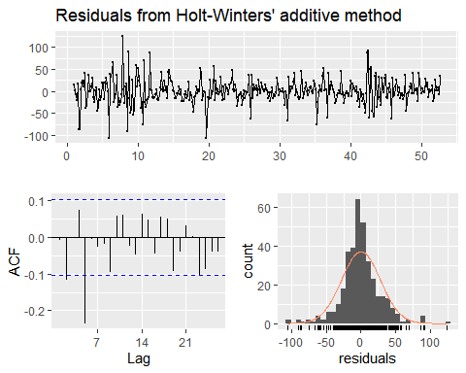

##   
## Ljung-Box test  
##   
## data: Residuals from Holt-Winters' additive method  
## Q* = 36.563, df = 3, p-value = 5.693e-08  
##   
## Model df: 11. Total lags used: 14

atm2_hw_fit%>% forecast(h=31) %>% autoplot()

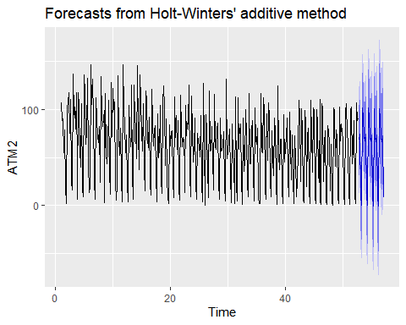

### Holt-Winters with Box Cox Adjustment

atm2_lambda <- BoxCox.lambda(ATM2)  
atm2_adj_hw_fit <- hw(ATM2, h = 31, lambda = atm2_lambda)  
checkresiduals(atm2_adj_hw_fit)

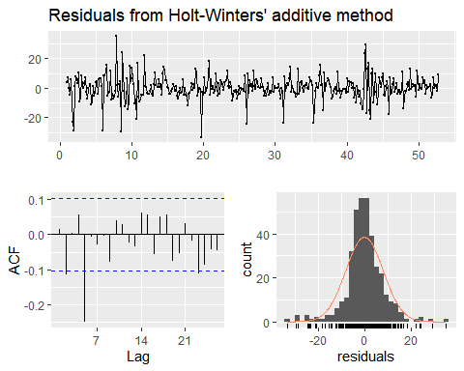

##   
## Ljung-Box test  
##   
## data: Residuals from Holt-Winters' additive method  
## Q* = 34.635, df = 3, p-value = 1.455e-07  
##   
## Model df: 11. Total lags used: 14

atm2_adj_hw_fit%>% forecast(h=31) %>% autoplot()

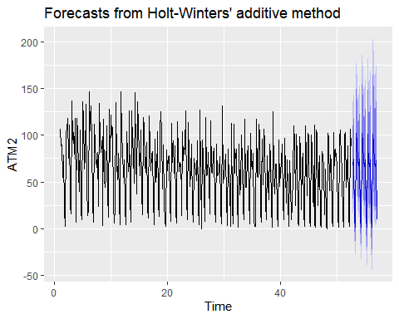

#### ARIMA

atm2_arima_fit <- auto.arima(ATM2)  
checkresiduals(atm2_arima_fit)

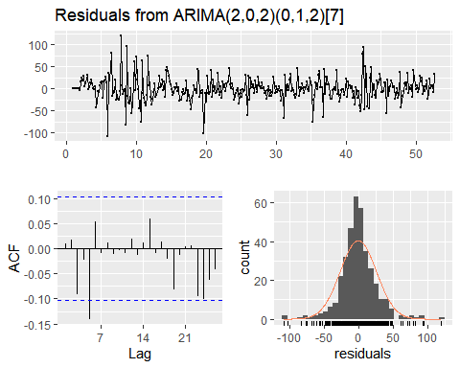

##   
## Ljung-Box test  
##   
## data: Residuals from ARIMA(2,0,2)(0,1,2)[7]  
## Q* = 12.12, df = 8, p-value = 0.1459  
##   
## Model df: 6. Total lags used: 14

atm2_arima_fit%>% forecast(h=31) %>% autoplot()

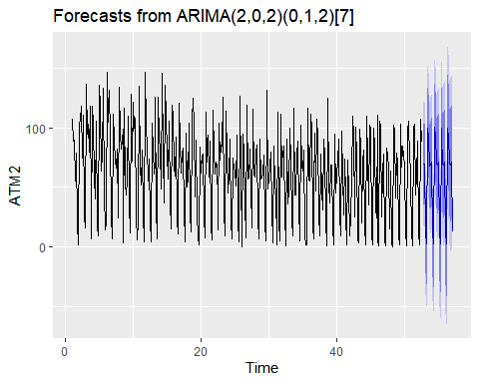

kpss.test(resid(atm2_arima_fit))

## Warning in kpss.test(resid(atm2_arima_fit)): p-value greater than printed p-  
## value

##   
## KPSS Test for Level Stationarity  
##   
## data: resid(atm2_arima_fit)  
## KPSS Level = 0.078093, Truncation lag parameter = 5, p-value = 0.1

### ARIMA with Box Cox Adjustment

atm2_lambda = BoxCox.lambda(ATM2)  
atm2_box_arima_fit <- Arima(ATM2, order = c(5, 0, 5), seasonal = c(0, 1, 1), lambda = atm2_lambda)  
checkresiduals(atm2_box_arima_fit)

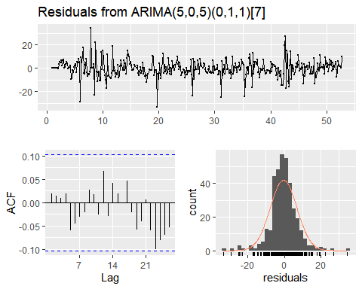

##   
## Ljung-Box test  
##   
## data: Residuals from ARIMA(5,0,5)(0,1,1)[7]  
## Q* = 6.2679, df = 3, p-value = 0.09928  
##   
## Model df: 11. Total lags used: 14

atm2_box_arima_fit%>% forecast(h=31) %>% autoplot()

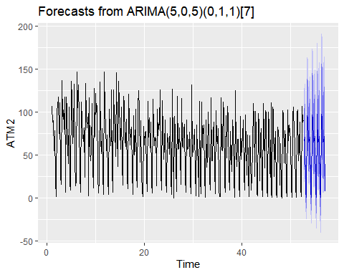

kpss.test(resid(atm2_box_arima_fit))

## Warning in kpss.test(resid(atm2_box_arima_fit)): p-value greater than printed p-  
## value

##   
## KPSS Test for Level Stationarity  
##   
## data: resid(atm2_box_arima_fit)  
## KPSS Level = 0.11532, Truncation lag parameter = 5, p-value = 0.1

### MODEL EVALUATION

I will use the tsCV function and evaluate the models.My goal is to find the model that produces minumum RMSE.

h <- 31  
get_rmse <- function(error) {  
 sqrt(mean(error^2, na.rm = TRUE))  
}  
atm2_arima_forecast <- function(x, h) {  
 forecast(Arima(x, order = c(2, 0, 2), seasonal = c(0, 1, 2)), h = h)  
}  
atm2_arima_box_forecast <- function(x, h) {  
 forecast(Arima(x, order = c(5, 0, 5), seasonal = c(0, 1, 1),lambda = atm2_lambda), h = h)  
}  
  
residuals_stl <- tsCV(ATM2, stlf, h = h, s.window = 7, robust = TRUE)  
residuals_stl_arima <- tsCV(ATM2, stlf, h = h, s.window = 7, robust = TRUE, method = "arima")  
residuals_hw <- tsCV(ATM2, hw, h = h)  
residuals_arima <- tsCV(ATM2, atm2_arima_forecast, h = h)  
residuals_arima_box <- tsCV(ATM2, atm2_arima_box_forecast, h = h)  
data.frame(Model_Name = c("STL", "STL & ARIMA", "Holt-Winters", "ARIMA","ARIMA-BOX_COX"),  
 RMSE = c(get_rmse(residuals_stl[, h]), get_rmse(residuals_stl_arima[, h]), get_rmse(residuals_hw[, h]), get_rmse(residuals_arima[, h]),  
 get_rmse(residuals_arima_box[, h]))) %>%  
 arrange(RMSE) %>%  
 kable() %>%  
 kable_styling()

Model_Name

RMSE

ARIMA

39.69270

ARIMA-BOX_COX

41.24307

STL & ARIMA

44.05280

STL

44.59259

Holt-Winters

58.72761

The ARIMA(2, 0, 2)(0, 1, 2) model gives the minumum RMSE among the other models.The residuals appear to be approximately normally distributed with a mean around zero.

### ATM #3

#### Data Cleanup

The ATM#3 data is quite challenging data as seen below since most of values are zero.

atm_data %>%  
 filter(ATM == "ATM3") %>%  
 mutate(nonzero = if_else(Cash == 0, "No", "Yes")) %>%  
 ggplot(aes(DATE, Cash, color = nonzero)) +  
 geom_point() +  
 ggtitle("ATM #3") +  
 scale_color_brewer(palette = "Set1") +  
 theme(axis.title = element_blank(), legend.position = "none")

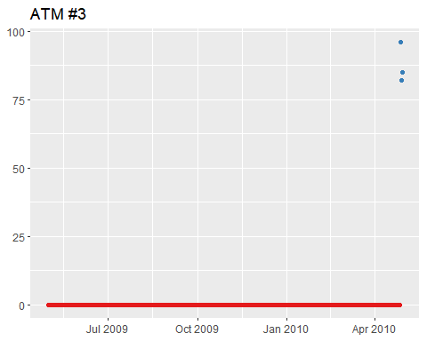

#### Model Creation

I will be using mean value for ATM3 data since we only have three observations.

#### Mean of Observations

atm3 <- atm_data %>%  
 filter(ATM == "ATM3", Cash > 0)  
atm3_mean <- mean(atm3$Cash)

The ARIMA model gives the minumum RMSE among the other models.

### ATM #4

#### Data Cleanup

The ATM#4 also challenging, however it is not as bad as ATM #3 data.

atm4 <- atm_data %>%  
 filter(ATM == "ATM4")

Here, I’d like to review the “atm4” timeseries data to determine whether there is a seosanality and ACF and PACF plots.

ATM4 <- atm_data[atm_data$ATM == "ATM4",]  
ATM4 <- ATM4[complete.cases(ATM4),]  
ATM4 <- ts(ATM4[c("Cash")],frequency = 7)  
ggtsdisplay(ATM4,   
 main = "RAW ATM4",  
 xlab = "DAY",  
 ylab = "CASH")

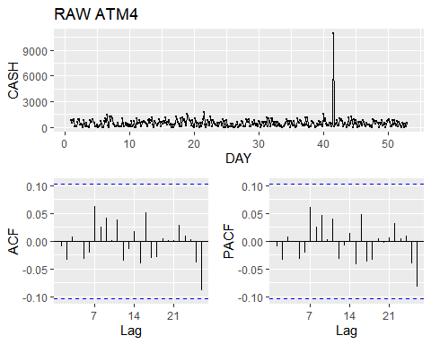

I will check Seasonality and Outlier for atm4 data.

#### Outlier and Seasonality

atm4$weekday <- factor(weekdays(as.Date(atm4$DATE)))  
atm4$weekday <- ordered(atm4$weekday,levels = c("Mon","Tues","Wedn","Thurs","Fri","Satur","Sun"))  
#drop NaN values  
atm4 <- atm4[complete.cases(atm4),]  
ggplot(atm4[complete.cases(atm4),],aes(x=weekday,y=Cash,color=ATM))+  
 geom_boxplot()+  
 ggtitle("ATM #4 OUTLIER/SEASONALTY PLOT")

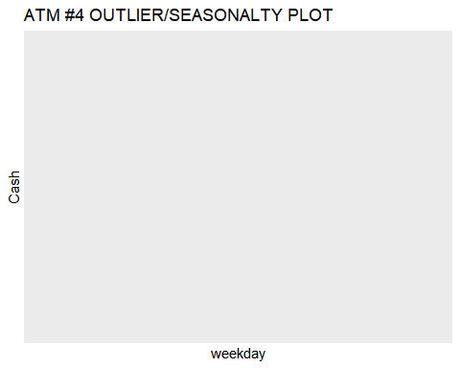

Box plots of the amount of cash is taken by customer in each of days from ATM2.As we can see on plot above, the Friday has higher mean amount of cash is taken than rest of days.The thursday has the minumum mean of cash amount is taken.The Tuesdaya has one extreme value that greater than any day’s mean value.

#### Model Creation

I will use following forecating models on this time series and determine which one is better by estimatin error metric RMSE. I will use time series cross validation function to estimate RMSE for timeseries data.

* Seasonal and Trend decomposition (STL)
* Seasonal and Trend decomposition (STL) with ARIMA
* Holt-Winters
* Holt-Winters with Box Cox Adjustment
* ARIMA
* ARIMA with Box Cox Adjustment

ATM4 <- atm_data[atm_data$ATM == "ATM4",]  
ATM4 <- ATM4[complete.cases(ATM4),]  
ATM4 <- ts(ATM4[c("Cash")],frequency = 7)  
Box.test(diff(ATM4,lag=7), type = "Ljung-Box")

##   
## Box-Ljung test  
##   
## data: diff(ATM4, lag = 7)  
## X-squared = 0.081947, df = 1, p-value = 0.7747

kpss.test(diff(ATM4,lag=7))

## Warning in kpss.test(diff(ATM4, lag = 7)): p-value greater than printed p-value

##   
## KPSS Test for Level Stationarity  
##   
## data: diff(ATM4, lag = 7)  
## KPSS Level = 0.014025, Truncation lag parameter = 5, p-value = 0.1

ggtsdisplay(diff(ATM4,lag=7),   
 main = "DIFFERENCED ATM4, Lag=7",  
 xlab = "DAY",  
 ylab = "")

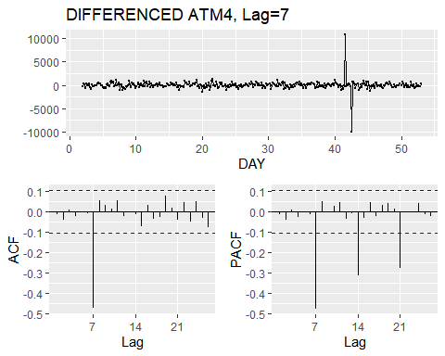

The result of KPSS and Box-Cox test indicates that atm1 timeseries is statioanry eventhou we see some extreme values on lag=7.

#### Seasonal and Trend decomposition (STL)

atm4_stl_fit <- ATM4 %>%  
 stlf(h = 31, s.window = 7, robust = TRUE)  
checkresiduals(atm4_stl_fit)

## Warning in checkresiduals(atm4_stl_fit): The fitted degrees of freedom is based  
## on the model used for the seasonally adjusted data.

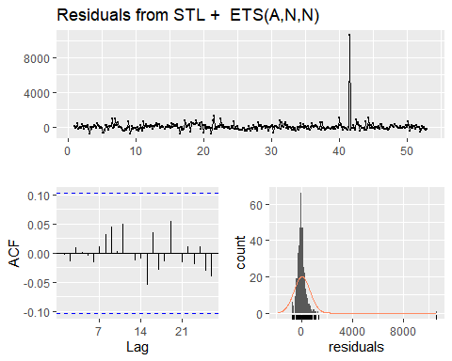

##   
## Ljung-Box test  
##   
## data: Residuals from STL + ETS(A,N,N)  
## Q* = 2.4559, df = 12, p-value = 0.9983  
##   
## Model df: 2. Total lags used: 14

checkresiduals(atm4_stl_fit)

## Warning in checkresiduals(atm4_stl_fit): The fitted degrees of freedom is based  
## on the model used for the seasonally adjusted data.



##   
## Ljung-Box test  
##   
## data: Residuals from STL + ETS(A,N,N)  
## Q* = 2.4559, df = 12, p-value = 0.9983  
##   
## Model df: 2. Total lags used: 14

atm4_stl_fit%>% forecast(h=31) %>% autoplot()

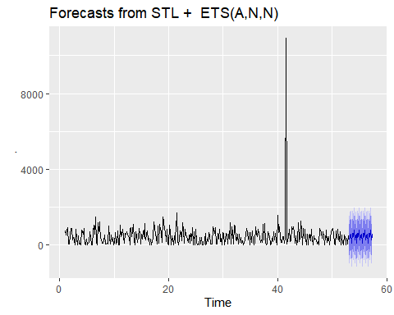

#### Seasonal and Trend decomposition (STL) with ARIMA

atm4_stl_arima_fit <- ATM4 %>%  
 stlf(h = 31, s.window = 7, robust = TRUE, method = "arima")  
checkresiduals(atm4_stl_arima_fit)

## Warning in checkresiduals(atm4_stl_arima_fit): The fitted degrees of freedom is  
## based on the model used for the seasonally adjusted data.

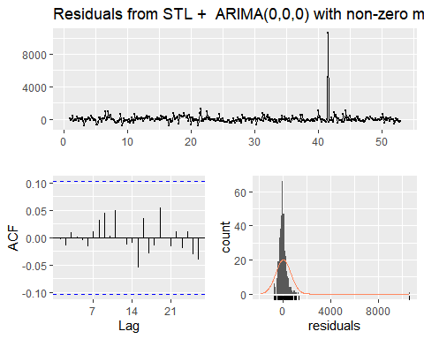

##   
## Ljung-Box test  
##   
## data: Residuals from STL + ARIMA(0,0,0) with non-zero mean  
## Q* = 2.4561, df = 13, p-value = 0.9993  
##   
## Model df: 1. Total lags used: 14

atm4_stl_arima_fit%>% forecast(h=31) %>% autoplot()

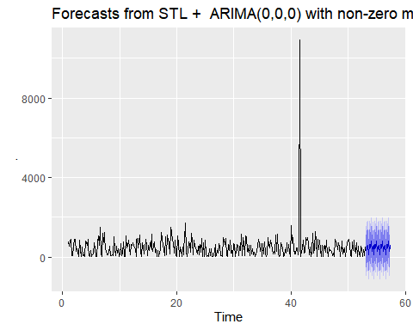

#### Holt-Winters

atm4_hw_fit <- hw(ATM4, h = 31)  
checkresiduals(atm4_hw_fit)

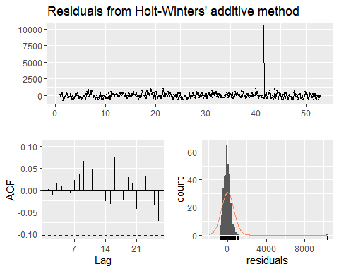

##   
## Ljung-Box test  
##   
## data: Residuals from Holt-Winters' additive method  
## Q* = 3.7364, df = 3, p-value = 0.2914  
##   
## Model df: 11. Total lags used: 14

atm4_hw_fit%>% forecast(h=31) %>% autoplot()

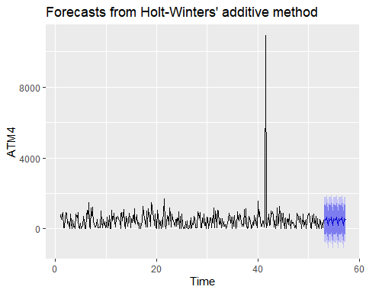

### Holt-Winters with Box Cox Adjustment

atm4_lambda <- BoxCox.lambda(ATM4)  
atm4_adj_hw_fit <- hw(ATM4, h = 31, lambda = atm4_lambda)  
checkresiduals(atm4_adj_hw_fit)

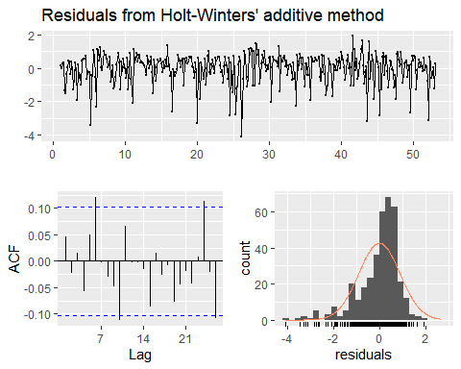

##   
## Ljung-Box test  
##   
## data: Residuals from Holt-Winters' additive method  
## Q* = 16.33, df = 3, p-value = 0.0009704  
##   
## Model df: 11. Total lags used: 14

atm4_adj_hw_fit%>% forecast(h=31) %>% autoplot()

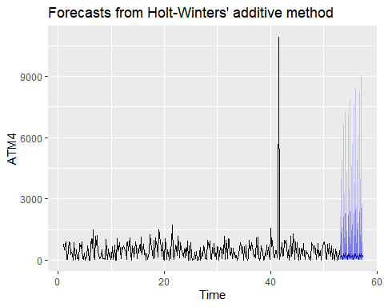

#### ARIMA

atm4_arima_fit <- auto.arima(ATM4)  
checkresiduals(atm4_arima_fit)

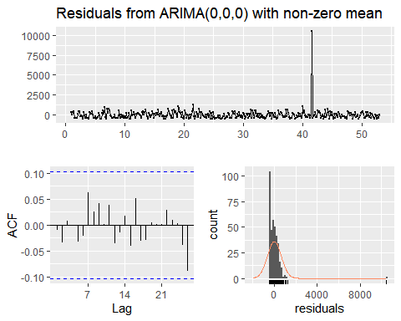

##   
## Ljung-Box test  
##   
## data: Residuals from ARIMA(0,0,0) with non-zero mean  
## Q* = 4.6668, df = 13, p-value = 0.9818  
##   
## Model df: 1. Total lags used: 14

atm4_arima_fit%>% forecast(h=31) %>% autoplot()

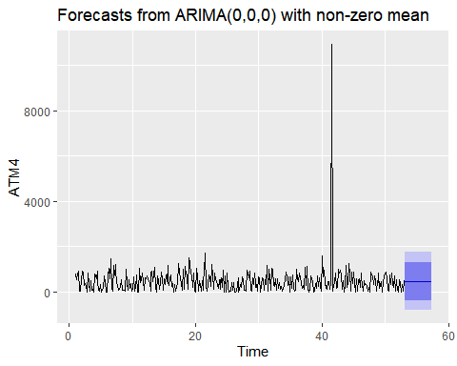

kpss.test(resid(atm4_arima_fit))

## Warning in kpss.test(resid(atm4_arima_fit)): p-value greater than printed p-  
## value

##   
## KPSS Test for Level Stationarity  
##   
## data: resid(atm4_arima_fit)  
## KPSS Level = 0.079654, Truncation lag parameter = 5, p-value = 0.1

### ARIMA with Box Cox Adjustment

atm4_lambda = BoxCox.lambda(ATM4)  
atm4_box_arima_fit <- Arima(ATM4, order = c(0, 0, 2), seasonal = c(0, 1, 1), lambda = atm2_lambda)  
checkresiduals(atm4_box_arima_fit)

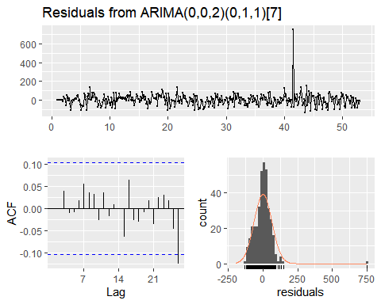

##   
## Ljung-Box test  
##   
## data: Residuals from ARIMA(0,0,2)(0,1,1)[7]  
## Q* = 3.6778, df = 11, p-value = 0.9784  
##   
## Model df: 3. Total lags used: 14

atm4_box_arima_fit%>% forecast(h=31) %>% autoplot()

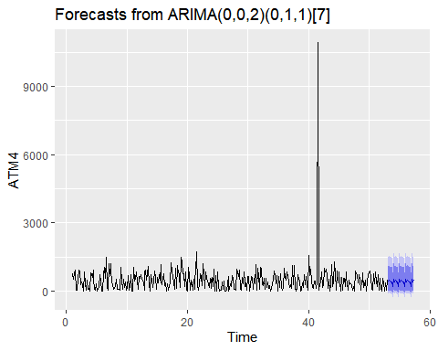

kpss.test(resid(atm4_box_arima_fit))

## Warning in kpss.test(resid(atm4_box_arima_fit)): p-value greater than printed p-  
## value

##   
## KPSS Test for Level Stationarity  
##   
## data: resid(atm4_box_arima_fit)  
## KPSS Level = 0.074774, Truncation lag parameter = 5, p-value = 0.1

### MODEL EVALUATION

I will use the tsCV function and evaluate the models.My goal is to find the model that produces minumum RMSE.

h <- 31  
get_rmse <- function(error) {  
 sqrt(mean(error^2, na.rm = TRUE))  
}  
atm4_arima_forecast <- function(x, h) {  
 forecast(Arima(x, order = c(0, 0, 0)), h = h)  
}  
atm4_arima_box_forecast <- function(x, h) {  
 forecast(Arima(x, order = c(0, 0, 2), seasonal = c(0, 1, 1),lambda = atm4_lambda), h = h)  
}  
  
residuals_stl <- tsCV(ATM4, stlf, h = h, s.window = 7, robust = TRUE)  
residuals_stl_arima <- tsCV(ATM4, stlf, h = h, s.window = 7, robust = TRUE, method = "arima")  
residuals_hw <- tsCV(ATM4, hw, h = h)  
residuals_arima <- tsCV(ATM4, atm4_arima_forecast, h = h)  
residuals_arima_box <- tsCV(ATM4, atm4_arima_box_forecast, h = h)  
data.frame(Model_Name = c("STL", "STL & ARIMA", "Holt-Winters", "ARIMA","ARIMA-BOX_COX"),  
 RMSE = c(get_rmse(residuals_stl[, h]), get_rmse(residuals_stl_arima[, h]), get_rmse(residuals_hw[, h]), get_rmse(residuals_arima[, h]),  
 get_rmse(residuals_arima_box[, h]))) %>%  
 arrange(RMSE) %>%  
 kable() %>%  
 kable_styling()

Model_Name

RMSE

ARIMA

675.1356

STL & ARIMA

689.7695

ARIMA-BOX_COX

696.7529

STL

697.5947

Holt-Winters

777.7074

The ARIMA(0, 0, 2)(0, 1, 1) model gives the minumum RMSE among the other models withresiduals approximately normally distributed with a mean around zero.

### SUMMARY

atm1_forecast <- atm1_arima_fit %>% forecast(h=31)  
atm2_forecast <- atm2_arima_fit %>% forecast(h=31)  
atm3_forecast <- rep(atm3_mean, h=31)  
atm4_forecast <- atm4_box_arima_fit %>% forecast(h=31)  
atm_forecasts_df <- data.frame("DATE" = seq(ymd("2010-05-01"), ymd("2010-05-31"), by = "1 day"), "ATM" = c("ATM1"), "Cash" = c(atm1_forecast$mean))  
atm_forecasts_df <- data.frame("DATE" = seq(ymd("2010-05-01"), ymd("2010-05-31"), by = "1 day"), "ATM" = c("ATM2"), "Cash" = c(atm2_forecast$mean)) %>%  
 rbind(atm_forecasts_df, .)  
atm_forecasts_df <- data.frame("DATE" = seq(ymd("2010-05-01"), ymd("2010-05-31"), by = "1 day"), "ATM" = c("ATM3"), "Cash" = atm3_forecast) %>%  
 rbind(atm_forecasts_df, .)  
atm_forecasts_df <- data.frame("DATE" = seq(ymd("2010-05-01"), ymd("2010-05-31"), by = "1 day"), "ATM" = c("ATM4"), "Cash" = c(atm4_forecast$mean)) %>%  
 rbind(atm_forecasts_df, .)   
atm_forecasts_df %>%  
 kable() %>%  
 kable_styling()

DATE

ATM

Cash

2010-05-01

ATM1

86.805607

2010-05-02

ATM1

100.640560

2010-05-03

ATM1

74.714560

2010-05-04

ATM1

4.762634

2010-05-05

ATM1

100.063192

2010-05-06

ATM1

79.356704

2010-05-07

ATM1

85.410706

2010-05-08

ATM1

86.967155

2010-05-09

ATM1

100.640560

2010-05-10

ATM1

74.714560

2010-05-11

ATM1

4.762634

2010-05-12

ATM1

100.063192

2010-05-13

ATM1

79.356704

2010-05-14

ATM1

85.410706

2010-05-15

ATM1

86.967155

2010-05-16

ATM1

100.640560

2010-05-17

ATM1

74.714560

2010-05-18

ATM1

4.762634

2010-05-19

ATM1

100.063192

2010-05-20

ATM1

79.356704

2010-05-21

ATM1

85.410706

2010-05-22

ATM1

86.967155

2010-05-23

ATM1

100.640560

2010-05-24

ATM1

74.714560

2010-05-25

ATM1

4.762634

2010-05-26

ATM1

100.063192

2010-05-27

ATM1

79.356704

2010-05-28

ATM1

85.410706

2010-05-29

ATM1

86.967155

2010-05-30

ATM1

100.640560

2010-05-31

ATM1

74.714560

2010-05-01

ATM2

69.432448

2010-05-02

ATM2

69.881366

2010-05-03

ATM2

12.308924

2010-05-04

ATM2

2.758906

2010-05-05

ATM2

99.519624

2010-05-06

ATM2

93.446892

2010-05-07

ATM2

68.207442

2010-05-08

ATM2

68.692335

2010-05-09

ATM2

71.724476

2010-05-10

ATM2

12.261298

2010-05-11

ATM2

2.746415

2010-05-12

ATM2

100.273631

2010-05-13

ATM2

93.053089

2010-05-14

ATM2

70.543642

2010-05-15

ATM2

68.678272

2010-05-16

ATM2

71.633493

2010-05-17

ATM2

12.311587

2010-05-18

ATM2

2.806723

2010-05-19

ATM2

100.203746

2010-05-20

ATM2

93.028275

2010-05-21

ATM2

70.616283

2010-05-22

ATM2

68.670276

2010-05-23

ATM2

71.572003

2010-05-24

ATM2

12.344230

2010-05-25

ATM2

2.848040

2010-05-26

ATM2

100.157484

2010-05-27

ATM2

93.010606

2010-05-28

ATM2

70.664886

2010-05-29

ATM2

68.665877

2010-05-30

ATM2

71.530466

2010-05-31

ATM2

12.365385

2010-05-01

ATM3

87.666667

2010-05-02

ATM3

87.666667

2010-05-03

ATM3

87.666667

2010-05-04

ATM3

87.666667

2010-05-05

ATM3

87.666667

2010-05-06

ATM3

87.666667

2010-05-07

ATM3

87.666667

2010-05-08

ATM3

87.666667

2010-05-09

ATM3

87.666667

2010-05-10

ATM3

87.666667

2010-05-11

ATM3

87.666667

2010-05-12

ATM3

87.666667

2010-05-13

ATM3

87.666667

2010-05-14

ATM3

87.666667

2010-05-15

ATM3

87.666667

2010-05-16

ATM3

87.666667

2010-05-17

ATM3

87.666667

2010-05-18

ATM3

87.666667

2010-05-19

ATM3

87.666667

2010-05-20

ATM3

87.666667

2010-05-21

ATM3

87.666667

2010-05-22

ATM3

87.666667

2010-05-23

ATM3

87.666667

2010-05-24

ATM3

87.666667

2010-05-25

ATM3

87.666667

2010-05-26

ATM3

87.666667

2010-05-27

ATM3

87.666667

2010-05-28

ATM3

87.666667

2010-05-29

ATM3

87.666667

2010-05-30

ATM3

87.666667

2010-05-31

ATM3

87.666667

2010-05-01

ATM4

416.325318

2010-05-02

ATM4

462.084491

2010-05-03

ATM4

433.476211

2010-05-04

ATM4

396.933789

2010-05-05

ATM4

415.667039

2010-05-06

ATM4

218.504549

2010-05-07

ATM4

532.792032

2010-05-08

ATM4

412.217409

2010-05-09

ATM4

461.255552

2010-05-10

ATM4

433.476211

2010-05-11

ATM4

396.933789

2010-05-12

ATM4

415.667039

2010-05-13

ATM4

218.504549

2010-05-14

ATM4

532.792032

2010-05-15

ATM4

412.217409

2010-05-16

ATM4

461.255552

2010-05-17

ATM4

433.476211

2010-05-18

ATM4

396.933789

2010-05-19

ATM4

415.667039

2010-05-20

ATM4

218.504549

2010-05-21

ATM4

532.792032

2010-05-22

ATM4

412.217409

2010-05-23

ATM4

461.255552

2010-05-24

ATM4

433.476211

2010-05-25

ATM4

396.933789

2010-05-26

ATM4

415.667039

2010-05-27

ATM4

218.504549

2010-05-28

ATM4

532.792032

2010-05-29

ATM4

412.217409

2010-05-30

ATM4

461.255552

2010-05-31

ATM4

433.476211

write.csv(atm_forecasts_df,"atm_forecasts_df.csv")

## Part B - Forecasting Power

Part B consists of a simple dataset of residential power usage for January 1998 until December 2013. Your assignment is to model these data and a monthly forecast for 2014. The data is given in a single file. The variable ‘KWH’ is power consumption in Kilowatt hours, the rest is straight forward. Add this to your existing files above.

### Data Review-Missing values

kable(tail(power_data))

CaseSequence

YYYY-MMM

KWH

919

2013-Jul

8415321

920

2013-Aug

9080226

921

2013-Sep

7968220

922

2013-Oct

5759367

923

2013-Nov

5769083

924

2013-Dec

9606304

power_ts <-power_data %>%  
 select(KWH) %>%  
 ts(start = decimal_date(date("1998-01-01")), frequency = 12)  
autoplot(power_ts)

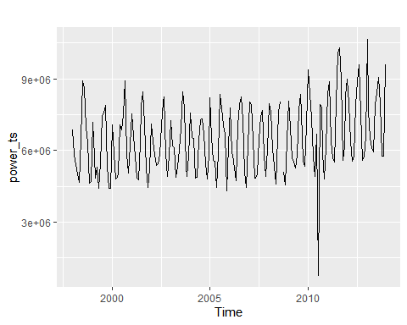

ggseasonplot(power_ts)

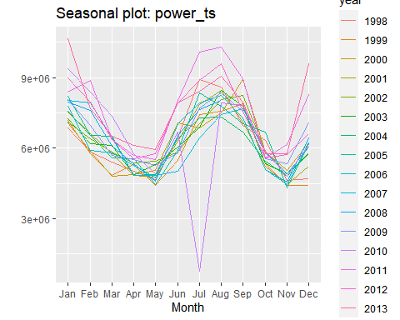

ggsubseriesplot(power_ts)

## Warning: Removed 16 row(s) containing missing values (geom_path).

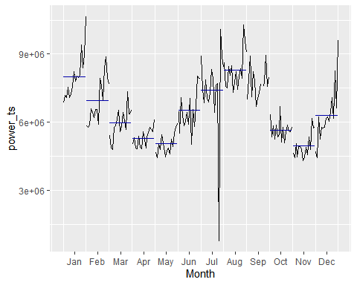

gglagplot(power_ts)

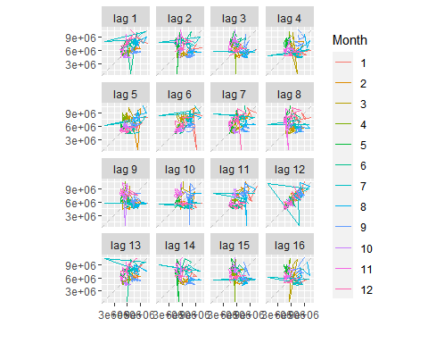

ggAcf(power_ts)

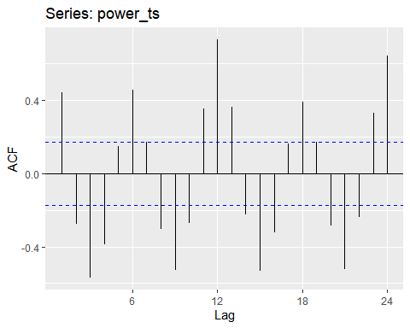

The power_data contains 1 missing values on Sept 2008.The data also contains an extreme value in july 2010.ACF plot suggest that there is a sesonality in power_data.I possoble need to use lag=12 sesonality adjustment.

I will use tsclean package to clean the missing values and winsorize extreme value and replot the differents graphs.

power_ts <- tsclean(power_ts)  
ggtsplot <- function(ts, title) {  
 grid.arrange(  
 autoplot(ts) +  
 scale_y_continuous() +  
 ggtitle(title) +  
 theme(axis.title = element_blank()),  
 grid.arrange(  
 ggAcf(ts) + ggtitle(element_blank()),  
 ggPacf(ts) + ggtitle(element_blank()), ncol = 2)  
 , nrow = 2)  
}  
ggtsplot(power_ts, "Using tsclean package Power Usage (KWH)")

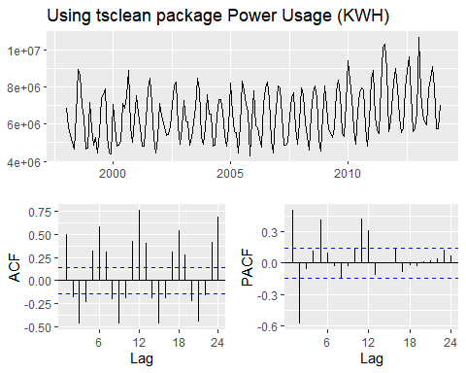

It is clearn that there is a seasonality in this data.

#### Model Creation

I will try to build a model that captures seasonality.

#### ARIMA with Box Cox Adjustment

power_ts <- tsclean(power_ts)  
power_ts_lambda = BoxCox.lambda(power_ts)  
power_ts_diff<-BoxCox(power_ts, power_ts_lambda)  
ggtsdisplay(diff(power_ts_diff, 12), points = FALSE, main = "Differenced (lag-12) Box-Cox transformed residential power usage")

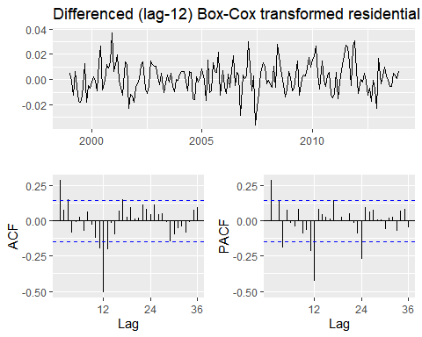

The timeseries data looks statioanary, I wont use seosanaly differencing.I also can see that extreme value in the PACF and ACF at lag=1 and lag=4.

power_ts_arima_fit <- Arima(power_ts, order = c(1, 0, 0), seasonal = c(0, 1, 1), lambda = power_ts_lambda)  
checkresiduals(power_ts_arima_fit)

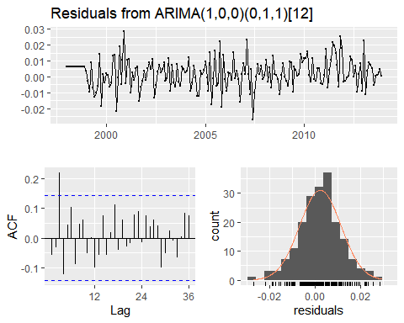

##   
## Ljung-Box test  
##   
## data: Residuals from ARIMA(1,0,0)(0,1,1)[12]  
## Q* = 31.099, df = 22, p-value = 0.0941  
##   
## Model df: 2. Total lags used: 24

power_ts_arima_fit%>% forecast(h=31) %>% autoplot()

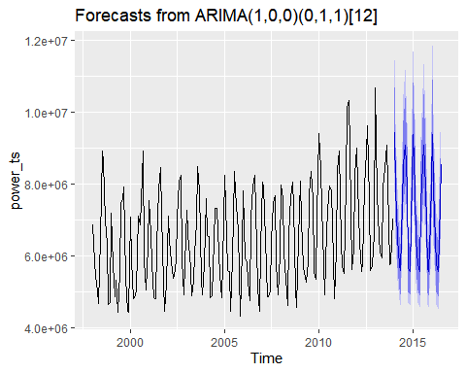

kpss.test(resid(power_ts_arima_fit))

## Warning in kpss.test(resid(power_ts_arima_fit)): p-value greater than printed p-  
## value

##   
## KPSS Test for Level Stationarity  
##   
## data: resid(power_ts_arima_fit)  
## KPSS Level = 0.32902, Truncation lag parameter = 4, p-value = 0.1

### Box-Cox Holt-Winters Model

power_ts <- tsclean(power_ts)  
adj_hw_fit <- hw(power_ts, h = 12, lambda = power_ts_lambda)  
checkresiduals(adj_hw_fit)

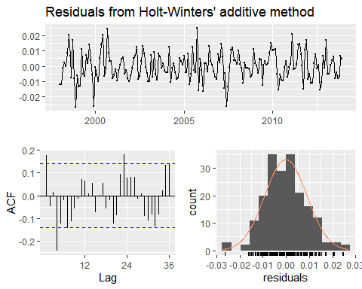

##   
## Ljung-Box test  
##   
## data: Residuals from Holt-Winters' additive method  
## Q* = 48.973, df = 8, p-value = 6.433e-08  
##   
## Model df: 16. Total lags used: 24

### MODEL EVALUATION

I will use the tsCV function and evaluate the models as I used for PART A.My goal is to find the model that produces minumum RMSE.

h <- 12  
get_rmse <- function(error) {  
 sqrt(mean(error^2, na.rm = TRUE))  
}  
  
power_ts_arima_fit_forecast <- function(x, h) {  
 forecast(Arima(x, order = c(1, 0, 0), seasonal = c(0, 1, 1), lambda = power_ts_lambda), h = h)  
}  
  
residuals_hw <- tsCV(power_ts, hw, h = h)  
residuals_arima <- tsCV(power_ts, power_ts_arima_fit_forecast, h = h)  
data.frame(Model_Name = c("Holt-Winters", "ARIMA"),  
 RMSE = c(get_rmse(residuals_hw[, h]), get_rmse(residuals_arima[, h]))) %>%  
 arrange(RMSE) %>%  
 kable() %>%  
 kable_styling()

Model_Name

RMSE

ARIMA

703989.5

Holt-Winters

1010721.9

The ARIMA(1, 0, 0)(0, 1, 1) model gives the minumum RMSE among the other model.

### SUMMARY

Since Arima Model gives better RMSE result, I will use ARIMA model for forecasting purposes.

power_ts_forecast <-power_ts_arima_fit %>% forecast(h=12)  
power_forecast_df <-data_frame(DATE = paste0(2014, "-", month.abb), POWER_KWH = power_ts_forecast$mean)

## Warning: `data_frame()` is deprecated, use `tibble()`.  
## This warning is displayed once per session.

power_forecast_df %>%  
 kable() %>%  
 kable_styling()

DATE

POWER_KWH

2014-Jan

9417011

2014-Feb

7893327

2014-Mar

6436805

2014-Apr

5756614

2014-May

5570785

2014-Jun

7479484

2014-Jul

8522770

2014-Aug

9080593

2014-Sep

7909745

2014-Oct

5661778

2014-Nov

5568654

2014-Dec

6919608

write_csv(power_forecast_df,"power_forecast_df.csv")

## Part C - BONUS, optional (part or all)

Part C consists of two data sets. These are simple 2 columns sets, however they have different time stamps. Your optional assignment is to time-base sequence the data and aggregate based on hour (example of what this looks like, follows). Note for multiple recordings within an hour, take the mean. Then to determine if the data is stationary and can it be forecast. If so, provide a week forward forecast and present results via Rpubs and .rmd and the forecast in an Excel readable file.

### Data Engineering

colnames(water1_data)= c("w1_date_time","WaterFlow")  
colnames(water2_data)= c("w2_date_Time","WaterFlow")  
water_df= water1_data %>% mutate(w2_date_Time = lubridate::round_date(w1_date_time,"hour") ) %>% select(w2_date_Time,WaterFlow) %>% bind_rows(water2_data) %>% group_by(w2_date_Time) %>% summarize(WaterFlowF = mean(WaterFlow, na.rm = T))  
colnames(water_df)= c("Date_Time","WaterFlow")  
water_ts = ts(water_df$WaterFlow,frequency = 24)

### Data Graphs

autoplot(water_ts) +  
 labs(title = "Water Flow by Hourly", subtitle = "[October 23, 2015 - December 3, 2015]", x = "Day", y = "Water_flow")

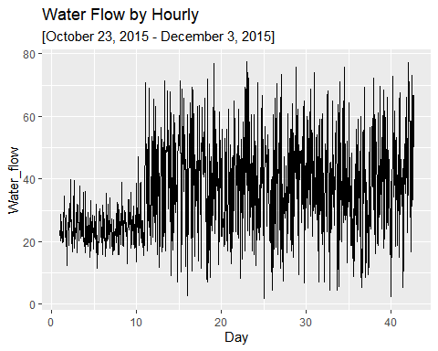

It is clear that data shows a lot of high and low as outliers or shocks.The variance of data also seems like not constant.

ggtsdisplay(water_ts)

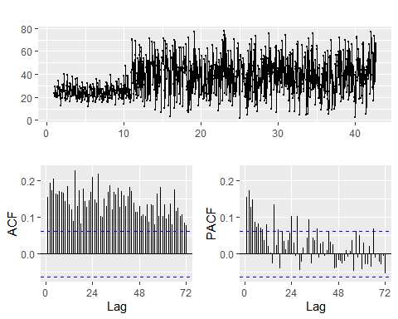

The ACF and PACF plots above indivates that AR(5) autoregression of 5, and the ACF a MA(2) moving average of order 2

### Model Creation

I will use following forecating models on this time series and determine which one is better by estimatin error metric RMSE. I will use time series cross validation function to estimate RMSE for timeseries data.

#### ARIMA

water_ts_arima_fit <- auto.arima(water_ts)  
checkresiduals(water_ts_arima_fit)

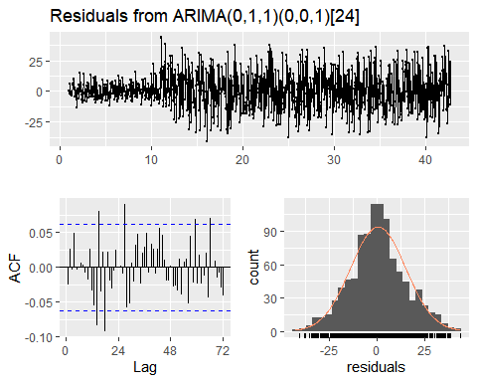

##   
## Ljung-Box test  
##   
## data: Residuals from ARIMA(0,1,1)(0,0,1)[24]  
## Q* = 67.6, df = 46, p-value = 0.02068  
##   
## Model df: 2. Total lags used: 48

water_ts_arima_fit%>% forecast(h=168) %>% autoplot()

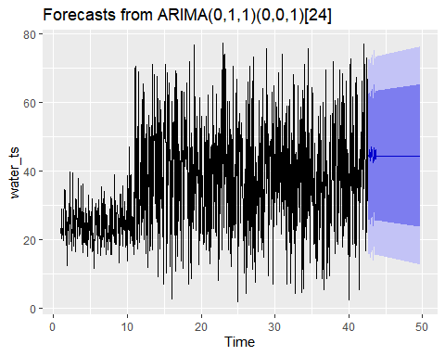

kpss.test(resid(water_ts_arima_fit))

## Warning in kpss.test(resid(water_ts_arima_fit)): p-value greater than printed p-  
## value

##   
## KPSS Test for Level Stationarity  
##   
## data: resid(water_ts_arima_fit)  
## KPSS Level = 0.076651, Truncation lag parameter = 7, p-value = 0.1

### ARIMA with Box Cox Adjustment

water_ts_lambda = BoxCox.lambda(water_ts)  
water_ts_box_arima_fit <- Arima(water_ts, order=c(1, 1, 1),lambda = water_ts_lambda)  
checkresiduals(water_ts_box_arima_fit)

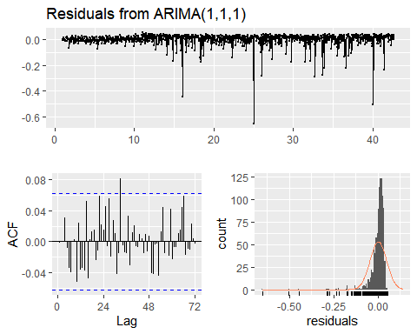

##   
## Ljung-Box test  
##   
## data: Residuals from ARIMA(1,1,1)  
## Q* = 41.128, df = 46, p-value = 0.6761  
##   
## Model df: 2. Total lags used: 48

water_ts_box_arima_fit%>% forecast(h=168) %>% autoplot()

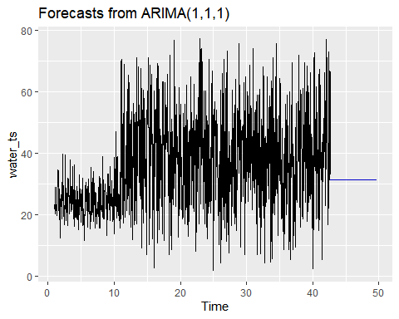

kpss.test(resid(water_ts_box_arima_fit))

## Warning in kpss.test(resid(water_ts_box_arima_fit)): p-value greater than  
## printed p-value

##   
## KPSS Test for Level Stationarity  
##   
## data: resid(water_ts_box_arima_fit)  
## KPSS Level = 0.087414, Truncation lag parameter = 7, p-value = 0.1

### MODEL EVALUATION

I will use the tsCV function and evaluate the models as I used for PART A and PART B.My goal is to find the model that produces minumum RMSE.

h <- 168  
get_rmse <- function(error) {  
 sqrt(mean(error^2, na.rm = TRUE))  
}  
  
water_ts_arima_fit_forecast <- function(x, h) {  
 forecast(Arima(x, order = c(0, 1, 1),seasonal = c(0, 0, 1)), h = h)  
}  
  
water_ts_arima_box_fit_forecast <- function(x, h) {  
 forecast(Arima(x, order=c(1, 1, 1), lambda = water_ts_lambda), h = h)  
}  
  
  
''

## [1] ""

residuals_arima<- tsCV(water_ts,water_ts_arima_fit_forecast, h = h)  
residuals_arima_box <- tsCV(water_ts, water_ts_arima_box_fit_forecast, h = h)  
data.frame(Model_Name = c("ARIMA", "ARIMA_BOX_COX"),  
 RMSE = c(get_rmse(residuals_arima[, h]), get_rmse(residuals_arima_box[, h]))) %>%  
 arrange(RMSE) %>%  
 kable() %>%  
 kable_styling()

Model_Name

RMSE

ARIMA

17.36650

ARIMA_BOX_COX

18.82279

### SUMMARY

The ARIMA and ARIMA with Box_COX transformation model results are pretty close.However, Since Arima gives minumum value in RMSE result, I will use ARIMA(0,1,1)(0,0,1) model for forecasting purposes.

water_forecast<-water_ts_arima_fit %>% forecast(h=168)  
water_forecast_df <- data.frame(water_forecast$mean)  
colnames(water_forecast_df) <- "water_flow"  
row.names(water_forecast_df) <- seq(ymd_hm("2015-12-3 17:00"), ymd_hm("2015-12-10 16:00"), by = "hour")  
kable(water_forecast_df)

water_flow

2015-12-03 17:00:00

44.10568

2015-12-03 18:00:00

45.27422

2015-12-03 19:00:00

46.18329

2015-12-03 20:00:00

44.17254

2015-12-03 21:00:00

45.49246

2015-12-03 22:00:00

44.69631

2015-12-03 23:00:00

42.99370

2015-12-04 00:00:00

44.72864

2015-12-04 01:00:00

46.97255

2015-12-04 02:00:00

44.73431

2015-12-04 03:00:00

46.39813

2015-12-04 04:00:00

45.59040

2015-12-04 05:00:00

45.52474

2015-12-04 06:00:00

43.32449

2015-12-04 07:00:00

44.10577

2015-12-04 08:00:00

42.42523

2015-12-04 09:00:00

43.14329

2015-12-04 10:00:00

44.67196

2015-12-04 11:00:00

46.79987

2015-12-04 12:00:00

43.47161

2015-12-04 13:00:00

46.13864

2015-12-04 14:00:00

44.38329

2015-12-04 15:00:00

43.58102

2015-12-04 16:00:00

46.20608

2015-12-04 17:00:00

44.46400

2015-12-04 18:00:00

44.46400

2015-12-04 19:00:00

44.46400

2015-12-04 20:00:00

44.46400

2015-12-04 21:00:00

44.46400

2015-12-04 22:00:00

44.46400

2015-12-04 23:00:00

44.46400

2015-12-05 00:00:00

44.46400

2015-12-05 01:00:00

44.46400

2015-12-05 02:00:00

44.46400

2015-12-05 03:00:00

44.46400

2015-12-05 04:00:00

44.46400

2015-12-05 05:00:00

44.46400

2015-12-05 06:00:00

44.46400

2015-12-05 07:00:00

44.46400

2015-12-05 08:00:00

44.46400

2015-12-05 09:00:00

44.46400

2015-12-05 10:00:00

44.46400

2015-12-05 11:00:00

44.46400

2015-12-05 12:00:00

44.46400

2015-12-05 13:00:00

44.46400

2015-12-05 14:00:00

44.46400

2015-12-05 15:00:00

44.46400

2015-12-05 16:00:00

44.46400

2015-12-05 17:00:00

44.46400

2015-12-05 18:00:00

44.46400

2015-12-05 19:00:00

44.46400

2015-12-05 20:00:00

44.46400

2015-12-05 21:00:00

44.46400

2015-12-05 22:00:00

44.46400

2015-12-05 23:00:00

44.46400

2015-12-06 00:00:00

44.46400

2015-12-06 01:00:00

44.46400

2015-12-06 02:00:00

44.46400

2015-12-06 03:00:00

44.46400

2015-12-06 04:00:00

44.46400

2015-12-06 05:00:00

44.46400

2015-12-06 06:00:00

44.46400

2015-12-06 07:00:00

44.46400

2015-12-06 08:00:00

44.46400

2015-12-06 09:00:00

44.46400

2015-12-06 10:00:00

44.46400

2015-12-06 11:00:00

44.46400

2015-12-06 12:00:00

44.46400

2015-12-06 13:00:00

44.46400

2015-12-06 14:00:00

44.46400

2015-12-06 15:00:00

44.46400

2015-12-06 16:00:00

44.46400

2015-12-06 17:00:00

44.46400

2015-12-06 18:00:00

44.46400

2015-12-06 19:00:00

44.46400

2015-12-06 20:00:00

44.46400

2015-12-06 21:00:00

44.46400

2015-12-06 22:00:00

44.46400

2015-12-06 23:00:00

44.46400

2015-12-07 00:00:00

44.46400

2015-12-07 01:00:00

44.46400

2015-12-07 02:00:00

44.46400

2015-12-07 03:00:00

44.46400

2015-12-07 04:00:00

44.46400

2015-12-07 05:00:00

44.46400

2015-12-07 06:00:00

44.46400

2015-12-07 07:00:00

44.46400

2015-12-07 08:00:00

44.46400

2015-12-07 09:00:00

44.46400

2015-12-07 10:00:00

44.46400

2015-12-07 11:00:00

44.46400

2015-12-07 12:00:00

44.46400

2015-12-07 13:00:00

44.46400

2015-12-07 14:00:00

44.46400

2015-12-07 15:00:00

44.46400

2015-12-07 16:00:00

44.46400

2015-12-07 17:00:00

44.46400

2015-12-07 18:00:00

44.46400

2015-12-07 19:00:00

44.46400

2015-12-07 20:00:00

44.46400

2015-12-07 21:00:00

44.46400

2015-12-07 22:00:00

44.46400

2015-12-07 23:00:00

44.46400

2015-12-08 00:00:00

44.46400

2015-12-08 01:00:00

44.46400

2015-12-08 02:00:00

44.46400

2015-12-08 03:00:00

44.46400

2015-12-08 04:00:00

44.46400

2015-12-08 05:00:00

44.46400

2015-12-08 06:00:00

44.46400

2015-12-08 07:00:00

44.46400

2015-12-08 08:00:00

44.46400

2015-12-08 09:00:00

44.46400

2015-12-08 10:00:00

44.46400

2015-12-08 11:00:00

44.46400

2015-12-08 12:00:00

44.46400

2015-12-08 13:00:00

44.46400

2015-12-08 14:00:00

44.46400

2015-12-08 15:00:00

44.46400

2015-12-08 16:00:00

44.46400

2015-12-08 17:00:00

44.46400

2015-12-08 18:00:00

44.46400

2015-12-08 19:00:00

44.46400

2015-12-08 20:00:00

44.46400

2015-12-08 21:00:00

44.46400

2015-12-08 22:00:00

44.46400

2015-12-08 23:00:00

44.46400

2015-12-09 00:00:00

44.46400

2015-12-09 01:00:00

44.46400

2015-12-09 02:00:00

44.46400

2015-12-09 03:00:00

44.46400

2015-12-09 04:00:00

44.46400

2015-12-09 05:00:00

44.46400

2015-12-09 06:00:00

44.46400

2015-12-09 07:00:00

44.46400

2015-12-09 08:00:00

44.46400

2015-12-09 09:00:00

44.46400

2015-12-09 10:00:00

44.46400

2015-12-09 11:00:00

44.46400

2015-12-09 12:00:00

44.46400

2015-12-09 13:00:00

44.46400

2015-12-09 14:00:00

44.46400

2015-12-09 15:00:00

44.46400

2015-12-09 16:00:00

44.46400

2015-12-09 17:00:00

44.46400

2015-12-09 18:00:00

44.46400

2015-12-09 19:00:00

44.46400

2015-12-09 20:00:00

44.46400

2015-12-09 21:00:00

44.46400

2015-12-09 22:00:00

44.46400

2015-12-09 23:00:00

44.46400

2015-12-10 00:00:00

44.46400

2015-12-10 01:00:00

44.46400

2015-12-10 02:00:00

44.46400

2015-12-10 03:00:00

44.46400

2015-12-10 04:00:00

44.46400

2015-12-10 05:00:00

44.46400

2015-12-10 06:00:00

44.46400

2015-12-10 07:00:00

44.46400

2015-12-10 08:00:00

44.46400

2015-12-10 09:00:00

44.46400

2015-12-10 10:00:00

44.46400

2015-12-10 11:00:00

44.46400

2015-12-10 12:00:00

44.46400

2015-12-10 13:00:00

44.46400

2015-12-10 14:00:00

44.46400

2015-12-10 15:00:00

44.46400

2015-12-10 16:00:00

44.46400

write.csv(water_forecast_df,"water_flow_forecast.csv")