RECOMMENDER SYSTEMS
A Collaborative Filtering Approach Based on Naïve Bayes Classifier
Report 2
Code Documentation

Supervisor: Gamze USLU, Ph.D.

Ömer MANAV – 210209003
Kaan Bahadır SAĞRA – 210201011

Overview
This document explains the Python code in nbcf_enhanced.py. The code is divided into five sections: (1) imports and settings, (2) dataset loading, (3) algorithm functions, (4) evaluation, and (5) visualisation. Each section is shown with its code and then explained in plain language.

Section 1 — Imports and Settings

1.1 Library Imports
The script starts by importing all the external libraries it needs.

import pandas as pd
pandas: Used to load the dataset file and work with tabular data.

import numpy as np
numpy: Used for numerical calculations such as computing means and percentiles.

import matplotlib.pyplot as plt
matplotlib.pyplot: The main library for creating all figures and saving them as image files.

import matplotlib.patches as mpatches
mpatches: Provides coloured patch objects that are used to build custom legend entries in bar charts.

import seaborn as sns
seaborn: A higher-level plotting library. Used here specifically for drawing confusion matrix heatmaps.

import math
math: Provides the log() and exp() functions used in all probability calculations.

import time
time: Used to measure how long each prediction takes, via time.perf_counter().

from collections import defaultdict
defaultdict: A dictionary that returns an empty dict for any missing key. Used to build the user and item rating indexes without needing to check for missing keys manually.

from sklearn.model_selection import train_test_split
train_test_split: Splits the full rating dataset into a training set (80 %) and a test set (20 %).

from sklearn.metrics import confusion_matrix, precision_score, recall_score, f1_score
sklearn.metrics: Provides standard classification metrics: confusion matrix, precision, recall, and F1 score.

import warnings
warnings.filterwarnings('ignore')
warnings: Suppresses non-critical warnings, for example when a rating class has zero predictions and sklearn would normally show a division-by-zero message.

1.2 Global Constants
R_values = [1, 2, 3, 4, 5]
R_values: The five possible rating values. All probability distributions are computed over these five classes.

alpha = 0.01
alpha: The Laplace smoothing parameter. It is added to all counts to prevent any probability from being exactly zero.

num_R = len(R_values) # 5
num_R: The number of rating classes, used in the smoothing formula.

DECAY_LAMBDA = 1e-7
DECAY_LAMBDA: The decay rate for temporal weighting. At this value, a rating made roughly 115 days ago has a weight of about 0.37, and a rating from three years ago has a weight of about 0.09.

Section 2 — Dataset Loading and Preparation

2.1 Reading the File
ratings_df = pd.read_csv(
'ml-1m/ratings.dat', sep='::', engine='python',
encoding='latin-1',
names=['user_id', 'item_id', 'rating', 'timestamp']
)

sep='::': MovieLens-1M uses '::' as the separator between fields. The Python engine is needed because the faster C engine does not support multi-character separators.
encoding='latin-1': The file contains some characters that are not valid UTF-8. Using latin-1 prevents a reading error.
names=[...]: The file has no header row, so column names are given manually.

2.2 Train / Test Split
train_df, test_df = train_test_split(ratings_df, test_size=0.2, random_state=42)

test_size=0.2: 20 % of all ratings are held out for testing. The split is done at the individual rating level, which is standard practice in offline CF evaluation.
random_state=42: A fixed random seed makes the split reproducible. Running the script multiple times will always give the same train/test split.

2.3 Building the Rating Indexes
user_r = defaultdict(dict) # user_r[u][i] = rating
item_r = defaultdict(dict) # item_r[i][u] = rating
user_ts = defaultdict(dict) # user_ts[u][i] = timestamp

for _, row in train_df.iterrows():
user_r[row['user_id']][row['item_id']] = row['rating']
item_r[row['item_id']][row['user_id']] = row['rating']
user_ts[row['user_id']][row['item_id']] = row['timestamp']

user_r: A nested dictionary. Given a user ID, it returns all items that user has rated and the rating values. This gives O(1) lookup speed during prediction.
item_r: The same data indexed the other way. Given an item ID, it returns all users who rated it and their ratings.
user_ts: Stores the timestamp for every (user, item) pair. Used later to compute how old each rating is.

global_max_ts = train_df['timestamp'].max()
global_max_ts: The most recent timestamp in the training set. All age values are measured from this reference point.

Section 3 — Core Algorithm Functions

3.1 Prior Probability Functions
These functions compute how often a given rating appears for an item or a user, using Laplace smoothing.

def calc_item_prior(i, y, item_r, alpha=0.01, num_R=5):
if i not in item_r:
return 1.0 / num_R
ratings = list(item_r[i].values())
count_y = sum(1 for r in ratings if r == y)
return (count_y + alpha) / (len(ratings) + num_R * alpha)

Return 1/num_R: If item i has never been rated, we return a uniform probability (0.2 for each class). This handles the cold-start case safely.
count_y: The number of times item i received rating y in the training data.
Laplace formula: (count + alpha) / (total + 5 × alpha) adds a small pseudocount to every class, which prevents zero probabilities for unseen combinations.

def calc_user_prior(u, y, user_r, alpha=0.01, num_R=5):
if u not in user_r:
return 1.0 / num_R
ratings = list(user_r[u].values())
count_y = sum(1 for r in ratings if r == y)
return (count_y + alpha) / (len(ratings) + num_R * alpha)

calc_user_prior: Works the same as calc_item_prior but from the user side: how often does user u give rating y to any item.

3.2 Likelihood Functions
These functions compute the conditional probability that a related item (or user) has a specific rating, given what rating we believe the target item (or user) deserves.

def calc_ub_likelihood(i, y, j, k, item_r, alpha=0.01, num_R=5):
users_iy = {u for u, r in item_r.get(i, {}).items() if r == y}
match = sum(1 for u in users_iy if item_r.get(j, {}).get(u) == k)
total = sum(1 for u in users_iy if u in item_r.get(j, {}))
return (match + alpha) / (total + num_R * alpha)

Question answered: Among users who gave item i rating y, what fraction also gave item j rating k?
users_iy: The group of users who rated item i with exactly rating y — the evidence group.
match: How many of those users also rated item j with rating k.
total: How many of those users rated item j at all. This is the denominator before smoothing.

def calc_ib_likelihood(u, y, v, k, user_r, alpha=0.01, num_R=5):
items_uy = {it for it, r in user_r.get(u, {}).items() if r == y}
match = sum(1 for it in items_uy if user_r.get(v, {}).get(it) == k)
total = sum(1 for it in items_uy if it in user_r.get(v, {}))
return (match + alpha) / (total + num_R * alpha)

Question answered: Among items that user u rated y, what fraction did co-rater v also rate with k?

3.3 Log-Space Normalisation
def normalize_log_scores(log_scores_dict):
max_log = max(log_scores_dict.values())
probs = {y: math.exp(log_s - max_log)
for y, log_s in log_scores_dict.items()}
total = sum(probs.values())
return {y: p / total for y, p in probs.items()}

Why log-space: Multiplying many small probabilities leads to floating-point underflow (the result becomes zero). Adding their logarithms avoids this problem.
Subtracting max_log: This is the log-sum-exp trick. It shifts all values so the largest becomes 0 before calling exp(), which prevents both underflow and overflow.
Division by total: Converts the raw exponentiated values into a proper probability distribution that sums to 1.

3.4 Scoring Functions
These three functions compute the posterior probability distribution over the five rating classes for a given (user, item) pair.

def ub_score(u, i, user_r, item_r, alpha=0.01, num_R=5):
log_scores = {}
past_items = list(user_r.get(u, {}).items())
for y in R_values:
log_s = math.log(calc_item_prior(i, y, item_r, alpha, num_R))
for j, k in past_items:
lik = calc_ub_likelihood(i, y, j, k, item_r, alpha, num_R)
log_s += math.log(lik) if lik > 0 else -1e9
log_scores[y] = log_s
return normalize_log_scores(log_scores)

Outer loop: We compute one log-score for each candidate rating class y.
log_s start: We begin with log of the item prior — how often item i receives rating y overall.
Inner loop: For each item j that user u has already rated with rating k, we add log P(k | y, i, j). Each past rating adds one piece of evidence under the Naïve Bayes assumption.
lik > 0 guard: Under Laplace smoothing, likelihoods are always positive, but we guard against edge cases by using −1e9 instead of log(0).

The ib_score function has the same structure as ub_score but loops over past_users (users who rated item i) instead of past_items, and starts from the user prior instead of the item prior.

def hybrid_score(u, i, user_r, item_r, alpha=0.01, num_R=5):
ub_s = ub_score(u, i, user_r, item_r, alpha, num_R)
ib_s = ib_score(u, i, user_r, item_r, alpha, num_R)
n_Iu = len(user_r.get(u, {}))
n_Ui = len(item_r.get(i, {}))
w_ub = 1.0 / (1 + n_Iu)
w_ib = 1.0 / (1 + n_Ui)
for y in R_values:
hybrid[y] = (ub_val ** w_ub) * (ib_val ** w_ib)

w_ub, w_ib: These weights depend on how many ratings are available on each side. More available ratings means less relative weight, because the other side needs to compensate less.
Geometric combination: Raising each probability to a fractional power is equivalent to a weighted geometric mean. This is a standard way to combine probability distributions.

3.5 Temporal Decay Functions
def temporal_weight(user_id, item_id, global_max_ts, decay_lambda=DECAY_LAMBDA):
ts = user_ts.get(user_id, {}).get(item_id, global_max_ts)
age = global_max_ts - ts
return math.exp(-decay_lambda * age)

age: The number of seconds between when the rating was made and the most recent rating in the training set.
exp(-lambda × age): A recent rating (age ≈ 0) gives weight ≈ 1.0. An older rating gives a lower weight. Lambda = 1e-7 means a three-year-old rating has weight ≈ 0.09.
Fallback: If no timestamp exists, global_max_ts is used, which gives age = 0 and weight = 1.0.

def ub_score_temporal(u, i, user_r, item_r, alpha=0.01, num_R=5):
...
for j, k in past_items:
w = temporal_weight(u, j, global_max_ts)
lik = calc_ub_likelihood(i, y, j, k, item_r, alpha, num_R)
log_s += w * (math.log(lik) if lik > 0 else -1e9)

Only change vs ub_score: The log-likelihood of each past rating is multiplied by its temporal weight w before being added. Recent ratings contribute more; old ratings contribute less.
Mathematical meaning: Multiplying a log-likelihood by w ∈ (0, 1] is the same as raising the original likelihood to the power w. This is a principled way to reduce the influence of old evidence within the Naïve Bayes framework.

3.6 Confidence Score
def prediction_confidence(scores_dict):
probs = list(scores_dict.values())
entropy = -sum(p * math.log(p + 1e-12) for p in probs)
max_entropy = math.log(len(probs))
return 1.0 - (entropy / max_entropy) if max_entropy > 0 else 1.0

entropy: Shannon entropy measures how spread out the probability distribution is. Low entropy means one class has most of the probability — the model is confident. High entropy means the probability is spread across all classes — the model is uncertain.
Division by max_entropy: Divides by log(5) to normalise the result to the range [0, 1].
1e-12 guard: Prevents log(0). In practice, Laplace smoothing ensures all probabilities are positive, so this guard is never triggered.

3.7 predict_argmax
def predict_argmax(scores):
return max(scores, key=scores.get)

Purpose: Returns the rating class with the highest posterior probability. This is the final integer prediction that is compared against the true rating.

Section 4 — Evaluation

4.1 Choosing the Evaluation Subset
small_users = {u for u in user_r if 20 <= len(user_r[u]) <= 30}
eval_df = test_df[test_df['user_id'].isin(small_users)].head(1000)

small_users: We limit evaluation to users who have between 20 and 30 ratings in the training set. Users with fewer ratings do not have enough history for the model to work well. Users with many more ratings make each prediction slow, because the inner loop is very long.
.head(1000): We cap the evaluation at 1,000 records to keep the total runtime reasonable.

4.2 Main Evaluation Loop
for _, row in eval_df.iterrows():
u, i, true_r = int(row['user_id']), int(row['item_id']), int(row['rating'])
t0 = time.perf_counter()
h_s, ub_s, ib_s = hybrid_score(u, i, user_r, item_r)
latencies_h.append(time.perf_counter() - t0)

true_r: The actual rating from the test set. This is used to compute the prediction error.
time.perf_counter(): Records the start and end time of each prediction call. The difference gives the latency in seconds. We record latency separately for the standard hybrid and the temporal hybrid to compare their speed.

errors_ub.append(abs(true_r - p_ub))
errors_ib.append(abs(true_r - p_ib))
errors_h.append(abs(true_r - p_h))
errors_ht.append(abs(true_r - p_ht))
Absolute error: For each prediction, we store |true_r − predicted_r|. Taking the mean over all entries gives the MAE.

4.3 Classification Metrics
prec_h = precision_score(actuals, preds_h, average='macro', zero_division=0)
rec_h = recall_score(actuals, preds_h, average='macro', zero_division=0)
f1_h = f1_score(actuals, preds_h, average='macro', zero_division=0)

average='macro': The metric is computed separately for each of the five rating classes and then averaged. Every class gets the same weight, regardless of how often it appears in the data.
zero_division=0: If a rating class is never predicted, its precision is set to 0 instead of raising an error.

4.4 Confidence Filtering
conf_threshold = 0.3
high_conf_mask = [c >= conf_threshold for c in confidences]
coverage = sum(high_conf_mask) / len(high_conf_mask)
mae_filtered = np.mean([e for e, m in zip(errors_ht, high_conf_mask) if m])

conf_threshold: Predictions with confidence below 0.3 are treated as uncertain and excluded from the filtered evaluation.
coverage: The fraction of test records where the model's confidence is at or above the threshold.
mae_filtered: The MAE computed only on high-confidence predictions. If the confidence score is useful, this should be lower than the overall MAE.

Section 5 — Visualisation

5.1 Styling Helpers
def styled_ax(ax, title, xlabel='', ylabel=''):
ax.set_facecolor(BG)
ax.set_title(title, fontweight='bold', color=BLUE, ...)
ax.spines[['top','right']].set_visible(False)

Purpose: Applies the same visual style to every subplot. This ensures all figures look consistent without repeating the same formatting code in each one.

def draw_academic_table(ax, df, title):
ax.axis('off')
table = ax.table(cellText=df.values, colLabels=df.columns, ...)
table.auto_set_font_size(False)
table.set_fontsize(10)
table.scale(1, 1.8)

ax.axis('off'): Hides the plot axes so that only the table is visible on a blank background.
scale(1, 1.8): Makes the rows 80 % taller than the default. This improves readability.

5.2 What Each Figure Shows
- Table 1 – Rating Matrix: A small excerpt of the rating matrix for one target user and item. Shows what the raw data looks like before any computation.
- Tables 2 and 3 – Priors and UB Likelihoods: Actual numerical values of the item prior and user-based likelihoods for one example (user, item) pair.
- Tables 4 and 5 – IB Likelihoods and All Scores: Completes the running example with item-based likelihoods and the final posterior probabilities for all six model variants.
- Figure 1 – Confusion Matrices: Four matrices (5-class raw counts, 5-class normalised, binary raw, binary normalised) showing where the model makes errors.
- Figure 2 – MAE Bar Chart: A direct comparison of the four main methods on the MAE metric.
- Figure 3 – Per-Class F1 Score: Shows which rating classes are harder to predict correctly (usually rating 1 and rating 2, because they appear less often).
- Figure 4 – Confidence Analysis: Left panel shows the distribution of confidence scores. Right panel shows MAE for each confidence level, checking whether the confidence score is a good predictor of accuracy.
- Figure 5 – Rating Distribution: Compares the predicted and actual distributions of ratings, and shows MAE broken down by true rating value.
- Figure 6 – Latency Analysis: Histogram of per-prediction times and throughput as a function of how many past ratings a user has.
- Table 7 – Full Metrics Summary: A single table combining all key metrics for all four model variants.
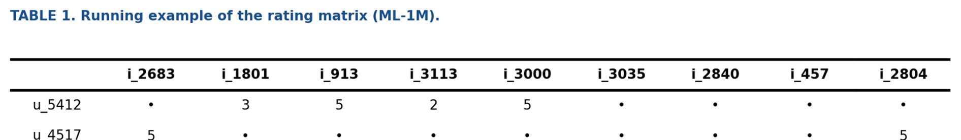

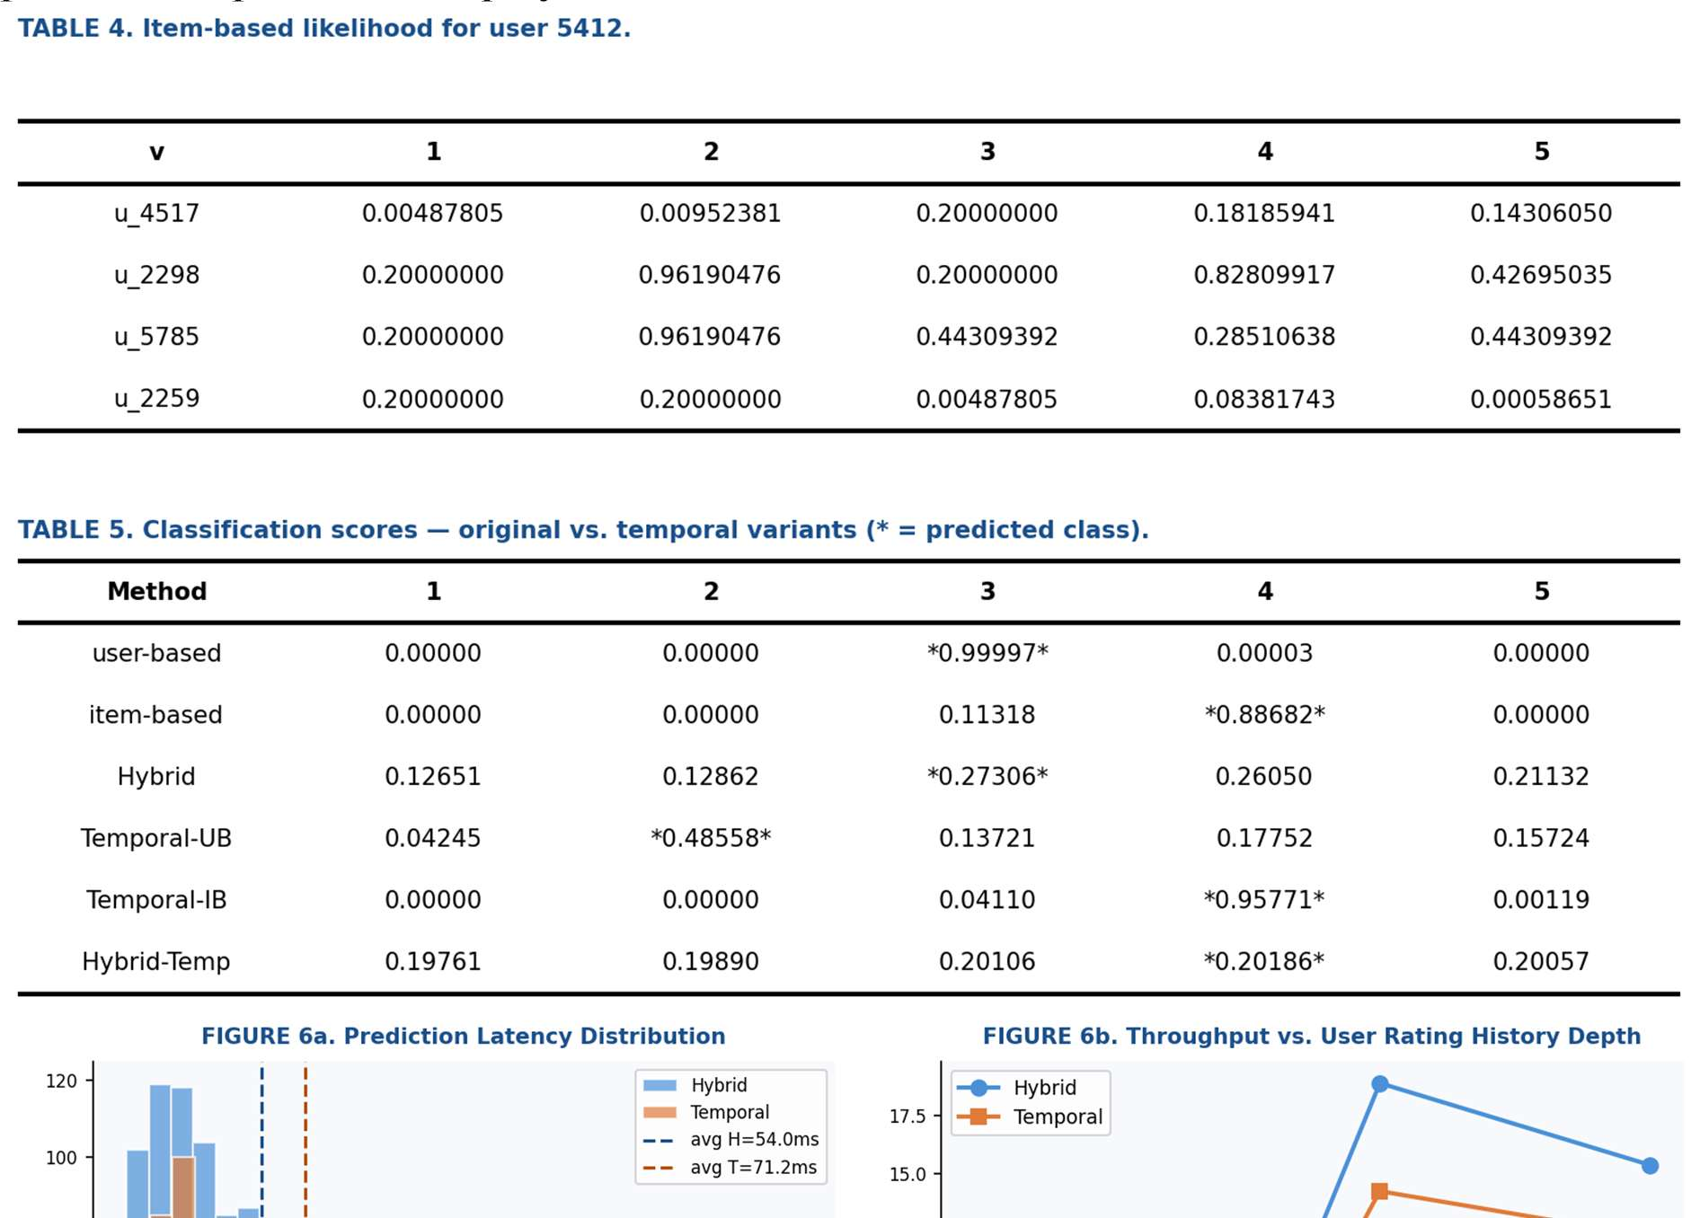
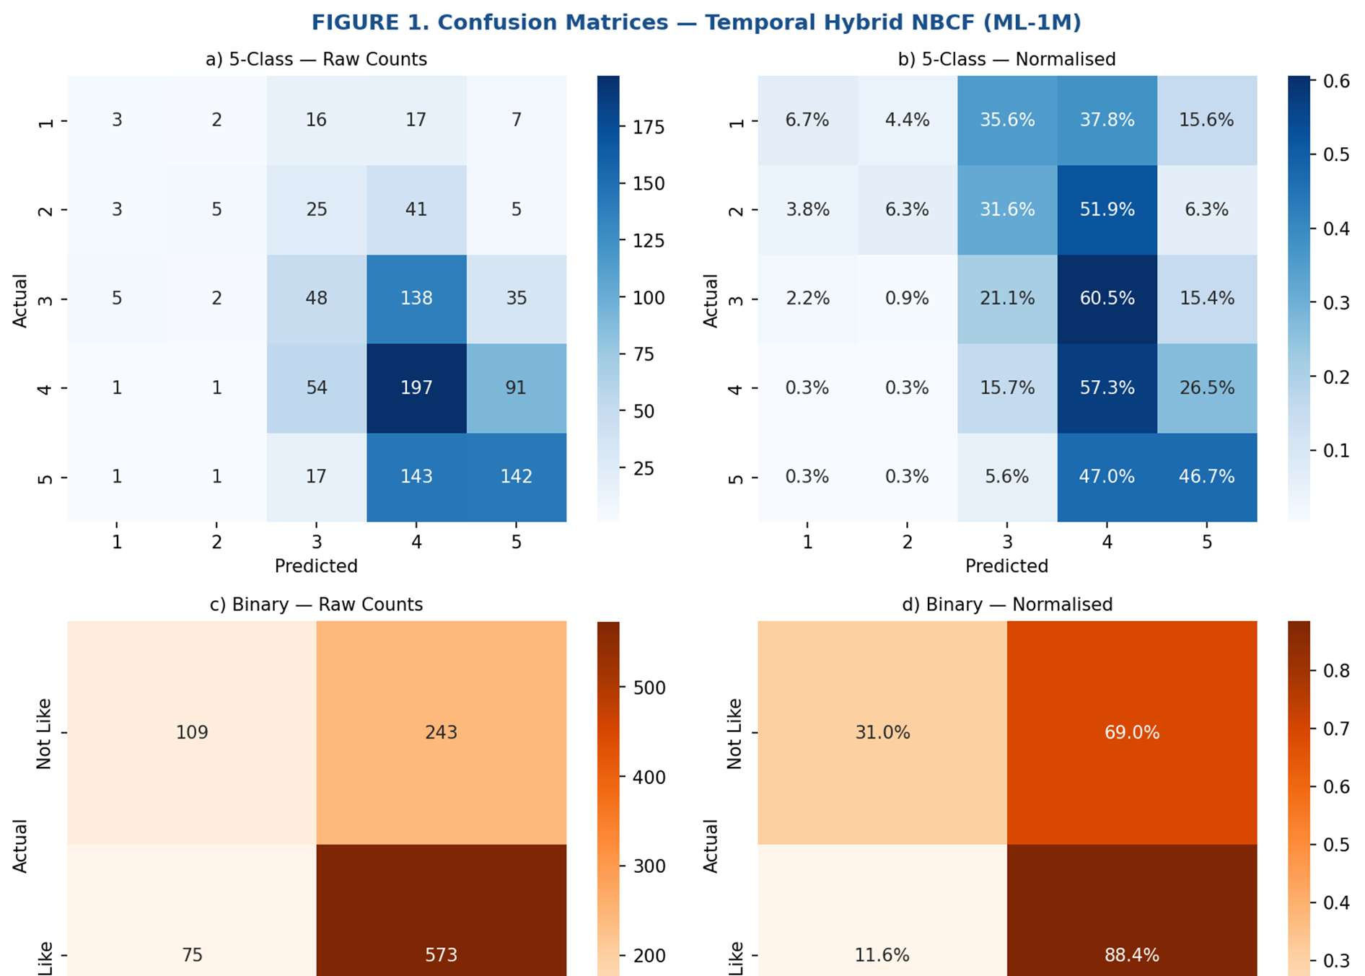
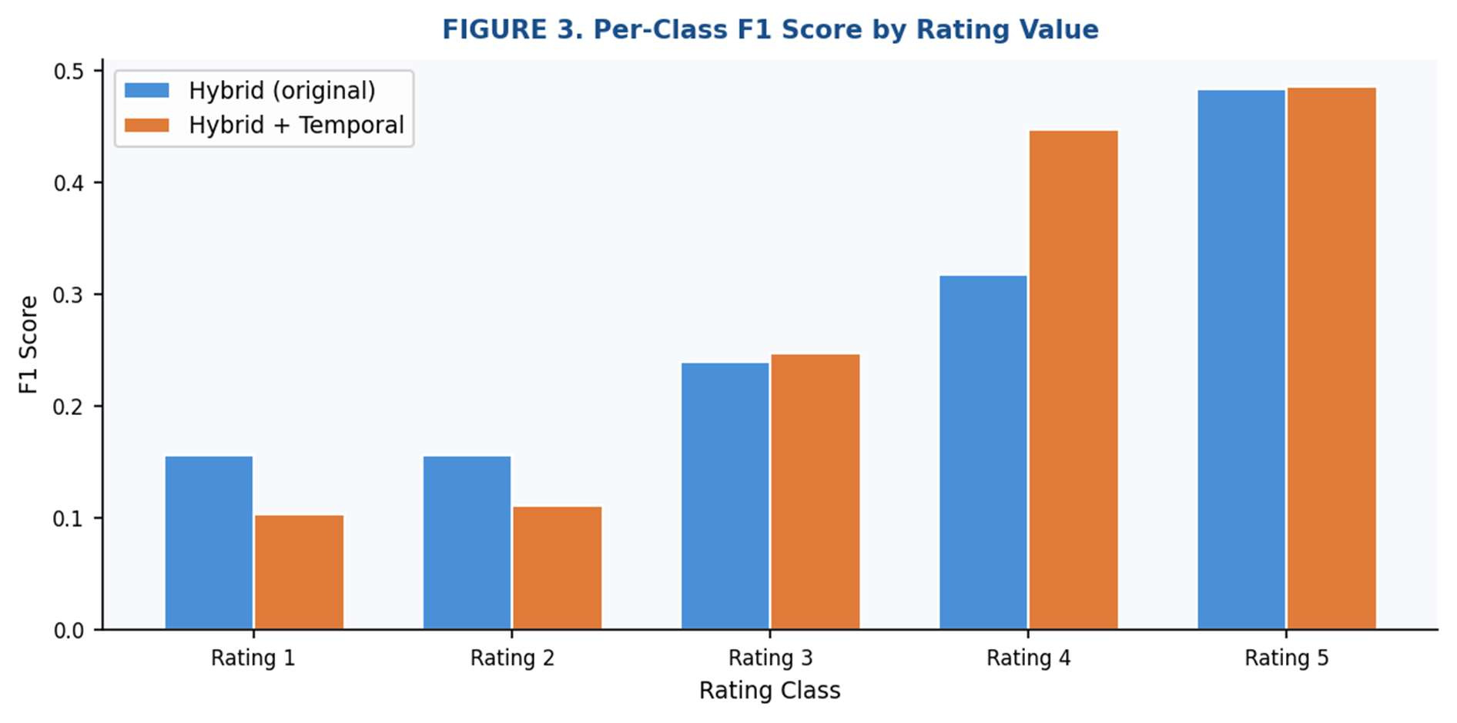
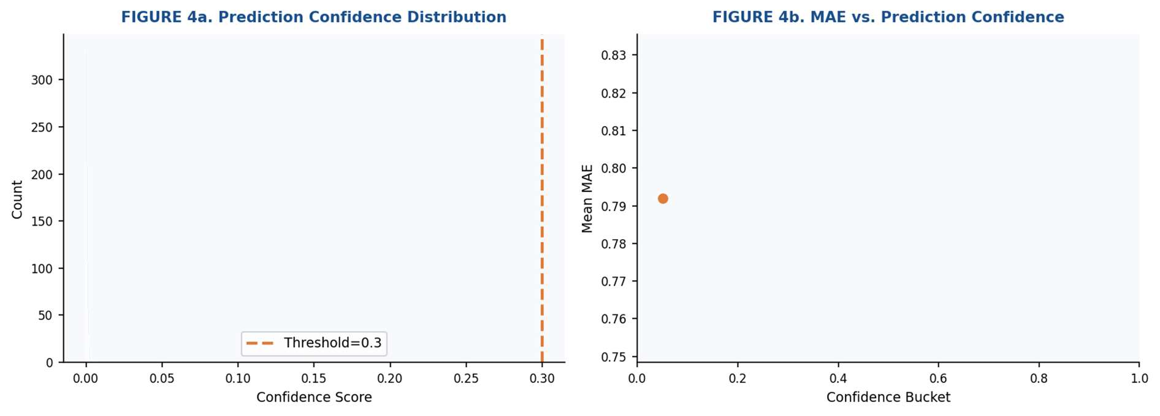
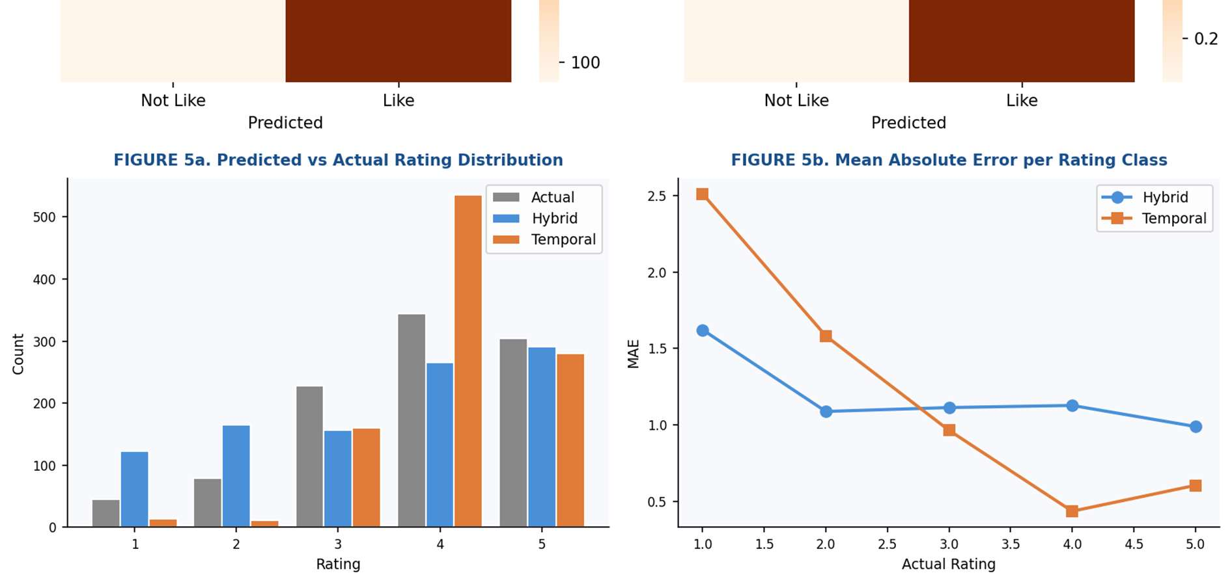

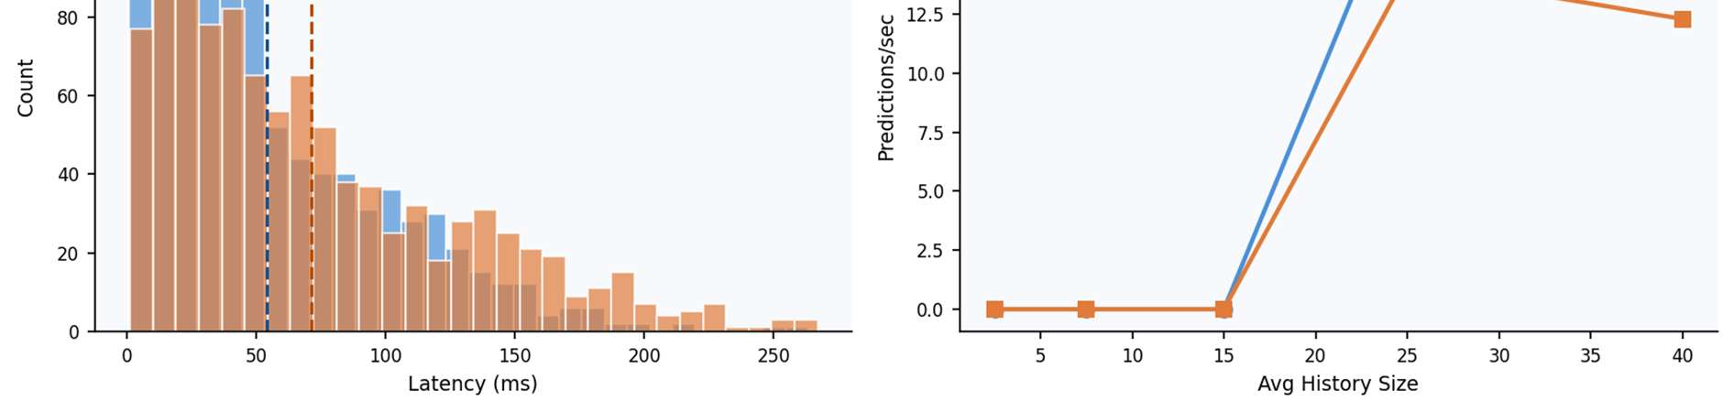

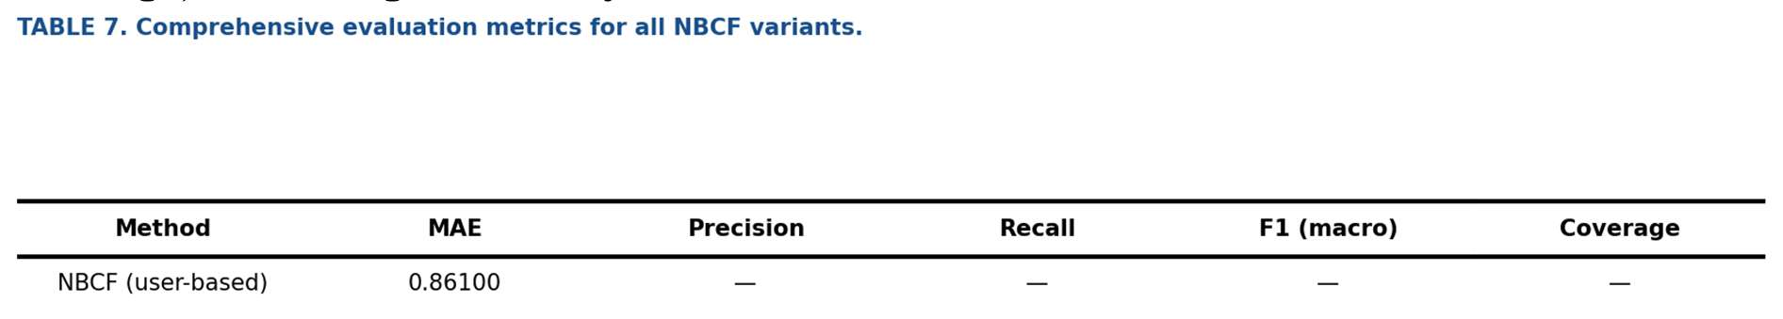

5.3 Saving Figures
plt.savefig('outputs/figure1_confusion_matrices.png', dpi=150, bbox_inches='tight')

dpi=150: 150 dots per inch gives good image quality when inserted into a document.
bbox_inches='tight': Removes extra whitespace around the figure so that axis labels are not cut off.
outputs/ directory: All images are saved to a single folder to keep the project directory clean.

Conclusion
The code is organised into small, single-purpose functions. The prior and likelihood functions are defined first. Then they are combined into scoring functions. The scoring functions are then extended with temporal decay. Finally, the evaluation and visualisation sections use these functions to measure and display results.
Adding temporal decay required only three new functions: temporal_weight, ub_score_temporal, and ib_score_temporal. The rest of the code did not need to change. This shows that the NBCF framework is flexible and can be extended without rebuilding the whole system.

Recommender Systems – Report 2 | Ömer MANAV / Kaan Bahadır SAĞRA

