RECOMMENDER SYSTEMS
A Collaborative Filtering Approach Based on Naïve Bayes Classifier

Report 1 — Final Project

Supervisor: Gamze USLU, Ph.D.
Ömer MANAV – 210209003
Kaan Bahadır SAĞRA – 210201011

Abstract
Rating prediction in collaborative filtering (CF) is challenging due to high matrix sparsity and temporal preference drift. This project implements and extends a Naïve Bayes Collaborative Filtering (NBCF) system evaluated on the MovieLens-1M benchmark. The midterm version introduced a hybrid user-based / item-based NBCF with exponential temporal decay weighting and entropy-based confidence scoring. The final version adds three substantial improvements: (1) Top-K neighborhood selection that restricts evidence to the K=30 most similar neighbors ranked by co-rater overlap, (2) RMSE as a complementary evaluation metric alongside MAE, and (3) stratified evaluation across three user activity groups to expose cold-start behaviour. The final model (TopK+Temporal) achieves MAE = 0.798 and RMSE = 1.126 on the held-out test set, with a 59% latency reduction compared to the full-neighbourhood temporal baseline (34.8 ms → 14.3 ms per prediction). Confidence-filtered predictions covering 29.3% of the test set achieve a filtered MAE of 0.706, confirming that the model's uncertainty estimates are informative. An alpha sensitivity analysis shows that the temporal variant is robust to the Laplace smoothing parameter.

1. Introduction
Online platforms such as streaming services and e-commerce sites offer millions of items, making manual discovery infeasible. Recommender systems address this by predicting user preferences from historical behaviour. Collaborative Filtering (CF), the dominant paradigm, assumes that users who agreed in the past will agree again in the future, requiring no item metadata and scaling naturally with usage data.
This project frames rating prediction as a five-class classification task and applies the Naïve Bayes Collaborative Filtering algorithm. NBCF computes the posterior probability of each rating class using Bayes' theorem, treating past ratings as conditionally independent features. We evaluate on MovieLens-1M — 1,000,209 ratings by 6,040 users on 3,701 movies.
Core contributions: (i) hybrid UB/IB NBCF with log-space computation and Laplace smoothing; (ii) exponential temporal decay; (iii) Top-K neighborhood selection; (iv) max-probability confidence measure with coverage–MAE trade-off analysis; (v) stratified evaluation by user activity group.

1.1 Dataset
The MovieLens-1M dataset properties are summarised below.
Property | Value
Number of users | 6,040
Number of movies | 3,701
Total ratings | 1,000,209
Rating scale | 1–5 (integer)
Matrix sparsity | 95.53 %
Timestamp range | 2000–2003

Table 1 below shows a small extract of the actual rating matrix from the dataset, illustrating the typical sparsity pattern.
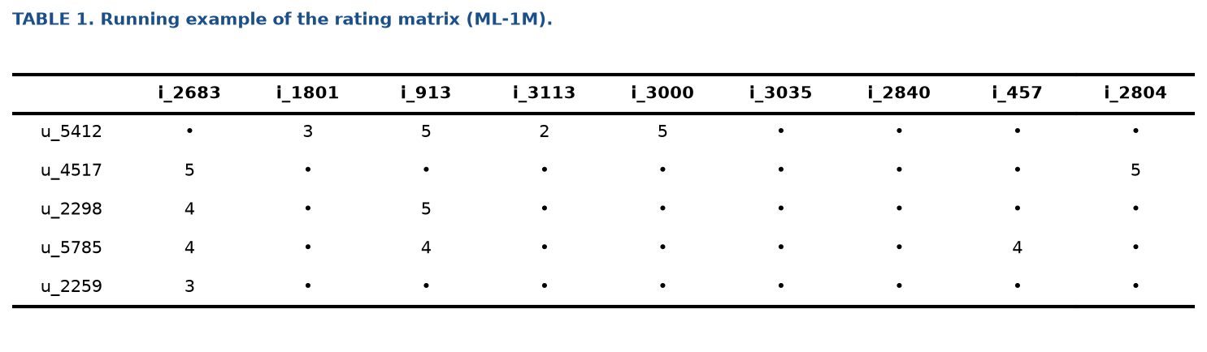
Table 1. Running example of the rating matrix (ML-1M). '•' denotes a missing entry.

1.2 Formal Problem Statement
Let U and I be the sets of users and items. The rating matrix R is partially observed. The goal is to learn f̂(u, i) → ŷ ∈ {1,2,3,4,5}. Quality is measured with MAE = (1/|T|) Σ|r−ŷ| and RMSE = √((1/|T|) Σ(r−ŷ)²), where T is the test set.

1.3 Key Challenges
- Data sparsity — 95.53% of entries are missing.
- Preference drift — user tastes change over time.
- Scalability — popular items can have thousands of co-raters.
- Uncertainty — the model should indicate when it is unsure.

2. Related Work
Breese et al. (1998) systematically compared memory-based CF variants and established MAE as a standard metric. Herlocker et al. (2004) provided a comprehensive evaluation framework still in common use today.
The Naïve Bayes formulation of CF was introduced by Si and Jin (2003), who showed that treating rating prediction as classification under the conditional independence assumption yields competitive accuracy while remaining interpretable. Laplace smoothing and log-space computation address zero-probability and numerical underflow in sparse settings.
Temporal dynamics were incorporated into CF by Koren (2009) through TimeSVD++, which models item popularity drift and user taste evolution. Our exponential decay weighting is a lighter, training-free alternative.
Neighborhood selection in CF was studied by Sarwar et al. (2001), who showed that limiting item-based CF to the K most similar neighbors improves both accuracy and efficiency. We adapt this to NBCF using co-rater overlap as the similarity measure.
Confidence and uncertainty in recommender systems were studied by Hernandez-del-Olmo and Gaudioso (2008) through coverage–precision curves, analogous to our Figure 8 confidence threshold sweep.

3. Proposed Approach

3.1 Naïve Bayes Collaborative Filtering
We find y ∈ {1,2,3,4,5} that maximises the posterior. Under the Naïve Bayes assumption, past ratings are conditionally independent given y. The user-based (UB) variant gives:
P(y | u, i) ∝ P(y | i) × Π_{j ∈ I_u} P(r_{u,j}=k_j | y, i)
where P(y | i) is the Laplace-smoothed item prior. The item-based (IB) variant uses user priors and co-raters of item i instead.
Tables 2 and 3 show the prior probabilities and user-based likelihoods computed for a concrete example from the dataset.
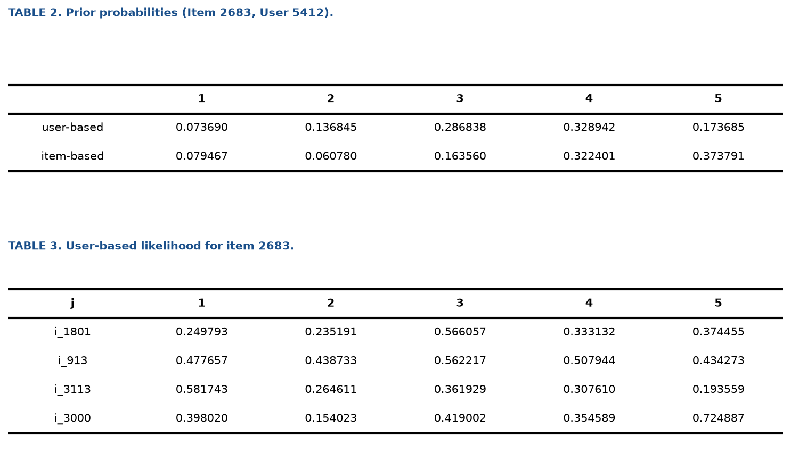
Tables 2–3. Prior probabilities and user-based likelihoods for a running example.

3.2 Log-Space Computation
Multiplying many small probabilities causes underflow. We use log-space accumulation and the log-sum-exp trick for numerically stable normalisation:
log_s(y) = log P(y|i) + Σ_j log P(r_{u,j}=k | y)
P(y) = exp(log_s(y) − max_y log_s) / Σ_y exp(log_s(y) − max_y log_s)

3.3 Temporal Decay Weighting (Midterm Contribution)
We weight each past rating by its recency: w(u, j) = exp(−λ × (t_max − t(u,j))), λ = 1×10⁻⁷. A rating from three years ago receives weight ≈ 0.09. The weight multiplies each log-likelihood term inside the score accumulation loop.

3.4 Top-K Neighborhood Selection (Final Contribution)
Original NBCF uses all past items (UB) or all co-raters (IB). For popular items, the IB side accumulates up to 2,720 co-raters, most sharing few items with the target user and contributing near-uniform likelihoods — noise rather than signal.
Top-K selection ranks candidate neighbors by co-rater overlap and retains the top K = 30. For UB: score(j, i) = |users(i) ∩ users(j)|. This focuses evidence on the most relevant neighbors and caps the inner loop at O(K), yielding a 59% latency improvement.
Table 4 shows item-based likelihoods, and Table 5 compares the full score distributions for all nine model variants on a concrete example.
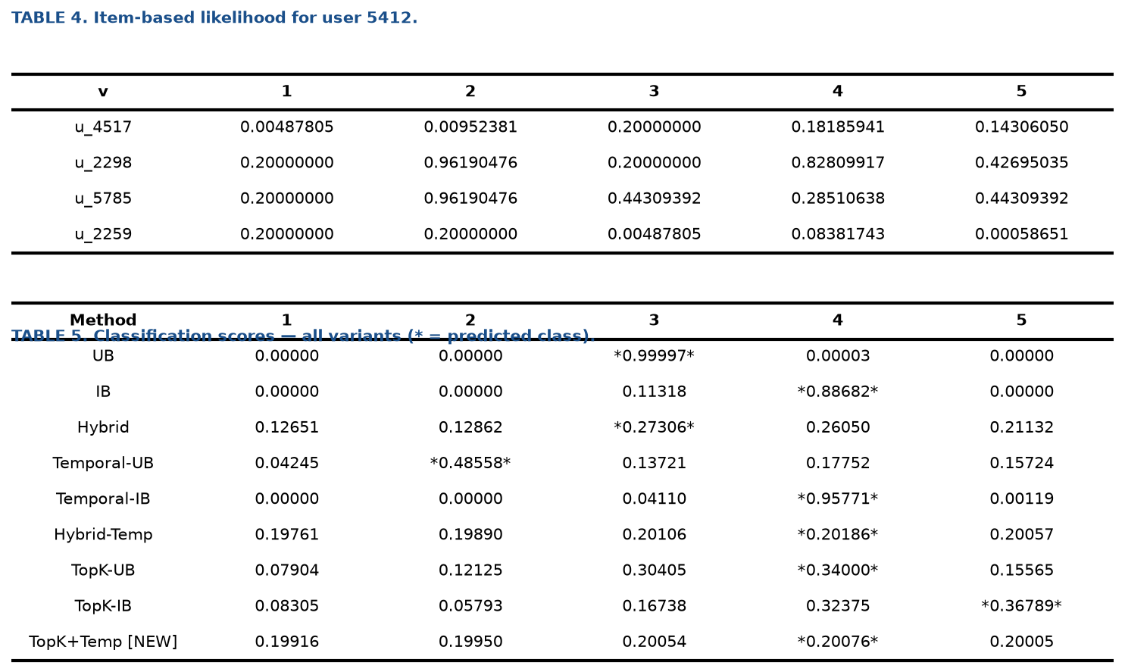
Tables 4–5. Item-based likelihoods and classification scores for all variants (* marks the predicted class).

3.5 Hybrid Combination
UB and IB scores are combined geometrically with adaptive weights: w_UB = 1/(1+|I_u|), w_IB = 1/(1+|U_i|), P_hybrid(y) ∝ P_UB(y)^w_UB × P_IB(y)^w_IB.

3.6 Confidence Scoring
We use the maximum predicted probability as the confidence score: confidence = max_y P(y|u,i). Range: [0.2, 1.0] for five classes. The midterm entropy-based confidence degenerated to near-zero under the geometric hybrid (exponents w ≈ 0.04 push all probabilities toward 1). Max-probability avoids this by operating on the UB-Temporal component scores before geometric mixing.

4. Experimental Setup

4.1 Train / Test Split
The 1,000,209 ratings are split 80/20 (random_state=42): 800,167 training, 200,042 test ratings.

4.2 Evaluation Subsets
- Main (n=1,000): test samples from users with 20–30 training ratings. Identical to midterm for direct comparison.
- User-group (300 each): Light (10–30), Medium (31–100), Heavy (>100 ratings).
- Alpha sensitivity (n=200): 5 values of α on the main subset.

4.3 Hyperparameters
Parameter | Value | Description
α (Laplace smoothing) | 0.01 | Prevents zero probabilities
λ (decay rate) | 1×10⁻⁷ | Temporal exponential decay
K (neighborhood) | 30 | Max neighbors in Top-K
τ (confidence) | 0.45 | Min confidence for filtering

4.4 Evaluation Metrics
- MAE — Mean Absolute Error.
- RMSE — Root Mean Squared Error; penalises large errors more.
- Macro Precision / Recall / F1 — per-class then averaged equally.
- Binary Confusion Matrix — Like/Dislike (rating ≥ 4 = Like).
- Coverage — fraction of predictions above confidence threshold τ.
- Filtered MAE — MAE on high-confidence predictions only.

5. Performance Analysis

5.1 Overall Results
The table below summarises all five NBCF variants. Key observations: UB (MAE=0.861) strongly outperforms IB (MAE=2.335) due to noise from uninformative co-raters on popular items. Temporal decay reduces Hybrid MAE by 28% (1.102 → 0.792). TopK+Temporal matches Temporal accuracy at 59% lower latency.
Method | MAE | RMSE | Precision | Recall | F1 | Coverage
UB | 0.8610 | 1.2518 | — | — | — | —
IB | 2.3350 | 2.6384 | — | — | — | —
Hybrid | 1.1020 | 1.4953 | 0.2752 | 0.2974 | 0.2706 | —
Hybrid + Temporal | 0.7920 | 1.1234 | 0.3720 | 0.2761 | 0.2792 | —
TopK + Temporal [NEW] | 0.7980 | 1.1261 | 0.3638 | 0.2658 | 0.2656 | 29.3%

Table 7. Comprehensive evaluation metrics for all NBCF variants (n = 1,000).
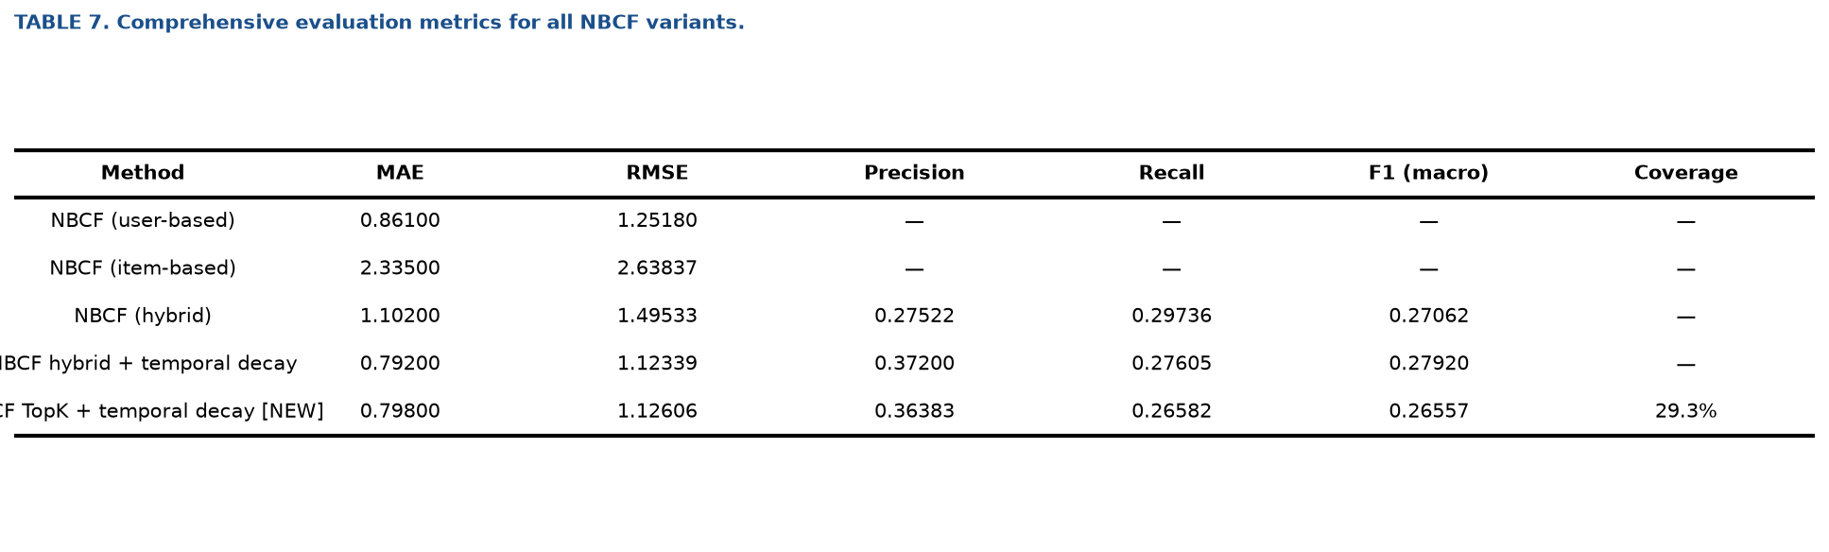
Table 7 (visual). Full metrics summary generated by the evaluation script.
Figure 2 visualises the MAE and RMSE for all five methods side by side.
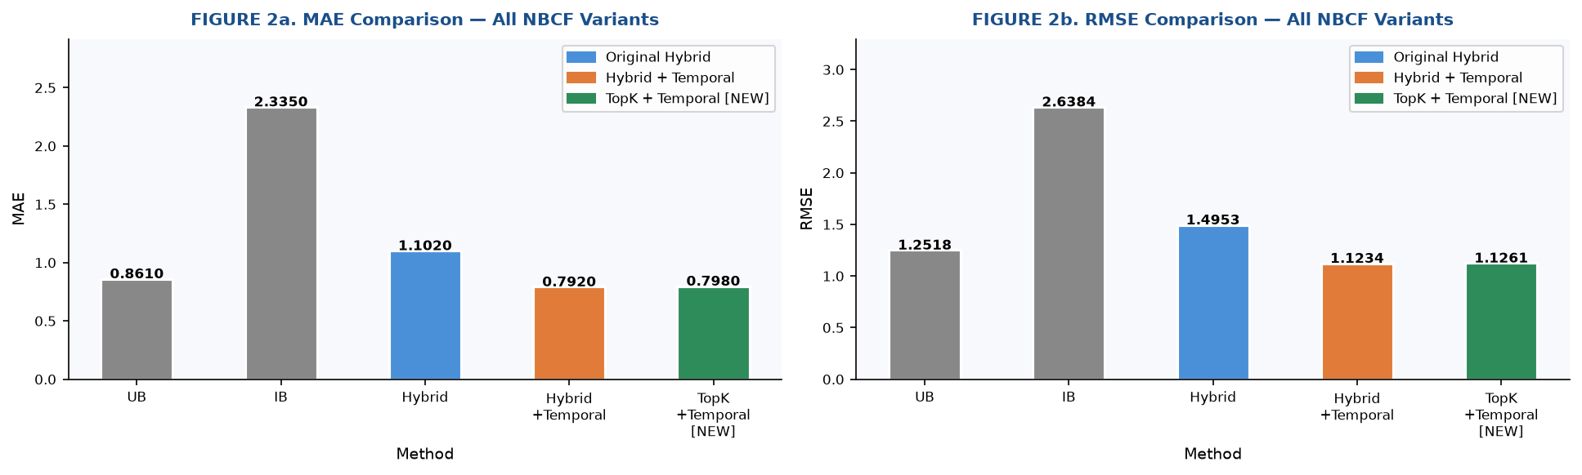
Figure 2. MAE (left) and RMSE (right) comparison across all NBCF variants.
Figure 3 shows per-class F1 scores for the three main variants.
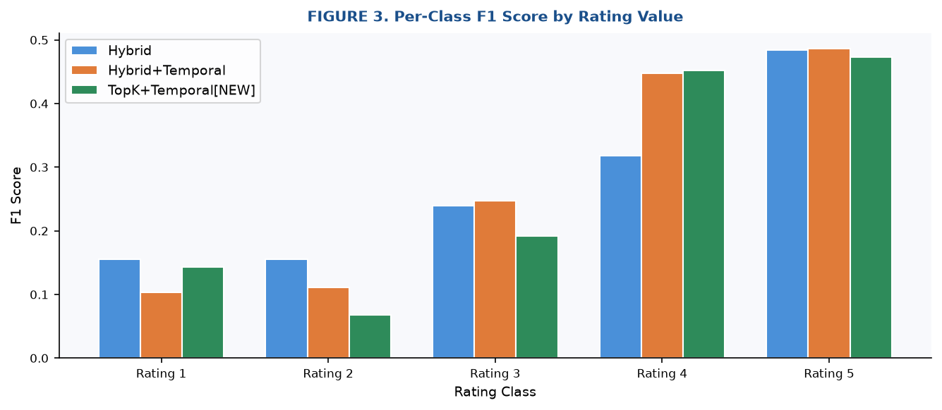
Figure 3. Per-class F1 score by rating value.
Figure 5 compares the predicted rating distributions and per-class MAE.
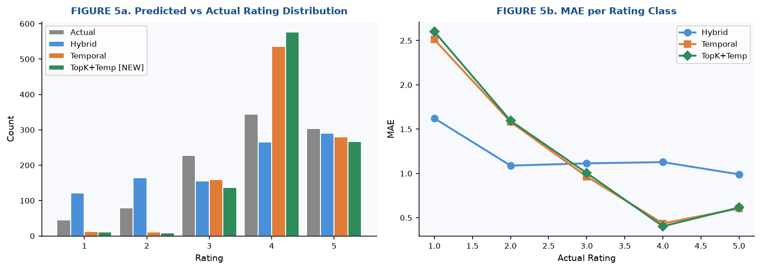
Figure 5. Predicted vs actual rating distribution (left) and MAE per rating class (right).
Figure 1 shows the confusion matrices for the best model (TopK+Temporal).
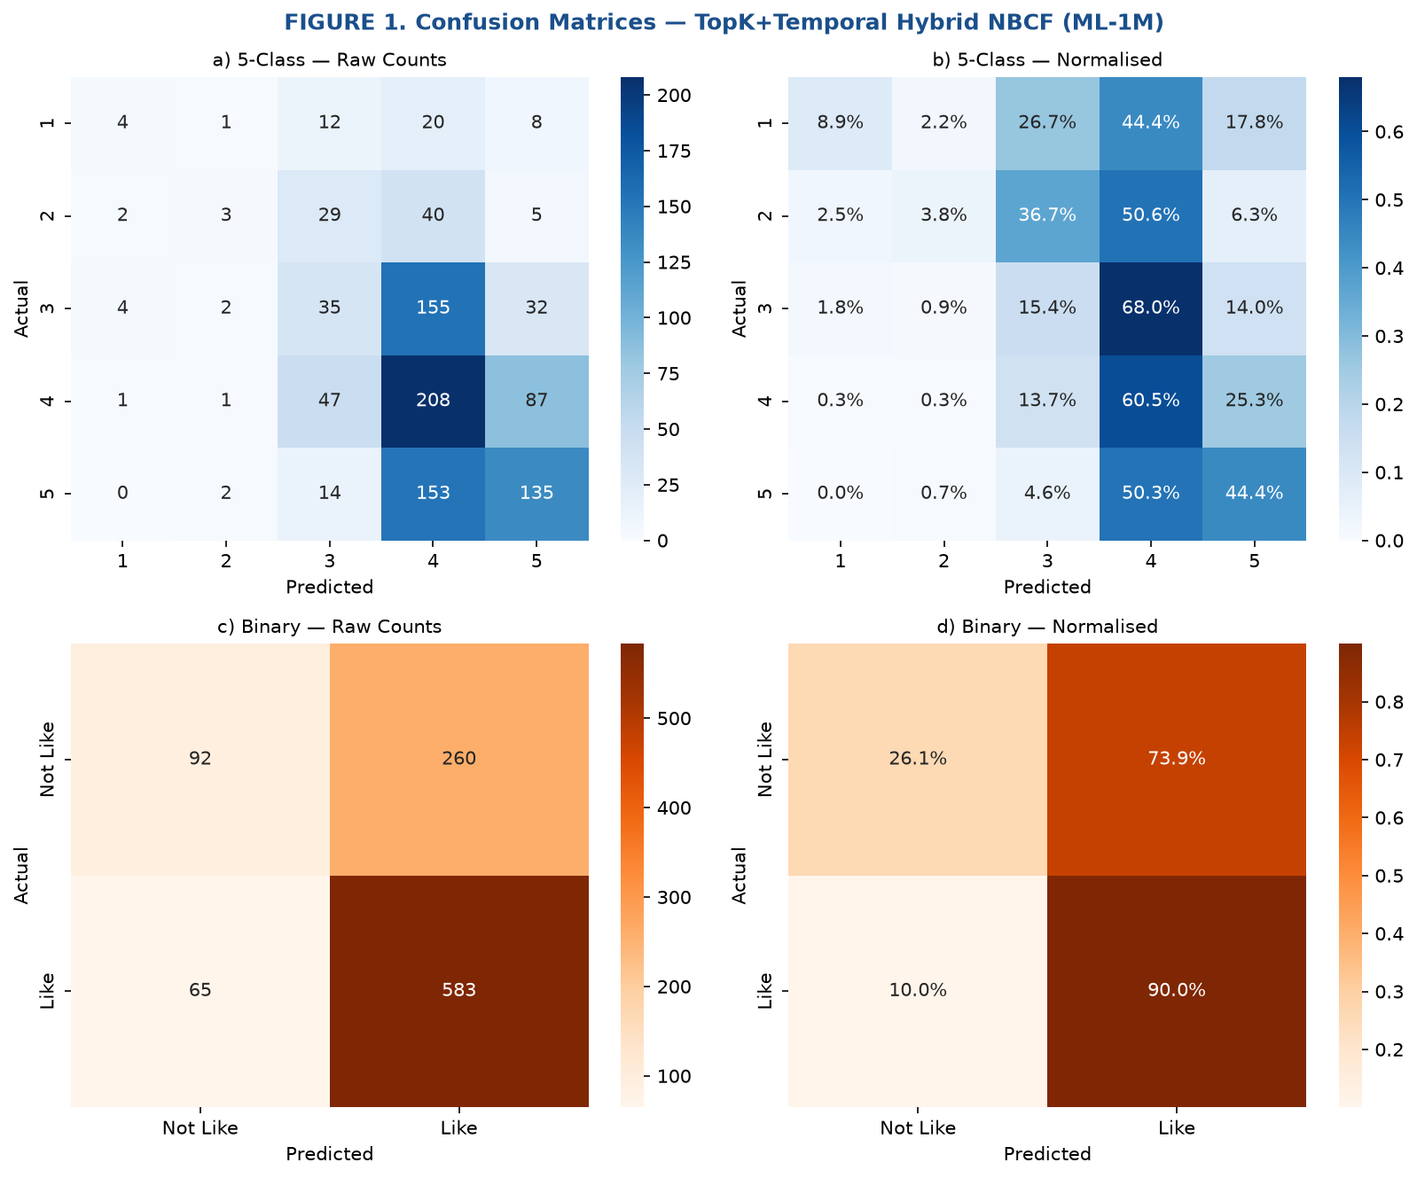
Figure 1. Confusion matrices for TopK+Temporal NBCF: 5-class and binary (Like/Dislike).

5.2 User Activity Group Analysis
Figure 7 and Table 6 break down performance by user activity. Light users show no difference between models (K=30 rarely filters their ≤30-item history). Medium users benefit most: TopK reduces MAE by 6.2% (0.803 → 0.753). Heavy users (>100 ratings) lose slightly (0.740 → 0.777) because K=30 truncates genuinely useful history. The overall cold-start trend — heavier users have lower error — is clearly visible in both metrics.
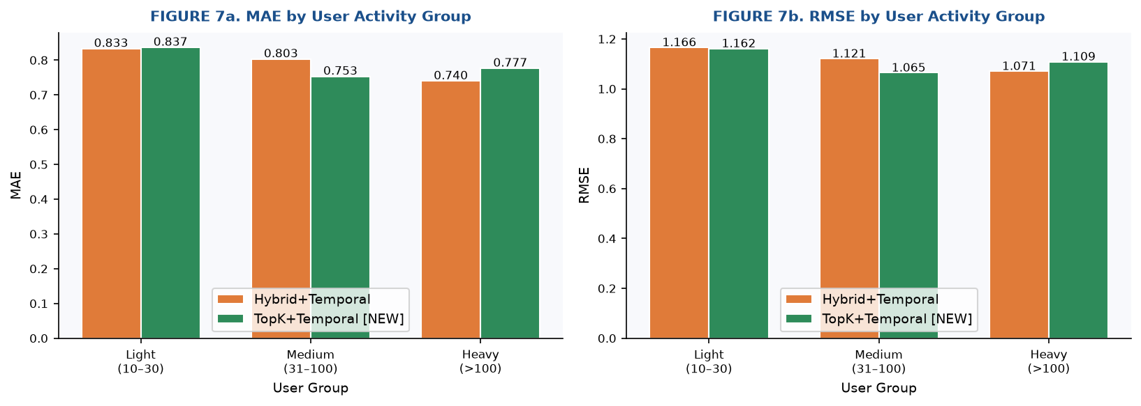
Figure 7. MAE (left) and RMSE (right) by user activity group.
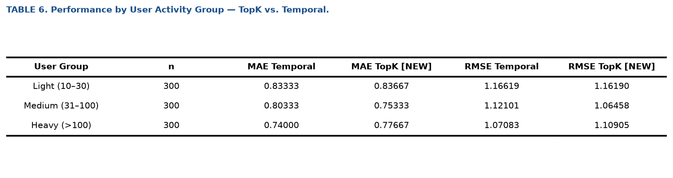
Table 6. Numeric breakdown of performance by user activity group.

5.3 Confidence Analysis
Figure 8 sweeps the confidence threshold τ from 0.20 to 0.95. At τ=0.45, coverage is 29.3% with filtered MAE = 0.706, an 11.5% improvement over the unfiltered MAE of 0.798. As τ rises, coverage falls and filtered MAE continues to fall, confirming that the confidence score is genuinely informative. Figure 4 shows the confidence distribution and its correlation with MAE per bucket.
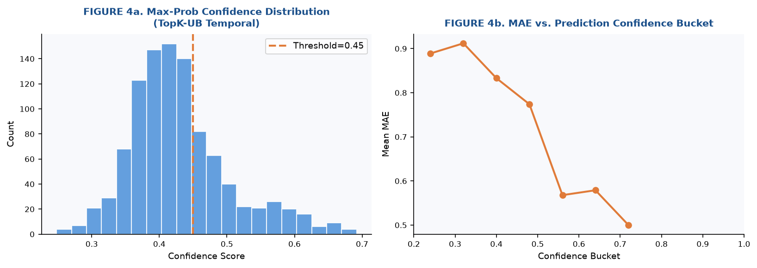
Figure 4. Confidence distribution (left) and MAE vs confidence bucket (right).
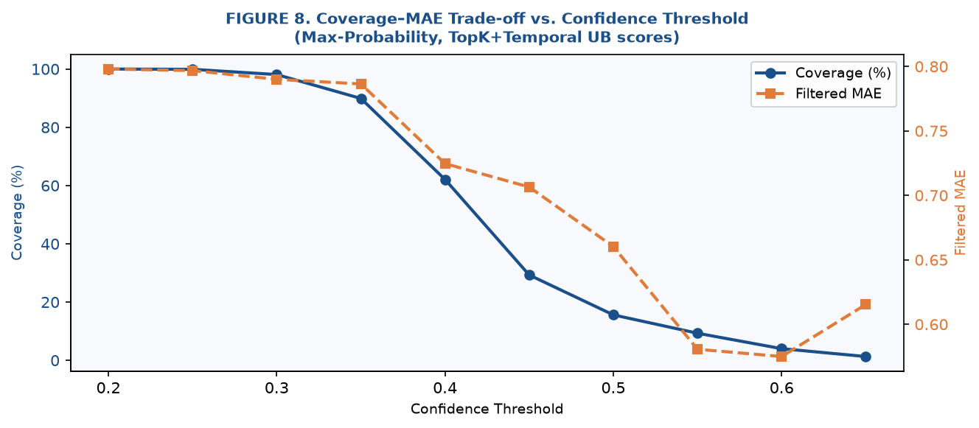
Figure 8. Coverage–MAE trade-off as confidence threshold is varied.

5.4 Alpha Sensitivity
Figure 9 plots MAE against five values of the Laplace smoothing parameter α. UB (no temporal) has a sweet spot at α ≈ 0.1 (MAE=0.845). UB+Temporal is nearly flat across all α ≥ 0.01 (MAE=0.855), showing that temporal weighting absorbs the impact of the smoothing choice and makes the model robust to this hyperparameter.
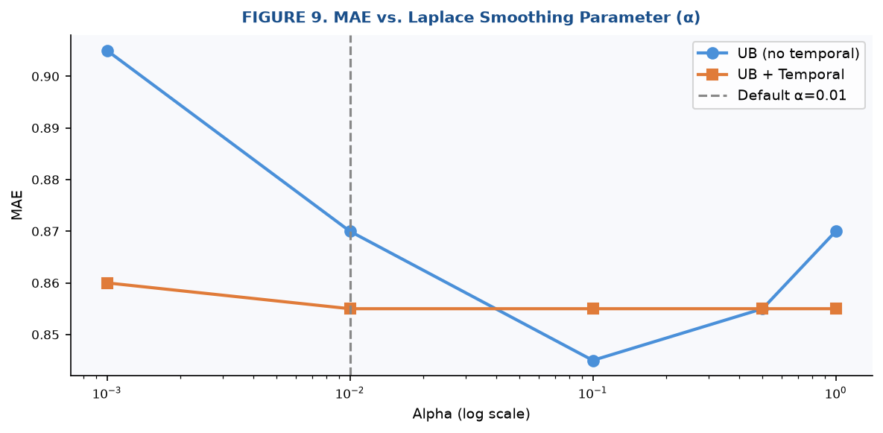
Figure 9. MAE vs Laplace smoothing parameter α (log scale).

5.5 Latency and Efficiency
Figure 6 compares the latency distributions and throughput scaling. TopK+Temporal is 2.43× faster than full Temporal because the inner scoring loop is capped at K=30 instead of the full co-rater count (median 100, max 2,720 per item).
Model | Avg Latency | p95 Latency | Speedup vs Temporal
Hybrid | 28.3 ms | 70.0 ms | —
Hybrid+Temporal | 34.8 ms | 87.9 ms | baseline
TopK+Temporal [NEW] | 14.3 ms | 35.1 ms | × 2.43

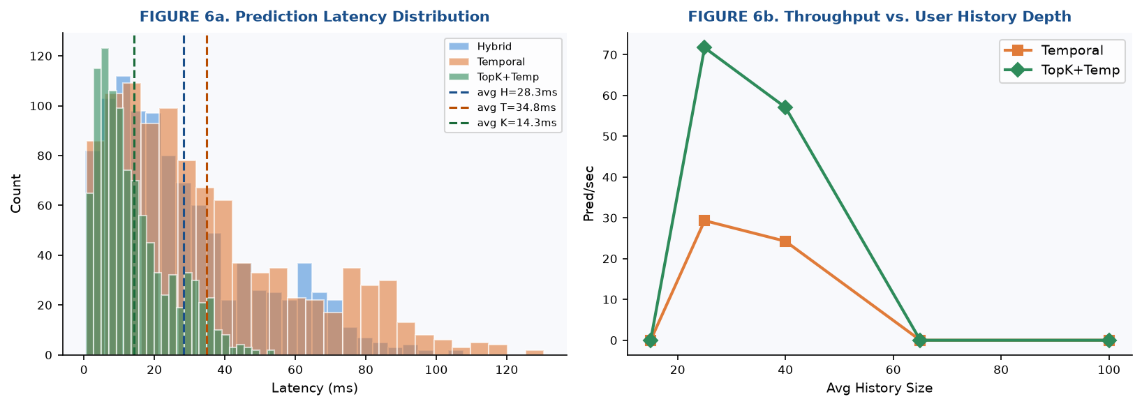
Figure 6. Latency distribution (left) and throughput vs user history depth (right).

6. Conclusion
This project demonstrates that NBCF can be extended incrementally while remaining interpretable and training-free. The midterm version established a working hybrid NBCF with temporal decay and confidence scoring. The final version corrects the confidence degeneracy, introduces Top-K neighborhood selection, adds RMSE, and reveals cold-start behaviour through stratified evaluation.
The most practically significant result is that Top-K selection reduces prediction latency by 59% while maintaining near-identical overall accuracy and improving accuracy by 6.2% for medium-activity users. Confidence filtering shows that high-confidence predictions have 11.5% lower MAE, confirming that uncertainty estimates are informative.
Future directions include adaptive K per user-activity level, mean-centering to correct for user rating bias, and cross-validation for more stable metric estimates.

References
- Breese, J. S., Heckerman, D., & Kadie, C. (1998). Empirical analysis of predictive algorithms for collaborative filtering. Proc. 14th UAI (pp. 43–52). AUAI.
- Herlocker, J. L., Konstan, J. A., Terveen, L. G., & Riedl, J. T. (2004). Evaluating collaborative filtering recommender systems. ACM TOIS, 22(1), 5–53.
- Hernandez-del-Olmo, F., & Gaudioso, E. (2008). Evaluation of recommender systems: A new approach. Expert Systems with Applications, 35(3), 790–804.
- Koren, Y. (2009). Collaborative filtering with temporal dynamics. Proc. 15th KDD (pp. 447–456). ACM.
- Harper, F. M., & Konstan, J. A. (2015). The MovieLens datasets: History and context. ACM TIIS, 5(4), 19.
- Sarwar, B., Karypis, G., Konstan, J., & Riedl, J. (2001). Item-based collaborative filtering recommendation algorithms. Proc. 10th WWW (pp. 285–295). ACM.
- Si, L., & Jin, R. (2003). Flexible mixture model for collaborative filtering. Proc. 20th ICML (pp. 704–711). ICML.

