Project 5: AI-Assisted Network Operations Center
Correlation Layer Evaluation: Deterministic Rules vs. Local LLM
Omar (Omer Salih Osman Gesmalla)
Final-year Network Engineering Portfolio Project

Executive Summary
This project builds a dual-site AI-assisted Network Operations Center (NOC) platform that ingests alerts from four independent, real, working signal sources — a compliance auditor, an SNMP-based anomaly detector, a Suricata intrusion detection system, and a WAN-fault diagnostic tool — and correlates them into incidents. The central research question, continuing the AI-vs-deterministic-baseline methodology used throughout this portfolio, is whether a locally hosted LLM (qwen2.5:7b via Ollama) adds real correlation value beyond a small, hand-written set of deterministic rules based on time windows and network topology adjacency.
Both correlators were evaluated against six hand-crafted synthetic incident scenarios covering the realistic range of NOC situations: a genuine multi-signal incident, coincidental unrelated events, a noisy false-alarm mix, a deliberately multi-hop "pivot" attack, a routine compliance-only audit, and a full four-source coordinated incident.
The deterministic correlator performed exactly as designed on all six scenarios, including a known and deliberately accepted limitation: it cannot reason across more than one topology hop. The LLM correlator matched or slightly exceeded the deterministic baseline in one case (recognizing that a PASS finding is semantically different from a FAIL finding, something the rule engine cannot perceive at all), but on the scenario purpose-built to test whether an LLM could close the deterministic correlator's multi-hop gap, it failed to do so in both tested prompt conditions — including when explicitly given the exact fact needed to make the connection. The LLM also showed inconsistent time-weighting behavior across scenarios, correctly disregarding a topology-adjacent but time-distant pair in one case while incorrectly merging a similarly time-distant pair in another. This is an honest, narrow negative result for LLM-added value in this specific correlation task, consistent with this portfolio's recurring finding that simple deterministic methods match or outperform LLM inference on well-defined detection and reasoning tasks.

1. Introduction and Research Question
This is the fifth project in a portfolio of AI-assisted networking systems, each pairing a deterministic, rule-based or statistical baseline against an LLM-based approach on the same task, and reporting the comparison honestly rather than assuming the AI approach is superior by default.
Project 5 combines the working components of Projects 1 through 4 — a compliance auditor, an anomaly detector, an intrusion detection system, and a WAN-fault diagnostic copilot — into a single dual-site topology, converts each tool's native output into one shared alert schema, and adds a new correlation layer on top: the task of deciding which alerts, across potentially all four sources, belong to the same real-world incident.
Research question: given a stream of alerts from four different signal sources, does a local LLM correlate them into incidents more accurately than a simple deterministic rule (time window plus network topology adjacency)?

2. System Architecture
The platform runs on a single GNS3 project ("noc-platform") split into two sites, connected by a redundant dual WAN link, with a management/collection host ("AI-Server") bridged into both sites for evidence collection and alert processing.
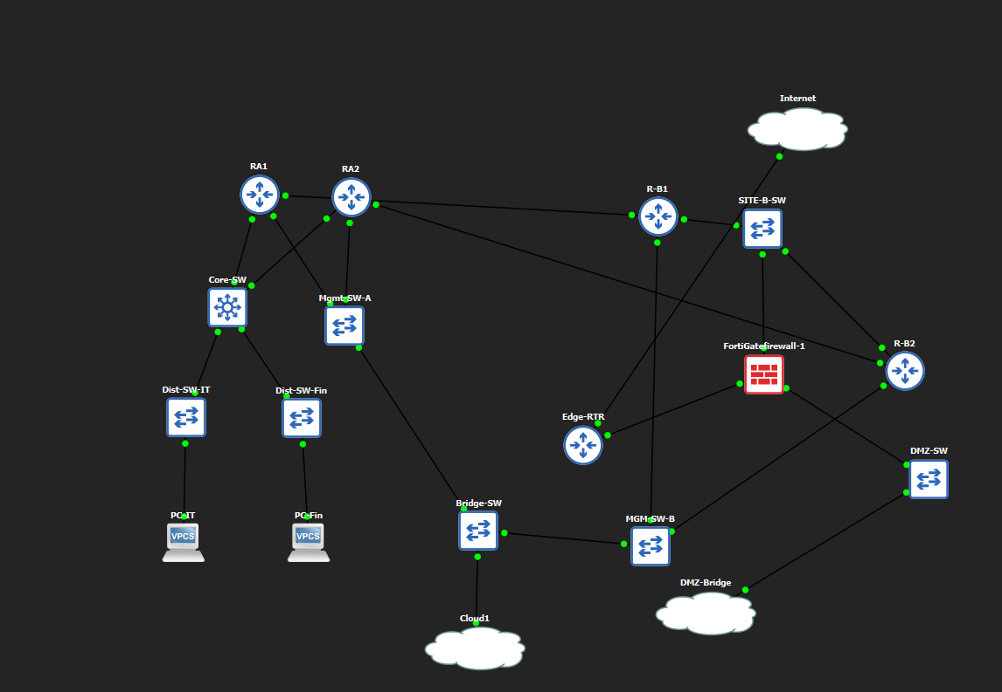
Figure 1 — Full GNS3 topology, showing Site A (left, labeled RA1/RA2), Site B and the DMZ (right, including FortiGate-firewall-1 and DMZ-SW), and the shared bridge infrastructure connecting both sites to AI-Server.

2.1 Site A — Enterprise Core
R-A1 and R-A2 form an HSRP-redundant router pair (R-A1 active, priority 110; R-A2 standby, priority 90; virtual IP 10.10.1.1), both running OSPF area 0. Core-SW is an L3 switch carrying three VLANs (the R-A1/R-A2 shared segment, an IT VLAN, and a Finance VLAN), with two access-layer switches and two VPCS end hosts beneath it. Site A is the target of the compliance and anomaly detection signal sources.

2.2 Site B — Perimeter and DMZ
R-B1 and R-B2 form a second HSRP-redundant pair (same design, R-B1 active), connected to a FortiGate firewall that separates an internal zone from a DMZ zone. The DMZ hosts DMZ-Web, a Debian server running nginx and Suricata, which is the target of the intrusion detection signal source.

2.3 WAN Link and Scope of Each Signal Source
R-A1 has a dedicated WAN link to R-B1; R-A2 has a separate WAN link to R-B2 — this dual-homed design is what the WAN-fault diagnostic tool monitors. By design, compliance auditing and anomaly detection are scoped only to Site A (R-A1/R-A2); intrusion detection is scoped only to DMZ-Web; R-B1/R-B2 are never directly audited or polled — their role is purely as the transit path. The WAN-fault tool is the only one of the four that inspects all four routers, since a WAN fault is inherently about the connection between sites.

3. Signal Sources
Each signal source is an independently working tool, reused with minimal adaptation from an earlier project in this portfolio, run against this project's own topology and devices.

3.1 Compliance Auditor (Site A)
Reused from Project 1. Connects to R-A1 (SSH) and R-A2 (Telnet-only, deliberately) and evaluates a set of deterministic configuration rules — no LLM involvement in detection, only in optional narrative reporting. This produces a clean contrast pair by design: R-A1 is fully SSH-configured (RSA key pair, privilege-15 local user) and mostly passes; R-A2 is deliberately left Telnet-only and mostly fails. A recurring implementation detail worth noting: Cisco IOS defaults new users and VTY lines to privilege level 1, which silently breaks commands like show running-config over a remote session rather than failing loudly — both routers required explicit privilege 15 configuration before the auditor could collect a trustworthy configuration snapshot. A real audit run against the rebuilt routers produced 5 findings for R-A1 and 7 for R-A2, all converted into the shared alert schema.

3.2 Anomaly Detector (Site A)
Reused from Project 2. Polls R-A1/R-A2 over SNMP (community string "labcomm", read-only) across three interfaces per device — the LAN-facing, WAN-facing, and management interfaces — and applies a threshold detector that flags any interface counter delta exceeding 10 times that device's own median delta, the same methodology Project 2 validated against an Isolation Forest baseline. A controlled moderate flood (elevated VPCS ping traffic, roughly 2-3x baseline) was correctly NOT flagged, while a controlled severe flood (a Linux ping flood from AI-Server) was correctly flagged, producing 13 threshold-exceeding events with severities derived from how far each value exceeded its threshold, ranging from 2.2x up to 29.7x. The data showed a coherent ramp-up-then-taper-down pattern consistent with a real, bounded flood test rather than noise. One additional finding worth recording: the anomaly consistently showed up on the WAN-facing and management interfaces rather than the interface actually facing the ping target, a direct consequence of asymmetric routing between the request and reply paths — the same class of finding surfaced independently in Projects 1 and 3.

3.3 Intrusion Detection System (DMZ)
Reused from Project 3. Suricata with the ET Open ruleset (approximately 52,000 rules) runs on DMZ-Web, listening on the DMZ-facing interface. Consistent with Project 3's original finding, only Nmap-style port scanning reliably triggers a default signature (ET SCAN "Possible Nmap User-Agent Observed", signature 2024364); SSH brute-force and generic SQL-injection/path-traversal payloads did not match any active signature against a bare nginx server with no backend application — of the ruleset's roughly 467 SQL-injection rules, all are commented out by default, and the remaining active rules are written against specific commercial products rather than generic attack syntax. This is kept as an honest, unmodified characteristic of the ruleset rather than artificially forced to succeed. A real port scan produced 4 correctly-classified intrusion alerts.

3.4 WAN-Fault Diagnostic Tool (Both Sites)
Reused from Project 4, adapted to this project's own topology for the first time. An evidence collector connects to all four routers over SSH/Telnet and gathers interface, OSPF, HSRP, CDP, and access-list state, plus a sourced reachability matrix (each router pings every other router's loopback address, which exercises the real routed path rather than a simple directly-connected check). A second, purely deterministic diagnostic script applies six rule categories — interface state changes, HSRP role changes, OSPF neighbor-count drops, OSPF area mismatches, reachability regressions, and ACL deny-counter hits — and reports only the differences actually present between two evidence snapshots, with no LLM involvement. As in Project 4, an OSPF dead-timer race condition required a deliberate wait before collecting evidence immediately after a fault, or the stale (soon-to-expire) neighbor entry produces an incomplete result. A controlled fault (shutting the WAN interface between R-A1 and R-B1) produced exactly the expected three findings — interface down, plus OSPF adjacency loss reported independently by both ends of the link — and reverting the fault correctly produced zero findings, confirming full recovery.

4. System Build and Troubleshooting
Standing up this topology surfaced three substantial, genuinely instructive faults, none of which were part of any planned fault-injection test — they were real infrastructure problems encountered while building the platform. They are documented here because each one involved a non-obvious root cause found only through methodical elimination, and each yielded a lesson applicable well beyond this project.

4.1 FortiGate Configuration Database Corruption
After the topology was fully addressed and routed, traffic from AI-Server to DMZ-Web failed completely (100% packet loss) despite every individually-checked layer being correct: static and OSPF routes, ARP resolution, ICMP-echo settings, firewall policy rules (an explicit accept policy existed for the exact path), CPU/memory/session-table health, and even the DMZ-facing host's own network stack. Packet captures taken simultaneously on the links either side of the firewall proved the request packet reached the firewall's internal interface but never appeared on its DMZ-facing interface — the drop was happening inside the firewall itself.
The decisive evidence came from two internal FortiGate diagnostics: the firewall's own session-statistics counter (policy_deny) incremented on every attempt despite the explicit accept policy, and its configuration CLI began failing — config firewall policy and config router ospf both returned parse errors, while config system interface continued to work normally, and show commands for the broken sections still printed correct-looking output. This combination indicates a corrupted internal configuration database scoped to specific subsystems, most likely caused by earlier non-graceful virtual-machine stop/starts (a boot-time warning about a filesystem inconsistency, tied to an "unsafe reboot," had appeared earlier and was not fully resolved by a subsequent disk scan). Rather than continue attempting to repair a corrupted internal database from the CLI, the firewall node was replaced outright: a fresh instance was deployed and its full configuration — interface addressing, OSPF, and both firewall policies — was reapplied from documented values in under fifteen minutes. Connectivity was restored with 0% packet loss.
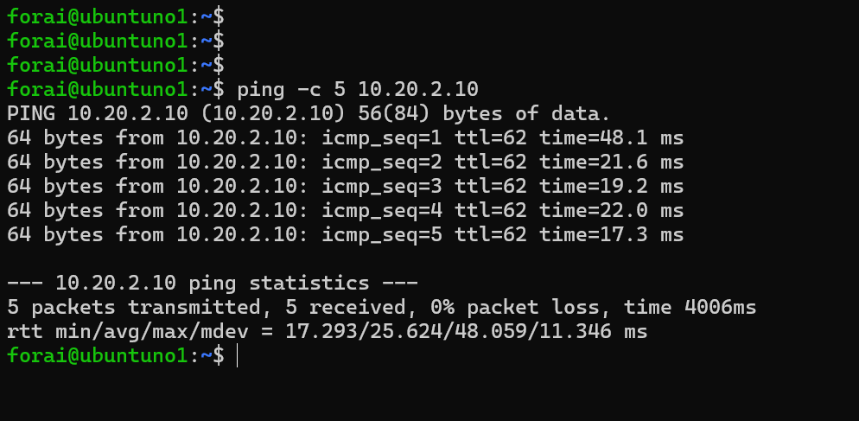
Figure 2 — Confirmed end-to-end connectivity (0% packet loss, 5/5 replies) immediately after the firewall rebuild.

4.2 Cascading Loss of the Site A Branch
Deleting the corrupted firewall node in GNS3 also removed the entire Site A branch — both core routers, the distribution switches, and both end hosts. GNS3 node deletion only ever removes a node's own links, never unrelated nodes; the two events were unrelated rather than a cascading bug, but no project snapshot or configuration backup existed to recover from, so the branch had to be rebuilt from first principles. Both routers were reconstructed using the original Project 4 report as an addressing and design reference, since this project deliberately reuses that same dual-router WAN topology as its Site A/Site B backbone. Once rebuilt, the compliance auditor and anomaly detector were both re-verified successfully against the new router instances before any further work continued.

4.3 HSRP Silently Broken by IGMP Snooping
After the rebuild, both core routers reported themselves simultaneously as the active HSRP router, each unaware of the other ("Standby: unknown" on both sides) — despite OSPF, running over the same physical link, converging normally. Packet-level debugging on one router proved it was transmitting a correct HSRP Hello message every three seconds that never arrived at all, while the same link carried OSPF's own multicast traffic without issue. The root cause was IGMP snooping on the connecting Layer 3 switch: the switch's own OSPF process automatically joins the OSPF multicast groups on that VLAN, but nothing ever joins HSRP's multicast group, so snooping silently treated it as unregistered traffic and dropped it. Disabling IGMP snooping on the relevant VLAN resolved the issue immediately, with both routers correctly reporting each other within seconds.

5. Unified Alert Schema
All four signal sources' native output formats are converted by a dedicated adapter script into one shared schema, so the correlation layer can treat every alert identically regardless of its origin:
Field | Description
event_id | Unique identifier for the alert
timestamp | ISO-8601 timestamp with timezone offset
source | One of: compliance, anomaly, intrusion, wan_fault
device | The network device the alert concerns
rule_or_signature | The specific rule, signature, or finding name
severity | One of: low, medium, high, critical
description | Human-readable detail of the finding

6. Correlation Layer Design

5.1 Deterministic Correlator
The deterministic correlator merges alerts from all four sources and groups them into incidents using a union-find algorithm over two simple, fully auditable rules. Two alerts merge into the same incident only if both are true:
- Time window — the two alerts occur within 5 minutes of each other (configurable).
- Topology adjacency — the two alerts involve the same device, or two devices that are directly connected in the network topology.
The adjacency graph is hand-authored from the actual topology: R-A1–R-A2, R-A1–R-B1, R-A2–R-B2, R-B1–R-B2, R-B1–DMZ-Web, and R-B2–DMZ-Web. This is a deliberately simple, single-hop rule: it has no mechanism to reason about IP addresses embedded in alert text, and no mechanism to chain a connection across more than one adjacency edge in a single grouping step beyond what transitive union-find naturally provides through a continuous chain of directly-overlapping pairs.

5.2 LLM Correlator
The LLM correlator sends the same alert set to a locally hosted qwen2.5:7b model (via Ollama, temperature 0 for reproducibility) and asks it to decide only which alerts belong together, returning a JSON list of event_id groups plus a short reasoning string per group. All derived summary fields (sources involved, devices involved, highest severity) are then computed in Python from the original alert data, identically to how the deterministic correlator computes them — this keeps the comparison focused purely on the grouping judgment itself, not on formatting differences between the two approaches.
Two prompt conditions were tested: a baseline condition giving the model only the raw alerts, and a topology-hint condition that additionally includes a short plain-English description of the network topology and each router's own IP address.

7. Evaluation Methodology
Six synthetic incident scenarios were hand-crafted with deliberately controlled timestamps to exercise the full range of realistic correlation situations. Hand-crafted data was used deliberately, since both correlators only ever read the timestamp, device, source, and severity fields of an alert — testing grouping logic this way is equally valid to, and far faster than, live-injecting every fault repeatedly.
# | Scenario | Design intent
1 | True multi-signal incident | WAN fault on R-B1 plus an intrusion attempt on adjacent DMZ-Web, ~3 minutes apart — should merge into one incident.
2 | Coincidental unrelated events | Same/adjacent devices, but ~6.5 hours apart — must NOT merge, proving time overrides adjacency.
3 | Noisy / false-alarm mix | Five low/medium alerts scattered across a whole day — must all stay separate, proving volume alone doesn't cause clustering.
4 | Multi-hop pivot | Anomaly on R-A1 followed by an intrusion on DMZ-Web (two topology hops away, via R-B1), with the intrusion's source IP matching R-A1's own address — deliberately tests whether either correlator can catch a connection the single-hop rule structurally cannot.
5 | Compliance-only | A single routine audit run producing several findings on adjacent devices — should merge, but should read as routine, not alarming.
6 | Full four-way overlap | A genuine coordinated incident chaining anomaly, WAN-fault, and intrusion alerts across three devices and two topology hops, plus one deliberately unrelated stale compliance finding from 14 minutes earlier that must stay excluded.

8. Results
Incident counts produced by each approach, against the known-correct (ground truth) grouping for each scenario:
# | Ground truth | Deterministic | LLM (no hint) | LLM (+ topology hint)
1 | 1 incident | 1 — correct | 3 — under-merged | 2 — partially improved, still incorrect
2 | 2 incidents | 2 — correct | — | 2 — correct
3 | 5 incidents | 5 — correct | — | 3 — incorrectly over-merged
4 | 2 incidents (known deterministic limitation) | 2 — as designed | 2 — same split, no added value | 2 — still failed to connect, even with the exact clue given
5 | 1 incident | 1 — correct | — | 2 — plausible alternative reading (separated PASS from FAIL)
6 | 2 incidents | 2 — correct | — | 3 — correctly isolated stale noise, but under-merged the real incident by one hop

8.1 Scenario 1 — Under-merging, then partial correction
Without topology information, the LLM split the incident into three groups. Notably, its own stated reasoning for the isolated R-A1 finding acknowledged it occurred "at the same time as the other WAN fault alerts" — it correctly used timing, but had no basis to know R-A1 and R-B1 are physically connected. With the topology hint added, it correctly merged R-A1 and R-B1 together, but still failed to merge that group with the DMZ-Web intrusion group, despite the same topology hint explicitly stating that R-B1 sits directly in front of DMZ-Web.
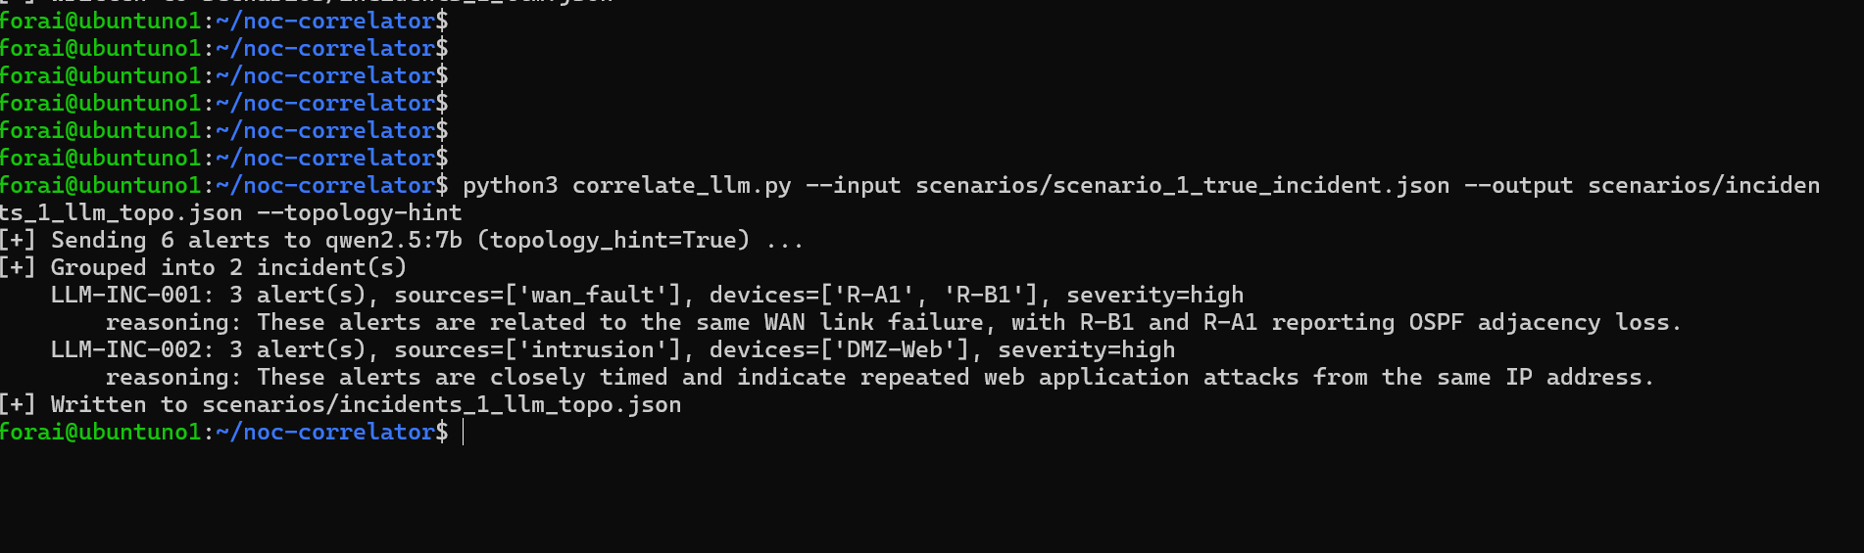
Figure 3 — LLM correlator output for Scenario 1 with the topology hint enabled: R-A1 and R-B1 are correctly merged (LLM-INC-001), but the DMZ-Web intrusion group (LLM-INC-002) remains separate, one hop short of the correct single-incident answer.

8.2 Scenario 2 — Correct despite an available false lead
With the topology hint (which explicitly connects R-B1 and DMZ-Web), the LLM still correctly kept these two clusters separate, given they were roughly 6.5 hours apart. This is a reassuring result: topology awareness did not cause reckless over-merging here.

8.3 Scenario 3 — Inconsistent time-weighting, including a self-contradiction
With the topology hint, the LLM merged R-A1 (08:12) with R-A2 (13:29) as "closely-timed" — they are in fact over five hours apart — and separately merged R-A2 (10:03) with R-A1 (21:58), despite its own reasoning text for that very group stating "no direct relationship to each other," and then grouping them regardless. This directly contradicts the correct time-weighting behavior shown in Scenario 2, within the same overall prompt design.

8.4 Scenario 4 — The central negative result
This scenario was purpose-built as the one case where LLM-added value over the deterministic correlator was plausible: a source IP embedded in the intrusion alert's description matches R-A1's own address. Without the topology hint, the LLM produced the identical split as the deterministic baseline, never mentioning the IP match. With the topology hint — which explicitly states "R-A1's own IP address is 10.10.1.2," placed in the same prompt as an intrusion alert reading "10.10.1.2 -> 10.20.2.10:80" — the LLM still failed to connect the two, and its reasoning never referenced the IP match. Neither correlator solved this scenario; the LLM did not use the exact fact it was given to close the gap.

8.5 Scenario 5 — A genuine point of LLM-added semantic judgment
The deterministic correlator merged all four compliance findings, including R-A1's single PASS result, purely because they occurred at the same instant on adjacent devices — it has no way to read alert content. The LLM split the PASS result into its own group, reading the semantic difference between a passing and failing finding. This is a plausible, arguably better reading of the situation, and the clearest example in this evaluation of an LLM contributing judgment a simple rule cannot.

8.6 Scenario 6 — The multi-hop limit again
The LLM correctly isolated the deliberately-planted unrelated stale finding, matching the ground truth for that part exactly. But it again stopped one hop short on the real incident: it merged the anomaly and WAN-fault alerts (a single adjacency hop, R-A2 to R-B2) but did not extend that group to include the DMZ-Web intrusion alerts, despite the topology hint explicitly describing that connection.

9. Discussion
A consistent pattern emerges across Scenarios 1, 4, and 6: qwen2.5:7b reliably merges alerts across a single topology hop when given the relevant structural information, but does not reliably extend that reasoning across two hops, even when the full path is explicitly spelled out in the prompt. This is a precise, specific capability boundary, not a vague inconsistency — three independent scenarios reproduce the exact same failure shape.
A second, separate finding concerns internal consistency: the model correctly disregarded a large time gap between topology-adjacent devices in Scenario 2, then incorrectly closed a similarly large time gap in Scenario 3 — in one instance explicitly contradicting its own stated reasoning for the grouping it made. This suggests the model's time-weighting is not applied uniformly, which matters for a NOC tool where false-merging noisy alerts into a fabricated incident could be actively harmful to an operator's trust and workload.
Scenario 5 is the one clear counterexample in the LLM's favor: it demonstrated a kind of judgment — distinguishing a PASS finding from FAIL findings — that the deterministic correlator is structurally incapable of, since the deterministic rule never inspects alert content at all.
Taken together, these results do not support a simple "LLM adds value" or "LLM adds no value" conclusion. They support a narrower, more useful one: on this hardware and with this model, the LLM correlator is not yet a reliable upgrade over the deterministic baseline for multi-hop topology reasoning, is inconsistent in its time-weighting, but can offer genuine value in reading the semantic content of alerts that a rule-based system cannot perceive at all.

10. Limitations
- Only one model (qwen2.5:7b) was tested, at a single configuration (temperature 0), with one run per scenario/condition — no repeat-trial variance study was performed, unlike Project 4's methodology for its copilot evaluation.
- The synthetic scenarios are hand-crafted JSON rather than live-injected faults; this was a deliberate, documented design choice for speed, but means the underlying tools' real output formatting quirks are not exercised in these specific correlation tests (they were separately validated against real tool output for each of the four signal sources).
- The topology adjacency graph is small (five devices) and manually authored; results may not generalize to larger or more irregular topologies.
- By design, R-B1/R-B2 are never targets of compliance or anomaly checks, and Site A is never a target of intrusion detection — the correlation layer was evaluated only within this scoping, not against a fully symmetric four-source-per-device design.

11. Conclusion
This project's four independent signal sources all work correctly and were validated against real tool output on a real topology. The deterministic correlator performs exactly as designed, including a known, accepted single-hop limitation. The LLM correlator did not reliably close that limitation, even when given the specific fact needed to do so, and showed inconsistent time-weighting across otherwise similar scenarios — but it did demonstrate one genuine advantage, reading alert semantics that a rule-based approach cannot access at all.
This result is consistent with the recurring finding across this portfolio: for well-defined detection and correlation tasks, simple deterministic methods match or outperform locally-hosted LLM inference, though the LLM approach is not without narrow, real value where semantic judgment — not structural reasoning — is what's actually required. Future work could test a larger model or few-shot prompting to see whether the multi-hop limitation is a model-scale issue or a more fundamental limitation of this correlation approach, and could add a repeat-trial variance study matching Project 4's methodology to establish how consistent these findings are across multiple runs.

