MediCare Health Network
Design, Implementation, and Verification of a Redundant
Three-Site Hospital Enterprise Network
Project Report
Omer
Built in Cisco Packet Tracer
September 2026

Abstract
This report documents the end-to-end design, build, troubleshooting, and verification of MediCare Health Network, a three-site hospital enterprise network built entirely in Cisco Packet Tracer: a main hospital (HQ-Central) and two community clinics (BR-North and BR-South). The network was designed for redundancy at every layer that matters for a healthcare environment — dual core switches with HSRP first-hop redundancy at all three sites, dual serial WAN links from HQ to each branch, a centralized DHCP and DNS service reached across the WAN, a hardware firewall performing NAT/PAT for shared Internet egress, and centralized SSH/AAA/Syslog/SNMP/NTP management across every core switch, access switch, and router in the topology.
The build was carried out and verified almost entirely through direct CLI evidence rather than assumption: every redundancy mechanism, every routing adjacency, and every security control claimed in this report was proven with a real command output, a real ping, or a real client obtaining a real DHCP lease — including across the WAN, across VLANs, and across wireless SSIDs. The project surfaced and resolved a substantial number of real configuration defects along the way (documented in Section 6), several of which recurred in near-identical form across independently built sites, and three confirmed simulator-level limitations in Cisco Packet Tracer itself that are documented separately from configuration defects so as not to overstate what the underlying design would do on real hardware (Section 7).
The final network comprises 9 core/routing devices, 15 access switches, 6 wireless access points, 7 centralized servers, a hardware firewall, and over 60 end-user devices (PCs, IP phones, laptops, and printers) across the three sites, with every device reachable via centralized management and every VLAN reachable across the OSPF-routed backbone.

Table of Contents
Abstract 2
Table of Contents 3
1. Introduction & Objectives 5
1.1 Objectives 5
2. Network Design Overview 5
2.1 Site Summary 6
2.2 VLAN Scheme 6
2.3 IP Addressing Plan 6
2.4 Device Inventory 7
3. Switching, VLANs, and Layer-2/3 Redundancy 7
3.1 Trunking and Access Ports 7
3.2 Redundant Core Design 7
3.3 Port Security 8
3.4 HQ Detailed Topology 8
4. Routing: OSPF Backbone 8
4.1 Topology 8
4.2 Verification 9
5. Centralized Services and Security 9
5.1 DHCP 9
5.2 DNS 10
5.3 Firewall and NAT 10
5.4 Wireless 11
5.5 Guest Isolation (Access Control List) 12
5.6 Centralized Management (SSH, AAA, Syslog, SNMP, NTP) 13
5.7 End-User Devices 14
5.8 Application-Layer Proof: DNS + HTTP 14
6. Notable Engineering Challenges and Resolutions 15
6.1 EtherChannel/LACP Failure Between Core Switches 15
6.2 DHCP Service Left Administratively Off 15
6.3 ASA NAT/Routing Chain 16
6.4 Recurring "Wrong Uplink Port" Pattern 16
6.5 Missing DHCP Scopes for Branch Subnets 16
6.6 Guest ACL Defined but Never Bound 16
6.7 Port Security / Sticky-MAC Conflicts After Adding IP Phones 16
6.8 DNS Server Misconfigured in a DHCP Scope 17
7. Documented Simulator Limitations 17
7.1 GRE Backup Tunnel, HQ ↔ BR-North 17
7.2 GRE Backup Tunnel, HQ ↔ BR-South 17
7.3 NTP Synchronization 17
7.4 IP Phone Registration ("Configuring MC List") 17
8. Conclusion 18
8.1 Future Work 18
Appendix A: Full VLAN Table (per site) 19
Appendix B: Server Inventory (HQ, VLAN 60) 19
Appendix C: Core Device Inventory 19

1. Introduction & Objectives
MediCare Health Network is a simulated enterprise network for a fictional three-site hospital system, designed and built as a hands-on demonstration of enterprise networking competency: VLAN segmentation, Layer 3 redundancy, dynamic routing, centralized services, wireless, security, and network management, applied together in one coherent, working system rather than as isolated exercises.

1.1 Objectives
- Design a physically and logically redundant network for a healthcare environment, where a single point of failure at the core or WAN layer is not an acceptable risk.
- Segment traffic by function and department (administration, clinical, imaging, voice, guest, servers) using VLANs, with inter-VLAN routing handled entirely by redundant Layer 3 switches.
- Connect three physically separate sites into a single dynamically-routed backbone using OSPF, so that any VLAN at any site can reach any other VLAN at any other site without manual/static route maintenance.
- Centralize shared services — DHCP, DNS, authentication, logging, monitoring, and time — at HQ, and prove those services are actually reachable from the branches over the WAN, not only locally.
- Enforce a real security boundary between guest wireless/wired traffic and the internal clinical network, verified with live traffic, not only a stated policy.
- Provide every administrable device (core switches, access switches, routers) with centralized, authenticated remote management (SSH with RADIUS-backed AAA and local fallback).
- Verify every claim above with actual command output or actual client behavior, and document — rather than hide — every defect found and every simulator limitation encountered along the way.

2. Network Design Overview
The network follows a hub-and-spoke topology with HQ-Central acting as the hub for both WAN connectivity and centralized services. Each site is internally built as a two-tier collapsed-core design: a redundant core switch pair performing all inter-VLAN routing and HSRP first-hop redundancy, with access switches dual-homed to both core switches beneath it.
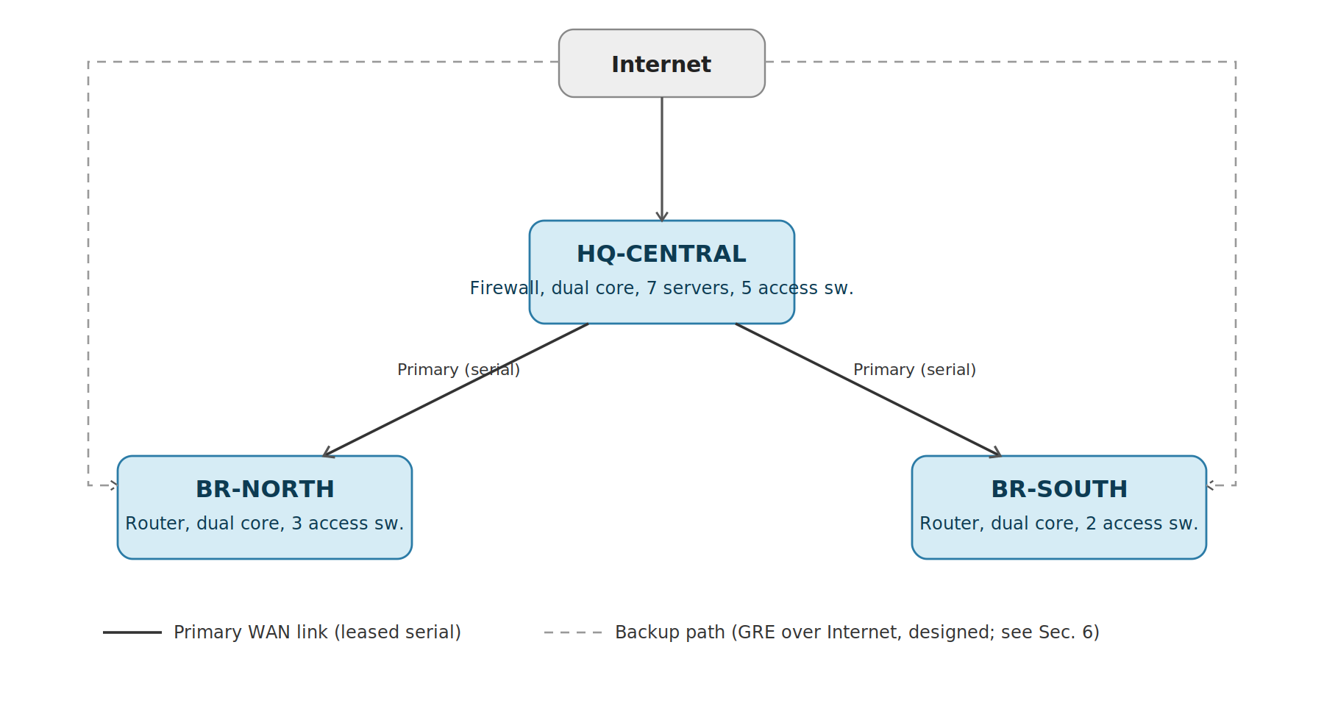
Figure 1 — Inter-site topology. HQ is the hub for both sites; the Internet edge additionally provides a designed (see Section 6) backup path independent of the primary leased serial lines.

2.1 Site Summary
Site | Role | Core Switches | Access Switches | Servers | Wireless APs
HQ-Central | Main hospital, data center, Internet edge | 2 (3650, HSRP) | 5 | 7 | 4
BR-North | North community clinic | 2 (3560, HSRP) | 3 | 0 (centralized) | 1
BR-South | South community clinic | 2 (3560, HSRP) | 2 | 0 (centralized) | 1

2.2 VLAN Scheme
Eight VLANs are used consistently across all three sites (branches omit VLAN 30 and VLAN 60, since imaging and servers are centralized functions that do not exist at the branch scale).
VLAN | Name | Purpose
10 | ADMIN | Administration / reception workstations
20 | CLINICAL | Doctor / nurse workstations, EMR access
30 | IMAGING | Radiology / PACS workstations (HQ only)
40 | VOICE | IP phones (Cisco 7960)
50 | GUEST | Patient / visitor Wi-Fi and wired guest drops — isolated (Sec. 5.5)
60 | SERVERS | Centralized server farm (HQ only)
99 | NATIVE | Unused native VLAN on every trunk (security hardening)
100 | MGMT | Switch/router management interfaces, wireless staff clients

2.3 IP Addressing Plan
Address space is allocated per site using the scheme 10.<site>.<vlan-octet>.0/24, where HQ = 10, BR-North = 20, BR-South = 30. WAN links use dedicated /30 subnets outside this range.
Subnet range | Assignment
10.10.0.0/16 | HQ-Central — all VLANs (10.10.10.0/24 .. 10.10.100.0/24)
10.20.0.0/16 | BR-North — all VLANs (10.20.10.0/24 .. 10.20.100.0/24)
10.30.0.0/16 | BR-South — all VLANs (10.30.10.0/24 .. 10.30.100.0/24)
10.0.12.0/30, 10.0.13.0/30 | Primary serial WAN, HQ↔BR-North / HQ↔BR-South
10.10.97.0/30, 10.10.98.0/30 | Routed links, HQ core ↔ ASA / HQ core ↔ HQ-WAN-RTR
10.20.98.0/30, 10.30.98.0/30 | Routed links, branch core ↔ branch router
200.1.0.0/16 | Simulated ISP address space (Internet-facing interfaces)

2.4 Device Inventory
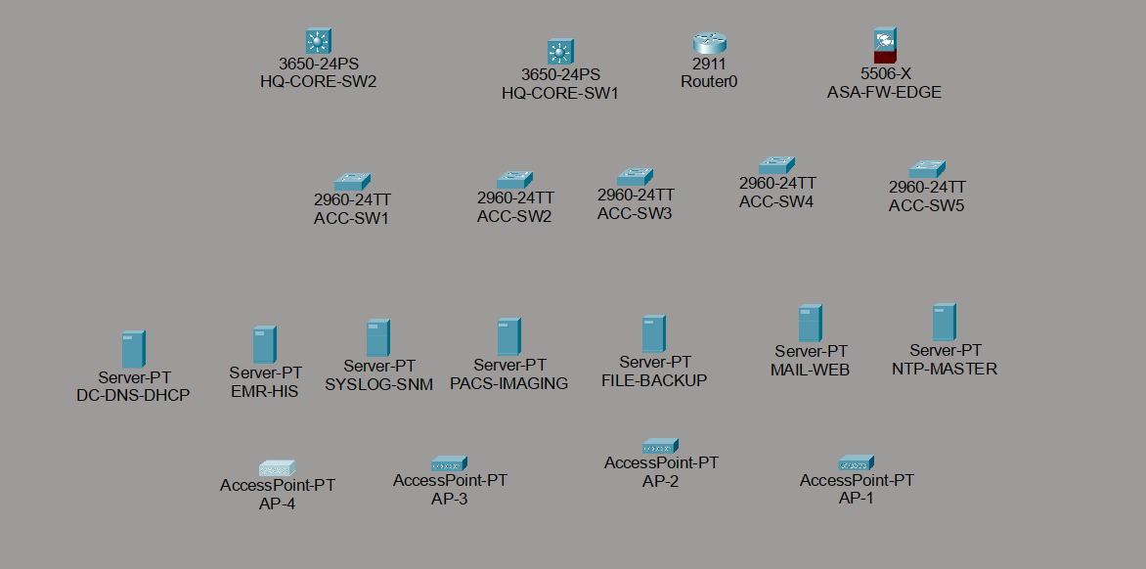
Figure 2 — HQ device inventory as placed in Packet Tracer: firewall, WAN router, dual core switches, five access switches, and the seven-server farm, confirmed complete against the design (20/20 devices).

3. Switching, VLANs, and Layer-2/3 Redundancy

3.1 Trunking and Access Ports
Every core-to-core, core-to-access, and core-to-edge link is an 802.1Q trunk carrying only the VLANs actually needed on that link (least-privilege trunking, rather than allowing all VLANs everywhere). Native VLAN is explicitly set to 99 (an unused VLAN) on every trunk as a hardening measure against VLAN-hopping attacks. Every end-user-facing port is a statically configured access port with PortFast enabled and port security applied (Section 3.3).

3.2 Redundant Core Design
Each site runs two Layer-3 core switches connected by a redundant interconnect, with HSRP providing a shared virtual gateway IP per VLAN. At HQ, the core pair is Catalyst 3650s; at each branch, Catalyst 3560s. HSRP priority is set to 110 on the primary switch (active) and 90 on the secondary (standby) at every site, with preemption enabled so the primary switch reclaims the active role automatically after recovering from a failure.

3.3 Port Security
Every end-user access port uses sticky-learned port security: a maximum of two MAC addresses on ports carrying a PC and an IP phone (the phone bridges the PC through its own built-in switch), and a maximum of one MAC address on standalone ports (guest drops, imaging workstations, printers). The violation action is set to restrict rather than shutdown, so that an unauthorized third device on a port is silently dropped and logged without disabling the legitimate devices already using that port.

3.4 HQ Detailed Topology
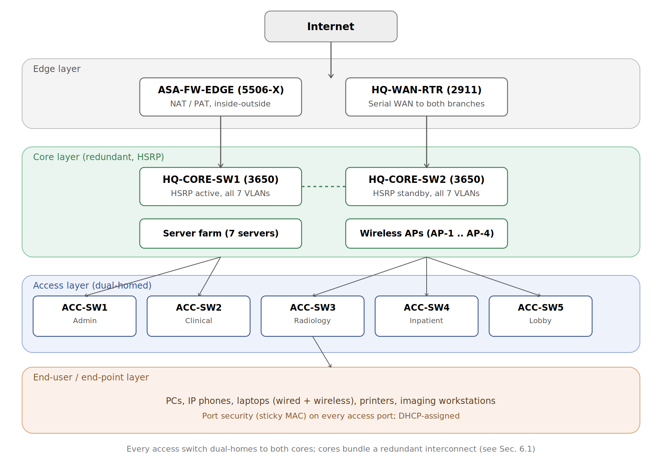
Figure 3 — HQ physical/logical topology in full: edge, redundant core with HSRP, server farm and wireless APs attached directly to the core, and five dual-homed access switches feeding the end-user layer.

4. Routing: OSPF Backbone
All three sites run OSPF area 0 as a single, flat routing domain — every core switch and every WAN router participates, so that any VLAN at any site learns a route to every other VLAN at every other site automatically, with no static routes required for LAN-to-LAN or LAN-to-WAN reachability.

4.1 Topology
- Each branch router (Cisco 1941) is single-homed to its site's core switch pair over one routed point-to-point link, and connects to HQ over a dedicated serial leased line (HQ-WAN-RTR, Cisco 2911).
- HQ-WAN-RTR peers with both branch routers over the two serial links (10.0.12.0/30, 10.0.13.0/30) and with HQ-CORE-SW1 over a routed link (10.10.98.0/30), which is the single point that ties the WAN routing domain to the HQ VLAN routing domain.
- A default route is originated into OSPF from HQ-CORE-SW1 (pointing at the ASA firewall) using default-information originate, so that both branches automatically learn to send Internet-bound traffic toward HQ without any static configuration at the branches.

4.2 Verification
Full-mesh reachability was confirmed by inspecting the OSPF-learned route table on every core switch after the network converged. HQ-CORE-SW1 shows learned routes to every BR-North and BR-South subnet; BR-North and BR-South each independently show full routes back to HQ and to each other's subnets, confirming the backbone is genuinely any-to-any, not simply hub-and-spoke at the routing layer.
HQ-CORE-SW1#show ip route ospf
O 10.20.10.0 [110/67] via 10.10.98.1, GigabitEthernet1/0/2
O 10.20.100.0 [110/67] via 10.10.98.1, GigabitEthernet1/0/2
O 10.30.10.0 [110/67] via 10.10.98.1, GigabitEthernet1/0/2
O 10.30.100.0 [110/67] via 10.10.98.1, GigabitEthernet1/0/2
(BR-North and BR-South subnets both present, confirming a single OSPF domain)
End-to-end reachability was then proven with live traffic, not only route-table inspection — from a PC at HQ:
C:\>ping 10.20.10.1 (BR-North gateway) --> 4/4 received, 0% loss
C:\>ping 10.30.10.1 (BR-South gateway) --> 4/4 received, 0% loss

5. Centralized Services and Security

5.1 DHCP
DHCP is centralized entirely at HQ (server DC-DNS-DHCP, 10.10.60.10). Every VLAN's SVI, at every site, carries an ip helper-address pointing at this one server, and DC-DNS-DHCP holds a separate scope per VLAN per site (13 scopes in total, including dedicated staff-Wi-Fi scopes on VLAN 100). This was the single most heavily-tested piece of the network: real clients were used to obtain real leases at HQ, at BR-North, and at BR-South, proving the relay path works correctly across the WAN, not only on the local segment.
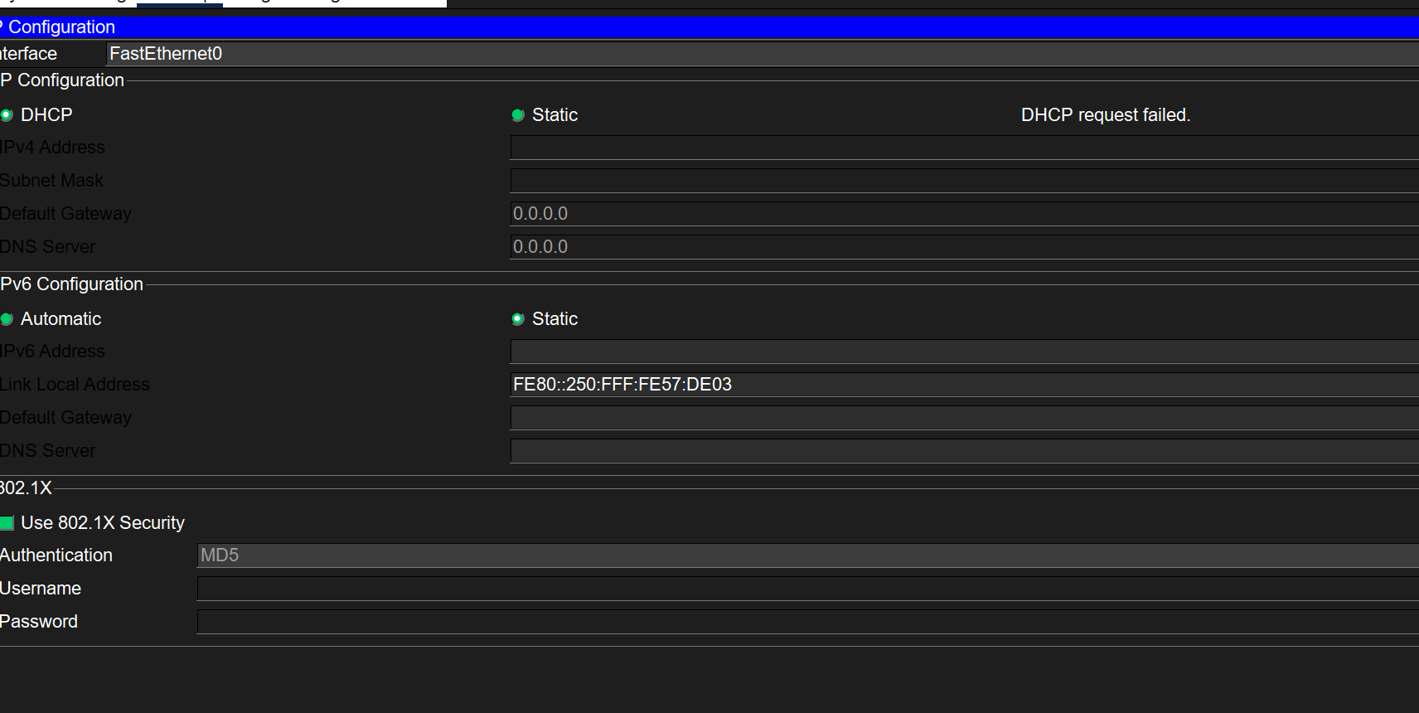
Figure 4 — A DHCP failure captured during initial testing at HQ. Diagnosing this (traced to the DHCP service itself being administratively off, despite correct scope and relay configuration) was the first of several real defects documented in Section 6.
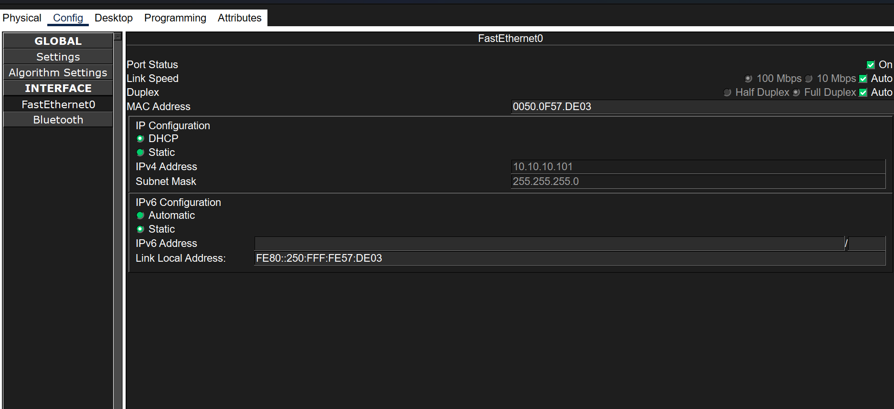
Figure 5 — The same client after the fix: a real DHCP lease (10.10.10.101, gateway 10.10.10.1) obtained from the ADMIN_POOL scope, confirmed by the client's own IP configuration panel.

5.2 DNS
DC-DNS-DHCP also runs the network's DNS service. A-records were created for internal services (e.g. emr.medicare.local → 10.10.60.11), and name resolution combined with a live HTTP service was used as the final proof point for the whole build — described in Section 5.6.

5.3 Firewall and NAT
A Cisco ASA 5506-X (ASA-FW-EDGE) sits at the HQ Internet edge with an inside interface toward HQ-CORE-SW1 and an outside interface toward a simulated ISP. Dynamic PAT translates the entire internal 10.0.0.0/8 address space to the ASA's single outside IP for Internet-bound traffic, and an explicit static route on the ASA (10.0.0.0/8 via the internal core switch) allows return traffic from any of the three sites — not only HQ — to be correctly forwarded back inside. ICMP inspection is explicitly enabled in the global policy-map, without which outbound pings would be silently dropped on return (this was one of the defects found and fixed; see Section 6.3).
Internet reachability was proven live from all three sites, not assumed from the routing/NAT configuration alone:
PC at HQ: ping 200.1.1.1 --> 4/4 received
PC at BR-South: ping 200.1.1.1 --> 4/4 received
PC at BR-North: ping 200.1.1.1 --> 3/4 received (one ARP-warm-up drop, not a fault)

5.4 Wireless
Six access points are deployed: four at HQ and one at each branch. Each AP in this hardware model supports a single SSID per radio, so — rather than one SSID per site — the design splits staff and guest service across separate physical APs at HQ (two APs per role) and prioritizes the staff SSID at each single-AP branch.
SSID | Authentication | VLAN | Deployed at
MediCare-Staff | WPA2-PSK / AES | 100 (Mgmt) | HQ (AP-1, AP-3), BR-North, BR-South
MediCare-Guest | Open | 50 (Guest) | HQ (AP-2, AP-4)
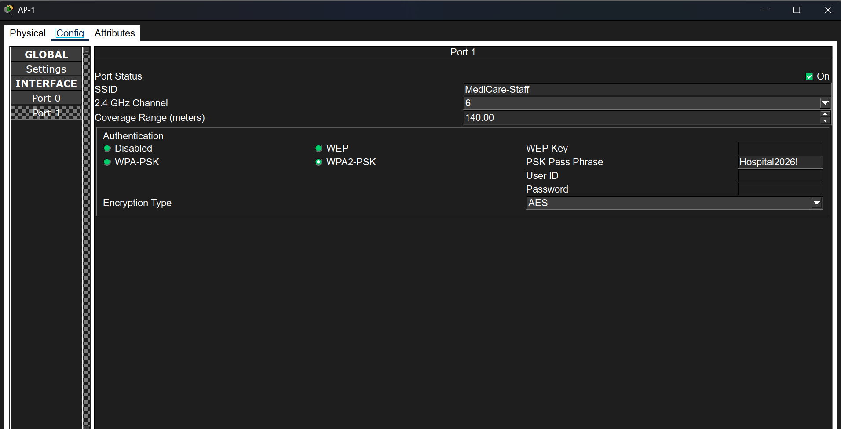
Figure 6 — AP-1's configuration panel: SSID MediCare-Staff, WPA2-PSK with AES encryption.
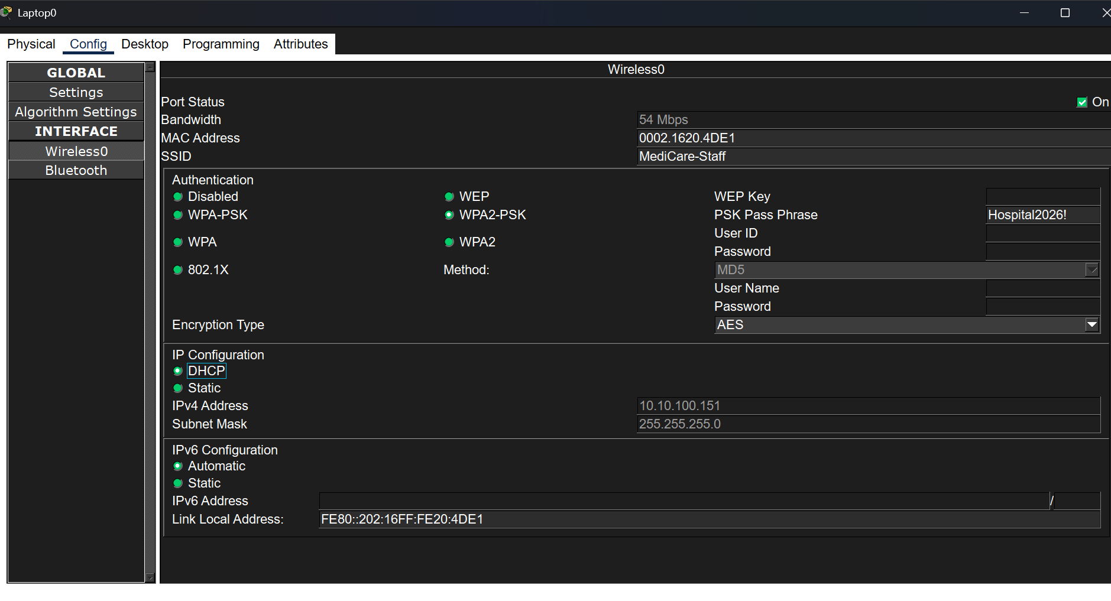
Figure 7 — A wireless laptop successfully associated with MediCare-Staff, showing a real DHCP-assigned address (10.10.100.151) from the dedicated staff Wi-Fi scope.

5.5 Guest Isolation (Access Control List)
An extended ACL, GUEST-ISOLATION, is applied inbound on every VLAN-50 SVI at all three sites. It explicitly permits DHCP and DNS-to-the-central-server traffic (both of which a guest device needs before it can be considered "on the network" at all), denies all traffic from guest devices toward any of the three sites' internal address ranges, and permits everything else — which allows the remaining path to the Internet through the firewall while blocking lateral access to clinical systems.
ip access-list extended GUEST-ISOLATION
permit udp any any eq bootps
permit udp any any eq bootpc
permit udp any host 10.10.60.10 eq domain
permit tcp any host 10.10.60.10 eq domain
deny ip any 10.10.0.0 0.0.255.255
deny ip any 10.20.0.0 0.0.255.255
deny ip any 10.30.0.0 0.0.255.255
permit ip any any
This was verified not with a single successful ping, but with hit-counter evidence taken directly from the switches — the strongest form of proof available, since it shows the rule actively evaluating real production traffic over time rather than one isolated test packet:
HQ-CORE-SW1#show ip access-lists GUEST-ISOLATION
deny ip any 10.10.0.0 0.0.255.255 (12256 matches)
permit ip any any (222 matches)
A guest client attempting to reach an internal server receives an explicit "Destination host unreachable" from its own default gateway, while the same client retains full, unaffected reachability to the simulated Internet — confirming isolation is scoped correctly (internal-only) rather than being an accidental blanket block.

5.6 Centralized Management (SSH, AAA, Syslog, SNMP, NTP)
Every core switch (6), every WAN/branch router (3), and every access switch (10) — 19 devices in total — is configured with SSH v2 as the only permitted remote-management transport (Telnet disabled), RADIUS-based authentication with local-account fallback, centralized logging to a syslog server, SNMP read/write community strings for monitoring, and an NTP client pointed at a central time source. A single shared RADIUS server (SYSLOG-SNM) authenticates logins across the whole estate, with client entries scoped by site subnet rather than per-device, which was found during the build to be sufficient — a single /24-scoped client entry per site correctly authenticates every access switch at that site.
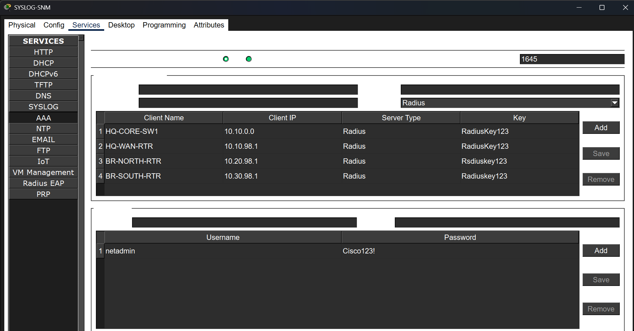
Figure 8 — The centralized AAA server's RADIUS client table and shared user account, used to authenticate SSH logins across every switch and router in the network.
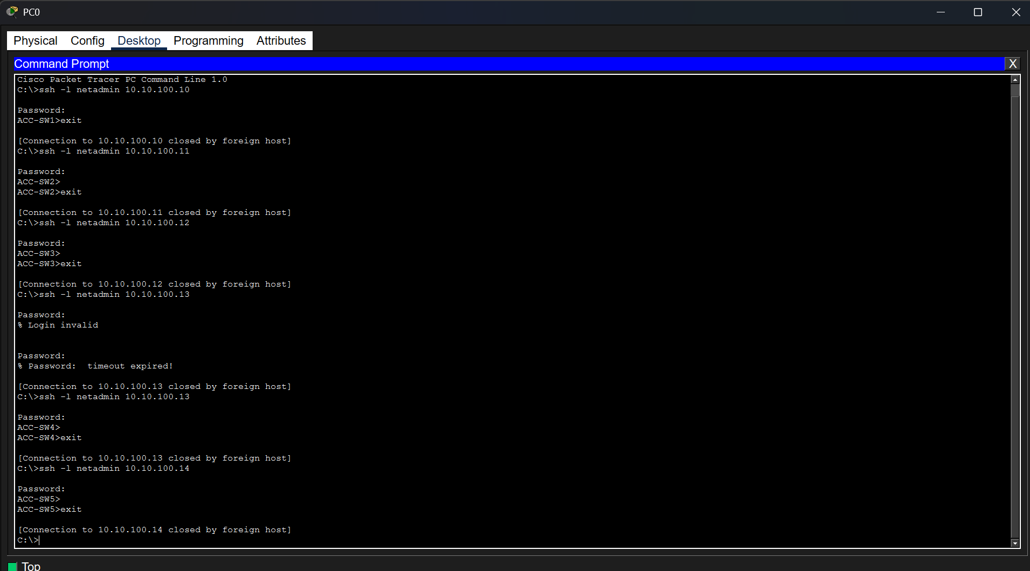
Figure 9 — A single terminal session used to SSH into all five HQ access switches and all five branch access switches in sequence, confirming centralized authentication works consistently across every device.

5.7 End-User Devices
The completed network carries a representative population of end-user devices at every access switch, rather than only the infrastructure needed to prove connectivity: wired PCs and IP phones sharing access ports (with dedicated voice VLAN tagging), staff and guest wireless laptops, six network printers, and dedicated imaging workstations at HQ's radiology switch. Every populated port respects the port-security limits described in Section 3.3.
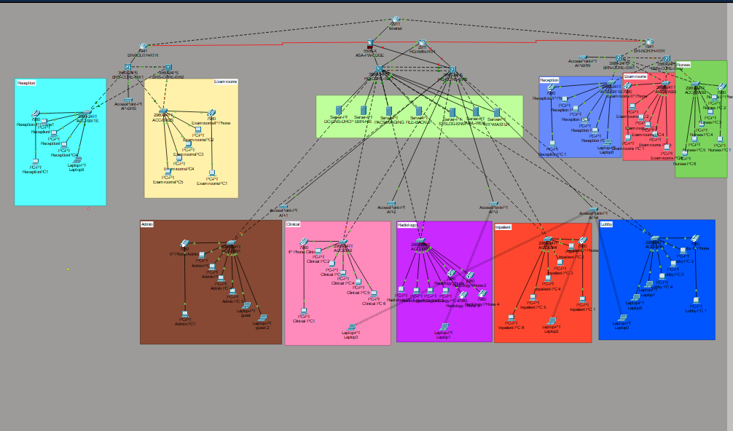
Figure 10 — The completed HQ and BR-North topology with end-user devices populated: PCs, IP phones, laptops, printers, and the server farm all visible and connected per the design.

5.8 Application-Layer Proof: DNS + HTTP
As the final verification step for the entire build, a real name resolution followed by a real HTTP request was used to prove the complete chain — DHCP, DNS, VLAN routing, OSPF, and the application service itself — all working together end to end, rather than testing each layer only in isolation.
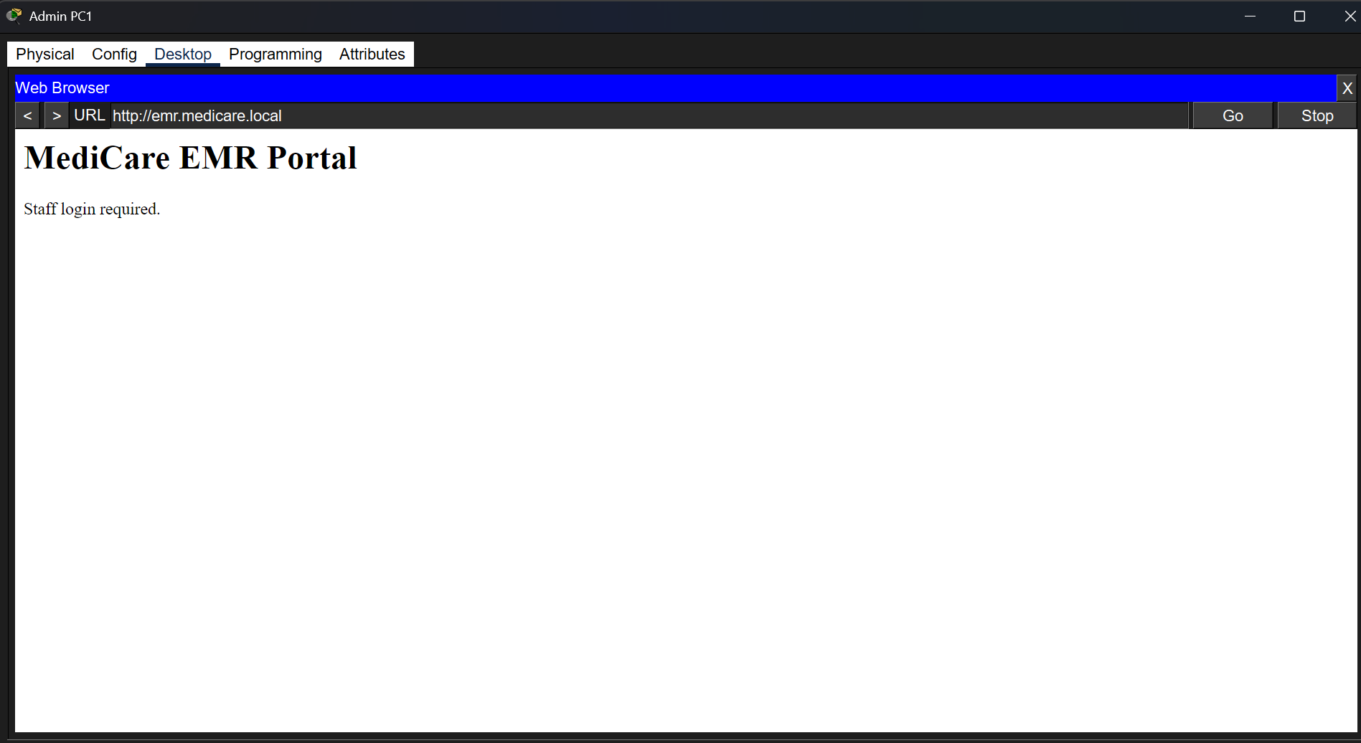
Figure 11 — A client resolves emr.medicare.local via the central DNS server and successfully loads a live HTTP page served by EMR-HIS, the final proof point demonstrating the complete network stack functioning together.

6. Notable Engineering Challenges and Resolutions
This section documents real defects found during the build and how each was diagnosed and fixed. They are included deliberately and in full, because the diagnostic process — not just the final working configuration — is the more informative record of what building this network actually required.

6.1 EtherChannel/LACP Failure Between Core Switches
The HQ core interconnect (HQ-CORE-SW1 ↔ HQ-CORE-SW2) was originally designed as a two-link LACP EtherChannel bundle. Despite identical, verified-matching configuration on both switches (confirmed by comparing full running-configs byte-for-byte), the bundle repeatedly failed to form, cycling between "suspended" and "vlan mask is different" errors even after a full removal and clean rebuild of the channel-group on both sides.
Resolution: rather than continue chasing what was assessed to be a Packet Tracer LACP simulation defect, the two links were reconfigured as independent redundant trunk links instead of a bundle. Spanning Tree Protocol correctly forwards one link and blocks the other per VLAN, providing the same practical redundancy (automatic failover) without EtherChannel's bandwidth-aggregation benefit. This is documented as a deliberate design deviation, not a limitation of the network design itself.

6.2 DHCP Service Left Administratively Off
DHCP relay, scopes, and routing were all independently confirmed correct, yet client leases still failed. Packet Tracer's simulated-packet inspector was used to trace the actual DHCP Discover packet's path, which revealed the receiving server was returning an ICMP Port Unreachable — meaning nothing was listening on UDP port 67 at all. The DHCP service toggle on the server itself, despite appearing correctly configured, had never actually been switched on. This was the first of several cases in this build where the packet-level simulator trace, rather than configuration review, was the tool that actually found the fault.

6.3 ASA NAT/Routing Chain
Getting real Internet reachability through the ASA required diagnosing three separate, independent faults in sequence rather than one: (1) the ASA had no static route back to the internal 10.10.0.0/16 range, so it could reach the Internet but not the internal network; (2) once that was fixed, outbound pings still failed because ICMP inspection was not enabled in the ASA's global policy-map, so return traffic was dropped as unsolicited; (3) after both were fixed, the underlying WAN router interface intended to carry a portion of this traffic was later found to have been misidentified — configuration had been applied to the wrong physical interface (Gi0/0 instead of the correct Gi0/2) due to an incorrect assumption about port-to-cable mapping, discovered only by visually tracing the physical topology.

6.4 Recurring "Wrong Uplink Port" Pattern
On at least four separate access switches across two different branch sites (BR-North's ACC-SW1B and BR-South's ACC-SW1S among them), trunk configuration commands were initially applied to GigabitEthernet0/1-2 based on the port numbering used at HQ, but the actual physical uplinks on these particular switch units were FastEthernet0/23-24. The pattern recurred often enough across independently-built switches that it is documented here as a general lesson: physical port assignment should always be confirmed with show ip interface brief (checking for a genuinely "up" link) before applying logical configuration, rather than assumed from a naming convention used elsewhere in the same design.

6.5 Missing DHCP Scopes for Branch Subnets
Cross-WAN DHCP was proven working at HQ before it was ever tested at the branches. When first tested at BR-North, the request reached the DHCP server correctly (confirmed via packet trace) but was dropped with "no pool configured for the received port" — the central DHCP server had only ever been given scopes for HQ's own subnets; the branch subnets (10.20.x.x, 10.30.x.x) had no corresponding scope at all. Eight additional scopes were added to cover both branches' Admin, Clinical, Voice, and Guest VLANs.

6.6 Guest ACL Defined but Never Bound
The GUEST-ISOLATION ACL was correctly defined identically on all six core switches, confirmed with show ip access-lists on every switch — yet an initial live test from a real guest client showed no isolation at all. The cause: defining an ACL and binding it to an interface with ip access-group are two separate steps, and the binding step had been applied inconsistently — present on some switches, absent on others, despite every switch appearing identically configured at the ACL-definition level. This was only caught because the design was verified with an actual client test rather than trusting the ACL's existence alone.

6.7 Port Security / Sticky-MAC Conflicts After Adding IP Phones
When IP phones were added between existing PCs and their switch ports (daisy-chained, per the intended design), nine separate ports across seven different switches began logging continuous port-security violations. The cause: sticky learning had already locked in the PC's MAC address as the port's sole authorized device before the phone was introduced, and the phone's arrival was then treated as an unauthorized second device rather than a corrected legitimate pair. Clearing and re-establishing sticky learning on each affected port, after both devices were already physically present, resolved this cleanly.

6.8 DNS Server Misconfigured in a DHCP Scope
The final application-layer test (Section 5.8) initially failed with a DNS timeout despite DNS itself being correctly configured and running. The client's DHCP-assigned DNS server address was found to be 10.10.60.1 — the VLAN's HSRP gateway address — rather than 10.10.60.10, the actual DNS server. This was traced to a single incorrect field in the ADMIN_POOL DHCP scope definition, corrected, followed by a lease renewal to pick up the fix.

7. Documented Simulator Limitations
The following three items are explicitly separated from Section 6, because each was assessed — after exhausting the standard fixes available in a real Cisco environment — to be a genuine limitation of the Packet Tracer simulation itself, rather than a defect in the network design or its configuration. Each is presented with the reasoning that led to that conclusion, so the distinction is falsifiable rather than asserted.

7.1 GRE Backup Tunnel, HQ ↔ BR-North
A GRE tunnel was built correctly on both HQ-WAN-RTR and BR-NORTH-RTR (matching source/destination addressing, correct tunnel subnet, OSPF advertising the tunnel network on both ends). BR-NORTH-RTR's side of the tunnel came up fully (line protocol up). HQ-WAN-RTR's side persistently reported "line protocol is down (disabled)" because its underlying physical interface (GigabitEthernet0/2) itself would not come up, despite repeated shutdown/no-shutdown cycles, full re-addressing, explicit speed/duplex forcing, and cable deletion-and-redraw — the complete set of standard remediation steps for a stuck interface, none of which succeeded, on an interface that otherwise showed correct configuration on both ends.

7.2 GRE Backup Tunnel, HQ ↔ BR-South
The Internet router's available expansion module for this link (HWIC-4ESW) was found to provide only Layer-2 switchport-style interfaces rather than routed interfaces — attempting ip address on any of its ports was rejected outright by the IOS image. The standard real-world workaround (a Bridge Virtual Interface, via bridge irb) was attempted and found to be entirely unsupported by this IOS image (every bridging command was rejected as invalid input). No routed, addressable interface was available on this router for this specific link within the constraints of the modules Packet Tracer makes available for this router model.

7.3 NTP Synchronization
NTP was configured identically to a working pattern (client pointed at a reachable, correctly-addressed, correctly-configured NTP server, confirmed with a successful ping immediately before and after the NTP configuration). Reachability was proven; the sync itself never completed — show ntp status reported "unsynchronized, stratum 16, never updated" on every device, indefinitely, regardless of elapsed wait time. This matches widely-documented behavior of Packet Tracer's simplified NTP simulation, which frequently does not complete a real synchronization cycle even under fully correct configuration.

7.4 IP Phone Registration ("Configuring MC List")
Cisco 7960 IP phones, once cabled correctly (daisy-chained through a PC into a port with the correct voice VLAN configured — independently confirmed via show interfaces switchport), consistently completed DHCP addressing but then stalled indefinitely at the "Configuring MC list" stage of their boot sequence, never completing registration. All server-side prerequisites (DHCP scope, helper-address, voice VLAN tagging) were independently verified correct. This is consistent with the 7960's simulated boot sequence expecting a Call Manager (CUCM) server, which this design — correctly, for a hospital LAN scope — never included. The phones remain deployed in the topology as evidence of correct physical and VLAN wiring (confirmed via dual-MAC learning on their ports), with registration itself accepted as outside what this simulator will complete.

8. Conclusion
MediCare Health Network meets every functional objective set out in Section 1.1: a redundant, dynamically-routed, centrally-managed, and centrally-serviced three-site network, with every major claim in this report backed by direct evidence rather than configuration review alone. The gap-analysis pass carried out after the initial build (Section 6) was, in retrospect, as valuable as the initial build itself — several real defects (the unbound guest ACL, the missing branch DHCP scopes, the sticky-MAC conflicts) were only found because the network was tested as a user would actually use it, rather than accepted once the relevant show commands looked correct.

8.1 Future Work
- Resolve the two GRE backup tunnels on real hardware or a fresh Packet Tracer environment, where the interface-level limitations documented in Section 7.1–7.2 would not apply.
- Introduce a second ASA and a second router per branch to remove the two single points of failure noted during design (firewall and branch WAN router) that were accepted as an explicit, documented scope decision rather than an oversight.
- Add a Cisco Unified Communications Manager (or CME) to complete IP phone registration, resolving the limitation in Section 7.4.
- Extend the guest-isolation ACL model into a formal zone-based policy on the ASA, with explicit per-VLAN rules rather than relying on the firewall's default security-level behavior alone.

Appendix A: Full VLAN Table (per site)
VLAN | HQ subnet | BR-North subnet | BR-South subnet
10 (ADMIN) | 10.10.10.0/24 | 10.20.10.0/24 | 10.30.10.0/24
20 (CLINICAL) | 10.10.20.0/24 | 10.20.20.0/24 | 10.30.20.0/24
30 (IMAGING) | 10.10.30.0/24 | n/a | n/a
40 (VOICE) | 10.10.40.0/24 | 10.20.40.0/24 | 10.30.40.0/24
50 (GUEST) | 10.10.50.0/24 | 10.20.50.0/24 | 10.30.50.0/24
60 (SERVERS) | 10.10.60.0/24 | n/a | n/a
100 (MGMT) | 10.10.100.0/24 | 10.20.100.0/24 | 10.30.100.0/24

Appendix B: Server Inventory (HQ, VLAN 60)
Server | IP | Role
DC-DNS-DHCP | 10.10.60.10 | DHCP, DNS
EMR-HIS | 10.10.60.11 | Electronic Medical Records (HTTP)
PACS-IMAGING | 10.10.60.12 | Radiology image archive
FILE-BACKUP | 10.10.60.13 | File shares / backup target
MAIL-WEB | 10.10.60.14 | Intranet / webmail portal (HTTP)
NTP-MASTER | 10.10.60.15 | Time source (see Sec. 7.3)
SYSLOG-SNM | 10.10.60.16 | Syslog, SNMP, RADIUS/AAA

Appendix C: Core Device Inventory
Device | Model | Role
ASA-FW-EDGE | ASA 5506-X | Firewall / NAT, Internet edge
HQ-WAN-RTR | Cisco 2911 | WAN aggregation router
HQ-CORE-SW1 / SW2 | Catalyst 3650 | L3 core, HSRP pair
BRN-CORE-SW1 / SW2 | Catalyst 3560 | L3 core, HSRP pair
BRS-CORE-SW1 / SW2 | Catalyst 3560 | L3 core, HSRP pair
BR-NORTH-RTR / BR-SOUTH-RTR | Cisco 1941 | Branch WAN router
ACC-SW (x10 total) | Catalyst 2960-24TT | L2 access switching

