AI-Assisted Intrusion Detection / Prevention System
with DMZ Segmentation
Extending a Hybrid Deterministic-Detection and LLM-Reporting Architecture from Static Configuration Compliance and Behavioural Anomaly Detection to Network Intrusion Detection in a Segmented DMZ
Companion Project Report (Project 3)
Omer Salih Osman Gesmalla
Student ID: 25/27558
July 2026

Abstract
This project extends the hybrid deterministic-detection and LLM-assisted reporting architecture validated across two companion projects (an AI-assisted network compliance auditor, and an AI-assisted behavioural anomaly detector) into a third distinct problem domain: network intrusion detection and prevention (IDS/IPS) in a segmented DMZ topology. A new enterprise-representative GNS3 topology was built from scratch, comprising an edge router, a FortiGate firewall with a dedicated DMZ interface, a DMZ-hosted web server running the Suricata IDS engine (ET Open ruleset, 52,022 signatures), and an internal Layer-3 core with three department VLANs. The shared AI-Server infrastructure from the companion projects was reused to host both the attack-generator toolchain and the locally-served LLM (Ollama, qwen2.5:7b).
A controlled fault-injection methodology consistent with both companion projects was used: three attack techniques (Nmap reconnaissance scanning, Hydra-driven SSH credential brute-forcing, and a custom HTTP client sending SQL-injection and path-traversal payloads) were executed across 11 independent trials against the DMZ web server, and a purpose-built deterministic alert correlator cross-referenced each attack's precise timestamp window against Suricata's alert log to compute detection rate without any LLM involvement. The evaluation produced an honest, low overall detection rate of 1/11 (9.1%): the default ET Open ruleset reliably detected reconnaissance scanning via a signature-based User-Agent match, but detected zero of three SSH brute-force trials (including an extended, higher-volume trial ruling out attempt count as the cause) and zero of six web-attack trials, a result attributed to the ruleset's reliance on encrypted-traffic-blind connection heuristics for SSH and application-specific fingerprints for web attacks that do not match a generic static target.
The AI reporting layer, explicitly instructed that the deterministic detection results were fixed ground truth to be explained and prioritised rather than altered, nonetheless introduced a factual arithmetic or count error in every one of three independent report-generation runs -- an incorrect percentage in the first run, and incorrect attack-count statements in the second and third. A lightweight automated validator was added and successfully caught the percentage error but not the count errors, illustrating that automated validation narrows but does not eliminate the need for human review of LLM-generated content. This finding provides a third, independent line of evidence -- following the companion projects' documented severity-ranking inconsistency and factual-inversion bug respectively -- supporting this project portfolio's consistent architectural position: LLM output must never be treated as authoritative over deterministic, structured detection results, regardless of how explicitly it is instructed otherwise.

Table of Contents
1. Introduction & Motivation
2. Relationship to Companion Projects & Differentiation
3. System Architecture
4. Network Topology & Lab Environment
4.1 Devices
4.2 Addressing Plan
4.3 DMZ Segmentation & Firewall Policy
5. Implementation
5.1 Firewall & Routing Configuration
5.2 DMZ-Web Build: nginx and Suricata
5.3 Attack Generator Scripts
5.4 Deterministic Alert Correlator
5.5 AI Reporting Layer
6. Evaluation & Results
6.1 Fault-Injection Methodology
6.2 Results Summary
6.3 Detection Gap Analysis
6.4 Operational Reliability Observation
7. Notable Engineering Challenges & Resolutions
7.1 Asymmetric Routing: AI-Server to DMZ
7.2 Asymmetric Return Routing: DMZ-Web to Internal Network
7.3 Firewall Policy Interface Mismatch (VLAN Sub-Interface)
7.4 Suricata Default Interface Misconfiguration
7.5 Suricata Log Rotation Mid-Session
7.6 Clock Skew Between Correlated Hosts
8. AI Reporting Layer Evaluation
9. Discussion & Limitations
10. Conclusion & Future Work
Appendix A: Attack Generator Source Excerpts
Appendix B: Sample Correlation Report (JSON Excerpt)
Appendix C: Sample AI-Generated Report with Errors Annotated

1. Introduction & Motivation
Two companion projects developed and evaluated a hybrid architecture in which deterministic logic performs detection and a locally hosted large language model (LLM) is used exclusively to explain and prioritise already-determined findings. The first project applied this architecture to static configuration compliance auditing; the second extended it to dynamic, behavioural SNMP-based anomaly detection. Both evaluations supported the same conclusion from different angles: deterministic detection logic was reproducible and reliable, while the LLM reporting layer exhibited measurable inconsistency (inconsistent severity ranking in the first project; a reproducible factual-inversion bug in the second).
This project tests the same architectural pattern against a third, qualitatively different problem domain: network intrusion detection. Where compliance auditing asks "is this configuration line present or absent?" and anomaly detection asks "is this numeric time-series pattern unusual?", intrusion detection asks a third kind of question -- "does this network traffic match a known attack signature or behavioural pattern?" -- evaluated here using an industry-standard, unmodified open-source IDS engine (Suricata with the ET Open ruleset) rather than a custom-built detector, providing a useful contrast with the bespoke detection logic used in the two companion projects.

1.1 Objectives
- Design and build a new, DMZ-segmented enterprise GNS3 topology, separate from the topology reused across the two companion projects.
- Deploy a DMZ-facing web server monitored by Suricata IDS, running an unmodified, industry-standard open-source ruleset (ET Open).
- Configure FortiGate firewall policies enforcing realistic DMZ security boundaries (restricted WAN-to-DMZ access, DMZ-to-internal denial).
- Implement a multi-technique attack generator toolchain (reconnaissance scanning, credential brute-forcing, web application attacks) producing structured, timestamped evidence.
- Implement a deterministic alert correlator that computes detection rate directly from IDS logs, with no LLM involvement in the calculation.
- Integrate the same locally-hosted LLM (Ollama, qwen2.5:7b) used in the companion projects as a non-authoritative reporting layer, and evaluate its factual reliability under explicit instruction to treat detection results as fixed.
- Evaluate detection performance using a controlled, multi-trial fault-injection methodology consistent with both companion projects.

2. Relationship to Companion Projects & Differentiation
This project reuses the shared AI-Server infrastructure (Ubuntu, hostname ubuntuno1) built for the companion projects, including its existing Ollama/qwen2.5:7b deployment, avoiding duplicated infrastructure effort. It does not reuse the companion projects' network topology, since a DMZ-segmented design with a dedicated attack surface required a materially different topology, built from scratch as project enterprise-dmz-ids in GNS3.
Architecturally, this project carries forward the central design principle established in both companion projects and stated explicitly in each: detection must remain deterministic and auditable, while the LLM is confined to explanation, prioritisation, and report-writing. Where the compliance auditor implemented its own rule engine and the anomaly detector implemented its own statistical/ML detection methods, this project deliberately uses an unmodified, industry-standard third-party detection engine (Suricata with the default ET Open ruleset) rather than bespoke detection logic, and pairs it with a purpose-built deterministic correlator rather than relying on Suricata's own alerting as the sole measurement mechanism. This distinguishes the project's contribution from off-the-shelf IDS deployment: the correlator provides an independent, auditable computation of detection rate against controlled, timestamped ground-truth attacks.

3. System Architecture
The system is organised as a five-stage pipeline, mirroring the structure of both companion projects:
- Stage 1: Network Topology -- a segmented DMZ lab topology in GNS3, providing a realistic attack surface (a DMZ web server) separated from an internal enterprise network by a stateful firewall.
- Stage 2: Detection Engine -- Suricata, an industry-standard open-source IDS, monitoring the DMZ-facing interface with the unmodified ET Open signature ruleset.
- Stage 3: Attack Generator -- Python scripts producing controlled, structured, timestamped attack traffic across three distinct techniques.
- Stage 4: Deterministic Correlator -- a Python module that cross-references attack timestamps against Suricata's alert log and computes detection rate, entirely independent of any LLM.
- Stage 5: AI Reporting Layer -- a locally hosted LLM (qwen2.5:7b via Ollama) that consumes only the correlator's structured JSON output and produces a prioritised, human-readable findings report.

3.1 Design Principle Carried Forward
As in both companion projects, the LLM never receives raw attack traffic, raw Suricata logs, or any unprocessed data -- it receives only the deterministic correlator's already-computed JSON findings, and its prompt explicitly instructs it to treat the detection results (detected/not-detected, alert counts, overall rate) as fixed ground truth that must not be altered, questioned, or reinterpreted. Section 8 evaluates how reliably this instruction was actually followed.

4. Network Topology & Lab Environment
The topology was built from scratch in GNS3 (project name: enterprise-dmz-ids) and comprises an edge router, a FortiGate firewall with a dedicated DMZ interface, a DMZ web server, an internal Layer-3 core with three department VLANs and matching distribution switches, and the AI-Server reused from the companion projects, bridged into the management VLAN exactly as in those projects.
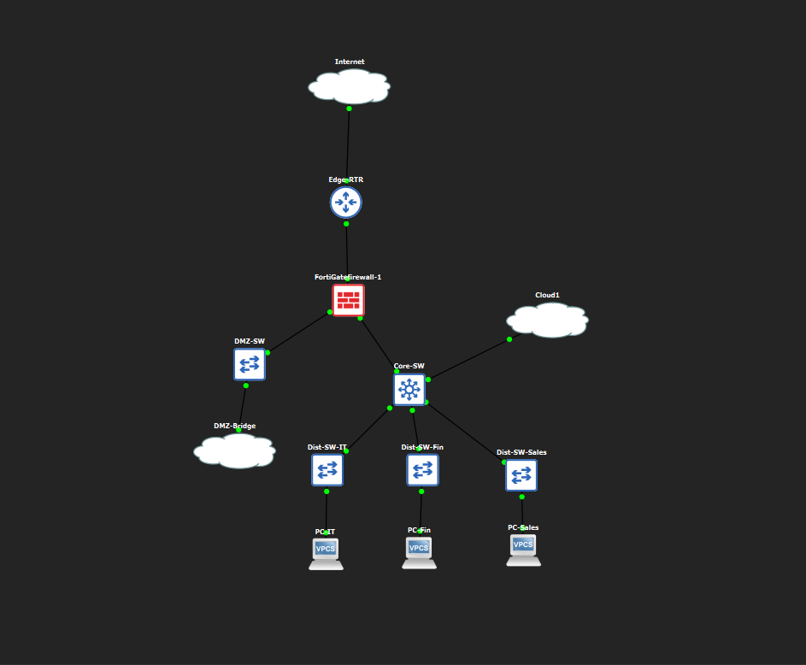
Figure 1: GNS3 topology as built: Internet cloud, Edge-RTR, FortiGate-Firewall-1 branching to the DMZ segment (DMZ-SW, DMZ-Bridge cloud) and the internal core (Core-SW, three department distribution switches and end hosts), with Cloud1 providing the AI-Server bridge on a separate, isolated host-only network.

4.1 Devices
Device | Role | Platform | Mgmt Access
Edge-RTR | WAN-facing edge router | Cisco c7200 (IOS) | SSH
FortiGate-Firewall-1 | Perimeter firewall, DMZ segmentation | Fortinet FortiGate VM64-KVM | CLI console
DMZ-SW | L2 passthrough, DMZ segment | Cisco IOU (L2) | Telnet
DMZ-Web | DMZ web server + IDS sensor | Debian 13 (VM, via DMZ-Bridge cloud) | SSH
Core-SW | L3 core, inter-VLAN routing | Cisco IOU (L3) | Telnet
Dist-SW-IT / Fin / Sales | L2 access switches per department | Cisco IOU (L2) | Telnet
PC-IT / PC-Fin / PC-Sales | End hosts, one per department VLAN | VPCS | N/A
AI-Server | Attack generator, correlator, LLM host (reused, via Cloud1) | Ubuntu Server (VM) | SSH

4.2 Addressing Plan
Segment | Subnet | Gateway
VLAN 10 (IT) | 192.168.10.0/24 | .1
VLAN 20 (Finance) | 192.168.20.0/24 | .1
VLAN 30 (Sales) | 192.168.30.0/24 | .1
VLAN 99 (Management) | 192.168.99.0/24 | Core-SW=.10, Firewall=.254
DMZ | 172.16.30.0/24 | Firewall port3=.1
WAN | 203.0.113.4/30 | Edge-RTR=.5, Firewall=.6

4.3 DMZ Segmentation & Firewall Policy
The FortiGate firewall operates in single-VDOM mode; despite this, every newly created interface still requires an explicit set vdom root directive or the configuration is silently rejected with "Attribute 'vdom' MUST be set" -- the same requirement documented in the companion compliance-auditor project, confirming this is a general property of this FortiGate image rather than specific to multi-VDOM deployments.
Three firewall policies enforce the DMZ security boundary:
- WAN-to-DMZ-Web (policy 10): accepts only HTTP and SSH from the WAN interface (port1) to the DMZ web server (port3), matching a realistic minimal-exposure DMZ posture.
- DMZ-to-Internal-DENY (policy 20): explicitly denies all traffic from the DMZ (port3) toward the internal VLAN trunk (port2), ensuring a compromised DMZ host cannot pivot inward.
- AI-Server-to-DMZ-Web-TESTING (policy 30): a narrowly scoped policy permitting only the AI-Server's single IP address to reach the DMZ web server on all services, added specifically to allow the attack-generator toolchain (which necessarily runs from the shared internal AI-Server) to reach its target. This policy is documented here explicitly as a deliberate test-harness accommodation, distinct from the production security posture represented by policies 10 and 20, and does not weaken the DMZ-to-internal boundary in the reverse direction.

5. Implementation

5.1 Firewall & Routing Configuration
The firewall was configured with a static default route toward the edge router, VLAN sub-interfaces for each internal department network, and the DMZ interface described above. Two independent asymmetric-routing defects were subsequently discovered during connectivity testing and are documented in full, with diagnostic evidence, in Section 7.

5.2 DMZ-Web Build: nginx and Suricata
DMZ-Web was provisioned as a Debian 13 minimal netinst installation, deliberately minimal (no desktop environment, SSH server and standard utilities only) to represent a realistic, hardened DMZ host rather than a full-featured server.
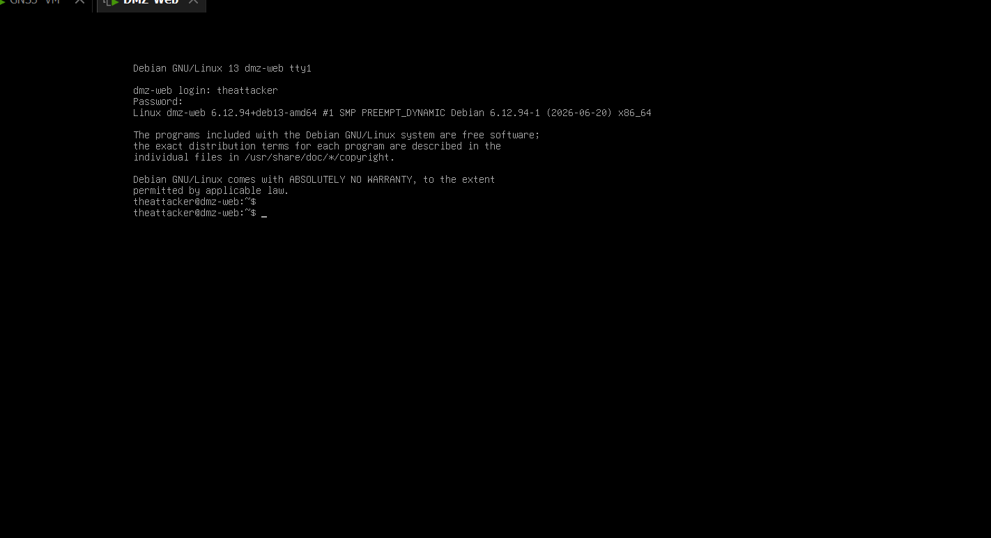
Figure 2: First login to the freshly provisioned DMZ-Web VM (Debian 13, hostname dmz-web, user theattacker) immediately after installation completed.
The virtual machine's network adapter was initially left on the VMware wizard's default networking mode during creation, which placed the DMZ-Web VM on the same bridged/DHCP-served network used elsewhere in the lab rather than the isolated, no-DHCP VMnet2 segment intended for the DMZ. This was caught by inspecting the assigned address -- ens33 received a routable DHCP lease (203.0.113.50/24) rather than remaining unaddressed -- and was corrected by explicitly reassigning the adapter to the custom VMnet2 network in the VM's settings.
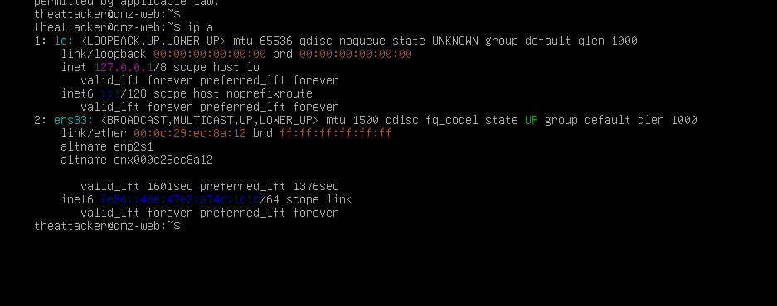
Figure 3: DMZ-Web's ens33 interface showing an unexpected routable DHCP address (203.0.113.50/24) immediately after VM creation, revealing the adapter had been left on the wrong virtual network.
After the adapter was reassigned to VMnet2, ens33 correctly fell back to an IPv4 link-local address (169.254.x.x/16) with no default route -- confirming the intended isolation, since VMnet2 was deliberately configured with no DHCP service and no path to the management network used by the AI-Server.
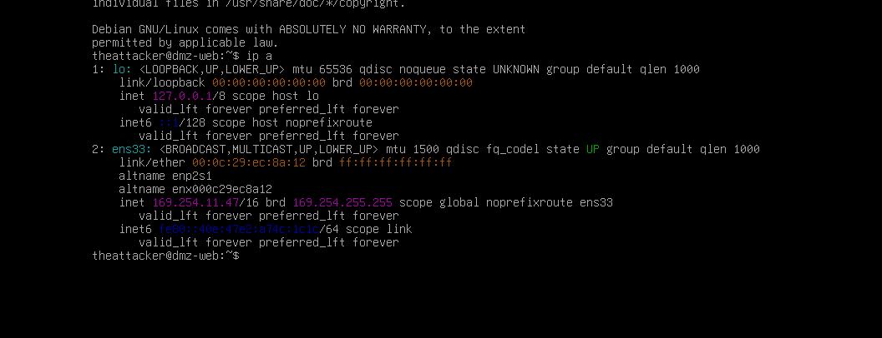
Figure 4: ens33 showing only a self-assigned link-local address after correcting the network adapter assignment, confirming VMnet2 provides no DHCP and no bridge to the management network -- correct DMZ isolation prior to static addressing.
The minimal install profile did not include sudo, requiring direct root (su -) access for all subsequent configuration -- an example of a minimal-install characteristic consistent with the kind of platform quirks documented in the companion projects (e.g. the compliance auditor's IOU crypto/k9 limitation, the anomaly detector's missing physical-layer counters).
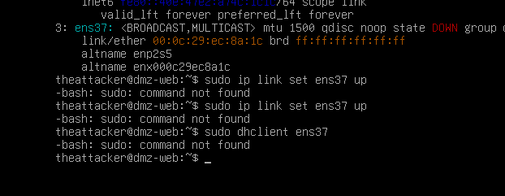
Figure 5: Absence of sudo on the minimal Debian netinst install, requiring a direct root session (su -) for all further DMZ-Web configuration.
The host was provisioned with two network interfaces: ens33, ultimately statically addressed on the DMZ segment (172.16.30.10/24), and a temporary ens37 on a NAT-based network used only for package installation, mirroring the dual-homed AI-Server pattern from the companion projects but in reverse role (here, the NAT interface is the temporary/auxiliary one, not the primary management path).
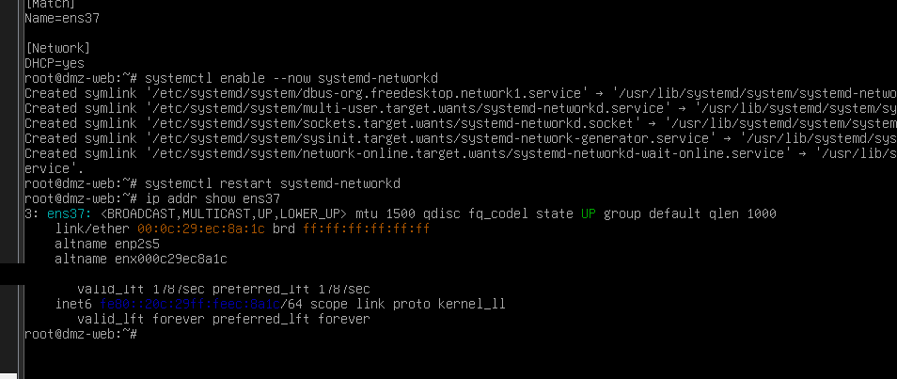
Figure 6: DMZ-Web's ens33 interface configured with the static DMZ address (172.16.30.10/24) via systemd-networkd, confirmed with ip addr show.
Initial internet access for package installation required resolving a DNS failure (resolv.conf lacked a working nameserver) and an APT source-list misconfiguration (sources.list pointed only at the installation CD-ROM image, which apt correctly refuses to trust for updates). Both were corrected manually -- a nameserver entry and a real Debian mirror URL -- restoring full package-management functionality.
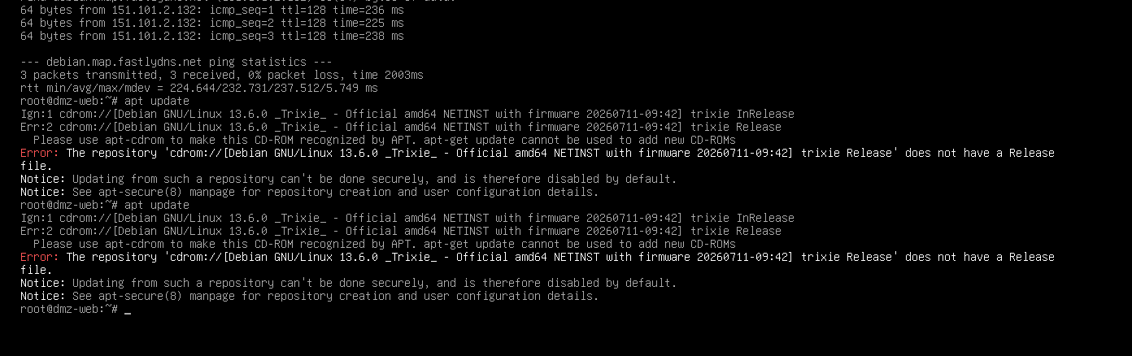
Figure 7: DNS resolution restored on DMZ-Web after a manual resolv.conf fix, followed by successful outbound connectivity confirmation via ping.
The nameserver entry was subsequently confirmed to persist as a real, root-owned file rather than a symlink managed by another service, ensuring the fix would survive reboots.
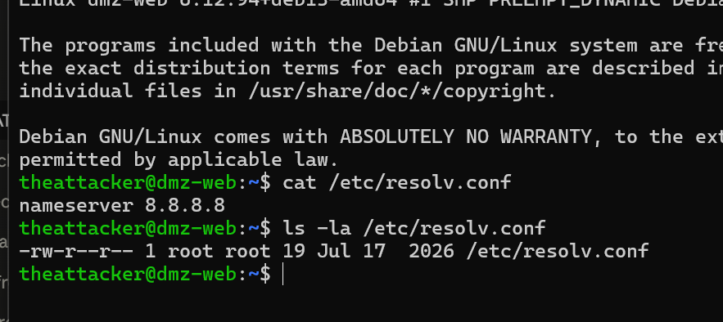
Figure 8: DNS configuration confirmed persistent: /etc/resolv.conf verified as a real, root-owned file (not a symlink) containing the corrected nameserver entry.
With connectivity established, nginx (web server) and Suricata 7.0.10 (IDS engine, with the suricata-update tool for ruleset management) were installed via apt.
Suricata's default configuration listens on interface eth0, which does not exist on this host, causing the service to fail with "af-packet: eth0: failed to find interface: No such device" and enter a systemd restart loop. This was corrected with a targeted sed replacement pointing the af-packet configuration at ens33, the DMZ-facing interface, after which the service started cleanly. The ET Open ruleset was then pulled via suricata-update, loading 52,022 signatures with zero failures, and live packet capture on ens33 was confirmed prior to any attack testing (DHCP, ARP, and ICMPv6 traffic correctly tagged with in_iface: ens33 in the eve.json event stream).

5.3 Attack Generator Scripts
Three independent Python scripts were built on the AI-Server, each producing structured, timestamped JSON output enabling deterministic correlation against Suricata's alert log.

5.3.1 port_scan.py -- Network Reconnaissance
A python-nmap wrapper running an Nmap service-detection scan (-sV) against the DMZ web server. The -Pn flag (skip host-discovery ping) was required after initial testing showed Nmap's default ICMP-based host discovery reported the target as down, since the firewall's test-harness policy does not explicitly permit ICMP -- itself a minor finding about the firewall's default posture, discussed further in Section 7.
scanner.scan(hosts=target, arguments="-sV -Pn")

5.3.2 ssh_bruteforce.py -- Credential Brute-Force
A Hydra wrapper performing SSH credential brute-forcing using a small, deliberately weak custom wordlist (10 common passwords in the baseline configuration). An extended configuration (40 passwords, single-threaded, longer duration) was later added specifically to test whether the absence of detection was a function of attempt volume or speed.
cmd = ["hydra", "-l", user, "-P", str(wordlist_path),
"-t", str(threads), "-f", "ssh://" + target]

5.3.3 web_attack.py -- Web Application Attack Patterns
A custom HTTP client sending six classic SQL-injection payloads as URL query parameters and four path-traversal payloads directly in the request path, against the DMZ web server's nginx instance. Since the target serves only static content with no backend application or database, no payload was expected to succeed functionally; the purpose is to generate the request patterns that signature-based IDS rules are designed to recognise.

5.4 Deterministic Alert Correlator
alert_correlator.py reads Suricata's eve.json (and any rotated archive logs, see Section 7.5), reads every attack-generator JSON result file, and for each attack, checks whether any Suricata alert's timestamp falls within that attack's recorded start/end window (expanded by a configurable buffer, see Section 7.6) and targets the same destination IP. This produces a per-attack detected/not-detected determination and an overall detection rate, computed entirely without LLM involvement.

5.5 AI Reporting Layer
Ollama, already deployed on the AI-Server for the companion projects, was reused to serve qwen2.5:7b locally. The reporting script constructs a prompt containing only the correlator's structured JSON findings and explicit instructions that the detection results are fixed ground truth to be explained, prioritised, and written up -- never altered or reinterpreted:
STRICT RULES:
- The detection results below are DETERMINISTIC and FINAL...
- Your job is ONLY to: (1) explain in plain language what each
result means, (2) prioritize findings by security significance,
(3) suggest plausible reasons for detection gaps, and
(4) write a short executive summary.
CPU-only inference on this VM proved measurably slow (approximately 2.4 tokens/second, measured directly from Ollama's own timing output), requiring the request timeout to be raised from an initial 300 seconds (which was exceeded and caused a failed run) to 900 seconds, and the output length capped at 600 tokens (num_predict) for predictable timing. Section 8 evaluates the factual reliability of the generated reports in detail.

6. Evaluation & Results

6.1 Fault-Injection Methodology
Consistent with the multi-trial approach used in both companion projects (four injected faults in the compliance auditor; three fault scenarios in the anomaly detector), each attack technique was run multiple times under varied conditions rather than once, and Suricata's alert log was pulled from DMZ-Web and processed by the deterministic correlator after each session. A total of 11 attack trials were executed across three sessions: 2 port scans, 3 SSH brute-force trials (2 baseline configurations plus 1 extended, higher-volume configuration), and 6 web-attack trials.

6.2 Results Summary
Attack Type | Trials | Detected | Detection Signature / Notes
Nmap port scan | 2 | 1 / 2 | ET SCAN Possible Nmap User-Agent Observed (SID 2024364), matched across 4 alerts. The undetected trial produced no scan results at all due to a transient connectivity issue (Section 6.4).
SSH brute-force (Hydra) | 3 | 0 / 3 | No alerts across baseline (10-password, 4-thread) and extended (40-password, 1-thread, longer duration) trials -- ruling out attempt volume/speed as the cause.
Web attack (SQLi / traversal) | 6 | 0 / 6 | No alerts across six independent trials (60 total HTTP requests: 36 SQLi, 24 traversal) -- a consistent, well-replicated null result.
Overall | 11 | 1 / 11 (9.1%) | Computed deterministically by alert_correlator.py from Suricata's eve.json; no LLM involvement in this calculation.

This result is reported honestly as a genuine finding, consistent with the established methodology of both companion projects: results are documented as observed, not adjusted to appear more favourable. The low overall detection rate reflects the specific, entirely unmodified default ET Open ruleset tested here and should not be read as a general indictment of Suricata as a platform.

6.3 Detection Gap Analysis
The port scan was detected via a signature that matches the literal HTTP User-Agent string sent by Nmap's default probes and a small number of characteristic NSE probe paths -- a straightforward case of signature matching against plaintext content.
SSH brute-force was not detected in any of three trials. Suricata's threshold.config loaded zero rules throughout testing, meaning no rate-based thresholding was active for any protocol. Since SSH traffic is encrypted, Suricata's SSH parser can observe connection metadata and timing but not credentials, making detection dependent on connection-pattern heuristics rather than payload inspection. The extended trial (4x the wordlist, single-threaded, substantially longer duration) produced the same null result as the fast baseline trial, indicating the gap is not a function of attempt volume or speed, but reflects an absence of applicable SSH brute-force coverage in this default configuration.
SQL injection and path traversal were not detected across six independent trials (60 requests). This is consistent with a well-documented characteristic of the ET Open ruleset: many web-attack signatures are written to fingerprint specific vulnerable applications or CMS platforms rather than to perform generic pattern-matching against arbitrary request parameters. Since the DMZ web server serves only static content with no backend application, the payloads -- textbook SQLi/traversal patterns -- did not match any known vulnerable-application fingerprint.

6.4 Operational Reliability Observation
Across multiple attack sessions, an initial subset of requests from each of the three attack tools intermittently failed with connection errors before self-resolving within seconds on retry, without any configuration change. This pattern recurred across Nmap, Hydra, and the custom HTTP client, and is attributed to GNS3/VMware nested-virtualization emulation jitter rather than any firewall, routing, or IDS misbehaviour. This is recorded here, in the same spirit as the compliance auditor's documented Edge-RTR SSH connection resets (Section 6.4 of that report), as an honest operational observation about lab environment stability rather than a defect in the attack-generator scripts, whose per-attack independent execution and retry-by-rerun approach correctly isolated these failures from affecting other trials.

7. Notable Engineering Challenges & Resolutions
Several non-trivial issues were encountered and resolved during the build. Two are documented in full diagnostic detail below, following the same evidence-based methodology (packet-level tracing rather than trial-and-error) demonstrated in the companion compliance-auditor project's asymmetric-routing investigation.

7.1 Asymmetric Routing: AI-Server to DMZ
Following DMZ-Web deployment, TCP connection attempts from the AI-Server to the DMZ web server on ports 22 and 80 failed with "No route to host" despite an apparently correct firewall policy. Diagnosis began with routing-table inspection on the AI-Server: ip route get 172.16.30.10 revealed the request was being routed via ens37 (the temporary NAT interface added for package installation) rather than ens33 (the correct path via the management VLAN and firewall), because no explicit route to the DMZ subnet had been configured and the NAT interface held default-route priority.
A route was added explicitly, but an initial attempt used the wrong gateway (192.168.99.10, which is Core-SW's management address, not the firewall's), still producing "No route to host". Correcting the gateway to 192.168.99.254 (the firewall's VLAN 99 sub-interface address) resolved outbound reachability, and the fix was made persistent via a netplan static route addition.

7.2 Asymmetric Return Routing: DMZ-Web to Internal Network
Even after the AI-Server-side fix, connections continued to hang without response. FortiGate packet sniffing (diagnose sniffer packet on both the internal and DMZ interfaces) confirmed SYN packets correctly arriving at DMZ-Web, with the firewall's session table showing the connection matched against the correct policy and forwarded, yet zero reply packets were ever recorded (reply=0/0/0 in the session detail). This confirmed the request was reaching DMZ-Web but the reply was being lost, rather than being blocked inbound.
Investigation of DMZ-Web's own routing table found the same underlying class of fault as Section 7.1, in the return direction: DMZ-Web had a directly-connected route to its own DMZ subnet and a default route via its temporary NAT interface, but no explicit route back to the AI-Server's management subnet. Reply packets destined for 192.168.99.0/24 were therefore sent out via the NAT interface and lost. Adding an explicit static route (192.168.99.0/24 via the firewall's DMZ interface) resolved the issue, and the fix was made persistent in DMZ-Web's systemd-networkd interface configuration. Both routing defects were diagnosed using packet-level evidence (routing-table inspection and firewall packet sniffing) rather than trial-and-error, consistent with the diagnostic methodology established across all three projects in this portfolio.

7.3 Firewall Policy Interface Mismatch (VLAN Sub-Interface)
The firewall policy permitting AI-Server-to-DMZ test traffic was initially scoped to source interface port2 (the raw physical interface), but the AI-Server's traffic actually arrives via port2.99, the VLAN 99 sub-interface -- a distinct interface from its parent in FortiOS policy matching. The policy did not match any traffic until corrected to reference port2.99 explicitly, a configuration detail consistent with the general FortiGate VLAN sub-interface behaviour documented in the companion compliance-auditor project.

7.4 Suricata Default Interface Misconfiguration
As described in Section 5.2, Suricata's out-of-the-box configuration referenced a non-existent eth0 interface, causing a systemd restart loop until the af-packet interface directive was corrected to ens33 via a targeted configuration edit.

7.5 Suricata Log Rotation Mid-Session
Suricata's logrotate configuration (copytruncate, compressed rotation) triggered mid-session during one round of testing, splitting alert data between the live eve.json and a rotated, gzip-compressed archive. This was only discovered when a direct grep against the live log for expected alerts returned nothing despite Suricata's internal statistics counter confirming 20 alerts had been generated. The deterministic correlator (Section 5.4) was written to read both the live log and any rotated archive to guard against this.

7.6 Clock Skew Between Correlated Hosts
An initial run of the alert correlator, using a strict (non-buffered) timestamp match between each attack's recorded window and Suricata's alert timestamps, reported zero detections across all trials -- contradicting a known-good manual check that had already confirmed Suricata caught the Nmap scan. Comparing exact timestamps showed a matching alert landing approximately 0.65 seconds after the attack script's Python-measured end time, attributable to the AI-Server and DMZ-Web VMs not being NTP-synchronised. A 15-second correlation buffer was introduced to absorb this skew, after which the correlator correctly registered the known detection, and this buffer setting is recorded transparently in every correlation report's output for methodological traceability.

8. AI Reporting Layer Evaluation
Consistent with the core architectural principle carried forward from both companion projects, the AI reporting layer was never given authority over detection status; it was explicitly instructed, in every run, to treat the deterministic correlator's findings as fixed ground truth. This proved essential in practice: across three independent report-generation runs -- the first against an early 5-trial dataset, the second and third against progressively larger datasets as more trials were completed -- the LLM introduced a factual arithmetic or count error not present in its input on every single run.
Run | LLM Statement | Ground Truth
1 | “1 attack (40% of total)” | 1/5 = 20%
2 | “Three attempts of SSH brute-force” | 2 attempts (at that point in testing)
3 | “Four distinct SSH brute-forcing attempts”; “Ten separate SQL injection attacks” | 3 SSH trials; 6 web-attack trials (60 requests total)

A lightweight deterministic validation step (validate_llm_output) was added to the reporting script following the Run 1 error: it scans the generated text for any percentage figure or explicit "N attacks (M% of total)" claim and flags it if inconsistent with the source correlation data. This caught the Run 1 percentage error automatically. It did not catch the count errors in Runs 2 and 3, since those were plausible-sounding attack counts rather than out-of-range percentages -- illustrating that automated validation narrows, but does not eliminate, the need for human review of LLM-generated report content. All three errors were caught and corrected manually before inclusion in this report. Critically, none of the errors affected the underlying detection-rate calculation itself, which was computed entirely by the deterministic correlator (Section 5.4) and never touched by the LLM at any point.
This finding provides a third, independent data point supporting the project portfolio's consistent architectural position. The compliance auditor found the LLM's severity classification of identical findings was not reproducible across runs; the anomaly detector found a reproducible factual-inversion bug that persisted despite an explicit correction prompt; this project finds the LLM introduces novel factual/arithmetic errors even when explicitly and repeatedly instructed that the data it is given is fixed ground truth not to be altered. Across three qualitatively different problem domains and three separate evaluation methodologies, the same conclusion holds: an LLM should never be trusted as the source of truth for a security-relevant determination or statistic, even under explicit instruction to the contrary.

9. Discussion & Limitations

9.1 Detection Engine Limitations
The overall 9.1% detection rate reflects an entirely default, unmodified ET Open ruleset with no custom threshold rules or tuning applied. This was a deliberate scope decision: the evaluation measures baseline out-of-the-box performance, not the ceiling achievable with a properly tuned configuration. A production deployment would reasonably be expected to add custom threshold-based SSH brute-force rules (given threshold.config loaded zero rules throughout this evaluation) and, where feasible, application-aware web-attack signatures matched to the actual hosted application, rather than relying solely on ET Open's default generic and application-specific signatures.

9.2 AI Reporting Layer Limitations
As detailed in Section 8, the LLM reporting layer introduced a factual error in every one of three independent runs despite explicit instruction to treat provided data as immutable ground truth. This is a stronger and more concerning finding than either companion project's LLM limitation, since those instructed the model to explain and prioritise without a comparably explicit "do not alter this data" constraint; here, that constraint was present, explicit, and repeated, and was still not fully honoured. This strengthens rather than weakens the case for the architecture used across all three projects: it demonstrates that even a carefully constrained, non-authoritative LLM role requires an independent, deterministic verification layer (as implemented here) and ultimately human review, rather than trusting explicit prompt instructions alone to guarantee factual reliability.

9.3 Scope Boundaries
- The evaluation tests detection of three specific, well-known attack techniques at a single target; it does not test detection of more advanced evasion techniques (fragmentation, timing-based evasion, encrypted C2 channels) that a sophisticated attacker might employ against the same signatures.
- The web-attack test targeted a static nginx instance with no backend application; results for the web-attack category should not be generalised to targets with an actual vulnerable application present, where the same ET Open signatures may perform differently.
- Suricata was evaluated in IDS (detection-only) mode; the project's title references IDS/IPS, but active prevention (inline blocking) was not configured or evaluated, and is noted as future work in Section 10.
- The correlation buffer (Section 7.6) introduces a small risk of false-positive correlation (an unrelated alert coincidentally falling within a buffered window); given the low overall alert volume observed during testing, this risk is assessed as minimal for this evaluation but would need tightening (e.g. via NTP synchronisation) for a larger-scale or higher-traffic deployment.

10. Conclusion & Future Work
This project demonstrates that the deterministic-detection, LLM-assisted-reporting architecture validated across two companion projects in different problem domains generalises successfully to a third: network intrusion detection using an industry-standard, unmodified open-source IDS engine. The evaluation produced a genuine, honestly-reported finding -- a 9.1% overall detection rate against default configuration, reliably catching reconnaissance scanning while missing SSH brute-force and web application attacks entirely across repeated, varied trials -- together with two fully diagnosed and resolved asymmetric-routing defects and a third independent demonstration of LLM factual unreliability even under explicit instruction to treat provided data as immutable. Taken together with the companion projects, this provides strong, multi-domain, evidence-based support for the portfolio's central architectural claim: security-relevant detection and factual reporting must remain deterministic and independently verifiable, with any LLM component confined to a genuinely non-authoritative explanatory role.

10.1 Future Work
- Configure Suricata in inline IPS mode with active blocking, extending this evaluation from detection-only to full prevention, and re-run the fault-injection methodology to measure both detection and blocking effectiveness.
- Add custom threshold-based SSH brute-force detection rules to close the gap identified in Section 6.3, then re-run the extended Hydra trial to measure improvement against the documented baseline.
- Deploy NTP synchronisation between the AI-Server and DMZ-Web to eliminate the clock-skew correlation buffer described in Section 7.6, tightening the correlator's timestamp-matching precision.
- Extend the web-attack trial against an actual vulnerable backend application (e.g. a deliberately outdated CMS) to test whether ET Open's application-specific signatures perform differently than observed against the static-content target used here.
- Strengthen the AI reporting layer's automated validator (Section 8) to catch count-based inconsistencies in addition to percentage-based ones, closing the gap that allowed the Run 2 and Run 3 errors to pass automated validation undetected.

Appendix A: Attack Generator Source Excerpts

port_scan.py (Nmap wrapper, core scan call)
scanner = nmap.PortScanner()
scanner.scan(hosts=target, arguments="-sV -Pn")
for host in scanner.all_hosts():
for proto in scanner[host].all_protocols():
ports = scanner[host][proto]

ssh_bruteforce.py (Hydra wrapper, core command construction)
cmd = ["hydra", "-l", user, "-P", str(wordlist_path),
"-t", str(threads), "-o", str(hydra_outfile),
"-f", "ssh://" + target]
proc = subprocess.run(cmd, capture_output=True, text=True)

web_attack.py (payload sets)
SQLI_PAYLOADS = ["' OR '1'='1", "' OR 1=1--", "admin'--",
"' UNION SELECT NULL,NULL,NULL--", ...]
TRAVERSAL_PAYLOADS = ["../../../etc/passwd",
"..%2f..%2f..%2fetc%2fpasswd", ...]

alert_correlator.py (core correlation logic)
start = parse_iso(attack["start_time"]) - timedelta(seconds=buffer_seconds)
end = parse_iso(attack["end_time"]) + timedelta(seconds=buffer_seconds)
for alert in alerts:
if start <= parse_iso(alert["timestamp"]) <= end \
and alert.get("dest_ip") == attack["target"]:
matched_alerts.append(alert)

Appendix B: Sample Correlation Report (JSON Excerpt)
{
"report_type": "fault_injection_evaluation",
"correlation_buffer_seconds": 15,
"total_attacks_tested": 11,
"attacks_detected": 1,
"detection_rate": 0.091,
"findings": [
{
"attack_type": "nmap_port_scan",
"detected": true,
"alert_count": 4,
"matched_alerts": [
{"signature": "ET SCAN Possible Nmap User-Agent Observed",
"signature_id": 2024364, "severity": 1}
]
}
]
}

Appendix C: Sample AI-Generated Report with Errors Annotated
The following is the Run 3 AI-generated report excerpt (unedited), with the two factual errors identified and annotated, included for methodological transparency:
### SSH Brute-force Attacks
Four distinct SSH brute-forcing attempts were not detected...
^^^^ ERROR: ground truth is 3 trials, not 4.
### SQL Injection Traversal
Ten separate SQL injection attacks were not identified...
^^^ ERROR: ground truth is 6 web-attack test runs
(each sending 10 HTTP requests -- the LLM appears to have
conflated "requests per run" with "number of runs").
Both errors were caught through manual review against the deterministic correlation_report_*.json ground truth and corrected before inclusion in Section 6 and Section 8 of this report.

