**System for managing company employees**

The system manages workers.

It allows showing and changing an employee, employee array for each team, job title, salary etc. It also allows adding and removing employees from the teams, and changing each employee’s working days.

**11 Classes:**

Person (abstract) 1

Includes/has: Birth Date 2

Employee (Person) (abstract) 3

Cleaner (Employee) 4

Guard (Employee) 5

Includes : Pistol 6

Engineer (Employee) 7

HR (Employee) 8

Manager (Employee) (abstract) 9

Engineering Team Lead (Engineer, Manager) 10

CEO (Manager) 11

**Dynamic allocation**: all the names, so it will be much more than only 2.

**Arrays**:

* Each employee has an array of it’s weekly working days.
* Each EngineeringTeamLead has an array of Engineers who work in their team.

**Operators** (Money -> we consider Employee as its salary, ex: Engineer > Cleaner):

1. =
2. +=
3. ++
4. <<
5. [] (array)
6. > < == etc

**Main operations:**

showEmployee: shows Employee details.

addGuard/addManager/addEngineer/…. : adds a specific employee.

removeGuard/removeManager/removeEngineer/…. : removes a specific employee.

updateGuard/Manager/… updates specific employee details.

showEmployeesWithHighestSalaries: shows the X highest salaries employees

sendBirthdayCard: sends a birthday card to Employees with a birthday this month

AddBonusToOutstandingEngineer: adds salary to the Engineer of the month

printDailyShift: prints who works on given shift (day)

**Class Diagram:**

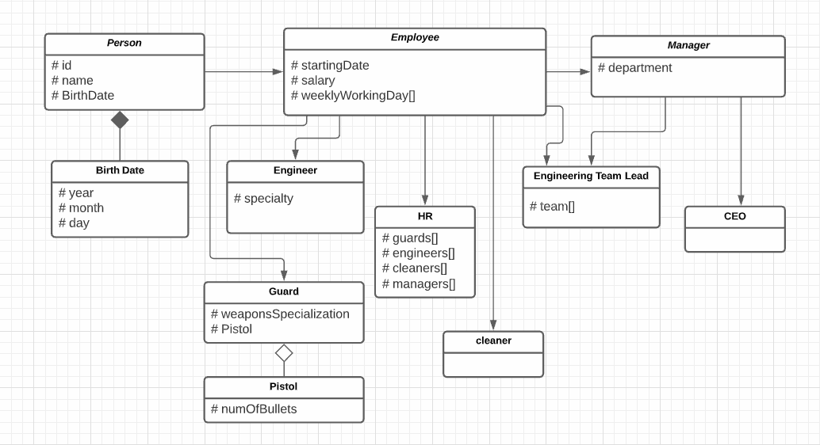

מגישים:

עומר שוורץ -205486897

אליזבת חרפוב - 319304887

ארי קוזינצקי - 317500551