Traffic Sign Detection with Image Processing Techniques

Ömer Sokmaz 1, Tolga Demirci 1

1 Dept. of Computer Engineering, Eskisehir Technical University, Eskisehir, Turkiye

omersokmaz@eskisehir.edu.tr, t_demirci@eskisehir.edu.tr

*Abstract*—Detecting traffic signs and markers has become very important nowadays when autonomous vehicles are increasing. Since traffic accidents on highways account for 2 percent of all deaths in the world. This is why we have developed a traffic sign recognition system for both autonomous and non-autonomous vehicles. We used 20 pictures taken in jpg format.

Keywords:İmage Processing,Object Detection,Traffic Sign Detection,

# Introduction

Today, with the development of artificial intelligence, the demand for autonomous vehicles is increasing. With the increase of autonomous vehicles, how reliable these vehicles are in traffic has become debatable. When we look at the studies on detection and recognition, even though artificial intelligence studies are dominant, it is not considered to use the images without any processing. we tried to detect it on 20 images without using any artificial intelligence model.

# Materıal and methodology

## Material

In this study, 20 pictures taken in Eskişehir and surrounding provinces, most of which contain more than one traffic sign, were used.

## Methodology

Identify applicable sponsor/s here. *(sponsors)*

All images were first loaded into the 'Clour Thresholder' tool on MATLAB, and the region to be detected was tried to be clarified by playing the color pixel values in more than one space (RGB, HSV etc.).

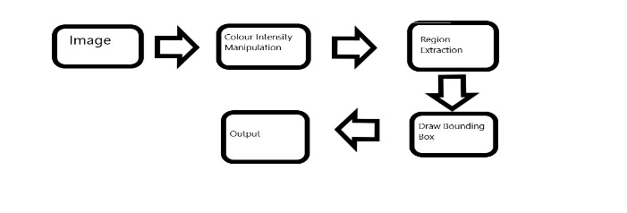

Figure 1 Structure of Program Flow

Then, with the 'Region Analyzer' tool on MATLAB, the regions to be detected on the images were selected region by region, and other unwanted regions were removed.

metin, yol içeren bir resim

Açıklama otomatik olarak oluşturuldu

Figure 2 Image After the Colour Thresholder

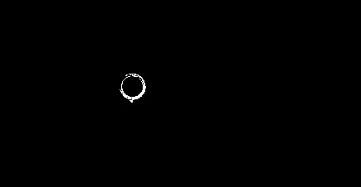

Figure 3 Image after the Region Analyzer

After these operations, bounding box was drawn on the signs determined by 'regionprops', which is one of the functions on MATLAB.

metin, yol, sahne, gök içeren bir resim

Açıklama otomatik olarak oluşturuldu

Figure 4 Detected Traffic Signs

# Conclusions

At the end of the study, FP, FN, TP and TN values were determined and precision and f1 score values were calculated as 0.8.

##### References