Statistical Analysis II Homework
Omer Taha Kerem
2026-04-05
library(readxl)
veri <- read_excel("paired_veri.xlsx", sheet = 3)
x <- veri$`Veri 69`
# [TR] Shapiro-Wilk normallik testi uygulanmıştır.
# [EN] Shapiro-Wilk normality test was applied.
shapiro.test(x)
##
## Shapiro-Wilk normality test
##
## data: x
## W = 0.95418, p-value = 0.1057
# [TR] p-değeri > 0.05 olduğu için veri normal dağılım göstermektedir.
# [TR] Bu nedenle parametrik test (paired t-test) kullanılacaktır.
# [EN] Since p-value > 0.05, the data is normally distributed.
# [EN] Therefore, a parametric test (paired t-test) will be used.
once <- x[1:20]
sonra <- x[21:40]
# [TR] Bağımlı örneklem t-testi uygulanmıştır.
# [EN] Paired sample t-test was applied.
t.test(once, sonra, paired = TRUE)
##
## Paired t-test
##
## data: once and sonra
## t = -1.0241, df = 19, p-value = 0.3187
## alternative hypothesis: true mean difference is not equal to 0
## 95 percent confidence interval:
## -6.184909 2.120929
## sample estimates:
## mean difference
## -2.03199
# [TR] p-değeri > 0.05 olduğu için anlamlı fark yoktur.
# [EN] There is no statistically significant difference.

R Markdown
This is an R Markdown document. Markdown is a simple formatting syntax for authoring HTML, PDF, and MS Word documents. For more details on using R Markdown see http://rmarkdown.rstudio.com.
When you click the Knit button a document will be generated that includes both content as well as the output of any embedded R code chunks within the document. You can embed an R code chunk like this:
summary(cars)
## speed dist
## Min. : 4.0 Min. : 2.00
## 1st Qu.:12.0 1st Qu.: 26.00
## Median :15.0 Median : 36.00
## Mean :15.4 Mean : 42.98
## 3rd Qu.:19.0 3rd Qu.: 56.00
## Max. :25.0 Max. :120.00

Including Plots
You can also embed plots, for example:
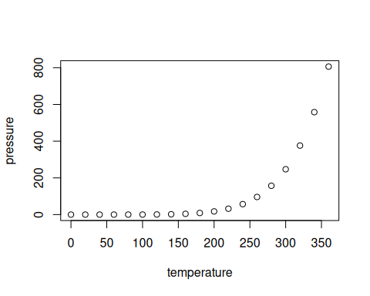
Note that the echo = FALSE parameter was added to the code chunk to prevent printing of the R code that generated the plot.

