Boston University – MET
Omer TAS
MRI –SEGMENTATION

Link kaltura video
https://2159741-5.kaf.kaltura.com/media/1_qplu8oif

“This dataset contains brain MR images together with manual FLAIR abnormality segmentation masks.The images were obtained from The Cancer Imaging Archive (TCIA).
They correspond to 110 patients included in The Cancer Genome Atlas (TCGA) lower-grade glioma collection with at least fluid-attenuated inversion recovery (FLAIR) sequence and genomic cluster data available”.Maciej A. Mazurowski, Kal Clark, Nicholas M. Czarnek, Parisa Shamsesfandabadi, Katherine B. Peters, Ashirbani Saha "Radiogenomics of lower-grade glioma: algorithmically-assessed tumor shape is associated with tumor genomic subtypes and patient outcomes in a multi-institutional study with The Cancer Genome Atlas data." Journal of Neuro-Oncology, 2017.
The data includes different measurements, age and whether patient survived.
Some Images

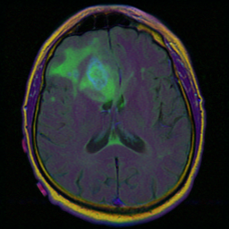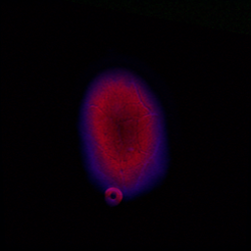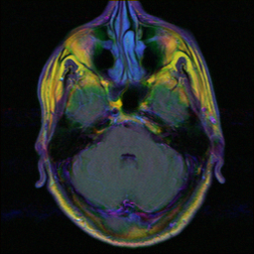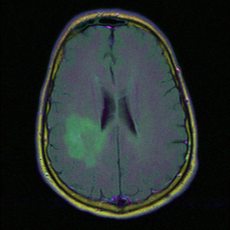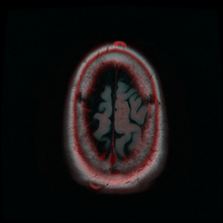

link
https://www.kaggle.com/mateuszbuda/lgg-mri-segmentation

What are submitted
project.doc , presentation.pptx and 6 python files : project.py, tree.py, logistic.py, KNN.py, bayes.py and svm.py
project.py has the best classifier (Tree) and main explanations. If you are interested you can read other 5 python files as well.
Data Preprocessing
Name of the csv file = data.csv
All attributes and class = death01 0 survived
['RNASeqCluster', 'MethylationCluster','miRNACluster', 'CNCluster','RPPACluster','OncosignCluster','COCCluster', 'histological_type', 'neoplasm_histologic_grade', 'laterality', 'tumor_location', 'gender','age_at_initial_pathologic' 'race', 'ethnicity','death01']
14 attributes
Handling Missing Values
Last row removed from data since class label and more than half of the attributes were missing.
Missing categorical variables were replaced with mode. There are no missing continuous attributes.
I saved the clean data as cleandata.csv
Now, we will continue with cleandata.csv
Following columns were deleted from cleandata.csv
'Unnamed: 0': reason : It is just number of the index. Which is already available.
"Patient": reason: It id of each patient has no meanings. i.e. TCGA_CS_4942
"tumor_tissue_site" : reason: it is consist of only number 1. It has a single value.
Following classifier are used

Model | TP | FP | TN | FN | accuracy | TPR | TNR
Tree | 26 | 0 | 9 | 0 | 100.0% | 100.0% | 100.0%
Logistic | 25 | 7 | 2 | 1 | 77.14% | 96.15% | 22.22%
Best KNN | 25 | 9 | 0 | 0 | 71.43% | 96.15% | 0.0%
Naïve Bayes | 22 | 7 | 2 | 4 | 68.57% | 84.62% | 22.22%
Best SVM | 26 | 9 | 0 | 0 | 74.29% | 100.0% | 0.0%

Choosing best classifier
Although, decision tree has the best accuracy I used extra information to make decision and ensure there is no overfitting.
Randomly chose 5 new same instances for all classifier and ensemble:
For the same input following output received.
Tree | logistic | KNN | Bayes | SVM | Ensemble
1 | 1 | 0 | 1 | 1 | 1
1 | 0 | 0 | 0 | 0 | 0
1 | 1 | 1 | 1 | 1 | 1
0 | 0 | 0 | 1 | 0 | 0
0 | 0 | 0 | 1 | 0 | 0

When we look at decision we can see it is close to overall result. So, we can be somehow sure that decision tree isn’t overfitting.
Visualization
Also, we can visualize some of the attributes to have ideas how they are related.

