vMMR EEG rig: marker timing calibration
Photodiode latency tests, LSL timestamps and the PsychoPy start-up stall — 6–8 October 2026
Repository: vMMR_EEG_PsychoPy_experiment. Computer B = PsychoPy stimulus PC (LSL sender); computer A = Simulink + g.HIamp recording PC (LSL receiver).

Abstract
The vMMR EEG experiment sends event markers from the PsychoPy computer (B) over Lab Streaming Layer (LSL) to the Simulink/g.HIamp recording computer (A). Because a photodiode cannot be used during real sessions, we ran a calibration project to measure and remove the delay between each marker and the real on-screen event. A dedicated script flashed a corner square 100 times with increasing durations and sent one LSL marker per flash, while an optical sensor recorded the true onsets. The first recordings placed the photodiode 844–972 ms after its marker, stable within a run but different between runs, and independent of the Simulink frame length (4, 6, 8). We then added a second LSL inlet to the Simulink model that saves LSL timestamps and A's clock at every model step. These recordings located the cause: a single pause of about 0.8 s in the PsychoPy process when its fullscreen window first flipped, while the marker stream was already live. The Simulink model consumes one LSL sample per step, so it stalled with the stream and, because the sender drops missed samples after pauses, never caught up. Starting PsychoPy a minute later, turning off workspace logging or multithreading did not help. Creating the LSL stream only after the refresh-rate measurement (v1) or after the alignment screen (v2) removed the stall: the delay fell to 32.5–37.8 ms. Placing markers by their LSL timestamps gives a photodiode offset of 52.8 ms (SD 3.7 ms between runs, about 5 ms within runs) across all six timestamp runs, a candidate correction that needs no photodiode.

Next steps
- Repeat the fixed sender (v1) 3–5 times with the timestamp model, to pin down the run-to-run spread of the recorded-marker delay (now 32.5–37.8 ms) and of the timestamp-based offset (~53 ms).
- Re-test Simulink frame length with v1 (e.g. 1, 2, 4, 8). The earlier frame-length runs were all dominated by the stall. With the stall gone, the marker now waits 13–20 ms for the next amplifier frame and the within-run jitter is ~5 ms SD; a shorter frame should reduce both.
- Choose the correction method for the EEG analysis: (a) recorded marker + a fixed constant, or (b) marker placed by its LSL timestamp + ~53 ms. (b) was the most stable so far but requires the timestamp block in every recording.
- Keep the LSL timestamp block in the experiment Simulink model (LSLMarkerTimestamps) and save the *_LSLtiming.mat file with every session, whichever method is chosen; it also documents any stall.
- Fix the experiment script defaults in run_vMMR_experiment_v1_trig_after_framerate_measurement.py: lsl_keepalive_hz / lsl_nominal_srate are still 1200 and must match the 600 Hz Simulink inlet; expected_refresh_hz is already 59.94.
- Optional robustness fix in lsl_trigger.py: send missed samples after a pause (raise _MAX_CATCHUP_S) so any future pause on computer B is recovered instead of shifting the rest of the run. Check lsl_resyncs (should be 0) in every *_run_info.txt.
- Final test with the experiment script once the configuration is settled: run run_vMMR_experiment_v1_trig_after_framerate_measurement.py on the real rig with the chosen Simulink configuration, the photodiode square on face-on frames (photodiode_square / photodiode_test_mode) and the timestamp model; verify per face event that photodiode − marker matches the calibration constant (250 ms faces, 600 ms SOA), that lsl_resyncs is 0, that STD/DEV/TARGET codes are all present, and that the correction applied offline lands on the photodiode onsets. Then disable the photodiode for real sessions.
- Document the final configuration (Simulink model, frame length, sender version, correction constant) in README.md and AGENTS.md.

1. Set-up
Table 1. Rig
Part | Details
Computer B (stimulus) | Windows 11, AMD Radeon Vega 8 (integrated), Dell monitor 1920×1080; PsychoPy in .venv; scripts run_photodiode_latency_*.py, run_vMMR_experiment_*.py; LSL sender lsl_trigger.py (stream experiment_markers, int32, 1 channel)
Computer A (recording) | MATLAB/Simulink R2020a, g.HIsys blocks; g.HIamp at 600 Hz (65 channels); fixed-step discrete solver 1/600 s; To File writes EEG_data (time, EEG, photodiode, marker)
Optical chain | white 45 px square, bottom-right → GTEC-0270 optical sensor → GTEC-0274W g.TRIGbox → GTEC-0274TR adapter → g.HIamp digital input (recorded as a channel next to the EEG)
Marker path | PsychoPy flip callback → LSLTrigger.set() (latched marker, keepalive stream) → network → Simulink LSL Receive block (one sample per model step) → muxed with the EEG

2. Test method
run_photodiode_latency_v0.py (and its v1/v2 versions) shows a black screen and, per flash, a white square in the bottom-right corner while pushing LSL marker 20 on the same flip (win.callOnFlip). Flash *i* lasts 6 + (i−1) frames (100 ms to 1.75 s at 59.94 Hz) and its marker is latched for the same time, so each photodiode pulse can be matched to its marker by its width. Gaps between flashes are jittered 350–650 ms. A dark/light/dark calibration segment (markers 5/6/5) gives the photodiode polarity. Other markers: START 9, flash block 7, END 255 (stops the Simulink model).
Analysis: notebooks/photodiode_latency_test.ipynb (one recording) and notebooks/photodiode_latency_compare.ipynb (all recordings side by side, LSL timestamp analysis, comparison and printed conclusions). Delay = photodiode onset − marker onset of the same flash; jitter = SD of the delay after removing a linear drift.
Pairing note: numbering photodiode pulses by width (the original method) failed on real data because photodiode widths vary by about ±6 ms, a third of the 16.7 ms step (2–23 of 100 flashes paired). Every recording had exactly one pulse per marker with widths following the marker widths (r ≥ 0.9999), so pulses are now paired in order when that check passes; all 100 flashes paired in every run.

3. Chronology of what we checked

3.1 Display refresh rate (computer B)
At the Windows 120 Hz setting, PsychoPy flipped every 16.69 ms (59.93 Hz): the AMD driver presented only every second refresh, and the latency script's refresh check (2 % tolerance) aborted. Windows was set to 60 Hz. That mode is really 60000/1001 Hz:
Table 2. Real refresh rate of the stimulus display
Measure | Value
Windows setting | 60 Hz (available: 50, 59, 60, 100, 119, 120)
getActualFrameRate, 9 runs on 8 Oct | 59.934–59.943 Hz
Median frame interval in the flash blocks | 16.683 ms → 59.939 Hz
Frames > 1.5 × normal | 0–3 per run of 8 482 frames

expected_refresh_hz was set to 59.94 in the latency scripts and in the v1 experiment script. Frame counts are identical to 60 Hz (e.g. 250 ms = 15, 350 ms = 21, 600 ms = 36 frames); logged durations become exact.

3.2 LSL sample rate and the Simulink inlet
- nominal_srate is only stream metadata; what matters is the actual push rate vs. the rate the Simulink block reads. If the sender pushes faster, samples queue and markers drift later; if slower, the model waits.
- The original keepalive (sleep(1/600) loop) really sent ~491 samples/s at the 600 setting and ~971/s at 1200 (Windows timer granularity). The sender was rewritten to count samples against the clock (commit "Fixed the LSL sync issue"); v1/v2 runs sent 600.00 samples/s.
- The 7 Oct Simulink model read LSL at 200 Hz; the timestamp model reads at 600 Hz (one sample per model step). Because the inlet waits for a sample every step, the marker stream paces the whole model.
- The g.HIsys LSL Receive block outputs values only (no timestamps), so the .mat alone cannot show LSL timing. This led to the timestamp model (3.4).

3.3 Simulink frame length (v0 sender, no timestamps)
Table 3. Frame-length runs
Recording | Frame length | Delay mean (ms) | Jitter SD (ms) | Drift (ms/min) | Paired
Frame 8 (7 Oct) | 8 | 875.0 | 1.63 | -0.04 | 100/100
Frame 4 | 4 | 971.6 | 5.65 | -0.97 | 100/100
Frame 6 | 6 | 843.8 | 5.03 | +0.85 | 100/100
Frame 8 (8 Oct) | 8 | 852.2 | 5.51 | -1.18 | 100/100

The photodiode followed its marker by 844–972 ms, stable within each run but not between runs, with no systematic effect of frame length (the two frame-8 runs differ by 23 ms). The size of the delay ruled out the display (a 60 Hz monitor adds tens of ms at most).

3.4 Timestamp model and Simulink settings (v0 sender)
A MATLAB System block, LSLMarkerTimestamps (timestamped_LSL_model/), was added as a second inlet on experiment_markers. Every model step it saves: latest marker, rising-edge code, the edge's LSL timestamp on B's clock, the B→A clock offset (time_correction), A's LSL clock at that step, and the number of samples pulled; a second To File writes *_LSLtiming.mat. Runs with this model are labelled "TS" in the tables and figures. Four runs then tested one change each:
Table 4. Simulink-side changes tested
File-name tag | Change | Where
start_0 | baseline: PsychoPy started right after the model | —
start_1mindelay | PsychoPy started 1 min after the model | —
workspacelogging_off | Time, Output, Signal logging, Data stores unchecked | Model Settings → Data Import/Export
multithread_off | MultiThreadCoSim off for model and g.HIamp block | MATLAB Command Window (set_param)

Solver settings were checked and left as they were (fixed-step discrete 1/600, single-tasking, simulation pacing off). Enabling "treat each discrete rate as a separate task" was advised against (it can insert rate-transition delays).
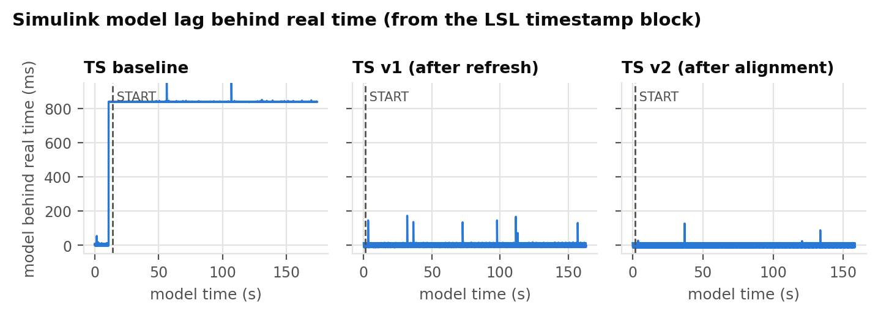
Figure 1. How far the Simulink model ran behind real time (A's clock minus model time). v0 baseline: one ~0.84 s step shortly before START that never recovers; v1 and v2: no persistent step (the short spikes are A-side hiccups that are caught up within about a second).

3.5 What the timestamps showed
- Marker transit B → Simulink was ~0.7 ms: the markers themselves were on time.
- Photodiode − marker (864–891 ms) = backlog (815–838 ms) + 48–58 ms.
- The backlog is one model stall of 797–839 ms, 3.20–3.21 s before START in every run, including the run started 1 min after the model. It is the only stall the model never caught up.
- No LSL samples arrived during the stall (the first step after it pulled 1 sample, not ~500), so the model was waiting for the marker stream.
- Computer B logged it too: every v0 *_run_info.txt shows lsl_resyncs: 1 and ~500 missing samples (≈ 0.83 s at 600/s), because lsl_trigger.py restarts its sample count after pauses > 0.1 s (_MAX_CATCHUP_S) instead of sending the missed samples.
- Start delay, logging off and multithreading off changed the delay only through the size of that one stall.
Table 5. Locating the stall on the PsychoPy log timeline (v0 timestamp runs)
Run | Window created (s) | Refresh measurement starts (s) | Stall (s) | Stall − measurement start (s) | START (s)
TS baseline | 25.84–28.58 | 29.75 | 29.82 | +0.07 | 33.03
TS 1-min delay | 79.92–82.67 | 83.71 | 83.78 | +0.07 | 86.97
TS logging off | 14.28–16.91 | 17.99 | 18.05 | +0.06 | 21.25
TS multithread off | 16.02–18.64 | 19.68 | 19.74 | +0.06 | 22.94

The stall starts 0.06–0.07 s after getActualFrameRate begins, more than 1 s after the window is created, i.e. at the first flips of the new fullscreen window. Since the LSL outlet already existed, that pause became a gap in the stream that paces the model.

3.6 Fix: create the LSL stream after the window set-up
Table 6. Script versions
Script | LSL outlet created | Start-Simulink prompt
run_photodiode_latency_v0.py | before the window (old) | console, Enter
run_photodiode_latency_v1_trig_after_framerate_measurement.py | after window + refresh measurement | stimulus screen, SPACE
run_photodiode_latency_v2_trig_after_space_input.py | after SPACE on the alignment screen | stimulus screen, SPACE; START sent after it
run_vMMR_experiment_v1_trig_after_framerate_measurement.py | after window + refresh measurement | stimulus screen; waits for the inlet as before

Table 7. Sender statistics on computer B (8 Oct)
Run (time) | Script | Samples/s | Samples sent | lsl_resyncs
13:01:17 | v0 | 597.2 | 122083 | 1
13:05:37 | v0 | 597.2 | 104308 | 1
13:16:44 | v0 | 597.2 | 104877 | 1
13:49:39 | v0 | 597.3 | 109844 | 1
14:02:26 | v0 | 597.9 | 142718 | 1
14:08:13 | v0 | 597.2 | 104304 | 1
14:18:55 | v0 | 597.2 | 104526 | 1
15:01:17 | v1_trig_after_framerate_measurement | 600.0 | 105529 | 0
15:05:39 | v2_trig_after_space_input | 600.0 | 98629 | 0

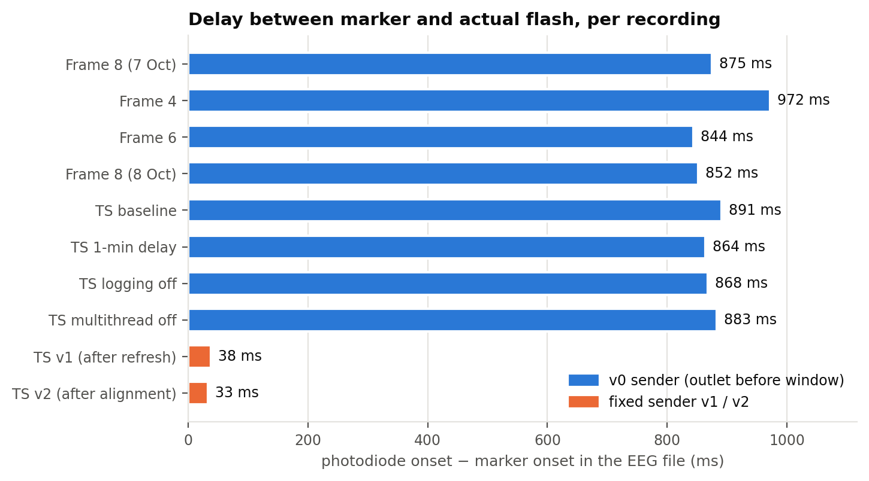
Figure 2. Photodiode − marker per recording. Blue: v0 sender; orange: fixed sender (v1, v2).

3.7 Results of all timestamp runs
Table 8. Timestamp runs (frame length 8)
Run | lsl_resyncs | Stalls kept | Backlog (ms) | Photodiode − marker (ms) | Jitter SD (ms) | Marker transit (ms) | Timestamp residual (ms)
baseline | 1 | 1 | 838.0 | 891.3 | 4.80 | 0.7 | 55.0 ± 4.7
1-min delay | 1 | 1 | 815.1 | 864.3 | 5.50 | 0.7 | 50.8 ± 5.4
logging off | 1 | 1 | 818.8 | 867.7 | 5.10 | 2.0 | 50.4 ± 5.2
multithread off | 1 | 1 | 824.9 | 882.6 | 5.15 | 0.7 | 59.4 ± 5.1
v1 (after refresh) | 0 | 0 | 1.0 | 37.8 | 5.45 | 16.5 | 50.0 ± 5.3
v2 (after alignment) | 0 | 0 | 0.2 | 32.5 | 5.30 | 19.6 | 51.5 ± 5.2

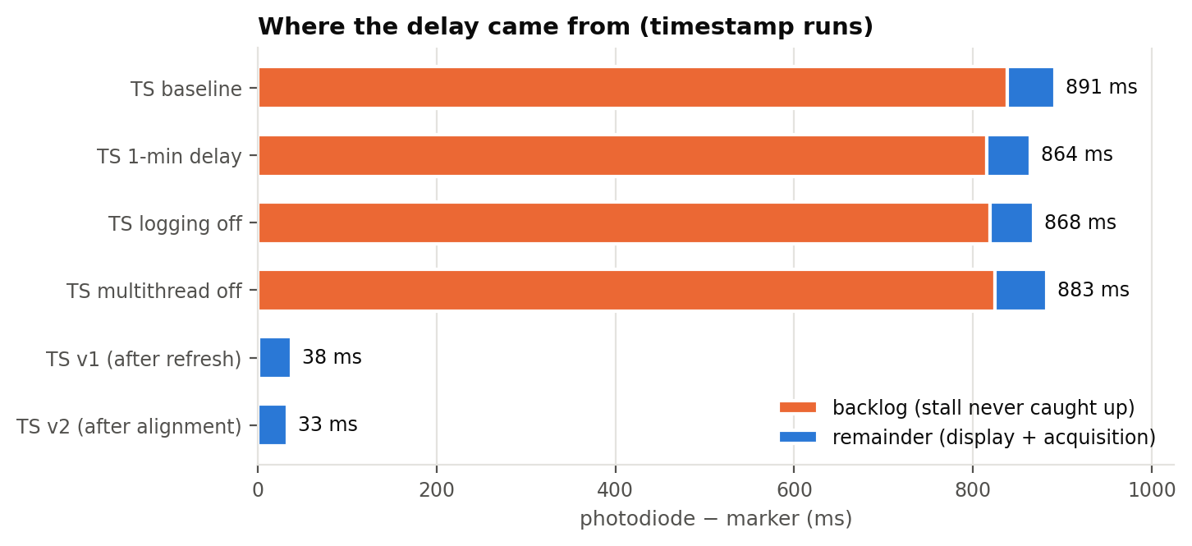
Figure 3. Delay decomposition. With v0 almost all of the delay is the backlog from the start-up stall; with v1/v2 the backlog is ~0.
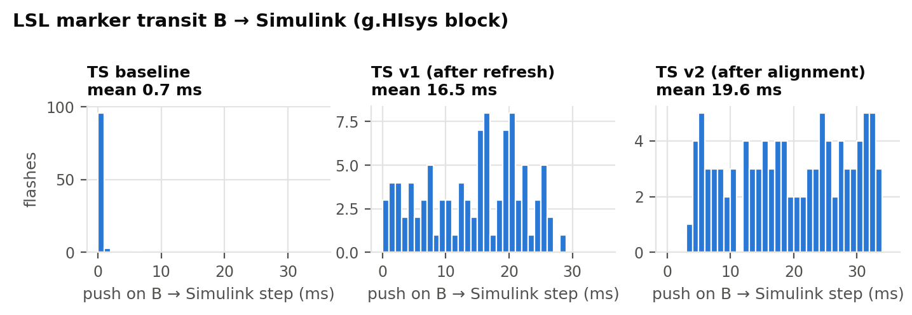
Figure 4. Marker transit from the push on B to the Simulink step that recorded it.
With the stall gone, marker transit rose from ~0.7 ms to 16.5–19.6 ms (g.HIsys block), spread evenly from 0 to about two amplifier frames. Likely reason (consistent with the data, not proven): without a backlog the model waits for the amplifier and processes each delivered frame (8 samples = 13.3 ms) in a burst, so a marker waits for the next burst. In v0 the 0.8 s backlog meant amplifier data was always ready, so the model ran at the pace of the LSL samples and picked up each marker immediately. This is why photodiode − marker with v1/v2 (32–38 ms) is below the v0 value without backlog (48–58 ms).
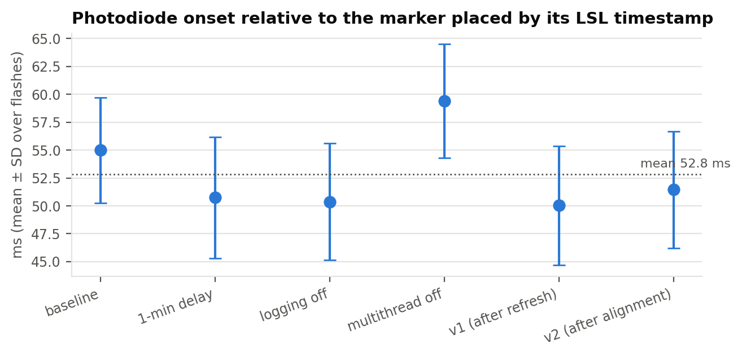
Figure 5. Photodiode onset relative to the marker placed by its LSL timestamp (B timestamp + clock offset, mapped to EEG samples). The offset is the same for v0 and the fixed senders.
The timestamp-based residual is the most stable quantity so far: 50.0–59.4 ms over six runs (mean 52.8 ms, between-run SD 3.7 ms; ~5 ms SD within a run). It contains the display latency (bottom-right corner, a few ms after the flip) and the acquisition latency, and needs no photodiode, so it is a candidate correction constant.

4. Changes made in the repository
Table 9. Files
File | Change
run_photodiode_latency_v0.py | refresh-check message; expected_refresh_hz 59.94 (user edits)
run_photodiode_latency_v1_trig_after_framerate_measurement.py | new: LSL outlet after window + refresh measurement
run_photodiode_latency_v2_trig_after_space_input.py | new: LSL outlet after the alignment screen
run_vMMR_experiment_v1_trig_after_framerate_measurement.py | new: same fix for the experiment; 59.94 default; LSL statistics in run_info
timing_utils.py | accepts 59.94 and 119.88 Hz
tests/ | tests for 59.94 Hz; static trigger tests run on v0 and v1 experiment scripts
notebooks/photodiode_latency_test.ipynb | reads recordings from data/EEG (and subfolders)
notebooks/photodiode_latency_compare.ipynb | new: multi-recording comparison, pairing by order, LSL timestamp analysis
timestamped_LSL_model/ | Simulink model with the LSLMarkerTimestamps block and its class file
HIamp_record_LSL_DD_vMMR_new.slx | the 7 Oct recording model (LSL Receive at 200 Hz)
README.md | v1/v2 section

5. Caveats
- Only one run each for v1 and v2; their constants need repeating (next steps).
- The burst explanation of the higher marker transit is a hypothesis consistent with the data.
- Raw recordings (data/) are not in the repository (git-ignored); they are on the lab computers.
- The .mat time axis is Simulink model time; EEG sample timing relative to real time comes only from the timestamp block.

