vMMR EEG rig: marker timing calibration
Photodiode latency tests, LSL timestamps and the PsychoPy start-up stall — 6–15 October 2026
Repository: vMMR_EEG_PsychoPy_experiment. Computer B = PsychoPy stimulus PC (LSL sender); computer A = Simulink + g.HIamp recording PC (LSL receiver).

Abstract
The vMMR EEG experiment sends event markers from the PsychoPy computer (B) over Lab Streaming Layer (LSL) to the Simulink/g.HIamp recording computer (A). Because a photodiode cannot be used in real sessions, we calibrated the delay between each marker and the real on-screen event. A test script flashed a corner square 100 times with increasing durations, sending one LSL marker per flash, while an optical sensor recorded the true onsets. Initially the photodiode followed its marker by 844–972 ms, varying between runs and unaffected by Simulink frame length. A second LSL inlet in the Simulink model, saving LSL timestamps and A's clock at every model step, located the cause: a ~0.8 s pause of PsychoPy at its first fullscreen flips while the marker stream was already live. The model consumes one LSL sample per step, so it stalled and never caught up. Start delay, workspace logging and multithreading changes did not help; creating the LSL stream after the refresh-rate measurement removed the stall. On 13 October, 8 runs of this fixed sender with a new experiment-start marker confirmed it: no stall, delay 40–63 ms, and no difference between frame lengths 8 and 4. The recorded marker still shifts with an LSL transit that varies between runs (2–12 ms); placing markers by their LSL timestamps removes this (56 ms, between-run SD 4.8 ms) and is the recommended correction. Within each run the delay spreads over about one display frame (SD ~5.6 ms), which arises on the display side.

Next steps
- Done – calibration database: 22 centre sessions on 14–15 October (18 short, 3 long, 1 full experiment length), pooled (section 7). The configuration was locked on 15 October (Table 12), including Windows at 59.94 Hz on computer B; check it before every session.
- Done – correction 62.4 ms (95 % CI 61.7–63.0), between-session SD 1.4 ms, with the local upper-envelope clock mapping (section 7.4).
- Done – analysis/marker_timing.py (correct_events); checked on all 22 sessions (mean error −0.2 ms, SD 5.7 ms) and with synthetic tests.
- Open – see docs/todo_experiment_and_analysis_2026-10.docx (part 1).
- Open – after the experiment-script update (docs/todo_experiment_and_analysis_2026-10.docx).
- Done – docs/supplement_marker_timing_calibration_2026-10-15.docx ([TBD] fields: computer-A versions, commit, data location).
- Done – README.md and AGENTS.md; lab guide docs/lab_guide_marker_timing_2026-10.docx. Re-check runs after any change remain the rule.
- Decided on 13 October: the ~5 ms within-run jitter is accepted (no display tuning; options if this is revisited: docs/jitter_reduction_options_2026-10.docx); frame length 8.

1. Set-up
Table 1. Rig
Part | Details
Computer B (stimulus) | Windows 11, AMD Radeon Vega 8 (integrated), Dell monitor 1920×1080; PsychoPy in .venv; scripts run_photodiode_latency_*.py, run_vMMR_experiment_*.py; LSL sender lsl_trigger.py (stream experiment_markers, int32, 1 channel)
Computer A (recording) | MATLAB/Simulink R2020a, g.HIsys blocks; g.HIamp at 600 Hz (65 channels); fixed-step discrete solver 1/600 s; To File writes EEG_data (time, EEG, photodiode, marker)
Optical chain | white 45 px square, bottom-right → GTEC-0270 optical sensor → GTEC-0274W g.TRIGbox → GTEC-0274TR adapter → g.HIamp digital input (recorded as a channel next to the EEG)
Marker path | PsychoPy flip callback → LSLTrigger.set() (latched marker, keepalive stream) → network → Simulink LSL Receive block (one sample per model step) → muxed with the EEG

2. Test method
run_photodiode_latency_v0.py (and its v1/v2 versions) shows a black screen and, per flash, a white square in the bottom-right corner while pushing LSL marker 20 on the same flip (win.callOnFlip). Flash *i* lasts 6 + (i−1) frames (100 ms to 1.75 s at 59.94 Hz) and its marker is latched for the same time, so each photodiode pulse can be matched to its marker by its width. Gaps between flashes are jittered 350–650 ms. A dark/light/dark calibration segment (markers 5/6/5) gives the photodiode polarity. Other markers: START 9, flash block 7, END 255 (stops the Simulink model).
Analysis: notebooks/photodiode_latency_test.ipynb (one recording) and notebooks/photodiode_latency_compare.ipynb (all recordings side by side, LSL timestamp analysis, comparison and printed conclusions). Delay = photodiode onset − marker onset of the same flash; jitter = SD of the delay after removing a linear drift.
Pairing note: numbering photodiode pulses by width (the original method) failed on real data because photodiode widths vary by about ±6 ms, a third of the 16.7 ms step (2–23 of 100 flashes paired). Every recording had exactly one pulse per marker with widths following the marker widths (r ≥ 0.9999), so pulses are now paired in order when that check passes; all 100 flashes paired in every run.

3. Chronology of what we checked

3.1 Display refresh rate (computer B)
At the Windows 120 Hz setting, PsychoPy flipped every 16.69 ms (59.93 Hz): the AMD driver presented only every second refresh, and the latency script's refresh check (2 % tolerance) aborted. Windows was set to 60 Hz. That mode is really 60000/1001 Hz:
Table 2. Real refresh rate of the stimulus display
Measure | Value
Windows setting | 60 Hz (available: 50, 59, 60, 100, 119, 120)
getActualFrameRate, 20 runs on 8 and 13 Oct | 59.934–59.945 Hz
Median frame interval in the flash blocks | 16.684 ms → 59.939 Hz
Frames > 1.5 × normal | 0–3 per run of 8 482 frames

expected_refresh_hz was set to 59.94 in the latency scripts and in the v1 experiment script. Frame counts are identical to 60 Hz (e.g. 250 ms = 15, 350 ms = 21, 600 ms = 36 frames); logged durations become exact.

3.2 LSL sample rate and the Simulink inlet
- nominal_srate is only stream metadata; what matters is the actual push rate vs. the rate the Simulink block reads. If the sender pushes faster, samples queue and markers drift later; if slower, the model waits.
- The original keepalive (sleep(1/600) loop) really sent ~491 samples/s at the 600 setting and ~971/s at 1200 (Windows timer granularity). The sender was rewritten to count samples against the clock (commit "Fixed the LSL sync issue"); v1/v2 runs sent 600.00 samples/s.
- The 7 Oct Simulink model read LSL at 200 Hz; the timestamp model reads at 600 Hz (one sample per model step). Because the inlet waits for a sample every step, the marker stream paces the whole model.
- The g.HIsys LSL Receive block outputs values only (no timestamps), so the .mat alone cannot show LSL timing. This led to the timestamp model (3.4).

3.3 Simulink frame length (v0 sender, no timestamps)
Table 3. Frame-length runs
Recording | Frame length | Delay mean (ms) | Jitter SD (ms) | Drift (ms/min) | Paired
Frame 8 (7 Oct) | 8 | 875.0 | 1.63 | -0.04 | 100/100
Frame 4 | 4 | 971.6 | 5.65 | -0.97 | 100/100
Frame 6 | 6 | 843.8 | 5.03 | +0.85 | 100/100
Frame 8 (8 Oct) | 8 | 852.2 | 5.51 | -1.18 | 100/100

The photodiode followed its marker by 844–972 ms, stable within each run but not between runs, with no systematic effect of frame length (the two frame-8 runs differ by 23 ms). The size of the delay ruled out the display (a 60 Hz monitor adds tens of ms at most).

3.4 Timestamp model and Simulink settings (v0 sender)
A MATLAB System block, LSLMarkerTimestamps (now in matlab/on_eeg_computer/), was added as a second inlet on experiment_markers. Every model step it saves: latest marker, rising-edge code, the edge's LSL timestamp on B's clock, the B→A clock offset (time_correction), A's LSL clock at that step, and the number of samples pulled; a second To File writes *_LSLtiming.mat. Runs with this model are labelled "TS" in the tables and figures. Four runs then tested one change each:
Table 4. Simulink-side changes tested
File-name tag | Change | Where
start_0 | baseline: PsychoPy started right after the model | —
start_1mindelay | PsychoPy started 1 min after the model | —
workspacelogging_off | Time, Output, Signal logging, Data stores unchecked | Model Settings → Data Import/Export
multithread_off | MultiThreadCoSim off for model and g.HIamp block | MATLAB Command Window (set_param)

Solver settings were checked and left as they were (fixed-step discrete 1/600, single-tasking, simulation pacing off). Enabling "treat each discrete rate as a separate task" was advised against (it can insert rate-transition delays).
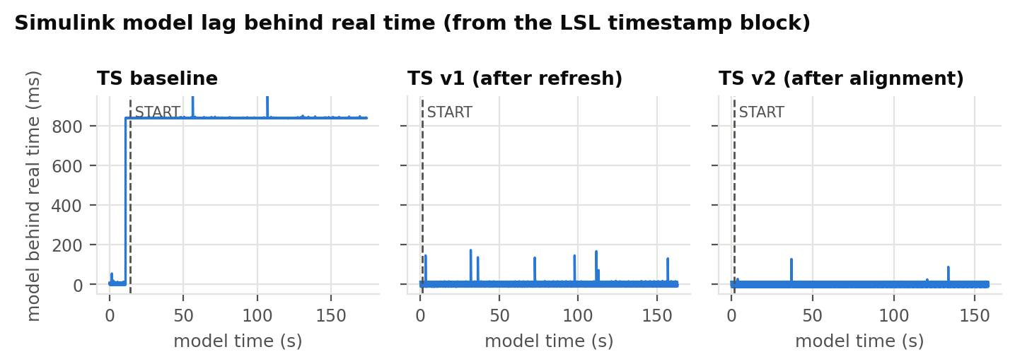
Figure 1. How far the Simulink model ran behind real time (A's clock minus model time). v0 baseline: one ~0.84 s step shortly before START that never recovers; v1 and v2: no persistent step (the short spikes are A-side hiccups that are caught up within about a second).

3.5 What the timestamps showed
- Marker transit B → Simulink was ~0.7 ms: the markers themselves were on time.
- Photodiode − marker (864–891 ms) = backlog (815–838 ms) + 48–58 ms.
- The backlog is one model stall of 797–839 ms, 3.20–3.21 s before START in every run, including the run started 1 min after the model. It is the only stall the model never caught up.
- No LSL samples arrived during the stall (the first step after it pulled 1 sample, not ~500), so the model was waiting for the marker stream.
- Computer B logged it too: every v0 *_run_info.txt shows lsl_resyncs: 1 and ~500 missing samples (≈ 0.83 s at 600/s), because lsl_trigger.py restarts its sample count after pauses > 0.1 s (_MAX_CATCHUP_S) instead of sending the missed samples.
- Start delay, logging off and multithreading off changed the delay only through the size of that one stall.
Table 5. Locating the stall on the PsychoPy log timeline (v0 timestamp runs)
Run | Window created (s) | Refresh measurement starts (s) | Stall (s) | Stall − measurement start (s) | START (s)
TS baseline | 25.84–28.58 | 29.75 | 29.82 | +0.07 | 33.03
TS 1-min delay | 79.92–82.67 | 83.71 | 83.78 | +0.07 | 86.97
TS logging off | 14.28–16.91 | 17.99 | 18.05 | +0.06 | 21.25
TS multithread off | 16.02–18.64 | 19.68 | 19.74 | +0.06 | 22.94

The stall starts 0.06–0.07 s after getActualFrameRate begins, more than 1 s after the window is created, i.e. at the first flips of the new fullscreen window. Since the LSL outlet already existed, that pause became a gap in the stream that paces the model.

3.6 Fix: create the LSL stream after the window set-up
Table 6. Script versions
Script | LSL outlet created | Start-Simulink prompt
run_photodiode_latency_v0.py | before the window (old) | console, Enter
run_photodiode_latency_v1_trig_after_framerate_measurement.py | after window + refresh measurement | stimulus screen, SPACE
run_photodiode_latency_v2_trig_after_space_input.py | after SPACE on the alignment screen | stimulus screen, SPACE; START sent after it
run_vMMR_experiment_v1_trig_after_framerate_measurement.py | after window + refresh measurement | stimulus screen; waits for the inlet as before

Table 7. Sender statistics on computer B (8 and 13 Oct)
Run (time) | Script | Samples/s | Samples sent | lsl_resyncs
08 Oct 13:01 | v0 | 597.2 | 122083 | 1
08 Oct 13:05 | v0 | 597.2 | 104308 | 1
08 Oct 13:16 | v0 | 597.2 | 104877 | 1
08 Oct 13:49 | v0 | 597.3 | 109844 | 1
08 Oct 14:02 | v0 | 597.9 | 142718 | 1
08 Oct 14:08 | v0 | 597.2 | 104304 | 1
08 Oct 14:18 | v0 | 597.2 | 104526 | 1
08 Oct 15:01 | v1_trig_after_framerate_measurement | 600.0 | 105529 | 0
08 Oct 15:05 | v2_trig_after_space_input | 600.0 | 98629 | 0
13 Oct 10:45 | v1_trig_after_framerate_measurement | 600.0 | 110857 | 0
13 Oct 10:50 | v1_trig_after_framerate_measurement | 600.0 | 101064 | 0
13 Oct 11:13 | v1_trig_after_framerate_measurement | 600.0 | 104428 | 0
13 Oct 11:17 | v1_trig_after_framerate_measurement | 600.1 | 7111 | 0
13 Oct 11:18 | v1_trig_after_framerate_measurement | 600.0 | 102215 | 0
13 Oct 11:22 | v1_trig_after_framerate_measurement | 600.0 | 103275 | 0
13 Oct 11:26 | v1_trig_after_framerate_measurement | 600.0 | 102648 | 0
13 Oct 11:30 | v1_trig_after_framerate_measurement | 600.0 | 103202 | 0
13 Oct 11:34 | v1_trig_after_framerate_measurement | 600.0 | 103008 | 0
13 Oct 11:38 | v1_trig_after_framerate_measurement | 600.0 | 103315 | 0
13 Oct 11:42 | v1_trig_after_framerate_measurement | 600.0 | 102041 | 0

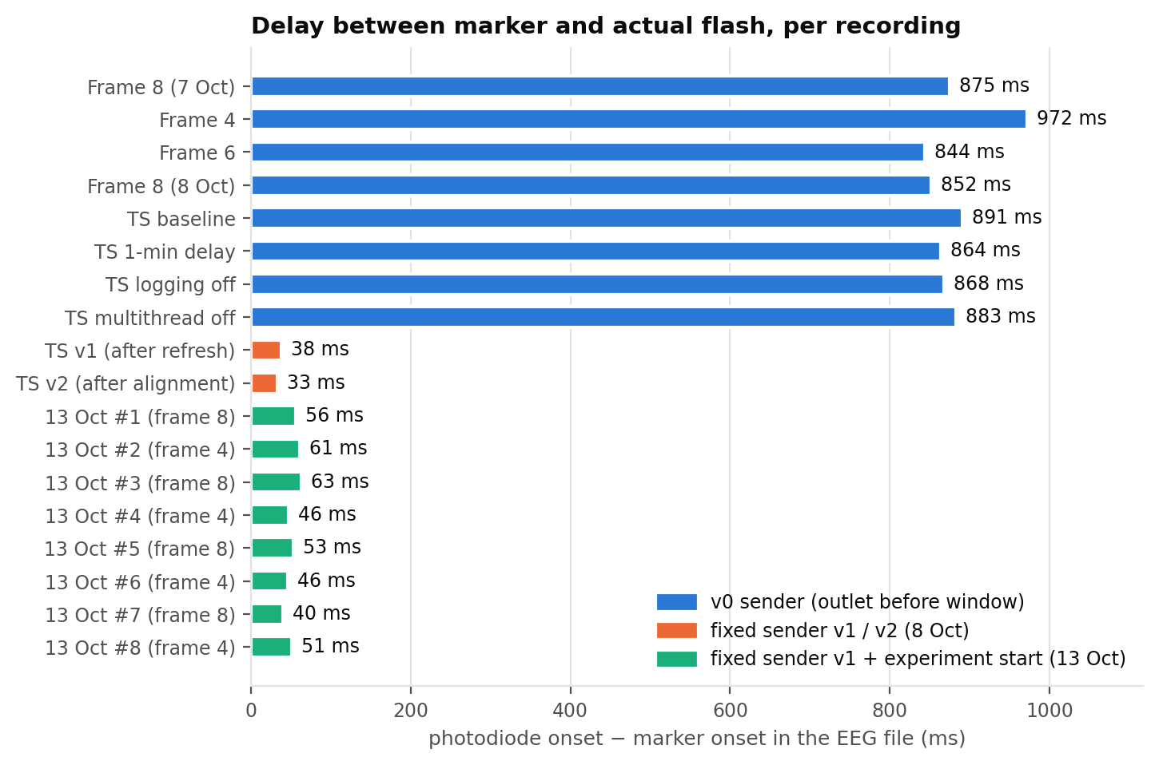
Figure 2. Photodiode − marker per recording. Blue: v0 sender; orange: fixed sender (v1, v2).

3.7 Results of all timestamp runs
Table 8. Timestamp runs (frame length 8)
Run | lsl_resyncs | Stalls kept | Backlog (ms) | Photodiode − marker (ms) | Jitter SD (ms) | Marker transit (ms) | Timestamp residual (ms)
baseline | 1 | 1 | 838.0 | 891.3 | 4.80 | 0.7 | 55.0 ± 4.7
1-min delay | 1 | 1 | 815.1 | 864.3 | 5.50 | 0.7 | 50.8 ± 5.4
logging off | 1 | 1 | 818.8 | 867.7 | 5.10 | 2.0 | 50.4 ± 5.2
multithread off | 1 | 1 | 824.9 | 882.6 | 5.15 | 0.7 | 59.4 ± 5.1
v1 (after refresh) | 0 | 0 | 1.0 | 37.8 | 5.45 | 16.5 | 50.0 ± 5.3
v2 (after alignment) | 0 | 0 | 0.2 | 32.5 | 5.30 | 19.6 | 51.5 ± 5.2
13 Oct #1 (frame 8) | 0 | 0 | 0.1 | 55.9 | 5.43 | 2.6 | 57.8 ± 5.5
13 Oct #2 (frame 4) | 0 | 0 | 0.1 | 60.6 | 5.60 | 1.6 | 62.3 ± 5.6
13 Oct #3 (frame 8) | 0 | 0 | -0.0 | 62.9 | 5.84 | 1.7 | 64.5 ± 5.9
13 Oct #4 (frame 4) | 0 | 0 | 0.2 | 46.4 | 5.60 | 7.1 | 52.4 ± 5.7
13 Oct #5 (frame 8) | 0 | 0 | 0.1 | 53.2 | 5.55 | 3.4 | 55.1 ± 5.5
13 Oct #6 (frame 4) | 0 | 0 | -0.0 | 46.1 | 5.43 | 7.9 | 52.5 ± 5.6
13 Oct #7 (frame 8) | 0 | 0 | -0.0 | 39.8 | 5.22 | 12.3 | 52.4 ± 5.2
13 Oct #8 (frame 4) | 0 | 0 | -0.1 | 50.8 | 5.75 | 4.5 | 53.3 ± 5.7

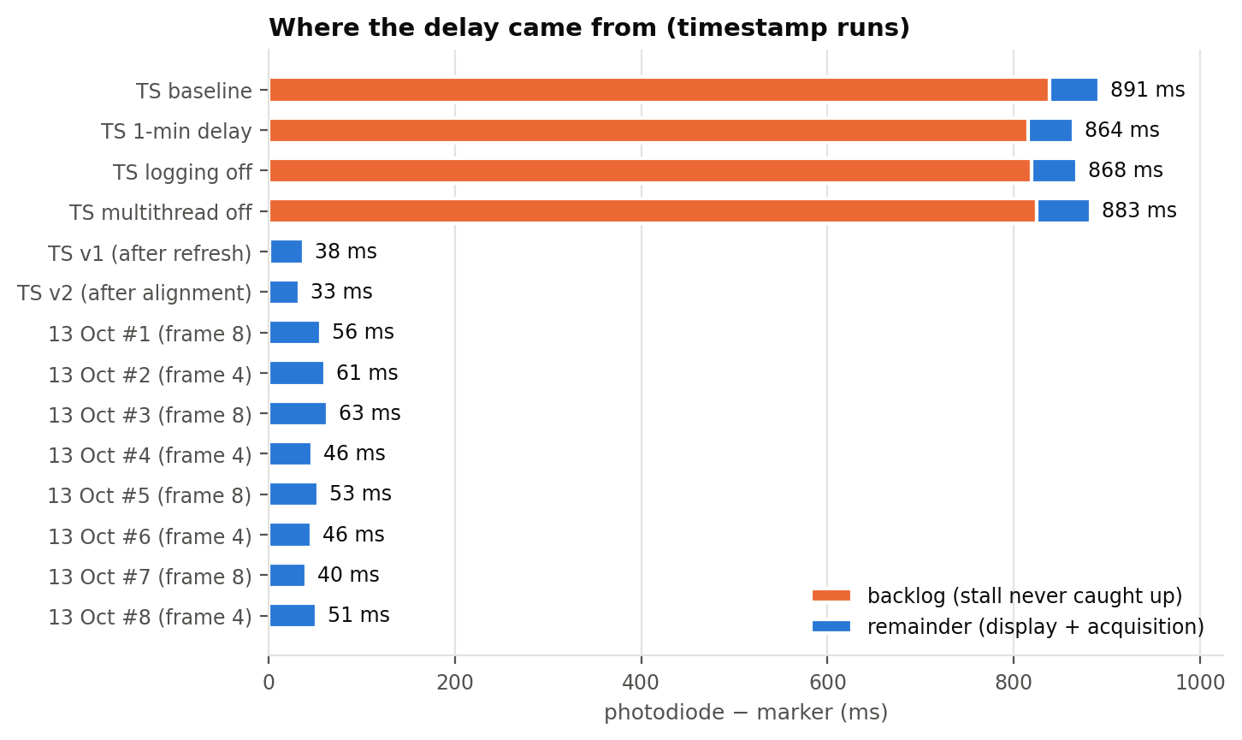
Figure 3. Delay decomposition. With v0 almost all of the delay is the backlog from the start-up stall; with v1/v2 the backlog is ~0.
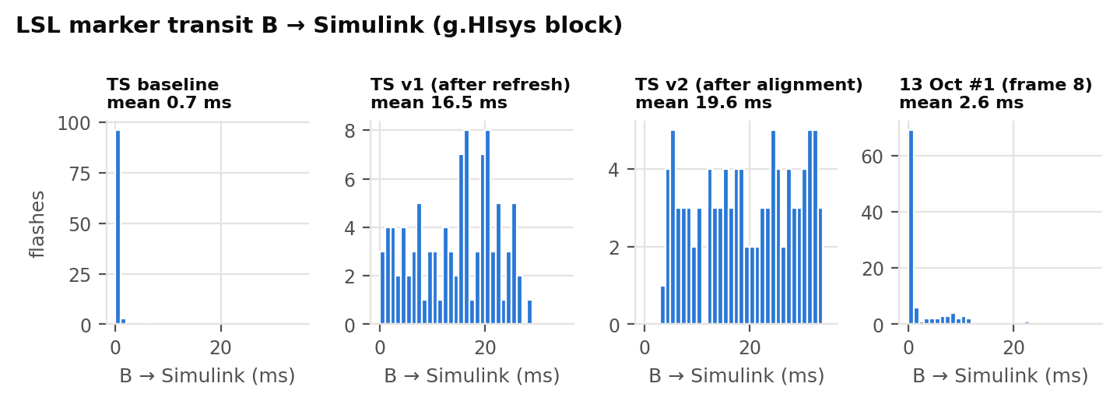
Figure 4. Marker transit from the push on B to the Simulink step that recorded it.
In the 8 October v1/v2 runs, marker transit rose from ~0.7 ms to 16.5–19.6 ms (g.HIsys block), spread evenly from 0 to about two amplifier frames. Likely reason (consistent with the data, not proven): without a backlog the model waits for the amplifier and processes each delivered frame (8 samples = 13.3 ms) in a burst, so a marker waits for the next burst. In v0 the 0.8 s backlog meant amplifier data was always ready, so the model ran at the pace of the LSL samples and picked up each marker immediately. This is why photodiode − marker with v1/v2 (32–38 ms) is below the v0 value without backlog (48–58 ms). Revised on 13 October: transit varied between runs with the same settings (1.6–12.3 ms, multithreading on, section 3.8), so the 8 October values are probably part of the same run-to-run variation rather than a fixed effect of the fix or of multithreading. Its cause is not known; the timestamp correction makes it irrelevant.
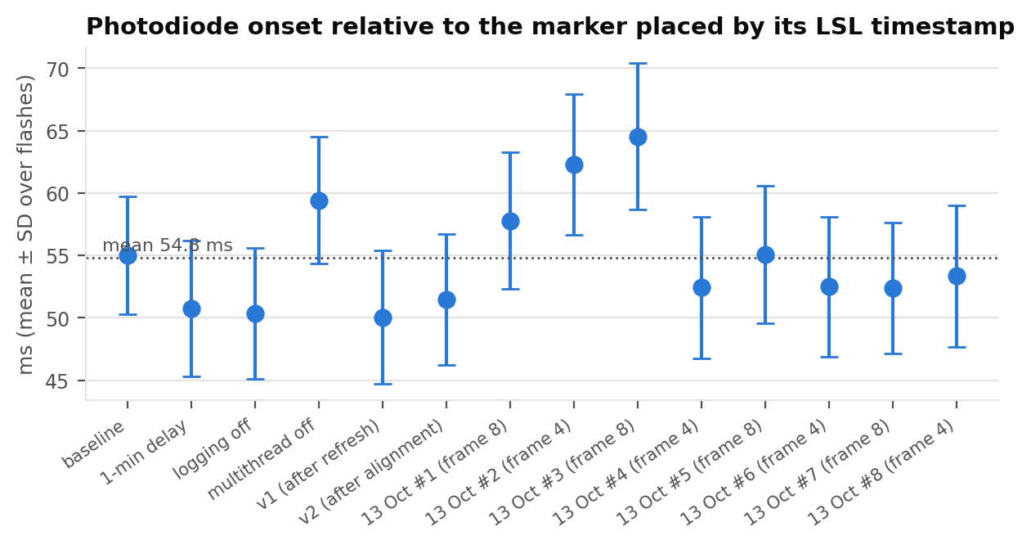
Figure 5. Photodiode onset relative to the marker placed by its LSL timestamp (B timestamp + clock offset, mapped to EEG samples). The offset is the same for v0 and the fixed senders.
The timestamp-based residual is the most stable quantity: 50.0–64.5 ms over 14 runs (mean 54.8 ms, between-run SD 4.6 ms; ~5 ms SD within a run). It contains the display latency (bottom-right corner, a few ms after the flip) and the acquisition latency, and needs no photodiode, so it is a candidate correction constant.

3.8 Follow-up on 13 October: experiment-start marker, frame length 8 vs 4
All three latency scripts got an experiment-start screen after the sensor-alignment screen: SPACE sends marker 1 on the next flip, and the baseline, calibration and flashes follow from it, so the calibration is counted from marker 1 (the notebook ignores everything before it). Runs used the fixed sender run_photodiode_latency_v1_trig_after_framerate_measurement.py, the timestamp model with its original settings (multithreading on, workspace logging on) and frame length 8 or 4, alternating. Files: photodiode_test_20261013_N_slx_frame_length_X_timestamped_LSL_trig_after_framerate_expstart.mat plus ..._LSLtiming.mat.
Table 10. 13 October runs (fixed sender, experiment-start marker)
Run | PsychoPy run | lsl_resyncs | Backlog (ms) | Photodiode − marker (ms) | Jitter SD (ms) | Marker transit (ms) | Timestamp residual (ms) | Marker 1 → first flash (s)
#1 (frame 8) | 20261013 111344 | 0 | 0.1 | 55.9 | 5.43 | 2.6 | 57.8 ± 5.5 | 13.06
#3 (frame 8) | 20261013 112213 | 0 | -0.0 | 62.9 | 5.84 | 1.7 | 64.5 ± 5.9 | 13.06
#5 (frame 8) | 20261013 113017 | 0 | 0.1 | 53.2 | 5.55 | 3.4 | 55.1 ± 5.5 | 13.03
#7 (frame 8) | 20261013 113802 | 0 | -0.0 | 39.8 | 5.22 | 12.3 | 52.4 ± 5.2 | 13.03
#2 (frame 4) | 20261013 111818 | 0 | 0.1 | 60.6 | 5.60 | 1.6 | 62.3 ± 5.6 | 13.05
#4 (frame 4) | 20261013 112620 | 0 | 0.2 | 46.4 | 5.60 | 7.1 | 52.4 ± 5.7 | 13.03
#6 (frame 4) | 20261013 113412 | 0 | -0.0 | 46.1 | 5.43 | 7.9 | 52.5 ± 5.6 | 13.08
#8 (frame 4) | 20261013 114205 | 0 | -0.1 | 50.8 | 5.75 | 4.5 | 53.3 ± 5.7 | 13.03

- No stall in any run: lsl_resyncs 0, backlog ≈ 0; marker 1 found in all runs, first flash 13.03–13.06 s later (2 s baseline + 9 s calibration + 2 s baseline, as designed).
- Photodiode − marker 39.8–62.9 ms (mean 52.0 ms, between-run SD 7.8 ms).
- Frame length 8 vs 4: no difference. Delay 52.9 vs 51.0 ms, within-run jitter 5.51 vs 5.60 ms (n = 4 and 4).
- Marker transit varies between runs: 1.6–12.3 ms, and the recorded-marker delay moves with it (r = -0.95 across runs; delay + transit = 52.1–64.6 ms).
- Timestamp-placed residual 52.4–64.5 ms (mean 56.3 ms, between-run SD 4.8 ms) is more stable than the recorded-marker delay (SD 7.8 ms), because it does not depend on the transit. It is the recommended correction.
- Within-run jitter (~5.6 ms SD) is on the display side. In every run the delay spans about 19–20 ms (one 16.7 ms display frame plus 1.7 ms EEG sampling) in two clusters about 11–12 ms apart (Figure 7); it is not related to LSL transit (mean r = +0.04) and it is identical for recorded and timestamp-placed markers (r = 0.99), so it arises between the flip on B and the light reaching the sensor.
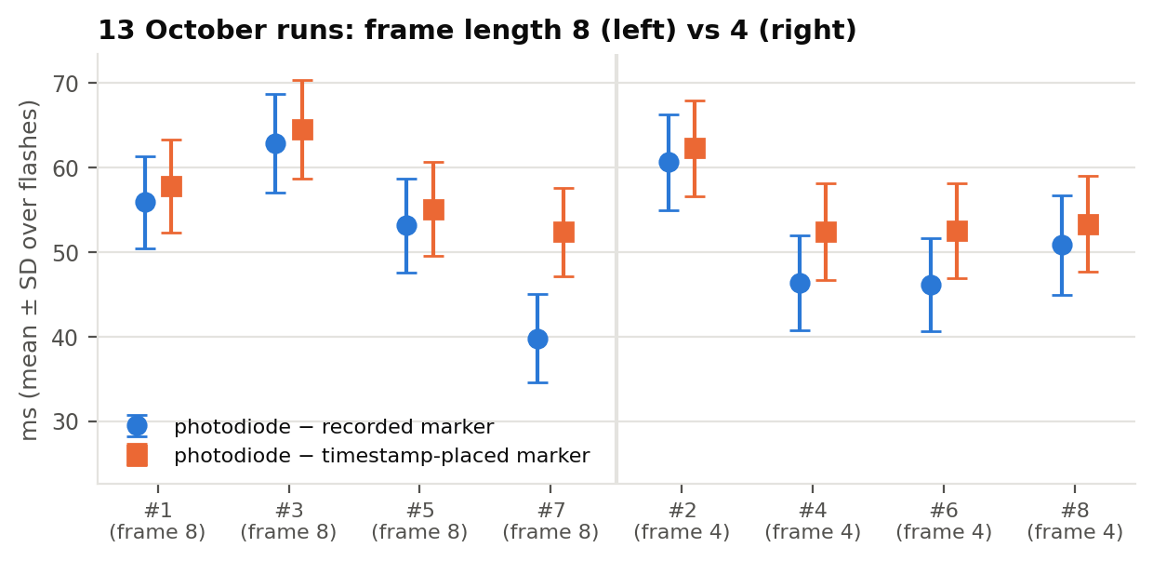
Figure 6. 13 October runs: photodiode − marker (recorded marker, blue) and photodiode − timestamp-placed marker (orange); error bars = within-run SD.
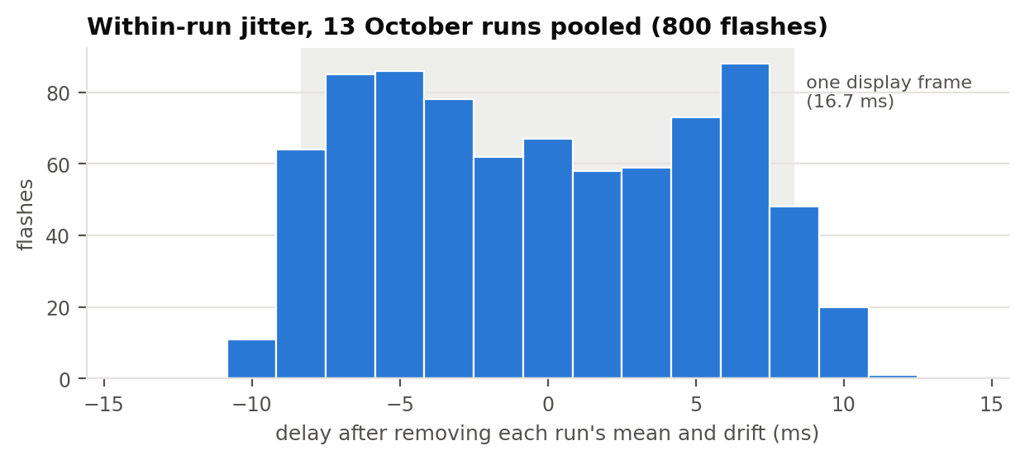
Figure 7. Shape of the within-run jitter: about one display frame wide (grey band), with two clusters ~11–12 ms apart.

4. Changes made in the repository
Table 9. Files
File | Change
run_photodiode_latency_v0.py | refresh-check message; expected_refresh_hz 59.94 (user edits)
run_photodiode_latency_v1_trig_after_framerate_measurement.py | new: LSL outlet after window + refresh measurement
run_photodiode_latency_v2_trig_after_space_input.py | new: LSL outlet after the alignment screen
run_vMMR_experiment_v1_trig_after_framerate_measurement.py | new: same fix for the experiment; 59.94 default; LSL statistics in run_info
timing_utils.py | accepts 59.94 and 119.88 Hz
tests/ | tests for 59.94 Hz; static trigger tests run on v0 and v1 experiment scripts
notebooks/photodiode_latency_test.ipynb | reads recordings from data/EEG (and subfolders)
notebooks/photodiode_latency_compare.ipynb | new: multi-recording comparison, pairing by order, LSL timestamp analysis
matlab/on_eeg_computer/ | Simulink model with the LSLMarkerTimestamps block and its class file (moved from timestamped_LSL_model/ on 13 Oct)
run_photodiode_latency_database.py | 13 Oct: calibration-database runs (centre square, short/long, run log, versions and hashes in run_info)
docs/ | this report, calibration_database_plan_2026-10.docx, collaborator_update_2026-10-13.docx, jitter_reduction_options_2026-10.docx, methods_supplement_marker_timing_SKELETON.docx
HIamp_record_LSL_DD_vMMR_new.slx | the 7 Oct recording model (LSL Receive at 200 Hz)
run_photodiode_latency_v0/v1/v2...py | 13 Oct: experiment-start screen after alignment; marker 1 on the next flip
notebooks/photodiode_latency_compare.ipynb | 13 Oct: counts from marker 1; file tags expstart, trig_after_framerate, trig_after_allignment
README.md | v1/v2 section; experiment-start marker

5. Current configuration
Table 11. Current configuration (13 October 2026)
Item | Setting
Display (computer B) | Windows 60 Hz mode = 59.94 Hz measured; expected_refresh_hz 59.94
PsychoPy script (latency test) | run_photodiode_latency_v1_trig_after_framerate_measurement.py: LSL stream created after the refresh measurement; experiment-start marker 1 after the alignment screen
LSL sender | lsl_trigger.py count-based keepalive; lsl_keepalive_hz = lsl_nominal_srate = 600; lsl_resyncs must be 0
Simulink model (computer A) | matlab/on_eeg_computer/HIamp_record_LSL_DD_vMMR.slx: g.HIamp 600 Hz, frame length 8, LSL Receive 600 Hz, LSLMarkerTimestamps block + *_LSLtiming.mat, stop on 255
Simulink settings | fixed-step discrete 1/600, single-tasking, pacing off, multithreading on (model on, g.HIamp block auto), workspace logging on
Database runs | run_photodiode_latency_database.py; square and sensor at the screen centre (fixed; the 13 Oct pilot runs used the bottom-right corner)
Run order | script → refresh measurement → start Simulink, SPACE → sensor alignment, SPACE → experiment start (marker 1), SPACE → baseline, calibration, flashes → END 255
File names | photodiode_test_YYYYMMDD_N_slx_frame_length_8_timestamped_LSL_trig_after_framerate_expstart.mat + ..._LSLtiming.mat
Correction | marker placed by its LSL timestamp + ~56 ms (between-run SD 4.8 ms, within-run SD ~5.6 ms)

6. Calibration database (decided 13 October)
The correction will be estimated from a dedicated database recorded with the frozen configuration in Table 11, using run_photodiode_latency_database.py. Decisions:
- Square and optical sensor at the screen centre for every run, where faces and primes appear, so the correction applies to the stimulus position. The sensor is not moved. (LCDs draw top to bottom, so the centre lights up about half a frame before the bottom-right corner used in all earlier runs.)
- Two days, 09:00–13:00: per day 24 short runs (100 flashes) in two blocks of 12 and one long run (500 flashes, ~12 min) between them; both computers restarted at the start of each block (4 cold starts in total). About 50 sessions overall.
- Why many short runs rather than a few long ones: within a run, 100 flashes already fix that run's offset to about ±0.5 ms; the uncertainty of the correction comes from the ~5 ms variation between runs, which is set at each start. Long runs check stability over a longer session.
- Exclusion rules fixed in advance: lsl_resyncs > 0, run aborted or file missing, dropped frames > 1 %, backlog > 5 ms, < 95 % of flashes paired. Excluded runs are reported, and repeated if time allows.
- Expected precision: 95 % CI of the correction about ±1.3 ms; 95 % prediction interval for a new session about ±9.5 ms.
- Traceability: every run records the git commit, SHA-256 hashes of the script and lsl_trigger.py, software versions and a row in data/database_run_log.csv.
Full protocol with times, run numbers and file names: docs/calibration_database_plan_2026-10.docx.

7. Database as run (14–15 October) and locked configuration
The two database days were run differently from the plan in section 6. This section records what was actually done, a display-setting issue found on 14 October, and the configuration that was locked on 15 October for the rest of the database and for the experiment.

7.1 Runs
- Script: run_photodiode_latency_v1_trig_after_framerate_measurement.py (not the database script). Square and optical sensor at the screen centre (commit 0cc537d); the on_cycle field for long runs was added in 34fc744. With on_cycle = 0 the two versions present identical stimuli.
- Run types: short runs (100 flashes, on_cycle = 0) and long runs (400 flashes, on_cycle = 100, so the duration ramp repeats every 100 flashes and pulses stay pairable).
- 14 October (day 1): 6 short runs, sqcenter_run01–run06 (13:59–14:44), and 1 long run, sqcenter_long01 (two complete attempts on computer B, 14:51 and 15:02; the one with the EEG file is the valid run). EEG files on computer A: main_20261014_fl_8_sqcenter_run01.mat … run06.mat and main_20261014_fl_8_sqcenter_run_long_01.mat, each with a matching _LSLtiming.mat. All PsychoPy run_info files show lsl_resyncs: 0 and ~600.0 samples/s.
- 15 October (day 2): further short and long runs, numbered again from 01 (the date in the file name distinguishes the days), session 002, same script and dialog values.
- Total: both days are pooled into one database (decision of 15 October). This is fewer than the ~50 sessions planned. With a between-run SD of about 4.8 ms, 14 runs give an expected 95 % CI of the correction of about ±2.8 ms (instead of ±1.3 ms) and a 95 % prediction interval for a new session of about ±11 ms; each additional run narrows the CI.
- Traceability: the v1 script does not write the git commit or file hashes to run_info (the database script would have). The code state is identified by commit 34fc744 (script unchanged since 14 October 15:26) and by the script: and parameter lines in each run_info.

7.2 Display-setting issue
On 14 October at 12:06 a new check (check_display_refresh_rate.py, 1200 flips) found Windows set to 120 Hz on computer B, although the 13 October configuration specified the 60 Hz mode. PsychoPy still flipped at 59.94 Hz (all 1199 intervals 16.68 ms, SD 0.08 ms), because the AMD Vega 8 driver presents every second refresh. A further check was made at 12:16. The Windows setting in force during the day-1 runs (13:59–15:02) is not stored in any run file; the operators confirmed on 15 October that Windows had been set back to the 59.94 Hz mode before those runs, the same mode as on day 2.
Why it matters: the flip rate and all frame counts are the same in both modes, but at 120 Hz the panel scans each image out in 8.3 ms instead of 16.7 ms, so the time from flip to light at the screen centre can differ by a few milliseconds. Each setting therefore has its own correction constant.
Decision (15 October): pool day 1 and day 2, both recorded in the 59.94 Hz mode. On 15 October at 12:22 Windows reported the 59 Hz (59.94 Hz) mode, and PsychoPy measured 59.942 Hz (1199/1199 intervals 14–19 ms, mean 16.683 ms, SD 0.087 ms). Because the day-1 setting rests on the operators' account, the day-1 and day-2 offsets are still compared at analysis and the result is reported.

7.3 Locked configuration (15 October 2026)
This configuration applies to the remaining database runs, the experiment validation sessions and the real experiment. Any change to an item below requires new calibration runs.
Table 12. Locked configuration (15 October 2026)
Item | Locked setting
Display (B) | DELL P2426H (EDID DEL43D4), 1920×1080, Windows refresh 59.94 Hz (Windows API reports 59 Hz; not 60 or 120). PsychoPy flips at 59.94 Hz (16.68 ms). Check with check_display_refresh_rate.py before each session
GPU / OS (B) | AMD Radeon Vega 8, driver 31.0.21916.2; Windows 11 Education 10.0.26200; power plan AMD Ryzen Balanced
Software (B) | Python 3.10.22 (.venv), PsychoPy 2026.2.4, pylsl 1.18.5 (liblsl 1.18); lsl_api.cfg KnownPeers 192.168.50.1 (computer A)
Code | branch photodiode-latency-calibration, commit 34fc744
Calibration script (B) | run_photodiode_latency_v1_trig_after_framerate_measurement.py: expected refresh 59.94 Hz, LSL keepalive and nominal rate 600, 45 px white square at the screen centre, text at y = 320, on_start_ms 100, on_step_ms 16.7, rng_seed 20261006; short = 100 flashes, on_cycle 0; long = 400 flashes, on_cycle 100
Markers | 9 start, 1 experiment start (after alignment), 5/6/5 calibration, 7 flash block, 20 flash, 255 end (stops the model)
Optical sensor | GTEC-0270 taped over the screen centre; g.TRIGbox → g.HIamp digital input
Model (A) | matlab/on_eeg_computer/HIamp_record_LSL_DD_vMMR.slx + LSLMarkerTimestamps.m (R2020a, liblsl-Matlab on the path); g.HIamp 600 Hz, frame length 8; fixed-step discrete 1/600, single-tasking, pacing off, multithreaded co-sim on (model on, g.HIamp block auto), workspace logging on, LSL Receive 600 Hz, stop constant 255
File names (A) | short: main_<YYYYMMDD>_fl_8_sqcenter_run<NN>.mat; long: main_<YYYYMMDD>_fl_8_sqcenter_run_long_<NN>.mat; each plus the same name ending _LSLtiming.mat (fl = Simulink frame length; NN restarts at 01 each day)
Run check | lsl_resyncs: 0 in the newest data/*_run_info.txt after every run

7.4 Result: the correction
The database was recorded as planned above: 22 sessions (14 Oct: 6 short + 1 long; 15 Oct: 12 short + 2 long + 1 full experiment length of 1200 flashes), 4,200 flashes, no session excluded. Full methods and results: docs/supplement_marker_timing_calibration_2026-10-15.docx.
- Correction: 62.4 ms (95 % CI 61.7–63.0) from the timestamp-placed marker to the light at the screen centre; between-session SD 1.4 ms; a new session is expected within 59.4–65.3 ms.
- Clock mapping changed during the analysis. The planned single median of t_A − model time per session gave 53.2 ms with SD 4.7 ms and two clusters of sessions, because the model processes the amplifier's 8-sample frames either in bursts or steadily one frame behind. The local 90th percentile within ±10 s of each event removes this and also follows the ~4 ppm amplifier-vs-PC clock drift (11 ms over 29 min with the median). The pilot value of ~56 ms in this report used the old mapping and is superseded.
- Per event: SD 5.7 ms, 97.7 % within ±10 ms, all within one display frame (leave-one-session-out).
- Replication: the 8 sessions of 13 October (corner sensor) gave SD 0.9 ms with the new mapping; the corner is 2.0 ms later than the centre.
- Implementation: analysis/marker_timing.py (correct_events), shared with the calibration analysis analysis/calibration_database_analysis.py. Data: data/EEG/final database/ (EEG_Computer_A, Computer_B, run_manifest.csv).

8. Caveats
- 13 October: n = 4 runs per frame length, sensor at the corner; the database (centre) will replace these pilot values, and the final constant is checked with the experiment script.
- The cause of the run-to-run variation in LSL transit is unknown; the timestamp correction avoids it.
- The display-side cause of the ~5.5 ms within-run jitter is a hypothesis; the jitter was accepted on 13 October and not investigated further.
- The Windows refresh setting is not written to run_info. Windows was found at 120 Hz at 12:06 on 14 October; the operators confirmed it was back at 59.94 Hz for the day-1 runs, as on day 2. Day 1 and day 2 are still compared at analysis (section 7.2).
- The database has far fewer runs (2 days) than the ~50 planned, so the correction is less precise (expected 95 % CI about ±2.8 ms with 14 runs).
- Raw recordings (data/) are not in the repository (git-ignored); they are on the lab computers.
- The .mat time axis is Simulink model time; EEG sample timing relative to real time comes only from the timestamp block.

