EE4414 Multimedia Communication System II
Homework 2 Solution (Analog Color TV Systems), Yao Wang
___________________________________________________________________________________

- Suppose a color is represented by a RGB triplet of (100, 100, 100). What are the YIQ values? Explain your result.

Using the conversion formula:
Y = 0.299 R + 0.587 G + 0.114 B, I = 0.596 R -0.275 G -0.321 B, Q = 0.212 R -0.523 G + 0.311 B
We get Y=100, I=0, Q=0. This result is as expected, as when R=G=B, we see a color-less gray value. So the chrominance components should both be zero, with Y indicating the luminance or brightness.

- Suppose a color is represented by a YIQ triplet of (70,-32,-32). What are the RGB values?
Using the conversion formula:
R =1.0 Y + 0.956 I + 0.620 Q, G = 1.0 Y - 0.272 I -0.647 Q, B =1.0 Y -1.108 I + 1.700 Q.

- What are the benefit of converting RGB values to YIQ (or any luminance+chrominance representation) when transmitting a color signal?

First, the Y component can be transmitted separately for the monochrome TV to receive the luminance signal. Second, the RGB images are correlated and sending them directly is wasteful of bandwidth. By converting the RGB representation to the YIQ representation, the resulting three components are less correlated and together they occupy narrower bandwidth. Finally, the human eye is less sensitive to chrominance than luminance, we can thus bandlimit the chrominance signal more than the luminance signal, further reducing the bandwidth required.

- Describe the QAM method used to multiplex the I and Q components together onto a color sub-carrier frequency. Draw the modulation and demodulation block diagram.

The QAM can multiplex two signals onto the same carrier frequency but with π/2 phase shift.
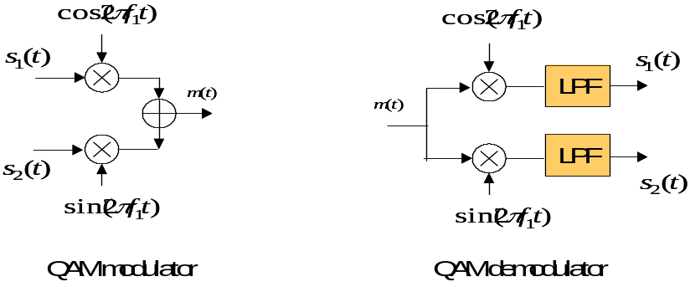

- What are the factors that one must consider when choosing the color sub-carrier frequency? What is the sub-carrier frequency used in NTSC color standard?

First, the color sub-carrier frequency f_{c} has to be sufficiently high, above the frequency range where the luminance signal is still significant; Second, f_{c} should to be lower than the audio sub-carrier by a sufficient margin, to avoid interference between audio and video. Finally, f_{c} should be chosen to be in between two harmonic peaks of the luminance signal. Let f_{l} be the line rate of the video, which is the fundamental frequency of a raster video, the luminance signal has harmonic peaks at integer multiples of f_{l} . For f_{c} to fall between these peaks, it should be equal to f_{l} /2 multiplied by an odd number. This odd integer should be chosen so that the resulting f_{c} satisfies the previous two constraints. With NTSC, the luminance signal is not very significant after 3.5 MHz, and the audio sub-carrier is at 4.5 MHz. The line rate is f_{l} =30*525=15750. The odd integer is chosen to be 455, so that f_{c} = 455 f_{l} /2 = 3.58 MHz.

- Draw a block diagram for demultiplexing YIQ components from the composite video signal (containing the baseband luminance signal and the QAM modulated I and Q). Explain each component.
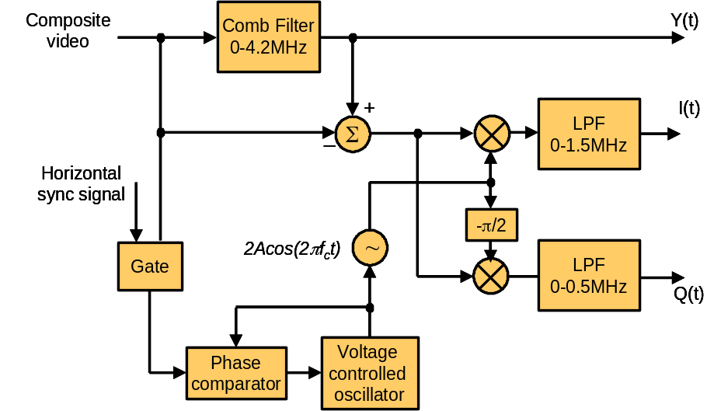

The comb filter will separate the Y from the composite signal. Subtracting Y from the composite will give the QAM multiplexed I and Q. The rest is for separating I and Q from this QAM signal. The gate is used to extract the color burst embedded in composite video. The extracted color burst signal is used to drive the phase comparator and VOC to generate a color-subcarrier signal at the receiver that is in sync with the one used at the transmitter. The rest is for standard QAM demodulation.

- Why are comb filters desired in separating luminance from chrominance than conventional low-pass/bandpass filter?

With a conventional lowpass filter, the extracted Y signal will contain the C signal and vice versa. Because the Y and C harmonic peaks interleave, by using a properly designed comb filter, better separation of Y and C can be achieved.

- Draw the overall spectrum of a color TV signal (including Y, I, Q and audio) when modulated over a carrier frequency.
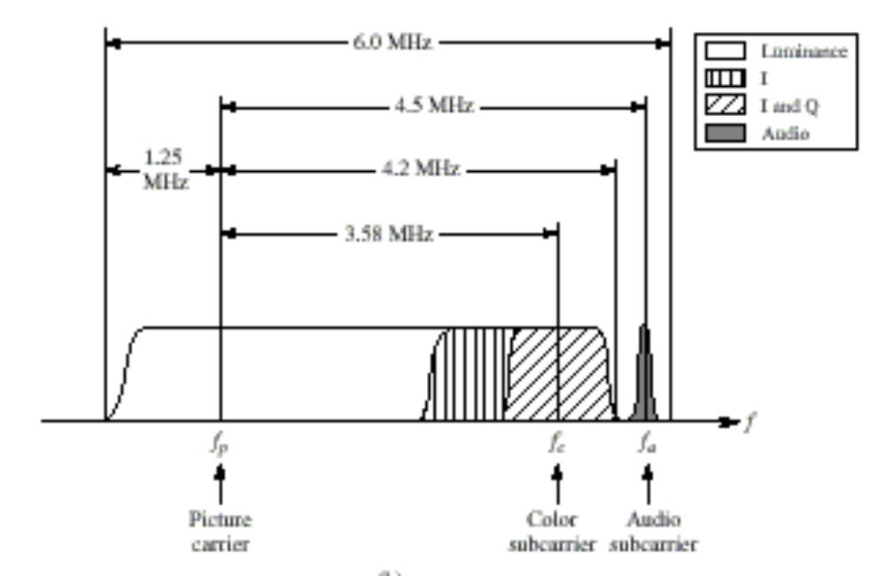

- How can a monochrome TV set automatically extract the luminance signal from a broadcasted color TV signal?

A low pass filter is used in a monochrome TV signal to extract the video signal. This lowpass filter has very low response at the spectrum range where the chrominance signal is inserted. Therefore, the retained video signal contains mostly Y component only, which carries the monochrome information.

- Draw the block diagram of the NTSC color TV transmitter and receiver, and explain functions of each component.

See figure in next page.

- Describe why backward compatibility is important in technology development.

Backward compatibility is essential for the market penetration of a new technology (e.g. color TV) when an old technology and products (e.g. monochrome TV) for the same application already exists. This is not only true for the migration of TV from monochrome to color, but in many other migrations as well, e.g. VHS to S-VHS VCR, from mono audio receiver to Hi-Fi stereo receiver, and more recently from VCD (MPEG1 movie) to DVD (MPEG2, which decodes MPEG1).

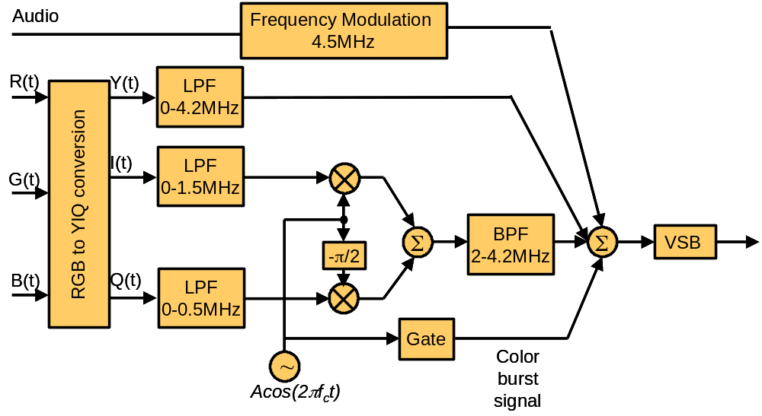

Transmitter

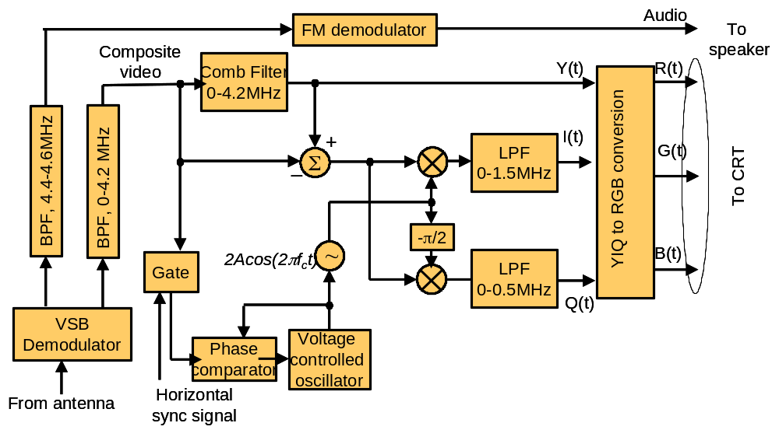

Receiver

