**System Demo**



**Program Incremet**



**Innovation and Planning**



**Iteration**

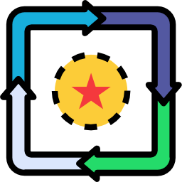

**PI Planning**



**Refinamiento Historias**



**Inception**



**Inspect and Adapt**

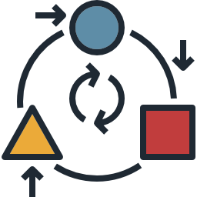

**Daily**

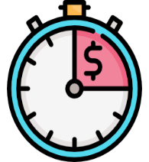

**Iteration Retrospective**



**Iteration**

**Review**



**Iteration**

**Planing**

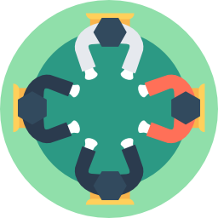

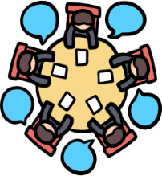

**Scrum of Scrum**

**PO Sync**



**Iteration Backlog**

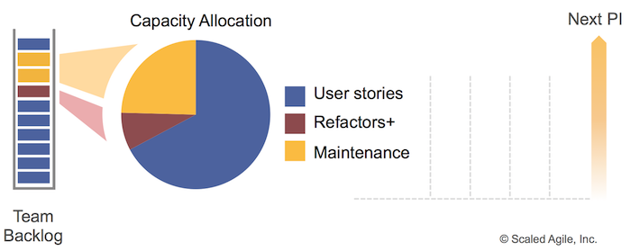

**Program Board**



**Historias de Usuario**



**Backlog**

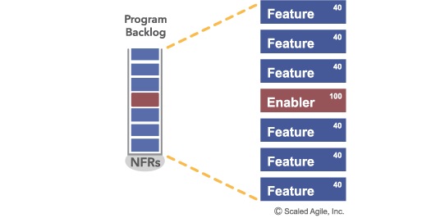

**Enabler**

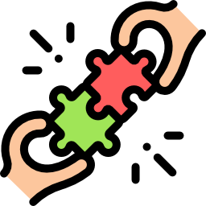

**Definition of Done**



**Definition of Ready**



**Reunión de Arquitectura**



**Product Owner**



**MVP**



**Plan PI**



**Mapa Riesgos PI**



**Objetivos PI**



**Feature**



**Dev Team**



**Scrum Master**



**Business Owners**



**Product Management**



**System Architect**



**RTE**



**Iteration**

**PI Planning**

**Refinamiento HU**

**Inception**

**Roles**

**Roles**

**Roles**

**Roles**

**Ceremonias**

**Ceremonias**

**Ceremonias**

**Ceremonias**

**Ceremonias**

**Ceremonias**

**Ceremonias**

**Ceremonias**

**Ceremonias**

**Ceremonias**

**Ceremonias**

**Ceremonias**

**Ceremonias**

**Ceremonias**

**Ceremonias**

**Ceremonias**

**Artefactos**

**Artefactos**

**Artefactos**

**Artefactos**

**Artefactos**

**Artefactos**

**Artefactos**

**Artefactos**

**Artefactos**

**Artefactos**

**Artefactos**

**Artefactos**

**Artefactos**

**Artefactos**

**Artefactos**

**Artefactos**