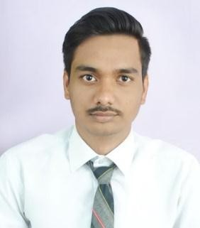ADITYA Y. MANDE

(Mechanical Engineering)

Email Id [:adityamande97@gmail.com](mailto:adityamande97@gmail.com)

Mobile No : +91-9689307122



**Career Objective**

To pursue a challenging career and be a part of progressive organization that gives scope to enhance my knowledge and utilize my skills towards the growth of the organizations.



**Work Experience**

Robert Bosch Pvt. Ltd.

**Line Leader, Zone Leader**

Pune, Maharashtra

Over 1 Year 5 Months of Progressive leadership experience in manufacturing, production, and implementation of lean process and organizational strategies. Innovated problem-solver committed to the development of a culture rooted in continuous improvement.

• Managed all aspects of the production line.

• Performed troubleshooting on equipment breakdowns.

• Checked products for quality.

• Encouraged and motivated employees to meet production deadlines and goals.

• Drafted reports and monitored progress.



**Educational Qualification**

• B.E. (Mechanical) from Nagpur University in 2019 with an aggregate of 69%.

• Diploma from K.D.K. College of Engineering in 2016 with an aggregate of 78%.

• SSC from D.D.Nagar High School in 2013 with 67%.



**Project Details**

* **TITLE : Design and Fabrication of Lorry Unloading System**

# **Description :** Main objective of this system is to eliminate traditional method which have been used for unloading bags.

As per our survey, we found such a problem which occurs in unloading of bags. So to make overcome on such problem we design a system which is light in weight and can be easily places over a lorry and unloading of bags takes place with the help of remote box. It also decreases ideal time of lorry and labor cost.



**Technical Skills**

Welding Machine operating, Lathe Machine operating and Sheet Metal operating.



**Computer Knowledge**

* Operating system: Window xp7, 8 and 10
* MSCIT
* Basic C Language



**Extra-Curricular Activities**

* Participated in quiz competition which is organized by DBACER.
* Team captain of college cricket team



**Strength**

* Problem solving
* Creative thinking
* Leadership
* Discipline and adaptable
* Believe in smart work



**Personal Details**

* Date of birth & Age :15th September 1997
* Father’s Name :Mr. Yashwantro R. Mande
* Occupation : Private Job
* Languages : English, Hindi & Marathi