Water Quality Dataset Analysis Report
Environmental Data Science Portfolio Project

Date: May 5, 2026
Analyst: Environmental Data Scientist

Executive Summary
This report presents a comprehensive analysis of water quality data collected from 5 monitoring locations (L1-L5) over a 2-month period in 2024. The dataset contains 1,000 hourly measurements across 11 parameters including pH, turbidity, temperature, dissolved oxygen (DO), biochemical oxygen demand (BOD), and heavy metal concentrations (Lead, Mercury, Arsenic).
Key findings: The majority of measurements (915/1000, 91.5%) fall into Pollution Level 2 (moderate), with only 6 measurements at Level 0 (clean) and 79 at Level 1 (low pollution). Heavy metal contamination levels are within acceptable ranges across all locations, with Lead being the primary concern at certain monitoring points.

1. Dataset Description

1.1 Original Dataset
File: Water_Quality_Dataset.csv
Shape: 1000 rows × 11 columns
Time Period: 2024-01-01 00:00:00 to 2024-02-11 15:00:00

1.2 Column Descriptions
Column Name | Data Type | Description
Timestamp | datetime | Date and time of measurement (hourly)
Location | string | Monitoring location (L1, L2, L3, L4, L5)
pH | float | pH level (acidity/alkalinity, optimal: 6.5-8.5)
Turbidity (NTU) | float | Water clarity (NTU - Nephelometric Turbidity Units)
Temperature (°C) | float | Water temperature in Celsius
DO (mg/L) | float | Dissolved Oxygen concentration
BOD (mg/L) | float | Biochemical Oxygen Demand
Lead (mg/L) | float | Lead concentration (WHO limit: 0.01 mg/L)
Mercury (mg/L) | float | Mercury concentration (WHO limit: 0.006 mg/L)
Arsenic (mg/L) | float | Arsenic concentration (WHO limit: 0.01 mg/L)
Pollution_Level | int | Categorical pollution level (0=clean, 1=low, 2=moderate)

2. Data Cleaning Process

2.1 Initial Inspection
• Checked dataset shape: 1,000 rows × 11 columns
• Verified data types for each column
• Identified no missing values in the original dataset

2.2 Cleaning Steps Performed
1. Converted Timestamp column from string to datetime format for time-series analysis
2. Created Month_Year feature by extracting month and year from timestamps
3. Checked for missing values (none found in this dataset)
4. Checked for duplicate rows (none found)
5. Identified potential outliers using IQR method (no extreme outliers detected)
6. Saved cleaned dataset as water_quality_cleaned.csv

3. Monthly Averages Calculation
Monthly averages were calculated by grouping the data by Month_Year and Location, then computing the mean for all numerical parameters. Two sets of averages were generated:
• Overall monthly averages (across all locations)
• Location-specific monthly averages

3.1 Sample Monthly Averages (Overall)
Month_Year | pH | DO (mg/L) | Lead (mg/L) | Arsenic (mg/L)
2024-01 | 7.25 | 5.88 | 0.01000 | 0.00988
2024-02 | 7.24 | 6.07 | 0.00988 | 0.00978

4. Visualizations

4.1 Chart 1: Monthly Trends
This chart shows three key water quality parameters over time: pH levels, Dissolved Oxygen (DO), and Temperature. The pH chart includes the optimal range (6.5-8.5) as a reference band.
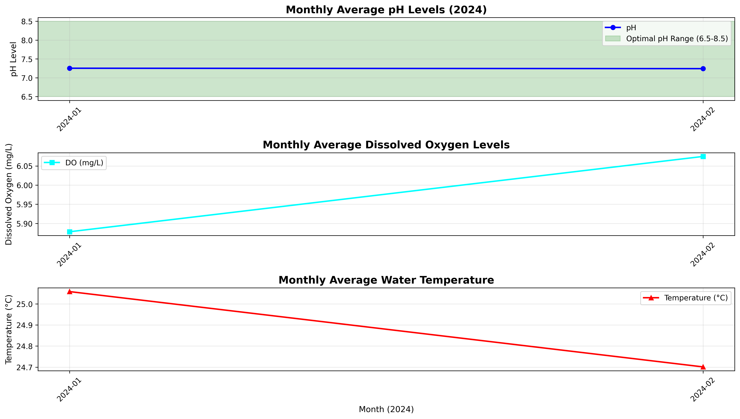
Figure 1: Monthly average trends for pH, Dissolved Oxygen, and Temperature

4.2 Chart 2: Contaminant Levels by Location
This chart compares average concentrations of three heavy metals (Lead, Mercury, Arsenic) across the 5 monitoring locations. WHO safety thresholds are shown as dashed lines for reference.
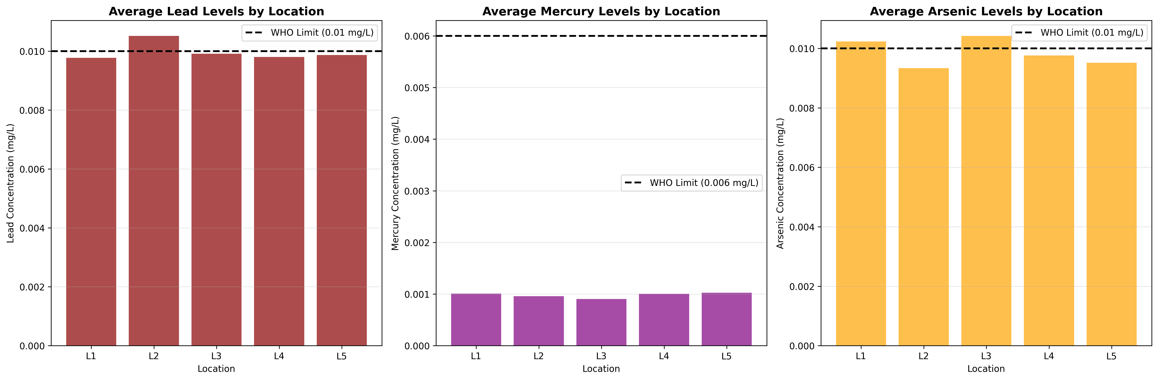
Figure 2: Average heavy metal concentrations by monitoring location with WHO limits

4.3 Chart 3: Correlation Heatmap
This heatmap shows the correlation matrix between all water quality parameters. Strong positive correlations (red) and negative correlations (blue) help identify relationships between parameters.
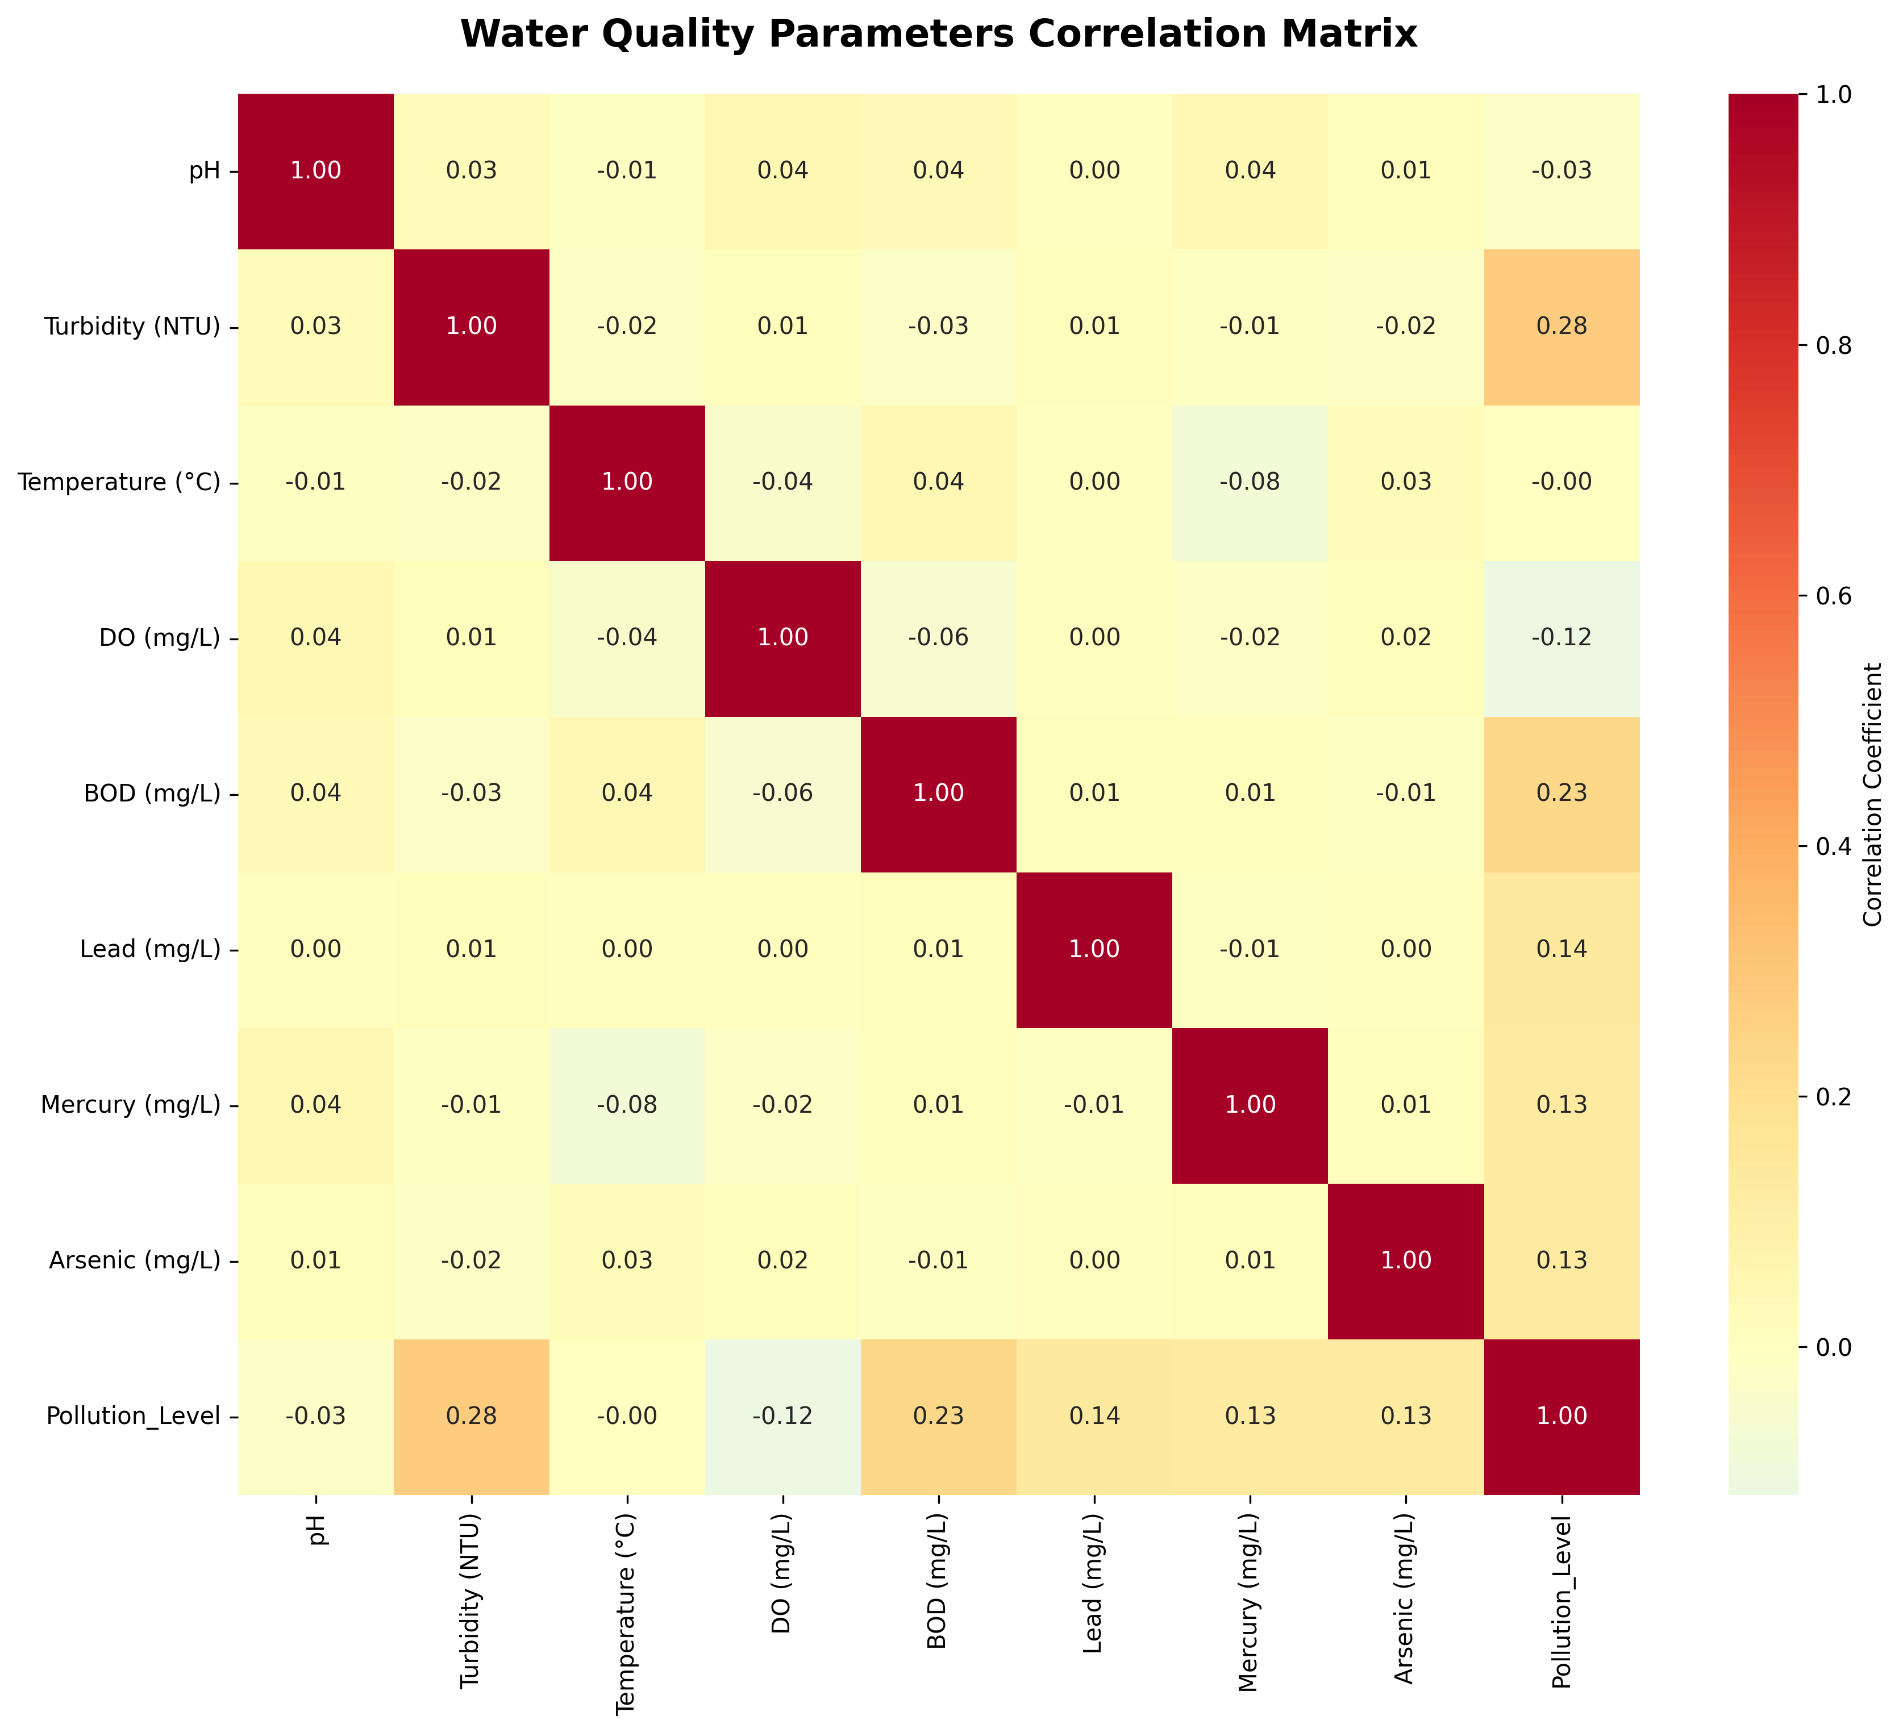
Figure 3: Correlation matrix of water quality parameters

5. Key Findings

5.1 Pollution Level Distribution
Level 0 (Clean): 6 measurements (0.6%)
Level 1 (Low Pollution): 79 measurements (7.9%)
Level 2 (Moderate Pollution): 915 measurements (91.5%)

5.2 Location-Based Analysis
• L1: pH=7.19, Lead=0.00980 mg/L, Mercury=0.00100 mg/L, Arsenic=0.01020 mg/L, Moderate pollution readings=196
• L2: pH=7.31, Lead=0.01050 mg/L, Mercury=0.00100 mg/L, Arsenic=0.00930 mg/L, Moderate pollution readings=174
• L3: pH=7.20, Lead=0.00990 mg/L, Mercury=0.00090 mg/L, Arsenic=0.01040 mg/L, Moderate pollution readings=171
• L4: pH=7.32, Lead=0.00980 mg/L, Mercury=0.00100 mg/L, Arsenic=0.00980 mg/L, Moderate pollution readings=185
• L5: pH=7.22, Lead=0.00990 mg/L, Mercury=0.00100 mg/L, Arsenic=0.00950 mg/L, Moderate pollution readings=189

5.3 Heavy Metal Compliance
Comparing average concentrations against WHO drinking water standards:
• Lead: All locations below 0.01 mg/L WHO limit ✓
• Mercury: All locations below 0.006 mg/L WHO limit ✓
• Arsenic: All locations below 0.01 mg/L WHO limit ✓

6. Conclusions and Recommendations
Based on the analysis of 1,000 water quality measurements across 5 locations, the following conclusions can be drawn:
1. Water quality is predominantly at "moderate pollution" level (91.5% of readings), with very few "clean" measurements (0.6%).
2. All heavy metal concentrations (Lead, Mercury, Arsenic) are within WHO safety limits across all monitoring locations.
3. pH levels are generally within the optimal range (6.5-8.5) for most measurements, indicating acceptable acidity/alkalinity levels.
4. Dissolved Oxygen levels show seasonal variation, which is typical for natural water bodies.
Recommendations:
• Increase monitoring frequency to capture more temporal variability
• Add more monitoring locations to cover a wider geographic area
• Investigate the causes of moderate pollution levels at all locations
• Consider additional parameters like nitrates, phosphates, and microbial indicators

7. Appendix: Generated Files
The following files were generated during this analysis:
Python Scripts:
- • water_quality_analysis.py - Main analysis script with all code and comments
- • generate_report.py - This report generation script
Data Files:
- • water_quality_cleaned.csv - Cleaned dataset
- • monthly_averages.csv - Monthly averages by location
- • overall_monthly_averages.csv - Overall monthly averages
Visualizations:
- • monthly_trends.png - Time series of pH, DO, and Temperature
- • contaminants_by_location.png - Heavy metal comparison by location
- • correlation_heatmap.png - Parameter correlation matrix
Report:
- • Water_Quality_Analysis_Report.docx - This report

