Hospital Management System

Database Project

CSE311

// ER Diagram

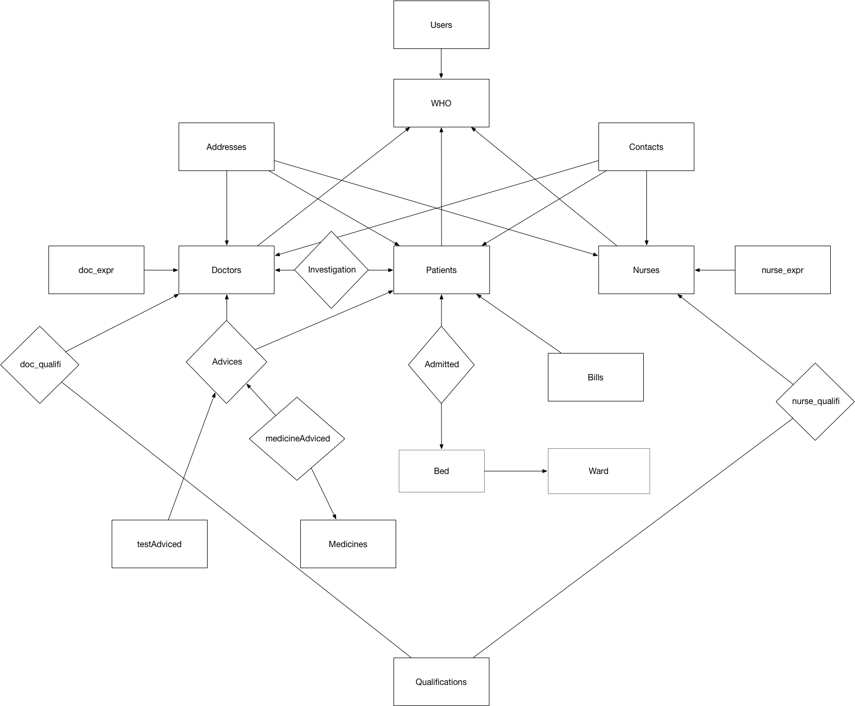

//Relational Schema

Addresses (addressId,street,streetName,area,thana,district);

Contacts (contactId,mob1,mob2,email);

Qualifications (quaId,quaName);

Patients(patientId,dateOfAdmission,fName,mName,lName,dateOfBirth,contactId,presAddress,permAddress,profession,amountDeposite,wardId ,depositorName,depositors);

Admitted (patientId,bedId);

Beds (bedId,bedType,bedRent,bedStatus,wardId);

Wards (wardId,warName,registerId,superviserId);

Bills (patientId,totalBill);

Investigations(patientId,height,weight,symptom,bloodPressure,breakfast,lunch,dinner,games,other,diseaseName,doctorId);

Doctors(doctorId,dateOfAppointment,fName,mName,lName,dateOfBirth,contactId,presAddress,permAddress,workingDays,specilation,registerId,membership,visitFee);

doc_exper (doctorId,title,started,till,org)

doc_qualifi (doctorId,quaId,board,year,cgpa,position);

Nurses (nurseId,dateOfAppointment ,fName,mName,lName,dateOfBirth ,contactId ,presAddress ,permAddress,dutyShift,superviserId);

nurse_exper (nurseId,title,started,till,org);

nurse_qualifi (nurseId,quaId,board,year,cgpa,position);

Advices (AdviceId,doctorId,patientId);

medicineAdviced (medicineId,adviceId,quantity,times,beforeAfter,medAdId);

Medicines (medicineId ,medicineName,medicineType,unitePrice double,quantity ,dateOfManu,expireDate);

testAdviced (adviceId,testName,testCategory);

WHO(id,type);

Users(user,pass,id);

//SQL DDL

CREATE TABLE Addresses (

addressId int(11) NOT NULL AUTO_INCREMENT,

street varchar(15) DEFAULT NULL,

streetName varchar(30) DEFAULT NULL,

area varchar(30) DEFAULT NULL,

thana varchar(30) DEFAULT NULL,

district varchar(30) DEFAULT NULL,

PRIMARY KEY (addressId);

);

CREATE TABLE Admitted (

patientId int(11) NOT NULL,

bedId int(11) NOT NULL

FOREIGN KEY (patientId) REFERENCES Patients (patientId)

ON DELETE CASCADE

ON UPDATE CASCADE,,

FOREIGN KEY (bedId) REFERENCES Beds (bedId),

ON DELETE CASCADE,

ON UPDATE CASCADE

);

CREATE TABLE Advices (

AdviceId int(11) NOT NULL AUTO_INCREMENT,

doctorId int(11) DEFAULT NULL,

patientId int(11) DEFAULT NULL,

PRIMARY KEY (AdviceId),

FOREIGN KEY (doctorId) REFERENCES Doctors (doctorId),

FOREIGN KEY (patientId) REFERENCES Patients (patientId)

);

CREATE TABLE Beds (

bedId int(11) NOT NULL AUTO_INCREMENT,

bedType varchar(30) DEFAULT NULL,

bedRent double NOT NULL,

bedStatus tinyint(1) DEFAULT NULL,

wardId int(11) DEFAULT NULL,

PRIMARY KEY (bedId),

wardId FOREIGN KEY (wardId) REFERENCES Wards (wardId)

ON DELETE CASCADE ON UPDATE CASCADE;

);

CREATE TABLE Bills (

patientId int(11) DEFAULT NULL,

totalBill double DEFAULT NULL,

FOREIGN KEY (patientId) REFERENCES Patients (patientId)

);

CREATE TABLE Contacts (

contactId int(11) NOT NULL AUTO_INCREMENT,

mob1 int(15) DEFAULT NULL,

mob2 int(30) DEFAULT NULL,

email varchar(45) DEFAULT NULL

);

CREATE TABLE Doctors (

doctorId int(11) NOT NULL AUTO_INCREMENT,

dateOfAppointment date NOT NULL,

fName varchar(30) NOT NULL,

mName varchar(30) NOT NULL,

lName varchar(30) NOT NULL,

dateOfBirth date NOT NULL,

contactId int(11) DEFAULT NULL,

presAddress int(11) NOT NULL,

permAddress int(11) DEFAULT NULL,

workingDays varchar(7) DEFAULT NULL,

specilation varchar(60) DEFAULT NULL,

registerId int(11) DEFAULT NULL,

membership varchar(60) DEFAULT NULL,

visitFee double DEFAULT NULL,

FOREIGN KEY (contactId) REFERENCES Contacts (contactId),

FOREIGN KEY (presAddress) REFERENCES Addresses (addressId),

FOREIGN KEY (permAddress) REFERENCES Addresses (addressId)

);

CREATE TABLE doc_exper (

doctorId int(11) DEFAULT NULL,

title varchar(256) DEFAULT NULL,

started date DEFAULT NULL,

till date DEFAULT NULL,

org varchar(256) DEFAULT NULL,

FOREIGN KEY (doctorId) REFERENCES Doctors (doctorId)

);

CREATE TABLE doc_qualifi (

doctorId int(11) DEFAULT NULL,

quaId int(11) DEFAULT NULL,

board varchar(30) DEFAULT NULL,

year int(11) DEFAULT NULL,

cgpa float(4,2) DEFAULT NULL,

position int(11) DEFAULT NULL,

FOREIGN KEY (doctorId) REFERENCES Doctors (doctorId)

ON DELETE CASCADE

ON UPDATE CASCADE,

FOREIGN KEY (quaId) REFERENCES Qualifications (quaId)

ON DELETE CASCADE

ON UPDATE CASCADE

);

CREATE TABLE Investigations (

patientId int(11) DEFAULT NULL,

height int(11) DEFAULT NULL,

weight int(11) DEFAULT NULL,

symptom varchar(256) DEFAULT NULL,

bloodPressure varchar(30) DEFAULT NULL,

breakfast varchar(256) DEFAULT NULL,

lunch varchar(256) DEFAULT NULL,

dinner varchar(256) DEFAULT NULL,

games varchar(256) DEFAULT NULL,

other varchar(256) DEFAULT NULL,

diseaseName varchar(60) DEFAULT NULL,

doctorId int(11) DEFAULT NULL

);

CREATE TABLE medicineAdviced (

medicineId int(10) UNSIGNED DEFAULT NULL AUTO_INCREMENT,

adviceId int(11) DEFAULT NULL,

quantity int(11) DEFAULT NULL,

times int(11) DEFAULT NULL,

beforeAfter int(11) DEFAULT NULL,

medAdId int(11) NOT NULL AUTO_INCREMENT,

FOREIGN KEY (medicineId) REFERENCES Medicines (medicineId)

ON DELETE NO ACTION

ON UPDATE CASCADE,

FOREIGN KEY (adviceId) REFERENCES Advices (AdviceId)

ON DELETE CASCADE

ON UPDATE CASCADE

);

CREATE TABLE Medicines (

medicineId int(10) UNSIGNED NOT NULL AUTO_INCREMENT,

medicineName varchar(40) NOT NULL,

medicineType varchar(30) NOT NULL,

unitePrice double NOT NULL,

quantity int(11) NOT NULL,

dateOfManu date NOT NULL,

expireDate date NOT NULL

);

CREATE TABLE Nurses (

nurseId int(11) NOT NULL AUTO_INCREMENT,

dateOfAppointment date NOT NULL,

fName varchar(30) NOT NULL,

mName varchar(30) NOT NULL,

lName varchar(30) NOT NULL,

dateOfBirth date NOT NULL,

contactId int(11) NOT NULL,

presAddress int(11) NOT NULL,

permAddress int(11) DEFAULT NULL,

dutyShift varchar(7) NOT NULL,

superviserId int(11) DEFAULT NULL,

FOREIGN KEY (contactId) REFERENCES Contacts (contactId)

ON UPDATE CASCADE,

FOREIGN KEY (presAddress) REFERENCES Addresses (addressId)

ON UPDATE CASCADE,

FOREIGN KEY (permAddress) REFERENCES Addresses (addressId)

ON UPDATE CASCADE

);

CREATE TABLE nurse_exper (

nurseId int(11) DEFAULT NULL,

title varchar(256) DEFAULT NULL,

started date DEFAULT NULL,

till date DEFAULT NULL,

org varchar(256) DEFAULT NULL,

FOREIGN KEY (nurseId) REFERENCES Nurses (nurseId)

);

CREATE TABLE nurse_qualifi (

nurseId int(11) NOT NULL,

quaId int(11) NOT NULL,

board varchar(30) NOT NULL,

year date NOT NULL,

cgpa double(4,2) NOT NULL,

position int(11) DEFAULT NULL,

FOREIGN KEY (nurseId) REFERENCES Nurses (nurseId)

ON DELETE CASCADE

ON UPDATE CASCADE,

FOREIGN KEY (quaId) REFERENCES Qualifications (quaId)

ON DELETE CASCADE

ON UPDATE CASCADE

);

CREATE TABLE Patients (

patientId int(11) NOT NULL AUTO_INCREMENT,

dateOfAdmission date DEFAULT NULL,

fName varchar(30) DEFAULT '',

mName varchar(30) DEFAULT '',

lName varchar(30) DEFAULT '',

dateOfBirth date DEFAULT NULL,

contactId int(11) DEFAULT NULL,

presAddress int(11) DEFAULT NULL,

permAddress int(11) DEFAULT NULL,

profession varchar(45) DEFAULT NULL,

amountDeposite double DEFAULT NULL,

wardId int(11) DEFAULT NULL,

depositorName varchar(60) DEFAULT NULL,

depositorsRel varchar(30) DEFAULT NULL,

FOREIGN KEY (presAddress) REFERENCES Addresses (addressId)

ON UPDATE CASCADE,

FOREIGN KEY (permAddress) REFERENCES Addresses (addressId)

ON UPDATE CASCADE,

FOREIGN KEY (wardId) REFERENCES Wards (wardId)

ON UPDATE CASCADE

);

CREATE TABLE Qualifications (

quaId int(11) NOT NULL,

quaName varchar(30) NOT NULL

);

CREATE TABLE testAdviced (

adviceId int(11) DEFAULT NULL,

testName varchar(40) DEFAULT NULL,

testCategory varchar(40) DEFAULT NULL,

FOREIGN KEY (adviceId) REFERENCES Advices (AdviceId)

ON DELETE CASCADE

ON UPDATE CASCADE

);

CREATE TABLE Users (

user varchar(30) DEFAULT NULL,

pass varchar(30) DEFAULT NULL,

id int(11) NOT NULL

);

CREATE TABLE Wards (

wardId int(11) NOT NULL AUTO_INCREMENT,

warName varchar(30) DEFAULT NULL,

registerId int(11) NOT NULL,

superviserId int(11) NOT NULL,

PRIMARY KEY (wardId)

);

CREATE TABLE WHO (

id int(11) NOT NULL,

type varchar(20) DEFAULT NULL,

PRIMARY KEY (id)

);