Abstract
This section details the conceptual modeling assumptions and stereotypes that will potentially be used in the threat/risk RFP but will be formally defined in SIMF (Semantic Information Modeling for Federation). SIMF will be submitted with threat/risk.
This is a work in progress, please contribute!
Contents
1.1 Abstract 1
1.2 Foundational Assumptions 3
1.2.1 Multiple representations of overlapping concepts 3
1.2.2 Models include data 3
1.2.3 Conceptual Models 3
1.2.4 Identity and identifiers 3
1.2.5 Facts 3
1.2.6 REPRESENTATIONs of a CONCEPT 4
1.2.7 REPRESENTATION identifiers 4
1.2.8 CONCEPT representation identifiers 5
1.2.9 Sources 5
1.2.10 Ownership 5
1.2.11 Lifetime and context of facts 6
1.3 Conceptual Modeling Profile Reference 7
1.3.1 Stereotype: Classification [Classifier] 7
1.3.2 Stereotype: Classifies [Generalization, Realization] 7
1.3.3 Stereotype: Conceptual Model [Package] 7
1.3.4 Stereotype: Disjoint with [Dependency] 8
1.3.5 Stereotype: Entity [Class] 9
1.3.6 Stereotype: Equivalent with [Dependency] 9
1.3.7 Stereotype: Intersection [Classifier] 9
1.3.8 Stereotype: Is in context [Relationship] 10
1.3.9 Stereotype: Source Reference [Classifier] 10
1.3.10 Stereotype: Phase [Class] 11
1.3.11 Stereotype: Quantity Kind [Classifier] 11
1.3.12 Stereotype: Represents [Realization] 12
1.3.13 Stereotype: Restriction [Association, Instance Specification] 12
1.3.14 Stereotype: Role [Class] 13
1.3.15 Stereotype: Union [Classifier] 14
1.3.16 Mapping Profile 14
1.3.17 Stereotype: Mapping [Package] 14
1.3.18 Stereotype: Physical [Package] 15
1.3.19 Stereotype: Rule [Class, Collaboration] 15

Foundational Assumptions

Multiple representations of overlapping concepts
A base assumption is that there are and will be multiple information resources that represent information about the same and overlapping things. These different representations may use different definitional languages (e.g. XML Schema, SQL, RDF, UML) and well as different domain terminology and human languages (e.g. Risk, Danger, Achtung, Risque). Our task is to federate information from multiple sources as well as express information from one source in another form.

Models include data
Any structured set of information about anything is considered a “model”. This usage of the term model is consistent with the ontological usage but is an expansion of the term as typically used in modeling languages such as UML.

Conceptual Models
For a SIMF implementation there will exist a conceptual model that contains a all the concepts to be interpreted and various mappings to physical or logical data representations. We will use the label CONCEPT and REPRESENTATION thorough to represent elements at both levels. It should also be noted that REPRESENTATION may or may not be fully physical, some REPRESENTATIONs may, in turn, have various syntaxes. For example, there are multiple syntaxes for RDF. We are treating all these layers of REPRESENTATION the same with the assumption there is an isomorphic transform between elements in the same REPRESENTATION family (e.g. the RDF logical model and RDF in Turtle Syntax). The conceptual model will be the “hub” or “pivot point” to integrate multiple REPRESENTATION models.
Conceptual models are intended to be models of the world – real world things. Facts about real world things are represented by data models in a data REPRESENTATION form but these facts also have a CONCEPT counterpart. While any implementation of a conceptual model must have some representation and/or behavior, the representation is abstract in terms of the specification (there is no normative syntax for data about instances of a conceptual model).
There are many possible implementation choices for CONCEPT models. Implementations MAY use the conceptual model only as a “virtual” rule set and have no physical representation of information about CONCEPT instances. Implementations MAY instantiate a physical representation corresponding directly to the conceptual model.
There is no assumption of any single or distinguished conceptual model. CONCEPT is a role for a model, some conceptual models may be derived from existing REPRESENTATIONs – particularly model based representations such as UML or OWL. Of course, some models will make better conceptual hubs than others. The Threat/RISK model is designed to be a conceptual model and will be refactored as required to represent the set of concepts represented by the REPRESENTATIONs it is intended to federate

Identity and identifiers
There are different forms of identity and identifiers. There is the identity of the “real world” thing that some representation is stating facts about and there is the identity of the representation (the data or assertion - facts or statements). An identifier for a thing is called its “sign”. The sign of the real-world thing and the sign of data about that thing are not the same. Most REPRESENTATION models have representation identifiers but sometimes confuse these as signs for (identifiers for) the real world thing. Further, anything may have multiple identifiers – however many technologies only have one. “Keys” tend to be signs for real things, but this is not consistent.

Facts
The term “fact” as used here is based on “fact modeling” but does not necessarily mean that something is “true”, a fact is some statement that asserts something - it may or may not be true and that truth may be contextual. Other terms could be “assertion” or “statement”.

REPRESENTATIONs of a CONCEPT
Where there exists some CONCEPT of something there is a REPRESENTATION data element representing facts about this concept. The concept is also a representation is some respects, but this representation is playing the role of representing the real-world thing, not a data structure.

Relation
- Verb form: representation pattern→represents→CONCEPT pattern
- Noun form: Representation(representation pattern, CONCEPT pattern)
“Represents” provides the basis for the relation between a REPRESENTATION and a CONCEPT. Both ends or the represents relation require an identity for the “fact” or “facts” being represented. Thus “represents” depends on the ability to identify both the REPRESENTATION and CONCEPT fact. See 1.2.7.
The represents relation asserts that the REPRESENTATION element represents information about the CONCEPT. The information is not assumed to be complete or consistent. For various types of concepts this implies:
- Individuals: That the REPRESENTATION individual is a sign for facts (data) about the CONCEPT individual. Individuals are identifiable instances where the extent of the sign represents a single “thing” in the world. Types, context, relations and values are not individuals.
- Types: That the REPRESENTATION type describes the CONCEPT type. The extent of the REPRESENTATION type MAY be a subset of the extent of the CONCEPT type.
- Context: That the REPRESENTATION context contextualizes all or a subset of the CONCEPT context.
- Relations: That the relation semantics holds true for the bound elements of both the REPRESENTATION and CONCEPT

REPRESENTATION identifiers
A REPRESENTATION resource contains a set of facts, such a resource may change over time so the set of facts may also change. At a particular time, as seen from a “transaction”, a resource has a fixed set of facts. Within a transaction a particular fact has an IDENTITY. The IDENTITY may be the same across multiple transactions from the same resource. The combination of the identity of the transaction and the identity of the fact within that transaction must be universally unique.
A fact in a REPRESENTATION resource has an IDENTIFIER. The form and structure of that identifier is technology dependent and not determined in this specification but it must be representable as a text string. Given a transaction/fact identifier combination any fact must be traceable to its origin. Where this pattern is replicated to the source of the fact, full provenance of the information is provided. A REPRESENTATION model may provide additional provenance information as part of a transaction and/or resource source reference but the semantics of that provenance is not assured unless the source is also a SIMF model.
Identical REPRESENTATION identifiers, within the same resource, are assumed to identify the same concept. Identical identifiers within different resources MAY be interpreted as identifying the same concept. Such identifiers are frequently called UUIDs or GUIDS.

Example physical identifiers
The STIX fragment:
<stix:TTP id="opensource:ttp-62ff7599-e1db-414f-b742-908def2ec219"
timestamp="2014-11-06T17:46:28.913306+00:00"
xsi:type="ttp:TTPType" version="1.1.1">
<ttp:Title>ZeuS</ttp:Title>
</stix:TTP>

Could use an XPATH expression for the ID, such as: ‘//*[@ID=”opensource:ttp-62ff7599-e1db-414f-b742-908def2ec219]’ as the physical ID for the TTP fact (asserting the existence of the TTP) and "‘//*[@ID=”opensource:ttp-62ff7599-e1db-414f-b742-908def2ec219”:]/Title[1]’ as the ID for the title fact.
Physical identifiers are not typically exposed to the user.

CONCEPT representation identifiers
All conceptual facts, or “CONCEPTS” reside in some knowledge base, this knowledge base has a unique physical and logical identity. Within a knowledge base there exists a set of concepts with an identifier unique within that knowledge base. The combination of the knowledge base identifier and the concept identifier must be universally unique.

Sources
All concepts come from some source outside of the conceptual system (even if this is a rule or inference operating in the conceptual system). Concepts have a SOURCE. All sources produce concept representations via some rule (inferences are considered rules). A REPRESENTATION of a concept (represents relation) is one such rule. Thus all concepts may be traced to their source as it existed at a particular time and was interpreted or computed based on a rule at that time.

Relation:
- Verb form: Fact→has source→Source Record
- Noun form: Source(Fact, Source Record)
Every conceptual fact has a source, that source identifies:
- The transaction. Transactions identify any physical resource as well as the time of the transaction.
- The rule that produced the fact
- The REPRESENTATION source identifier(s)
Since facts come from an identifiable source, that source and any internal structure MAY be used as a hint in producing the fact identifier. For resources with internal structure, this would typically be the Resource followed by a set of Packages followed by some name, ID or path of the REPRESENTATION fact.
The same source MAY result in multiple concepts. A representation concept is unique to a source but may be declared as equivalent to other representations concept.

Ownership
A representation concept, other than a resource, shall be “owned” by another concept, this ownership shall correspond with the structure of the source where such structure is important in interpreting the concept. The concept statement is owned, the ownership of the statement has no semantic interpretation with relation to what the concept means. Ownership of the concept may have a semantic interpretation as to the authority, scope or timeframe of the concept.
Ownership is one dimension of “context”, a concept may be contextualized by any number of context. Context may impact the interpretation of or trust in a concept. The context set of an owner in included in the context sets of concepts it owns.

Lifetime and context of facts
Logically concepts are never “deleted”, they may become irrelevant or dated as would be determined by statements about the concept. Implementations MAY optimize a knowledge base by deleting facts that have been determined to be irrelevant for all purposes of the knowledge base (i.e. they would never impact the truth of any computation or query). Deletion of facts is not, in general, recommended (deletion is so 20th century).
Example: the fact “Thomas Woodrow Wilson is president of the United States” was true “March 4, 1913 through March 4, 1921”. We accept it will always be true that this fact was true in this timeframe, so there is no sense in “deleting” the fact. The timeframe fact “March 4, 1913 through March 4, 1921” is a fact about the fact: “Thomas Woodrow Wilson is president of the United States”. Another fact about this fact is that its source resource was http://www.whitehouse.gov on January 14th, 2015 at 9:05PM-EST.
Note that the above implies that there may be more than one FACT that says exactly the same thing, but they may come from different sources or be stated in different context or timeframes. Or, different sources or context may assert conflicting facts about the same thing. Trust is a function of the interpretation of a set of facts, including their source, timeframe and context. Interpretation is time dependent (i.e. transactional), with respect to a given set of context operating on a given knowledge base at a given time. (Note that a knowledge base may include all or part of the contents of other repositories and that repositories may be physical or virtual). A knowledge base could be as small as one or more files on your tablet or as large as Google or Wikipedia.

Conceptual Modeling Profile Reference
The following documents the UML stereotypes defined for SIMF models, as such not all of these stereotypes are necessarily used within the threat/risk mode, but all are available for use. Each stereotype has a mapping to the SIMF meta model and logical grounding.

Stereotype: Classification [Classifier]
A classification describes a particular type definition to which an individual conforms at a particular time and in a particular set of context. Classifications may be added to or removed from an individual over time and in different context. All subtypes of a classification are classifications.
- Known subtypes: Role, Phase
For examples see “Classifies”.
See also:
- LEADing: <<type>>

Stereotype: Classifies [Generalization, Realization]
A classification defined by a <<Classifies>> generalization or realization is an arbitrary classification of an entity beyond any fundamental entity type. <<Classifies>> implies that the subtype is a <<Classification>>.
Examples
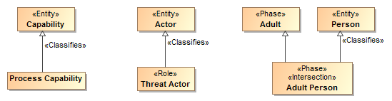
- Process capability is a classification that classifies Capabilities.
- Threat Actor is a role that classifies Actor
- An adult person is a phase of a person that is also an adult.

Stereotype: Conceptual Model [Package]
A conceptual model represents signs, assertions and classifications for “real world” objects. A conceptual model models the world (or a conceptualization of it), not data or computation. Conceptual models are the foundation of this specification.

URI:String (From UML)
A unique logical identifier for the model.
Examples
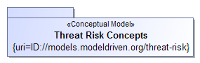
The package “Threat Risk Concepts” is marked as a conceptual model. The URI for this model is: ID://models.modeldriven.org/threat-risk.
Note: As a convention we are using “ID” for “Identity” to distinguish such URIs from internet addresses but otherwise use the HTTP naming convention. The relationship between an ID and any physical resource is outside of this specification.

Stereotype: Disjoint with [Dependency]
Disjoint specifies that the extent of real-world individuals for which the dependent elements are a sign, classification for or context of have no elements in common.
Note: We do NOT assume that anything has only one type or instance representation unless stated otherwise.
Examples
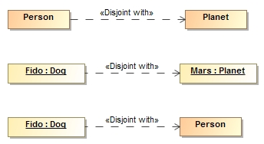
- No people are also planets
- Fido (A dog) is not Mars (APlanet). {the set of things that are Fido is disjoint with the set of things that are Mars}.
- Fido (A dog) is not a person (Even if Fido’s owner things he is). {the set of things that are Fido is disjoint with the set of things that are a Person}.

Stereotype: Entity [Class]
An entity is a foundational type of a class, what it essentially “is” as opposed to the roles it may play, phases it may be in or other arbitrary classifications. It is not expected that the entity type of an individual would change (TBD: Should it be illegal for a fundamental type of an instance to change?).
Examples
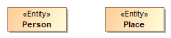
Person and Place are fundimental types.
See also
- LEADing: <<object>>

Stereotype: Equivalent with [Dependency]
Equivalent is an assertion that two elements in a model or data resource represent the same thing or set of things. Unlike ontological languages it is not assumed that the two elements are consistent as statements from different context may or may not agree.
Examples
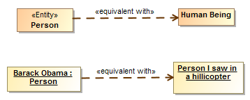
- Person and Human are equivelent types, they have the same extent.
- Barack Obama is the person I saw in a helicopter last night.
See also
- ODM/OWL: SameAs, EquivalentClass, EquivalentProperty

Stereotype: Intersection [Classifier]
An intersection is a class that has an extent which is the complete intersection of the extents of all supertypes. Intersection is a stronger statement than a subtype as a subtype may not be a complete intersection. If an instance has all supertypes the intersection type will be inferred.
Examples
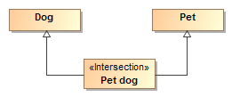
All dogs that are pets are pet dogs.

See also
- ODM/OWL: intersectionOf

Stereotype: Is in context [Relationship]
<<Is in context>> is an assertion that the source of the relationship is in the context of the target of the relationship. All assertions and rules defined in the target context apply to the source and everything in the context of the source (in context is transitive). Packages, classes, situations and instances are typical context.

Examples
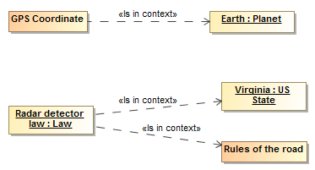
- GPS coordinates apply within the context of earth.
- The Radar detector law applies in the context of the state of Virginia and is in the context of rules of the road.

Stereotype: Source Reference [Classifier]
<<Reference>> provides traceability to the source of a piece of information in some information resource to facilitate provenance. Reference is a statement about the model data and has no semantic implication. Source reference may impact the trust in a statement but the evaluation of trust is outside of this specification.

Tag definitions
- Kind:String Specifies the kind of resource being referenced. (E.G. “XML”)
- Resource:URL Specifies the location of the resource
- Path:String Specifies the location of the information in the source. The form of expression of the path is dependent on the Kind.. Kinds and path languages are not defined in this specification.
- When: DateTime Specifies when the information was first asserted in the resource.
- TransactionID:String Transaction ID for the information.

Stereotype: Phase [Class]
Phase classifies some portion of an entities lifetime. Also known as a “State”.
Supertypes
- Classification
Examples
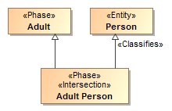
Adult is a phase (what it classifies not stated here). An Adult Person represents a phase in the life of a person.

Stereotype: Quantity Kind [Classifier]
<<Quantity Kind>> is an aspect common to mutually comparable quantities represented by one or more units. Units with a common quantity kind may be algorithmically converted to any other unit of that quantity kind. e.g. temperature.[ JCGM 200:2008].
Typically Units <<represents>> quantity kinds.
Examples
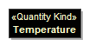
See also
- JCGM 200:2008

Stereotype: Represents [Realization]
<<Represents>> is an assertion that the source type or feature provides a more concrete way to represent the target type or feature. Represents may be used within conceptual models or from a physical model to a conceptual model.
Tag definitions
- In context:Namespace – context in which the representation applies
- Condition:Expresson – condition that must be true for the rule to fire
- Type – narrows the type in the conceptual model, usually used for properties
- TEMPLATE – rules that implement the representation
- CONCEPT:Property – the TEMPLATE parameter that maps to the concept (target)
- REPRESENTATION:Property – the template property that maps to the representation (source)
Examples
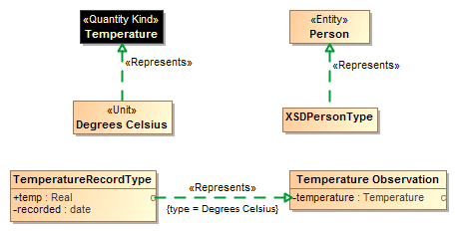
- Degrees Celsius is a unit to represent Temperature. Note that there could still be different ways to represent Degrees Celsius (e.g. As a real or integer)
- XSDPersonType (From a physical model) is a way to represent data about a Person (From a conceptual model)
- TemperatureRecordType::temp represents Temperature Observation::temperature as Degreed Celsius

Stereotype: Restriction [Association, Instance Specification]
A <<Restriction>> applied to an association asserts that the constraints of the supertype association or subsets or redefines of the association ends are tightened within the context of the related classifiers. Rather than defining a new association, a <<Restriction>> adds contextual constraints to an existing one.
A <<Restriction>> applied to an instance specification defines that instance specification as limiting the values the type may have to those defined in the instance specification. Where multiple instance specifications exist the values are “or’d together.
Examples
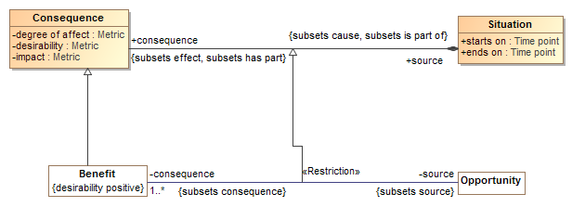
- The consequence/source relation between Consequence and source is refined as a restriction between Benefot and Opportunity.
- Instance restriction TBD.
See also:
- ODM/OWL: Subproperty, HasValue

Stereotype: Role [Class]
A <<Role>> is a classification of an entity based on that entities behavior, participation in a situation or capabilities. A <<Role>> <<Classifies>> the types that may play that role.
Supertypes
- Classification
Examples
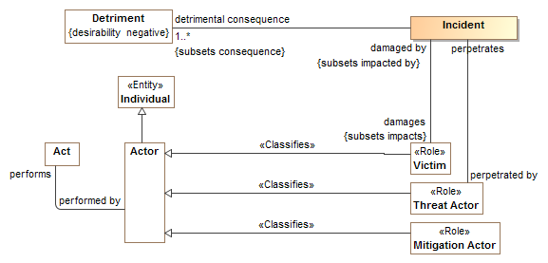
Victims, Threat Actors and Mitigation Actors are roles of actors which may be related to specific incidents.
See also
- LEADing: Role

Stereotype: Union [Classifier]
A <<Union>> is any context (Package or Classifier) that has an extent which is the complete union of the extents of all context that realize the Union.
Example
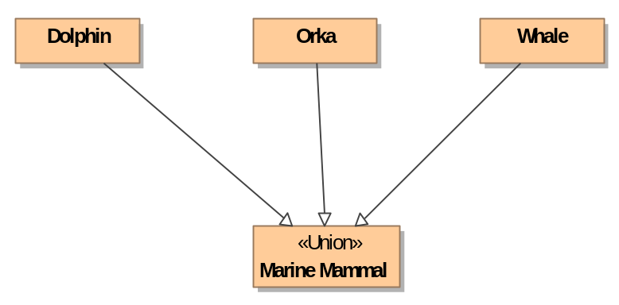
A Marine Mammal is either a Dolphin, Orka or Whale.
See Also
- OWL/ODM: UnionOf

Mapping Profile (In progress)

Stereotype: Mapping [Package]
A <<Mapping>> package represents signs and classification for mappings between different models.

URI:String (From UML)
A unique logical identifier for the model.
Examples
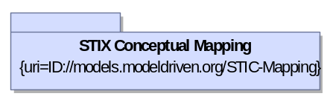

Stereotype: Representation [Package]
A <<Representation>> package represents signs and classification for a viewpoint, data and/or technology specific representation of concepts. If a model is not otherwise tagged, it is assumed to be Physical. Note that Physical models may also be logical or platform independent models.

URI:String (From UML)
A unique logical identifier for the model.
Examples
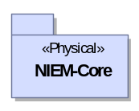

Stereotype: Template [Class, Collaboration]
A rule represents relations and values that must exist between instances of types in some context or set of context. A rule represented as a class is a “top level” rule where as a rule represented as a collaboration must be used within a class rule.
See the rule section for more information.

Stereotype: Rule [Class, Collaboration]

“transaction” in this context simply means a set of statemetns asserted at once, it may or may not have ACID properties as do DBMS transactions.

