VISHWAKARMA INSTITUTE OF TECHNOLOGY
YEAR – 2025-26 SEMESTER – 2
SUBJECT – PROBLEM SOLVING AND PROGRAMMING (PSP)

NAME – OM NIVRUTTI GHOTEKAR
DEPARTMENT – FY BTECH (AIML)
DIVISION – D BATCH 2
ROLL.NO. – 1030441
PRN.NO – 1251030180

Assignment

1.Problem Statement

A man needs to cross a river with three items: a goat, a tiger, and a bundle of grass.
There is only one boat available, which can carry a maximum of two at a time (including the man). Only the man can row the boat.

2. Objectives

To transport all entities safely across the river
To satisfy all safety constraints at every step
To design a logical step-by-step solution
To represent the solution using flowchart and algorithm

3. Flowchart

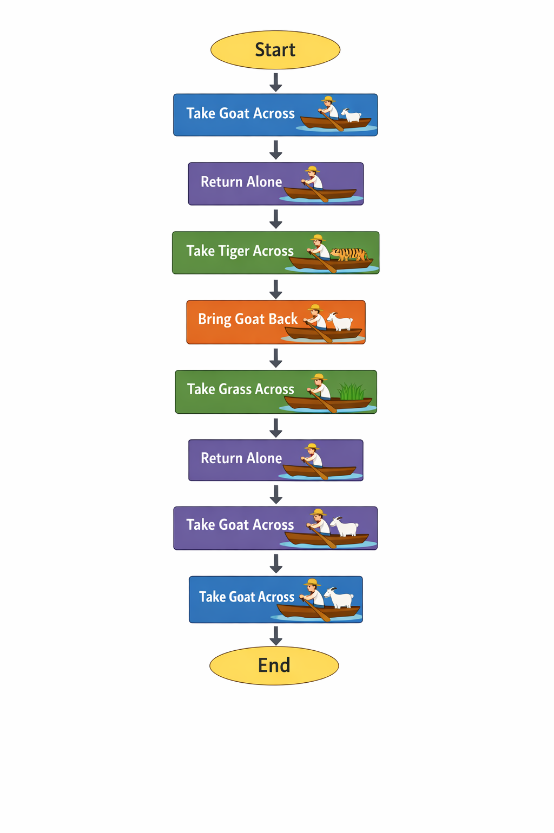

4. Algorithm

Step 1: Start
Step 2: Move Goat to the opposite bank.
Step 3: Return alone.
Step 4: Move Tiger to the opposite bank.
Step 5: Bring Goat back to prevent danger.
Step 6: Move Grass to the opposite bank.
Step 7: Return alone.
Step 8: Move Goat to the opposite bank.
Step 9: End (All safely crossed).

5. Code

#include <stdio.h>
int main() {
printf("River Crossing Solution\n\n");
printf("Step 1: Man takes Goat across.\n");
printf("Step 2: Man returns alone.\n");
printf("Step 3: Man takes Tiger across.\n");
printf("Step 4: Man brings Goat back.\n");
printf("Step 5: Man takes Grass across.\n");
printf("Step 6: Man returns alone.\n");
printf("Step 7: Man takes Goat across.\n");
printf("\nAll have safely crossed the river.\n");
return 0;
}

6. Conclusion

The river crossing puzzle demonstrates the importance of logical thinking and constraint management. By carefully analyzing unsafe combinations and planning movements accordingly, the problem is solved without violating any safety rule.
This problem enhances reasoning ability, stepwise problem solving, and algorithmic thinking.

