**MINOR PROJECT REPORT**

# On

**CAR PRO**

**BACHELOR OF TECHNOLOGY**

# In

**COMPUTER SCIENCE AND ENGINEERING**

**Submitted by**

**OM GHULE (A-41) VEDANT JAMDADE (A-68)**

**SAHIL TURKAR (A-61) FALGUNI KHADGI (A-17)**

**Under the guidance of**

**SWATI KOSANKAR**

**Department of Computer Science and Engineering**

[**G H RAISONI UNIVERSITY, AMRAVATI**](https://ghrcema.raisoni.net/index.php)

**2024-2025**

# DECLARATION

I declare that,

1. The work contained in the report is original and has been done by myself under the general supervision of my supervisor.
2. I have followed the guidelines provided by the Institute in writing the Synopsis.

1. I have conformed to the norms and guidelines given in the Ethical Code of Conduct of the University.
2. Whenever I have used materials (data, theoretical analysis, and text) from other sources, I have given due credit to them by citing them in the text of the Synopsis and giving their details in the references.
3. Whenever I have quoted written materials from other sources, I have put them under quotation marks and given due credit to the sources by citing them and giving required details in the references.
4. The report has been subjected to plagiarism check using professional software and found to be within the limits specified by the University.
5. The work has not been submitted to any other Institute for any degree or diploma.

OM GHULE

SAHIL TURKAR

FALGUNI KHADGI

VEDANT JAMDADE

**G H RAISONI UNIVERSITY, AMRAVATI**

**DEPARTMENT OF COMPUTER SCIENCE AND**

**ENGINEERING / ARTIFICIAL INTELLIGENCE**



## CERTIFICATE

**This is to certify that the minor project report entitled**

**CAR PRO**

**And it is submitted to**

**G H Raisoni University, Amravati**

**by**

## OM GHULE VEDANT JAMDADE

## SAHIL TURKAR FALGUNI KHADGI

**For the partial fulfilment of the requirement in the degree of**

**Bachelor of Technology in CSE /AI during the academic year 2024-2025.**

**Dr. Suresh Salankar**

**Dean, GHRUA**

|  |  |
| --- | --- |
|  |  |
| **Index** |  |

|  |  |  |
| --- | --- | --- |
| **Sr.**  **No.** | **Title** | **Page No.** |
| **1** | **Introduction** |  |
| **2** | **Objective** |  |
| **3** | **Block diagram/Flowchart** |  |

|  |  |  |
| --- | --- | --- |
| **4** | **Result and Conclusion** |  |
| **5** | **Reference** |  |

**Introduction**

**The rapid advancement of technology and the increasing dependence on digital platforms have**

**revolutionize various industries, including the automotive sector and This project focuses on developing an integrated online platform that provides comprehensive solutions for car rental & car servicing.**

**CAR RENTAL**

**•The website provides customers with an easy option to rent cars for a short- or long-term period of time.**

**• A user-friendly interface is combined with a varied fleet of automobiles to make it simple for consumers to search, compare, and reserve cars that suit their individual requirements and preferences.**

**CAR SERVICING**

**• The platform has an automobile maintenance function to guarantee the and best performance of cars.**

**• Customers may track their vehicle's service history, schedule maintenance repairs with approved service providers, and get timely reminders.**

**Project Objectives**

1.Streamline the Car Rental Process: Develop an intuitive online platform for users to browse, select, and rent cars easily and transparent pricing

2. Enhance Car Servicing Management: Implement a system for users to schedule car servicing and maintenance appointments online and Offer features for tracking service history

3. Improve User Experience: Design a user-friendly interface that makes navigation and usage of the platform straightforward and enjoyable

4. Increase Accessibility and Convenience: Ensure the platform is accessible via multiple devices, including desktops, tablets, and smartphones. Objective of the project Car Rental

**Block diagram/Flowchart**

**“If registered" in the context of car rental and car service means that the vehicle is officially documented with the relevant authorities, allowing it to be legally rented out or serviced. This ensures compliance with regulations and insurance requirements.**

**Car Rental Registration: Signing up to rent a vehicle, requiring personal info and payment details, ensuring legal use during the rental Period Car Service Registration: Documenting a vehicle for maintenance or repairs, including its registration and service history to ensure proper service.**

**Car Rental Login: Accessing your account on a car rental platform to manage reservations, view bookings, or update personal information Car Service Login: Accessing your account on a car service platform to schedule maintenance, track service history, or communicate with service providers**

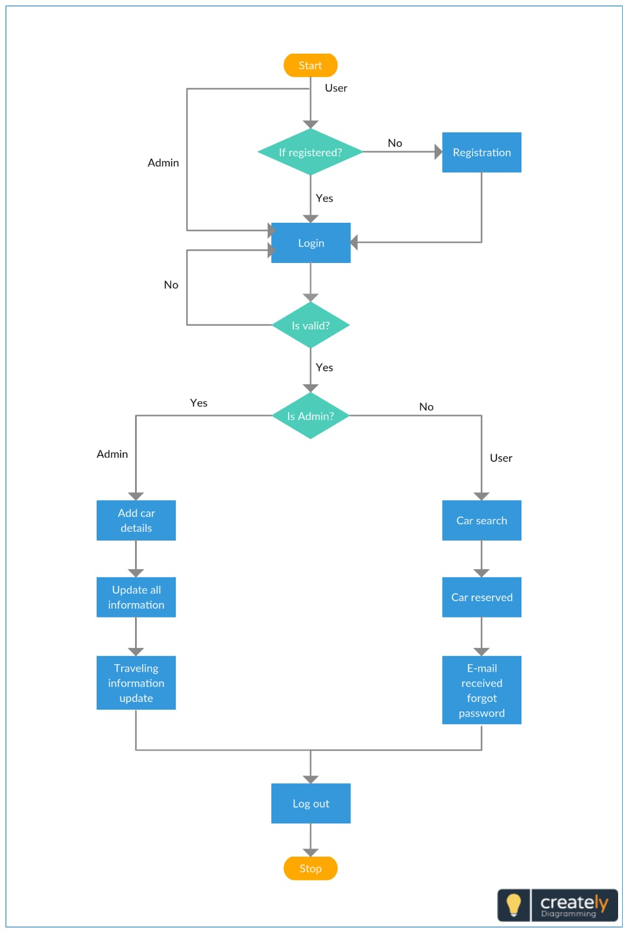

**Result and Conclusion**

**1. Enhanced User Convenience*:**

**car rental with easy online booking and a wide range of options. Efficient car servicing with online scheduling**

**2. Improved Operational Efficiency*:**

**Centralized management of services for better resource all location.**

**3. Increased User Engagement and Satisfaction*:**

**User-friendly interface for seamless navigation and higher engagement and Reliable and professional services building user trust.**

**4. Revenue Growth*:**

**Broader audience attraction leading to higher revenue. Additional revenue streams from value-added services.**

**conclusion**

**Creating a website for car rental, servicing, these services into one convenient platform. It enhances user experience, optimizes operations, and provides a secure, efficient solution for vehicle owners and users**

# References