Instructions to GIC Candidate

|  |
| --- |
| 1. Please check that you have the following:    1. Stable WIFI connection 2. You can use the internet to search for solutions      1. If you are stuck on a question, move on to the next one. |

GIC Technical Test

Front-end Development - React

60 min

All the best!

# Before you proceed, please read the following guide on how to start the project with Hackerrank

|  |  |
| --- | --- |
| Step 1: | Run > Install  - This will install the node_modules required for the project |
| Step 2: | Run > Run Server  - Wait for this to run for about 10sec or so |
| Step 3: | Run > Preview the app  - The app should appear in a preview window |

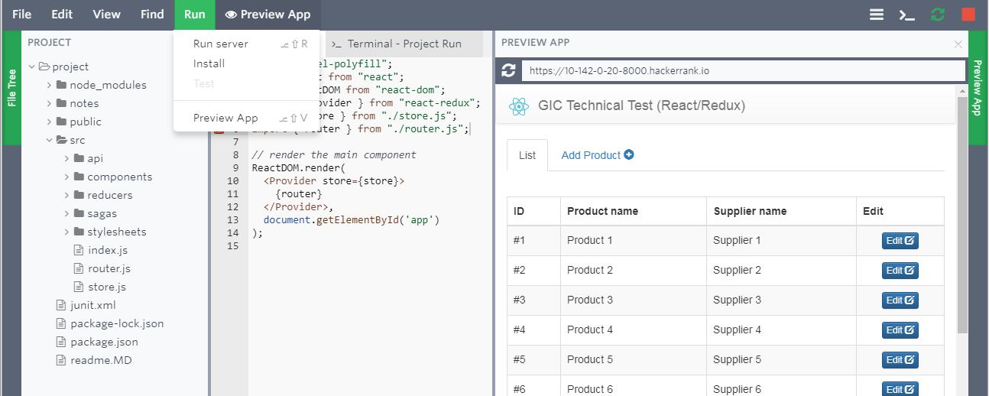

# Question 1: Introduction Tab

For this question, you need to create an information tab with the following requirements.

1. Create an “Introduction” tab (10 Points)



1. Provide the following content in the tab (10 Points)



(End of Question 1)

# Question 2: Product Count

For this question, you need to display the total number of products at the bottom of the product list table with the following requirements.

a. Count and Display the “Total no. of products” at the bottom-left of the table. (10 Points)

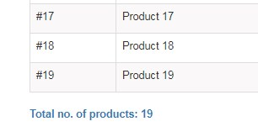

(End of Question 2)

# Question 3: Product Price

For this question, you need to add a “Product Price” data field to the product list table with the following requirements.

1. Add “Product Price ($)” data field to the product table. (20 Points)

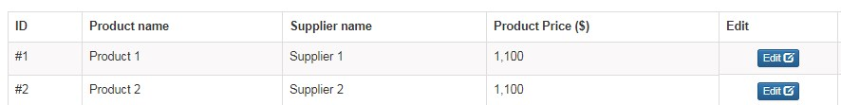

1. Ensure that you can add/edit the product price. Eg. in the edit screen: (20 Points)

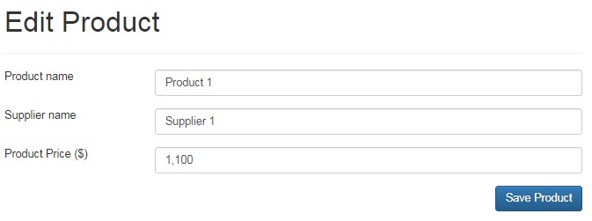

(End of Question 3)

# Question 4: Form Validation

For this question, you need to do form validation in the product edit screen.

a. In the product add/edit screen, check that you cannot save products, where the product names that are blank, or purely whitespace.  
(30 Points)

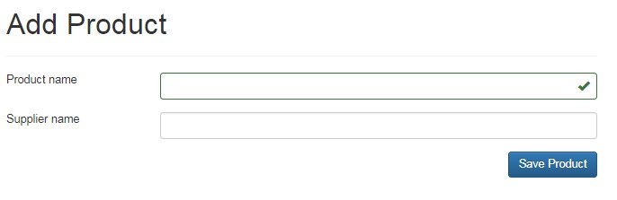

(End of Question 4)

# Question 5: Add in a delete function

For this question, you need to allow users to “delete” products from the product list table with the following requirements.

1. Create delete buttons that look similar to the following. (20 Points)

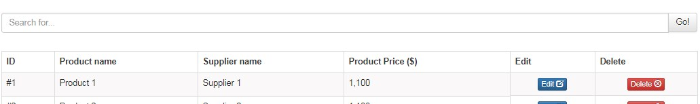

1. On clicking the delete button, the user will be prompted with a confirmation message. Here is an example. (30 Points)

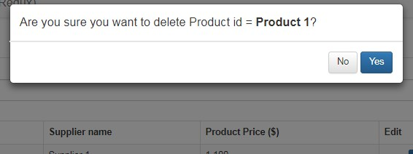

(End of Question 5)

# Question 6: Create a search component

For this question, you need to add a “Search” component to the product list table with the following requirements.

1. Create a search component that looks like the following: (20 Points)

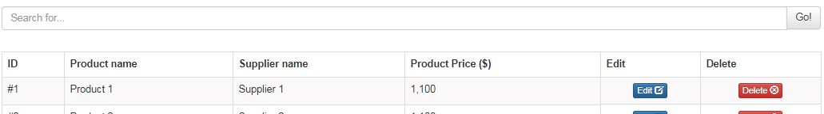

1. Filter the product listing dynamically. The search should list only the products where the product name contains the search value. (30 Points)

(End of Question 6)