ADITYA UNIVERSITY
Surampalem
Department of ARTIFICIAL INTELLIGENCE MACHINE LEARNING
DBMS CAPSTONE PROJECT
Project Documentation Report
Project Title:- E – Commerce Order Management System
Submitted by:
S.No | Student Name | Roll Number
1. | Nakkala Hema varshini | 25B11AI803
2. | Hanshitha Dhavala | 25B11AI271
3. | Prapurna Pothuraju | 25B11AI978
Course: Database Management Systems (DBMS) Course Code: 2501IT05
Faculty Coordinator: T.Srinivasulu
Academic Year: 2026-2027 Date of Submission: 15-09-2026
GitHub Repository Link: ____________________________________________

TABLE OF CONTENTS
(This table updates automatically when the document is opened in Microsoft Word. If it appears empty, right-click it and choose "Update Field".)
TABLE OF CONTENTS 1
1. ABSTRACT 1
2. INTRODUCTION 1
2.1 Background 1
2.2 Purpose of the Database 1
3. PROBLEM STATEMENT 1
4. OBJECTIVES 1
5. TOOLS & TECHNOLOGIES USED 1
6. DATABASE DESIGN 1
6.1 Identified Entities 1
6.2 Entity Attributes 1
6.3 ER Diagram 1
6.4 Relationships & Cardinality 1
6.5 Relational Database Schema 1
6.6 Normalization 1
7. DATABASE IMPLEMENTATION 1
7.1 DDL — Database and Table Creation 1
7.2 Sample Data — DML 1
7.3 Constraints & Data Integrity 1
7.4 SQL Operations & Queries 1
7.5 Sample Outputs / Screenshots 1
8. MODULES & FUNCTIONALITIES 1
9. GITHUB REPOSITORY & TEAM RESPONSIBILITIES 1
10. ENHANCEMENTS & FUTURE IMPROVEMENTS 1
11. CONCLUSION 1
12. REFERENCES 1
APPENDIX 1
A. Complete SQL Script 1
B. Additional Screenshots / Outputs 1

1. ABSTRACT
The Online Food Delivery Management System is a database-driven project designed to automate and streamline the food ordering process for customers, restaurants, and delivery personnel.
Traditional food ordering methods rely on manual record-keeping, which leads to data redundancy, delayed order tracking, and inconsistent payment records. This project addresses these issues by building a centralized relational database that efficiently stores and manages customer details, restaurant information, food items, orders, delivery status, and payment records. The system identifies six core entities—Customer, Restaurant, Food Item, Order, Delivery Person, and Payment—linked through well-defined relationships and cardinalities. Primary and foreign keys ensure data integrity, while constraints such as NOT NULL, UNIQUE, and CHECK maintain accuracy and consistency.
DDL, DML, and DQL operations, along with CRUD functionality and SQL queries, are implemented to demonstrate real-world usability. Overall, the project provides a reliable, scalable, and efficient database solution that improves order tracking, reduces redundancy, and enhances the food delivery experience for all stakeholders involved.

2. INTRODUCTION

2.1 Background
Food delivery has become a major part of daily life, with customers expecting quick and reliable service. However, when order details, customer records, and payments are handled manually or through scattered spreadsheets, it becomes difficult to track orders, avoid errors, and manage restaurant data efficiently. This project was selected to solve exactly that problem — building a structured database for an Online Food Delivery Management System. A database is required here because the system must store and connect large volumes of interrelated data (customers, restaurants, food items, orders, deliveries, and payments) in a way that is fast, consistent, and error-free — something manual or file-based systems cannot reliably offer.

2.2 Purpose of the Database
The database solves the problem of scattered, redundant, and error-prone record management by centralizing all information in one system. It will be used by customers (placing orders), restaurants (managing menus and orders), delivery personnel (updating delivery status), and administrators (overseeing the platform). The information it manages includes customer profiles, restaurant details, food item listings, order records, delivery status, and payment transactions — all linked so that any order can be traced from placement to delivery to payment

3. PROBLEM STATEMENT
Existing problem & limitations: Traditional food ordering systems depend on manual processes to manage customer records, product details, order tracking, and payments. This leads to data redundancy, inconsistent records, slow order tracking, and difficulty maintaining accurate payment and inventory information.
How the proposed system addresses it: The proposed centralized database system stores customer, food item, order, and payment data efficiently, using structured tables with defined relationships. This reduces redundancy, keeps data consistent, and enables fast, accurate order and payment tracking

4. OBJECTIVES
List 3–5 clear and measurable objectives.
- Objective 1: Automate the order management process
- Objective 2: Store customer, food item, order, and payment data efficiently
- Objective 3: Reduce data redundancy and improve data consistency
- Objective 4: Enable fast order tracking and payment management
- Objective 5: Maintain accurate inventory and order records

5. TOOLS & TECHNOLOGIES USED
List the DBMS software, IDE/client tool, and any front-end or scripting technology used to build and demonstrate the project.
Category | Tool / Technology Used
Database Server
Query / Admin Tool
Front-end (if any)
Operating System
Version Control | GitHub

6. DATABASE DESIGN

6.1 Identified Entities
Minimum: 6 entities. Provide a short description of each entity.
S.No | Entity Name | Description
1. | Customer | Stores details of registered users who place food orders
2. | Restaurant | Stores details of restaurants listed on the platform
3. | Food Item | Stores menu items offered by each restaurant
4. | Order | Records each order placed by a customer at a restaurant
5. | Delivery Person | Stores details of the person delivering an order
6. | Payment | Records payment details for each order

6.2 Entity Attributes
List the attributes of each entity. Mark Primary Keys (PK) and Foreign Keys (FK).
Entity | Attribute | Data Type | Key (PK/FK/—) | Attribute Type
Customer | Customer_Id | INT | PK | Simple
Customer | Name | VARCHAR(50) |  | Simple
Customer | Email | VARCHAR(50) |  | Simple
Customer | Mobile_Number | VARCHAR(50) |  | Simple
Customer | Address | VARCHAR(50) |  | Simple
Restaurent | Restaurent_Id | INT | PK | Simple
Restaurent | Name | VARCHAR(50) |  | Simple
Restaurent | Location | VARCHAR(50) |  | Simple
Restaurent | Contact_Number | VARCHAR(50) |  | Simple
Restaurent | Rating | Decimal(2,1) |  | Simple
FoodItem | Item_Id | INT | PK | Simple
FoodeItem | Restaurent_Id | INT | FK | Simple
FoodItem | Item_Name | VARCHAR(50) |  | Simple
FoodItem | Price | Decimal(10,2) |  | Simple
FoodItem | Availability | VARCHAR(50) |  | Simple
Order | Order_Id | INT | PK | Simple
Order | Customer_Id | INT | FK | Simple
Order | Restaurent_Id | INT | FK | Simple
Order | Order_Date | DATE |  | Simple
Order | Order_Status | VARCHAR(50) |  | Simple
Delivery_Person | Delivery_Person_Id | INT | PK | Simple
Delivery_Person | Order_Id | INT | FK | Simple
Delivery_Person | Vehicle_Details | VARCHAR(50) |  | Simple
Delivery_Person | Status | VARCHAR(50) |  | Simple
Delivery_Person | Time_Duration | TIME |  | Simple
Payment | Payment_Id | INT | PK | Simple
Payment | Order_Id | INT | FK | Simple
Payment | Payment_Method | VARCHAR(50) |  | Simple
Payment | Payment_Status | VARCHAR(50) |  | Simple
Payment | Total_Amount | DECIMAL(10,2) |  | Simple
Payment | Payment_Date | DATE |  | Simple
Attribute Type: Simple / Composite / Multi-valued / Derived

6.3 ER Diagram

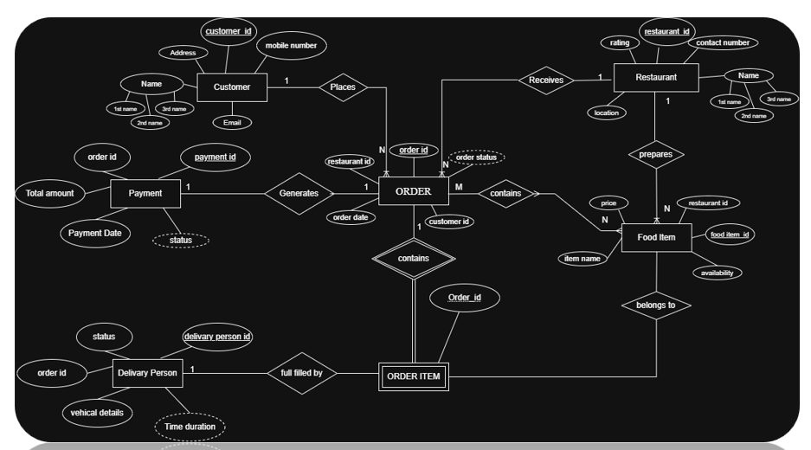

6.4 Relationships & Cardinality
Entity 1 | Relationship | Entity 2 | Cardinality (1:1 / 1:N / M:N)
Customer | Places | Order | 1:N
Restaurent | Receives | Order | 1:N
Restaurent | Prepares | Food Item | 1:N
Order | Contains | Food Item | M:N
Payment | Generates | Order | 1:1
Order | Contains | Order Item | 1:N
Delivery_Person | Fulfilled by | Order Item | 1:N

6.5 Relational Database Schema
List every table, its columns, data types, and identify PK/FK columns.
Table Name | Column Name | Data Type | PK/FK/— | Constraints
Customer | Customer_Id | NUMBER(20) | PK | NOT NULL
Customer | Name | VARCHAR2(40) | — | NOT NULL
Customer | Email | VARCHAR2(50) | — | UNIQUE, NOT NULL
Customer | Mobile_Number | NUMBER(10) | — | UNIQUE, NOT NULL
Customer | Address | VARCHAR2(100) | — | NOT NULL
Restaurant | Restaurant_Id | NUMBER(20) | PK | NOT NULL
Restaurant | Name | VARCHAR2(50) | — | NOT NULL
Restaurant | Location | VARCHAR2(100) | — | NOT NULL
Restaurant | Contact_Number | NUMBER(10) | — | UNIQUE
Restaurant | Rating | NUMBER(1) | — | CHECK (Rating IN (1,2,3,4,5))
Food_Item | Item_Id | NUMBER(20) | PK | NOT NULL
Food_Item | Restaurant_Id | NUMBER(20) | FK → Restaurant | NOT NULL
Food_Item | Item_Name | VARCHAR2(100) | — | NOT NULL
Food_Item | Price | NUMBER(8,2) | — | NOT NULL
Orders | Order_Id | NUMBER(20) | PK | NOT NULL
Orders | Customer_Id | NUMBER(20) | FK → Customer | NOT NULL
Orders | Restaurant_Id | NUMBER(20) | FK → Restaurant | NOT NULL
Orders | Order_Date | DATE | — | DEFAULT SYSDATE
Orders | Order_Status | VARCHAR2(30) | — | —
Order_Items | Order_Item_Id | NUMBER(20) | PK | NOT NULL
Order_Items | Order_Id | NUMBER(20) | FK → Orders | NOT NULL
Order_Items | Item_Id | NUMBER(20) | FK → Food_Item | NOT NULL
Order_Items | Quantity | NUMBER(5) | — | NOT NULL
Order_Items | Price | NUMBER(8,2) | — | NOT NULL
Delivery_Person | Delivery_Person_Id | NUMBER(20) | PK | NOT NULL
Delivery_Person | Name | VARCHAR2(50) | — | NOT NULL
Delivery_Person | Mobile_Number | NUMBER(10) | — | UNIQUE, NOT NULL
Delivery_Person | Vehicle_Number | VARCHAR2(20) | — | UNIQUE
Delivery_Person | Status | VARCHAR2(30) | — | —
Delivery | Delivery_Id | NUMBER(20) | PK | NOT NULL
Delivery | Order_Id | NUMBER(20) | FK → Orders | NOT NULL
Delivery | Delivery_Person_Id | NUMBER(20) | FK → Delivery_Person | NOT NULL
Delivery | Delivery_Status | VARCHAR2(30) | — | —
Delivery | Delivery_Date | DATE | — | —
Payment | Payment_Id | NUMBER(20) | PK | NOT NULL
Payment | Order_Id | NUMBER(20) | FK → Orders | NOT NULL
Payment | Payment_Method | VARCHAR2(20) | — | CHECK (IN 'ONLINE','OFFLINE')
Payment | Payment_Status | VARCHAR2(20) | — | CHECK (IN 'DONE','NOT DONE')
Payment | Total_Amount | NUMBER(10,2) | — | NOT NULL
Payment | Payment_Date | DATE | — | —

6.6 Normalization
Explain how redundancy and update anomalies were reduced. Show the normalization process up to 3NF where applicable.
UNF → 1NF → 2NF → 3NF

7. DATABASE IMPLEMENTATION

7.1 DDL — Database and Table Creation
Paste CREATE DATABASE / CREATE TABLE statements and include constraints such as NOT NULL, UNIQUE, CHECK, DEFAULT, PRIMARY KEY, and FOREIGN KEY.
[ PasteCREATE TABLE CUSTOMER(
CUSTOMER_ID NUMBER(20) PRIMARY KEY,
NAME VARCHAR2(40) NOT NULL,
EMAIL VARCHAR2(50) UNIQUE NOT NULL,
MOBILE_NUMBER NUMBER(10) UNIQUE NOT NULL,
ADDRESS VARCHAR2(100) NOT NULL
);
DESC CUSTOMER;
CREATE TABLE RESTAURANT(
RESTAURANT_ID NUMBER(20) PRIMARY KEY,
NAME VARCHAR2(50) NOT NULL,
LOCATION VARCHAR2(100) NOT NULL,
CONTACT_NUMBER NUMBER(10) UNIQUE,
RATING NUMBER(1) CHECK (RATING IN (1,2,3,4,5))
);
DESC RESTAURANT;
CREATE TABLE FOOD_ITEM(
ITEM_ID NUMBER(20) PRIMARY KEY,
RESTAURANT_ID NUMBER(20) NOT NULL,
ITEM_NAME VARCHAR2(100) NOT NULL,
PRICE NUMBER(8,2) NOT NULL,

CONSTRAINT FK_RESTAURANT_FOOD_ITEM
FOREIGN KEY (RESTAURANT_ID)
REFERENCES RESTAURANT(RESTAURANT_ID)
);
DESC FOOD_ITEM;
CREATE TABLE ORDERS(
ORDER_ID NUMBER(20) PRIMARY KEY,
CUSTOMER_ID NUMBER(20) NOT NULL,
RESTAURANT_ID NUMBER(20) NOT NULL,
ORDER_DATE DATE DEFAULT SYSDATE,
ORDER_STATUS VARCHAR2(30),

CONSTRAINT FK_CUSTOMER_ORDER
FOREIGN KEY (CUSTOMER_ID)
REFERENCES CUSTOMER(CUSTOMER_ID),

CONSTRAINT FK_RESTAURANT_ORDER
FOREIGN KEY (RESTAURANT_ID)
REFERENCES RESTAURANT(RESTAURANT_ID)
);
DESC ORDERS;
CREATE TABLE ORDER_ITEMS(
ORDER_ITEM_ID NUMBER(20) PRIMARY KEY,
ORDER_ID NUMBER(20) NOT NULL,
ITEM_ID NUMBER(20) NOT NULL,
QUANTITY NUMBER(5) NOT NULL,
PRICE NUMBER(8,2) NOT NULL,

CONSTRAINT FK_ORDER_ITEMS_ORDER
FOREIGN KEY (ORDER_ID)
REFERENCES ORDERS(ORDER_ID),

CONSTRAINT FK_ORDER_ITEMS_FOOD
FOREIGN KEY (ITEM_ID)
REFERENCES FOOD_ITEM(ITEM_ID)
);
DESC ORDER_ITEMS;
CREATE TABLE DELIVERY_PERSON(
DELIVERY_PERSON_ID NUMBER(20) PRIMARY KEY,
NAME VARCHAR2(50) NOT NULL,
MOBILE_NUMBER NUMBER(10) UNIQUE NOT NULL,
VEHICLE_NUMBER VARCHAR2(20) UNIQUE,
STATUS VARCHAR2(30)
);
DESC DELIVERY_PERSON;
CREATE TABLE DELIVERY(
DELIVERY_ID NUMBER(20) PRIMARY KEY,
ORDER_ID NUMBER(20) NOT NULL,
DELIVERY_PERSON_ID NUMBER(20) NOT NULL,
DELIVERY_STATUS VARCHAR2(30),
DELIVERY_DATE DATE,

CONSTRAINT FK_DELIVERY_ORDER
FOREIGN KEY (ORDER_ID)
REFERENCES ORDERS(ORDER_ID),

CONSTRAINT FK_DELIVERY_PERSON
FOREIGN KEY (DELIVERY_PERSON_ID)
REFERENCES DELIVERY_PERSON(DELIVERY_PERSON_ID)
);
DESC DELIVERY;
CREATE TABLE PAYMENT(
PAYMENT_ID NUMBER(20) PRIMARY KEY,
ORDER_ID NUMBER(20) NOT NULL,
PAYMENT_METHOD VARCHAR2(20)
CHECK (PAYMENT_METHOD IN ('ONLINE','OFFLINE')),
PAYMENT_STATUS VARCHAR2(20)
CHECK (PAYMENT_STATUS IN ('DONE','NOT DONE')),
TOTAL_AMOUNT NUMBER(10,2) NOT NULL,
PAYMENT_DATE DATE,

CONSTRAINT FK_PAYMENT_ORDER
FOREIGN KEY (ORDER_ID)
REFERENCES ORDERS(ORDER_ID)
);
DESC PAYMENT;
SQL Script / Screenshots Here ]

7.2 Sample Data — DML
Insert sufficient sample data into all tables. Include INSERT, UPDATE, and DELETE examples where applicable.
Table | No. of Records | Sample Data / Screenshot Reference
CUSTOMER | 5 | 5 customer records inserted (Customer_Id, Name, Email, Mobile_Number, Address) — e.g. Ravi Kumar, Priya Sharma, Arjun, Sneha Rao, Kiran Kumar
RESTAURANT | 5 | 5 restaurant records inserted (Restaurant_Id, Name, Location, Contact_Number, Rating) — e.g. Subbayya Gari Hotel, Pizza Hub, Spice Kitchen
FOOD_ITEM | 10 | 10 food item records inserted across the 5 restaurants (Item_Id, Restaurant_Id, Item_Name, Price) — e.g. Chicken Biryani, Veg Pizza, Fried Rice
ORDERS | 5 | 5 order records inserted (Order_Id, Customer_Id, Restaurant_Id, Order_Date, Order_Status) — statuses: DELIVERED, OUT FOR DELIVERY, PREPARING, PLACED
ORDER_ITEMS | 8 | 8 order-item records inserted (Order_Item_Id, Order_Id, Item_Id, Quantity, Price) linking orders to the specific items ordered
DELIVERY_PERSON | 4 | 4 delivery person records inserted (DeliveryPerson_Id, Name, Mobile_Number, Vehicle_Number, Status) — e.g. Suresh, Ramesh, Vijay, Mahesh
DELIVERY | 4 | 4 delivery records inserted (Delivery_Id, Order_Id, DeliveryPerson_Id, Delivery_Status, Delivery_Date)
PAYMENT | 5 | 5 payment records inserted (Payment_Id, Order_Id, Payment_Method, Payment_Status, Total_Amount, Payment_Date) — methods: ONLINE / OFFLINE

7.3 Constraints & Data Integrity
List the constraints and validations applied to keep the data accurate and consistent (no duplicate IDs, valid values, referential integrity).
Constraint / Validation | Applied On | Purpose | Evidence / Screenshot
PRIMARY KEY | Customer_Id, Restaurant_Id, Item_Id, Order_Id, Order_Item_Id, DeliveryPerson_Id, Delivery_Id, Payment_Id | Uniquely identifies every record in each table and prevents duplicate IDs | Ecommerce.sql — CREATE TABLE statements
NOT NULL | Name, Email, Mobile_Number, Address (Customer); Name, Location (Restaurant); Item_Name, Price (Food_Item); Customer_Id, Restaurant_Id (Orders) | Ensures mandatory fields always contain a value | Ecommerce.sql — CREATE TABLE statements
UNIQUE | Email, Mobile_Number (Customer); Contact_Number (Restaurant); Mobile_Number, Vehicle_Number (Delivery_Person) | Prevents duplicate emails, phone numbers and vehicle numbers | Ecommerce.sql — CREATE TABLE statements
CHECK | Rating IN (1,2,3,4,5) (Restaurant); Payment_Method IN ('ONLINE','OFFLINE'); Payment_Status IN ('DONE','NOT DONE') | Restricts column values to a valid, predefined set | Ecommerce.sql — CREATE TABLE statements
FOREIGN KEY | Restaurant_Id (Food_Item); Customer_Id, Restaurant_Id (Orders); Order_Id, Item_Id (Order_Items); Order_Id, DeliveryPerson_Id (Delivery); Order_Id (Payment) | Maintains referential integrity between related tables | Ecommerce.sql — CONSTRAINT ... FOREIGN KEY clauses
DEFAULT | Order_Date (Orders) DEFAULT SYSDATE | Automatically records the current date if no order date is supplied | Ecommerce.sql — CREATE TABLE ORDERS

7.4 SQL Operations & Queries
S.No | Operation / Query | Purpose | SQL Query / Screenshot Ref.
1 | DDL — CREATE TABLE | Define the structure of all 8 tables with columns, data types and constraints | CUSTOMER, RESTAURANT, FOOD_ITEM, ORDERS, ORDER_ITEMS, DELIVERY_PERSON, DELIVERY, PAYMENT
2 | Data Dictionary — DESC | View the structure/columns of each table after creation | DESC CUSTOMER; DESC RESTAURANT; DESC FOOD_ITEM; etc.
3 | DML — INSERT ALL | Insert multiple sample records into each table in a single statement | INSERT ALL ... INTO CUSTOMER / RESTAURANT / FOOD_ITEM / ORDERS / ORDER_ITEMS / DELIVERY_PERSON / DELIVERY / PAYMENT
4 | TCL — COMMIT | Permanently save all inserted data to the database | COMMIT;
5 | DQL — SELECT * | Retrieve and view all records from each table | SELECT * FROM CUSTOMER / RESTAURANT / FOOD_ITEM / ORDERS / ORDER_ITEMS / DELIVERY_PERSON / DELIVERY / PAYMENT

7.5 Sample Outputs / Screenshots

Figure 1:
[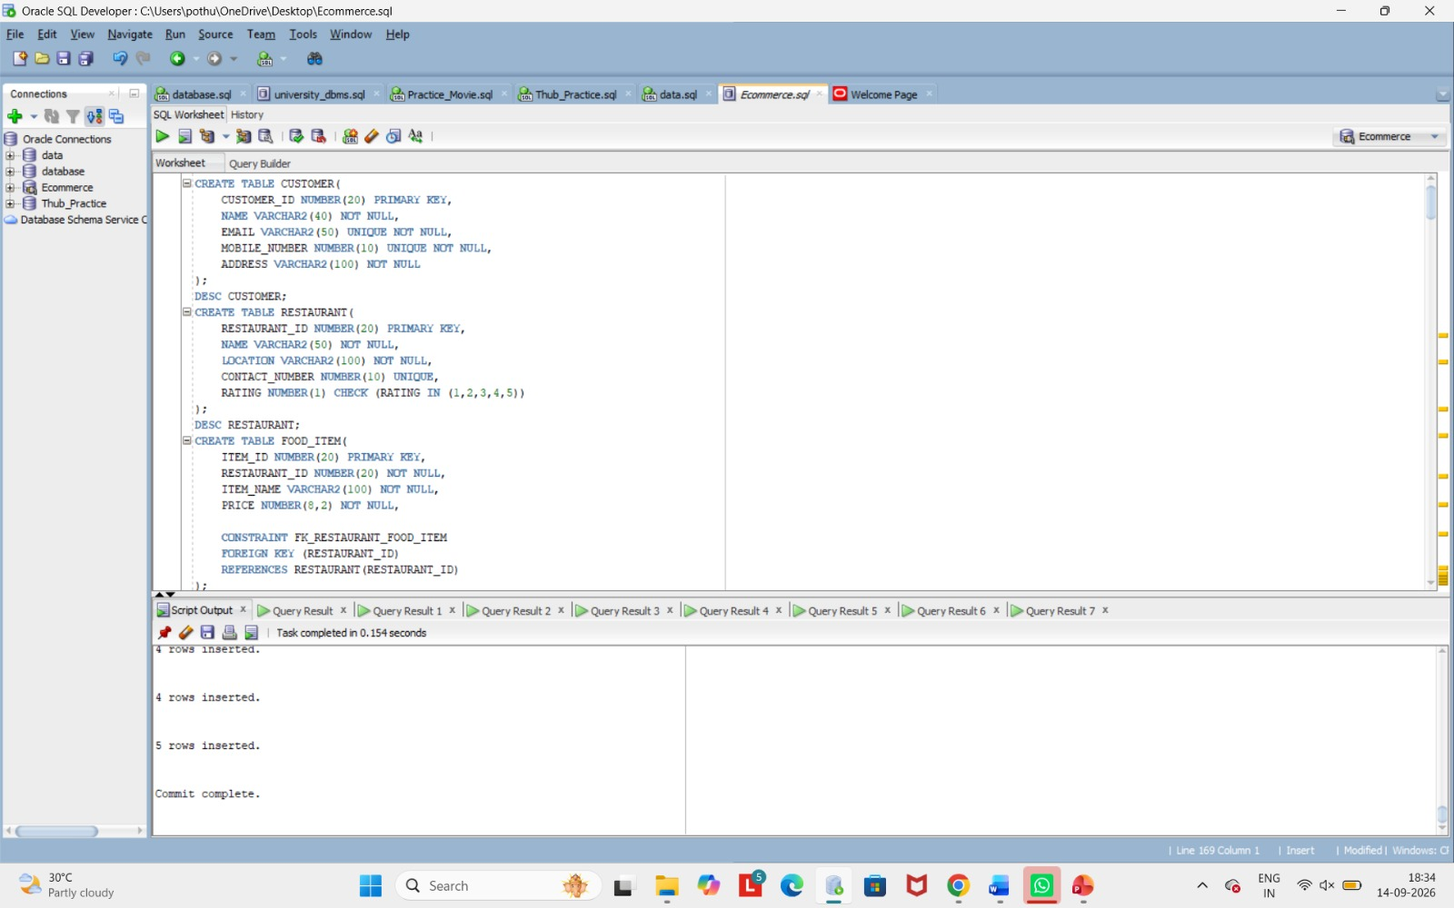 Insert Screenshot Here ]
Figure 2:
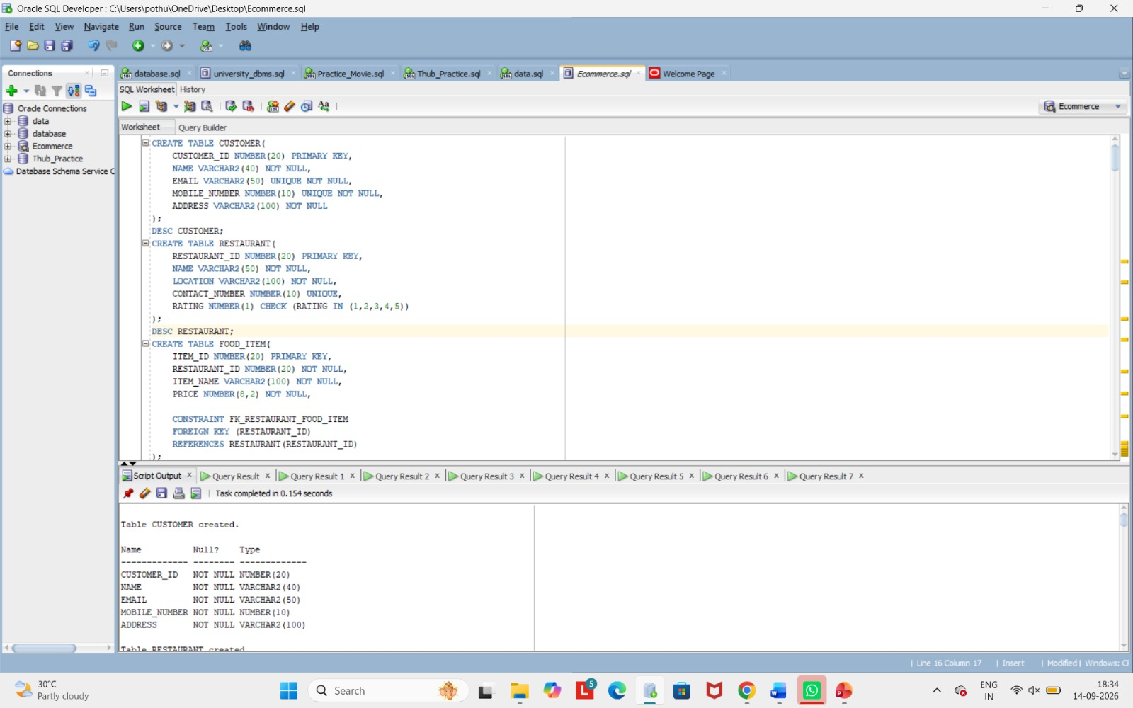 [ Insert Screenshot Here ]
Figure 3:
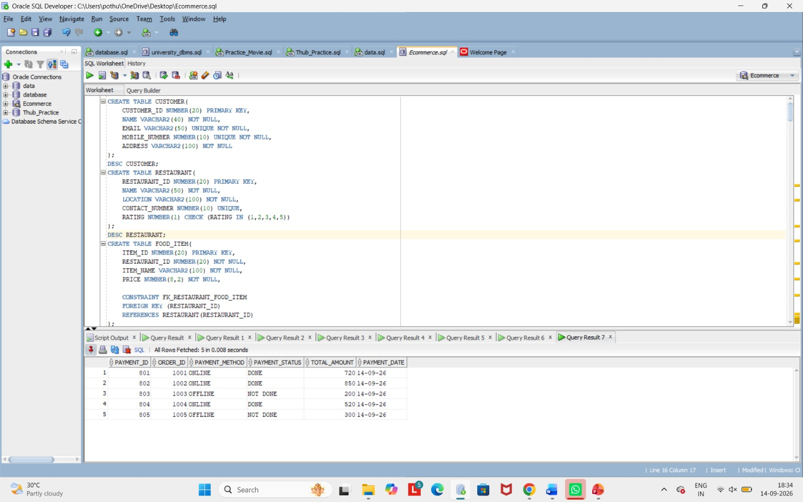

8. MODULES & FUNCTIONALITIES
Explain the major modules/features of the system and what each module does.
S.No | Module Name | Functionality
1 | Customer Management | Stores and manages customer details — name, email, mobile number and address — for placing orders
2 | Restaurant Management | Stores restaurant details such as name, location, contact number and rating
3 | Food Item Management | Manages the food items offered by each restaurant along with their prices, linked to the restaurant via Restaurant_Id
4 | Order Management | Handles order creation, linking each order to a customer and a restaurant, and tracks Order_Status (PLACED, PREPARING, OUT FOR DELIVERY, DELIVERED)
5 | Order Items Management | Records the individual food items, quantities and prices that make up each order
6 | Delivery Management | Manages delivery personnel details and assigns them to orders, tracking Delivery_Status and Delivery_Date
7 | Payment Management | Records payment method (ONLINE/OFFLINE), payment status (DONE/NOT DONE), total amount and payment date for each order

9. GITHUB REPOSITORY & TEAM RESPONSIBILITIES
Provide the repository link and clearly mention each team member's contribution.
Repository Link: ____________________________________________
Student Name | Roll Number | Role / Responsibility | Contribution Status
Nakkala Hema varshini | 25B11AI803 | Prepared Project Documention and Github Repository | Completed
Prapurna Pothuraju | 25B11AI978 | Created Databases and SQL Queries | Completed
Hanshitha Dhavala | 25B11AI271 | Designed ER Diagram and Relational Schema | Completed

10. ENHANCEMENTS & FUTURE IMPROVEMENTS
Add web/mobile UI integration.
Implement secure login and role-based access.
Add real-time order tracking.
Improve performance using indexing.
Add reports and dashboards.
Support larger data and users

11. CONCLUSION
Successfully developed the Food Delivery Management database.
Designed ER diagram and relational schema.
Implemented keys, constraints, and sample data.
Performed DDL, DML, DQL, CRUD, joins, and views.
Ensured data integrity and validation.
Gained practical knowledge of DBMS and SQL.

12. REFERENCES
List textbooks, articles, documentation, websites, or other resources referred to during the project.
1.Oracle Database Documentation
2.Oracle Academy
3.GitHub Documentation
4.DBMS Course Materials

APPENDIX

A. Complete SQL Script
CREATE TABLE CUSTOMER(
CUSTOMER_ID NUMBER(20) PRIMARY KEY,
NAME VARCHAR2(40) NOT NULL,
EMAIL VARCHAR2(50) UNIQUE NOT NULL,
MOBILE_NUMBER NUMBER(10) UNIQUE NOT NULL,
ADDRESS VARCHAR2(100) NOT NULL
);
DESC CUSTOMER;
CREATE TABLE RESTAURANT(
RESTAURANT_ID NUMBER(20) PRIMARY KEY,
NAME VARCHAR2(50) NOT NULL,
LOCATION VARCHAR2(100) NOT NULL,
CONTACT_NUMBER NUMBER(10) UNIQUE,
RATING NUMBER(1) CHECK (RATING IN (1,2,3,4,5))
);
DESC RESTAURANT;
CREATE TABLE FOOD_ITEM(
ITEM_ID NUMBER(20) PRIMARY KEY,
RESTAURANT_ID NUMBER(20) NOT NULL,
ITEM_NAME VARCHAR2(100) NOT NULL,
PRICE NUMBER(8,2) NOT NULL,

CONSTRAINT FK_RESTAURANT_FOOD_ITEM
FOREIGN KEY (RESTAURANT_ID)
REFERENCES RESTAURANT(RESTAURANT_ID)
);
DESC FOOD_ITEM;
CREATE TABLE ORDERS(
ORDER_ID NUMBER(20) PRIMARY KEY,
CUSTOMER_ID NUMBER(20) NOT NULL,
RESTAURANT_ID NUMBER(20) NOT NULL,
ORDER_DATE DATE DEFAULT SYSDATE,
ORDER_STATUS VARCHAR2(30),

CONSTRAINT FK_CUSTOMER_ORDER
FOREIGN KEY (CUSTOMER_ID)
REFERENCES CUSTOMER(CUSTOMER_ID),

CONSTRAINT FK_RESTAURANT_ORDER
FOREIGN KEY (RESTAURANT_ID)
REFERENCES RESTAURANT(RESTAURANT_ID)
);
DESC ORDERS;
CREATE TABLE ORDER_ITEMS(
ORDER_ITEM_ID NUMBER(20) PRIMARY KEY,
ORDER_ID NUMBER(20) NOT NULL,
ITEM_ID NUMBER(20) NOT NULL,
QUANTITY NUMBER(5) NOT NULL,
PRICE NUMBER(8,2) NOT NULL,

CONSTRAINT FK_ORDER_ITEMS_ORDER
FOREIGN KEY (ORDER_ID)
REFERENCES ORDERS(ORDER_ID),

CONSTRAINT FK_ORDER_ITEMS_FOOD
FOREIGN KEY (ITEM_ID)
REFERENCES FOOD_ITEM(ITEM_ID)
);
DESC ORDER_ITEMS;
CREATE TABLE DELIVERY_PERSON(
DELIVERY_PERSON_ID NUMBER(20) PRIMARY KEY,
NAME VARCHAR2(50) NOT NULL,
MOBILE_NUMBER NUMBER(10) UNIQUE NOT NULL,
VEHICLE_NUMBER VARCHAR2(20) UNIQUE,
STATUS VARCHAR2(30)
);
DESC DELIVERY_PERSON;
CREATE TABLE DELIVERY(
DELIVERY_ID NUMBER(20) PRIMARY KEY,
ORDER_ID NUMBER(20) NOT NULL,
DELIVERY_PERSON_ID NUMBER(20) NOT NULL,
DELIVERY_STATUS VARCHAR2(30),
DELIVERY_DATE DATE,

CONSTRAINT FK_DELIVERY_ORDER
FOREIGN KEY (ORDER_ID)
REFERENCES ORDERS(ORDER_ID),

CONSTRAINT FK_DELIVERY_PERSON
FOREIGN KEY (DELIVERY_PERSON_ID)
REFERENCES DELIVERY_PERSON(DELIVERY_PERSON_ID)
);
DESC DELIVERY;
CREATE TABLE PAYMENT(
PAYMENT_ID NUMBER(20) PRIMARY KEY,
ORDER_ID NUMBER(20) NOT NULL,
PAYMENT_METHOD VARCHAR2(20)
CHECK (PAYMENT_METHOD IN ('ONLINE','OFFLINE')),
PAYMENT_STATUS VARCHAR2(20)
CHECK (PAYMENT_STATUS IN ('DONE','NOT DONE')),
TOTAL_AMOUNT NUMBER(10,2) NOT NULL,
PAYMENT_DATE DATE,

CONSTRAINT FK_PAYMENT_ORDER
FOREIGN KEY (ORDER_ID)
REFERENCES ORDERS(ORDER_ID)
);
DESC PAYMENT;

INSERT ALL
INTO CUSTOMER (CUSTOMER_ID, NAME, EMAIL, MOBILE_NUMBER, ADDRESS)
VALUES (1, 'Ravi Kumar', 'ravi@gmail.com', 9876543210, 'Vijayawada')

INTO CUSTOMER (CUSTOMER_ID, NAME, EMAIL, MOBILE_NUMBER, ADDRESS)
VALUES (2, 'Priya Sharma', 'priya@gmail.com', 9876543211, 'Guntur')

INTO CUSTOMER (CUSTOMER_ID, NAME, EMAIL, MOBILE_NUMBER, ADDRESS)
VALUES (3, 'Arjun', 'arjun@gmail.com', 9876543212, 'Hyderabad')

INTO CUSTOMER (CUSTOMER_ID, NAME, EMAIL, MOBILE_NUMBER, ADDRESS)
VALUES (4, 'Sneha Rao', 'sneha@gmail.com', 9876543213, 'Visakhapatnam')

INTO CUSTOMER (CUSTOMER_ID, NAME, EMAIL, MOBILE_NUMBER, ADDRESS)
VALUES (5, 'Kiran Kumar', 'kiran@gmail.com', 9876543214, 'Rajahmundry')
SELECT * FROM dual;

INSERT ALL
INTO RESTAURANT (RESTAURANT_ID, NAME, LOCATION, CONTACT_NUMBER, RATING)
VALUES (101, 'Subbayya gari hotel', 'Kakinada', 9123456780, 5)

INTO RESTAURANT (RESTAURANT_ID, NAME, LOCATION, CONTACT_NUMBER, RATING)
VALUES (102, 'Pizza Hub', 'Guntur', 9123456781, 4)

INTO RESTAURANT (RESTAURANT_ID, NAME, LOCATION, CONTACT_NUMBER, RATING)
VALUES (103, 'Spice Kitchen', 'Hyderabad', 9123456782, 5)

INTO RESTAURANT (RESTAURANT_ID, NAME, LOCATION, CONTACT_NUMBER, RATING)
VALUES (104, 'Food Corner', 'Visakhapatnam', 9123456783, 3)

INTO RESTAURANT (RESTAURANT_ID, NAME, LOCATION, CONTACT_NUMBER, RATING)
VALUES (105, 'Tasty Bites', 'Rajahmundry', 9123456784, 4)
SELECT * FROM dual;

INSERT ALL
INTO FOOD_ITEM (ITEM_ID, RESTAURANT_ID, ITEM_NAME, PRICE)
VALUES (1, 101, 'Chicken Biryani', 250)

INTO FOOD_ITEM (ITEM_ID, RESTAURANT_ID, ITEM_NAME, PRICE)
VALUES (2, 101, 'Mutton Biryani', 320)

INTO FOOD_ITEM (ITEM_ID, RESTAURANT_ID, ITEM_NAME, PRICE)
VALUES (3, 101, 'Paneer Biryani', 220)

INTO FOOD_ITEM (ITEM_ID, RESTAURANT_ID, ITEM_NAME, PRICE)
VALUES (4, 102, 'Veg Pizza', 250)

INTO FOOD_ITEM (ITEM_ID, RESTAURANT_ID, ITEM_NAME, PRICE)
VALUES (5, 102, 'Chicken Pizza', 350)

INTO FOOD_ITEM (ITEM_ID, RESTAURANT_ID, ITEM_NAME, PRICE)
VALUES (6, 103, 'Chicken Noodles', 200)

INTO FOOD_ITEM (ITEM_ID, RESTAURANT_ID, ITEM_NAME, PRICE)
VALUES (7, 103, 'Paneer Curry', 180)

INTO FOOD_ITEM (ITEM_ID, RESTAURANT_ID, ITEM_NAME, PRICE)
VALUES (8, 104, 'Burger', 150)

INTO FOOD_ITEM (ITEM_ID, RESTAURANT_ID, ITEM_NAME, PRICE)
VALUES (9, 105, 'Fried Rice', 180)

INTO FOOD_ITEM (ITEM_ID, RESTAURANT_ID, ITEM_NAME, PRICE)
VALUES (10, 105, 'Manchurian', 160)
SELECT * FROM dual;

INSERT ALL
INTO ORDERS (ORDER_ID, CUSTOMER_ID, RESTAURANT_ID, ORDER_DATE, ORDER_STATUS)
VALUES (1001, 1, 101, SYSDATE, 'DELIVERED')

INTO ORDERS (ORDER_ID, CUSTOMER_ID, RESTAURANT_ID, ORDER_DATE, ORDER_STATUS)
VALUES (1002, 2, 102, SYSDATE, 'OUT FOR DELIVERY')

INTO ORDERS (ORDER_ID, CUSTOMER_ID, RESTAURANT_ID, ORDER_DATE, ORDER_STATUS)
VALUES (1003, 3, 103, SYSDATE, 'PREPARING')

INTO ORDERS (ORDER_ID, CUSTOMER_ID, RESTAURANT_ID, ORDER_DATE, ORDER_STATUS)
VALUES (1004, 1, 105, SYSDATE, 'DELIVERED')

INTO ORDERS (ORDER_ID, CUSTOMER_ID, RESTAURANT_ID, ORDER_DATE, ORDER_STATUS)
VALUES (1005, 4, 104, SYSDATE, 'PLACED')
SELECT * FROM dual;

INSERT ALL
INTO ORDER_ITEMS (ORDER_ITEM_ID, ORDER_ID, ITEM_ID, QUANTITY, PRICE)
VALUES (1, 1001, 1, 2, 250)

INTO ORDER_ITEMS (ORDER_ITEM_ID, ORDER_ID, ITEM_ID, QUANTITY, PRICE)
VALUES (2, 1001, 3, 1, 220)

INTO ORDER_ITEMS (ORDER_ITEM_ID, ORDER_ID, ITEM_ID, QUANTITY, PRICE)
VALUES (3, 1002, 5, 1, 350)

INTO ORDER_ITEMS (ORDER_ITEM_ID, ORDER_ID, ITEM_ID, QUANTITY, PRICE)
VALUES (4, 1002, 4, 2, 250)

INTO ORDER_ITEMS (ORDER_ITEM_ID, ORDER_ID, ITEM_ID, QUANTITY, PRICE)
VALUES (5, 1003, 6, 1, 200)

INTO ORDER_ITEMS (ORDER_ITEM_ID, ORDER_ID, ITEM_ID, QUANTITY, PRICE)
VALUES (6, 1004, 9, 2, 180)

INTO ORDER_ITEMS (ORDER_ITEM_ID, ORDER_ID, ITEM_ID, QUANTITY, PRICE)
VALUES (7, 1004, 10, 1, 160)

INTO ORDER_ITEMS (ORDER_ITEM_ID, ORDER_ID, ITEM_ID, QUANTITY, PRICE)
VALUES (8, 1005, 8, 2, 150)
SELECT * FROM dual;

INSERT ALL
INTO DELIVERY_PERSON
(DELIVERY_PERSON_ID, NAME, MOBILE_NUMBER, VEHICLE_NUMBER, STATUS)
VALUES (501, 'Suresh', 9988776655, 'AP05AB1234', 'AVAILABLE')

INTO DELIVERY_PERSON
(DELIVERY_PERSON_ID, NAME, MOBILE_NUMBER, VEHICLE_NUMBER, STATUS)
VALUES (502, 'Ramesh', 9988776656, 'AP07CD5678', 'BUSY')

INTO DELIVERY_PERSON
(DELIVERY_PERSON_ID, NAME, MOBILE_NUMBER, VEHICLE_NUMBER, STATUS)
VALUES (503, 'Vijay', 9988776657, 'TS09EF9012', 'AVAILABLE')

INTO DELIVERY_PERSON
(DELIVERY_PERSON_ID, NAME, MOBILE_NUMBER, VEHICLE_NUMBER, STATUS)
VALUES (504, 'Mahesh', 9988776658, 'AP16GH3456', 'BUSY')
SELECT * FROM dual;

INSERT ALL
INTO DELIVERY
(DELIVERY_ID, ORDER_ID, DELIVERY_PERSON_ID, DELIVERY_STATUS, DELIVERY_DATE)
VALUES (701, 1001, 501, 'DELIVERED', SYSDATE)

INTO DELIVERY
(DELIVERY_ID, ORDER_ID, DELIVERY_PERSON_ID, DELIVERY_STATUS, DELIVERY_DATE)
VALUES (702, 1002, 502, 'OUT FOR DELIVERY', SYSDATE)

INTO DELIVERY
(DELIVERY_ID, ORDER_ID, DELIVERY_PERSON_ID, DELIVERY_STATUS, DELIVERY_DATE)
VALUES (703, 1003, 503, 'ASSIGNED', SYSDATE)

INTO DELIVERY
(DELIVERY_ID, ORDER_ID, DELIVERY_PERSON_ID, DELIVERY_STATUS, DELIVERY_DATE)
VALUES (704, 1004, 504, 'DELIVERED', SYSDATE)
SELECT * FROM dual;

INSERT ALL
INTO PAYMENT
(PAYMENT_ID, ORDER_ID, PAYMENT_METHOD, PAYMENT_STATUS, TOTAL_AMOUNT, PAYMENT_DATE)
VALUES (801, 1001, 'ONLINE', 'DONE', 720, SYSDATE)

INTO PAYMENT
(PAYMENT_ID, ORDER_ID, PAYMENT_METHOD, PAYMENT_STATUS, TOTAL_AMOUNT, PAYMENT_DATE)
VALUES (802, 1002, 'ONLINE', 'DONE', 850, SYSDATE)

INTO PAYMENT
(PAYMENT_ID, ORDER_ID, PAYMENT_METHOD, PAYMENT_STATUS, TOTAL_AMOUNT, PAYMENT_DATE)
VALUES (803, 1003, 'OFFLINE', 'NOT DONE', 200, SYSDATE)

INTO PAYMENT
(PAYMENT_ID, ORDER_ID, PAYMENT_METHOD, PAYMENT_STATUS, TOTAL_AMOUNT, PAYMENT_DATE)
VALUES (804, 1004, 'ONLINE', 'DONE', 520, SYSDATE)

INTO PAYMENT
(PAYMENT_ID, ORDER_ID, PAYMENT_METHOD, PAYMENT_STATUS, TOTAL_AMOUNT, PAYMENT_DATE)
VALUES (805, 1005, 'OFFLINE', 'NOT DONE', 300, SYSDATE)
SELECT * FROM dual;

COMMIT;

SELECT * FROM CUSTOMER;
SELECT * FROM RESTAURANT;
SELECT * FROM FOOD_ITEM;
SELECT * FROM ORDERS;
SELECT * FROM ORDER_ITEMS;
SELECT * FROM DELIVERY_PERSON;
SELECT * FROM DELIVERY;
SELECT * FROM PAYMENT

