TABLE OF CONTENTS
- Cover Page
- Certificate
- Acknowledgement
- Table of Contents
- Abstract
- Introduction
- System Analysis
- Database Design
- ER Diagram
- Relational Schema
- Table Design
- Normalization
- SQL Implementation
- SQL Queries & Screenshots
- Conclusion & Future Enhancements
- References

Project Title:- E – Commerce Order Management System
Submitted by:
S.No | Student Name | Roll Number
1. | Nakkala Hema varshini | 25B11AI803
2. | Hanshitha Dhavala | 25B11AI271
3. | Prapurna Pothuraju | 25B11AI978
Course: Database Management Systems (DBMS) Course Code: 2501IT05
Faculty Coordinator: T.Srinivasulu
Academic Year: 2026-2027 Date of Submission: 27-09-2026
GitHub Repository Link: omhema2008-web/DBMS-E_Commerce

a
ABSTRACT

The Online Food Delivery Management System is designed to automate and manage the order-processing activities of a B2C food-delivery e-commerce platform through a centralized relational database. The system stores and manages information related to customers, restaurants, food items, orders, delivery personnel, and payments. The database minimizes redundancy, maintains data integrity through primary and foreign keys, and supports efficient retrieval of order and delivery information using SQL queries. Data accuracy is enforced through PRIMARY KEY, FOREIGN KEY, NOT NULL, UNIQUE, and CHECK constraints. The proposed system provides a structured foundation for customer management, restaurant management, food item management, order processing, delivery tracking, and payment management.
LIST OF FIGURES
Figure 1. ER Diagram of the Online Food Delivery Management System
Figure 2. Relational Database Schema
Figure 3. GitHub Repository and Team Collaboration
Figure 4. Database Creation and Constraints
Figure 5. Sample Data Insertion
Figure 6. DDL, DML, and DQL Operations
Figure 7. CRUD Operations and SQL Queries
Figure 8. Data Integrity and Validation Figure 9. Database Demonstration
LIST OF TABLES
Table 1. Major Database Entities
Table 2. Customer Table Structure
Table 3. Restaurant Table Structure
Table 4. Food Item Table Structure
Table 5. Order Table Structure
Table 6. Delivery Person Table Structure
Table 7. Payment Table Structure
Table 8. Primary and Foreign Keys
Table 9. Team Responsibilities

ACRONYMS
- DBMS – Database Management System
- ER – Entity Relationship
- SQL – Structured Query Language
- DDL – Data Definition Language
- DML – Data Manipulation Language
- DQL – Data Query Language
- DCL – Data Control Language
- TCL – Transaction Control Language
- PK – Primary Key
- FK – Foreign Key
- 1NF – First Normal Form
- 2NF – Second Normal Form
- 3NF – Third Normal Form

1. INTRODUCTION

1.1 Brief Information about the Project

The Online Food Delivery Management System is a database application that manages the ordering, delivery, and payment operations of a B2C food-delivery e-commerce platform. The project provides a centralized relational database for customers, restaurants, food items, orders, delivery personnel, and payments. It is intended to replace manual, paper-based order-taking processes with a structured database that supports consistent storage and fast retrieval of order and delivery information.

1.2 Motivation and Contribution of Project

The project is motivated by common problems in traditional food-ordering systems, where manual processes make it difficult to manage customer records, product details, order tracking, and payments. A centralized database provides a systematic approach to storing related order and delivery data and enforcing relationships through keys and constraints.

Centralizing customer, restaurant, order, and payment records in one relational database.

Reducing duplicate and inconsistent order information.

Maintaining referential integrity using primary and foreign keys.

Enabling fast order tracking and payment management.

Maintaining accurate inventory and order records.

1.3 Objectives of the Project
Automate the order management process.
Store customer, food item, order, and payment data efficiently.
Reduce data redundancy and improve data consistency.
Enable fast order tracking and payment management.
Maintain accurate inventory and order records.
Support efficient SQL queries for order and delivery reporting.

1.4 Scope of the Project
The scope covers database-oriented management of food-delivery order information. The core scope includes customer, restaurant, food item, order, delivery person, and payment data. The database can be used as the backend for an order-management application and can be extended later with customer ratings and reviews, loyalty/rewards programs, real-time GPS delivery tracking, multiple payment gateway integrations, and an admin analytics/reporting dashboard.
2. SYSTEM ANALYSIS

2.1 Existing System
- Manual record maintenance.
- Multiple Excel sheets or disconnected files.
- Duplicate records and inconsistent information.
- Time-consuming searches.
- Difficulty in generating consolidated reports.
- Higher possibility of data-entry errors.

2.2 Proposed System
The proposed system uses a centralized relational database. It organizes order-management information into related tables and uses primary keys, foreign keys, uniqueness rules, NOT NULL conditions, and CHECK constraints where appropriate. The system supports customer, restaurant, food item, order, delivery, and payment management.
- Centralized database
- Customer management
- Restaurant management
- Food item management
- Order management
- Delivery tracking
- Payment processing
- SQL-based reporting
- Referential integrity

2.3 Functional Requirements
Module | Functional Requirement
Customer Management | Add, update, search, and display customer details.
Restaurant Management | Store and maintain restaurant information.
Food Item Management | Store food item details and associate items with restaurants.
Order Management | Register customer orders and maintain order details.
Delivery Management | Assign delivery personnel to orders and track delivery status.
Payment Management | Store payment method, status, and amount associated with an order.
Search and Reporting | Retrieve customer, order, delivery, and payment information using SQL queries.

2.4 Non-Functional Requirements
- Performance – queries should return results efficiently for normal order-processing workloads.
- Integrity – invalid references and duplicate key values should be prevented.
- Security – database privileges should be controlled for administrative users.
- Usability – forms and reports should be understandable to users.
- Reliability – transactions should preserve consistent database state.
- Scalability – the design should support growth in customers, restaurants, and orders.

2.5 Requirements Specification

Category | Suggested Requirement
Hardware | Intel i3 or above; 4 GB RAM minimum; adequate storage; standard display and keyboard/mouse.
Operating System | Windows 10/11 or an equivalent supported platform.
Database | Oracle Database or another relational DBMS used by the implementation.

3. DATABASE DESIGN

3.1 Major Entities
Entity | Description
Customer | Stores customer records who place orders.
Restaurant | Stores restaurant details listed on the platform.
Food Item | Stores menu items offered by a restaurant.
Order | Represents a customer's order placed with a restaurant.
Order Item | Represents individual food items within an order.
Delivery Person | Stores delivery personnel details assigned to an order.
Payment | Stores payment information linked to an order.

3.2 ER Model

The ER model represents the major entities and their relationships. The source documentation identifies Customer–Order, Restaurant–Order, Restaurant–Food Item, Order–Order Item, Food Item–Order Item, Order–Delivery Person, and Order–Payment relationships. The diagram in the supplied project material also shows attributes such as Customer_Id, Restaurant_Id, Item_Id, Order_Id, Order_Item_Id, DeliveryPerson_Id, Payment_Id, and related order/payment attributes.3.3 Relationships

Relationship | Description
Customer → Order | One customer can place many orders.
Restaurant → Order | One restaurant can receive many orders.
Restaurant → Food Item | One restaurant can offer many food items.
Order → Order Item | One order can contain many order items.
Food Item → Order Item | One food item can appear in many order items.
Order → Delivery Person | One order is assigned to one delivery person.
Order → Payment | One order has one associated payment record.

4. ER DIAGRAM
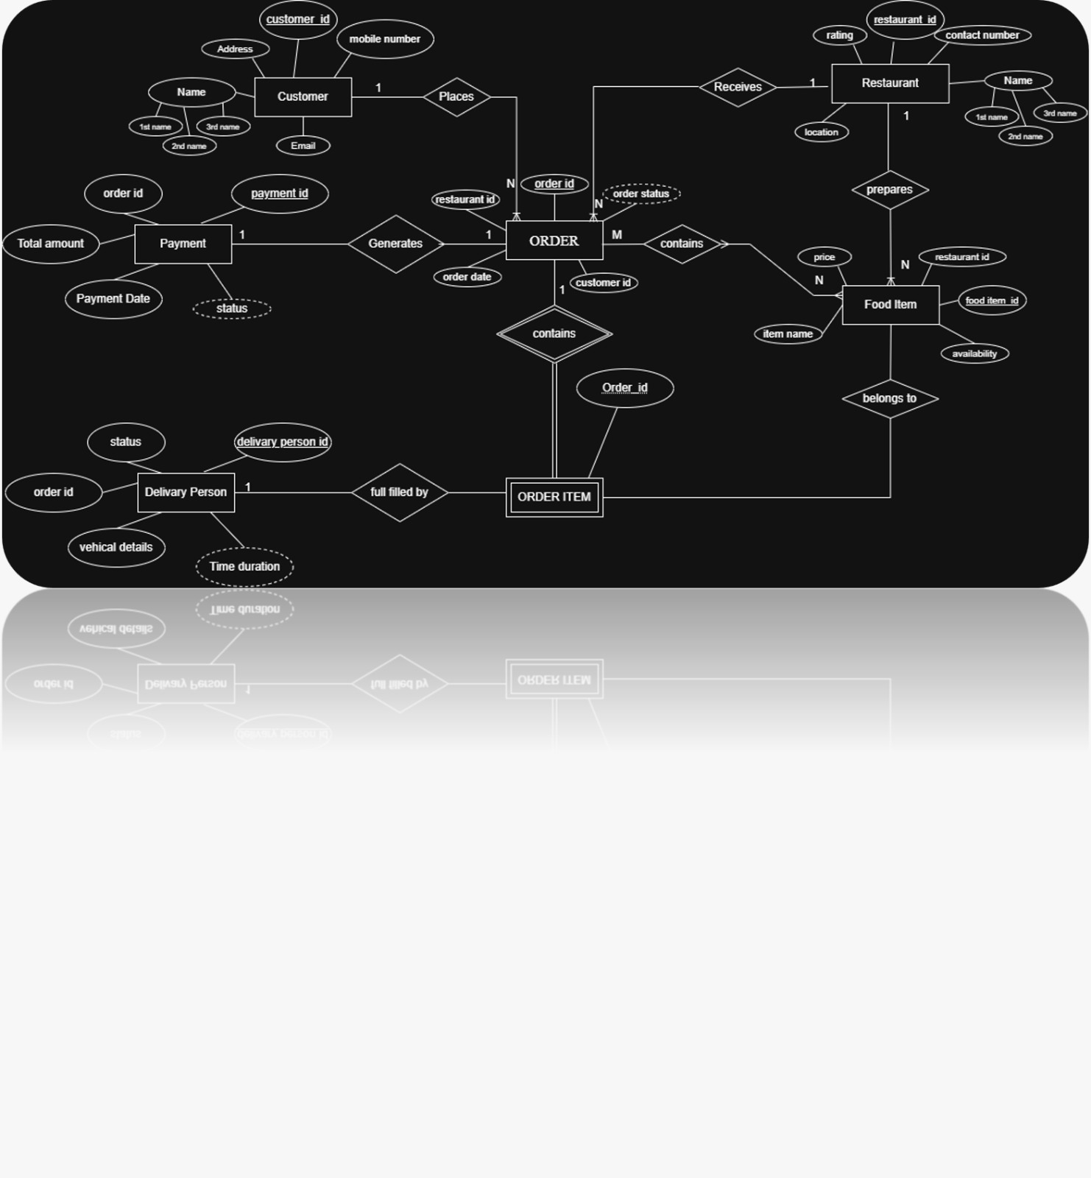

Figure 1: ER Diagram of E-Commerce order management System
The ER diagram summarizes the entity structure and cardinalities described in the supplied DBMS project material. It is a documentation-level representation; the final project team should align attribute names and cardinalities with the actual implemented database.

Relation | Relational Schema
CUSTOMER | Customer_Id (PK), Name, Email, Mobile_Number, Address
RESTAURANT | Restaurant_Id (PK), Name, Location, Contact_Number, Rating
FOOD_ITEM | Item_Id (PK), Restaurant_Id (FK), Item_Name, Price, Availability
ORDER | Order_Id (PK), Customer_Id (FK), Restaurant_Id (FK), Order_Date, Order_Status
ORDER_ITEM | Order_Item_Id (PK), Order_Id (FK), Item_Id (FK), Quantity, Subtotal
DELIVERY_PERSON | DeliveryPerson_Id (PK), Order_Id (FK), Vehicle_Details, Status, Time_Duration
PAYMENT | Payment_Id (PK), Order_Id (FK), Payment_Method, Payment_Status, Total_Amount, Payment_Date

The relational schema follows the structure presented in the supplied project material. Food Item references Restaurant; Order references Customer and Restaurant; Order Item references Order and Food Item; and Delivery Person and Payment each reference Order.
6. TABLE DESIGN

6.1 Department Table
Attribute | Data Type | Constraint | Description
Customer_Id | INT / NUMBER | PK, NOT NULL | Unique customer identifier
Name | VARCHAR | NOT NULL | Customer name
Email | VARCHAR | UNIQUE | Customer email
Mobile_Number | VARCHAR | UNIQUE | Customer contact number
Address | VARCHAR | — | Delivery address

6.2 Restaurant Table
Attribute | Data Type | Constraint | Description
Restaurant_Id | INT | PK | Unique restaurant identifier
Name | VARCHAR | NOT NULL | Restaurant name
Location | VARCHAR | — | Restaurant location
Contact_Number | VARCHAR | UNIQUE | Restaurant contact number
Rating | DECIMAL | CHECK | Restaurant rating (e.g. 0–5)

6.3 Food Item Table
Attribute | Data Type | Constraint | Description
Item_Id | INT | PK | Unique food item identifier
Restaurant_Id | INT | FK | References Restaurant
Item_Name | VARCHAR | NOT NULL | Name of the food item
Price | DECIMAL | CHECK | Item price, must be positive
Availability | VARCHAR / BOOLEAN | — | Whether the item is currently available

6.4 Order Table
Attribute | Data Type | Constraint | Description
Order_Id | INT | PK | Unique order identifier
Customer_Id | INT | FK | References Customer
Restaurant_Id | INT | FK | References Restaurant
Order_Date | DATE | — | Date the order was placed
Order_Status | VARCHAR | — | Current status of the order

6.5 Order Item Table
Attribute | Data Type | Constraint | Description
Order_Item_Id | INT | PK | Unique order-item identifier
Order_Id | INT | FK | References Order
Item_Id | INT | FK | References Food Item
Quantity | INT | CHECK | Quantity ordered, must be positive
Subtotal | DECIMAL | — | Line total for this item

6.6 Delivery Person Table
Attribute | Data Type | Constraint | Description
DeliveryPerson_Id | INT | PK | Unique delivery person identifier
Order_Id | INT | FK | References Order
Vehicle_Details | VARCHAR | — | Delivery vehicle information
Status | VARCHAR | — | Delivery status
Time_Duration | VARCHAR / INT | — | Delivery time taken

6.7 Payment Table
Attribute | Data Type | Constraint | Description
Payment_Id | INT | PK | Unique payment identifier
Order_Id | INT | FK | References Order
Payment_Method | VARCHAR | — | Method used for payment
Payment_Status | VARCHAR | — | Status of the payment
Total_Amount | DECIMAL | NOT NULL | Amount paid
Payment_Date | DATE | — | Date of payment

6.8 Keys and Constraints
Constraint Type | Applied To / Purpose
Primary Key | Customer_Id, Restaurant_Id, Item_Id, Order_Id, Order_Item_Id, DeliveryPerson_Id, Payment_Id
Foreign Key | Food_Item.Restaurant_Id; Order.Customer_Id; Order.Restaurant_Id; Order_Item.Order_Id; Order_Item.Item_Id; Delivery_Person.Order_Id; Payment.Order_Id
NOT NULL | Required attributes such as names and identifiers
UNIQUE | Email, mobile number, and restaurant contact number where applicable
CHECK | Values such as item price, order quantity, and restaurant rating can be restricted to valid ranges
DEFAULT | Can be used for fields such as order status or payment status when appropriate
7. NORMALIZATION
Normalization organizes data into related relations to reduce redundancy and update anomalies. The supplied project template explicitly requires documentation from UNF to 3NF. The following example uses a food order record to illustrate the process.
7.1 Unnormalized Form (UNF)
A single order record might contain Order_Id, Customer_Name, Customer_Address, Restaurant_Name, multiple food item values and quantities, and payment details all in one record. Repeating item groups and repeated customer/restaurant information create redundancy.
7.2 First Normal Form (1NF)
In 1NF, repeating groups are removed and each attribute contains atomic values. Each ordered food item is represented as a separate Order Item row. Customer and restaurant details may still be repeated across multiple order records.
7.3 Second Normal Form (2NF)
In 2NF, partial dependencies on a composite key are removed. Customer-specific attributes depend on Customer_Id, restaurant-specific attributes depend on Restaurant_Id, and item-specific attributes depend on Item_Id. These dependencies motivate separate Customer, Restaurant, and Food Item relations.
7.4 Third Normal Form (3NF)
In 3NF, transitive dependencies are removed. Restaurant details are stored in Restaurant rather than repeated in Food Item or Order. Payment details are linked to Order through Payment rather than embedded in the order record. Delivery details are linked to Order through Delivery Person. The resulting structure supports the 3NF objective stated in the supplied project material.
Relation | Reason for Separation
Customer | Stores customer-specific attributes once.
Restaurant | Stores restaurant-specific attributes once.
Food Item | Stores item-specific attributes and a Restaurant_Id reference.
Order | Stores the customer–restaurant order relationship.
Order Item | Stores the order–food item line details.
Delivery Person | Stores delivery assignment details for an order.
Payment | Stores payment information for an order.

8. SQL IMPLEMENTATION

8.1 DDL – Data Definition Language
The following DDL is a documentation-ready implementation aligned with the supplied relational schema. Data types may be adjusted to the specific DBMS used by the student team.
CREATE TABLE Customer (
Customer_Id NUMBER PRIMARY KEY,
Name VARCHAR2(100) NOT NULL,
Email VARCHAR2(100) UNIQUE,
Mobile_Number VARCHAR2(15) UNIQUE,
Address VARCHAR2(200)
);

CREATE TABLE Restaurant (
Restaurant_Id NUMBER PRIMARY KEY,
Name VARCHAR2(100) NOT NULL,
Location VARCHAR2(150),
Contact_Number VARCHAR2(15) UNIQUE,
Rating NUMBER CHECK (Rating BETWEEN 0 AND 5)
);

CREATE TABLE Food_Item (
Item_Id NUMBER PRIMARY KEY,
Restaurant_Id NUMBER,
Item_Name VARCHAR2(100) NOT NULL,
Price NUMBER CHECK (Price > 0),
Availability VARCHAR2(10),
CONSTRAINT fk_item_restaurant
FOREIGN KEY (Restaurant_Id)
REFERENCES Restaurant(Restaurant_Id)
);

CREATE TABLE Orders (
Order_Id NUMBER PRIMARY KEY,
Customer_Id NUMBER NOT NULL,
Restaurant_Id NUMBER NOT NULL,
Order_Date DATE,
Order_Status VARCHAR2(20),
CONSTRAINT fk_order_customer
FOREIGN KEY (Customer_Id) REFERENCES Customer(Customer_Id),
CONSTRAINT fk_order_restaurant
FOREIGN KEY (Restaurant_Id) REFERENCES Restaurant(Restaurant_Id)
);

CREATE TABLE Order_Item (
Order_Item_Id NUMBER PRIMARY KEY,
Order_Id NUMBER NOT NULL,
Item_Id NUMBER NOT NULL,
Quantity NUMBER CHECK (Quantity > 0),
Subtotal NUMBER,
CONSTRAINT fk_orderitem_order
FOREIGN KEY (Order_Id) REFERENCES Orders(Order_Id),
CONSTRAINT fk_orderitem_item
FOREIGN KEY (Item_Id) REFERENCES Food_Item(Item_Id)
);

CREATE TABLE Delivery_Person (
DeliveryPerson_Id NUMBER PRIMARY KEY,
Order_Id NUMBER NOT NULL,
Vehicle_Details VARCHAR2(100),
Status VARCHAR2(20),
Time_Duration VARCHAR2(20),
CONSTRAINT fk_delivery_order
FOREIGN KEY (Order_Id) REFERENCES Orders(Order_Id)
);

CREATE TABLE Payment (
Payment_Id NUMBER PRIMARY KEY,
Order_Id NUMBER NOT NULL,
Payment_Method VARCHAR2(30),
Payment_Status VARCHAR2(20),
Total_Amount NUMBER NOT NULL,
Payment_Date DATE,
CONSTRAINT fk_payment_order
FOREIGN KEY (Order_Id) REFERENCES Orders(Order_Id)
);

8.2 DML – Data Manipulation Language
INSERT INTO Customer VALUES (1,'Customer One','customer1@example.com','9000000001','12 Main Street');

INSERT INTO Restaurant VALUES (1,'Spice Villa','Downtown','9000000002',4.5);

INSERT INTO Food_Item VALUES (101,1,'Chicken Biryani',250,'YES');

INSERT INTO Orders VALUES (201,1,1,SYSDATE,'PLACED');

INSERT INTO Order_Item VALUES (301,201,101,2,500);

INSERT INTO Delivery_Person VALUES (401,201,'Bike - AP01AB1234','ASSIGNED','30 mins');

INSERT INTO Payment VALUES (501,201,'UPI','PAID',500,SYSDATE);

8.3 DQL – Data Query Language
SELECT * FROM Customer;

SELECT Order_Id, Order_Date, Order_Status
FROM Orders
WHERE Customer_Id = 1;

SELECT Item_Name, Price
FROM Food_Item
ORDER BY Price DESC;

SELECT c.Name, o.Order_Id, o.Order_Status
FROM Customer c
JOIN Orders o ON c.Customer_Id = o.Customer_Id;

SELECT c.Name, r.Name AS Restaurant_Name, f.Item_Name, oi.Quantity
FROM Customer c
JOIN Orders o ON c.Customer_Id = o.Customer_Id
JOIN Restaurant r ON o.Restaurant_Id = r.Restaurant_Id
JOIN Order_Item oi ON o.Order_Id = oi.Order_Id
JOIN Food_Item f ON oi.Item_Id = f.Item_Id;

9. SQL QUERIES & SCREENSHOTS
The following query set is prepared to satisfy the documentation requirement for a some query SQL section. The examples cover selection, filtering, joins, aggregation, subqueries, updates, deletion, and reporting. Exact outputs depend on the records inserted in the final project database.
- Crud and SQL Queries
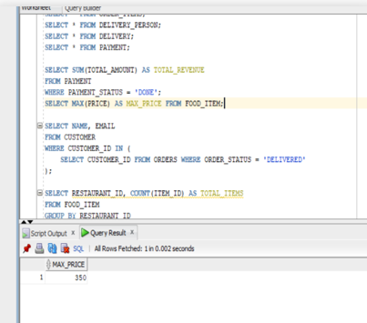

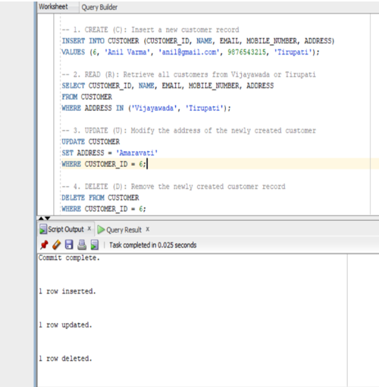

- DQL – QUERIES:

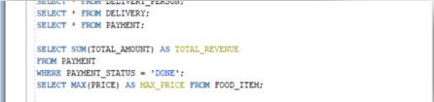

DML QUERIES:
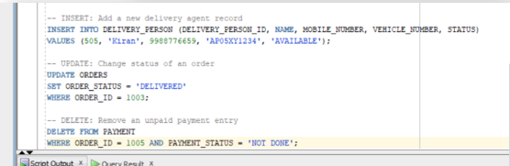

DDL QUERIES:

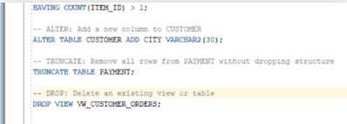

- SQL Table Creation and Execution:

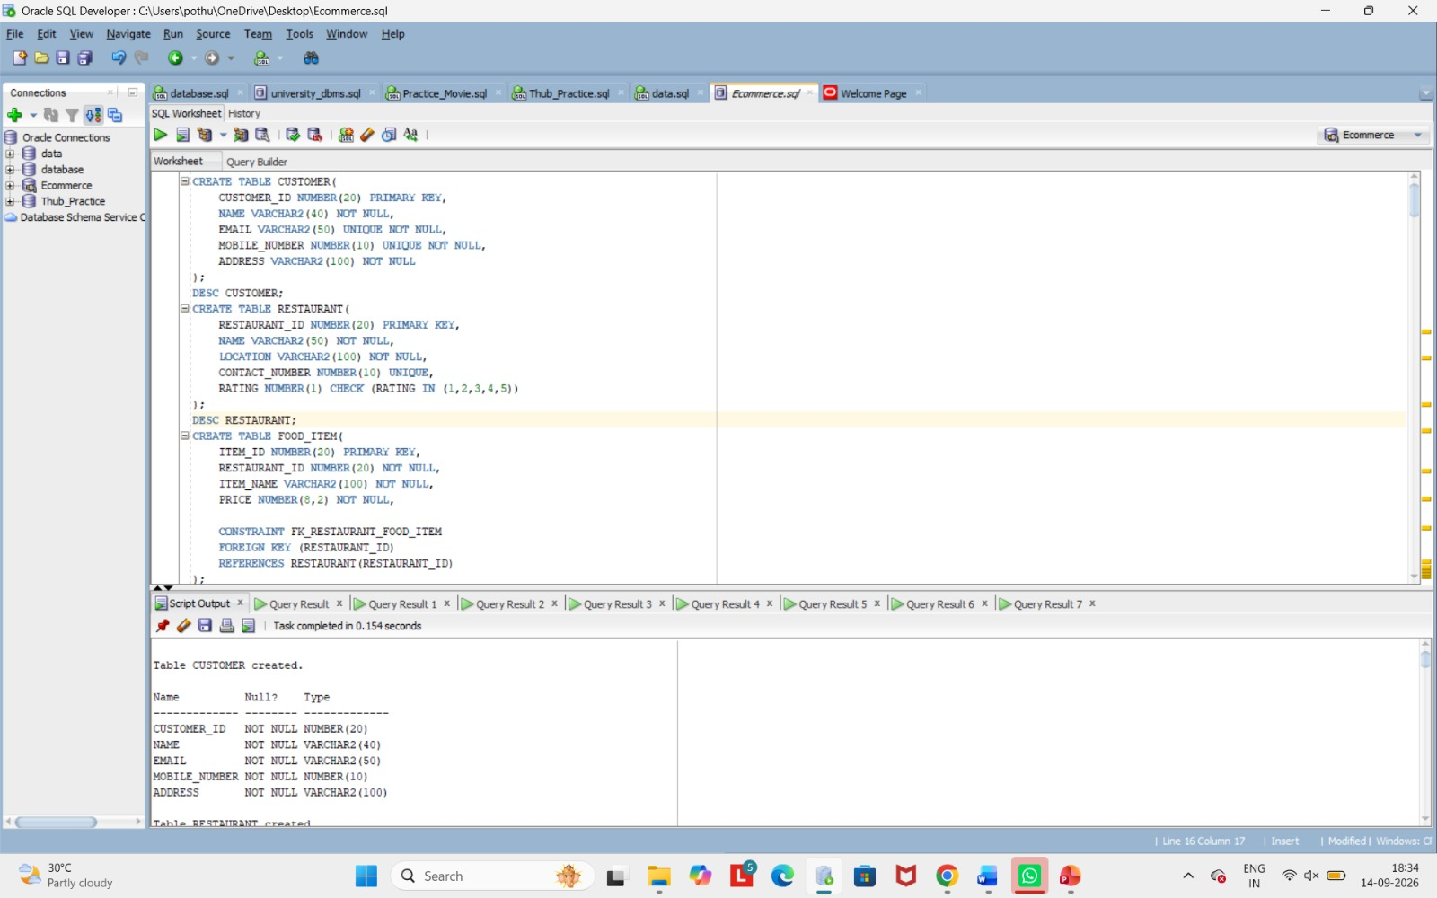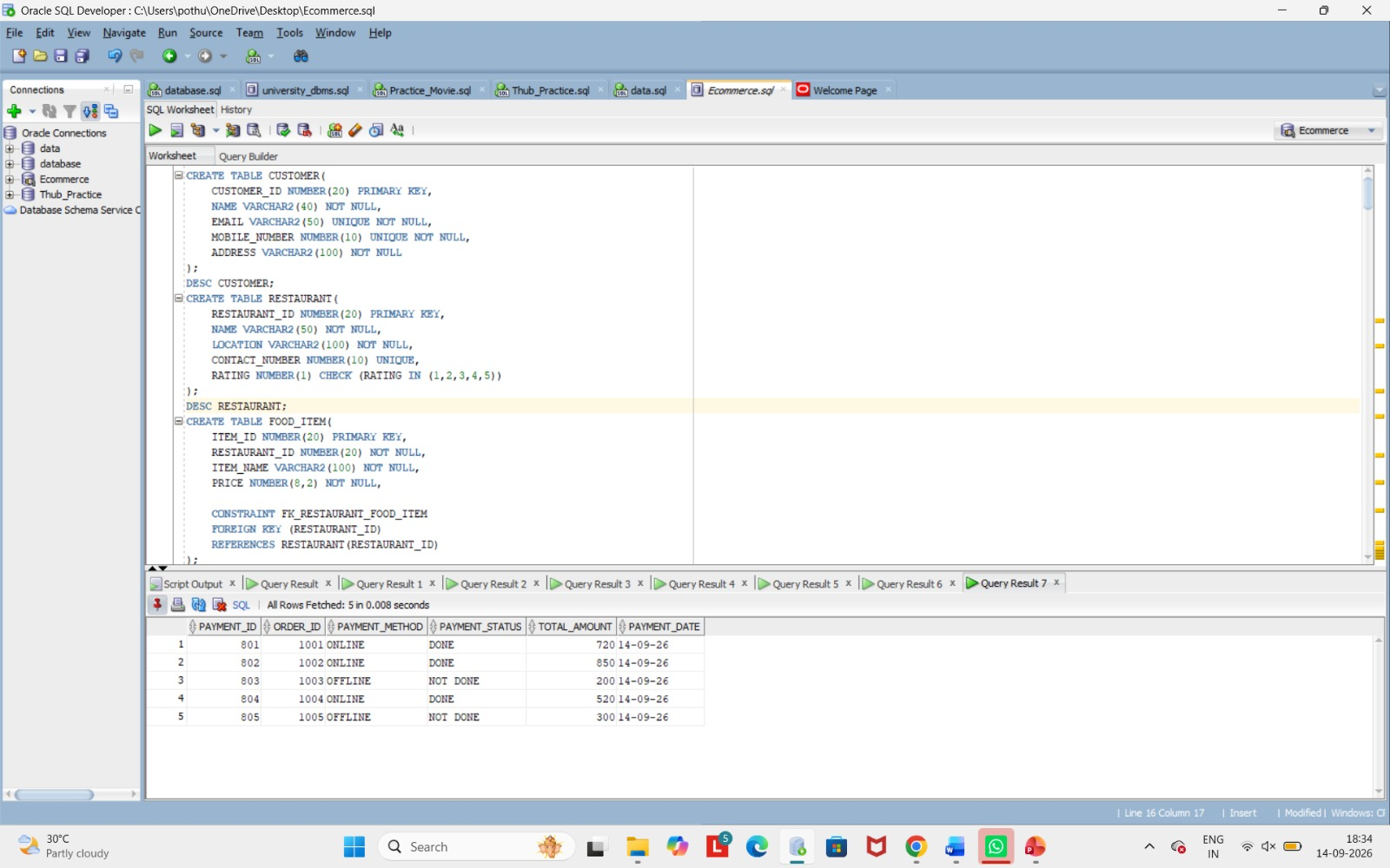

9. GITHUB REPOSITORY & TEAM RESPONSIBILITIES
Repository Link: ___ omhema2008-web/DBMS-E_Commerce_______________________________________
Student Name | Roll Number | Role / Responsibility | Contribution Status
Nakkala Hema varshini | 25B11AI803 | Handled Project Documention and Managed Github Repository and Coordinated Insertion and sample Data recoeds | Completed
Prapurna Pothuraju | 25B11AI978 | Created Databases and Wrote and Executed DDL, DML, DQL, and ensured Data Integrity | Completed
Hanshitha Dhavala | 25B11AI271 | Designed ER Diagram, Developed the Relational Database Schema, and Defined entity Relationships and Constraints | Completed

11. CONCLUSION
The Online Food Delivery Management System provides a structured relational database solution for managing core order-processing information. The design organizes customers, restaurants, food items, orders, order items, delivery personnel, and payments into related relations and applies primary keys, foreign keys, uniqueness rules, NOT NULL conditions, and CHECK constraints to support data integrity. The normalization process up to 3NF reduces redundancy and update anomalies. The SQL implementation and query set demonstrate how the database can support insertion, modification, retrieval, aggregation, and order/delivery reporting. The project therefore provides a suitable DBMS cornerstone implementation, built around six core entities, that can be extended into a complete food-delivery information system.

12. FUTURE ENHANCEMENTS
- PL/SQL triggers to automate real-time order and payment status updates.
- Indexing (B-tree indexes) to optimize query performance and search speed.
- Advanced reporting views to track delivery metrics and revenue trends.
- Real-time GPS delivery tracking.
- Customer ratings and review management.
- Multiple payment gateway integrations.
- Role-based access for administrators, restaurant owners, and delivery staff.
- Backup, recovery, audit logging, and stronger database security.
REFERENCES
- Korth, H. F., Silberschatz, A., and Sudarshan, S., Database System Concepts, McGraw Hill.
- Elmasri, R. and Navathe, S. B., Fundamentals of Database Systems, Pearson.

