

AMERICAN INTERNATIONAL UNIVERSITY-BANGLADESH (AIUB)
Department of Computer Science
Faculty of Science and Technology
CSC 2210: OBJECT ORIENTED PROGRAMMING 2
Summer 2025-2026
Section: P
Group No:
Project Report On
Clothing Store Management System
Supervised By
Al Jubair Hossain
Submitted By:
Name | ID
1. Snigdha Akther Omi | 24-58105-2
2. Nishat Jahan Nishi | 24-59229-3
3. Amrita Chakrabartty | 24-59278-3
4. Sumaiya Reza Ratre | 24-58682-2

CO2: Display and verify the mean of a real-life Project using the concepts of C# Graphical User Interface based environment with database integration to depict a desktop-based application.
Assessment Criteria | Not  Attended/  Incorrect (0) | Inadequate  (1-2) | Average  (3) | Good  (4) | Excellent  (5)
Evaluation Criteria | Evaluation Definition |  |  |  | Total =
Requirement fulfillment | Properly demonstrate a real-life scenario-based project with proper functional requirement identification for the ObjectOriented Programming project development activities.
Validation | Ensuring the ability of students’ proper demonstration on validation forms in their system in terms of dealing with the data.
Verification | Identifying if the students can verify the system data along with proper functional requirements in terms of data flow.
1

Table of Contents
1. INTRODUCTION 3

2. FEATURE LIST 3

3. ER DIAGRAM 9

4. UML DIAGRAM 9

4.1 Use Case Diagram 10

4.2 Activity Diagram 11

5. CONCLUSION 12

INTRODUCTION
The "CLOSET" - Clothing Store Management System is an integrated desktop application developed using C# in Microsoft Visual Studio / Visual Studio Code to deliver a modern, scalable solution for retail apparel management. Built to streamline store operations, the application features an intuitive and interactive user interface designed to serve both general shoppers and store administrators efficiently. The customer module supports secure user authentication (login and registration), allowing shoppers to seamlessly explore apparel across distinct categories—Men, Women, and Kids. Users can utilize real-time product search features, filter inventory, dynamic cart management (adding items and updating quantities), and complete purchases via diverse payment gateways including Cash, Card, and bKash. On the administrative side, the system provides a robust, centralized Admin Dashboard equipped with real-time summary counters and dynamic data grid views. This empowers administrators to monitor registered users, manage active employees, track stock levels in real-time, and view complete customer order histories effortlessly. To deliver comprehensive technical blueprint of the application, this project documents the architectural design through an Entity-Relationship (ER) Diagram for database structuring, a Use Case Diagram to define actor interactions, and Activity Diagrams to illustrate critical core workflows.

FEATURE LIST
Project Features:
    - User Authentication– Users can create an account and log in to the system.
    - Category-based Product Filtering – Products can be filtered by All, Women, Men, and Kids categories.
    - Real-time Product Search – Users can search for products by product name.
    - Shopping Cart– Users can add products to the cart, with validation for an empty cart.
    - Order Summary – Users can adjust product quantities (+ / -), and the total price updates automatically.
    - Multiple Payment Methods – Users can place orders using Cash, Card, or bKash.
    - Logout – Users can log out of the system with a confirmation prompt.
    - Admin Dashboard Overview & Key Features
Summary Metrics (Counter Cards):

    - Total Customer: Displays the real-time count of total registered customers/users in the system.

    - Products in Stock: Shows the total number of clothing products currently available in the inventory.

    - Active Employee: Tracks and displays the total number of active employees working in the store.

    - Navigation Options (Left Side Menu):

    - Over View: Reloads and displays the main dashboard view containing real-time summary cards and the customer order overview table.

    - Customer: Navigates to the customer management section to view detailed records of registered users.

    - Employee: Navigates to the employee management interface to view, manage, and update employee details (such as designation, salary, and active status).

    - Log Out: Logs out the current administrator session and safely returns to the main login screen.

    - Customer Purchases Data Grid (Main Data Table):

    - Customer Name: Lists the username of each registered customer in the database.

    - Chosen Product: Displays the specific clothing items selected or ordered by each customer (e.g., Kids T-Shirt, Classic Shirt).

    - Price: Shows the total transaction amount/price corresponding to the items chosen by the customer.
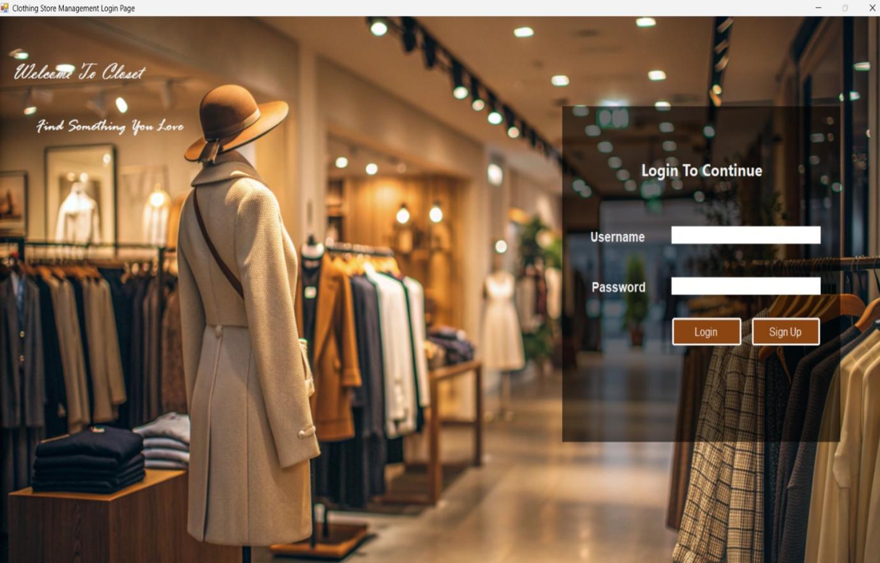

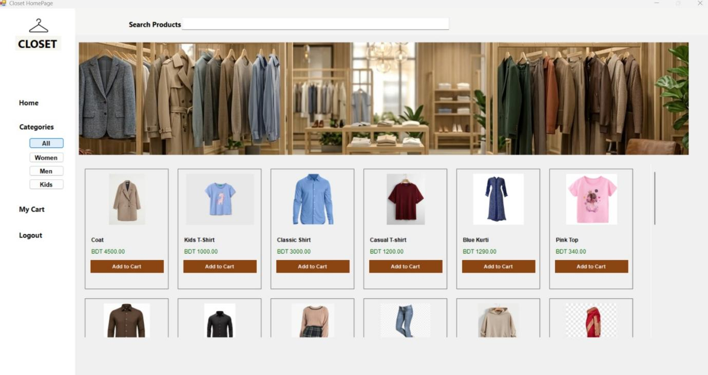

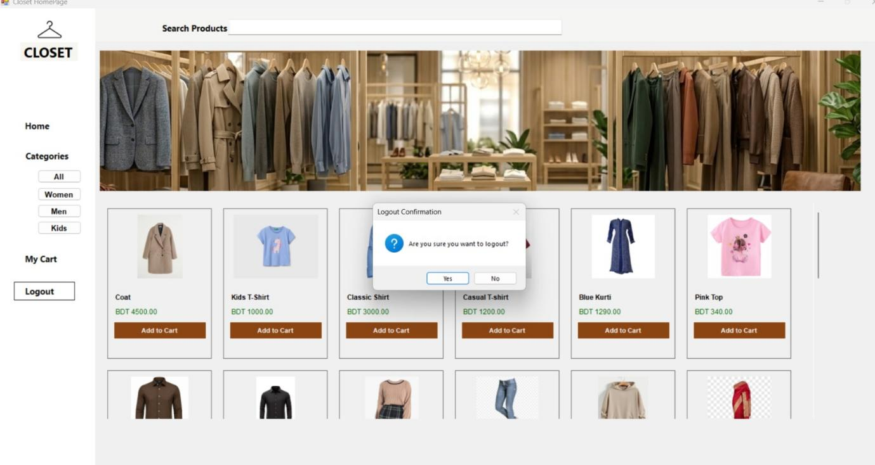

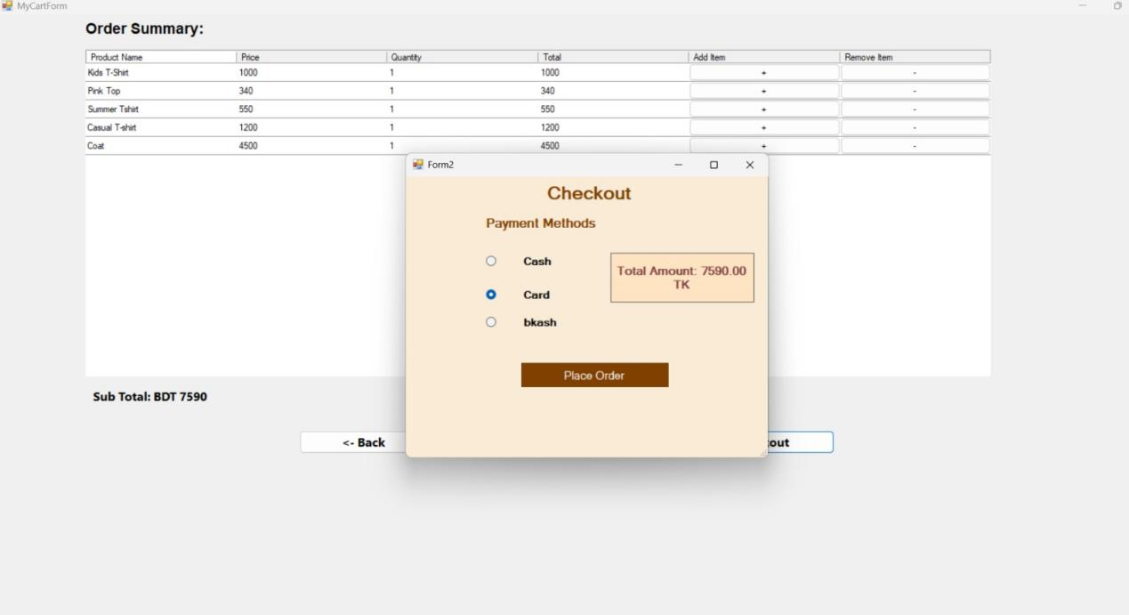

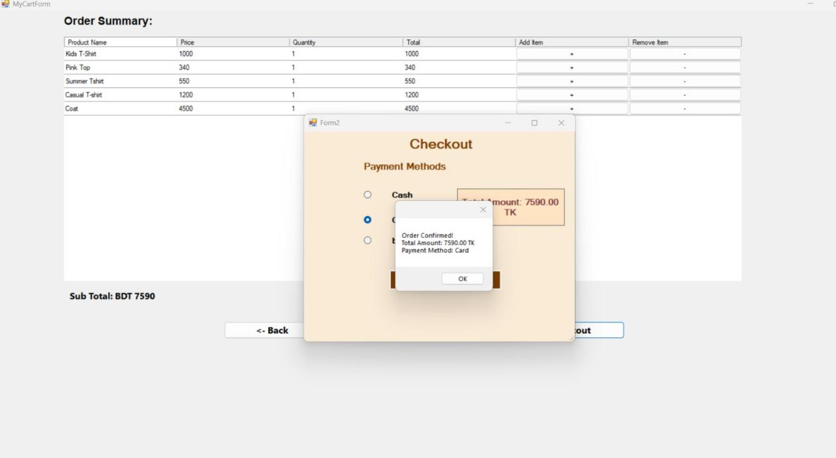

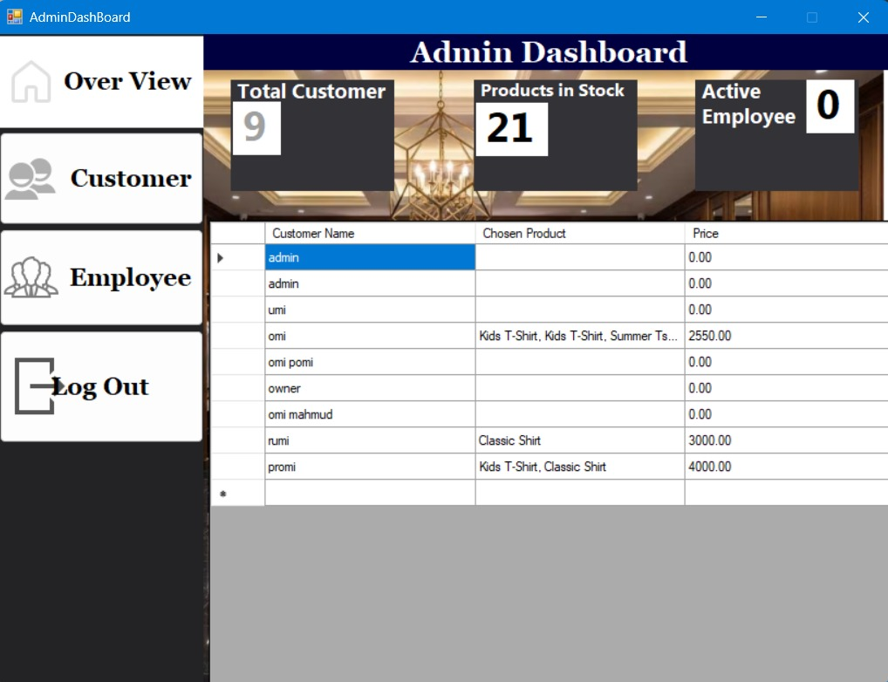

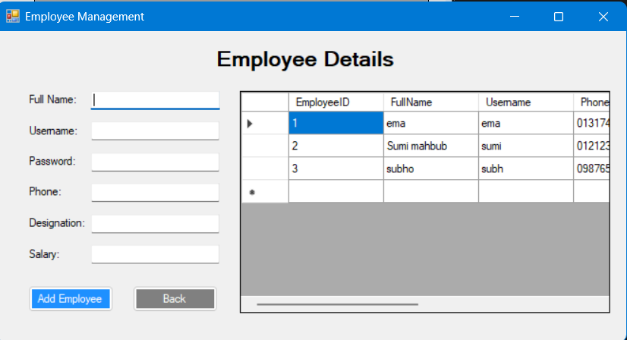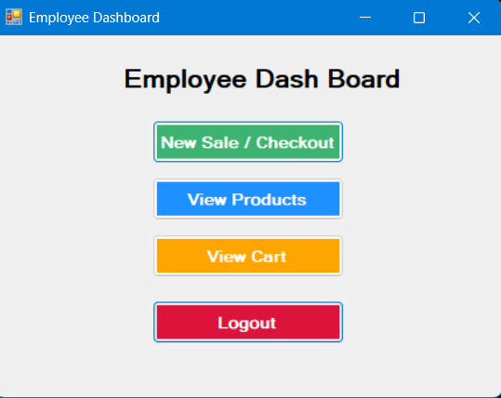
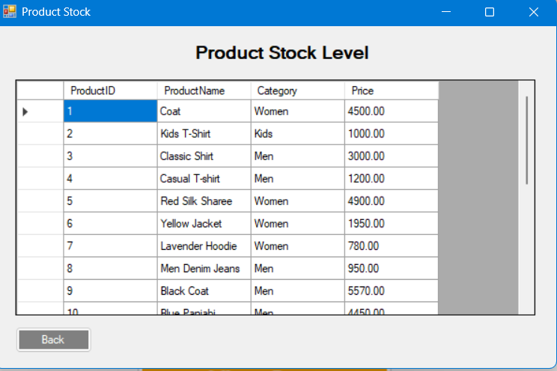

ER DIAGRAM
Along with diagram description

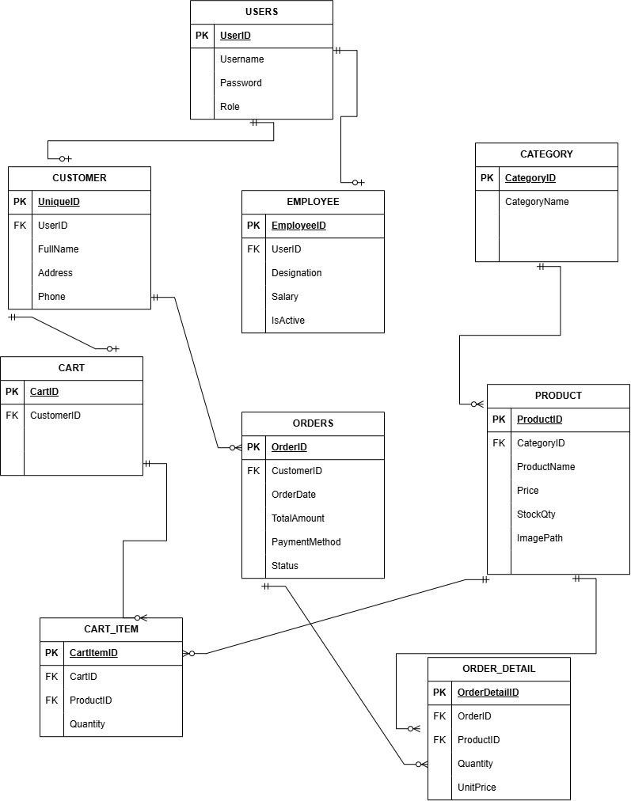

UML DIAGRAM

Use Case Diagram
Along with diagram description

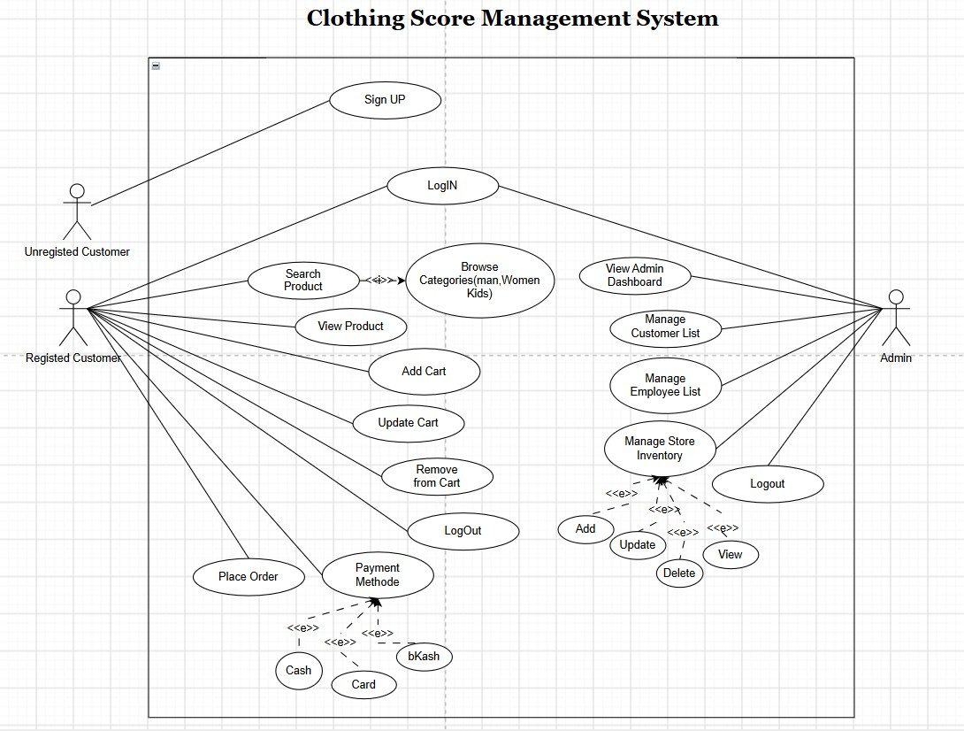

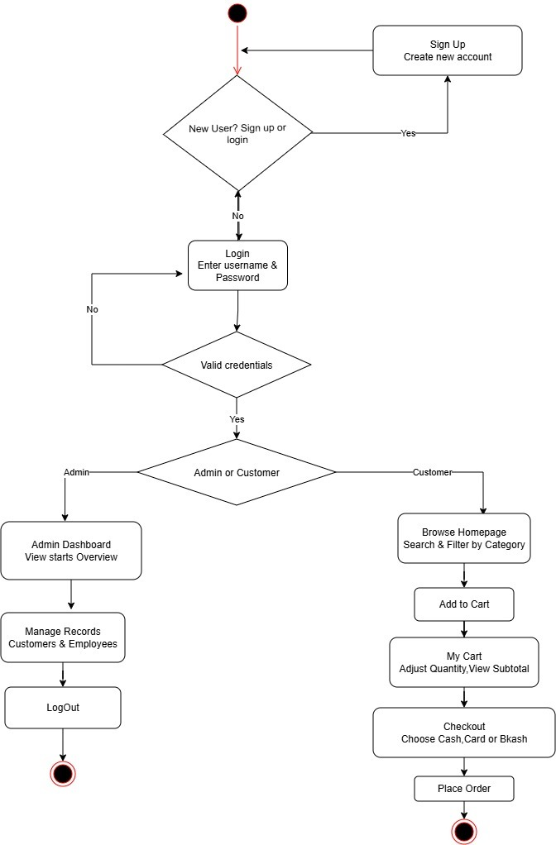
Activity Diagram.

Query
USE ClothingStoreDB;

CREATE TABLE UserLogin (
Id INT PRIMARY KEY IDENTITY(1,1), --identity 1,1 auto increment by one from 1
Username VARCHAR(50) NOT NULL,
Password VARCHAR(50) NOT NULL
);

INSERT INTO UserLogin (Username, Password) VALUES ('admin', '1234');

CREATE TABLE Products (
ProductID INT PRIMARY KEY IDENTITY(1,1),
ProductName VARCHAR(100) NOT NULL,
Category VARCHAR(50) NOT NULL,
Price DECIMAL(10, 2) NOT NULL,
ImagePath VARCHAR(255) NULL
);

INSERT INTO Products (ProductName, Category, Price, ImagePath)
VALUES
('Coat', 'Women', 4500.00, 'D:\ClothingSoreManagement\Clothing\Clothing\images\overcoat.jpg'),
('Kids T-Shirt', 'Kids', 1000.00, 'D:\ClothingSoreManagement\Clothing\Clothing\images\kids.jpg'),
('Classic Shirt', 'Men', 3000.00, 'D:\ClothingSoreManagement\Clothing\Clothing\images\shirt.png'),
('Casual T-shirt', 'Men', 1200.00, 'D:\ClothingSoreManagement\Clothing\Clothing\images\t-shirt.png');
select * from Products;

INSERT INTO Products (ProductName, Category, Price, ImagePath)
VALUES
('Red Silk Sharee', 'Women', 4900.00, 'D:\ClothingSoreManagement\Clothing\Clothing\images\Red Silk Sharee.jpeg'),
('Yellow Jacket', 'Women', 1950.00, 'D:\ClothingSoreManagement\Clothing\Clothing\images\Yellow Jacket.jpeg'),
('Lavender Hoodie', 'Women', 780.00, 'D:\ClothingSoreManagement\Clothing\Clothing\images\Lavender Hoodie.jpeg');
select * from Products;

INSERT INTO Products (ProductName, Category, Price, ImagePath)
VALUES
('Men Denim Jeans', 'Men', 950.00, 'D:\ClothingSoreManagement\Clothing\Clothing\images\Men Denim.png'),
('Black Coat', 'Men', 5570.00, 'D:\ClothingSoreManagement\Clothing\Clothing\images\Black Coat.png'),
('Blue Panjabi', 'Men', 4450.00, 'D:\ClothingSoreManagement\Clothing\Clothing\images\Panjabi.png');

INSERT INTO Products (ProductName, Category, Price, ImagePath)
VALUES
('Summer Tshirt', 'Kids', 550.00, 'D:\ClothingSoreManagement\Clothing\Clothing\images\Summer Tshirt.jpg'),
('Baby Hoodie', 'Kids', 770.00, 'D:\ClothingSoreManagement\Clothing\Clothing\images\baby green hoodie.jpg'),
('Jumper dress', 'Kids', 650.00, 'D:\ClothingSoreManagement\Clothing\Clothing\images\Baby Jumper dress.png'),
('Orange frock', 'Kids', 580.00, 'D:\ClothingSoreManagement\Clothing\Clothing\images\Orange frock.png');

INSERT INTO Products (ProductName, Category, Price, ImagePath)
VALUES
('Blue Kurti', 'Women', 1290.00, 'D:\ClothingSoreManagement\Clothing\Clothing\images\Blue Kurti.jpg'),
('Pink Top', 'Kids', 340.00, 'D:\ClothingSoreManagement\Clothing\Clothing\images\Pink Top.jpg'),
('Brown Shirt', 'Men', 480.00, 'D:\ClothingSoreManagement\Clothing\Clothing\images\Brown Shirt.jpg'),
('Black Shirt', 'Men', 560.00, 'D:\ClothingSoreManagement\Clothing\Clothing\images\Black Shirt.jpg'),
('Pink Western Dress', 'Women', 4500.00, 'D:\ClothingSoreManagement\Clothing\Clothing\images\Pink Western Dress.jpg'),
('Ladies Denim Jeans', 'Women', 900.00, 'D:\ClothingSoreManagement\Clothing\Clothing\images\Ladies Denim Jeans.jpg'),
('Beige Hoodie', 'Men', 1500.00, 'D:\ClothingSoreManagement\Clothing\Clothing\images\Beige Hoodie.jpg');

CREATE TABLE Admins (
AdminID INT PRIMARY KEY IDENTITY(1,1),
Username VARCHAR(50) NOT NULL UNIQUE,
Password VARCHAR(250) NOT NULL
);
GO

INSERT INTO Admins (Username, Password)
VALUES ('owner', '0987');
GO

);

USE ClothingStoreDB;
GO

CREATE TABLE Employees (
EmployeeID INT IDENTITY(1,1) PRIMARY KEY,
FullName VARCHAR(100) NOT NULL,
Username VARCHAR(50) UNIQUE NOT NULL,
Password VARCHAR(50) NOT NULL,
Phone VARCHAR(20),
Designation VARCHAR(50),
Salary DECIMAL(10, 2),
Status VARCHAR(20) DEFAULT 'Active'
);

CONCLUSION
​In conclusion, the Clothing Store Management System successfully fulfills the functional requirements of a modern desktop-based retail application built on the C# / .NET framework. By integrating essential customer shopping features with a robust administrative management interface, the application ensures efficient inventory tracking and seamless order processing. The simple user interface developed in Visual Studio provides a smooth experience for both shoppers and store administrators. Future enhancements can focus on adding backend database synchronization and advanced visual reporting features to further elevate the system's overall functionality.

https://github.com/omi-omi23/ClothingStoreManagementSystem.git

