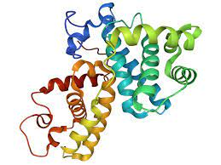

Compounds from ANPDb, and AfroDB database were obtained

(7672 compounds)

Protein was prepared using Pymol

Compounds were pre-filtering using Datawarrior

(2968 compounds)

3D structure of aldose reductase was obtained from PDB

(PDB id:1US0)

Molecular Docking Using Autodock Vina

(20 top hits were selected)

Absorption, Distribution, Metabolism, Excretion and Toxicity (ADMET) Studies

Protein Ligand Interaction Studies

Prediction of Biological Activity (PASS)

Molecular Dynamics Simulations

**TOP 5 LEAD COMPOUNDS**

MMPBSA Analysis