**MULTIOMICS WORKFLOW (mix-Omix approach)**

We present R multiomics pipeline as an easy to use and flexible pipeline that takes unrefined multiomics data as input, sample information and user-specified parameters to generate a list of output plots and data tables for quality control and downstream analysis.

**Steps summary**

* Install of the required software-mixOmics R package
* Data selection based on experimental design- Data with at least 2 omics(Genomics, Transcriptomics and Metabolics)
* Data preprocessing - Reformat data to matrices.
* Parameter selection- Visualisation of key features and Visualisation of correlations.

**Schematic illustration**



First time installation: Follow instructions on gitlab, Conda usage is optional, Run run_pipeline.R

|  |  |
| --- | --- |
| **METADATA** | **Sample Type** |
| **Sample 1** | **Treatment A** |
| **Sample 2** | **Treatment B** |

Data selection: Data with at least 2 omics Data with matched samples Consider experimental design

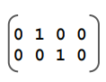

|  |  |  |
| --- | --- | --- |
| DATA | Feature 1 | Feature 2 |
| Sample 1 | 3.142 | 2.7 |
| Sample 2 | 10000 | 88.88 |

Data preprocessing: Reformat data to matrices Account for sparse values Consider experimental design



Parameter selection: Tune parameters on data, Perform trial runs, adjust parameters and rerun

|  |  |  |
| --- | --- | --- |
| CORRELATION | Feature 1 | Feature 2 |
| Feature X | 0.95 | 0.05 |
| Feature Y | -0.95 | -0.05 |

Results and interpretation: visualization of key features, Visualisation of correlations Results in tab separated files

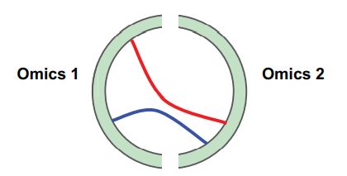

|  |  |  |
| --- | --- | --- |
| WEIGHT | Treatment A | Treatment B |
| Feature 1 | 5,6 | 3.8 |
| Feature 2 | -2.95 | -4.5 |