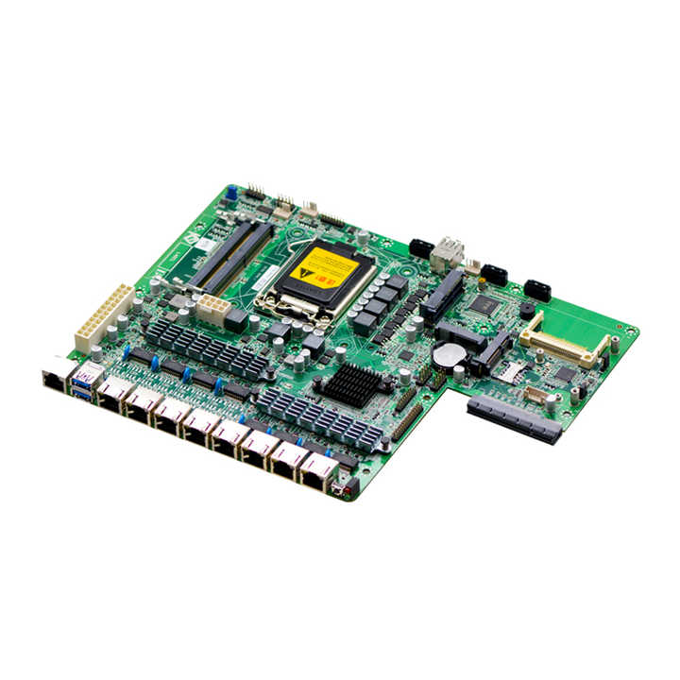

# IIT 1U Rack Mount LGA1151 SFP Optical Fiber H170 Firewall Motherboard 8 Port NIC OEM Network Appliance Main-board

|  |  |
| --- | --- |
| socket type | 1151 |
| Storage | SATA |
| maximum ram capacity | 32GB |
| chipset | H110 |
| brand name | EvrTech |
| CPU Support | 6th/7th8th/9th Gen i3-i5-i7 |
| memory type | DDR4 |
| form factor | ATX |
| chipset manufacturer | Intel |
| ports | SATA, VGA , PCI-Express X8, USB 2.0, PS2, USB 3.0 , 6*1 G +4 SFP |
| Launch Date | 2020 |
| Single package size | 25X10X8 cm |

# Network H110 DDR4 6th/7thGen I3-i5-i7 Server 6 Ethernet Ports 4*SFP Pfsense Firewal Ports Router Firewall Motherboard

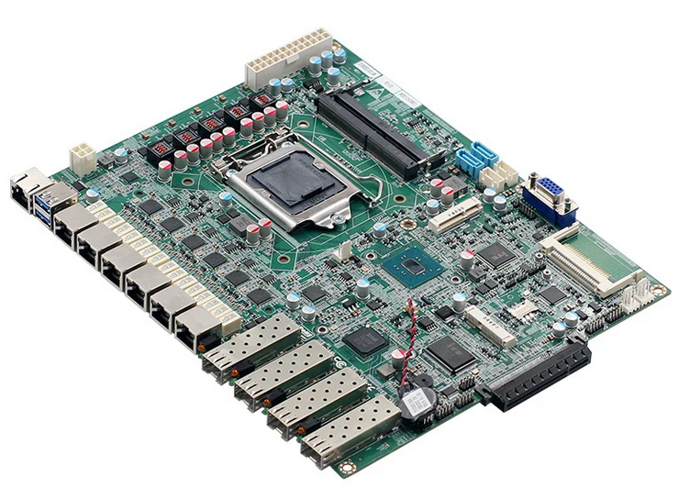

|  |  |
| --- | --- |
| socket type | 1151 |
| Storage | SATA |
| maximum ram capacity | 32GB |
| chipset | H110 |
| brand name | EvrTech |
| CPU Support | 6th/7th8th/9th Gen i3-i5-i7 |
| memory type | DDR4 |
| form factor | ATX |
| chipset manufacturer | Intel |
| ports | SATA, VGA , PCI-Express X8, USB 2.0, PS2, USB 3.0 , 6*1 G +4 SFP |
| Launch Date | 2020 |
| Single package size | 25X10X8 cm |

# ITX-M9F 4 Ethernet Ports Motherboard J1900 Fanless J1900 Router Motherboard 4 Ethernet Ports Motherboard

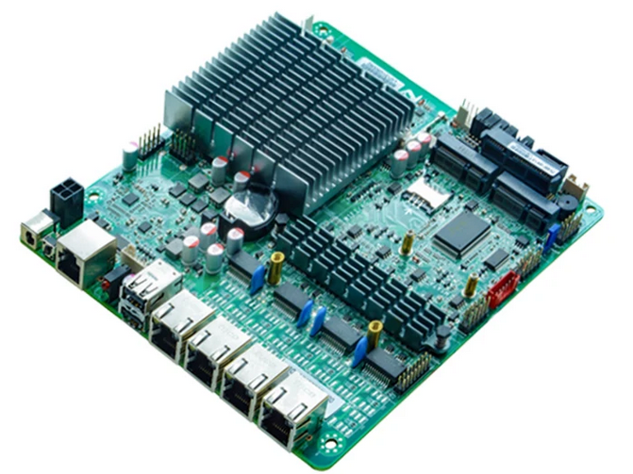

|  |  |
| --- | --- |
| socket type | Onboard CPU |
| Storage | SATA,Mini-SATA |
| maximum ram capacity | 1* DDR3 SODIMM,supports 1333/1066 MHz , Max. 8GB |
| chipset | Intel® Bay trail SOC platform, CPU integrates chipset J1900 |
| brand name | IIT |
| CPU Support | j1900 Quad core |
| memory type | 1 DDR3 DIMM |
| form factor | Mini-ITX |
| chipset manufacturer | Intel |
| ports | 1*COM + 2* USB + Serial 4*82574L Gigabit Lan |
| Launch Date | 2018 |
| Single package size | 170mm*170mm |
| Powert supply | DC 12V-19v Single power supply |

|  |  |
| --- | --- |
| socket type | Onboard CPU |
| Storage | SATA,Mini-SATA |
| maximum ram capacity | 1* DDR3 SODIMM,supports 1333/1066 MHz , Max. 8GB |
| chipset | Intel® Bay trail SOC platform, CPU integrates chipset J1900 |
| brand name | IIT |
| CPU Support | j1900 Quad core |
| memory type | 1 DDR3 DIMM |
| form factor | Mini-ITX |
| chipset manufacturer | Intel |
| ports | 1*COM + 2* USB + Serial 4*82574L Gigabit Lan |
| Launch Date | 2018 |
| Single package size | 170mm*170mm |
| Powert supply | DC 12V-19v Single power supply |

1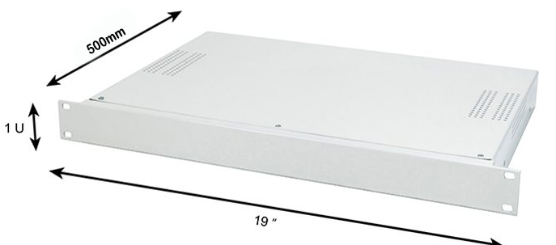U 19 Inch*L 500 MM Case ( White / Black )