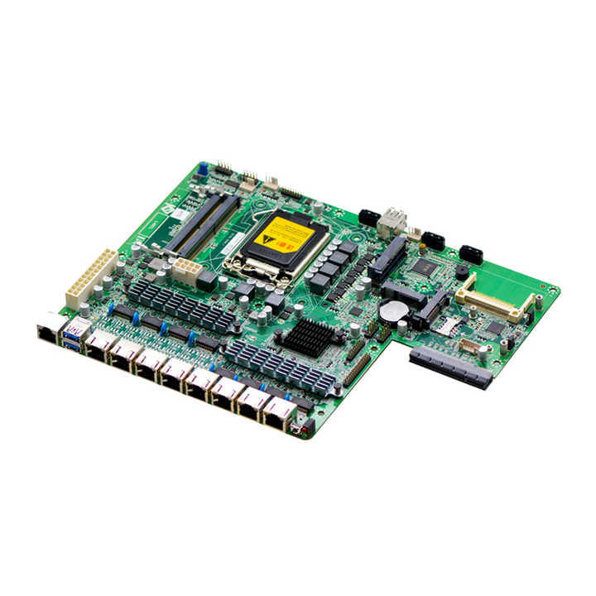

IIT 1U Rack Mount LGA1151 SFP Optical Fiber H170 Firewall Motherboard
8 Port NIC OEM Network Appliance Main-board

socket type | 1151
Storage | SATA
maximum ram capacity | 32GB
chipset | H110
brand name | EvrTech
CPU Support | 6th/7th8th/9th Gen i3-i5-i7
memory type | DDR4
form factor | ATX
chipset manufacturer | Intel
ports | SATA, VGA , PCI-Express X8, USB 2.0, PS2, USB 3.0 , 6*1 G +4 SFP
Launch Date | 2020
Single package size | 25X10X8 cm

Network H110 DDR4 6th/7thGen I3-i5-i7 Server 6 Ethernet Ports 4*SFP Pfsense Firewal Ports Router Firewall Motherboard
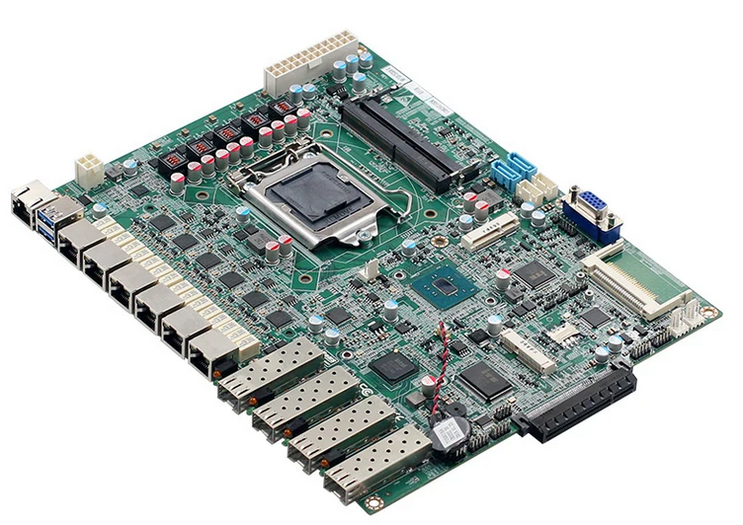

socket type | 1151
Storage | SATA
maximum ram capacity | 32GB
chipset | H110
brand name | EvrTech
CPU Support | 6th/7th8th/9th Gen i3-i5-i7
memory type | DDR4
form factor | ATX
chipset manufacturer | Intel
ports | SATA, VGA , PCI-Express X8, USB 2.0, PS2, USB 3.0 , 6*1 G +4 SFP
Launch Date | 2020
Single package size | 25X10X8 cm

ITX-M9F 4 Ethernet Ports Motherboard J1900 Fanless J1900 Router Motherboard 4 Ethernet Ports Motherboard
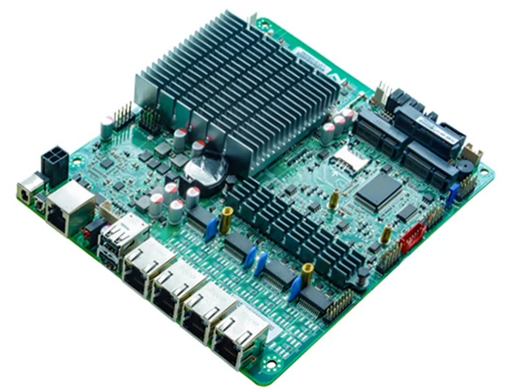
socket type | Onboard CPU
Storage | SATA,Mini-SATA
maximum ram capacity | 1* DDR3 SODIMM,supports 1333/1066 MHz , Max. 8GB
chipset | Intel® Bay trail SOC platform, CPU integrates chipset J1900
brand name | IIT
CPU Support | j1900 Quad core
memory type | 1 DDR3 DIMM
form factor | Mini-ITX
chipset manufacturer | Intel
ports | 1*COM + 2* USB + Serial 4*82574L Gigabit Lan
Launch Date | 2018
Single package size | 170mm*170mm
Powert supply | DC 12V-19v Single power supply

socket type | Onboard CPU
Storage | SATA,Mini-SATA
maximum ram capacity | 1* DDR3 SODIMM,supports 1333/1066 MHz , Max. 8GB
chipset | Intel® Bay trail SOC platform, CPU integrates chipset J1900
brand name | IIT
CPU Support | j1900 Quad core
memory type | 1 DDR3 DIMM
form factor | Mini-ITX
chipset manufacturer | Intel
ports | 1*COM + 2* USB + Serial 4*82574L Gigabit Lan
Launch Date | 2018
Single package size | 170mm*170mm
Powert supply | DC 12V-19v Single power supply

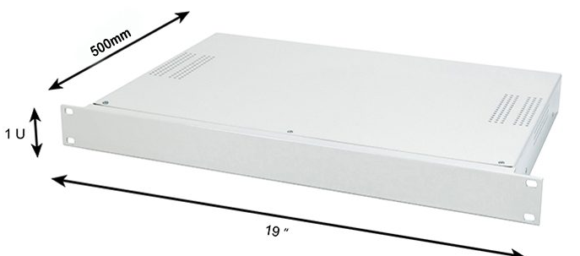
1U 19 Inch*L 500 MM Case ( White / Black )

