Amirkabir University of Technology (Tehran Polytechnic)
Department of Mechanical Engineering · Turbomachinery Course Project
Redesign of the Mitsubishi Power M701JAC Axial Compressor
Report 2 — Thermodynamic and Gas-Dynamic Design from Limited Information
448 MW ISO rating · 15 stages · pressure ratio 25 · 3000 rpm
Prepared by: Alireza Bayati · Melika Bali
Supervisor: Dr. Nader Montazerin
Date: 15 Aban 1405 (6 November 2026)
Prepared with the assistance of Claude (Anthropic); see Section 11. All calculations are reproducible with m701jac/report2/report2_calc.py in the project repository.

Contents
1 Why the M701JAC 2
2 The machine and how its compressor works 2
3 Assumed values 3
4 Design basis and air flow 4
5 Cycle and compressor efficiency 5
6 Mean-line sizing 5
7 Stage 1: velocity triangles and gas dynamics 6
8 Stage-by-stage design: four ways 7
9 Mechanical note 8
10 Results and conclusions 9
11 Use of AI 9
References 9

1 Why the M701JAC
The Phase 1 proposal took a 1990s-generation heavy-duty compressor (MAPNA MGT-70, pressure ratio 12 in 16 stages) as its subject. For the redesign we moved to the Mitsubishi Power M701JAC, because it represents the current limit of what an industrial axial compressor is asked to do. The reasons are engineering ones:
- Highest efficiency class. 44.0 % simple-cycle and above 64 % combined-cycle efficiency (LHV) [D2] place it among the most efficient heavy-duty gas turbines. Since the compressor absorbs roughly half of the turbine work (Section 5), such efficiency is only possible with a very good compressor.
- Very high stage loading. A pressure ratio of 25 in only 15 stages means an average stage pressure ratio of 1.24, against 1.17 in the Phase 1 machine. This requires transonic front stages, three-dimensional blading and boundary-layer control [D6–D8]. These are exactly the gas-dynamic problems this course studies.
- The compressor enables the hot section. The 1650 °C-class turbine inlet temperature raises the exhaust temperature unless the pressure ratio rises with it. The compressor was redesigned from PR 23 to PR 25 precisely to hold the exhaust temperature down [D4]. The compressor is therefore the key to the cycle, not a passive component.
- Operability. Variable inlet guide vanes plus three rows of variable stator vanes control rotating stall at start-up and keep the exhaust temperature high at part load. The machine has 50 % turndown, a 53 MW/min ramp rate and a 30-minute start [D1, D6]. These are the requirements of a modern grid with a large renewable share.
- Suited to the Iranian grid. It is a 50 Hz machine with direct drive at 3000 rpm and no gearbox. It burns natural gas or oil [D3], and Mitsubishi offers a conversion path to hydrogen firing [D2].
- Proven reliability. The J-series fleet has more than three million operating hours [D2]; ten M701JAC units in Thailand alone total 6,700 MW [D3].

2 The machine and how its compressor works
The working principle and the theory of Report 1 apply unchanged. Only the machine changes. Its main data [D2, D5, D6]:
Table 1. Main data of the M701JAC.
Item | M701JAC (448 MW rating)
Output / efficiency (ISO, LHV) | 448 MW / 44.0 % (heat rate 8182 kJ/kWh)
Compressor | Axial, 15 stages, 3-D blading; variable IGV + variable stator vanes on stages 1–3
Total pressure ratio | 25
Speed | 3000 rpm (50 Hz, cold-end direct drive)
Exhaust flow / temperature | 765 kg/s / 663 °C
Turbine | 4 stages, all blade and vane rows air-cooled; 1650 °C class
Published compressor features | transonic front stages (shock-loss reduction); start-up bleeds at low, middle and high pressure; rotating stall disappears at ≈ 60 % speed
Each stage is a rotor that adds swirl, and therefore work, followed by a stator that removes it. Both rows act as diffusers: the rotor in the relative frame ($W_{2}<W_{1}$) and the stator in the absolute frame ($V_{3}<V_{2}$). The relations used below are those of Report 1:
$$\frac{T_{02}}{T_{01}}=r_{p}^{\frac{γ−1}{γ η_{pc}}}, η_{isc}=\frac{r_{p}^{\left(γ−1\right)/γ}−1}{r_{p}^{\left(γ−1\right)/\left(γη_{pc}\right)}−1} \left(1\right)$$
$$Δh_{0}=U ΔV_{w}, \frac{V_{a}}{U}=ϕ, \frac{Δh_{0}}{U^{2}}=ψ \left(2\right)$$
$$R=\frac{h_{2}−h_{1}}{h_{3}−h_{1}}=0.5 ⇒ V_{w1}=\frac{U−ΔV_{w}}{2}, V_{w2}=V_{w1}+ΔV_{w}, W_{1}=V_{2}, W_{2}=V_{1} \left(3\right)$$
$$T=T_{0}−\frac{V^{2}}{2c_{p}}, p=p_{0}{\left(\frac{T}{T_{0}}\right)}^{\frac{γ}{γ−1}}, M_{rel}=\frac{W}{\sqrt{γRT}} \left(4\right)$$
$$\text{de Haller: } \frac{W_{2}}{W_{1}} \left(\text{rotor}\right), \frac{V_{3}}{V_{2}} \left(\text{stator}\right): ≥0.75 \text{light}, 0.70\text{–}0.75 \text{heavy}, <0.70 \text{not acceptable} \left(5\right)$$

3 Assumed values
Every value below is either an ISO or physical standard, a common-practice value, or a design choice made in this report. Nothing else enters the calculations.
Table 2. All assumed values used in this report.
Quantity | Value | Type | Use / remark
Inlet total state $T_{01}$, $p_{01}$ | 288.15 K, 101.325 kPa | ISO standard | Basis of the catalogue rating
Air: $γ$, $c_{p}$, $R$ | 1.4, 1004.5 J/kg·K, 287 J/kg·K | Standard value | Perfect gas throughout
Combustion gas: $γ_{g}$, $c_{pg}$ | 1.333, 1148 J/kg·K | Common practice | Turbine and exhaust in the cycle check only
Fuel lower heating value | 50.0 MJ/kg | Standard (methane) | Fuel and air flows (±4 % LHV changes air flow by ±0.1 %)
Generator + mechanical efficiency | 0.985 | Common practice | Shaft power for the cycle check
Combustor pressure loss | 4 % of $p_{02}$ | Common practice (3–5 %) | Turbine pressure ratio
Turbine exit pressure | 1.02 × ambient | Common practice | Exhaust diffuser and duct
Turbine polytropic efficiency $η_{pe}$ | 0.90–0.92 | Common practice | Cooled turbine at its practical best; fixes $η_{pc}$ (Section 5)
Compressor polytropic efficiency $η_{pc}$ | 0.86 | Derived (Section 5) | Inside the band 0.84–0.875 implied by the catalogue
Axial velocity $V_{a}$ | 170 m/s, constant | Design choice | Inlet axial Mach 0.51; constant through all stages
First-rotor hub-to-tip ratio | 0.50 | Design choice | Typical heavy-duty first stage (0.40–0.55)
Degree of reaction | 0.5 at mean radius, all stages | Design choice | Symmetric velocity triangles
Stage work distribution | equal, or non-uniform (stage 1 = 0.85, stage 15 = 0.80 × mean) | Design choice | Both are calculated (Section 8)
Annulus shape | constant mean or constant tip diameter | Design choice | Both are calculated (Section 8)
Radial whirl distribution | free vortex ($V_{w}r$ = const) | Common practice | Tip relative Mach number only
de Haller limits | 0.75 / 0.70 | Common practice | Equation (5)
Blade density, taper factor | 7800 kg/m³, 0.6 | Common practice | Stage-1 root stress only

4 Design basis and air flow
The catalogue fixes the heat input from the heat rate, and the fuel and air flows follow:
$$\dot{Q}=P⋅HR=448×\frac{8182}{3600}=1018.2 \text{MW}, {\dot{m}}_{f}=\frac{\dot{Q}}{LHV}=20.36 \text{kg/s}, {\dot{m}}_{a}=765−20.36=744.6 \text{kg/s} \left(6\right)$$
The compressor must therefore deliver 744.6 kg/s at a total-pressure ratio of 25. The overall energy balance $\dot{Q}−{\dot{m}}_{exh}c_{pg}\left(T_{exh}−T_{01}\right)$ = 449.1 MW of shaft power, against 448/0.985 = 454.8 MW required. It closes to within 0.6 % of the heat input, so the catalogue data are consistent.

5 Cycle and compressor efficiency
The cycle is evaluated as follows:
$$T_{02}=T_{01} r_{p}^{\frac{γ−1}{γη_{pc}}}, {\dot{W}}_{C}={\dot{m}}_{a}c_{p}\left(T_{02}−T_{01}\right), {\dot{m}}_{g}c_{pg}\left(T_{03}−T_{01}\right)={\dot{m}}_{a}c_{p}\left(T_{02}−T_{01}\right)+\dot{Q} \left(7\right)$$
$$\frac{T_{03}}{T_{04}}={\left(\frac{p_{03}}{p_{04}}\right)}^{\frac{γ_{g}−1}{γ_{g}}η_{pe}}, T_{04}=663 ^{∘}\text{C}, \frac{p_{03}}{p_{04}}=\frac{25×0.96}{1.02}=23.53 \left(8\right)$$
$T_{03}$ is the equivalent mixed turbine-inlet temperature, with the cooling air included. For any assumed compressor efficiency, equation (7) gives $T_{02}$ and $T_{03}$, and equation (8) then gives the turbine efficiency that the catalogue exhaust temperature requires:
Table 3. Cycle closure for a range of compressor efficiencies (448 MW rating).
η_pc | T₀₂ [K] | Ẇ_C [MW] | T₀₃ [°C] | Implied η_pe | η_isc | Ẇ_C / Ẇ_T
0.82 | 884.5 | 446.1 | 1682 | 0.934 | 0.729 | 0.498
0.84 | 861.2 | 428.6 | 1662 | 0.921 | 0.759 | 0.488
0.86 | 839.6 | 412.4 | 1644 | 0.909 | 0.788 | 0.479
0.88 | 819.4 | 397.4 | 1627 | 0.897 | 0.818 | 0.469
0.90 | 800.6 | 383.3 | 1611 | 0.886 | 0.848 | 0.460
A turbine has few stages, accelerating flow and no stall, so its efficiency is close to the best attainable. For a cooled heavy-duty turbine that is $η_{pe}$ = 0.90–0.92. Table 3 then fixes the compressor at $η_{pc}$ = 0.84–0.875, clearly lower than the turbine, as expected for a decelerating, stall-limited machine. We adopt $η_{pc}$ = 0.86. Two independent checks support it:
- the implied turbine efficiency is 0.909;
- the mixed turbine-inlet temperature is 1644 °C, matching the published 1650 °C class [D3, D4].
Compressor result: delivery temperature $T_{02}$ = 839.6 K (566 °C), isentropic efficiency 0.788, shaft power 412 MW. The compressor absorbs 48 % of the turbine work.
Note. With temperature-dependent $c_{p}$ (real gas), $T_{02}$ is 811 K instead of 840 K, while the work changes by less than 1 %. The perfect-gas values are kept throughout this report.

6 Mean-line sizing
Inlet annulus. At the IGV inlet the flow is axial, with $V_{a}$ = 170 m/s:
$$T_{1}=288.15−\frac{{170}^{2}}{2×1004.5}=273.76 \text{K}, p_{1}=84.70 \text{kPa}, ρ_{1}=1.078 {\text{kg/m}}^{3}, A_{1}=\frac{{\dot{m}}_{a}}{ρ_{1}V_{a}}=4.063 {\text{m}}^{2}$$
With a hub-to-tip ratio of 0.50: $D_{t}$ = 2.626 m, $D_{h}$ = 1.313 m, $D_{m}$ = 1.970 m, and the inlet axial Mach number is 0.513.
Loading. The total work is $Δh_{0}=c_{p}\left(T_{02}−T_{01}\right)$ = 553.9 kJ/kg, which is 36.93 kJ/kg per stage on average. With a constant mean diameter of 1.970 m, $U_{m}=πD_{m}N/60$ = 309.4 m/s, $ϕ$ = 0.549 and
$$\frac{Δh_{0}}{U^{2}}|_{total}=\frac{553.9×{10}^{3}}{{309.4}^{2}}=5.786, \frac{Δh_{0}}{U^{2}}|_{stage}=\frac{5.786}{15}=0.386, ΔV_{w}=\frac{36.93×{10}^{3}}{309.4}=119.3 \text{m/s}$$
A stage-loading coefficient of 0.386 is high for an industrial compressor. It confirms the “high-load” character of this machine [D3].

7 Stage 1: velocity triangles and gas dynamics
The design case selected in Section 8 has a constant tip diameter, which puts the stage-1 mean diameter at 1.923 m ($U$ = 302.1 m/s). With about 0.85 × mean work in stage 1 ($Δh_{0}$ = 31.6 kJ/kg) and $R$ = 0.5, equations (2)–(4) give:
Table 4. Stage 1 at mean radius (design case D).
Quantity | Value | Quantity | Value
$U$, $V_{a}$, $ϕ$ | 302.1 m/s, 170 m/s, 0.563 | $ψ$, $ΔV_{w}$ | 0.346, 104.5 m/s
$V_{w1}$ / $V_{w2}$ | 98.8 / 203.3 m/s | $α_{1}=β_{2}$ / $α_{2}=β_{1}$ | 30.2° / 50.1°
$V_{1}=W_{2}$ | 196.6 m/s | $V_{2}=W_{1}$ | 265.0 m/s
Static $T_{1}$, $p_{1}$ | 268.9 K, 79.55 kPa | $M_{1}$ (absolute) | 0.598
$M_{rel}$ at mean radius | 0.806 | $M_{rel}$ at tip (free vortex) | 1.157
de Haller, rotor = stator | 0.742 | Stage pressure ratio | 1.365
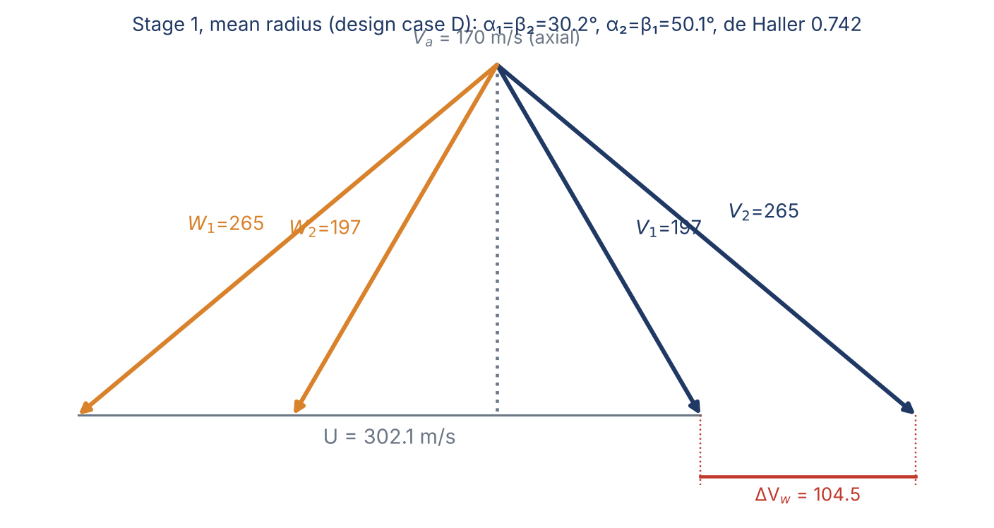
Figure 1. Stage-1 velocity triangles at mean radius (design case D).
Two results stand out:
- The tip is transonic ($M_{rel}$ = 1.16 at the tip, 0.81 at mean radius). This is why MHI uses three-dimensional design to reduce shock losses in the initial stages [D6]. It is also why the first stage cannot carry full load.
- The de Haller number of 0.742 lies in the heavy-loading band (0.70–0.75). Such a stage needs advanced blade design. This agrees with the published description of a high-loading, boundary-layer-controlled compressor [D7, D8].

8 Stage-by-stage design: four ways
With only the overall pressure ratio known, the work split between stages and the annulus shape must be chosen. Both choices were calculated in all four combinations, each reproducing PR 25 and 744.6 kg/s exactly:
Table 5. Four ways of distributing the work and shaping the annulus.
Case | Work distribution | Annulus | Max ψ | Min de Haller (stage) | Stage PR 1 / 15 | Blade height 1 / 15 | Stage-1 tip M_rel
A | equal | constant D_m = 1.970 m | 0.386 | 0.712 (all) | 1.435 / 1.144 | 684 / 78 mm | 1.173
B | non-uniform | constant D_m | 0.411 | 0.697 (8) | 1.365 / 1.114 | 690 / 77 mm | 1.160
C | equal | constant D_t = 2.626 m | 0.401 | 0.708 (1) | 1.435 / 1.144 | 696 / 62 mm | 1.171
D | non-uniform | constant D_t | 0.346 | 0.732 (2) | 1.365 / 1.114 | 703 / 61 mm | 1.157
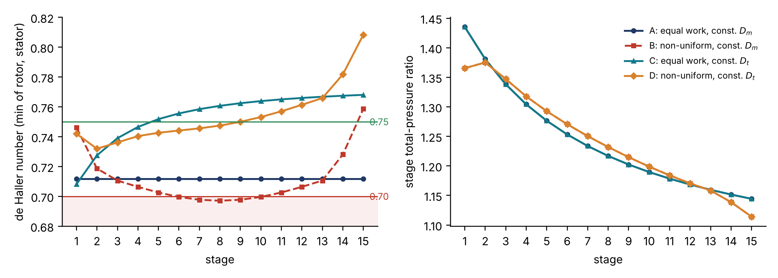
Figure 2. de Haller number and stage pressure ratio for the four cases.
What the comparison shows:
- Equal work is not equal pressure ratio. Even with equal work the stage pressure ratio falls from 1.435 to 1.144, because each stage starts hotter (cases A and C).
- Non-uniform work at constant mean diameter fails (case B). Moving work to the middle stages at constant blade speed pushes stages 6–10 below de Haller 0.70.
- A constant tip diameter makes the non-uniform distribution work (case D). The hub rises, so the mean radius and the blade speed grow from 302 to 403 m/s along the machine. The middle and rear stages can then take more work at a lower loading coefficient. The first two stages stay limited by the transonic tip and remain the most heavily loaded aerodynamically.
- Case D is adopted as the redesign: minimum de Haller 0.732, no stage below 0.70, and a loading that falls smoothly from 0.35 to 0.18.
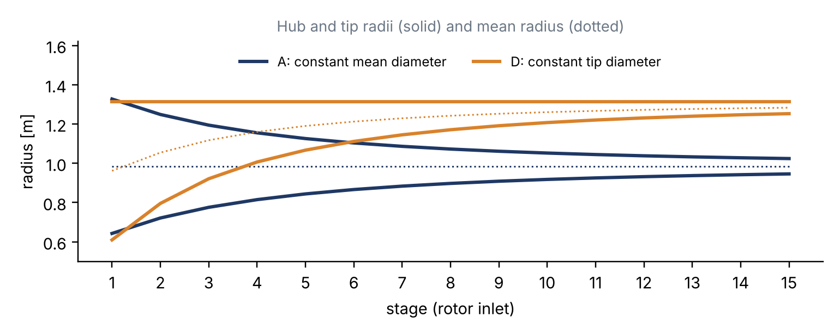
Figure 3. Hub, mean and tip radii along the compressor for constant mean diameter (A) and constant tip diameter (D).
Table 6. The redesigned compressor, stage by stage (case D, rotor-inlet values at mean radius; f = stage work / mean stage work; M tip = relative Mach number at the blade tip; dH = de Haller number).
Stage | f | ΔT₀ [K] | Stage PR | p₀ out [bar] | T₀ out [K] | D_m [m] | h [mm] | U [m/s] | φ | ψ | α₁/α₂ [°] | M tip | dH
1 | 0.855 | 31.4 | 1.365 | 1.38 | 319.6 | 1.923 | 703 | 302.1 | 0.563 | 0.346 | 30.2/50.1 | 1.157 | 0.742
2 | 0.970 | 35.7 | 1.375 | 1.90 | 355.2 | 2.109 | 518 | 331.2 | 0.513 | 0.327 | 33.3/52.3 | 1.053 | 0.732
3 | 1.005 | 37.0 | 1.347 | 2.56 | 392.2 | 2.234 | 392 | 351.0 | 0.484 | 0.301 | 35.8/53.3 | 0.962 | 0.736
4 | 1.024 | 37.7 | 1.318 | 3.38 | 429.8 | 2.320 | 307 | 364.4 | 0.467 | 0.285 | 37.5/54.0 | 0.889 | 0.740
5 | 1.041 | 38.3 | 1.293 | 4.37 | 468.1 | 2.380 | 246 | 373.9 | 0.455 | 0.275 | 38.6/54.5 | 0.831 | 0.743
6 | 1.054 | 38.8 | 1.271 | 5.55 | 506.9 | 2.424 | 202 | 380.8 | 0.446 | 0.268 | 39.3/54.9 | 0.784 | 0.744
7 | 1.063 | 39.1 | 1.250 | 6.93 | 545.9 | 2.458 | 168 | 386.1 | 0.440 | 0.263 | 39.9/55.1 | 0.743 | 0.746
8 | 1.066 | 39.2 | 1.232 | 8.54 | 585.1 | 2.484 | 142 | 390.2 | 0.436 | 0.258 | 40.4/55.3 | 0.708 | 0.747
9 | 1.063 | 39.1 | 1.215 | 10.38 | 624.2 | 2.504 | 122 | 393.4 | 0.432 | 0.254 | 40.8/55.4 | 0.677 | 0.750
10 | 1.054 | 38.8 | 1.199 | 12.44 | 662.9 | 2.520 | 106 | 395.9 | 0.429 | 0.248 | 41.2/55.5 | 0.650 | 0.753
11 | 1.041 | 38.3 | 1.184 | 14.73 | 701.2 | 2.534 | 93 | 398.0 | 0.427 | 0.243 | 41.6/55.5 | 0.626 | 0.757
12 | 1.024 | 37.7 | 1.170 | 17.24 | 738.8 | 2.544 | 82 | 399.6 | 0.425 | 0.237 | 41.9/55.5 | 0.604 | 0.761
13 | 1.005 | 37.0 | 1.158 | 19.97 | 775.8 | 2.553 | 74 | 401.0 | 0.424 | 0.231 | 42.2/55.4 | 0.585 | 0.766
14 | 0.930 | 34.2 | 1.139 | 22.74 | 810.0 | 2.560 | 66 | 402.1 | 0.423 | 0.212 | 43.0/55.1 | 0.564 | 0.782
15 | 0.804 | 29.6 | 1.114 | 25.33 | 839.6 | 2.566 | 61 | 403.0 | 0.422 | 0.183 | 44.1/54.5 | 0.542 | 0.808

9 Mechanical note
The first rotor carries the largest centrifugal load because it has the largest annulus area. With $σ=Kρ_{b}ω^{2}A_{1}/2π$ the root stress is about 300 MPa for a tapered steel blade, an acceptable level for compressor blade steels. The 50 Hz rotational frequency and its multiples, together with the stator blade-passing frequencies, are the excitations against which the front blades must be detuned [D6]. A detailed vibration analysis is outside the scope of this report.

10 Results and conclusions
Table 7. Summary of the redesign.
Quantity | Redesign (case D) | Catalogue / published
Air mass flow | 744.6 kg/s | 765 kg/s exhaust − fuel
Total pressure ratio | 25.0 (15 stages) | 25
Delivery temperature | 839.6 K (566 °C) | —
Compressor power / share of turbine work | 412 MW / 48 % | —
Polytropic / isentropic efficiency | 0.86 / 0.788 | —
Equivalent turbine inlet temperature | 1644 °C | 1650 °C class
Stage-1 tip diameter / tip relative Mach | 2.63 m / 1.16 | transonic front stages
Stage pressure ratio, first → last | 1.365 → 1.114 | —
Blade height, first → last | 703 → 61 mm | reduced outlet area
Lowest de Haller number | 0.732 (stage 2) | high-load design
Conclusions:
- The catalogue data close to within 0.6 %, so the redesign targets (744.6 kg/s, PR 25) are firm.
- The turbine runs near its best attainable efficiency, so the catalogue fixes the compressor polytropic efficiency at 0.84–0.875. With 0.86 the machine delivers 840 K air and absorbs 412 MW, about half of the turbine work.
- Equal pressure ratio per stage is not physical. Equal work already gives 1.43 → 1.14, and a realistic non-uniform distribution gives 1.37 → 1.11.
- Of the four ways examined, only the constant-tip annulus allows the non-uniform work distribution within the de Haller limits. It is adopted as the redesign.
- The first two stages are transonic at the tip and heavily loaded (de Haller 0.73–0.74), which explains the three-dimensional, high-loading design of the real machine.
Next steps (Report 3): blade numbers and chords from diffusion-factor limits; radial variation in stages 1–3; the role of the variable IGV and stators at off-design; the standard test and the virtual test.

11 Use of AI
All calculations in this report were coded and run by Claude (Anthropic) under the team’s direction. Every assumed value is listed in Table 2 and was reviewed by the team. The AI also checked the catalogue data for consistency and compared the perfect-gas results with a real-gas calculation (Section 5 note).

References
[D1] Mitsubishi Power, “M701J/JAC Series,” product page, https://power.mhi.com/products/gasturbines/lineup/m701j (accessed October 2026).
[D2] Mitsubishi Power, GTCC Gas Turbine Combined Cycle Power Plants, catalogue, 2026.
[D3] Y. Takashima et al., “Successful 10 Units Completion of M701JAC Gas Turbine Combined Cycle in Thailand,” MHI Technical Review 62(3), 2025.
[D4] K. Takamura et al., “Development of 1650°C Class Next Generation JAC Gas Turbine based on J Experience,” MHI Technical Review 56(3), 2019.
[D5] S. Hada et al., “High-efficiency Gas Turbine Development applying 1600°C class ‘J’ Technology,” MHI Technical Review 52(2), 2015.
[D6] S. Hada et al., “Test Results of the World’s First 1,600°C J-series Gas Turbine,” MHI Technical Review 49(1), 2012.
[D7] E. Ito et al., “Key Technologies for Ultra-High Temperature Gas Turbines,” MHI Technical Review 52(2), 2015.
[D8] K. Ishizaka et al., “Key Technologies for 1700°C Class Ultra High Temperature Gas Turbine,” MHI Technical Review 54(3), 2017.
[T1] S. L. Dixon and C. A. Hall, Fluid Mechanics and Thermodynamics of Turbomachinery, 7th ed. Butterworth-Heinemann, 2014.
[T2] H. I. H. Saravanamuttoo et al., Gas Turbine Theory, 7th ed. Pearson, 2017.
[T3] N. Montazerin, Turbomachines: Basic Design and Application (in Persian). Amirkabir University of Technology Press, 1999.

