Assumption Audit — from the Phase 1 estimate to the M701JAC analysis
Purpose. The Phase 1 calculations were accepted as reasonable, but the numbers assumed to start them were questioned, and two points were raised explicitly by Dr. Montazerin:
- some assumed efficiencies were too high;
- equal pressure ratio in every stage is wrong, because the stages carry different loads for specific reasons.
This document lists every number that was assumed rather than taken from a source and explains what has replaced it. It covers the Phase 1 MGT-70(3) estimate (proposal/source/calc.py) and the derived values in the team’s M701JAC dossier (§5). The new analysis is in m701jac/analysis/m701jac_analysis.py, and its generated tables are in results_tables.md in the same folder.
Rule now applied. Every input is tagged with its origin:
- CAT — published in the MHI catalogue (D2);
- DOC — stated in an MHI Technical Review (D3–D8);
- STD — a physical or ISO standard value;
- RNG — not published, so it is carried as a range with a stated basis, never as a single number.
Results are reported as a median and a 5–95 % band, so it is visible which results are fixed by data and which are dominated by assumptions. A rank-correlation table in the results shows which assumption drives which result.

1. The supervisor’s two points

1.1 Efficiency — “some assumed values are too high”
 | Phase 1 / dossier | Now
Compressor polytropic efficiency η_p | 0.90, fixed | range 0.86–0.91 (median ≈ 0.885)
Resulting isentropic efficiency at PR 25 | 0.86 (Phase 1, PR 12); the dossier did not state it (≈ 0.85 at PR 25) | 0.83 (0.80–0.86)
Why lower and why a range. A single “textbook” polytropic efficiency describes a well-designed stage. The number needed here is the whole-machine value, from the inlet flange to the diffuser exit. That value also carries:
- the inlet bellmouth and the variable IGV;
- the transonic front stages, where shock losses are explicitly confirmed by MHI (D6: “reduce the shockwave loss in the initial stages”);
- stages 14–15, where the blades are short, so tip clearance is large relative to blade height and the end-wall boundary layers are thick;
- bleed and extraction ports, seal leakages and the exit diffuser.
The value is not published, so a range is the honest representation.
Cross-check against the catalogue (new). The catalogue gives the pressure ratio, the heat rate, and the exhaust flow and temperature. For any assumed compressor efficiency, these data fix the delivery temperature, the mixed turbine-inlet enthalpy and the turbine expansion ratio. They therefore imply a turbine efficiency: a higher compressor efficiency must be balanced by a lower turbine efficiency. The model is an equivalent cooled turbine with 0–10 % intermediate-stage bleed, TIT ±50 K, 3–5 % combustor loss and 0–3 % exhaust back-pressure.
Compressor η_p | 0.86 | 0.88 | 0.90 | 0.92
Implied turbine η_p, median (range) | 0.906 (0.89–0.92) | 0.895 (0.88–0.91) | 0.884 (0.87–0.90) | 0.874 (0.86–0.89)
The implied turbine efficiencies are realistic for a modern cooled turbine across the adopted range of 0.86–0.91. Values below 0.86 would demand an unrealistically efficient turbine. So the data support the lower range, but they do not pin the value down. This is the most honest statement that can be made without OEM data, and it is a good point to discuss with the supervisor.
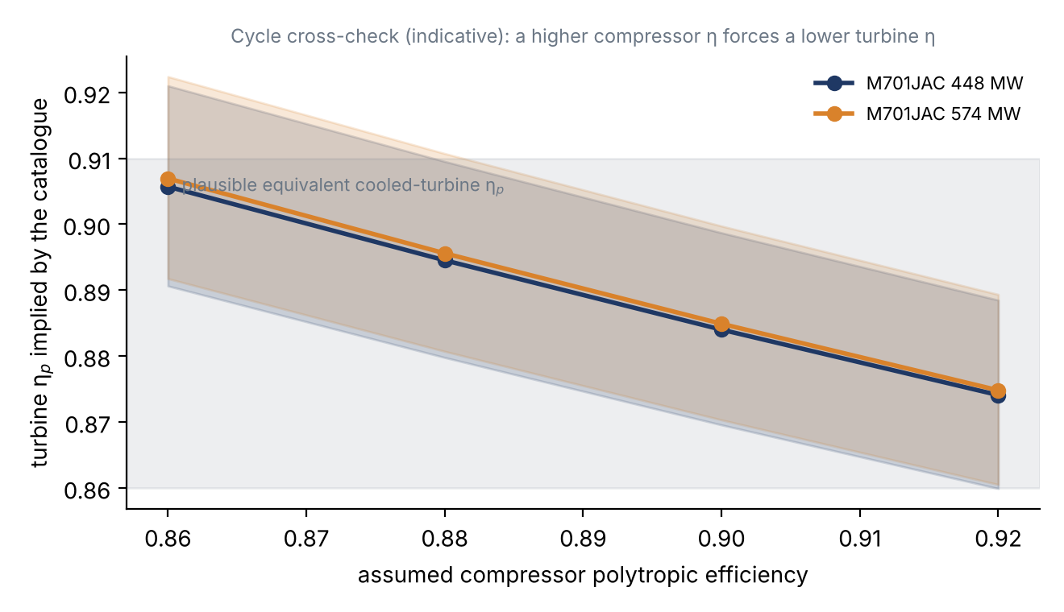
Cycle cross-check
Second effect found during the audit — constant c_p. Phase 1 and the dossier used c_p = 1004.5–1005 J/kg·K and γ = 1.4. Between 288 K and 790 K, c_p of humid air rises by about 6 %. With real-gas properties (Cantera, humid ISO air) at the same efficiency:
η_p | T₀₂ perfect gas | T₀₂ real gas | Difference | Specific work, perfect / real
0.885 | 815 K | 789 K | −26 K | 529 / 525 kJ/kg
0.90 (dossier) | 801 K | 777 K | −24 K | 515 / 511 kJ/kg
The perfect-gas model overstates the delivery temperature by about 25 K at PR 25. The power is almost unaffected, because the higher c_p offsets the lower temperature rise.
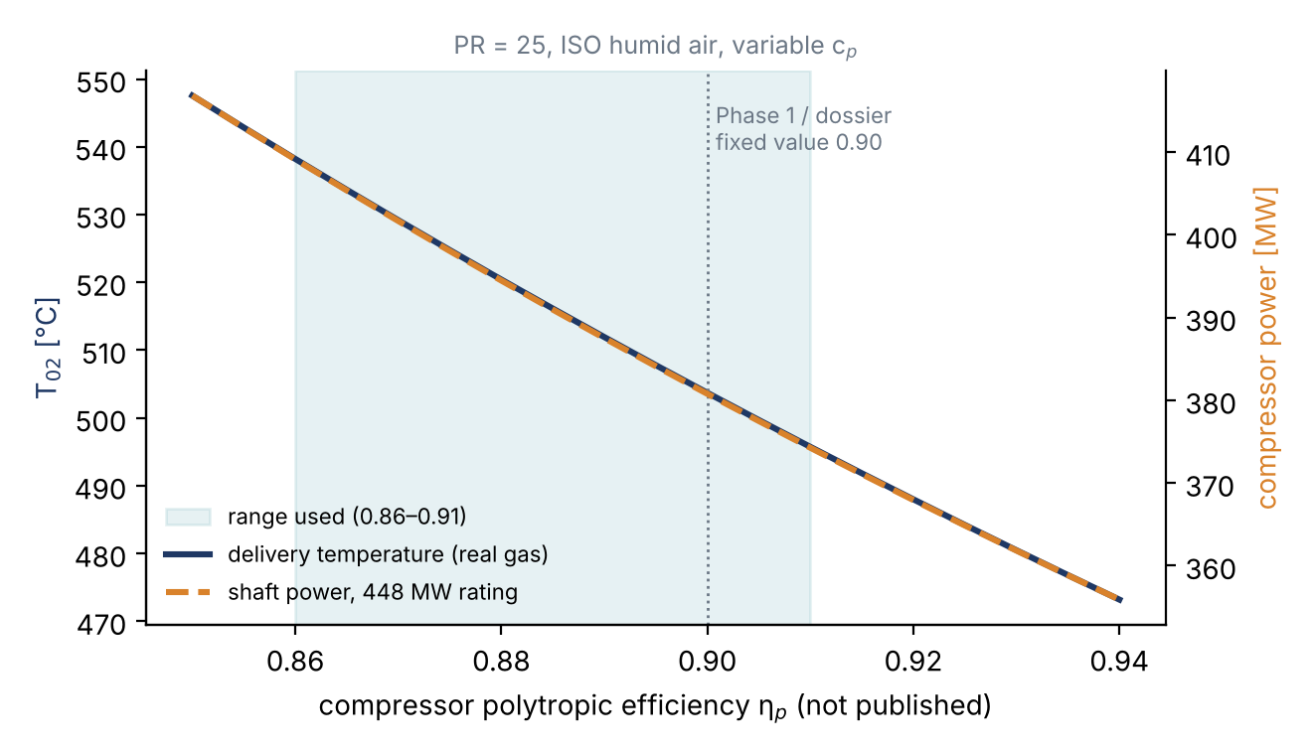
Delivery temperature and power versus efficiency

1.2 Stage loading — “equal pressure ratio in all stages is wrong”
Phase 1 (π_st = 12^(1/16) = 1.168 per stage) and dossier Table 6 (π_st = 25^(1/15) = 1.239) both assumed that every stage has the same pressure ratio. This is wrong for two independent reasons.
- Even equal work gives unequal pressure ratios. For a stage with temperature rise ΔT₀ and efficiency η, π_st = (1 + ηΔT₀/T₀,in)^(γ/(γ−1)). Each stage starts hotter than the one before, so the same work produces a smaller pressure ratio. With equal work in the M701JAC, π_st falls from about 1.42 in stage 1 to about 1.15 in stage 15.
- The work itself is not equal, for physical reasons:
  - Stage 1 is held back: the transonic tip (estimated M_rel ≈ 1.3, which D6 confirms is transonic), the IGV wakes and inlet distortion, and the start-up rotating-stall and surge-margin requirement that drives the variable IGV and three variable stator rows (D6, D8).
  - The middle stages carry more: the flow is subsonic and well matched. The work-done factor (Howell) falls as end-wall boundary layers grow, so the design loading is raised to compensate.
  - The last stages are unloaded: short blades, so clearance is large relative to height; thick end-wall boundary layers and blockage; and the exit flow must be close to axial for the diffuser and combustor.
  - MHI’s own description of the J/JAC compressor is “high-load, high-efficiency” (D3), with a boundary-layer-controlled, high-loading design verified on an eight-stage front-block rig (D7, D8). That is an aerodynamic loading distribution, not a uniform one.
The new model sets stage-1 work at 0.75–0.95 of the mean and the last stage at 0.70–0.90. The middle stages follow a gentle hump that keeps the total equal to the cycle work. The stage efficiencies are 1–4 points lower in stage 1 (shock loss) and 1–3 points lower in the last stage, and the mid-stage efficiency is solved so that the overall PR is exactly 25.
Stage | Equal PR (old) | Equal work | Non-uniform work (median, 5–95 %)
1 | 1.239 | 1.42 | 1.35 (1.31–1.38)
2 | 1.239 | 1.37 | 1.36 (1.35–1.38)
5 | 1.239 | 1.28 | 1.29
8 | 1.239 | 1.22 | 1.24
12 | 1.239 | 1.17 | 1.18
15 | 1.239 | 1.15 | 1.12 (1.10–1.13)
The full stage table, including stage ΔT₀ and exit p₀ and T₀, is in results_tables.md §6, and the plots are in fig_E_stage_distribution.png. The shape of this distribution is still an engineering model, because MHI does not publish the stage-by-stage pressures. It is a defensible starting point for the mean-line design, which will refine it.
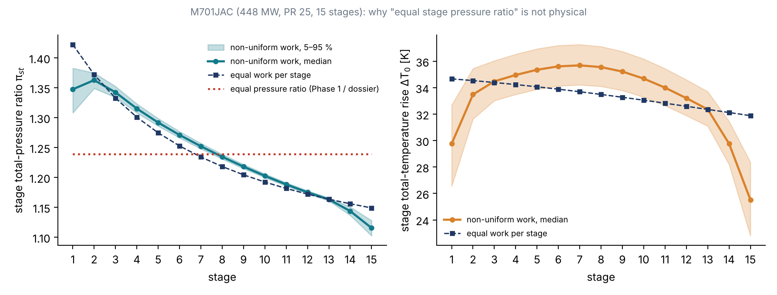
Stage distribution

2. Complete list of assumed numbers
# | Quantity | Phase 1 / dossier value | Problem | Treatment now | Status
1 | Compressor polytropic efficiency | 0.90 fixed | Too high for a whole machine (supervisor); one value hides the uncertainty | 0.86–0.91 range plus catalogue cycle cross-check (§1.1) | Replaced by bounded range
2 | c_p, γ | 1004.5–1005, 1.4 constant | T₀₂ overstated by ≈ 25 K at PR 25 | Real-gas humid ISO air (Cantera, GRI-Mech 3.0 thermo) | Replaced by physics
3 | Stage pressure ratio | Equal in every stage | Physically wrong (supervisor; §1.2) | Non-uniform work distribution with bounded shape factors | Replaced by model + range
4 | Fuel-to-air ratio | ≈ 2 % (dossier) | Not derived | Derived from heat rate and LHV: 2.7–3.0 % (fuel 20.4–22.1 kg/s for 448 MW) | Replaced by data
5 | Fuel LHV | 48 MJ/kg (Phase 1) | Fuel composition not stated | 46–50 MJ/kg (pure CH₄ = 50.03 MJ/kg); air flow changes by only ±0.1 % | Bounded, insensitive
6 | Inlet air mass flow | exhaust − fuel | Method fine; fuel value was assumed | 743.8 kg/s (743.0–744.6) for 448 MW; 996.4 kg/s for 574 MW | Data-derived
7 | Inlet axial velocity | c_x1 = 160 m/s | Arbitrary | Inlet axial Mach 0.45–0.60, constrained by the transonic front stages stated in D6 | Bounded + document constraint
8 | Inlet hub-to-tip ratio | 0.50 | Arbitrary | 0.40–0.55; it controls M_rel,tip (rank correlation +0.95) | Bounded; key unknown
9 | Exit axial velocity and mean radius | c_x = 130 m/s, constant mean radius | Arbitrary; constant mean radius is not known | Exit Mach 0.25–0.35; only the exit area is reported (no radius assumed) | Bounded
10 | Inlet pre-swirl | None (IGV open at design) | IGV angle not published | Kept, flagged; reduces M_rel,tip if the IGV is closed | Remaining assumption
11 | Blade material density | Steel, 7800 kg/m³ | Material not published | Kept, flagged (titanium would cut the stress by ≈ 42 %) | Remaining assumption
12 | Blade taper factor | K = 2/3 | Arbitrary | 0.55–0.70 | Bounded
13 | Mean-stage velocity triangles | φ = 0.55–0.59, ψ = 0.30–0.35, R = 0.5 (Phase 1, video) | Derived from equal-stage, constant-radius assumptions | Not used for M701JAC yet; ψ at the inlet mean radius is shown only as an indicator. Triangles come from the mean-line design in Phase 2 | Deferred to mean-line design
14 | Bleed and cooling extraction | Neglected | Cooling air is extracted at intermediate stages (D2) | Compressor power is reported as a full-delivery upper bound; the cross-check gives a 7–22 % bypass fraction | Bounded, indicative
15 | Generator and mechanical losses | Neglected | Small, but they enter the back-work ratio | Closed by the energy-balance residual (+0.8 to +1.7 % of heat input) | Data-checked
16 | Inlet / exhaust pressure losses | None | ISO ratings are at generator terminals; losses not stated | Exhaust back-pressure 0–3 % in the cross-check; inlet losses still neglected | Partly bounded

3. What is now fixed by data, and what is not
Fixed by the catalogue to within about 0.3 %:
- inlet air flow;
- fuel flow;
- heat input;
- the energy balance (closes to +1.1 % for the 448 MW rating).
Dominated by one unpublished input each:
- delivery temperature and compressor power — the efficiency;
- first-rotor tip diameter — inlet axial Mach and hub-to-tip ratio;
- relative tip Mach — mainly the hub-to-tip ratio;
- exit annulus area — exit Mach.
These are the quantities on which the reverse engineering should concentrate any further documentary evidence: photographs (the M701J rotor photo), cross-section drawings, and papers on the J-series compressor.

4. Open questions for the team and the supervisor
- Which rating is the target? The catalogue lists two M701JAC ratings: 448 MW with PR 25 and 765 kg/s, and 574 MW with PR > 25 and 1,024 kg/s. The Thailand units (D3) deliver 662–700 MW net combined cycle each. That is above the 650 MW rating of the 448 MW gas turbine, so the fleet in service is most likely the larger machine. This analysis runs both ratings.
- The 60 Hz → 50 Hz scaling rule does not reproduce the catalogue flows. A 1.2× scale of the current M501JAC (815 kg/s) would pass 1,174 kg/s at 3000 rpm. The two M701JAC ratings correspond to linear scales of 0.97 and 1.12. The documented rule (D5) holds for the J series (M701J/M501J output ratio 680/470 = 1.45), but it should not be used to derive M701JAC geometry from M501JAC data without a source.
- Is the efficiency range of 0.86–0.91 acceptable to the supervisor, given the cycle cross-check?

Review of the M701JAC Technical Data Dossier (compiled 5 Aban 1405)
This review checks the dossier (m701jac/sources/M701JAC_Technical_Dossier.docx) claim by claim against the source documents supplied with it (D2–D8). D1, the product page, was supplied only as its figures (correction curves, layouts, rotor photo), not as text. Claims that rest on D1 alone are therefore marked as not verifiable from the supplied files.
Legend: ✅ confirmed · ⚠️ needs correction or a caveat · ❓ not verifiable from the supplied files

Confirmed
Dossier item | Source check
Table 3 — both ISO ratings: 448 MW / 8182 kJ/kWh / 44.0 % / PR 25 / 765 kg/s / 663 °C and 574 MW / 8295 kJ/kWh / 43.4 % / PR > 25 / 1,024 kg/s / 646 °C; 3000 rpm | ✅ D2, performance table (pp. 21–22). The energy balance closes to +1.1 % (448 MW) and +1.7 % (574 MW) of heat input, so the data are self-consistent (results_tables.md §1)
Table 4 — MPCP1 650 MW / 840 MW, > 64 %, GT/ST split 441.7/208.3 and 570.9/269.1 MW | ✅ D2
Variable IGV plus variable vanes on the first three stages (“four stages operate together”) | ✅ D2 p. 9–10; D6 §2.2
Start-up bleed from low-, middle- and high-pressure stages | ✅ D6 §2.2
Rotating stall extinguished at ≈ 60 % speed; efficiency and air flow measured at each IGV angle | ✅ D6 §3.2
J-series compressor PR 23, based on the H-series compressor (PR 25); 3-D design; full-scale high-speed research compressor | ✅ D6 §2.2
JAC: PR raised from 23 to 25 to limit the exhaust-temperature rise; rotating-stall concern at start-up; T-Point verification May 2018 | ✅ D4 §4.3
“High-load, high-efficiency compressor” | ✅ D3 §3.1 (iii)
Boundary-layer-controlled high-loading compressor; eight-stage front-block rig with variable vanes; surge verification | ✅ D7 §2.1, D8 §2.1
M501G 17 stages / PR 20 / 267 MW; M501J 15 stages / PR 23 / 327 MW gross (330 MW in D4) | ✅ D6 Table 1, D4 Table 1
M501JAC 425 MW / PR 25 (D4) and 453 MW / PR > 25 (D2) | ✅
M701J = 1.2× geometric scale of M501J; flow and output × 1.44 | ✅ D5 §4.1 (GTCC 680 MW vs 470 MW = 1.45)
Bolted discs with torque pins (compressor), curvic couplings (turbine); two bearings; cold-end drive; axial exhaust; horizontally split casings | ✅ D6 §2.1, D2 p. 11–12
Turbine rows 1–4 blades and vanes air-cooled (JAC); row-1 vane cooled by compressor discharge air, others by intermediate-stage bleed | ✅ D2 p. 9–10
Correction curves (inlet temperature, barometric pressure) | ✅ D1 figures (received)

Needs correction or a caveat
- ⚠️ “2015 rating” / “2018 rating” labels (§3, Table 3). None of the supplied documents dates the two ratings. D2 lists both without years. Either cite the source of the years or remove them.
- ⚠️ §4.4: “The same rule links the M501JAC and M701JAC.” This contradicts D2. A 1.2× scale of the current M501JAC (815 kg/s) would pass 1,174 kg/s, but the M701JAC ratings pass 765 and 1,024 kg/s, which correspond to linear scales of 0.97 and 1.12. The rule is documented only for the J series (D5). Recommended wording: “the 1.2× rule was used for the J series (D5); the current M701JAC ratings do not follow it exactly.”
- ⚠️ Where the shock losses are (§4.2). D6 says “reduce the shockwave loss in the initial stages and frictional loss in the intermediate and final stages”. The D2 catalogue text reads “shockwave loss in the intermediate and final stages”, which looks like an editorial shortening. The dossier follows D6, which is the technical source, but it cites D1 and D6 together. Cite D6 alone, or note the discrepancy.
- ⚠️ §5 derived quantities. These repeat the Phase 1 assumptions that were challenged: η_p = 0.90 fixed, constant c_p, about 2 % fuel and equal stage pressure ratio. The replacements are in ASSUMPTIONS_AUDIT.md. In particular:
  - the fuel fraction from the heat rate is 2.7–3.0 %, not 2 %;
  - T₀₂ is 789 K (771–809 K) with real-gas properties, against 801 K;
  - the stage pressure ratio is not 1.239 in every stage: it runs from about 1.35 in the front stages to about 1.12 at the rear.
- ⚠️ §6, last paragraph: “This is why the M701JAC was not selected … and NASA Rotor 37 was chosen instead.” This does not match the submitted Phase 1 proposal, which selected the MGT-70(3) compressor and used Rotor 37 only as a validation benchmark. It also contradicts the new decision to reverse-engineer the M701JAC. Rewrite it as the list of data gaps the reverse engineering must fill.
- ⚠️ “15-stage axial” for the M701JAC. This is consistent with D2 (“flow path of the compressor … same shape as that of the J-series”) together with D5 and D6 (J series: 15 stages). However, no supplied document states it explicitly for the M701JAC. It is presumably on D1; add the D1 text or a screenshot.
- ⚠️ “Same flow path as J; PR raised” (Table 5). D2 says the JAC compressor flow path has the same shape as the J series. D4 says the JAC compressor has “a high pressure ratio design equivalent to our H-series”. Both can be true (same annulus, re-bladed for higher loading), but the dossier should say that this is an interpretation.

Not verifiable from the supplied files (D1 product-page text needed)
- ❓ 22 combustor cans for the M701JAC. D5 gives 22 for the steam-cooled M701J, so this is plausible.
- ❓ Approximate dimensions 16.7 × 6.5 × 6.9 m and weight 550 t.
- ❓ 30 % H₂ co-firing demonstrated.
- ❓ “> 3.2 million operating hours (Dec. 2025)”. D2 says “more than 3 million AOH, date as of May 2025”.

Useful additions from the documents (not yet in the dossier)
- D3 (Thailand): 10 M701JAC single-shaft GTCC units, 6,700 MW in total; GSRC and GPD 2,650 MW with 4 units each (≈ 662 MW net each); HKP 1,400 MW with 2 units (700 MW each). First unit in operation March 2021; 140,000 actual operating hours. Per-unit outputs above the 650 MW combined-cycle rating of the 448 MW gas turbine suggest that the fleet uses the larger (574 MW-class) machine.
- D2: the enhanced air-cooling system extracts air at the compressor outlet, cools it externally, re-compresses it in a dedicated compressor and returns it to the combustor casing. This matters for the compressor delivery-flow definition and for the energy balance, because the cooler rejects heat that does not leave through the exhaust.
- D4: the high-PR compressor has a “relatively reduced outlet flow area”. This agrees with the computed exit-to-inlet area ratio of about 0.10.

