AMIRKABIR UNIVERSITY OF TECHNOLOGY
Turbomachinery · Course Project · Supporting Document
Mitsubishi Power M701JAC Gas Turbine
Technical Data Dossier — Specifications and Public Documentation

This dossier compiles every quantitative specification of the Mitsubishi Power M701JAC (and its J-series predecessors) that is published in the manufacturer's public documentation, with each value traced to its source document. It supports the catalogue survey (Step 1) of the course project, in which the M701JAC was evaluated as the best-documented commercial axial compressor. All source documents listed in Section 1 are supplied with this dossier as original files.

Prepared by | Student ID | E-mail
Melika Bali | 40226417 | melika.bali@aut.ac.ir
Alireza Bayati | 40226419 | alirezabayati@aut.ac.ir

Instructor: Dr. Nader Montazerin · Compiled: 5 Aban 1405 (27 October 2026)

1. Document Index
Table 1 lists the public manufacturer documents that were located and downloaded. The file name is that of the copy supplied in the accompanying archive. Documents [D1]–[D3] concern the M701JAC directly; [D4]–[D8] document the J-series technology from which its compressor is derived.
Table 1. Manufacturer documents supplied with this dossier.
ID | Document | Content relevant to the compressor | File
D1 | Mitsubishi Power, M701J/JAC Series product page (accessed Oct. 2026) | Configuration, simple- and combined-cycle performance, compressor description, correction curves, layouts | M701JAC_product_page_figures/ (5 images); data in Tables 2–4
D2 | Mitsubishi Power, GTCC Gas Turbine Combined Cycle Power Plants catalogue (2026 edition, 12 pp.) | Full ISO rating table incl. pressure ratio, exhaust flow, CC split; J-series compressor description | D2_MHI_GTCC_Catalogue_2026.pdf
D3 | Takashima et al., "Successful 10 Units Completion of M701JAC GTCC in Thailand," MHI Tech. Rev. 62(3), 2025 | Fleet experience; high-load compressor to limit exhaust temperature | D3_MHI_TR_62-3_2025_M701JAC_Thailand.pdf
D4 | Takamura et al., "Development of 1650°C Class Next Generation JAC Gas Turbine based on J Experience," MHI Tech. Rev. 56(3), 2019 | PR 23 → 25; H-series heritage; T-Point verification of PR 25 compressor (May 2018) | D4_MHI_TR_56-3_2019_JAC_development.pdf
D5 | Hada et al., "High-efficiency Gas Turbine Development applying 1600°C class J Technology," MHI Tech. Rev. 52(2), 2015 | M701J as 1.2× scale of M501J; all-stage compressor CFD | D5_MHI_TR_52-2_2015_J_technology.pdf
D6 | Hada et al., "Test Results of the World's First 1,600°C J-series Gas Turbine," MHI Tech. Rev. 49(1), 2012 | Compressor design concept, IGV + 3 VSV, start bleeds, rotating-stall test | D6_MHI_TR_49-1_2012_J_test_results.pdf
D7 | Ito et al., "Key Technologies for Ultra-High Temperature Gas Turbines," MHI Tech. Rev. 52(2), 2015 | Boundary-layer-controlled high-loading compressor; 8-stage test rig | D7_MHI_TR_52-2_2015_key_technologies.pdf
D8 | Ishizaka et al., "Key Technologies for 1700°C Class Ultra High Temperature Gas Turbine," MHI Tech. Rev. 54(3), 2017 | Higher loading at equal stage count; surge verification on 8-stage rig | D8_MHI_TR_54-3_2017_1700C_technologies.pdf

2. General Configuration
Table 2. M701JAC configuration [D1], [D2].
Item | Value
Application / frequency | Heavy-duty power generation, 50 Hz, direct-drive
Rated speed | 3000 rpm
Compressor | 15-stage axial, 3-D blading; variable IGV + variable stator vanes on the first three stages
Combustor | 22 cans, can-annular; air-cooled (enhanced air-cooling system)
Turbine | 4-stage axial; rows 1–4 blades and vanes air-cooled
Turbine inlet temperature class | 1650 °C class (JAC); J-series 1600 °C [D4]
Rotor | Single rotor, two-bearing support; bolted discs with torque pins (compressor), CURVIC couplings (turbine)
Output shaft | Cold end (compressor-end drive), reduces thermal-expansion effect on alignment
Exhaust | Axial-flow exhaust
Casing | Horizontally split; blades removable with rotor in place
Approx. dimensions L × W × H | 16.7 × 6.5 × 6.9 m
Approx. weight | 550 t
Hydrogen capability | 30 % H₂ co-firing demonstrated
Fleet experience (J series) | > 3.2 million operating hours (Dec. 2025)

3. Performance Ratings
Two ISO base ratings are published. The 2015 rating is the high-flow, 574 MW machine; the 2018 rating is a lower-flow, higher-efficiency 448 MW machine. All values are at generator terminals, natural-gas fuel, ISO conditions (101.3 kPa, 15 °C, 60 % RH) [D2].
Table 3. Simple-cycle ISO performance [D1], [D2].
Parameter | M701JAC (2015 rating) | M701JAC (2018 rating)
ISO base rating | 574 MW | 448 MW
Efficiency (LHV) | 43.4 % | 44.0 %
Heat rate (LHV) | 8295 kJ/kWh (7862 Btu/kWh) | 8182 kJ/kWh (7755 Btu/kWh)
Compressor pressure ratio | > 25 | 25
Exhaust flow | 1024 kg/s | 765 kg/s
Exhaust temperature | 646 °C | 663 °C
NOx / CO | 25 / 9 ppm @ 15 % O₂ | 25 / 9 ppm @ 15 % O₂
Turndown load | 50 % | 50 %
Ramp rate | 66 MW/min | 53 MW/min
Starting time | 30 min | 30 min

Table 4. Combined-cycle performance, 1-on-1 single shaft (MPCP1) [D2].
Parameter | MPCP1 (M701JAC, 574 MW) | MPCP1 (M701JAC, 448 MW)
Plant output | 840 MW | 650 MW
Plant heat rate (LHV) | < 5625 kJ/kWh | < 5625 kJ/kWh
Plant efficiency (LHV) | > 64.0 % | > 64.0 %
Gas-turbine power | 570.9 MW | 441.7 MW
Steam-turbine power | 269.1 MW | 208.3 MW

3.1 Performance correction curves
Mitsubishi publishes typical correction curves for compressor inlet temperature and barometric pressure [D1]. They are reproduced in Figures 1 and 2. They are directly usable in the virtual-test step of the project for converting site data to ISO conditions.
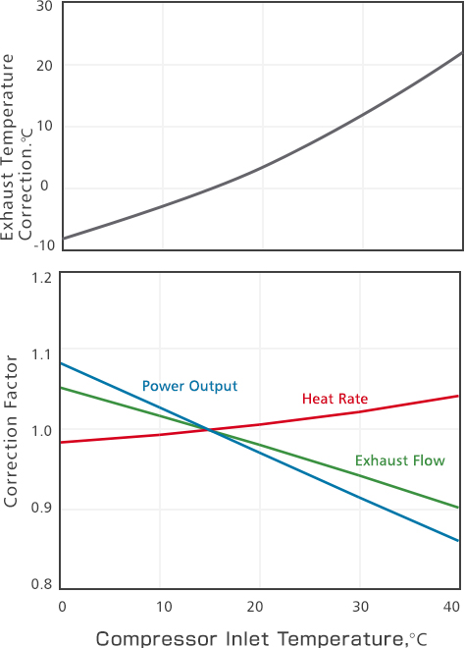
Figure 1. Effect of compressor inlet temperature on power output, heat rate, exhaust flow and exhaust temperature (typical) [D1].
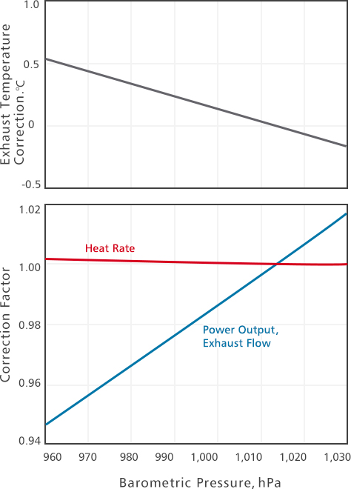
Figure 2. Effect of barometric pressure on gas-turbine performance (typical) [D1].

4. Compressor — Published Technical Information

4.1 Design lineage
Table 5. Evolution of the Mitsubishi large-frame compressor [D2], [D4], [D5], [D6].
Model | Freq. | Speed (rpm) | Stages | Pressure ratio | GT output | Note
M501G | 60 Hz | 3600 | 17 | 20 | 267 MW | Predecessor
H-series | — | — | — | 25 | — | Compressor verified at T-Point, 2001
M501J | 60 Hz | 3600 | 15 | 23 | 327–330 MW | Based on H-series compressor
M501JAC | 60 Hz | 3600 | 15 | 25 (catalogue > 25) | 425–453 MW | Same flow path as J; PR raised
M701J | 50 Hz | 3000 | 15 | 23 | — | 1.2× geometric scale of M501J
M701JAC | 50 Hz | 3000 | 15 | 25 / > 25 | 448 / 574 MW | Same flow path shape as J

4.2 Aerodynamic design
- The J-series compressor is an axial design with a pressure ratio of 23, based on the H-series compressor (pressure ratio 25) [D6].
- Advanced 3-D design techniques were used to reduce shock-wave loss in the initial stages and frictional loss in the intermediate and final stages [D1], [D6]. The front stages are therefore transonic.
- The concept was evaluated with 3-D CFD and verified on a full-scale high-speed research compressor [D6]; all-stage CFD of the actual compressor was compared with casing-pressure measurements [D5].
- For the JAC, the pressure ratio was raised from 23 to 25 to limit the rise in exhaust temperature caused by the higher turbine inlet temperature. Because a high-PR compressor has a relatively reduced outlet flow area, heavier rotating stall at low-PR start-up was a concern. A J-based compressor with PR 25 was verified at T-Point in May 2018, with good starting characteristics and aerodynamic performance [D4].
- MHI describes the JAC compressor as "high-load, high-efficiency", installed specifically to control the exhaust-gas temperature rise [D3].
- Supporting research: a boundary-layer-controlled, high-loading compressor developed in the Japanese 1700 °C national project, tested on a scale model of the front eight stages with variable vanes, including surge verification [D7], [D8].

4.3 Variable geometry, start-up and operability
- Variable inlet guide vanes plus variable stator vanes on the first three stages, i.e. four variable rows operating together [D1], [D2].
- Purpose: suppress rotating stall at start-up, and modulate air flow at part load to keep exhaust temperature high for bottoming-cycle efficiency [D2], [D6].
- Bleed from low-, middle- and high-pressure stages during start-up [D6].
- J-series factory test: rotating stall extinguished at about 60 % of rated speed; natural frequencies, blade/vane vibration stress and pressure fluctuations measured; compressor efficiency and inlet air flow measured at each IGV angle [D6].

4.4 Scaling between 60 Hz and 50 Hz machines
The 50 Hz M701J was obtained from the 60 Hz M501J by geometric scaling with a scale factor equal to the reciprocal of the speed ratio, 3600/3000 = 1.2. Stresses, temperatures and velocity triangles are thereby preserved, while air flow and output scale with the square of the scale factor (1.2² = 1.44) [D5]. The same rule links the M501JAC and M701JAC. It is a direct application of turbomachinery similarity (constant U = ωr, constant flow coefficient), as discussed in Dixon & Hall.

5. Derived Quantities (Group Estimates)
The values below are not published by the manufacturer. They are derived from the catalogue data of Table 3 for the 448 MW rating (PR = 25), using the same assumptions as the Phase 1 report: ideal gas, γ = 1.4, c_{p} = 1004.5 J/(kg·K), η_{p} = 0.90 assumed, ISO inlet, and a fuel-to-air ratio of about 2 %.
Table 6. Estimated compressor quantities, M701JAC 448 MW rating.
Quantity | Estimate | Basis
Mean stage pressure ratio | 25^{1/15} ≈ 1.239 | Catalogue PR and stage count
Compressor inlet air flow | ≈ 750 kg/s | Exhaust flow 765 kg/s less ≈ 2 % fuel
Compressor delivery temperature | ≈ 801 K (528 °C) | T₀₂/T₀₁ = 25^{0.2857/0.90} = 2.78
Mean stage temperature rise | ≈ 34 K | ΔT₀/15
Compressor shaft power | ≈ 390 MW | ṁ·c_{p}·ΔT₀, constant c_{p}

These estimates are order-of-magnitude checks only. Bleed and cooling-air extraction, variable c_{p} and the actual polytropic efficiency are not published and would change them by several per cent.

6. Information Not Publicly Available
The following data, essential for a blade-level reverse engineering, are not published by Mitsubishi Power. This is why the M701JAC was not selected as the machine for reverse engineering in the Phase 1 report, and NASA Rotor 37 was chosen instead.
- Annulus (hub and casing) radii and the meridional flow path.
- Blade and vane counts per row, chord, solidity, stagger, metal angles and section profiles.
- Stage-by-stage pressure ratio, loading and reaction distribution.
- Compressor map (pressure ratio and efficiency versus corrected flow), surge line and IGV/VSV schedule.
- Bleed and cooling-air extraction flows; compressor isentropic or polytropic efficiency.
- Blade materials, Campbell diagrams and clearances.

Sources
[D1] Mitsubishi Power, "M701J/JAC Series," https://power.mhi.com/products/gasturbines/lineup/m701j, accessed 27 Oct. 2026.
[D2] Mitsubishi Power, "GTCC Gas Turbine Combined Cycle Power Plants," catalogue, https://power.mhi.com/catalogue/pdf/gtcc.pdf, 2026.
[D3] Y. Takashima et al., MHI Technical Review, vol. 62, no. 3, 2025, https://www.mhi.com/technology/review/pdf/e623/e623060.pdf.
[D4] K. Takamura et al., MHI Technical Review, vol. 56, no. 3, 2019, https://power.mhi.com/randd/technical-review/pdf/index_67e.pdf.
[D5] S. Hada et al., MHI Technical Review, vol. 52, no. 2, 2015, https://power.mhi.com/randd/technical-review/pdf/index_20e.pdf.
[D6] S. Hada et al., MHI Technical Review, vol. 49, no. 1, 2012, https://power.mhi.com/randd/technical-review/pdf/index_22e.pdf.
[D7] E. Ito et al., MHI Technical Review, vol. 52, no. 2, 2015, https://power.mhi.com/randd/technical-review/pdf/index_18e.pdf.
[D8] K. Ishizaka et al., MHI Technical Review, vol. 54, no. 3, 2017, https://power.mhi.com/randd/technical-review/pdf/index_34e.pdf.

