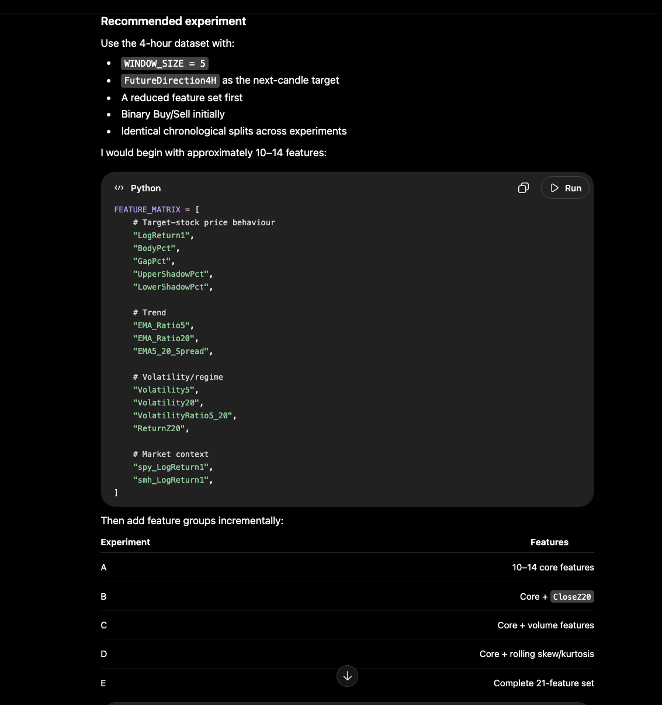

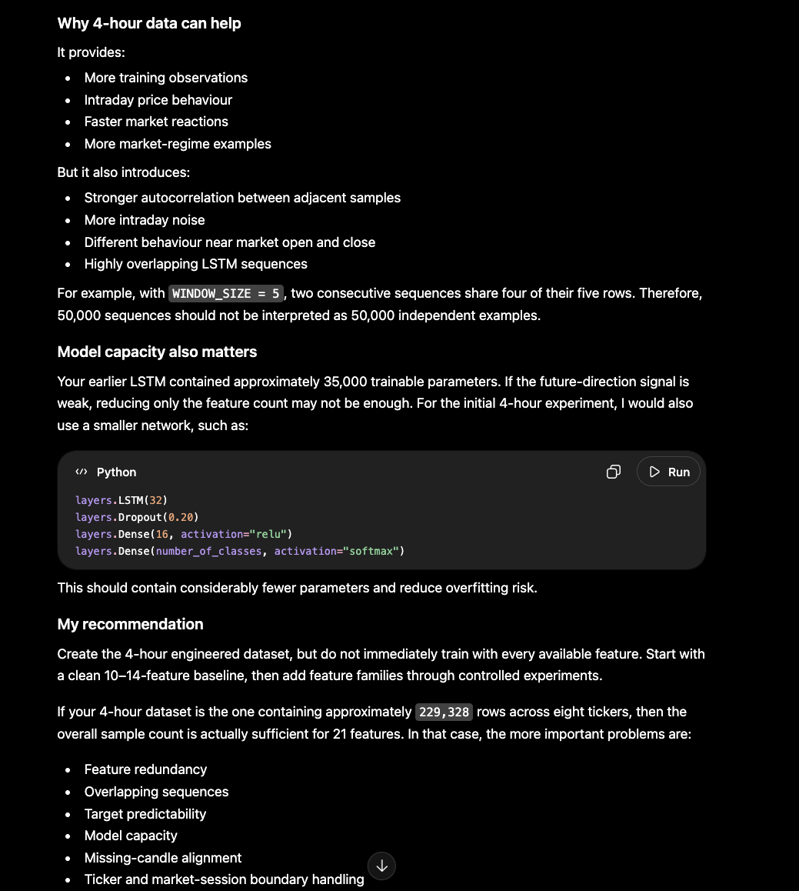

How to run from colab
Make sure files are uploaded in MyDrive/training-ai directory
Classification : !python "/content/drive/MyDrive/training-ai/train_lstm_model-task_new.py" -bs 4hours --task classification --classification-target FutureDirection --window-size 5 --experiment-name 4hoursclassification-futuredirection-w5-21features-4hours
Regression call from colab

!python "/content/drive/MyDrive/training-ai/train_lstm_model-task_new.py" -bs 4hours -t regression --regression-target FutureLogReturn1 --window-size 5 --experiment-name 4hours-regression-futureLogReturn1-w5-21features-4hours

