AI Avatar Assistant

Green Tech Solution develops innovative AI-powered solutions focused on digital interaction, communication automation, and intelligent virtual assistants. Through the use of autonomous AI systems, 3D avatars, and real-time speech engines, it creates products that transform how organisations communicate and engage with their audiences.

The AI Avatar system, integrated into any digital platform, enables cost-effective and scalable personalised interaction —
available 24/7 with no human overhead.
Presented here is the AI Avatar service — an innovative system that automates and personalises information delivery through a fully conversational 3D avatar with real-time lip-sync, voice synthesis, and dynamic facial expressions.

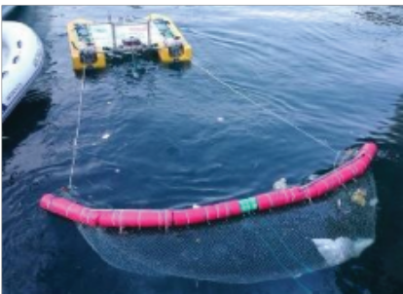





LITTER HUNTER rappresenta una soluzione ingegneristica sul servizio di pattugliamento per gli addetti alla salvaguardia ambientale degli specchi d’acqua marini, lacustri e fluviali. Il sistema automatico LITTER HUNTER, integrato al territorio consente con costi competitivi il rilevamento ed il recupero dei rifiuti galleggianti, attraverso l’utilizzo di droni e natanti automatizzati.
In its complete form, the system is composed of three fundamental layers:
Presentation (Frontend), Intelligence (AI Core), and Voice (TTS + Lip-sync Engine).
FRONTEND
AI CORE VOICE

THE TECHNOLOGY

The AI Avatar technology enables real-time, knowledge-grounded conversation through a fully integrated pipeline:
document ingestion, semantic retrieval, local LLM inference, neural text-to-speech, and frame-accurate lip-sync — all running on local infrastructure with no cloud dependency.
The 3D avatar is rendered in WebGL using React Three Fiber. The GLTF model supports full skeletal animation, facial expression morph targets (smile, angry, surprised, sad), and Mixamo-compatible animation clips (Talking, Laughing, Dancing, Crying) — all running at 60fps in the browser.
>






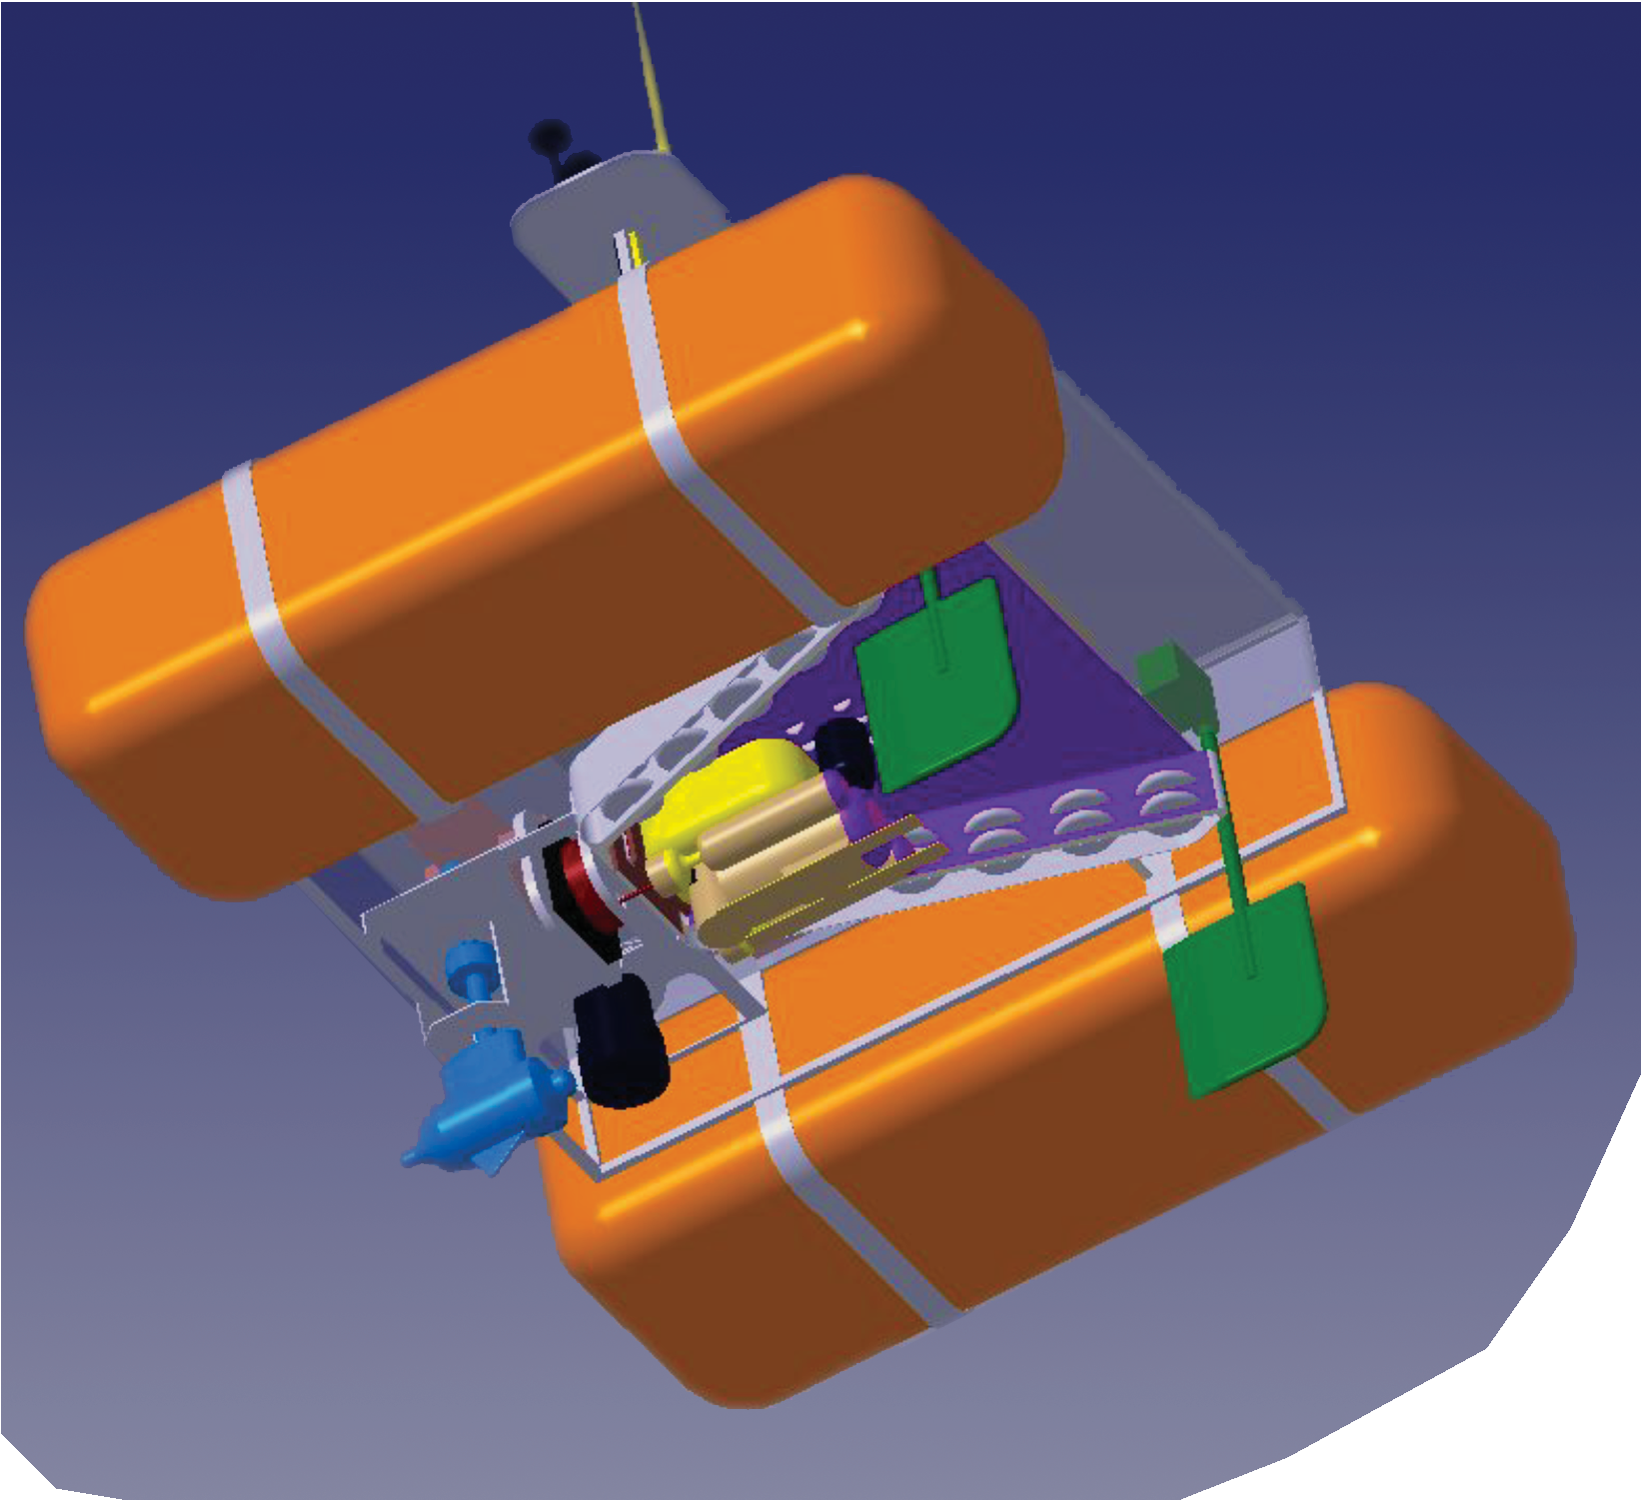










Powered by Ollama
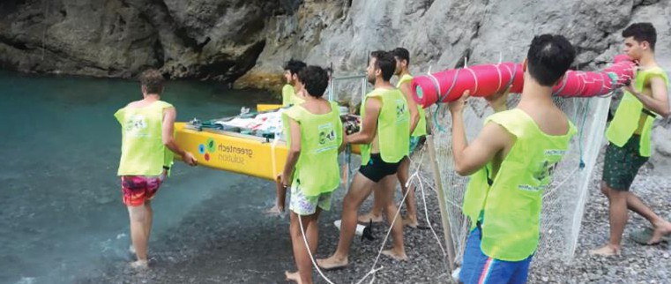
















Il natante è un catamarano ad energia elettrica (non inquinante), la cui struttura centrale è delle dimensioni massime di 2 x 2 metri. A tale struttura viene equipaggiata una rete a traino con panne galleggianti, dell’ampiezza di tre metri che raccoglie i rifiuti galleggianti che incontra, rilasciandoli nel punto prestabili-to programmato nell’autopilota.

Powered by Ollama

THE SERVICE OFFERED
The AI Avatar responds to user questions in under 3 seconds — from text input to spoken, lip-synced, animated answer — running 24/7 with no staff overhead required.
The FastAPI backend processes each query: retrieves relevant context via ChromaDB RAG, generates a structured response with Ollama (phi3), converts it to speech with Microsoft Edge TTS, and runs Rhubarb for phoneme-accurate lip-sync data.

The AI Avatar operates in the market for digital communication, HR technology, customer service automation, and personalised e-learning. The system addresses both institutional and corporate segments,
which have grown significantly with the rise of remote interaction and AI adoption. Our primary clients in the Italian and European market include: HR departments, recruitment agencies, educational institutions, hospitality operators, retail brands,
and public administration offices. Other clients are foundations, NGOs, and organisations seeking to modernise their citizen-facing services.

The activities of Green Tech Solution SRL span three key application areas:
- Conversational AI Avatar for Professionals — Deployment of a personalised AI avatar trained on a professional's CV, portfolio, or bio. Visitors interact in natural language and receive spoken, animated answers — replacing static profile pages with a living, intelligent 24/7 presence.
- Enterprise Knowledge Assistant — A company-facing or customer-facing avatar trained on internal documentation, product catalogues, or policy documents. Answers questions instantly, reducing support load and ensuring consistent, accurate information delivery at scale.

- Educational Outreach & Demonstrations — Interactive avatar-based presentations at events, trade fairs, and exhibitions. The avatar engages visitors, explains services, and collects leads — providing an immersive, memorable brand experience with zero staff overhead.








