**ACKNOWLEDGEMENTS**

I would like to take this opportunity to express my heartfelt gratitude to everyone who assisted me in successfully completing my field report at the TANZANIA TELECOMMUNICATION LIMITED (TTCL). Special thanks go to the following individuals:

I would like to express my sincere acknowledgment for the support I received during my field report at the TANZANIA TELECOMMUNICATION LIMITED (TTCL). I am grateful to everyone who played a role in enabling me to successfully conduct my fieldwork at TTCL.

First and foremost, I am thankful to God for granting me the ability to complete my fieldwork successfully. I extend my gratitude to Mister for their invaluable assistance in helping me secure my field placement at TTCL. Their support was instrumental, and without them, I would not have been able to carry out my fieldwork at TTCL.

I also want to express my appreciation to ENG MDEKA the manager of the Networking and System engineering at ICT Department at TTCL, who served as my supervisor. I am thankful for his guidance and mentorship throughout my fieldwork period. Additionally, I am grateful to Mr. SUDI and all the workers at TTCL Networking and infrastructure at the ICT Department for their continuous support during my fieldwork. Lastly, I am deeply grateful to my parents for their unwavering support and encouragement throughout my entire fieldwork journey. Their support was invaluable and motivated me to successfully complete my field report.

I would also like to extend my sincere thanks to all those whose names are not mentioned here but who contributed in various ways to the success of my field report. Thank you all for your significant contributions to making this journey possible.

**ABSTRACT**

**Introduction**

Practical training (PT) is an essential component of Information Technology (IT) courses in Diploma. It provides students with the opportunity to apply theoretical knowledge in real-world settings, gain practical experience, and develop new skills. This report aims to provide an overview of my field practical training experience at the UTT AMIS INVESTMENT SERVICES PLC and its impact on my professional development.

**Chapter One: Background and Objectives of UTT AMIS:** The first chapter provides background information and a description of UTT AMIS, including its organizational structure, objectives, and the role of the ICT department in achieving the organization's support functions.

**Chapter Two: Skills Enhancement, Tasks, Challenges, Solutions, and Results:** Chapter two focuses on the specific tasks assigned during the field practical training and the challenges encountered. It details the problems underlying these tasks and presents a meticulous analysis of proposed solutions. Both technical and non-technical approaches employed to implement these solutions are discussed. Also, into the skills acquired and honed during the practical training period. It discusses the new skills assimilated and the existing skills that were significantly improved.

**Chapter Three: Conclusion and Recommendations:** Chapter three concludes the report by summarizing my field practice experience at UTT AMIS JNVESTMENT SERVICES PLC and providing recommendations for UTT AMIS INVESTMENT SERVICES PLC improving computing science training programs. It also includes feedback that may help UTT AMIS INVESTMENT SERVICES PLC improve further.

**In conclusion,** this report provides a comprehensive overview of my field practical training experience at UTT AMIS INVESTMENT SERVICES PLC and its impact on my professional development. It also highlights the importance of PT in IT courses and provides recommendations for improving computing science training programs.

**ABBREVIA**T**ION**

|  |  |  |
| --- | --- | --- |
|  |  |  |
| BIOS | – | Basic input/output system |
| CD | – | Compact disc |
| CMS | _ | Content Management System |
| CMS | _ | Content Management System |
| DHCP | _ | Dynamic Host Configuration Protocol |
| DICT | – | Directorate of information and communication Technology |
| DNS | _ | Domain Name System |
|  |  |  |
| DVD | – | Digital versatile disc |
| FAQ | _ | Frequently Asked Questions |
| FOL | – | Faculty of Law |
| FTP | _ | File Transfer Protocol |

|  |  |  |
| --- | --- | --- |
| DVD | – | Digital versatile disc |
| FAQ | _ | Frequently Asked Questions |
| FOL | – | Faculty of Law |
| FTP | _ | File Transfer Protocol |
| GIT | _ | Global Information Tracker (originally GNU Interactive Tools) |
|  | _ |  |
| ICT | – | Information and Communication Technology |
| IDM | – | Institute of Development and Management |
| INTERVLAN | _ | Inter-Virtual Local Area Network |
| IP | – | Internet protocol |
| ISP | _ | Internet Service Provider |
| IT | – | Information technology |
|  |  |  |
| LAN | – | Local Area Network |

|  |  |  |
| --- | --- | --- |
| MAC | – | Media Access Control |
| MARIADB | _ | Maria Database |
| MYSQL | _ | My Structured Query Language |

**LIST** **O**F **CONTENTS**

**ACKNOWLEDGEMENTS** ........................................................................................................................ i

**ABSTRACT**.......................................................................................................................................... ii

**ABBREVIATION**....................................................................................................................................iii

**LIST OF CONTENTS**.....................................................................................................................v

**LIST OF FIGURES**.....................................................................................................................vii

**LIST OF TABLES** ................................................................................**Error! Bookmark not defined.**

**CHAPTER ONE**............................................................................................................................. 1

**1.0 INTRODUCTION**.................................................................................................................1

**1.1 History Background**....................................................................................................................2

**1.2 Mission and Vision**......................................................................................................................... 2

1.2.1 OUR MISSION.................................................................................................................2

1.2.2 OUR VISION....................................................................................................................2

**1.3 Organization structure** ...................................................................................................... 2

**CHAPTER TWO**………………………………………………………………………………5

**2.0 INTRODUCTION……………………………………………………………………………………………5**

**2.1 TASK ASSIGNED………………………………………………………………………...5**

**2.1.1 Router and Switch Configuration………………………………………………………...5**

**2.1.2 Printer installation……………………………………………………………………......5**

2.1.3  **Network switch configuration**……………………………………………………………………………………………5

2.1.4 **Server Configuration**…………………………………………………………………………………………………………..5

2.1.5 **Window installation**……………………………………………………………………………………………………………5

2.1.6 **Computer maintenance and repair**……………………………………………………………………………………..5

2.1.7 **How to connect network cable**…………………………………………………………………………………………….5

2.1.8 **Virtual Machine Operation**………………………………………………………………………………………………………5

LIST OF FIGURES

Figure 1. The organization structure at UTT.................................................................................... 3

Figure 2. Omary and other PT student performance assigned task ..................................................4

Figure 3. Router setting(secret, password, hostname and username)...............................................7

Figure 4. Download Ubuntu server IOS. .........................................................................................9

Figure 5. Create a Virtual Machine.................................................................................................10

Figure 6. Start a Virtual Machine....................................................................................................11

Figure 7. Install Ubuntu server.....................................................................................................12

................................................................................................... 13

Figure 10. Example of network loop ..............................................................................................22

Figure 11. Fiber optical cables .......................................................................................................22

...................................................................................................... 23

.............................................................................. 23

Figure 13.Heat shrink tubes ............................................................................................................24

CHAPTER ONE

**1.0 INTRODUCTION**

Nestled within the vibrant intellectual landscape of the UTT AMIS is the UTT AMIS, an esteemed Information and Communication Technology (ICT) Department. Owned and operated by UTT AMIS, UTT stands as a beacon of technological innovation, offering world-class ICT solutions not only to the institution but also to the wider public. Headquartered at UTT AMIS second floor, Sukari House, Sokoine Street, Dar es salaam. UTT AMIS extends its expertise across key Tanzanian cities, including Dar es Salaam, Arusha, Dodoma, Mbeya, Mwanza and Zanzibar.

UTT AMIS diverse array of services encapsulates the essence of cutting-edge technology. From imparting essential ICT training and pioneering software development and systems integration to providing robust ICT infrastructure and security solutions, UTT AMIS contributions to the ICT landscape are unparalleled. Their commitment to excellence is further underscored by their bespoke ICT consulting services, tailored to meet the unique needs of their clients, thus exemplifying a customer-focused approach.

UTT AMIS offers a diverse range of services, encompassing essential areas of ICT;

1. **ICT Training:** At UTT AMIS, training services are meticulously crafted in alignment with contemporary technology, ensuring students are equipped with cutting-edge knowledge and skills.
2. **Software Development & Systems Integration:** With an in-depth understanding of institution needs, UTT AMIS excels in designing and developing solutions that address complex challenges faced by clients.
3. **ICT Infrastructure & Security Solutions:** UTT AMIS stands as a leader in providing top- notch ICT infrastructure services and security solutions, ensuring businesses operate in a secure and efficient digital environment.
4. **ICT Consulting:** UTT AMIS goes beyond conventional services, offering consultancy services tailored to meet the unique needs of clients. Their customer-focused approach ensures that businesses receive personalized and effective solutions.

1.1 History Background

UTT AMIS was incorporated in 2013 to take over management of collective investment schemes from the Unit Trust of Tanzania (UTT AMIS) following the Shareholder’s decision to restructure UTT AMIS. UTT AMIS was reassigned with the management of collective investment schemes and other activities of the predecessor organization from 1st October 2013. Currently, UTT AMIS manages six collective investment schemes namely Umoja Unit Trust Scheme, more popularly known as the Umoja Fund, Wekeza Maisha/Invest Life Unit Trust Scheme, Watoto Fund, Jikimu Fund, Liquid Fund and Bond Fund. UTT AMIS also provides Wealth Management service to middle and high net worth individual clients and institutions.

# Mission and Vision

1.2.1 OUR MISSION

"To offer people-oriented innovative products, providing comparatively superior returns and achieving high service standards that meet and exceed stakeholders' expectations".

1.2.2 OUR VISION

"Continue being the most trusted and accessible investment partner that makes a difference to peoples' lives".

# 1.3 Organization structure

The UTT AMIS INVESTMENT SERVICES PLC operates under a comprehensive structure, beginning with the Board of Directors, providing strategic oversight. Reporting directly to the Board, the Managing Director leads the institution's operations, supported by the Procurement Unit and Internal Auditor for financial integrity. Assisting in coordination, the Deputy Managing Director plays a pivotal role. Notably, within the Organization departments, the ICT (where I worked in) focuses on ICT infrastructure and systems development. This structured framework ensures the efficient functioning of UTT AMIS INVESTMENT SERVICES PLC, promoting excellence in education and innovation.

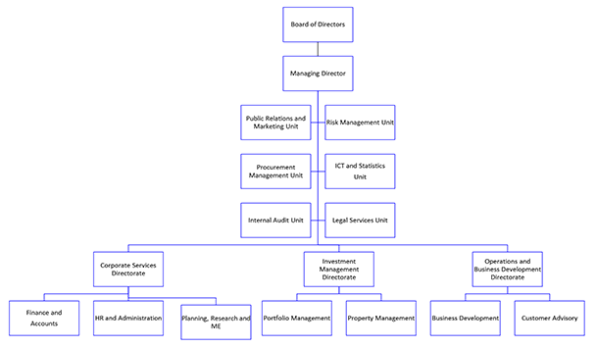

*Figure 1. The organization structure at UTT AMIS*

During my practical training experience at the UTT AMIS INVESTMENT SERVICES PLC. I had the privilege to work within the Network & System Engineering Department. In this dynamic role, our team specialized in ICT commercial services, offering a range of solutions to both internal and external clients. Our responsibilities extended to managing UTT AMIS, ICT services, ensuring seamless connectivity and reliable systems for various academic and administrative functions. Additionally, our department was involved in infrastructure services, focusing on the design, implementation, and maintenance of advanced IT infrastructure. This practical training provided valuable insights into the intricate world of ICT solutions and engineering, enriching my skills and understanding of technology in an educational context.

1.4 Objective of PT for IT in Diploma

The Practical Training (PT) program for Information Technology (IT) diploma students aims to bridge the gap between theoretical knowledge and real-world applications. Through PT, students are expected to apply their classroom learning to practical IT scenarios, gaining hands-on experience in areas such as network configuration, software development, system administration, and troubleshooting. The program nurtures problem-solving skills, fosters effective communication and teamwork, and exposes students to industry-standard practices and technologies. Additionally, PT provides an opportunity for students to explore IT specializations, build professional confidence, understand workplace ethics, receive constructive feedback, and enhance their resumes for future employment. Ultimately, the objective is to prepare students for the IT workforce by equipping them with practical skills, industry insights, and professional confidence essential for a successful career in Information Technology.

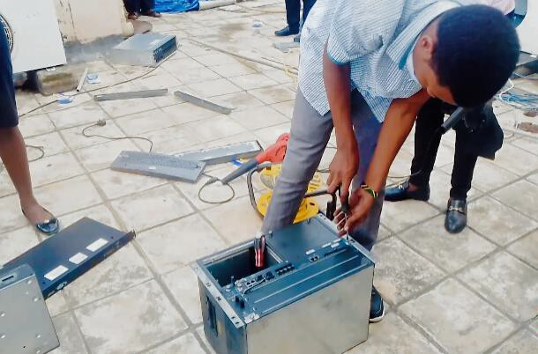

*Figure 2. Omary and other PT student performance assigned task*

2 CHAPTER TWO

*Practical Experience at UTT AMIS Training*

**2.0 INTRODUCTION**

In this chapter, I'll talk about my time working at the UTT AMIS. During my training, I was given various tasks by my supervisor, like solving network problems and creating a website for UTT AMIS users. I'll share the challenges I faced and how I tackled them. Some issues were technical, involving the setup of network devices, while others were about making the website easy to use. I'll explain the solutions I came up with in simple terms, showing how I improved things step by step. This chapter will give you a clear picture of what I did during my training at UTT AMIS.

# 2.1 TASK ASSIGNED

The following are the specific tasks I was assigned during my practical training at the UTT AMIS. These tasks covered a wide range of areas:

**Printer installation:**

1. Installing gateway, Ip address and network with a computer install.

# Network Management:

1. Configuring and managing routers, switches, wireless access points, and other network devices.
2. Troubleshooting network problems, conducting device inventory, and performing hardware checks.

**Computer Maintenance:**

1. Installing various Window distributions.

2. Handling tasks like recovering CMOS battery, device cables like SATA and hard disk drive for proper function of a computer into organization.

In the following sections, I'll share the challenges faced in each task and the detailed steps I took to successfully complete them. These experiences not only enhanced my skills but also significantly contributed to the functioning and security of UTT AMIS network and services.

2.1 Activity performed during the field practical

Overall activities I’m performed at the UTT AMIS Asset investor services referral organization during the field attachment period;

Router and Switch Configuration

A network switch (also called switching hub, bridging hub, officially MAC Bridge) is a computer that connects devices together on a computer network, by using packet switching to receive, process and forward data to the destination device. Unlike less advanced network hubs, a network

switch forwards data only to one or multiple devices that need to receive it, rather than

broadcasting the same data out of each of its ports. Configuration involved erasing all existing data and settings, providing a fresh start for the configurations. During this process, new security measures were implemented, including setting up a new secret, password, hostname, and username. These security measures were crucial to ensuring the integrity and confidentiality of the network.

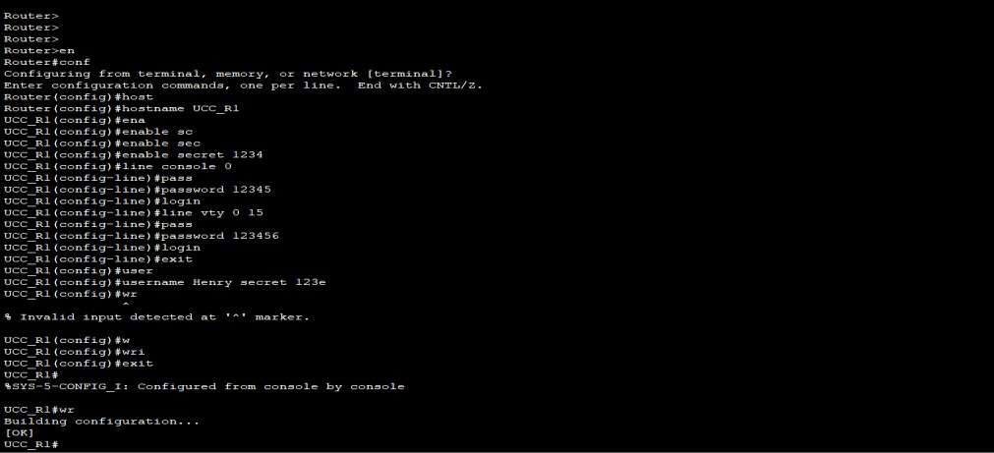

*Figure 3. Router setting (secret, password, hostname and username)*

Before configuration you need to be connected to the devices. The following are the ways to be connected to the device

Device can be connected to in several ways, including:

1. Ethernet Cable: Directly connecting a computer to the router using an Ethernet cable provides a stable and fast connection.
2. Wi-Fi: Using a Wi-Fi connection, devices can connect to the router wirelessly, providing flexibility and mobility.
3. Browser Interface: Accessing the router's web-based interface through a web browser allows configuration and management settings.
4. SSH (Secure Shell): Securely accessing the router's command-line interface remotely using SSH, especially for advanced configurations.
5. Console Port: Connecting a computer to the router's console port via a console cable allowsdirect access for configuration and troubleshooting.

Each method offers specific advantages based on the user's needs and the network environment.

The following are some configuration of router: -

**External Interface (connecter to ISP)**

Configure the router's external interface (Internet-facing) with the ISP's IP address: 196.44.161.1/24.

interface GigabitEthernet0/0

ip address 196.44.161.1 255.255.255.0

no shutdown

**Internal Interface (Connected to Switch)**

Configure the router's internal interface (fa0/0) with the IP address 192.168.1.1/24.Connect the router's internal interface to the switch using an Ethernet cable. Ensure proper physical connectivity.

interface FastEthernet0/0

ip address 192.168.1.1 255.255.255.0

no shutdown

# NAT Configuration

## Set up NAT (Network Address Translation) to enable private IP addresses within the internal network.

ip nat inside source list 1 interface GigabitEthernet0/0 overload ip access-list standard 1

permit 192.168.1.0 0.0.0.255

# DHCP Configuration

## Implement DHCP (Dynamic Host Configuration Protocol) to provide IP addresses ranging from 192.168.8.31 to 192.168.1.254 for devices within the network.

ip dhcp pool LAN

network 192.168.1.0 255.255.255.0

default-router 192.168.1.1

dns-server 196.44.168.10

**DNS Configuration**

Specify the DNS server address as 196.44.168.10 for name resolution.

ip name-server 196.44.168.10

# Routing Configuration

ip route 0.0.0.0 0.0.0.0 196.44.161.1

# Save the Configuration

write memory

**Switch Configuration**

Here is how to configure VLAN

vlan 1 name VLAN1 vlan 2 name VLAN2 vlan 3 name VLAN3

interface range FastEthernet0/1-8 switchport mode access

switchport access vlan 1

interface range FastEthernet0/9-16 switchport mode access

switchport access vlan 2

interface range FastEthernet0/17-23 switchport mode

access

switchport access vlan 3

# Saving the Configuration write memory

In conclusion, we successfully implemented inter-VLAN routing, enabling seamless communication between different VLANs. Additionally, we configured an access point, providing wireless connectivity to PCs within our network. This setup ensured efficient data exchange and enhanced flexibility for our users, contributing to a well-optimized and functional network environment.

2.1.3 VIRTUAL MACHINE OPERATINS:

In the context of Virtual Machine Operations, I installed various operating systems on different platforms. Specifically, I set up virtual machines for Ubuntu Desktop, Ubuntu Server, and Kali Linux within the VirtualBox software. These virtual machines allowed me to work with different operating systems in isolated environments, providing a safe space for testing and learning without affecting my primary system. This approach facilitated hands-on experience and skill development across multiple platforms.

2.1.3.1 How to install OS in Virtual machine

Here are the concise steps for installing Ubuntu Server on a virtual machine:

1. Download Ubuntu Server ISO: Obtain the Ubuntu Server installation file from the official website.

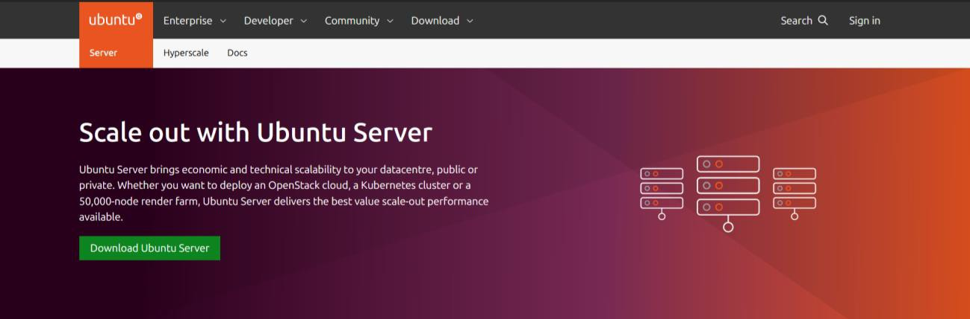

*Figure 4. Download Ubuntu Server ISO*

1. Create a Virtual Machine: Open VirtualBox, create a new virtual machine, and allocate resources like RAM and storage.

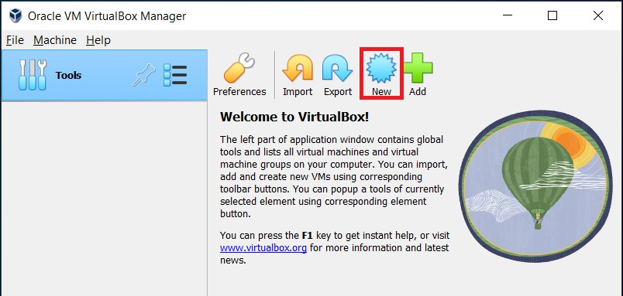

*Figure 5. Create a Virtual Machine*

1. Attach Ubuntu ISO: In the virtual machine settings, attach the downloaded Ubuntu Server ISO file as the installation media.
2. Start the Virtual Machine: Launch the virtual machine, which will boot from the Ubuntu Server ISO.

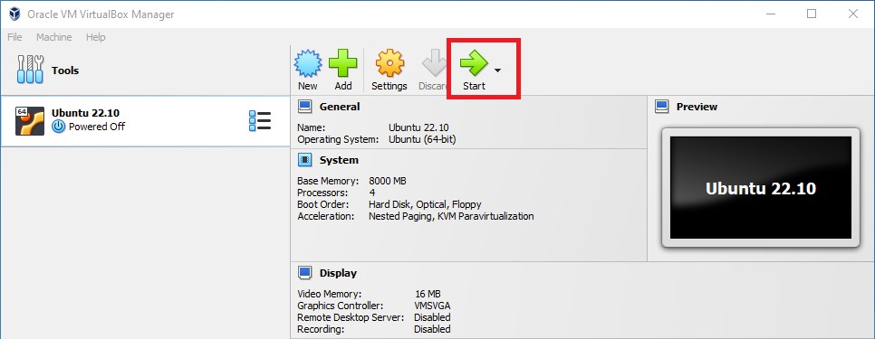

*Figure 6. Start the Virtual Machine*

5. Install Ubuntu Server: Follow the on-screen prompts to install Ubuntu Server. Configure language, location, keyboard layout, and user credentials.

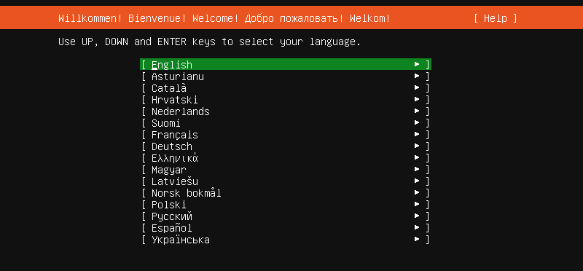

*Figure 7. Install Ubuntu server*

6. Partition Disks: Choose disk partitioning options, such as guided partitioning or manual partition setup.

7. Install Grub Boot Loader: Allow the installer to install the GRUB boot loader, ensuring Ubuntu boots properly.

8. Complete Installation: Once installation completes, remove the installation media (ISO) and restart the virtual machine.

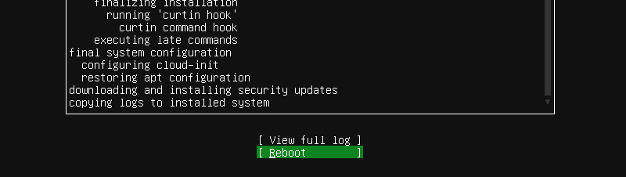

Figure 8. Complete Installation

9. Post-Installation Setup: After reboot, log in with the provided credentials and perform any additional configurations as needed.

These steps provide a succinct overview of the Ubuntu Server installation process on a virtual machine.

I configured various virtual machine settings, including network configurations and other adjustments, to optimize their performance and functionality.

2.1.4 Printer installation

Printer installation. This was one among the task have doing during the field time is a peripheral machine which makes a persistent representation of graphics or text, usually on paper. While most output is human-readable, bar code printers are an example of an expanded use for printers. Different types of printers include 3D printers, inkjet printers, laser printers, and thermal printers. HP LaserJet 5 printer The Game Boy Pocket Printer, a thermal printer released as a peripheral for the Nintendo Game Boy. This is an example of a wide-carriage dot matrix printer, designed for 14-inch (360 mm) wide paper, shown with 8.5-by-14-inch (220 mm × 360 mm) legal paper. Wide carriage printers were often used in the field of businesses, to print accounting records on 11-by-14-inch (280 mm × 360 mm) tractor-feed paper. They were also called "132-column.

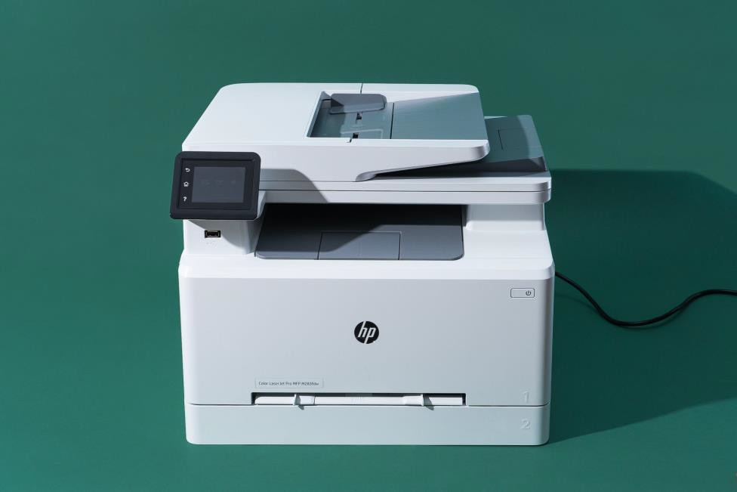

Figure 9. Printer installation

2.1.5 Network switch configuration

Network switch configuration (also called switching hub, bridging hub, and, by the IEEE, MAC bridge). This was one among the task have doing during the field time. Network switch is networking hardware that connects devices on a computer network by using packet switching to receive and forward data to the destination device. Avaya ERS 2550T-PWR, a 50-port Ethernet switch. A network switch is a multiport network bridge that uses MAC addresses to forward data at the data link layer (layer 2) of the OSI model. Some switches can also forward data at the network layer (layer 3) by additionally incorporating routing functionality. Such switches are commonly known as layer-3 switches or multilayer switches. Switches for Ethernet are the most common form of network switch. The first MAC Bridge was invented in 1983 by Mark Kempf, an engineer in the Networking Advanced Development group of Digital Equipment Corporation. The first 2 port Bridge product (LANBridge 100) was introduced by that company shortly after. The company subsequently produced multi-port switches for both Ethernet and FDDI such as Giga Switch. Digital decided to license its MAC Bridge patent in a royalty-free, nondiscriminatory basis that allowed IEEE standardization. This permitted a number of other companies to produce multi-port switches, including Kalpana. Ethernet was initially a shared-access medium, but the introduction of the MAC bridge began its transformation into its most-common point-to-point form without a collision domain. Switches also exist for other types of networks including Fibre Channel, Asynchronous Transfer Mode, and InfiniBand.

Figure 6:

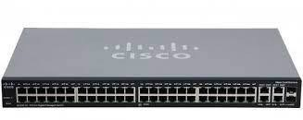

Figure 10. Cisco Packet

2.1.6 Server configuration

Server configuration. This was one among the task have doing during the field time In computing, a server is a piece of computer hardware or software (computer program) that provides functionality for other programs or devices, called "clients". This architecture is called the client–server model. Servers can provide various functionalities, often called "services", such as sharing data or resources among multiple clients or performing computations for a client. A single server can serve multiple clients, and a single client can use multiple servers. A client process may run on the same device or may connect over a network to a server on a different device. Typical servers are database servers, file servers, mail servers, print servers, web servers, game servers, and application servers. Client–server systems are usually most frequently implemented by (and often identified with) the request–response model: a client sends a request to the server, which performs some action and sends a response back to the client, typically with a result or acknowledgment. Designating a computer as "server-class hardware" implies that it is specialized for running servers on it. This often implies that it is more powerful and reliable than standard personal computers, but alternatively, large computing clusters may be composed of many relatively simple, server components.



Figure 10. Server configuration

2.1.7 Window installation

Window installation. This was one among the task have doing during the field time. Windows Setup is the program that installs Windows or upgrades an existing Windows installation. It is also the basis for the following installation and upgrade methods: Interactive Setup, Automated installation, Windows Deployment Services, Windows Setup Installation Types Windows Setup can perform both clean and upgrade installations. However, it does not perform computer-to- computer migrations. Instead, you must use Windows Easy Transfer, the User State Migration Tool (USMT), or another migration tool to move data from a previous installation to the new operating system. Custom installations. Windows Setup can perform a custom installation, also known as a clean installation, which saves your previous Windows installation but does not migrate your settings. The previous Windows installation will not boot after a clean installation. Upgrade installations. Windows Setup can perform an installation that retains your settings and preferences while upgrading your operating system. Windows Setup Process the Windows Setup program starts and restarts the computer, gathers information, copies files, and creates or adjusts configuration settings. The following table shows the overall process for Windows Setup: Windows Setup phase.

Windows Setup phase.

Step 1. On window installation. Select the language your want to use on installation of window

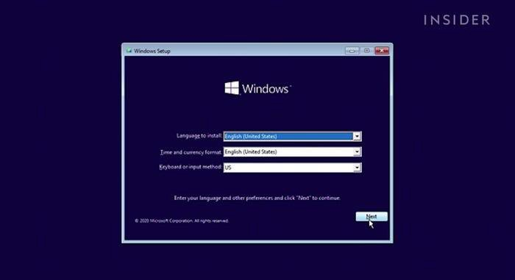

Figure 11. Language select

Step 3. Accept the license terms of Microsoft then click next.

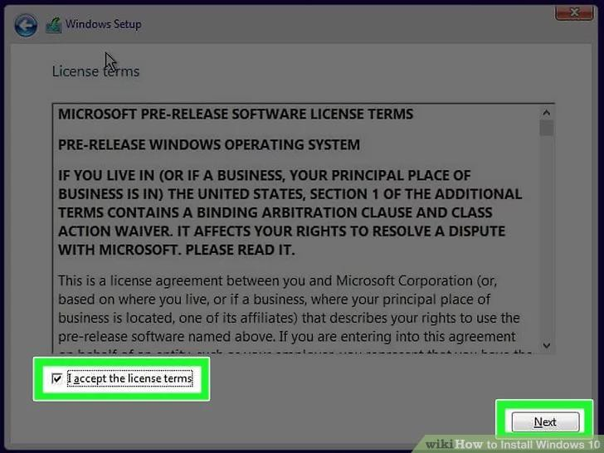

Figure 12. Accept license terms

Step 4. Select one option to upgrade or customer then click next

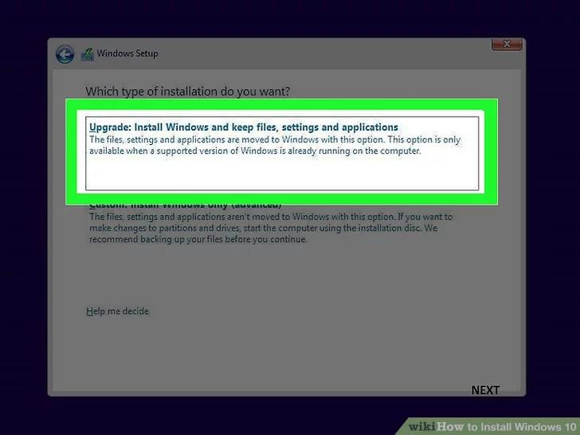

Figure 13. Select to upgrade

Step 5. The installation was started

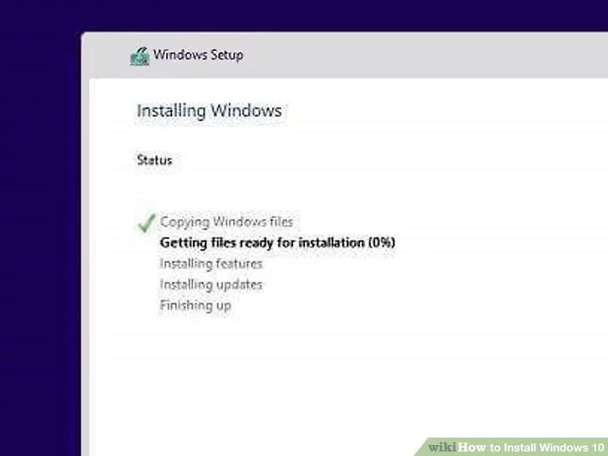

Figure 14.

2.1.8 Computer repair and maintenance

This was one among the task have doing during the field time Meaning of computer Maintenance is the process of keeping computer in a good state of repair. Computer containing accumulated dust and debris may not run properly. Dust and debris will accumulate as a result of air cooling. Any filters used to mitigate this need regular service and changes. If the [cooling](https://en.wikipedia.org/wiki/Computer_cooling) [system](https://en.wikipedia.org/wiki/Computer_cooling) is not filtered then regular computer cleaning may prevent short circuits and overheating.

The following are the importance of computer maintenance

1. To keep computer in good state of repair
2. It prevents loss of data
3. Check harmful materials e.g. dust, virus, outdated software
4. Check any malfunctions of peripherals.
5. To increase the performance of computer

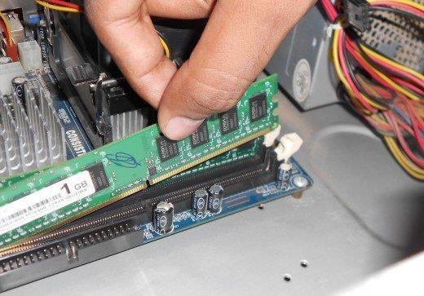

Figure 14. Computer repair and Maintenance

2.1.9 How to create network cable

Network cable. Cables are commonly used to carry communication signals within local area network. One among type of cables is twisted pair cable. Is the most common type of cable see today local area network (LAN) a pair are twisted to provide protection against crosstalk.

There are two types of twisted pairs these are shield twisted pair (STP) and unshielded twisted pair (UTP)

Unshielded twisted pair cable is most common network media. Unshielded twisted pair (UTP) consists of four pairs of thin, copper wires covered in color coded plastic insulation that are twisted together. The wire pairs are then covered with a plastic outer jacket UTP cables are of small diameter and does need grounding. Since there is no shielding for UTP cabling, it relies only on the cancellation to avoid noise

UTP cable wiring and colors code

There are two popular wiring schemes that most people use today this is T568A and T568B the table below as shown the UTP cable wiring and colors code.

|  |  |  |
| --- | --- | --- |
| S/NO | colors code for T568A | colors code for T568B |
| 01 | White green | White orange |
| 02 | Green | Orange |
| 03 | White orange | White green |
| 04 | Blue | Blue |
| 05 | White blue | White blue |
| 06 | Orange | Green |
| 07 | White brown | White brown |
| 08 | Brown | Brown |

Table 2: Colors codes used for creating UTP cables

The following is the step of creating UTP cables.

2.1.9.1.1 Step 1. Collecting Materials like wiring, RJ-45 ang crimping tool

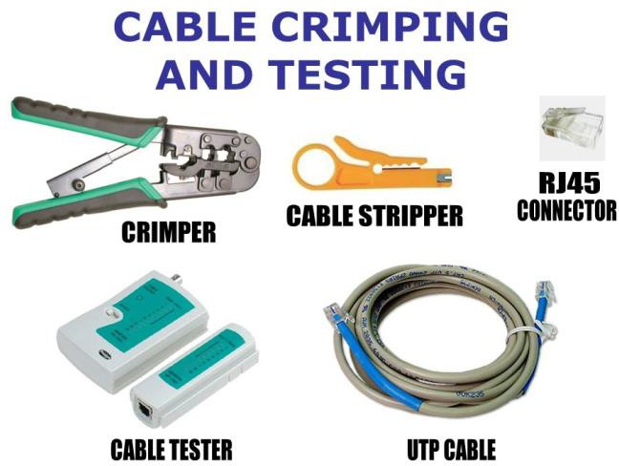

Figure 15. Step 1 to create UTP cable

2.1.9.1.2 Step 2. Cutter, now we take the cutter and cut the cable

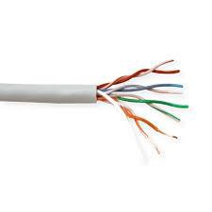

Figure 13. Select to upgrade

Figure 15: Step 2 to create UTP cable

2.1.9.1.3 Step 3. Standard, now you use the standard that you need

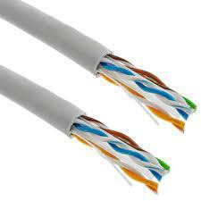

Figure 16: Step 3 to create UTP cable

2.1.9.1.4 Step 4. RJ-45, we proceed to enter the cables in the RJ-45 head

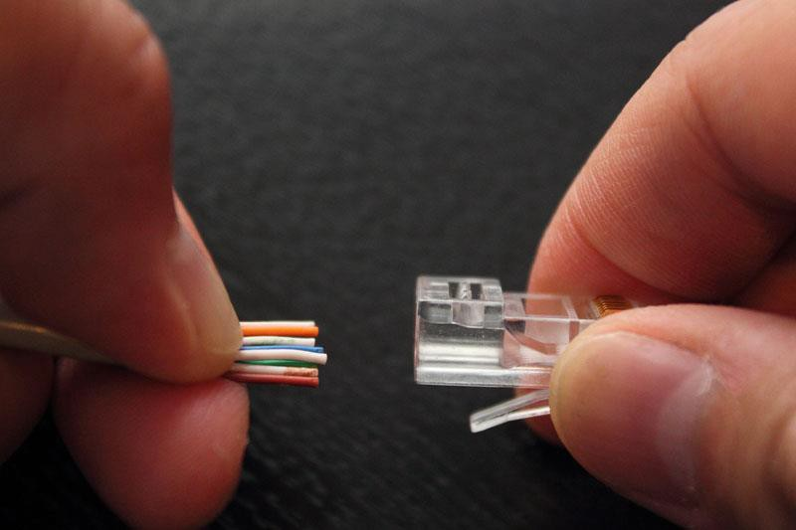

Figure 17: Step 4 to create UTP cable

17

2.1.9.1.5 Step 5. Pushing the wire in RJ-45 through by Crimping Tools

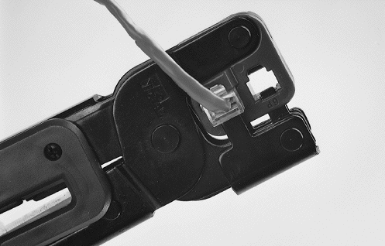

Figure 18: Step 5 to create UTP cable

2.1.9.1.6 Step 6. Testing

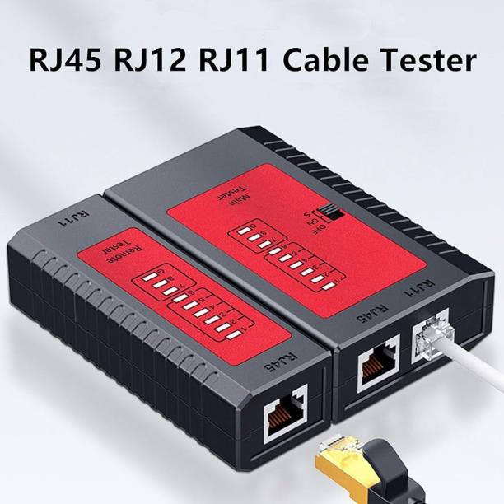

Figure 19: Step 6 to create UTP cable

18

**2.1.2.1.2 Troubleshooting LAN**

Here's a step-by-step guide to troubleshooting common LAN problems:

1. **Identify the Problem:**

Collect Information: Gather details about the issue, such as when it started, which devices are affected, recent changes in the network, etc.

Define the Problem: Is it a connectivity issue, slow performance, intermittent disconnections, or something else?

1. Physical Checks:

Cables and Connections: Ensure all cables (Ethernet, power) are properly connected and not damaged.

Devices: Check if network devices (routers, switches, modems) have power and are functioning.

Network Interface Cards (NICs): Verify NICs in computers are enabled and functioning properly.

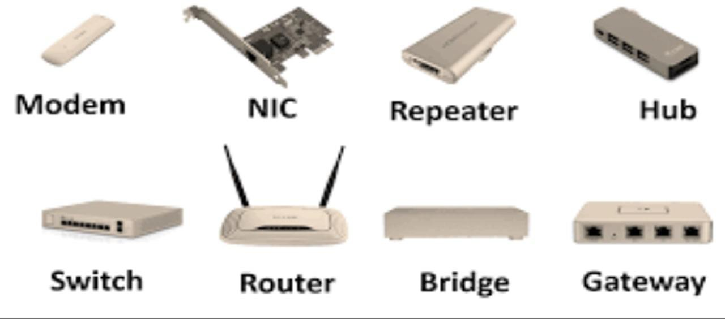

*Figure 12. Device you need to check for physical connection*

1. Check Network Configuration:

IP Configuration: Ensure devices have correct IP addresses, subnet masks, gateways, and DNS settings.

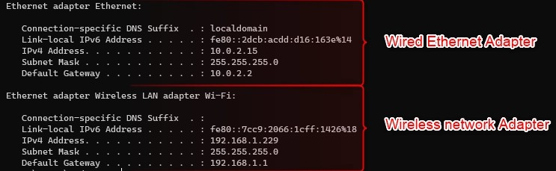

*Figure 13. IP addresses, subnet masks, gateways, and DNS*

DHCP: If using DHCP, check if the DHCP server is running and has available IP addresses to assign.

Static IP Addresses: Verify static IP addresses for devices are correctly configured.

1. **Ping and Connectivity Tests:**

Ping Test: Use the ping command to check connectivity between devices. This helps identify if the issue is with a specific device or the entire network.

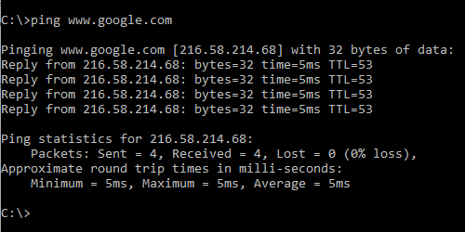

*Figure 14. ping test*

Traceroute: Use traceroute to identify the path taken by packets and where the connection is failing.

1. Check Network Devices:

Router/Modem: Restart the router/modem to refresh configurations.

Switches/Hubs: Ensure they are operational. Test by connecting a device directly to them. Firewall/Security Software: Check if firewall settings are blocking network traffic.

1. **Software and Drivers:**

Update Drivers: Ensure network adapter drivers on computers are up-to-date.

Operating System Updates: Make sure the operating system is updated with the latest patches and security fixes.

Operating System Updates: Make sure the operating system is updated with the latest patches and security fixes.

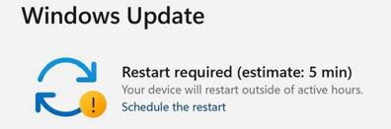

*Figure 15. windows Update*

1. **Security Settings:**

Firewall/Antivirus: Check firewall and antivirus settings for any rules blocking network traffic.

Security Protocols: Ensure WPA/WPA2/WPA3 security protocols are correctly configured for Wi-Fi networks.

1. **Wireless Network Issues:**

Signal Interference: Identify and remove sources of signal interference (other electronicdevices, thick walls, etc.).

Channel Selection: For Wi-Fi networks, choose the least congested channel to reduce interference.

1. **Network Hardware Issues:**

Faulty Hardware: Test network devices individually to identify any faulty hardware components.

Overloaded Devices: Check if any device (router, switch) is overloaded with too many connections.

# Advanced Tools: Network Analyzers:

# Use network analyzer tools to diagnose network traffic, packet loss, and bandwidth usage. Logging: Check router and server logs for error messages and anomalies.

# Consult Documentation and Online Resources:

Manufacturer’s Documentation: Refer to the manuals and guides of your network devices.

Online Forums/Communities: Seek help from online tech communities where experts might assist in troubleshooting.

1. Contact Support:

Internet Service Provider (ISP): If the issue persists and it's related to the internet connection, contact your ISP for assistance.

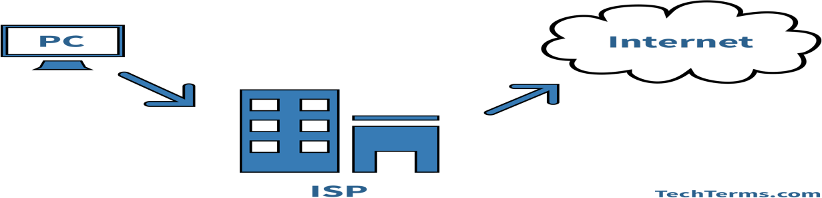

*Figure 16. ISP check*

Device Manufacturer: Reach out to the manufacturer’s support for advanced troubleshooting and potential hardware replacement.

**Here are some steps that I followed to solve network issues in some office and different venues**

1. **Initial Assessment:**

Identified network issues in the classroom where the internet wasn't working. The classroom had its own switch connecting students' computers.

1. **Investigation at Server Room:**

Went to the main network branch (server room) to trace the connection from the class. Tried changing the port at the server room, but the issue persisted, indicating the problem was not in the server room.

1. **Classroom Inspection:**

Checked the connections inside the classroom and found the switch connections were secure. Also Inspected each table's cable connection. Discovered a loop in the wiring causing the network malfunction.

1. **Problem Resolution:**

Removed the loop in the cable connections, resolving the issue and restoring network functionality.

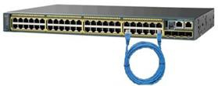

*Figure 17. Example of network loop*

By following these steps, the problem in the classroom's network was identified and successfully resolved, ensuring proper connectivity for students' computers.

2.2 **KEY ACHIEVEMENT**

During my fieldwork at the UTT AMIS INVESTMENT SERVICES PLC, I achieved significant milestones that underscore my growth and expertise in the field of information technology. My key accomplishments include:

2.2.2 Proficient Network Management and Troubleshooting:

I demonstrated expertise in onsite network troubleshooting and repair, resolving issues promptly. Additionally, I actively participated in building networks, configuring routers, switches, and access points. This hands-on experience improved my skills in network architecture and troubleshooting.

**2.3 NEW KNOWLEDGE AND SKILLS**

**2.3.3 Network Building and Configuration:**

Creating and configuring networks involve understanding network architecture, device connections, and communication protocols. Initially unfamiliar with these concepts, I learned to 36 design and implement networks from scratch. This encompassed tasks such as connecting routers, switches, and access points, as well as configuring IP addresses, subnets, and gateways. I became proficient in using tools like PUTTY for secure remote access, enabling me to manage network devices efficiently. This skill set is crucial for establishing and maintaining robust, secure networks in various environments.

2.3.5 Computer Maintenance:

Computer maintenance involves a range of tasks to ensure optimal system performance and security. My training encompassed various Linux settings and administration techniques. This included learning how to recover passwords, configure user accounts, manage system updates, and troubleshoot common issues. Mastering these tasks ensures the smooth functioning of computers, enhances security protocols, and facilitates efficient user interactions with the systems.

These explanations showcase the depth of my learning journey, emphasizing the practical application of each skill in real-world scenarios. The hands-on experiences and theoretical knowledge gained have equipped me with a comprehensive skill set, making me adept in multiple areas of information technology.

In conclusion, In simple words, my time at the UTT AMIS INVESTMENT SERVICES PLC has been amazing. I learned a lot about computers and technology. I now know how to work with virtual machines, use Linux systems, create websites using Drupal, and fix computer problems. These skills have made me better at solving problems and working with different technologies. I feel confident and ready to face challenges in the IT world. This experience has opened many doors for me and made me a skilled IT professional.

**CHALLENGES FACED AND SOLUTIONS IMPLEMENTED**

2.4.1 Laptop Malfunction:

My laptop malfunctioned during the fieldwork, causing significant inconvenience. I promptly informed my supervisor, who allowed me to use their desktop. However, this came with the condition that I could access it without altering their settings or creating multiple accounts. I adhered to these terms and utilized the desktop until my laptop was repaired.

CHAPTER THREE

**CONCLUSION AND RECOMMENDATIONS**

**3.0 INTRODUCTION**

In this final chapter, I look back on my time at the UTT AMIS INVESTMENT SERVICES PLC (UTT AMIS). Here, I talk about what I learned, the things I found easy, and the challenges I faced at UTT AMIS. I also discuss what could be better and offer suggestions for improvements. This chapter shows how my time at UTT AMIS changed me and helped me become better at working with technology.

3.1 CONCLUSION

Reflecting on my experience at the UTT AMIS INVESTMENT SERVICES PLC (UTT AMIS), it's evident that my time there was instrumental in shaping my expertise in the field of information technology. The journey was marked by substantial growth and hands-on learning, leading to the mastery of essential skills.

**.**One of the standout strengths of UTT AMIS lies in the exceptional caliber of its technical team.

The members exhibited unparalleled knowledge and were always ready to assist, providing invaluable guidance and support. Their dedication played a pivotal role in my learning, allowing me to overcome various challenges and excel in my tasks.

**.**Moreover, the practical aspect of learning at UTT AMIS was immensely beneficial. The availability of diverse ICT devices, including routers, access points, printers, and switches, provided an immersive learning environment. Engaging with these devices hands-on significantly enhanced my understanding of IT concepts, translating theoretical knowledge into practical skills.

**.**Despite the challenges posed by limited resources and space, the collaborative spirit among the staff and students prevailed. The exchange of knowledge and the cooperative atmosphere fostered an environment of continuous learning, where questions were welcomed, and solutions were collectively sought.

  In essence, UTT AMIS became more than an educational institution; it transformed into a platform where challenges were met with resilience, and barriers were overcome through collective effort. My experience there not only enriched my technical skills but also instilled in me a profound sense of adaptability and problem-solving.

As I move forward in my IT career, the foundation laid at UTT AMIS will continue to guide me. The supportive environment, coupled with practical exposure, has equipped me with the skills and confidence necessary to face the complexities of the IT landscape. UTT AMIS has not just been a place of learning; it has been a crucible where my capabilities were honed, preparing me for the challenges that lie ahead.

**3.2 RECOMMENDATION**

**3.2.1 Recommendation to UTT AMIS (UTT AMIS INVESTMENT SERVICES PLC)**

I suggest investing in a more powerful electric generator to guarantee a stable electricity supply for the servers. Given that UTT AMIS hosts both the institution and customer websites, a reliable power source is crucial to ensure uninterrupted services. During my PT, electricity outages were frequent, causing disruptions in the institution network and impacting our work. Having a dependable power supply is vital for maintaining the stability of UTT AMIS services, and a more robust generator would mitigate these challenges effectively.

Additionally, I recommend creating a comprehensive database of PT students who have successfully completed their programs at UTT AMIS. This database can serve as a valuable resource, allowing UTT AMIS to keep track of these students and provide them with enhanced opportunities when they reapply for the PT program or seek internships. By maintaining a record of successful PT students, UTT AMIS can foster a stronger sense of community and support their students' ongoing career development.

**3.2 RECOMMENDATION**

**3.2.2 Recommendation to CBE (College of business Education)**

I strongly suggest extending the duration of the field placement (PT) for diploma students. Currently, the allocated six weeks proved to be insufficient for gaining comprehensive practical knowledge.

For instance, during my PT, I missed the opportunity to participate in building a network at UTT AMIS new building with my institutions, simply due to time constraints. To ensure that students have adequate time to engage in meaningful projects and acquire essential skills, I recommend extending the PT duration to at least 8 to 10 weeks.

This extended period would allow students to delve deeper into practical experiences, enabling them to contribute effectively and learn more during their field placements.

REFERENCES