**JOB STATUS TABLE Runbook**

*Contents of document-*

1. Structure of Job status table in snowflake
2. General flow of steps
3. Extract
4. Load Landing
5. Load Stage
6. Flowchart

The ETL python package methods handle the Job status table.

1. **Structure:** This is the structure of job status table in snowflake

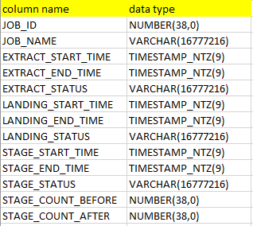

1. **Flow:** The general flow of the ETL job is as follows: -

**Extract job 🡪 Load in Landing of Snowflake Job 🡪 Load in Stage of Snowflake**

1. *Extract*
2. The user gives table name to be loaded as the argument in extract.
3. A new Job ID is created in the Job_Status_Table in snowflake each time the extract is run.
4. If the extract fails for certain records it will show a ‘Fail’ status in the Job_Status_Table.
5. IF ‘Fail’ the extract needs to be run again which will generate a new Job ID.
6. The failed records will be reflected in Daily_Error_Table
7. IF ‘SUCCESS’ then the process moves to next stage that is load Landing.
8. *Load Landing*
9. After extract success, The user gives table name to be loaded in the landing schema in Snowflake as the argument.
10. This job uses PUT and COPY_INTO snowflake commands to load in the extracted table in the Landing Schema.
11. If the Load fails for certain records it will show a ‘Fail’ status in the Job_Status_Table.
12. IF ‘Fail’ , then the Load job is run again which overrides the previous Fail status until it shows ‘Success’ .
13. The failed records will be reflected in Daily_Error_Table
14. IF ‘Success’ then the process moves to next stage that is load Stage.
15. If the user wants to load the table which has shown ‘Success’ previously (second pass), it will override this record in the Job_Status_Table.
16. *Load Stage*
17. After Load success, the user gives table name to be loaded in the Stage schema in Snowflake as the argument.
18. Next, a Snowflake stored procedure called SP_LOAD_STAGE is executed which loads data in stage tables with load strategies being TYPE 2, UPSERT or INSERT ONLY.
19. If the Load fails for certain records it will show a ‘Fail’ status in the Job_Status_Table.
20. IF ‘Fail’, then the Load job is run again which overrides the previous Fail status until it shows ‘Success’
21. The failed records will be reflected in Daily_Error_Table
22. IF ‘Success’ then the process is completed.
23. If the user wants to load the table which has shown ‘Success’ previously (second pass), it will override this record in the Job_Status_Table.
24. **Flowchart:**

