John O’Hollaren

ECE 532

Homework 4

**Problem 1**

All my mosfets are in saturation:

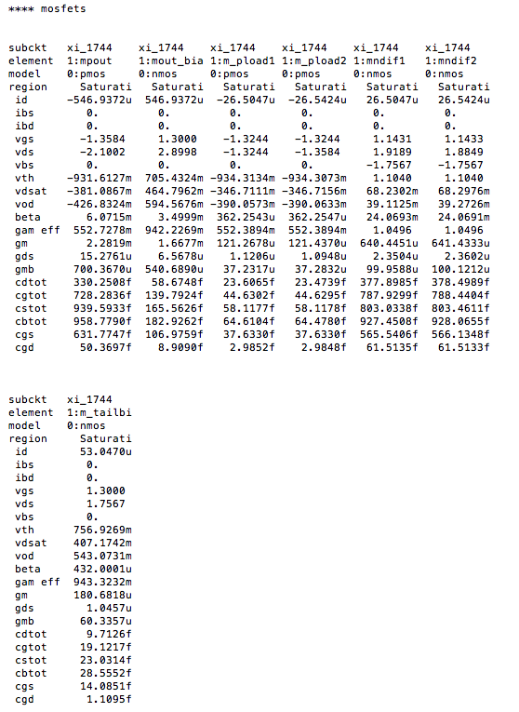

*HSpice File

*.OPTIONS ACCT POST PROBE

.OPTIONS ACCT POST ACOUT=0 DCON=1 ACCURATE=1 UNWRAP LIST

.OP

*.TRAN 200n 2.5m sweep BIAS .9v 1.7v .1v

*.TRAN 1u .3m

*.TRAN 1u 3ms sweep biasvalue 0 1.8 .1

*.TRAN 1u 50ms sweep cvalue 0 4p .5p

*.TRAN .001u .001ms sweep sfreq 5e6 20e6 2e6

*.TRAN 10n 200us

* Do this sweep so we can see right where we want to be biased

* This will be helpful for AC Analysis, could use this for ACGND etc?

*.DC SWEEP biasvalue 1.3995v 1.4005v .00001v

*.DC sweep bias .5v 2.0v .25v width .5u 50u .4u

*.DC sweep vbias .5v 2.0v .25v

*.DC

.GLOBAL vdd gnd

.PARAM VDD=5.0

.AC dec 10 1 1GHz

**.AC dec 10 1 1GHz sweep offset 1.5 3.5 .1

**.AC dec 10 1 1GHz sweep cvalue 0 2.0p .1p

* Use this for AC Analysis

* builds off ACGND

Vp1 INP ACGND AC=1e-4

**VSRC INP gnd 1.25 AC 1 sin(.0001 0 1)

*vp1 INP 0 sin (.9 .0005 3000)

*vinp INP 0 sin (2.2 .130 sfreq)

*vinp INP 0 .9v

*vinn INN 0 2.9v

*vbias outbias 0 sin (offset .4 1e3)

*vbias outbias 0 sin (3.8 .01 5e4)

*vinp P1 0 sin (1.25 .001 1000)

*vbias outbias 0 outbias

*VPOS INP 0 2.0v

* for AC analysis we have to set up these inputs

*vp1 INP 0 biasvalue

*vinn N_1237 0 1.4

*Small Amp SLew Test

*vinn INP gnd pulse 2.499 2.501 2n .1n .1n 1000n 2000n

*Larger Amp SLew Test

*vinp INP 0 0 pulse 2.49 2.51 2n .1n .1n 1600n 3200n

* this is for measuring slew rate and settling time

* comment this out for AC, only for DC

*Vp1 INP 0 0 pulse 2.5 3.0 2n 2n 1n 1600n 3200n

*vinp INP 0 0 pulse 2.499 2.501 2n 0.1n 0.1n 40u 80u

*vinp INP 0 0 pulse 2.1 2.9 2n 0.1n 0.1n 40u 80u

*Vp1 INP 0 0 pulse .9070v .893v 2n 0.1n 0.1n 40u 80u

*Vinp INP 0 0 pulse 1.v 1.8v 2n 0.1n 0.1n 5u 10u

*vinp INN 0 .9v

*vinp P1 0 0 pulse 2.3 2.7 2n 0.1n 0.1n 40u 80u

*Input Range Test (INN = INP with slow ramp; open loop))

*vinp INP 0 0 pulse 1.3 1.4 2n 30u 30u 2u 84u

*vinn INN 0 0 pulse 1.2 3.5 2n 30u 30u 2u 84u

* Power supply definitions

vdd vdd gnd 5.0v

vacgnd ACGND gnd 2.9v

*vgainctln gainctln gnd 0

*vgainctlp gainctlp gnd vdd

*vbias bias 0 1.25

vnbias NBIAS 0 1.3

* these are floating nodes used for debugging

*vpc PC 0 3.0

*vnc NC 0 2.7

.subckt HIGHBWN OUTPUT NIN NBIAS PIN VDD GROUND

C2 N$653 OUTPUT C=7p

R3 N$229 N$653 R=1850

MPOUT OUTPUT N$229 VDD VDD PMOS L=1.6e-6 W=225e-6 M=1

MOUT_BIAS OUTPUT NBIAS GROUND GROUND NMOS L=1.6e-6 W=48e-6 M=1

* load devices / resistors for diff pair

M_PLOAD1 N$239 N$239 VDD VDD PMOS L=1.6e-6 W=14e-6 M=1

M_PLOAD2 N$229 N$239 VDD VDD PMOS L=1.6e-6 W=14e-6 M=1

* this is the diff pair

MNDIF1 N$239 NIN N$228 GROUND NMOS L=1.6e-6 W=300e-6 M=1

MNDIF2 N$229 PIN N$228 GROUND NMOS L=1.6e-6 W=300e-6 M=1

* tail current

M_TAILBIAS N$228 NBIAS GROUND GROUND NMOS L=1.6e-6 W=6e-6 M=1

.ends HIGHBWN

* spice command to initialize a node, this is an intial condition

* might need to use this

*.IC v(N_1237) 1.4

* ACGND BIAS GAINCTLN GAINCTLP OUTPUT P1

XI_1744 OUT INN NBIAS INP VDD GND HIGHBWN

*.subckt BOOKAMPPIP GND INN INP OUT pipbias VDD

*XI_1744 GND INN INP OUTPUT BIAS VDD BOOKAMPPIP

* GAIN 4 or 12 dB is 45000

*RFeed INN OUT 45000

* for open loop gain we comment these out

* gain should be 2 with this setup, these are resistors around the subcircuit

*RFeed INN OUT 20000 ROpen INN OUT 100G COpen INN GND 1u

* ACGND is a bias at 2.9V. this is the common mode center. AC GND

* could be at 0 v, but that would load down output, we want it at common mode

* if ACGND is at 0V, we would get more offset

*Rgnd INN ACGND 20000

*Rgnd INN GND 20000

*MXBIAS VDD BIAS BIAS VDD PMOS L=4u W=30u

*RBIAS BIAS GND 850k

**XI_1744 BIAS OUTPUT INP OUTPUT opampip

**MXM4 N_1235 GAINCTLP N_1237 VDD PMOS L=.7u W=5u

**RXR4 OUTPUT N_1236 133333

***RXRS N_1236 N_1235 1

**RXRS OUTPUT N_1237 1386666

*RXRS OUTPUT N_1237 1386666

**RXRS OUTPUT N_1237 700000

***MXM1 N_1235 GAINCTLN N_1236 gnd NMOS L=.7u W=50u

**RXR2 N_1235 N_1237 133333

*RXR3 N_1237 ACGND 7923

*Cload OUTPUT gnd 3.5p

* small load capacitor

Cload OUT GND 20p

.probe ac vdb(OUT) vp(OUT)

.probe ac gain=par('20*log10(vm(OUT)/vm(INP))')

.probe ac phase=par('vp(OUT)-vp(INP,INN)')

.probe ac margin=par('vp(OUT)-vp(INP,INN)+180')

* .INCLUDE '/ece/digital/share/saturn/hspice/opampjim/pip/pip.sp.pex'

.INCLUDE 'spice_models/ami.5um.typmodels'

.END

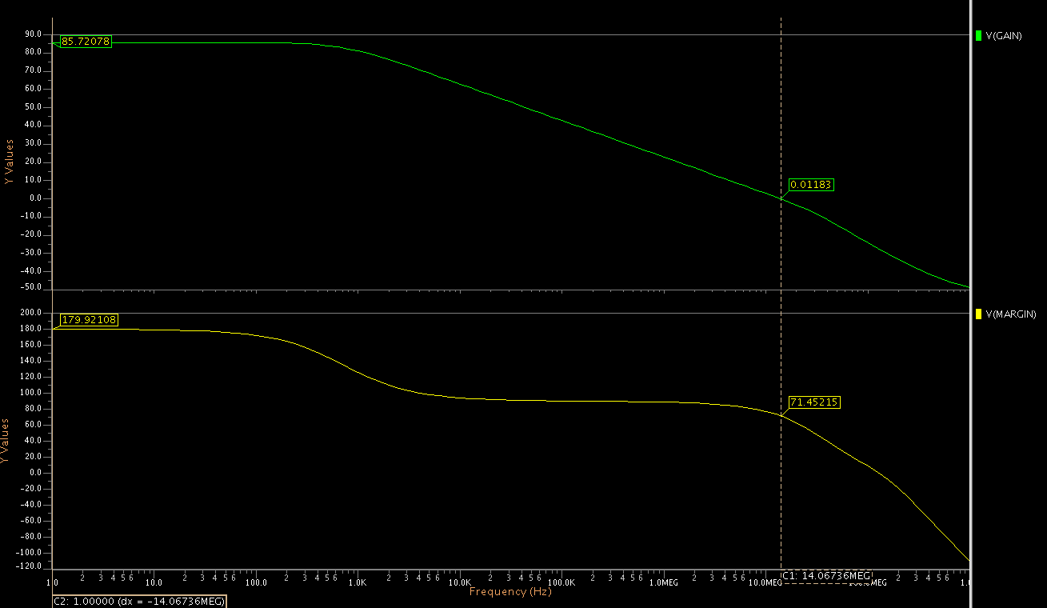

85 dB gain

14 MHz BW

71 degrees Phase Margin

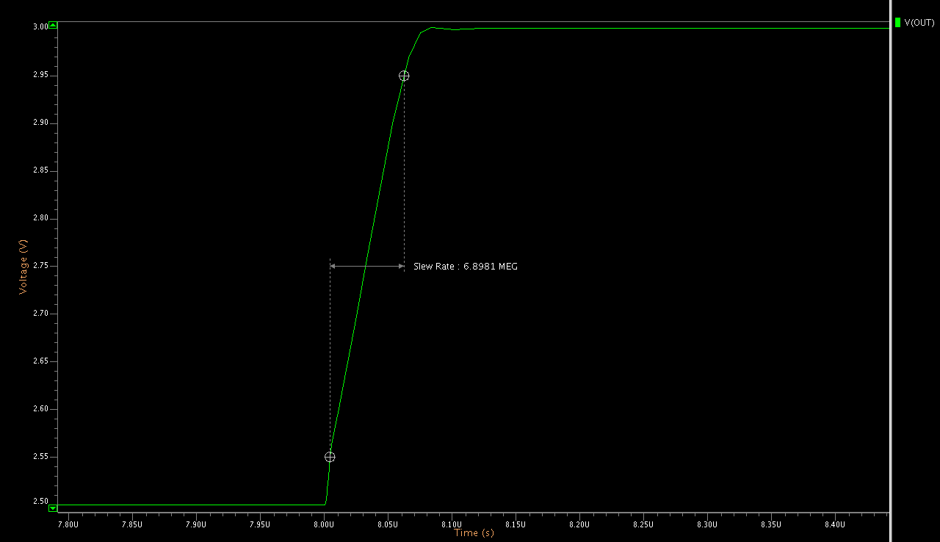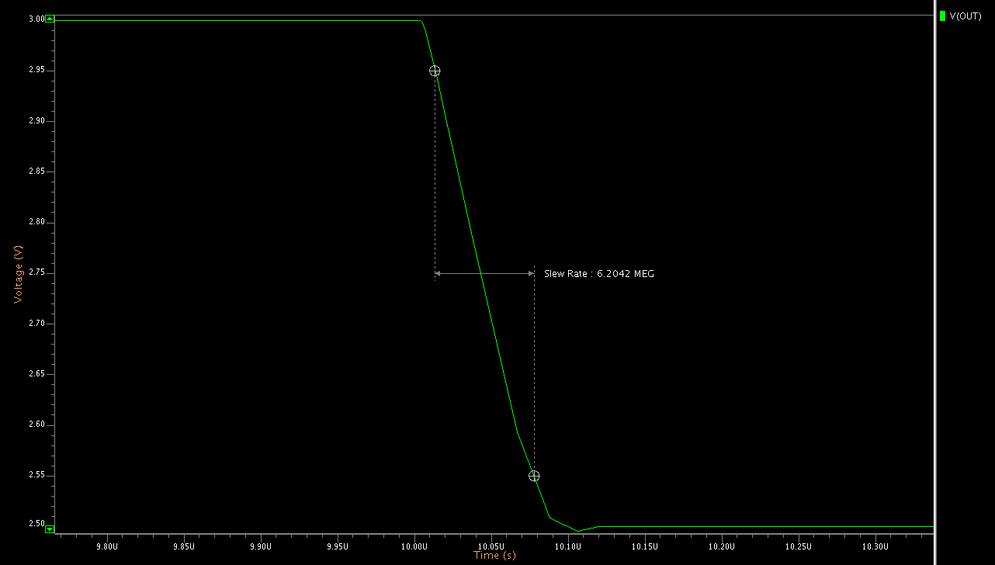

Positive Slew: 6.9 V / us

Negative Slew: 6.2 V / us

I used the typical ideal models, so offset is almost non existent and op amp is very accurate, for example here is the output for a non-inverting gain 2 amplifier to double a 1V input, the offset is only 1.4 mV

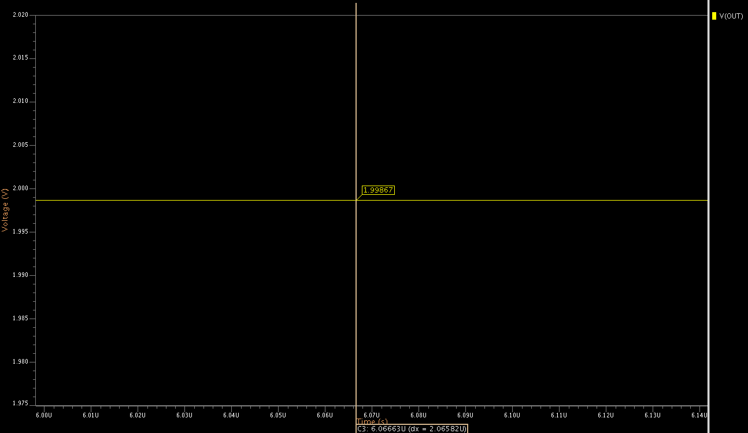

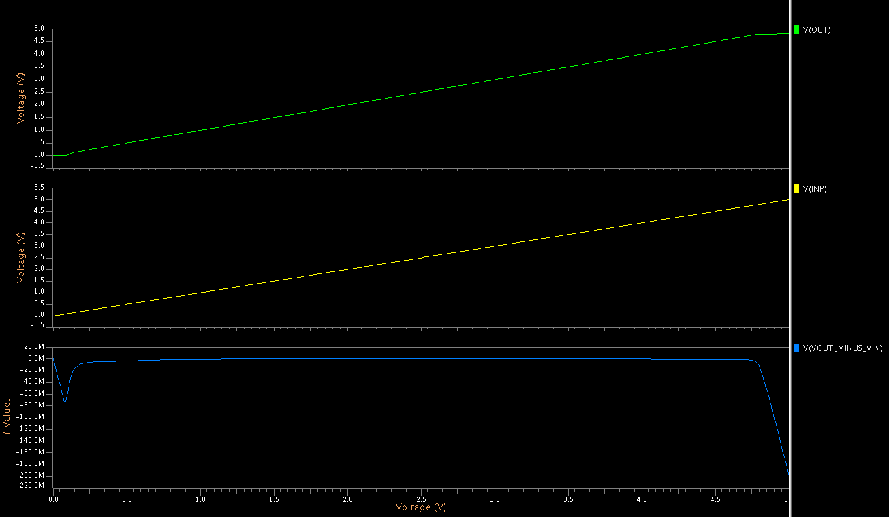

Common mode range is approximately 0.5 to 4.5 V

Here is my circuit schematic with all W/L ratios and component values:

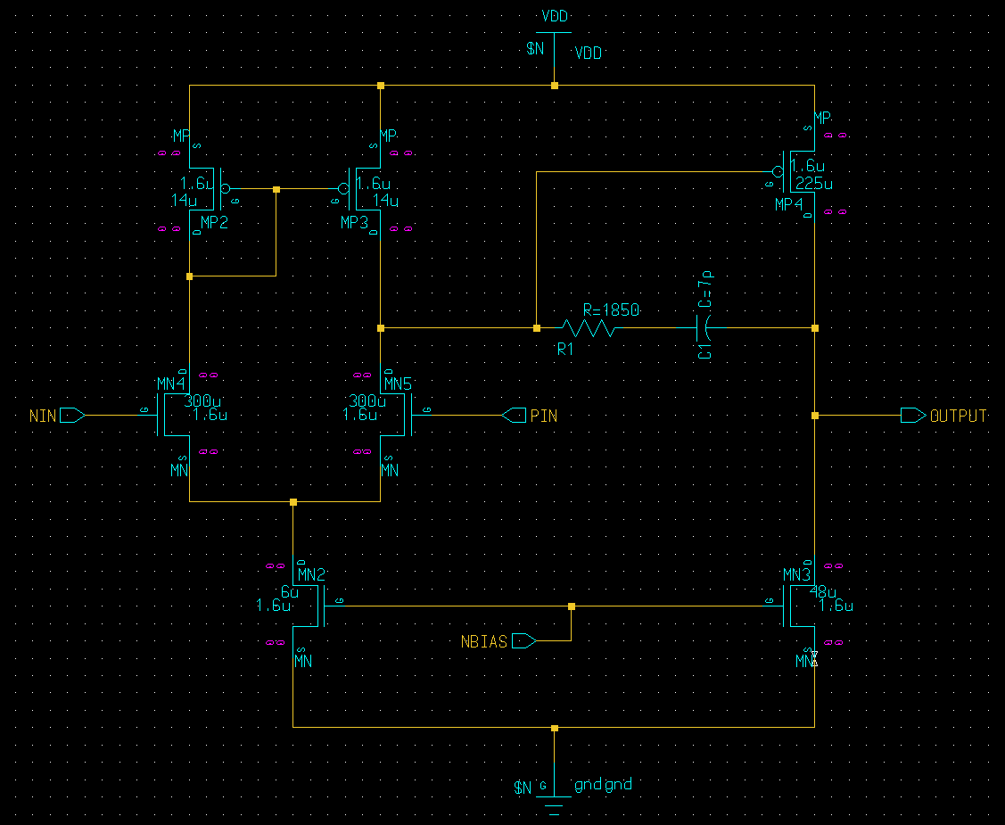

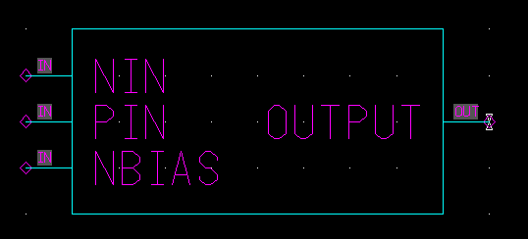

Here is my overall layout (common centroid close ups etc., on following pages):

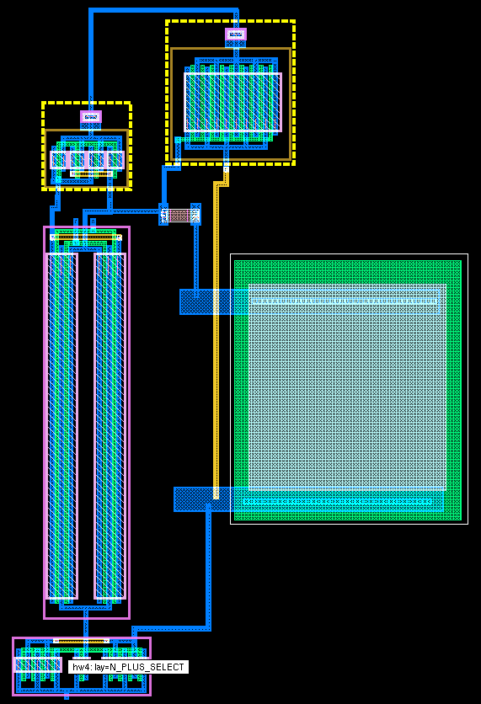

Output gain PMOS:

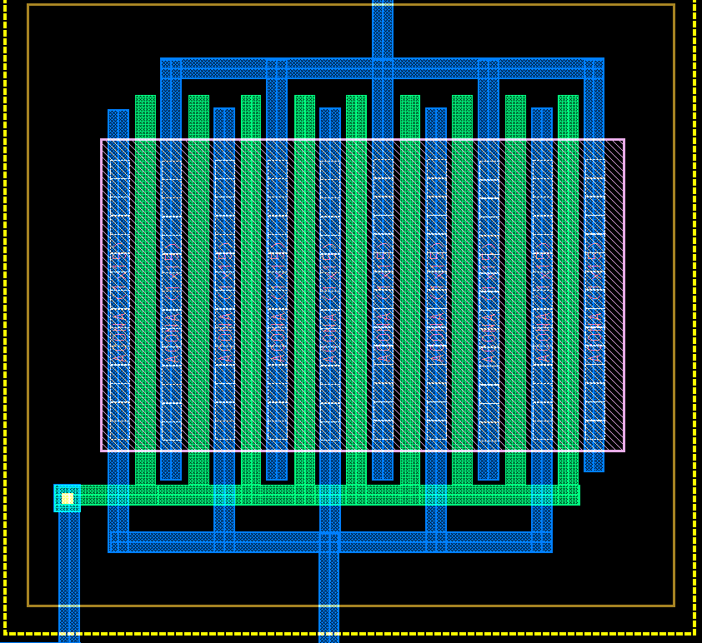

Common Centroid for PMOS current mirror active load:

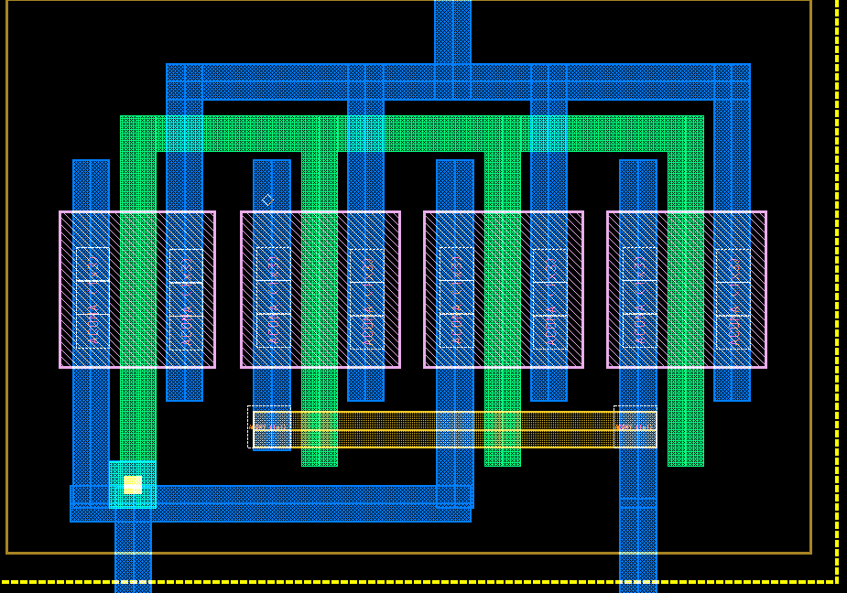

NMOS Differential Pair Common Centroid and MN2 / MN3 Common Centroid:

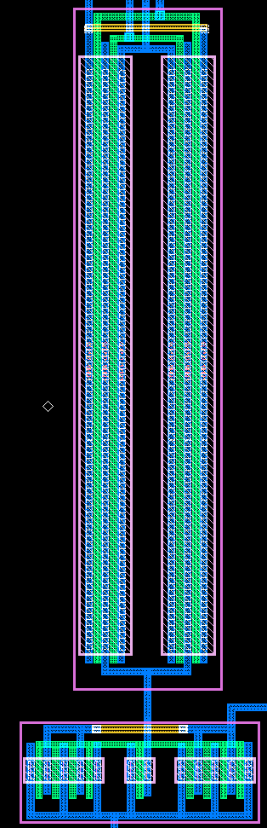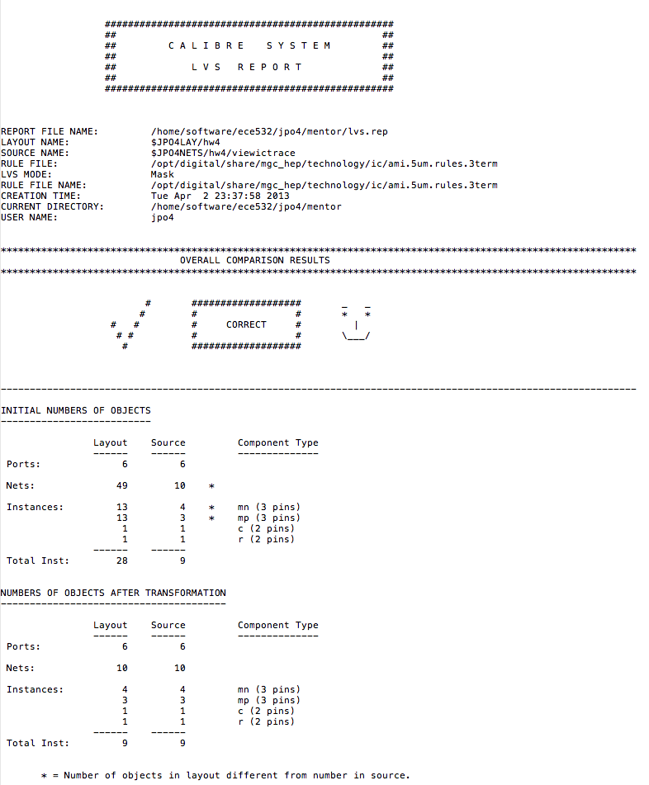**Number 2**

With this 50 mV step, the amplifier is near to critically damped, which makes sense considering the 70 degrees of phase margin; although it is just slightly over damped. (70 degrees is just slightly overdamped).

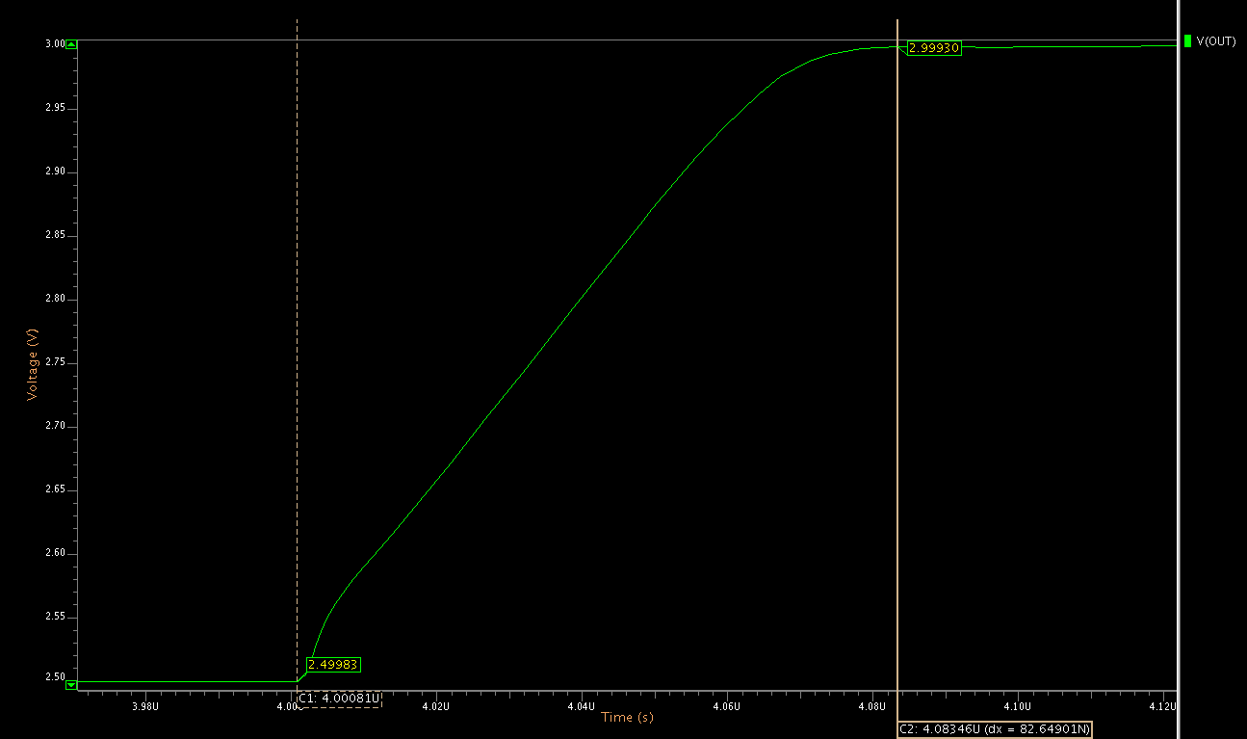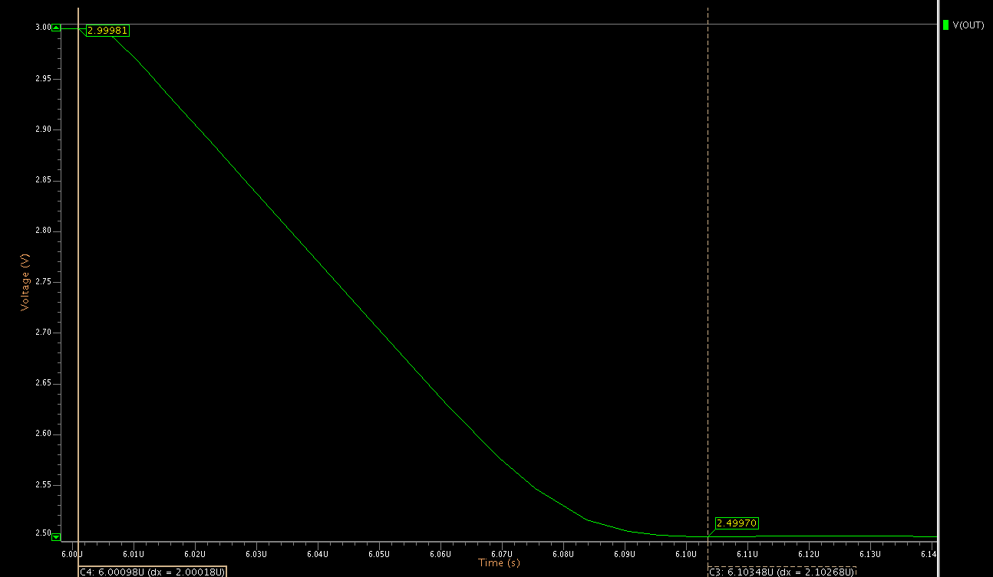

The positive settling time is 0.8 us

The negative settling time is 1.0 us

**Number 3**

0 degrees

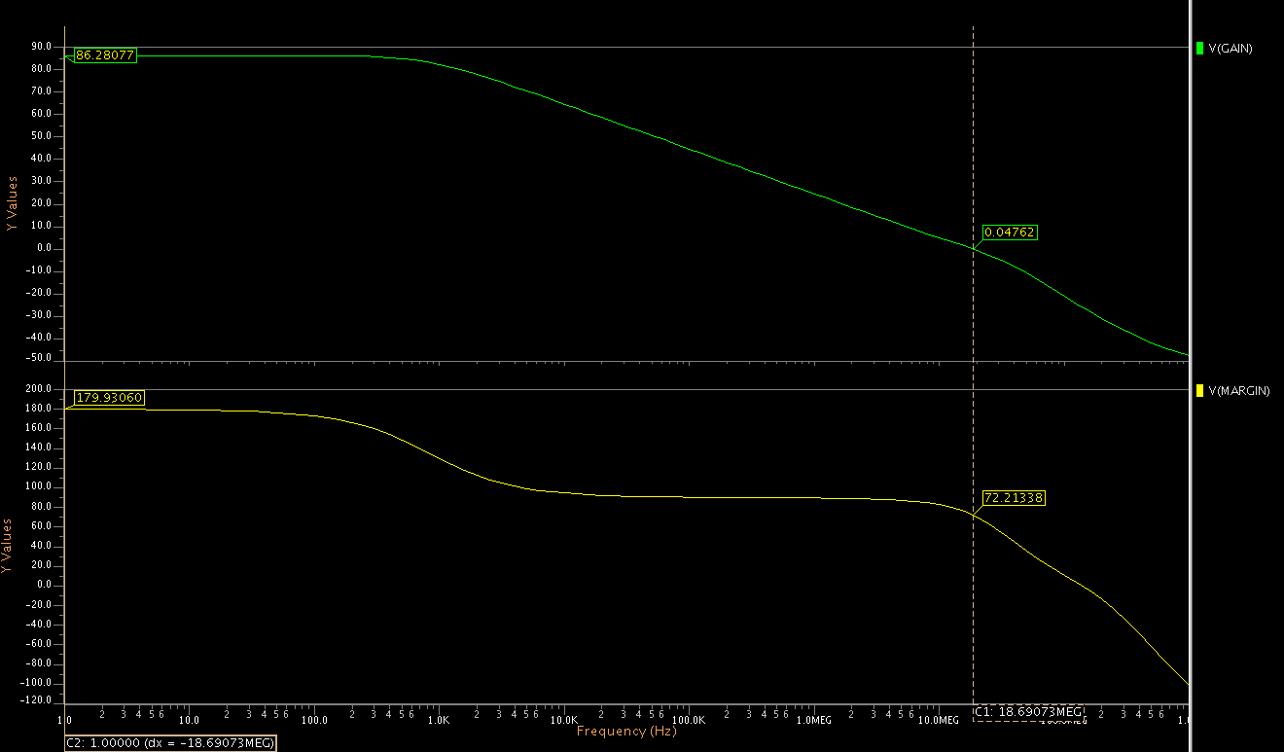

75 degrees

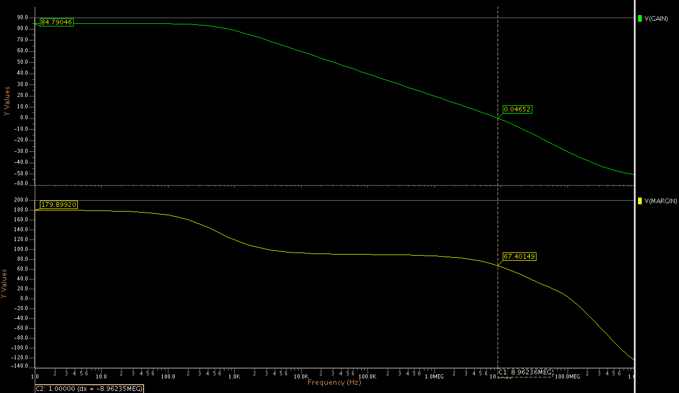

0 degrees

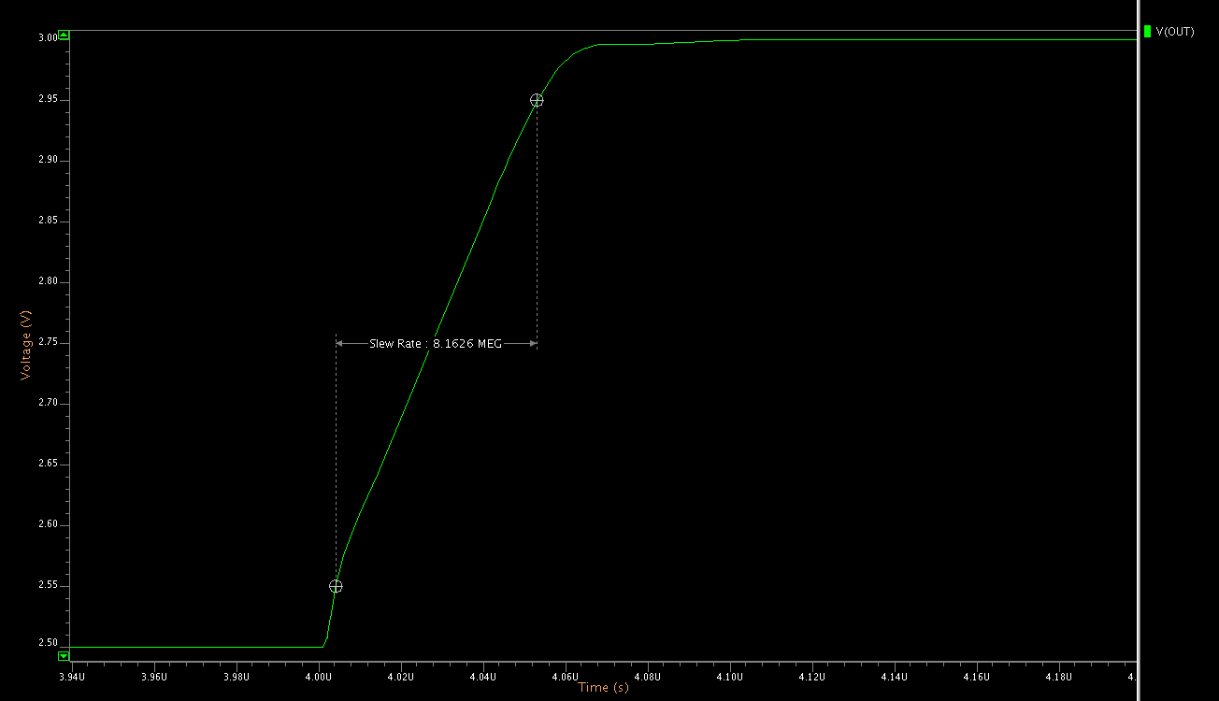

75 degrees

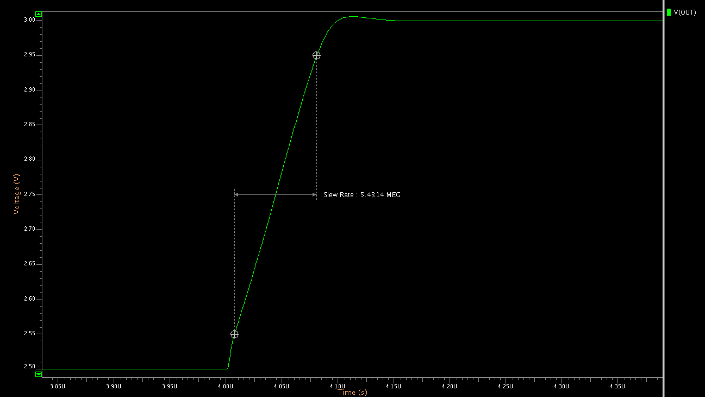

At 0 degrees C the BW, gain and phase margin are all improved.

At 75 degrees C they are all worse.

At 0 degrees C the slew rate improves (positive shown on previous page, negative is the same), at 75 degrees C it gets worse.

The common mode input range does not noticeably change.

Note that in the entire temperature range 0 – 75, my op amp still meets all the requirements.