Validation Results (GPU-MCML with MWC RNG vs. CPU-MCML with MT RNG)
7layerskin_600nm.mci
100M photons
GPUMCML_MWC vs. CPUMCML_MT  gpumcml/Fermi/sevenlayer_600nm_100M.mco VS.  cpumcml/ MT_RNG/sevenlayer_600nm_100M_run1.mco | CPUMCML_MWC vs CPUMCML_MWC  cpumcml/MWC_RNG/sevenlayer_600nm_100M_run1.mco VS.  cpumcml/ MWC_RNG/sevenlayer_600nm_100M_run2.mco
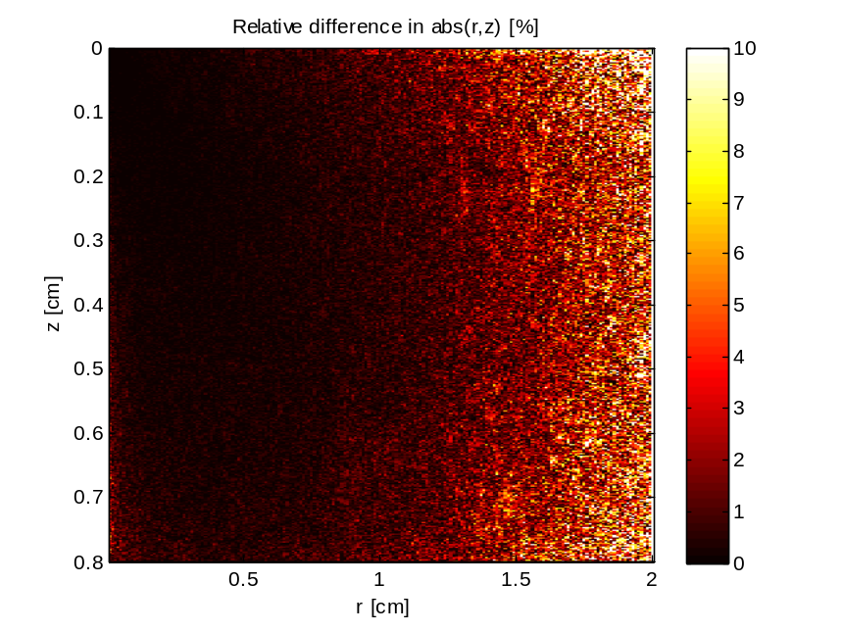 | 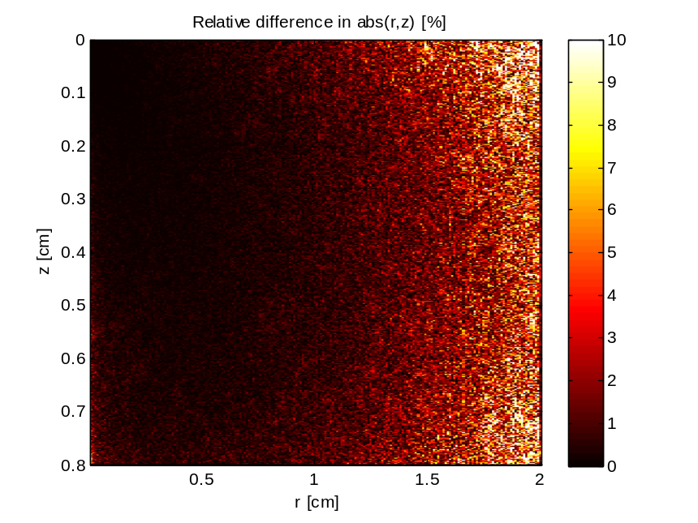

GPUMCML_MWC vs. CPUMCML_MT  gpumcml/Fermi/sevenlayer_600nm_100M.mco VS.  cpumcml/ MT_RNG/sevenlayer_600nm_100M_run2.mco | CPUMCML_MWC vs CPUMCML_MWC  cpumcml/MWC_RNG/sevenlayer_600nm_100M_run1.mco VS.  cpumcml/ MWC_RNG/sevenlayer_600nm_100M_run2.mco
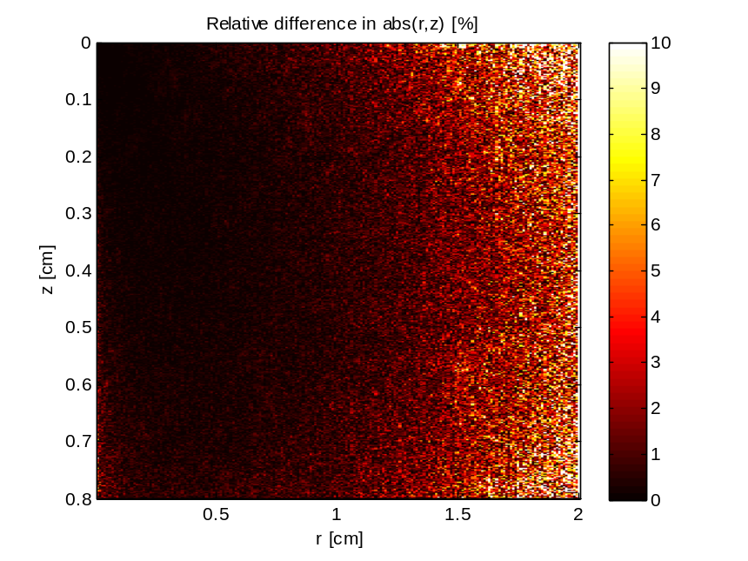

GPUMCML_MWC vs. CPUMCML_MT  gpumcml/Fermi/sevenlayer_600nm_100M.mco VS.  cpumcml/ MT_RNG/sevenlayer_600nm_100M_run3.mco | CPUMCML_MWC vs CPUMCML_MWC  cpumcml/MWC_RNG/sevenlayer_600nm_100M_run1.mco VS.  cpumcml/ MWC_RNG/sevenlayer_600nm_100M_run2.mco
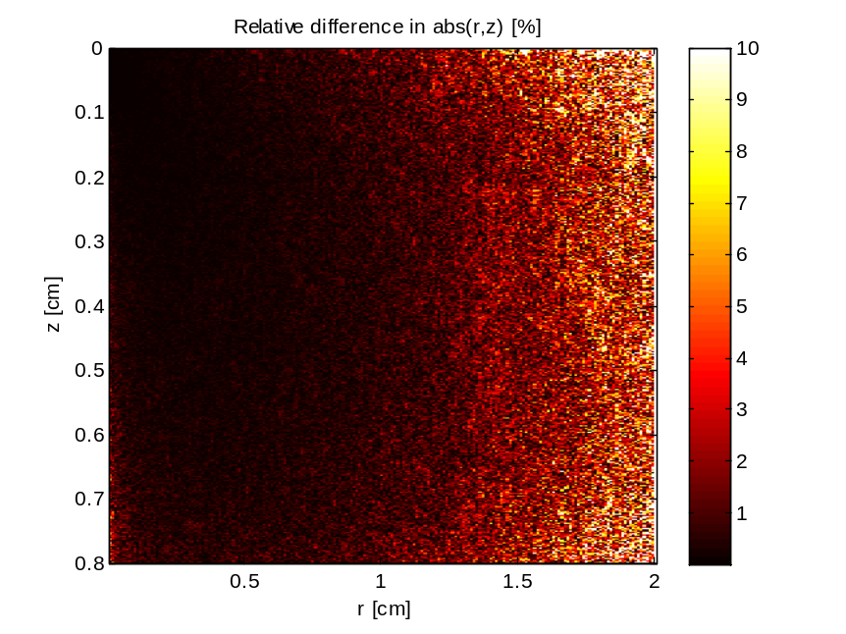

GPUMCML_MWC vs. CPUMCML_MT  gpumcml/Fermi/sevenlayer_600nm_100M.mco VS.  cpumcml/ MT_RNG/sevenlayer_600nm_100M_run3.mco | CPUMCML_MT vs CPUMCML_MT  cpumcml/MT_RNG/sevenlayer_600nm_100M_run1.mco VS.  cpumcml/ MT_RNG/sevenlayer_600nm_100M_run2.mco
 | 