Validation Results
7layerskin_600nm.mci
10M photons

GPUMCML vs. CPUMCML  gpumcml/sevenlayer_600nm_10M.mco VS. cpumcml/sevenlayer_600nm_10M_run1.mco | CPUMCML vs CPUMCML  cpumcml/sevenlayer_600nm_10M_run1.mco VS. cpumcml/sevenlayer_600nm_10M_run2.mco
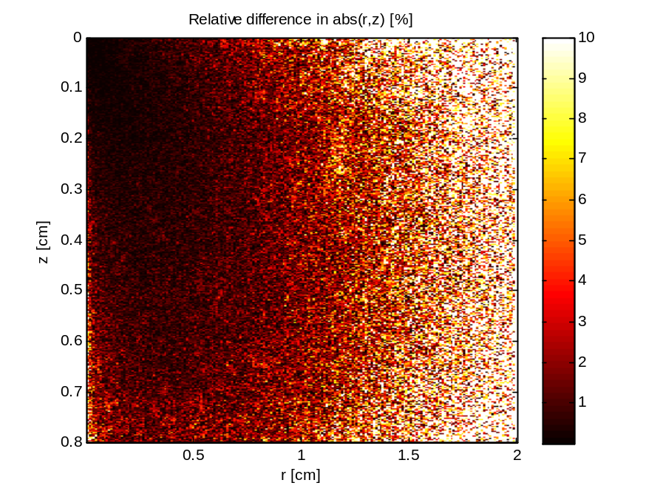 | 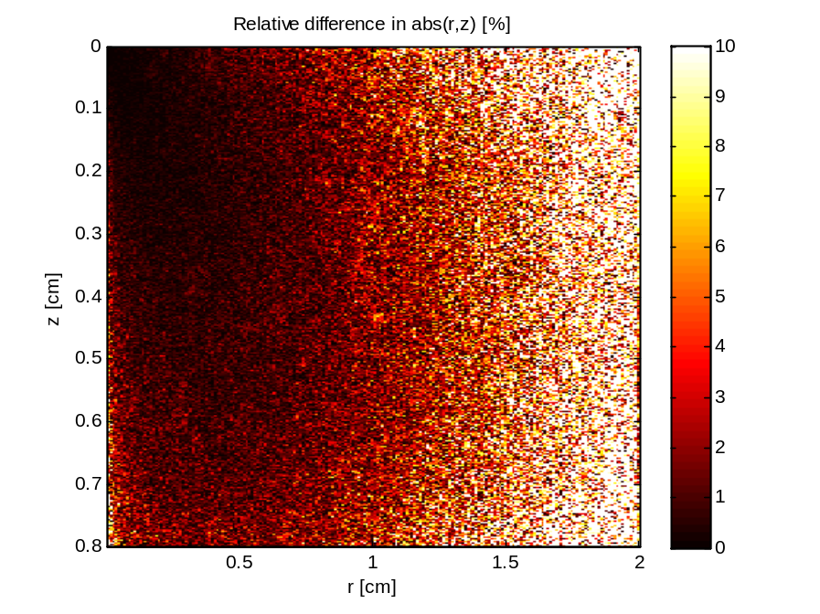
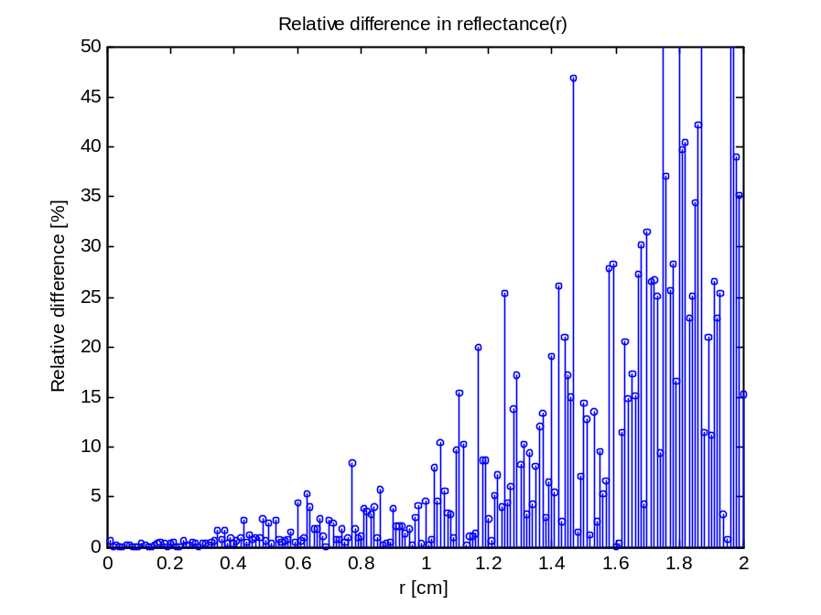 | 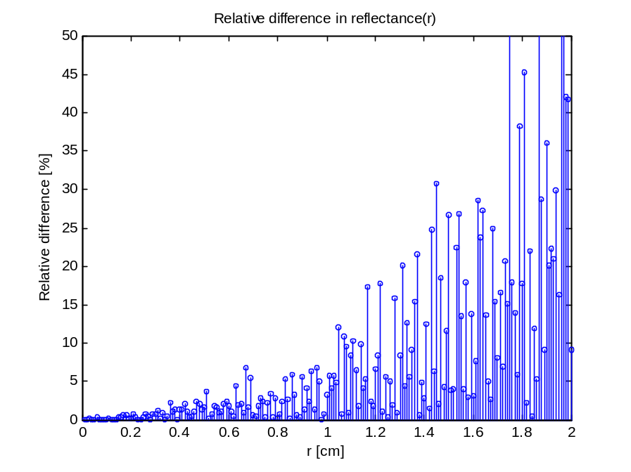
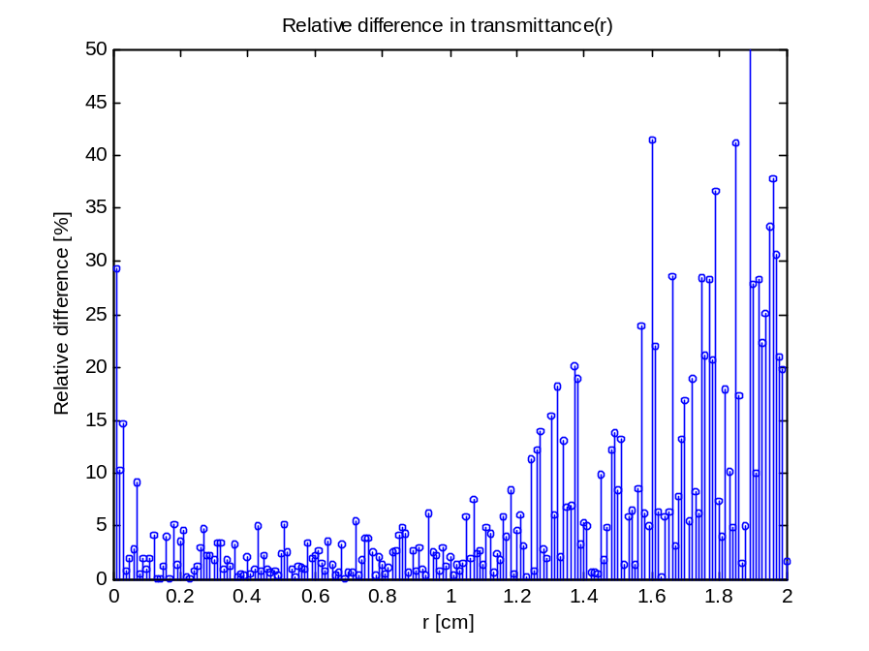 | 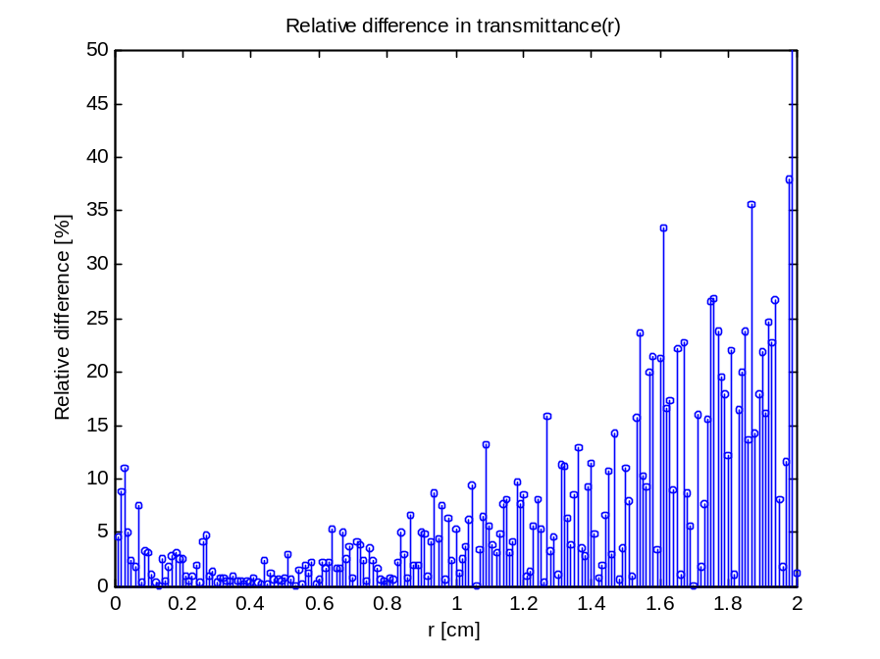

50M photons

GPUMCML vs. CPUMCML  gpumcml/sevenlayer_600nm_50M.mco VS. cpumcml/sevenlayer_600nm_50M_run1.mco | CPUMCML vs CPUMCML  cpumcml/sevenlayer_600nm_50M_run1.mco VS. cpumcml/ sevenlayer_600nm_50M_run2.mco
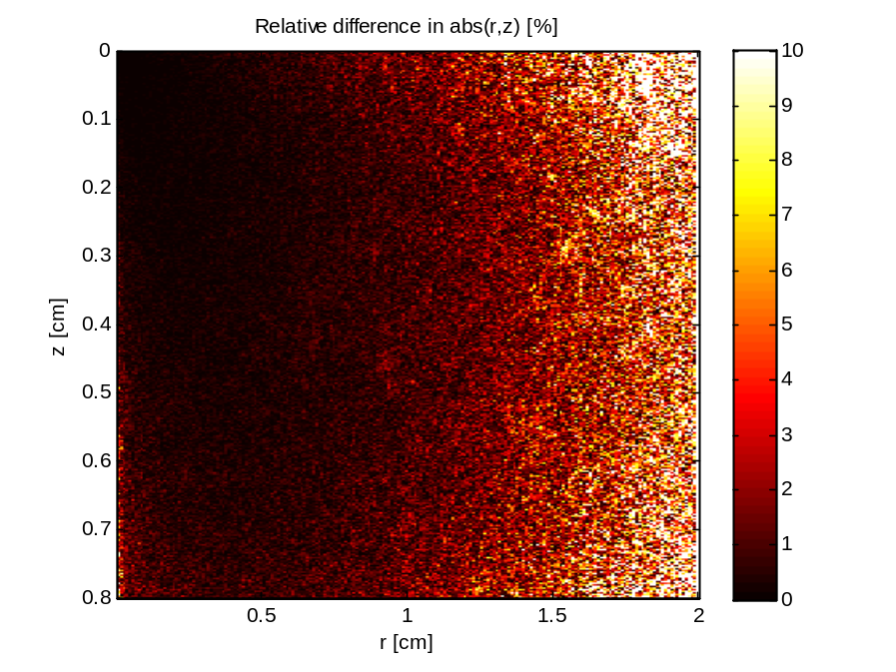 | 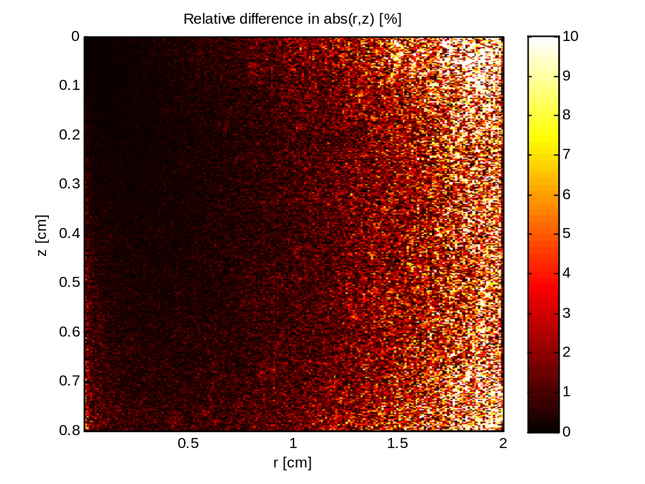
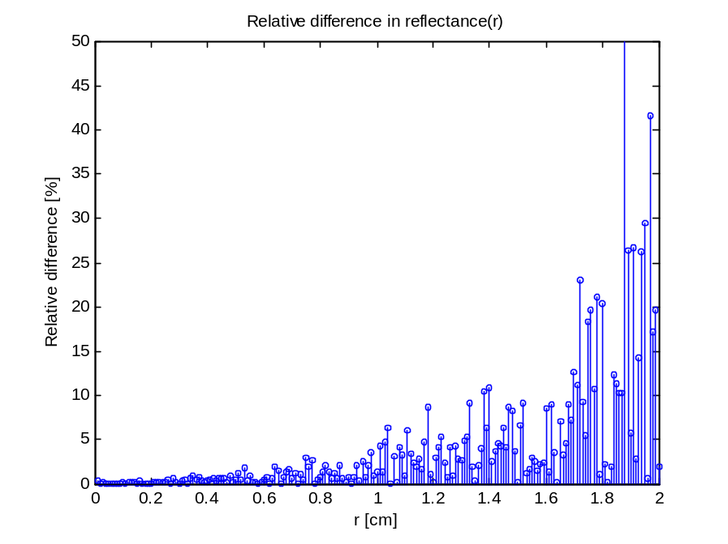 | 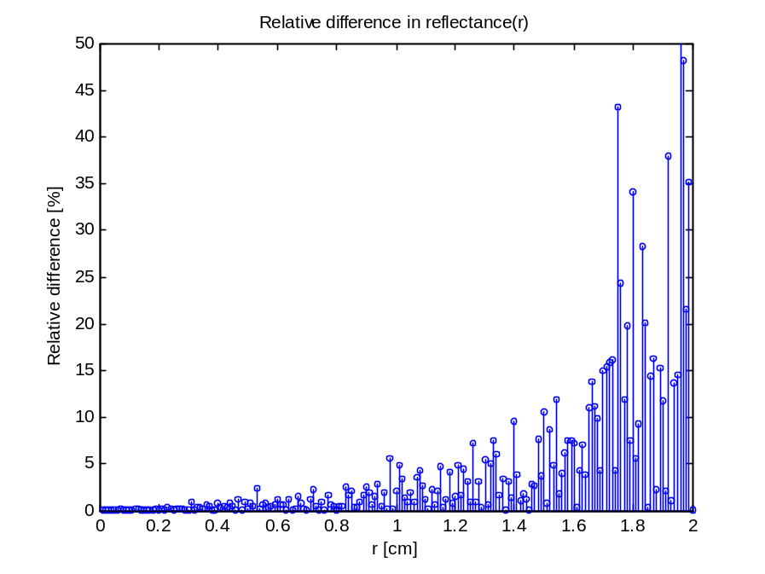
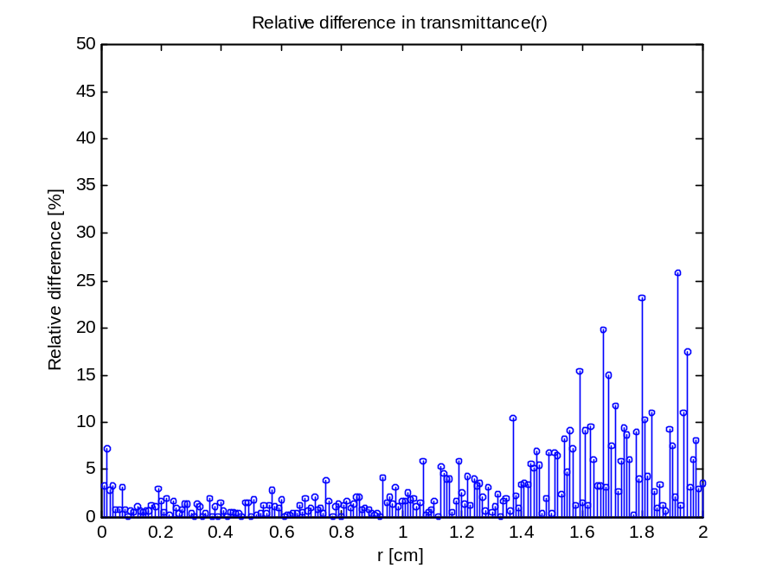 | 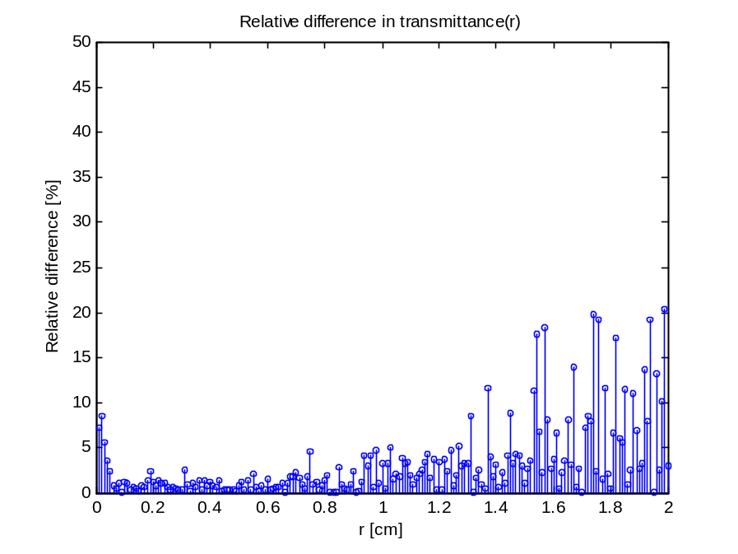
100M photons

GPUMCML vs. CPUMCML  gpumcml/sevenlayer_600nm_100M.mco VS. cpumcml/sevenlayer_600nm_100M_run1.mco | CPUMCML vs CPUMCML  cpumcml/sevenlayer_600nm_100M_run1.mco VS. cpumcml/sevenlayer_600nm_100M_run2.mco
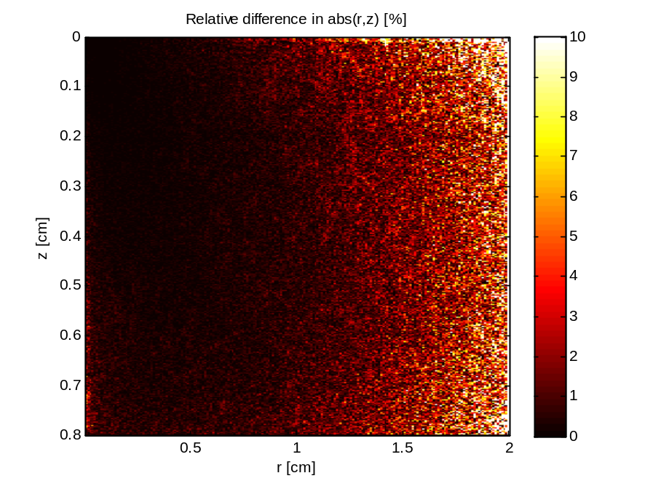 | 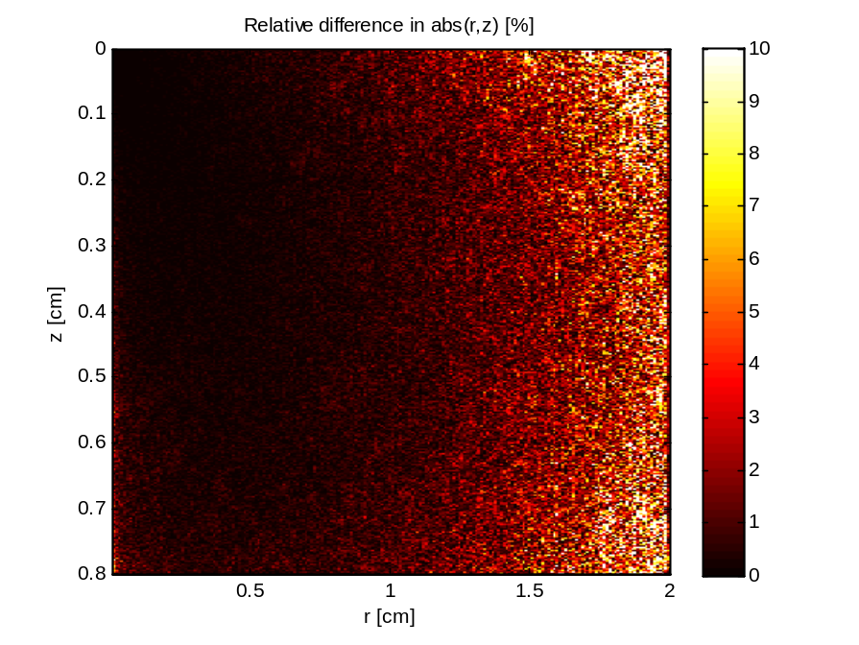
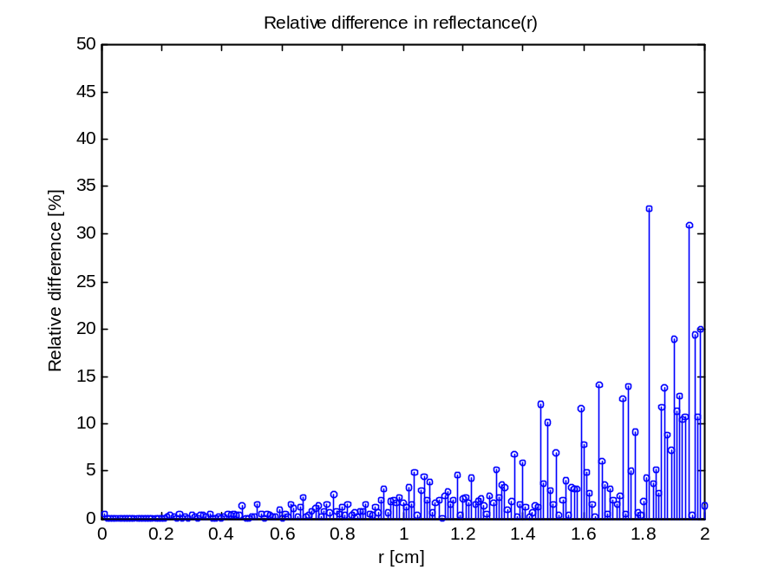 | 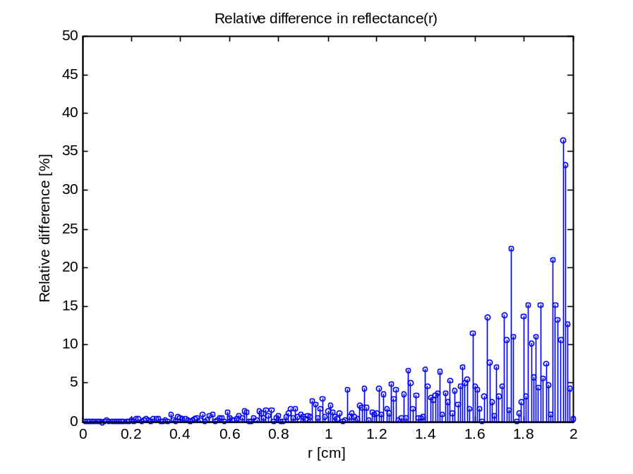
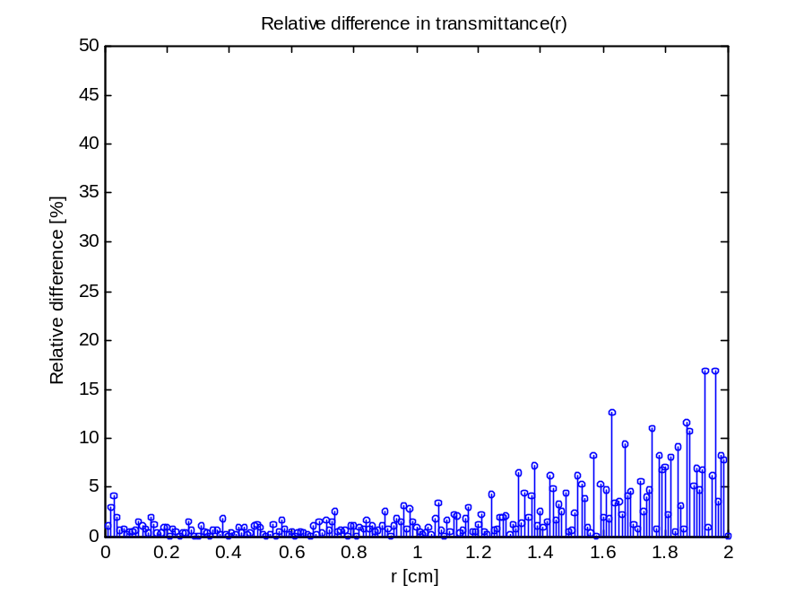 | 