Validation Results on Fermi
7layerskin_600nm.mci
File Descriptions

- Default optimizations: 23.02s
- sevenlayer_600nm_100M.mco

- Enable USE_TRUE_CACHE (4 copies of A_rz): 55.70s
- sevenlayer_600nm_100M.true_cache_4.mco

- Enable USE_TRUE_CACHE (8 copies of A_rz): 47.89s
- sevenlayer_600nm_100M.true_cache_8.mco

- Enable USE_TRUE_CACHE (15 copies of A_rz): 48.79s
- sevenlayer_600nm_100M.true_cache_15.mco

- Use 32-bit elem for A_rz in smem: 33.13s
- sevenlayer_600nm_100M.32b_smem.mco

- Cache a 64x96 region of A_rz in smem (4 copies of A_rz): 26.33s
- sevenlayer_600nm_100M.64_96_4.mco

- Cache a 64x96 region of A_rz in smem (8 copies of A_rz): 27.25s
- sevenlayer_600nm_100M.64_96_8.mco

- Use 40 regs per thread and 768 threads per block: 23.45s
- sevenlayer_600nm_100M.40r768t.mco

100M photons

GPUMCML vs. CPUMCML  gpumcml/Fermi/sevenlayer_600nm_100M.mco VS. cpumcml/sevenlayer_600nm_100M_run1.mco | CPUMCML vs CPUMCML  cpumcml/sevenlayer_600nm_100M_run1.mco VS. cpumcml/sevenlayer_600nm_100M_run2.mco
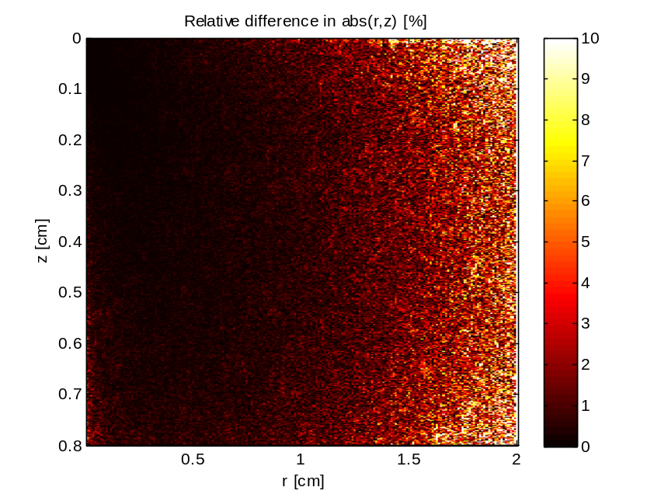 | 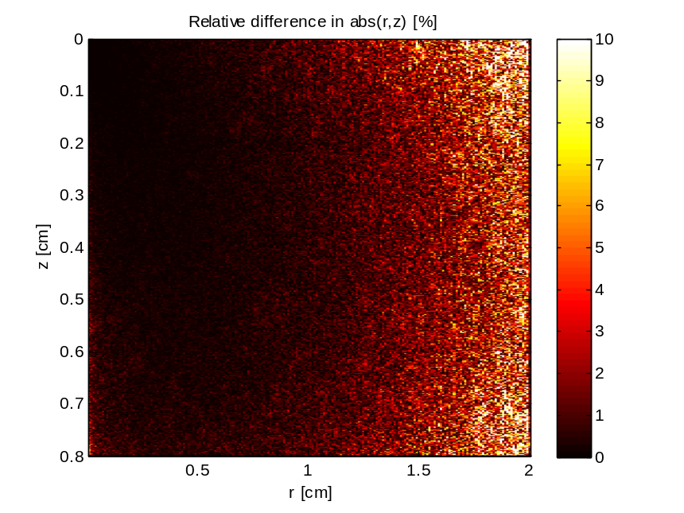

GPUMCML vs. CPUMCML  gpumcml/Fermi/sevenlayer_600nm_100M.32b_smem VS. cpumcml/sevenlayer_600nm_100M_run1.mco | CPUMCML vs CPUMCML  cpumcml/sevenlayer_600nm_100M_run1.mco VS. cpumcml/sevenlayer_600nm_100M_run2.mco
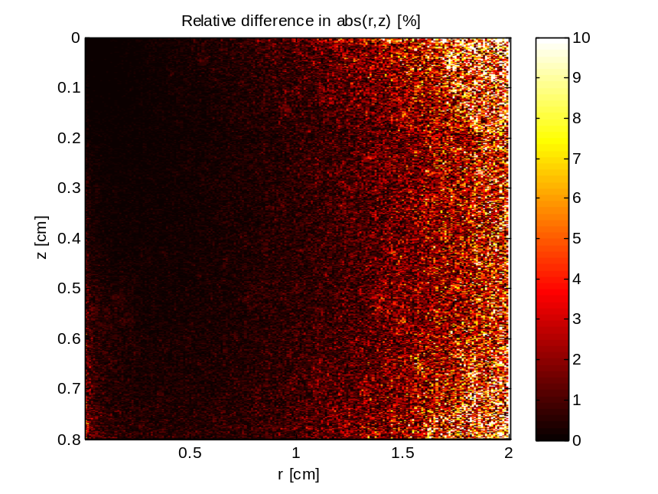

GPUMCML vs. CPUMCML  gpumcml/Fermi/sevenlayer_600nm_100M.40r768t VS. cpumcml/sevenlayer_600nm_100M_run1.mco | CPUMCML vs CPUMCML  cpumcml/sevenlayer_600nm_100M_run1.mco VS. cpumcml/sevenlayer_600nm_100M_run2.mco
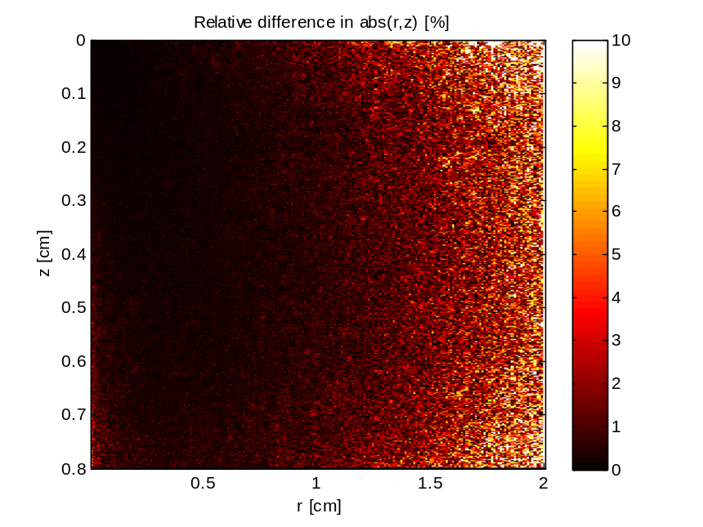

GPUMCML vs. CPUMCML  gpumcml/Fermi/sevenlayer_600nm_100M.64_96_4 VS. cpumcml/sevenlayer_600nm_100M_run1.mco | CPUMCML vs CPUMCML  cpumcml/sevenlayer_600nm_100M_run1.mco VS. cpumcml/sevenlayer_600nm_100M_run2.mco
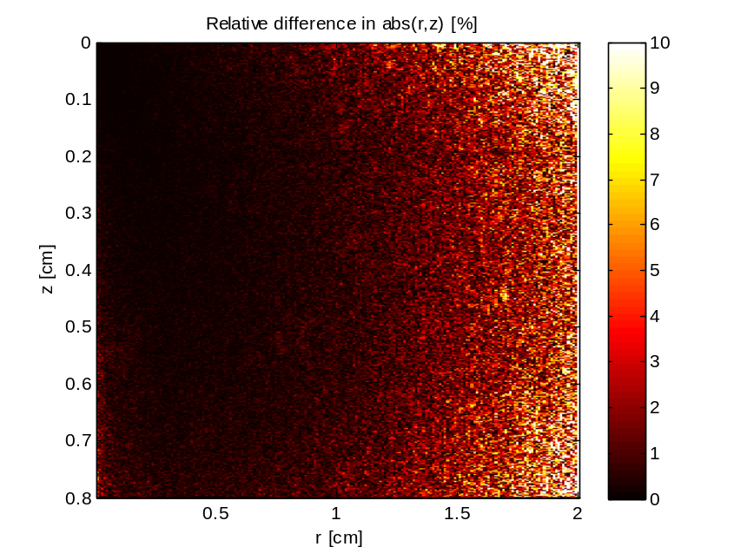

GPUMCML vs. CPUMCML  gpumcml/Fermi/sevenlayer_600nm_100M.64_96_8 VS. cpumcml/sevenlayer_600nm_100M_run1.mco | CPUMCML vs CPUMCML  cpumcml/sevenlayer_600nm_100M_run1.mco VS. cpumcml/sevenlayer_600nm_100M_run2.mco
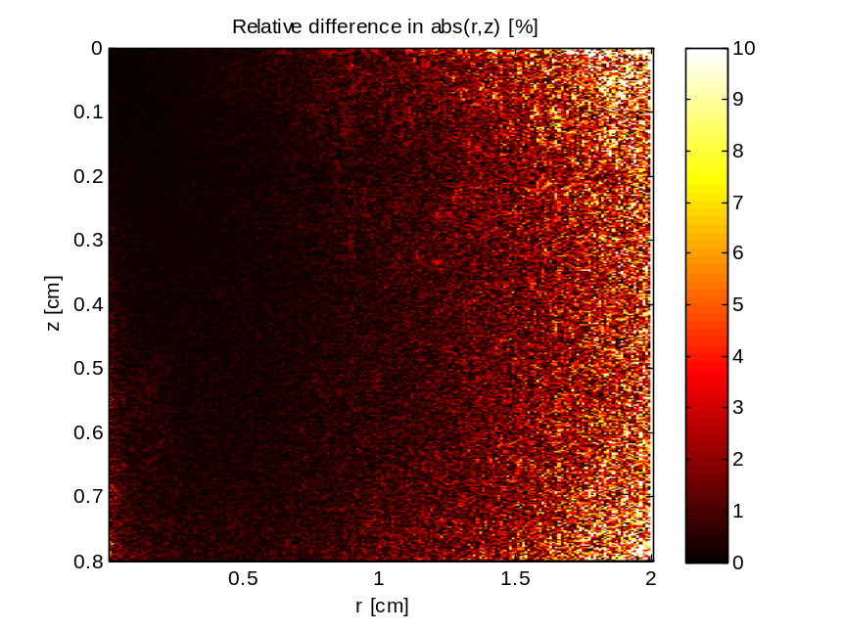

GPUMCML vs. CPUMCML  gpumcml/Fermi/sevenlayer_600nm_100M.64_96_8 VS. cpumcml/sevenlayer_600nm_100M_run1.mco | CPUMCML vs CPUMCML  cpumcml/sevenlayer_600nm_100M_run1.mco VS. cpumcml/sevenlayer_600nm_100M_run2.mco

GPUMCML vs. CPUMCML  gpumcml/Fermi/sevenlayer_600nm_100M.true_cache_4 VS. cpumcml/sevenlayer_600nm_100M_run1.mco | CPUMCML vs CPUMCML  cpumcml/sevenlayer_600nm_100M_run1.mco VS. cpumcml/sevenlayer_600nm_100M_run2.mco
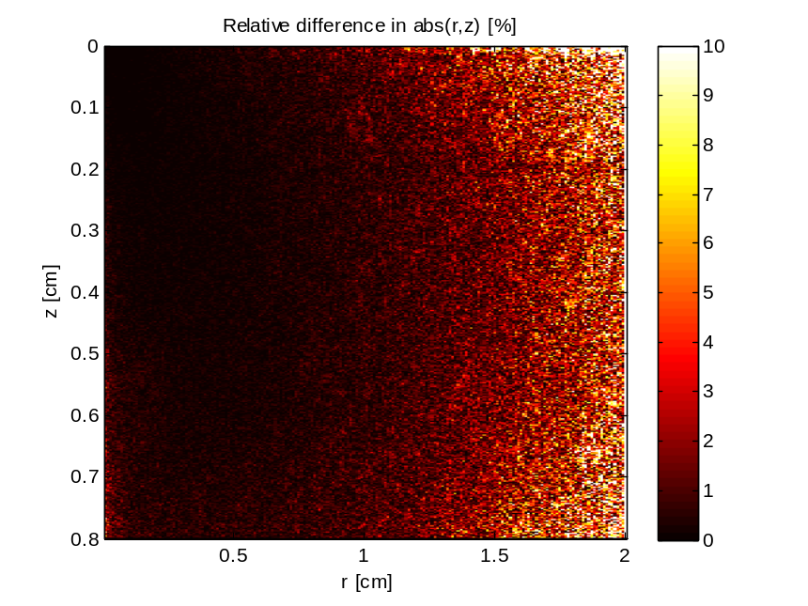

GPUMCML vs. CPUMCML  gpumcml/Fermi/sevenlayer_600nm_100M.true_cache_8 VS. cpumcml/sevenlayer_600nm_100M_run1.mco | CPUMCML vs CPUMCML  cpumcml/sevenlayer_600nm_100M_run1.mco VS. cpumcml/sevenlayer_600nm_100M_run2.mco
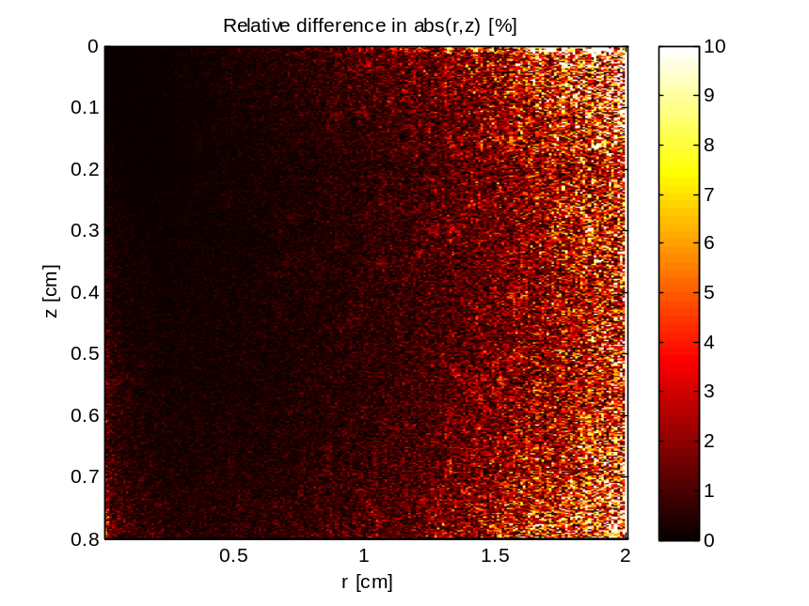

GPUMCML vs. CPUMCML  gpumcml/Fermi/sevenlayer_600nm_100M.true_cache_15 VS. cpumcml/sevenlayer_600nm_100M_run1.mco | CPUMCML vs CPUMCML  cpumcml/sevenlayer_600nm_100M_run1.mco VS. cpumcml/sevenlayer_600nm_100M_run2.mco
