Validation Results on Fermi
7layerskin_600nm.mci
100M photons

GPUMCML vs. CPUMCML  gpumcml/Fermi/sevenlayer_600nm_100M.mco VS. cpumcml/sevenlayer_600nm_100M_run1.mco | CPUMCML vs CPUMCML  cpumcml/sevenlayer_600nm_100M_run1.mco VS. cpumcml/sevenlayer_600nm_100M_run2.mco
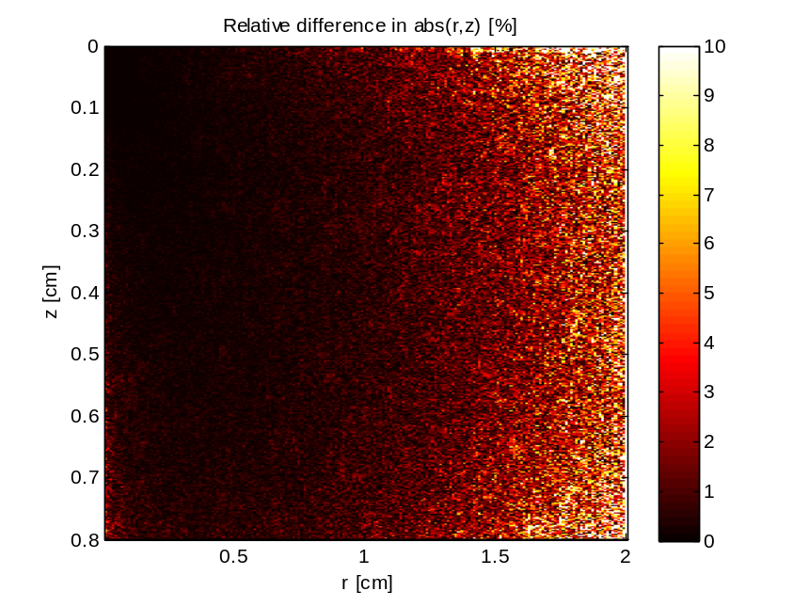 | 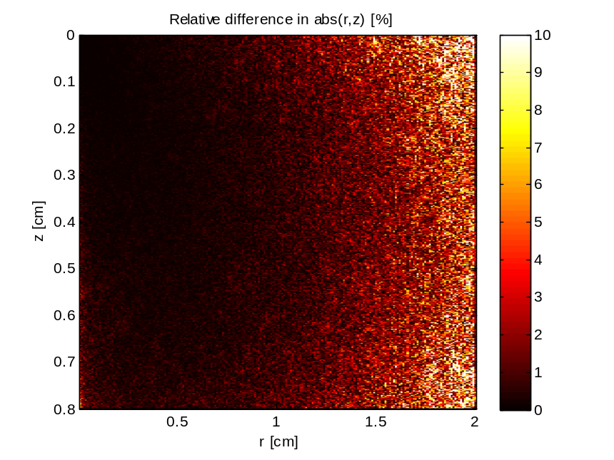

GPUMCML vs. CPUMCML  gpumcml/Fermi/sevenlayer_600nm_100M.32b_smem VS. cpumcml/sevenlayer_600nm_100M_run1.mco | CPUMCML vs CPUMCML  cpumcml/sevenlayer_600nm_100M_run1.mco VS. cpumcml/sevenlayer_600nm_100M_run2.mco
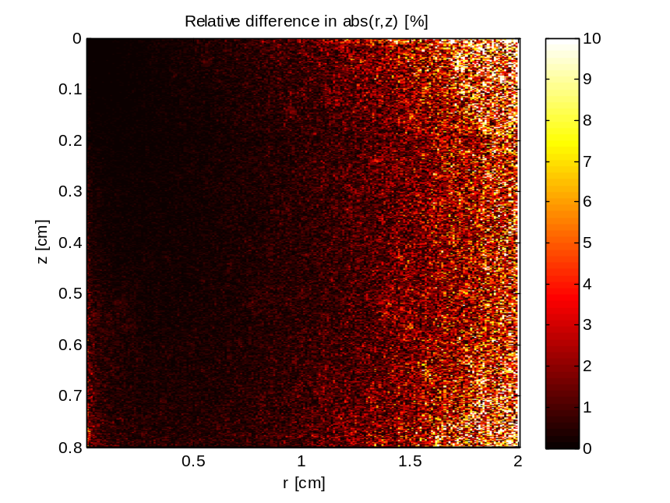

GPUMCML vs. CPUMCML  gpumcml/Fermi/sevenlayer_600nm_100M.40r768t VS. cpumcml/sevenlayer_600nm_100M_run1.mco | CPUMCML vs CPUMCML  cpumcml/sevenlayer_600nm_100M_run1.mco VS. cpumcml/sevenlayer_600nm_100M_run2.mco
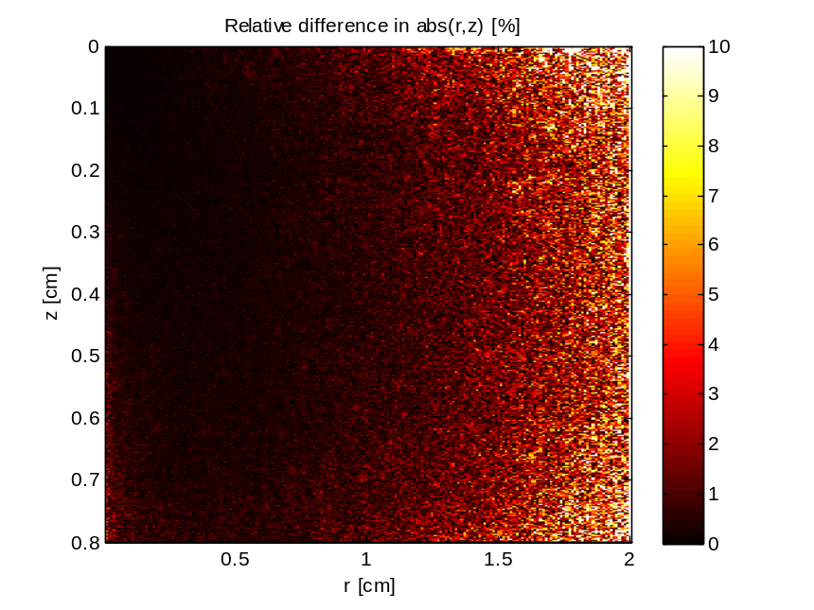

GPUMCML vs. CPUMCML  gpumcml/Fermi/sevenlayer_600nm_100M.64_96_4 VS. cpumcml/sevenlayer_600nm_100M_run1.mco | CPUMCML vs CPUMCML  cpumcml/sevenlayer_600nm_100M_run1.mco VS. cpumcml/sevenlayer_600nm_100M_run2.mco
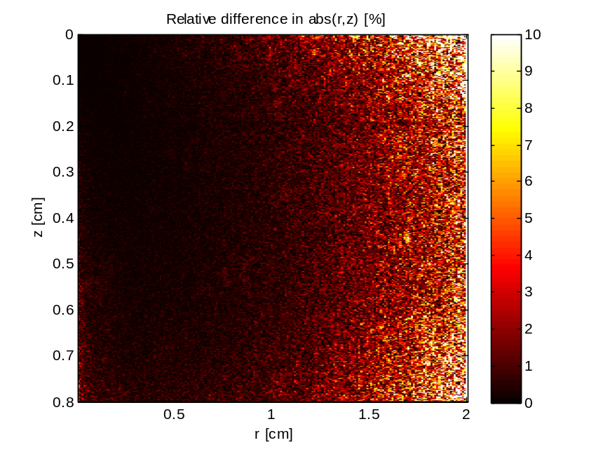

GPUMCML vs. CPUMCML  gpumcml/Fermi/sevenlayer_600nm_100M.64_96_8 VS. cpumcml/sevenlayer_600nm_100M_run1.mco | CPUMCML vs CPUMCML  cpumcml/sevenlayer_600nm_100M_run1.mco VS. cpumcml/sevenlayer_600nm_100M_run2.mco
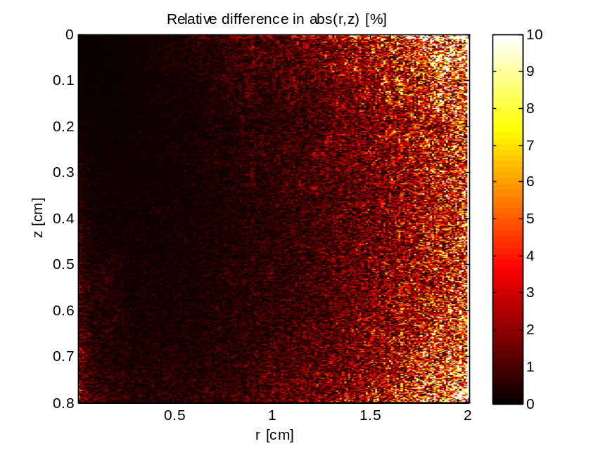

GPUMCML vs. CPUMCML  gpumcml/Fermi/sevenlayer_600nm_100M.64_96_8 VS. cpumcml/sevenlayer_600nm_100M_run1.mco | CPUMCML vs CPUMCML  cpumcml/sevenlayer_600nm_100M_run1.mco VS. cpumcml/sevenlayer_600nm_100M_run2.mco

GPUMCML vs. CPUMCML  gpumcml/Fermi/sevenlayer_600nm_100M.true_cache_4 VS. cpumcml/sevenlayer_600nm_100M_run1.mco | CPUMCML vs CPUMCML  cpumcml/sevenlayer_600nm_100M_run1.mco VS. cpumcml/sevenlayer_600nm_100M_run2.mco
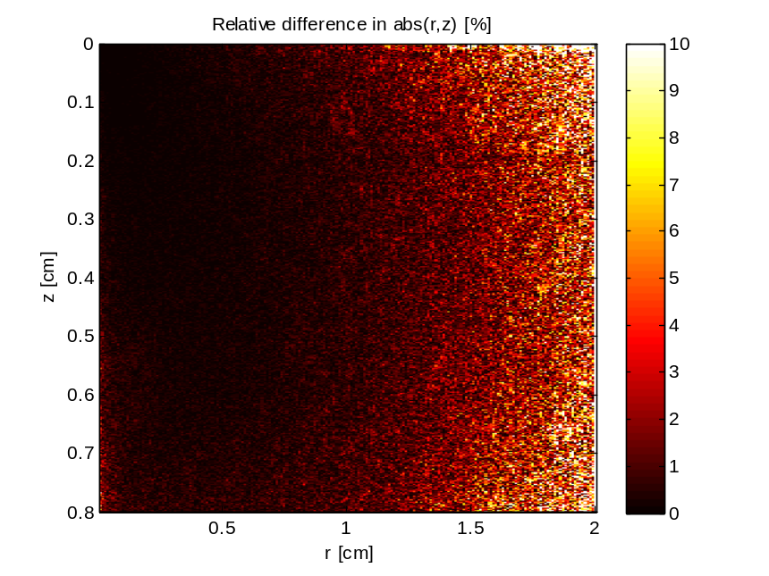

GPUMCML vs. CPUMCML  gpumcml/Fermi/sevenlayer_600nm_100M.true_cache_8 VS. cpumcml/sevenlayer_600nm_100M_run1.mco | CPUMCML vs CPUMCML  cpumcml/sevenlayer_600nm_100M_run1.mco VS. cpumcml/sevenlayer_600nm_100M_run2.mco
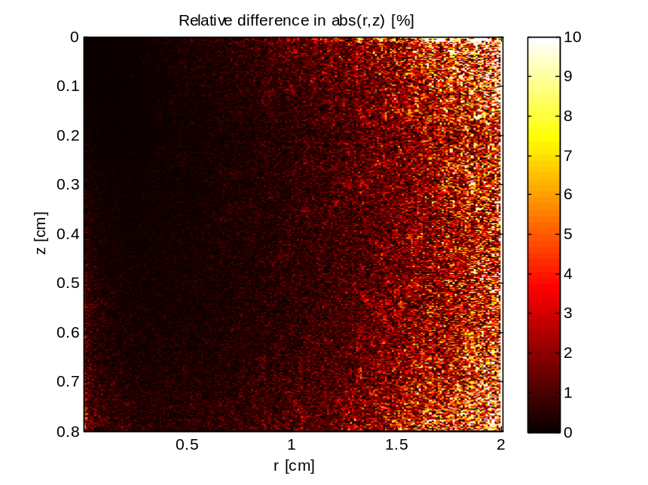

GPUMCML vs. CPUMCML  gpumcml/Fermi/sevenlayer_600nm_100M.true_cache_15 VS. cpumcml/sevenlayer_600nm_100M_run1.mco | CPUMCML vs CPUMCML  cpumcml/sevenlayer_600nm_100M_run1.mco VS. cpumcml/sevenlayer_600nm_100M_run2.mco
