EE 525 Project 3
10-bit Multiplier Design
3-12-10

Team AN:
Nathaniel McVicar
Corey Olson

Delay: 953 ps
Energy: 4.74 pJ per operation
FOM: 4.303 ns^2 * pJ

Table of Contents
Introduction 3
Specifications 3
Analytical Approach 3
Design Features 6
Design Features 6
Top Level 6
Booth Encoder 6
Compressor 7
Adder 8
Clock Buffers 9
Clock Delay 10
Output Buffer 11
Verification 12
Critical Path 12
Analysis 12
Simulation 12
Functional Simulation 12
References 12

Introduction

The goal of this project was to design a 10-bit multiplier using the NCSU Free 45nm PDK. The multiplier should be fast, with low energy per operation as a secondary goal. To accomplish these goals, we are using design and simulation tools from the cadence design suite along with the HSPICE simulator. We will design a multiplier to multiply two 10-bit signed numbers with delay and power in mind, draw the schematic to simulate functionality and adjust transistor sizing for maximum performance. In addition to the required testing and verification for this project, we will attempt to improve our multiplier’s performance even further using pipelining techniques.

Specifications

This competitive project will be ranked upon the figure of merit shown in Equation 1 for all designs that meet the following specifications.

FOM = Energy * Delay²
Equation 1: Figure of Merit Calculation

- 10 bit operands a and b will be multiplied to form the 20 bit output p
- Use FreePDK45 VTG transistors
- Must use modified Booth to generate the partial products and a tree to compress them
- Each output bit must drive a 50fF capacitive load, added in the simulation file
- Each input bit must be driven by a minimum sized buffer, which is added in the simulation file, with a rise time of 20ps at the input
- Inputs
  - Operand A and complement: a[9:0], _a[9:0]
  - Operand B and complement: b[9:0], _b[9:0]
  - A clock with a rise time of 20 ps and a maximum delay of 30 ps from the inputs: clk
- Worst case precharge time may be only 100 ps greater than worst case delay
- Outputs
  - 20 bit product: p[19:0]
- Maximum operating voltage: VDD=1.2V
- Delays are measured from 50% of the rising edge of the clock to 50% of the rising edge of the output with a 50fF capacitive load
- Tests must be run using a vector stimulus file

Analytical Approach

The goal of this project was to produce a fast multiplier while also trying to minimize the power consumed. For our design we choose to focus primarily on delay, with power being a secondary concern. The design of a multiplier is complex because a fast multiplier requires many separate logical stages. This project simplified the design step somewhat by requiring modified Booth partial product generation and a tree compressor for the resulting partial products. The primary design decision remaining was the style of adder used for the final addition.

For the modified Booth partial product generation, we choose to use dynamic logic because minimizing delay was paramount. Modified Booth lends itself very well to this design because there are no inverting stages, and inverted inputs are provided. Because XORs are difficult for dynamic logic our Booth encoder used a slightly modified system that generates a POS signal in addition to the traditional NEG signal (often called M) [1]. This method, in conjunction with a selector that required no inversions [2] simplified the dynamic implementation immensely and reduced delay.

Because we used a non-inverting domino logic family, it is very difficult to invert inputs to gates. For this reason we required a booth encoder that didn’t rely on an XOR with the negative signal. In order to achieve this, we used the following equation which makes use of the POS signal mentioned above. Note that POS and NEG must both be true in the -0 case and false in the +0 case. Also, inverted y’s are available as inputs.

A compression tree was used to reduce the number of partial products that must be summed by the adder down to two vectors. The goal of the compression tree is to compress the partial products as quickly as possible and pass them along to the adder. We therefore implemented a dynamic hybrid compression tree to give us the fastest results possible. This was accomplished in two stages by using some (5,5,4) compression blocks. Unfortunately many XORs need to be computed during the compression, so inverted inputs are required, in order to avoid early dynamic node discharging. The output of the Booth encoding doesn’t provide inverted inputs, so they were generated through a dynamic inverter. To properly precharge and evaluate the input values with the dynamic inverter, the data must be stable at the inputs to the compression before the rising edge of the clock. To do this, the clock to the dynamic inverters is delayed by the maximum delay through the Booth partial product generator.

Because of the nature of the tree compression scheme and the fact that there are more partial product bits with middle weights, the bits with middle significance are the last to arrive at the final addition stage. This means that to minimize delay, the final adder must be able to compute all of the bits in the second half (the most significant bits) of the addition very quickly. A select adder is very well suited to this delay profile because the additional delay for the bits after the central delay peak can be limited to only a single multiplexer.

For the non-select portion of the adder, we chose to use a spanning-tree adder with radix-4 cells. The tree has only three nodes, and these are arranged in a near Brent-Kung manner. The addition of each group is performed by a Manchester carry chain of length 4. This adder is very fast and small (power efficient) for small numbers of bits because it only requires at most 2 logic levels followed by a single Manchester carry chain. Each spanning-tree adder adds 10-bits, since this is near the peak in the delay profile and also means that all final bits can be computed by two adders. The first adder is completely standard, and handles the least significant 10 bits. The second adder is actually two adders with their outputs selected by a mux, depending on which carry bit arrives from the first adder. For optimal performance the carry select adder must begin after peak delay.

For the final adder implementation, we choose to use dynamic logic for speed. Unfortunately, the sum generation and multiplexed output is very difficult to implement purely in dynamic logic, since generating inverted input to gates is impossible without resorting to dual-rail domino, clock delay or other complex schemes. For this reason, the XOR is implemented using a dynamic AND and OR followed by a static NOR [3], and the output multiplexer uses transmission gate logic. Finally, output buffering is required to drive the large output capacitance, especially because of the use of transmission gates.

Design Features

Top Level

The top level design of our multiplier has three main modules and some extraneous buffers as shown in Figure 1. The main modules are the booth encoder, the compressor, and the adder. These main modules are all implemented in dynamic logic to provide the optimal speed.

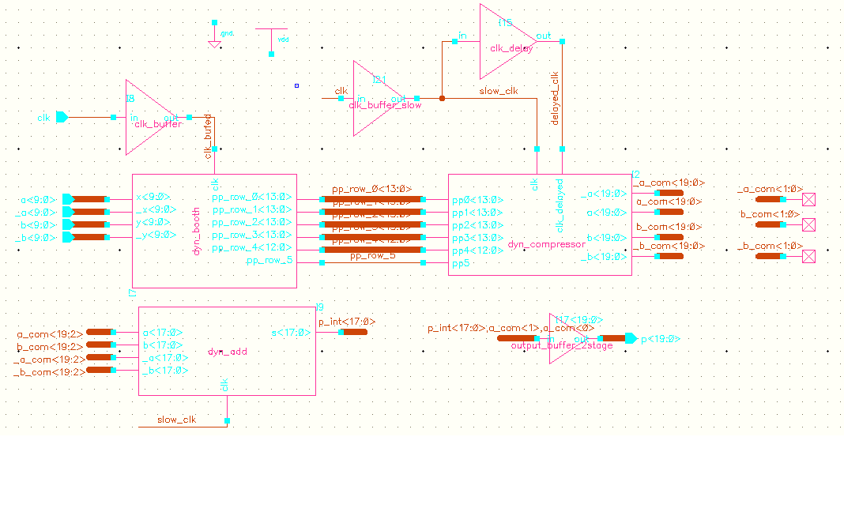
Figure 1: Top level schematic of 10-bit multiplier

Booth Encoder

A modified booth encoding scheme was used for this project, and the booth encoder that was implemented is shown in Figure 2. It creates 6 partial products from the 10 bit inputs. Four of the partial products are 14 bits, one is 13 bits, and the final one is 1 bit in length.

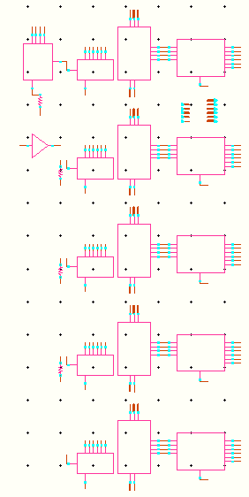
Figure 2: Booth encoder schematic

Compressor

The compression tree quickly generates two vectors that can be added together by the adder from the 6 partial products created by the booth encoder. To accomplish this compression in 2 stages, (5,5,4) compression blocks were used in conjunction with half and full adders. A block diagram of the compression scheme is shown in Figure 3, and the final schematic of the compressor is shown in Figure 4.

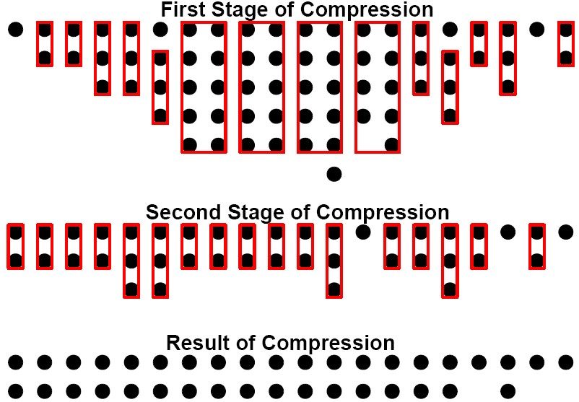
Figure 3: Compressor block diagram

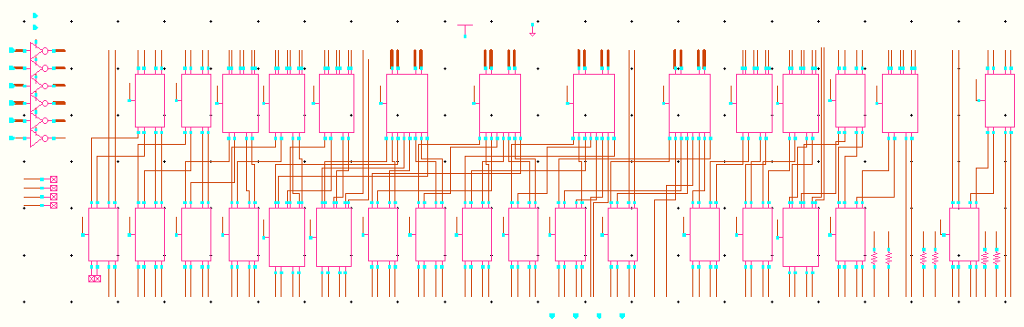
Figure 4: Compressor Schematic

Adder

The final product is computed by summing the two vectors from the compressor. A dynamic adder was used to accomplish this, and is shown in Figure 5. The middle bits of the adder arrive latest, so a carry select adder is used to optimize for delay. An adder tree is used for the lower bits, and the carry out of the 11th bit is used as a select for the most significant outputs, which were pre-computed assuming a 0 and a 1 carry in.

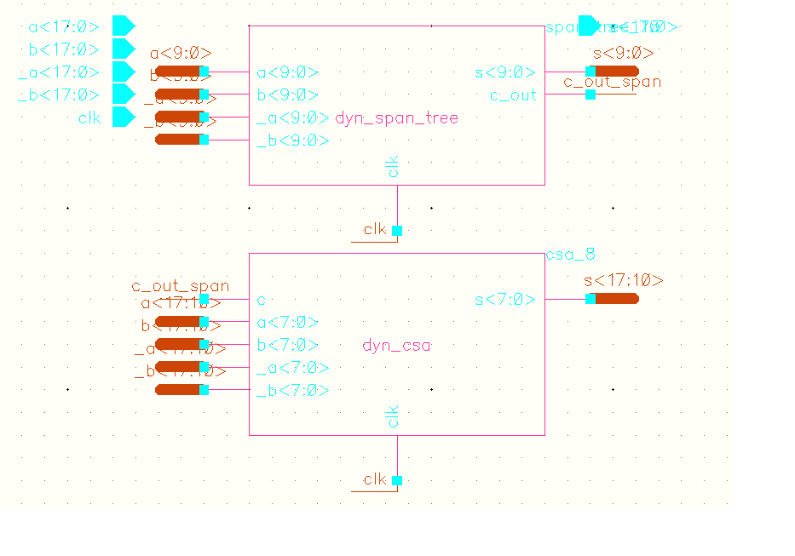
Figure 5: 20 bit adder schematic

Clock Buffers

Due to the high fan-out of the clock in dynamic circuits, there must be a large clock buffer to provide a clock signal to the entire circuit that has a sharp rising edge. However, the falling edge of the clock is not as important, so the clock buffer may be skewed to provide a slow falling edge in order to have a faster rising edge. The skewed clock buffer is shown in Figure 6. Also, the clock must only be distributed to the booth encoder very quickly. We conserve power by having two clock domains that are driven by the same input clock, but are the output of 2 different clock buffers. The clock to the compressor and the adder is much slower, and is shown in Figure 7.

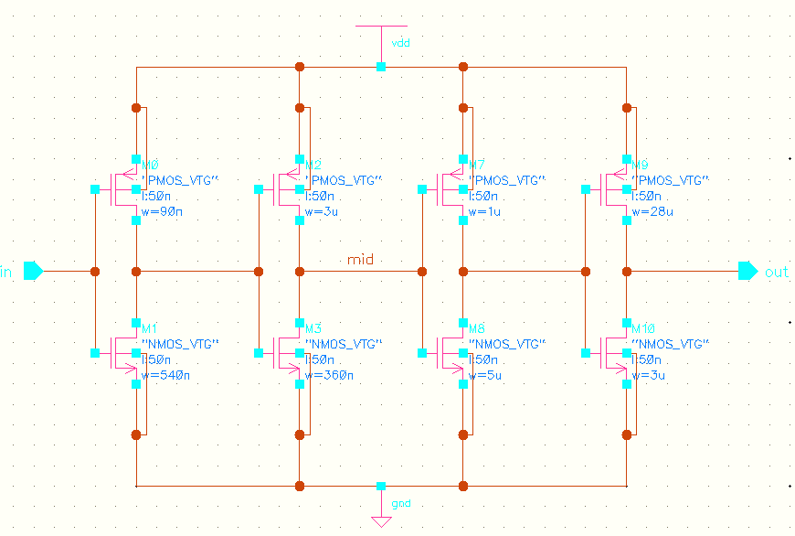
Figure 6: Fast clock buffer schematic

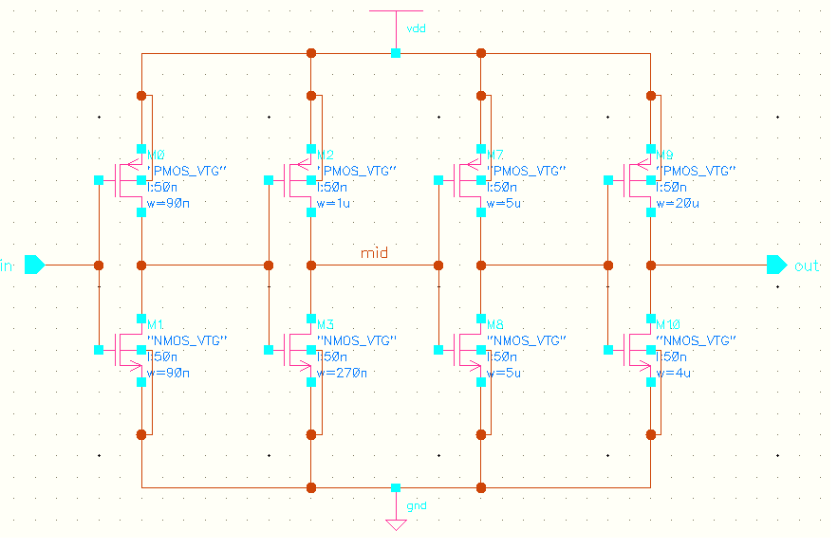
Figure 7: Slow clock buffer schematic

Clock Delay

Because XOR gates must be used throughout the compressor, inverted versions of almost all partial products are required. However, the inverted version of the signal cannot be calculated until the signal is stable out of the booth encoder. To delay the evaluation of the inverted partial products by the compressor, the clock delay line shown in Figure 8 is used.

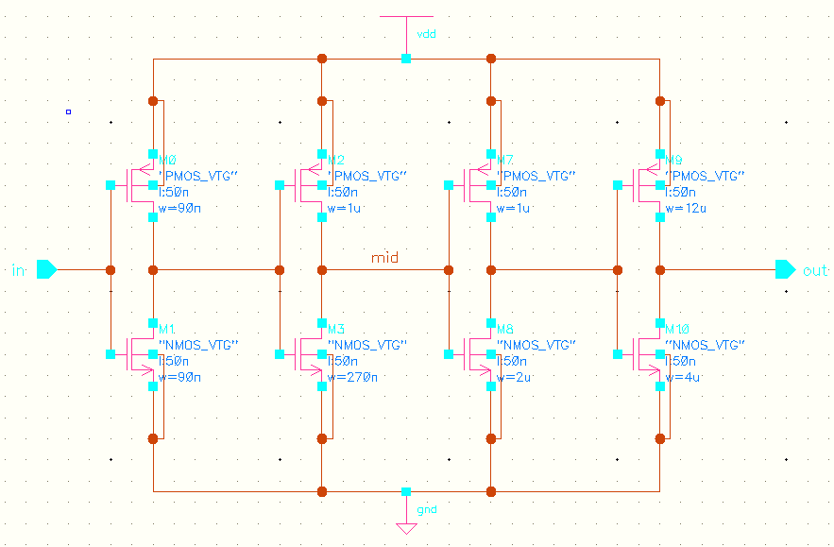
Figure 8: Clock delay buffer schematic

Output Buffer

According to the specification, the outputs of the multiplier must drive a 50fF capacitive load. However, the adder outputs its product vector through a pass gate mux. This will not drive a large capacitive load well, so the output buffer shown in Figure 9 is needed.

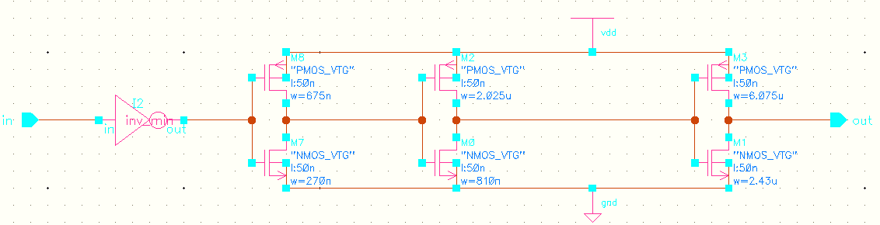
Figure 9: Output buffer schematic

Verification

Critical Path

Analysis

There are no long logic chains through the booth partial product generation logic. Due to the parallel nature of the structure, the delay for the partial product bits is close to identical, so the critical path of our design is based on the worst case delay through the compressor. Since the delay of bits 10, 12, and 14 through the compressor is longest, bit 14 will define the critical path of our design. The critical path flows through bit 14, but due to the adder tree, bit 19 will be the last bit evaluated.
This is due to a significant flaw in our final adder design. The adder was based on early estimates, where we believed that the 10th bit was the longest path through the compressor. Using this information, the adder was designed to mux all products after the 12th bit. This would have matched the delay profile of the compressor, with time to add bits 12 through 20, and given a very fast final addition. Instead, bit 14 was on the critical path. This bit has to ripple through the final adder before the mux (based on the carry out from the first adder stage) can generate the correct output, resulting in an unexpected critical path.

Simulation

The schematic simulation of the critical path of our multiplier design is shown in Figure 10. The delay from the clock rising edge to the output is 953 ps.

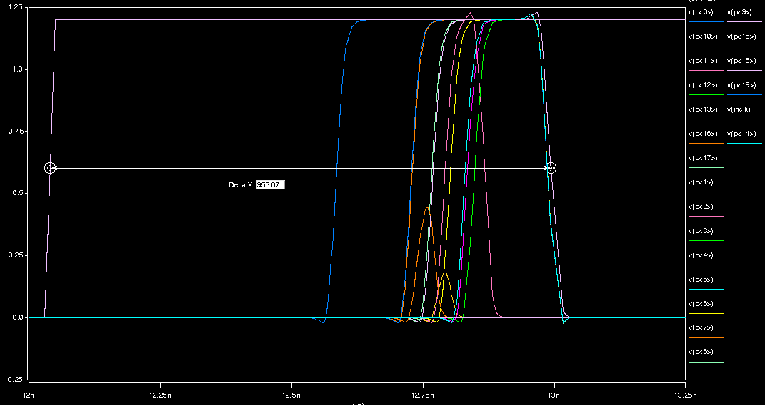
Figure 10: Critical path simulation with 50fF capacitive load

Functional Simulation

To demonstrate functional correctness of a multiplier, you must verify all bits can be a 0 or a 1, and that the result can be positive or negative. To verify the correct sign of the output, you must check all combinations of the inputs being positive and negative. Lastly, you must also verify that any number multiplied by 0 produces a product of 0 (for both A and B = 0). The simulation in Figure 11 shows the previously enumerated test cases.

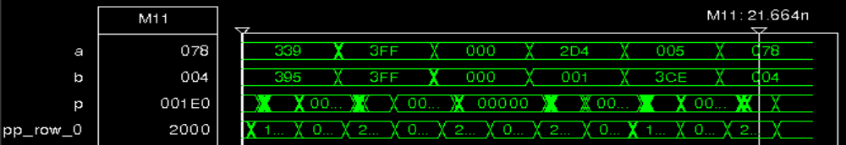
Figure 11: Functional simulation

References

[1] Inoue, A.; Ohe, R.; Kashiwakura, S.; Mitarai, S.; Tsuru, T.; Izawa, T.; Goto, G.; , "A 4.1 ns compact 54×54 b multiplier utilizing sign select Booth encoders," Solid-State Circuits Conference, 1997. Digest of Technical Papers. 43rd ISSCC., 1997 IEEE International , vol., no., pp.416-417, 497, 6-8 Feb 1997

[2] Li-Rong Wang; Shyh-Jye Jou; Chung-Len Lee; , "A well-structured modified Booth multiplier design," VLSI Design, Automation and Test, 2008. VLSI-DAT 2008. IEEE International Symposium on , vol., no., pp.85-88, 23-25 April 2008

[3] Stephen V. Kosonocky. “Dynamic Adder with Reduced Logic.” U.S. Patent 7 085 796, Aug. 1, 2006.

