EE 525 Project 1
SRAM Design
1-27-10

Team AN:
Nathaniel McVicar
Corey Olson

Area: 328.33 um^2
Delay (Non-inverted): 602 ps
FOM (Non-inverted): 197654 ps * um^2

2. Final Layout

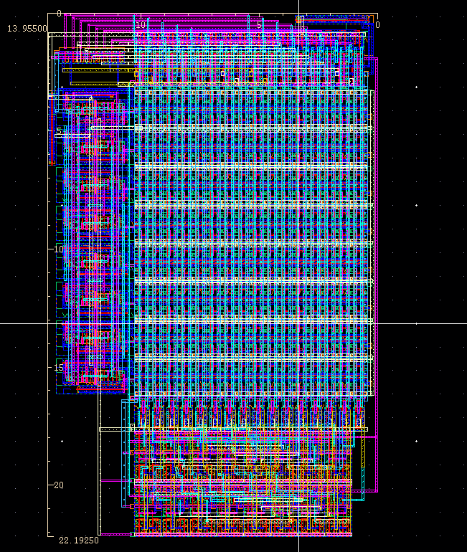
Figure 1: Final Layout Area is 13.955 um x 22.1925 um = 309.69 um^2
(adjusted to meet the required aspect ratio is 14.795 um = 328.33 um^2)

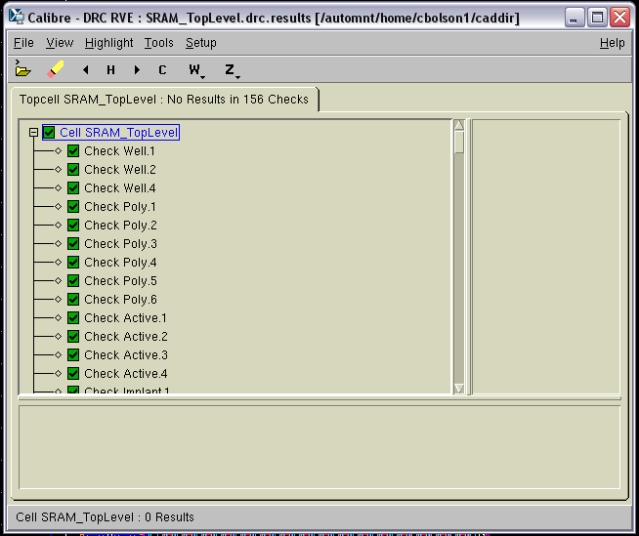
Figure 2: Screenshot of DRC Results

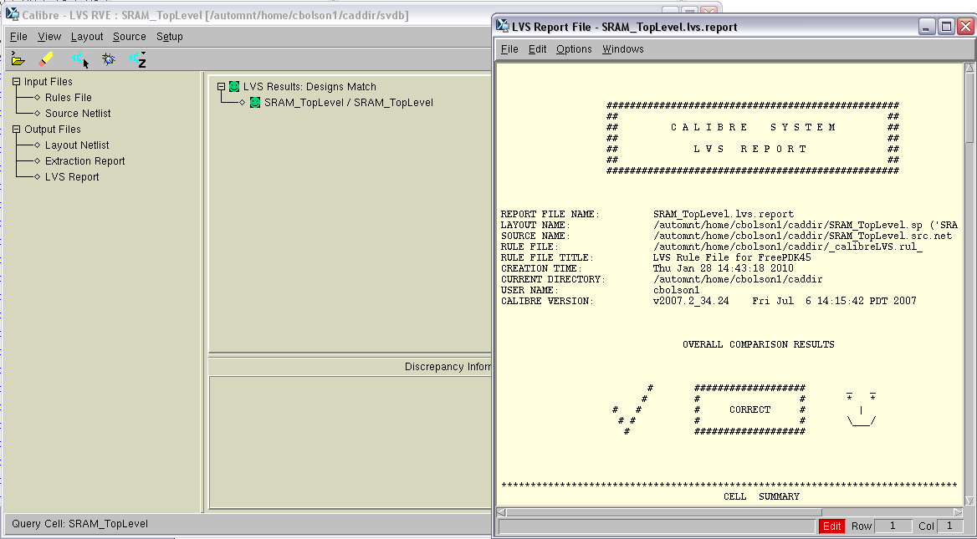
Figure 3: Screenshot of LVS Results
3: Block Level SRAM Description

For this laboratory project we chose to use a standard SRAM design very similar to the one discussed in the book and in class. The inputs are: 5 address bits, 8 data bits, a read/write select and a clock. There are also 8 data output bits which have a complemented version. The high level design, featuring the blocks described below, can be found in Figure 4.

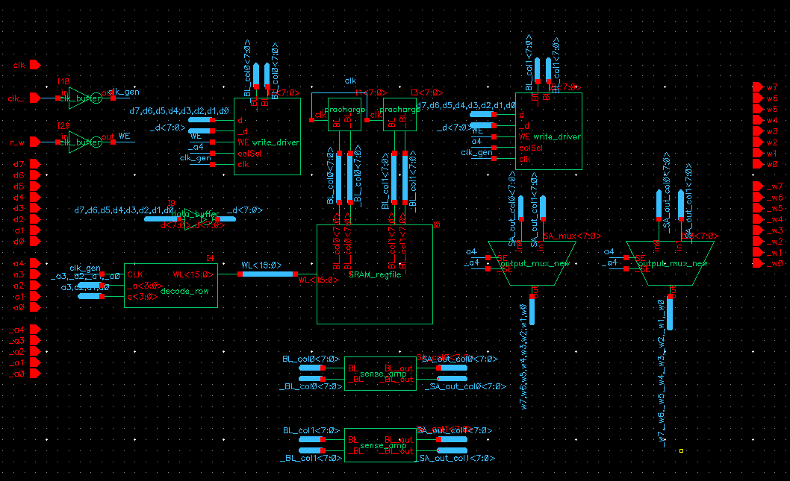
Figure 4: 8 Bit SRAM Schematic

Our first input stage buffers the input signals that have high fanout or are on the critical path. These buffers, when combined with the buffers already on the inputs, help provide high speed and also produce complemented versions of signals where it is necessary. In our final design, the clock, write enable and data write lines used additional input buffering. These buffers were sized experimentally because we found that calculations through techniques such as logical effort proved to be too imprecise and produced unexpected results when simulated.
The heart of the design is an array of 256 6-transistor SRAM cells, arranged in 2 columns made up 16 8-bit words each. Each cell is made up of a pair of cross-coupled inverters and is connected to a pair of bit-lines through pass transistors activated by a word line shared across each row. On every cycle, independent of what operations will be performed, the bit-lines are precharged to a logical 1 during the negative phase of the clock.
The read path and write path operate independently. This is possible because the read operation in a standard 6 transistor SRAM design is not destructive, so in essence, a read is occurring on every cycle. In addition, a write occurs on cycles where the write enable input (the compliment of the r_w input signal) is true. This type of design is power inefficient, since the all bit-lines are charged unnecessarily each cycle, but that was not a major concern for this project. On the write path, the write enable signal, the clock, the write data and the complemented write data (generated by an input buffer) all feed into the write driver block. This block pulls either the complemented or uncomplemented precharged bit-line down to overpower the inverter pair in a cell and change the data that SRAM cell stores when required. Since there is a write driver for each pair of bit-lines, there are a total of 16 write drivers and the most significant address bit is used as a column select for reads and writes. Because of this column select, only 8 of the write drivers can ever be active simultaneously.
The word line that is activated is selected by the 4 least significant address bits. This activation is performed by a row decoder implemented using a dynamic NAND gate with a footer and a non-inverting output stage. This fast and powerful driver activates only a single world line during the positive phase of the clock, using a simple boolean product of the address lines. Since there are 4 address lines, a total of 16 decoder dynamic gates are required. This logic serves the dual purpose of addresses decoded and prevents the pass-transistors in the SRAM from accidentally being activated during precharge.
During the read/write phase, when no write is occurring, one of the bit-lines for each cell will get pulled low because one side of the SRAM latch or the other will be a logical 0 (assuming no metastability). The difference that is developing (slowly, due to high capacitance) between this line and the high line will be detected and amplified by a sense amplifier. In our design, this amplifier is an analog amplifier that uses an always-on nFET to produce a bias current. Again, this design is bad from a power consumption perspective, but it is very fast and simple to get working without calculating precise bias values. It also does not require a clock, which speeds up the design by reducing clock fanout. One more advantage of this sense amplifier is its single ended outputs. Each amplifier produces a normal and complemented version of the bit-line’s difference. There is one amplifier for each set of bit-lines, and the amplifier’s outputs feed directly into the output muxes.
Each output multiplexer takes in one bit from each column. This results in eight muxes producing data outputs and eight additional muxes, producing complemented outputs. These multiplexers use chained NAND and NOR gates so that they can also serve as output amplifiers. This design is not as area efficient as a design that uses pass transistors, but it is very fast and ideal for driving the large 25 fF output capacitors.

4. Subcell Blocks

a. Row Decoder - We used a dynamic row decoder to provide maximum decode speed. Also, we designed the decoder pull up to a 1 strongly and down to a zero weakly, in order to get minimum clock to WL assertion delay through the decoder.
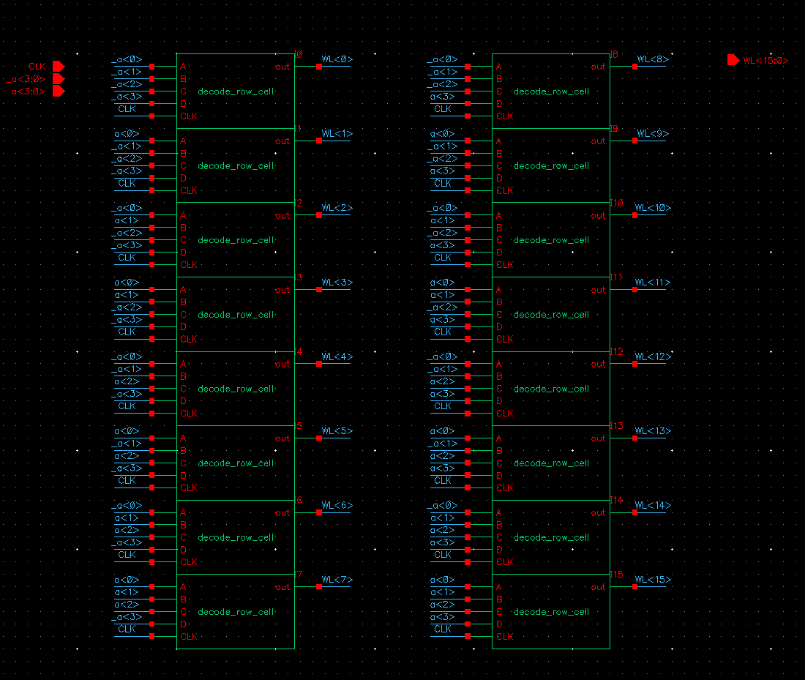
Figure 5: Full Decoder Schematic

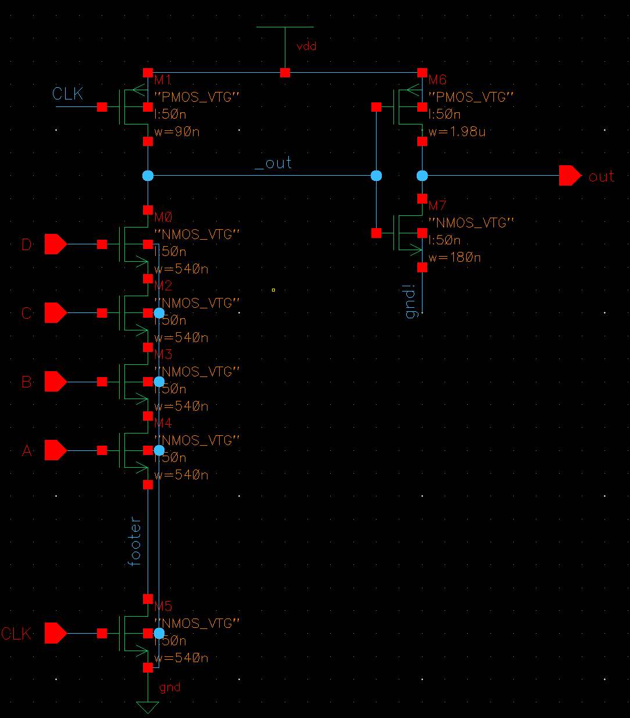
Figure 6: Single Word Line Decode Schematic

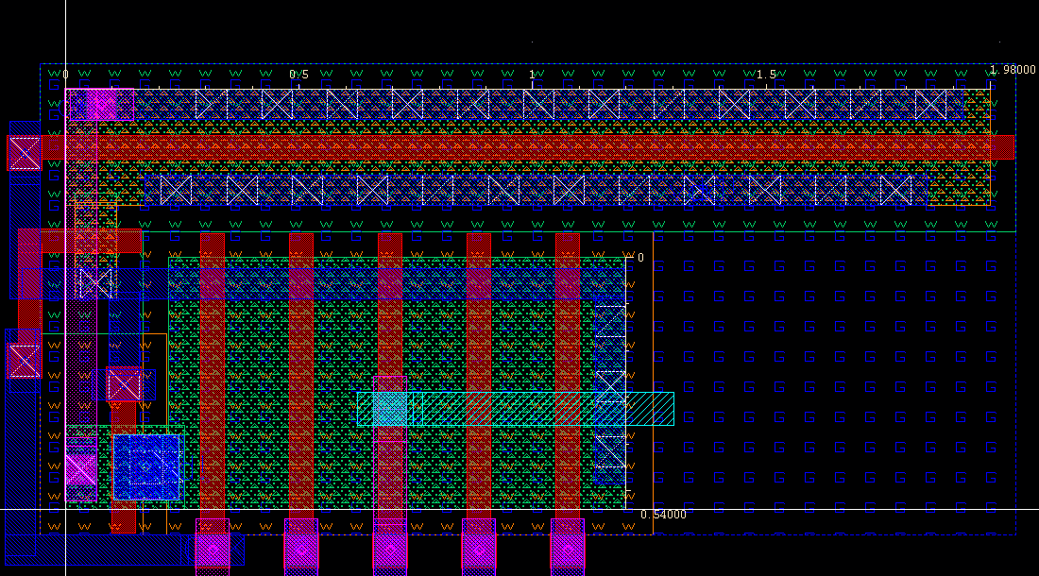
Figure 7: Single Word Decode Layout

b. Column Decoder – We implemented a design that did not use a true column decoder. Instead, our design used the most significant bit of the address as the column select for write operations, not allowing writes to the column if the column select bit is deasserted. The most significant bit was the select input to a mux on the output for read operations. The write driver is displayed later, so the output mux is shown here.

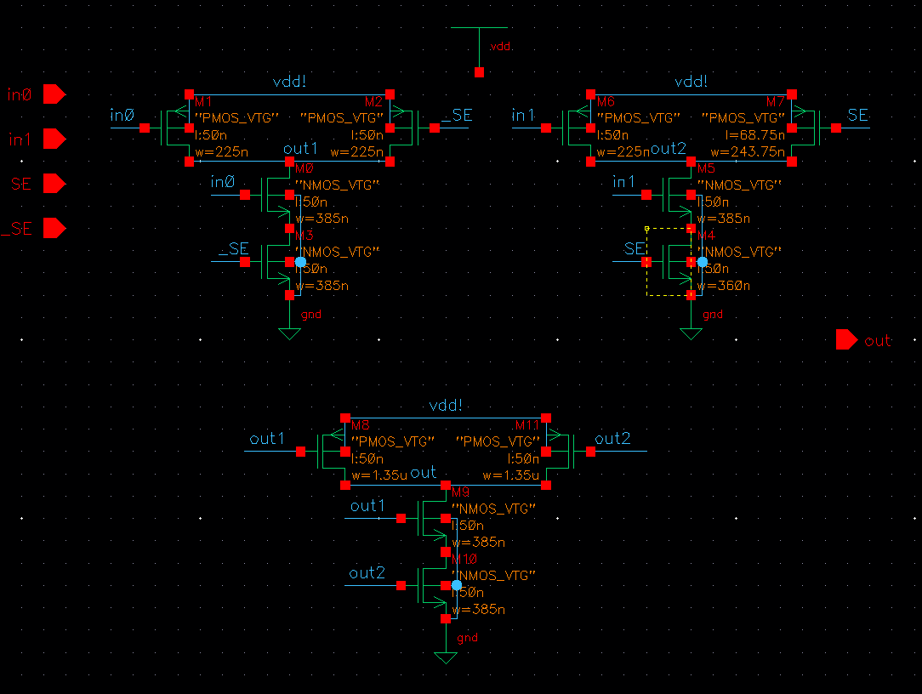
Figure 8: Output Mux Schematic

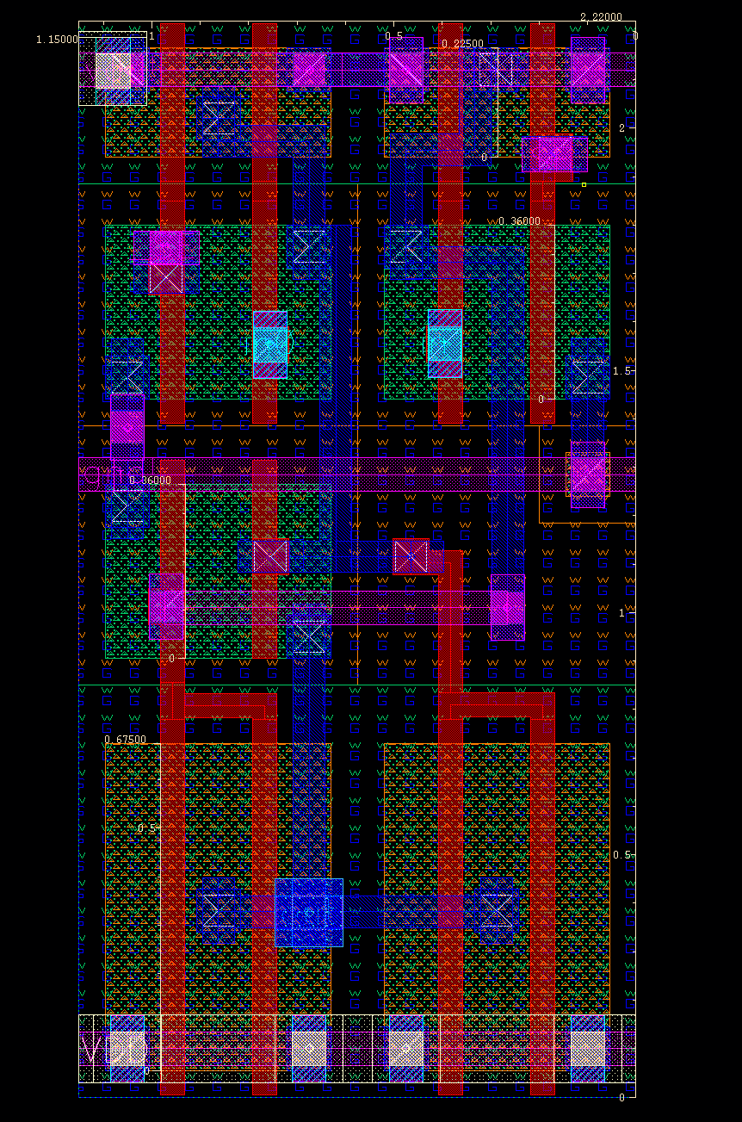
Figure 9: Output Mux Layout

c. SRAM cell – We designed the SRAM cell to be very near minimum size. Although this will decrease read speed, the minimum sized cells allow for a very high layout density, and other methods can be used to speed up the read operation (such as a the use of a sense amp).

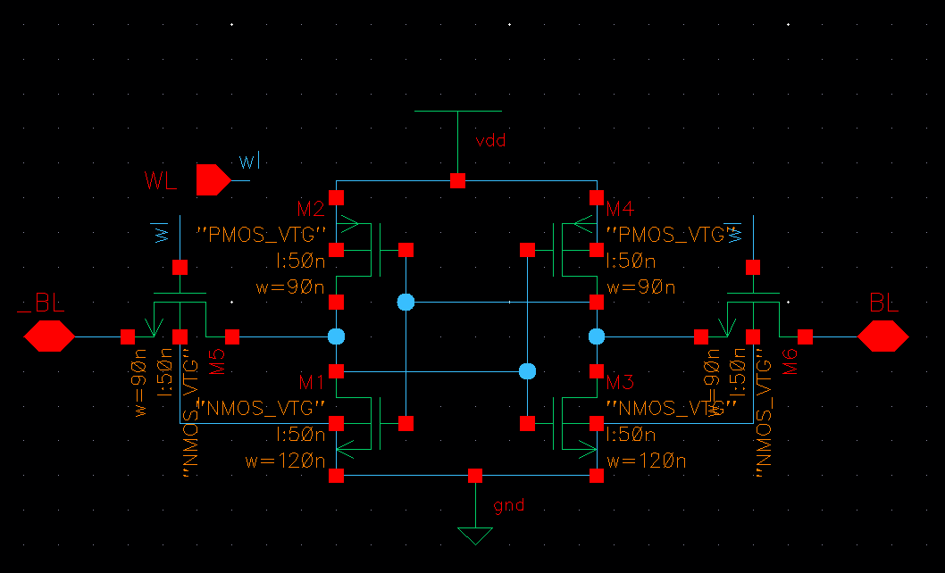
Figure 10: SRAM cell Schematic

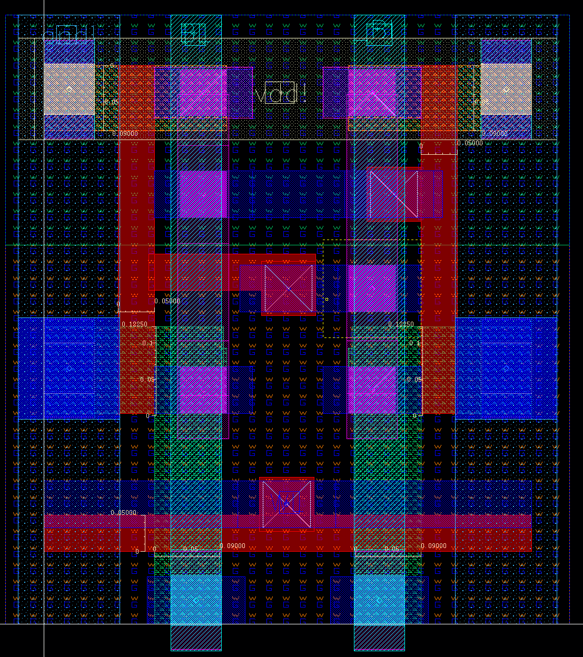
Figure 11: SRAM cell Layout

d. Write Driver - The write driver for this SRAM was designed to operate with a 2ns 50% duty cycle clock. Its pull down network is large enough so the bitlines are discharged well enough to accomplish a write during the 1ns high clock phase. The write driver was also used as a column decoder for the write cycle. The most significant address bit is used as the select bit for the appropriate column to ensure only one column is written at a time.

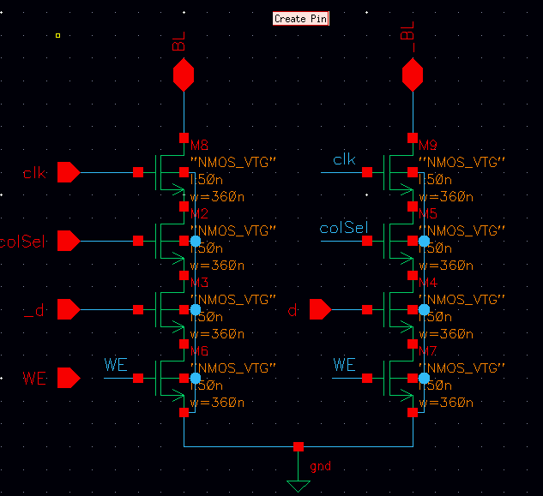
Figure 12: Write Driver Schematic

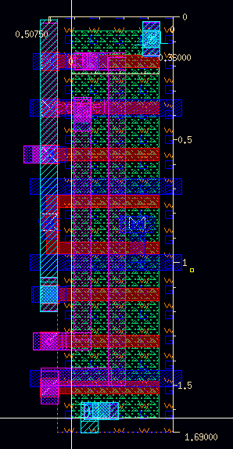
Figure 13: Write Driver Layout

e. Sense Amp – The sense amp was used in this SRAM to speed up the read cycle time. The bitlines have a large capacitance associated with them, due to the long wire and the amount of devices attached to the bitlines. Therefore the bitline voltage changes very slowly. The sense amp amplifies small changes in the bitline voltage so the data may propagate to the output bus faster.

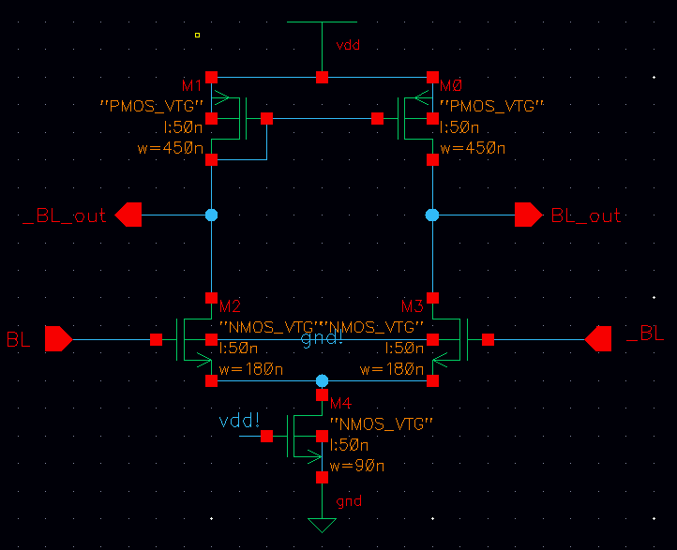
Figure 14: Sense Amp Schematic

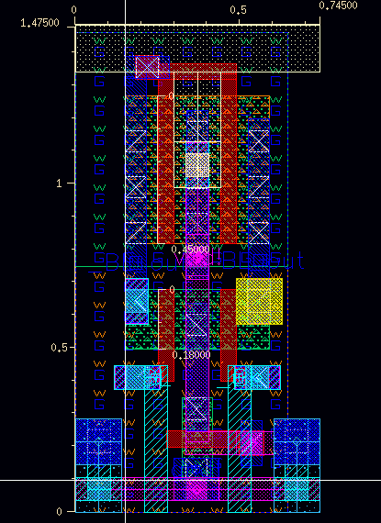
Figure 15: Sense Amp Layout

5. Analytical Approach

The goal of our design was to produce an SRAM with the fastest possible maximum operating frequency, not just the minimum read time. We tried to accomplish this at the cost of area and power, but produced a design that was fully operational under nominal process, voltage, and temperature conditions at a clock frequency of 500MHz.

To get a high maximum operating frequency, we first realized the critical clock edge in this SRAM design was the positive edge, since only 1 read or write operation can be performed during a clock cycle. We therefore based all of our design decisions on making the circuit perform faster on the positive edge of the clock at the expense of speed during the negative phase of the clock.

The most important design of the SRAM is the design of the base cell. This cell will be replicated many times, so its design is critical to the success of the overall design. When sizing the FETs of the SRAM cell, you must ensure that both read and write operations will be successful. The bitlines are precharged for reads and one is discharged for a write, so it is critical to realize that reading and writing a 0 in the SRAM cell are the critical operations. As described in the Weste textbook, the PFET in the cross coupled inverters must be weaker than the access transistors to ensure the cell can be written, and the access transistor must be weaker than the pull down NFET in the cross coupled inverters to ensure the data stored by the cell is not corrupted during a read operation. With this in mind, we set the PMOS devices in the SRAM cell to the minimum device sizing for this process. We then set the size of the access transistors to be slightly bigger than the PMOS transistors and the pull down NMOS transistors to be larger than the access transistors.

One of the first design decisions we made was to use a dynamic row decoder instead of a static row decoder. According to Weste, domino decoders are generally about 33% faster that static decoders. We saw this speed improvement as very important to our design goal, so we implemented the dynamic decoder in our SRAM at the cost of design complexity. The domino decoder itself uses fewer gates than the static decoder, but it requires an inverter on the output of the first stage. Since the critical delay through the decoder was on the assertion of one of the word lines, we made this a high skew inverter that had a much faster pull up than pull down slew rate. The output of this inverter fanned out to 16 access transistors, so we had to increase the device sizes of both the NMOS and PMOS in order to have sharper transitions.

The large capacitance on the bitlines, due to diffusion capacitance of the 16 access transistors on each bitline and the wire capacitance of the long bitlines, greatly slowed the slew rate of the bitlines. A sense amp on the bitlines detects small changes in the bitline voltage and amplifies the voltage differential across the bitline and its complement. We were able to use small device sizes in the sense amps and still speed up the transitions of the bitline voltages to the output mux. Power consumption was not a concern of this project, so we implemented an analog version of the sense amplifier, because of its lower design complexity compared to the digital version of the sense amp.

Originally our design used a single ended version of the sense amps that fed to an output mux, which is controlled by the MSB of the address. The output of the output mux then fed into an output buffer which created the _d outputs. However, simulation showed that even a well designed output buffer had a large delay relative to the overall delay of the circuit. We were able to eliminate the need for the output buffer by instead using a differential output of the sense amp, and muxing both outputs. One output mux creates the output data and the other creates the inverted version of the output data. This parallelized the creation of the inverted output data, and therefore we were able to eliminate the delay through the output buffer. The output mux now needs to drive a 25fF load, so an active version of a mux was used instead of the passgate version.

The precharge block for the SRAM design was not on the critical path for either the read or the write, so we made this as small as possible. We simply needed to ensure that the bitlines could be fully charged to a 1 from a discharged state during the low phase of the clock. After extracting the SRAM array, we ran many simulations to estimate the device sizes required to charge the capacitance on the bitlines in the required amount of time. Since only one bitline will discharge per cycle, we added a small balancing transistor between the bitlines to try to balance the voltage of the bitlines at the end of the precharge phase. This balancing transistor also creates a parallel path for the discharged bitline to be pulled up to VDD, so the balancing transistor decreases the required precharge time.

Similar to the precharge block, the write driver was not on the critical path of the design, but this needed to be strong enough to discharge the bitlines low enough so a 0 could be written into the SRAM cell. Once again, after extracting the SRAM array to get a more accurate value of the capacitance on the bitlines, simulations were run to ensure the drive strength of the write driver could meet this requirement.

Due to the importance of clock synchronization in this circuit and the large number of blocks that the clock fans out to, we added a clock buffer that was skewed for faster low to high transition times. This gave us a sharp rising edge for all of the clocks in the circuit and shortened our critical path delay.

6. Problems

The most significant problem we encountered during this project involved the inverted data outputs. Due to a misunderstanding of the analog sense amplifier, we attempted to use the opposite side of the amplifier as an inverted output, which is not how the sense amp behaves. This issue was not caught during schematic simulation, and resulted in severely degraded worst-case performance of 1039ps compared to a 503 ps worst case for the non-inverting outputs. It is worth noting however, that for most applications the fast non-inverting data outputs should be sufficient. This issue was addressed with additional output inverters. This greatly improves performance, although it is not as good as a solution that could have been implemented if the issue was discovered earlier.

Another significant issue is with the aspect ratio of the design. Although we knew our cells were almost twice as tall as they were tall, we overestimated the area required for the row decoding logic and underestimated the area required for the column logic. This results in a design that was much higher than it is wide, and a lot of empty space was burned when stating the total area in order to meet the aspect ratio requirement. The true area of approximately 310 µm² had to be padded to 330 µm².

7. Functional Simulation

The functional simulation, Figure 16, shows correct operation of the extracted SRAM netlist.
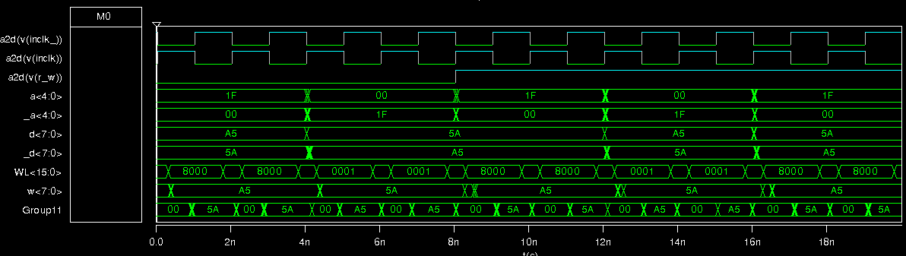
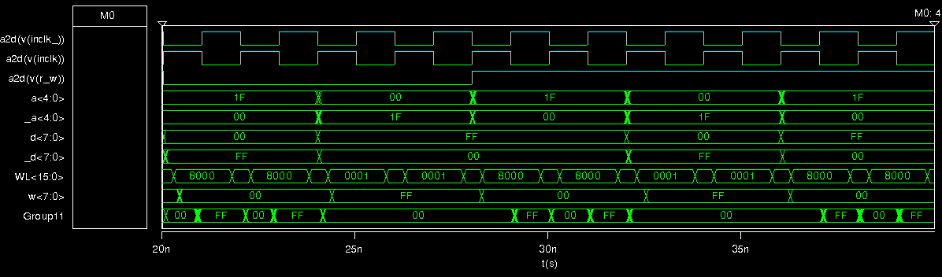
Figure 16: Functional correctness of first test vector

8. Worst Case Simulation

Through simulation we verified that our critical path on the non-inverting outputs was the path described in the section below. This path involves reading bit 0 from column 1 and word line 15. Delay measurement results for this path are contained in Figures 19 and 20. As shown in Figure 17, reading a 0 followed by a 1 is not the worst case.

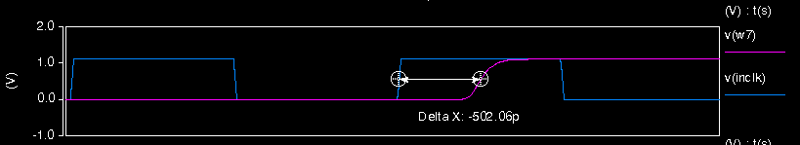
Figure 18: World Line 0, reading a 0 followed by a 1. Delay is 502 ps.
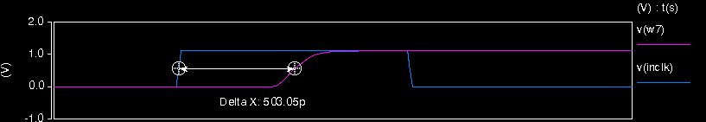
Figure 19: World Line 15, reading a 0 followed by a 1. Delay is 503 ps.
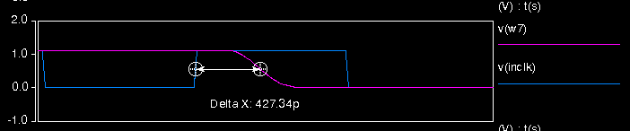
Figure 20: World Line 0, reading a 1 followed by a 0. Delay is 427 ps.

Unfortunately, due to the design issue discussed in the problems section above, our inverted outputs were much slower than the non inverted outputs. By simply using the non-inverted version of the output, the user could speed up the performance of the circuit greatly. The simulation of the worst case read delay through the inverted outputs is shown below. It is clearly a design flaw, but this can be completely avoided by using the non-inverted outputs.

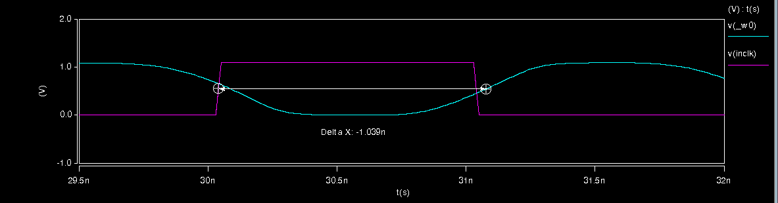
Figure 17: Worst case delay through the inverting outputs = 1.039ns

Switching the inverting outputs to use the standard outputs followed by a large inverter improved worst case performance significantly. See Figure 21.
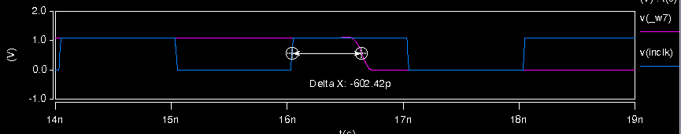
Figure 21: Worst case, with inverter, delay is 602 ps.

9. Critical Path

The critical path of our design is activated during a read cycle. It goes through the clock buffer, row decoder, SRAM cell, sense amp, and output mux. More specifically, the critical path goes through the row decoder block that generates word line 0 and the SRAM cell at bit 0 of column 1.

The critical path starts on the negative edge of the input clk_ clock. The clock buffer is skewed with a large pull up PMOS to sharpen the rising edge of the clock, and to deliver the clock to many gates in the SRAM. The output of the clock buffer then goes to the precharge and footer gates of the dynamic decoder. The precharge FET turns off, and the footer NMOS gate turns on, setting the footer to ground and allowing the pull down network to evaluate. Only one pull down network of the entire row decoder evaluates each cycle, and the output of that pull down network is inverted at the output of the decoder to assert only one word line per cycle.

Word line 15 is at the top of the design and is furthest from the output, so the signal must propagate furthest to reach the output once it is at the bitline. Therefore, word line 15 is on the critical path of our design. Also, column 1 is laid out further from the output of the decoder, so the word line signal takes longer to propagate to column 1 than to column 0. Also, the registers are laid out with bit 7 closest to the row decoder and bit 0 furthest from the row decoder, so bit 0 will be the critical path. The access transistors of bit 0, word line 15, column 1 is then enabled and the data is read. _BL is laid out to the right of BL for all SRAM cells, so the access transistor on _BL will see the assertion of the word line signal slightly after the BL access transistor. Therefore, the critical path will be reading a 0 on _BL of bit 0 of address 0x1F. This corresponds to actually reading a 1 from that cell.

The _BL line is pulled low by the SRAM cell through the access transistor, and the bitline feeds into the sense amp at the bottom of the design. The sense amp detects the small fluctuation in _BL, and pulls its inverted output low. That signal is then fed through the output mux, which is already set up with the proper select signals for that column. The data then propagates through the output mux to the output of the circuit at _w<0>.

