Layout
To minimize the footprint of the pseudo random bit sequence generator, layout was designed as shown in the Figure ##. Each block is rotated and placed in a way to make the design more compact, minimize the wasted space and short wiring. Similar color in the figure represents similar functionality. For example, green was used for sequencer circuit which is composed of differential clock generator, four-phase clock generator, and divided clock generator.
Dynamic latches (1~6) are the core of PRSG and have the most connections with peripheral circuitries; hence it was placed in the center. The numbers corresponds to the latches described in the schematic. Latch 7 is a temporary storage of the output feedback. Latch 5 and 6 are the first stages which are connected from latch 7 and other latches are place in order towards the output. For the correct behavior of each latch when reset signal is high, pull up/pull down transistors were attached on the sides for quick response. Since dynamic latch with four transistors were implemented, every other stage will have the same output value but neighboring latches will result in the inverted values. In result, pull up and pull down transistors were altered. Reset circuitry was placed at the right end of the layout since it takes quite a large area and it will be more convenient to connect to reset transistors.
Clock generators were placed at the bottom to have efficient connection to all the latches in the center. Control signals for the dynamic latches are from four-phase clock generator; therefore it was placed right below the latch chains. Differential clock generator is placed near reset and four-phase clock generator because it mainly sends both synchronous clock and clock bar signal to both circuits. Divided clock generator is only connected to the transmission gates of the output circuitry hence why it was placed on the left side of the clock generator where the transmission gates are located in the output circuitry.
Output circuitry is place on the remaining side which is placed next to (or above) the latches that are connected to the input of the output circuitry. Two identical output circuits were inserted to handle each output of two parallel latch chains. However, it was combined with a single output buffer (large inverter) since only one of the circuits will be transferring the data. Another purple block is found under the output circuitry which is an inverter that buffers the signal from the output circuitry.
The overall area of the layout is #####. Latch chains were small compare to registers with less number of transistors, but other circuitry took decent amount of space in the layout. However, if the number of bits from the pseudo random bit sequence generator is increased, we will have to implement more latches (or registers in other designs), then we will benefit in area and power consumption from this design.
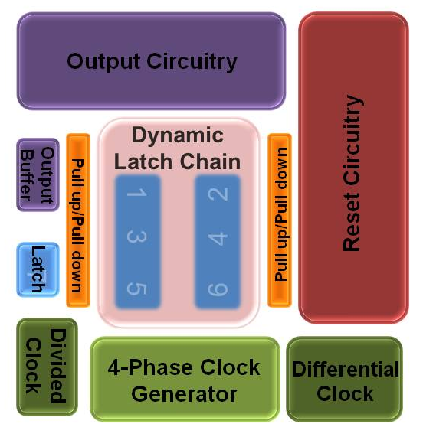
Figure ##. Complete PRSG (Toplevel) Layout Block Diagram

