

CIS 660 Data Mining
Final Project Report
Major: Computer Sciences
Topic: On time Air Predictor
Instructor: Dr Sunnie Chung
Submitted By
Omi Patel(2835823)
Preet Kanani(2845746)

INDEX

S.No. | Contents | Page No.
1 | Cover Page | 1
2 | Abstract | 3
3 | Project Problem Summary  Preparation of Project  Required Software’s and its installation | 4
4 | Work Flow and Query optimizer Implementation | 5
5 | Data Preparation  Data Description | 6
6 | Import Model | 7
7 | Data Cleaning  Data Preparation | 8
8 | Feature selection and Data Preprocessing | 10
9 | Build machine learning model  Random Forest Classifier | 13  14
10 | AUC Score (Area under the Receiver operating Characteristic Curve) | 15
11 | Precision Score  Future Implementation | 16
12 | Source code | 17
13 | Visualize Output of Model | 19

Abstract
Considering the present situation and scenario of domestic flights, in USA (Constraint: The country where the major transport for most of the people), the percentage of flight delays are seen in numerous instances and cancellations. For this project, we have considered the dataset of 5 major airports. which is one of the most depended and the world's biggest carrier as far as number of destinations served. In this case, with regards to domestic flights, AA has not satisfied the hopes as far as reliability or on-time performance in reality.

Flight Delays additionally bring about airline organizations working business flights to bring about enormous losses. In this way, they are attempting their best to anticipate or stay away from Flight Delays and Cancellations by taking certain measures. This examination targets breaking down flight data of US residential flights worked by American Airlines, covering top 5 busiest air terminals of US and foreseeing conceivable appearance deferral of the flight utilizing Data Mining and Machine Learning Approaches. The Gradient Boosting Classifier Model is deployed by preparing(training) and hyper-parameter tuning it, accomplishing a most extreme precision of 85.73%. Such an Intelligent System is basic in prognosticating flights ‘on-time execution.

Flying for business is brimming with vulnerability. For business travelers with a tight connection flights and on time schedule for meetings or an arrival time near an important meeting, even a short flight deferral can cause genuine tension and economical losses. There are around 33% of the flight delays that have been recorded for a year 2018-19. Of the postponed flights, 11% were delayed over one hour and 4% were deferred more than two, which is insensible. Postpones aren't only an aggravation for the traveler either — regarding lost profitability, productivity- organizations could see misfortunes into the many thousands, if not a great many dollars for each year.

As indicated by the Bureau of Transportation Statistics, local airlines revealed an on-time appearance performance of about 80% for 2018–19. Of the delayed flights, anyplace between 25–35% of those flights (contingent upon the long stretch of the year) were postponed because of terrible climate. Another 5–10% of delayed flights were because generally showing up aircraft. In the event that we can show these postponements precisely, we'll represent practically 50% of every single deferred flight every year!

Project Problem Summary:
- One of the major concerns for airliners around the world is how to predict delays which usually affect the functioning of aircrafts ultimately resulting in loss of revenue and increasing costs.
- The goal of this project is to predict whether a flight you are considering booking is likely to arrive on time. If you know that the flight is likely to be late, you might choose to book another flight.

Preparation of Project:

- Go to Bureau of Transportation Statistics site:
https://www.bts.gov/topics/airlines-and-airports-0
- Download the dataset and the guidelines from:
https://docs.microsoft.com/en-us/learn/paths/intro-to-ml-with-python/
https://docs.microsoft.com/en-us/learn/modules/predict-flight-delays-with-python/0-introduction
- Restore dataset and check whether the data is clean.
- After the step 2, you should see following tables.

Points - To - Remember for doing this project:

- Check the dataset and install all the prerequisites.
- Check the versions and the libraries before you run the program.py
- Clean the dataset and prepare data for machine learning model.
- Make sure the python program is picking the dataset properly or any missing attributes.
- Install the require library for the visualization.

Required Software’s and Installations:

- Install Jupyter 6.0.3 for better experience in Mac/ Windows.
- Install Python 3.7.6 or higher version for some of the library functionalities.
- FlightData (a Sample Data Warehouse) and data from 2019 for 5 major airports.
- Required libraries are mainly: PANDAS, SCIKIT-LEARN, MATPLOTLIB.

- WORK FLOW && Query Optimizer Implementation:

- Download Dataset FlightData.csv from Bureau of Transportation Statistics site:
https://www.bts.gov/topics/airlines-and-airports-0

- We have tried to get the dataset which has 1,100,000 data which cannot be loaded/ imported into an excel file in our local systems. So, we have selected the dataset which is lesser in volume i.e., FlightData.csv

- Download the one under as shown below.
Database-> Filter the results (5 major airports)
* Click on the zip file and download will start automatically.
- Copy this FlightData.csv file and paste it in the folder.

(The folder changes for each individual depends on the system Name, folder and program path etc.)

- After installing the python higher than 3.6 add few library installations such as:

* PANDAS for cleaning and preparing data to be used for machine learning model.
* SCIKIT-LEARN is used to create machine learning model.
* MATPLOTLIB is used to visualize the model’s performance.
- Install Jupyter 6.0.0 or higher and check whether python is free to connect to it.

Preparation of Data: (windows)

- Basically, we have prepared data using bureau of transportation statistics. we have picked attributes according to the requirement of this project.
- In bureau of transportation we have chosen data which is related to the airlines and airports and selected the attributes which really effect in predicting delay for the airlines.
- Here is the link which we have used in collecting the data.
https://www.bts.gov/topics/airlines-and-airports-0

- Data Description:

- This csv file contains 11231 rows and 26 columns.
- This data contains information about flights in 2019 from 5 major airports (ALT, DTW, JFK, MSP, SEA).
YEAR | Year that the flight took place
MONTH | Month that the flight took place (1-12)
DAY_OF_MONTH | Day of the month that the flight took place (1-31)
DAY_OF_WEEK | Day of the week that the flight took place (1=Monday, 2=Tuesday, etc.)
FLIGHT_NUM | Flight number
ORIGIN_AIRPORT_ID | ID of the airport of origin
ORIGIN | Origin airport code (ATL, DFW, SEA, etc.)
DESTINATION_AIRPORT_ID | ID of the destination airport
DESTINATION | Destination airport code (ATL, DFW, SEA, etc.)
SCHEDULE_DEP_TIME | Scheduled departure time
DEP_TIME | Actual departure time
DEP_DELAY | Number of minutes departure was delayed
DEP_DELAY_15 | 0=Departure delayed less than 15 minutes, 1=Departure delayed 15 minutes or more
SCHEDULE_ARR_TIME | Scheduled arrival time
ARR_TIME | Actual arrival time
ARR_DELAY | Number of minutes flight arrived late
ARR_DELAY_15 | 0=Arrived less than 15 minutes late, 1=Arrived 15 minutes or later
CANCELLED | 0=Flight was not cancelled, 1=Flight was cancelled
DIVERTED | 0=Flight was not diverted, 1=Flight was diverted
SCHEDULE_ELAPSED_TIME | Scheduled flight time in minutes
ACTUAL_ELAPSED_TIME | Actual flight time in minutes
DISTANCE | Distance traveled in miles

- Model Import:

- The following code is used to load flightdata.csv file.
- We need to create PANDAS data frame from it and display the first five rows

- This will help in picking the dataset from the given path(above) and shows the successful results in Terminal.
- Check the Columns before you start processing the next step: The Data Frame that you created contains on-time arrival information for a major U.S. airline. It has more than 11,000 rows and 26 columns. (The output says "5 rows" because DataFrame’s head() function only returns the first five rows.) Each row represents one flight and contains information such as the origin, the destination, the scheduled departure time, and whether the flight arrived on time or late. We'll look at the data more closely a bit later in this module.

- Read the flight data and explore it using pandas.
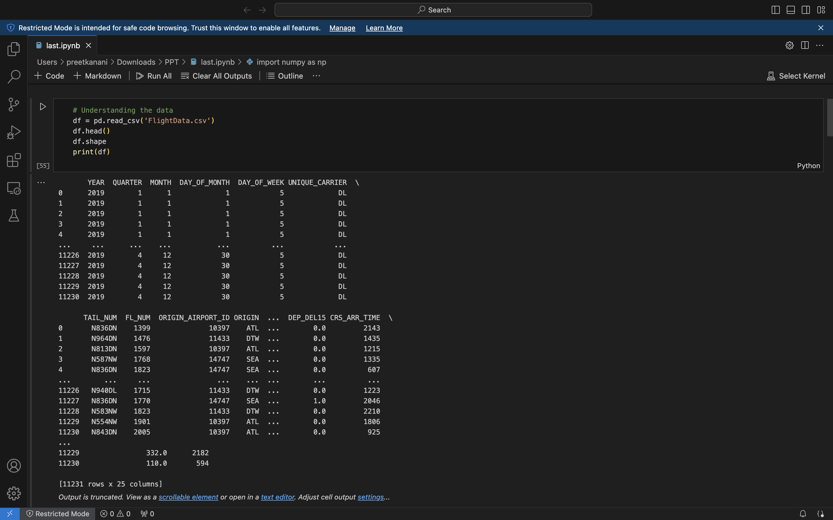

- Clean and Prepare Data:

- Checking for missing values

- One of the first things, we look for in a dataset is missing values.
- There is an easy way to check for missing values in Pandas. To demonstrate, execute the following code in a cell at the end of the jupyter notebook:

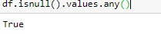

Confirm that the output is “True”, which indicates that there is at least one missing value somewhere in the dataset.

- Number of missing values in each column

- The next step is to find out where the missing values are. To do so, execute the following code:

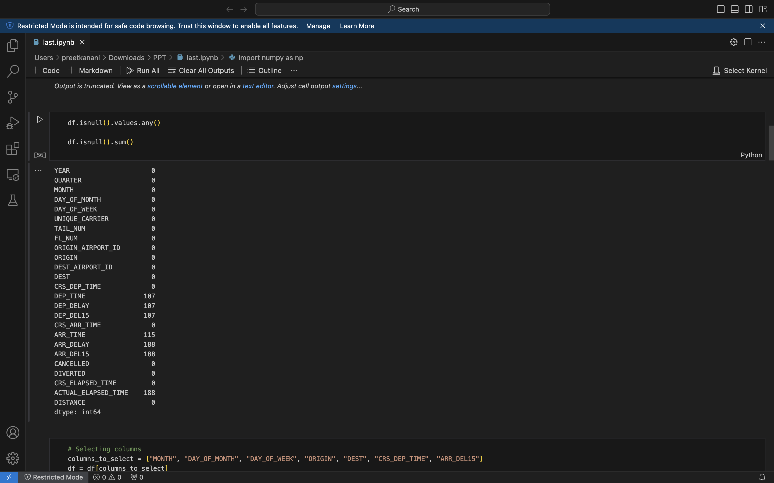
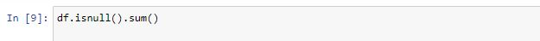
Confirm that you see the following output listing a count of missing values in each column:

- The DataFrame with column 26 removed

- Curiously, the 26th column (“Unnamed: 25”) contains 11,231 missing values, which equals the number of rows in the dataset.
- This column was mistakenly created because the CSV file which we imported contains comma at the end of each line.
- To eliminate that column, add the following code to the notebook and execute it:

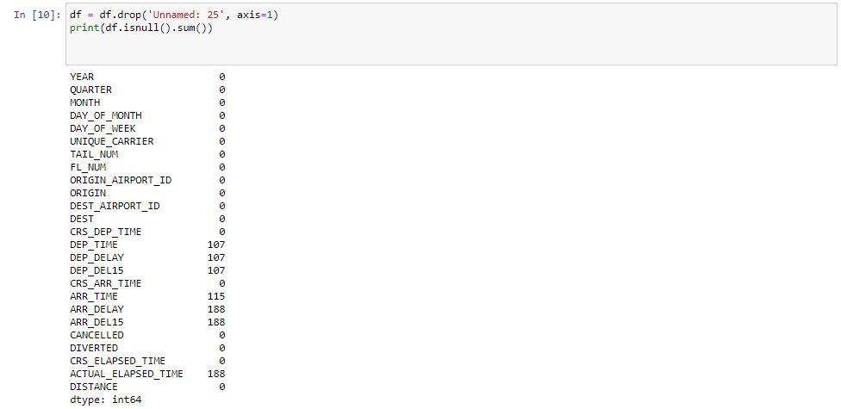

- Inspect the output and confirm that column 26 has disappeared from the DataFrame:

- Feature selection and Data Preprocessing

Feature Selection

1) The filtered DataFrame

- As the dataset contains lot of attributes that is not required for predicting we have selected the attributes that are needed to such as "MONTH", "DAY_OF_MONTH", "DAY_OF_WEEK", "ORIGIN", "DEST", “CRS_DEP_TIME", "ARR_DELAY_15”.
- Pandas provide easy way to filter out columns which we don’t want.
- Execute the following code in the jupyter notebook:

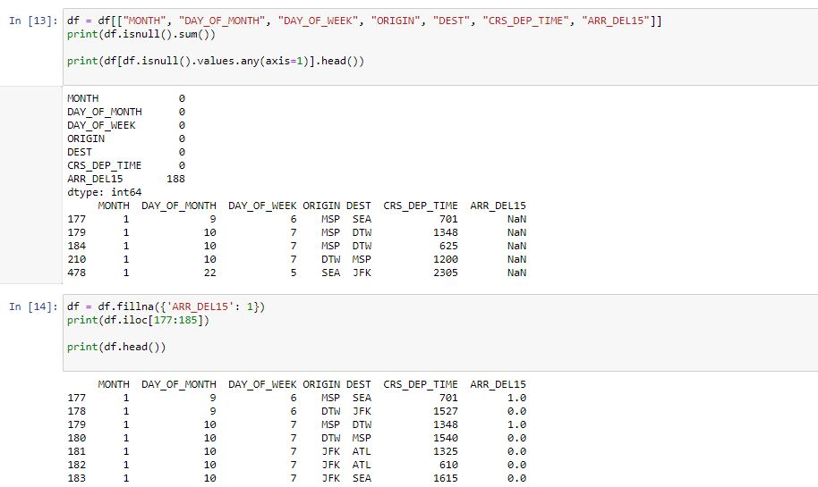
- The output shows that the DataFrame now includes only the columns that are relevant to the model, and that the number of missing values is greatly reduced:

2) Rows with missing values

- The only column that now contains missing values is the ARR_DEL15 column, which uses 0s to identify that arrived on time and 1s for flights that didn’t.
- Use the following code to show the five rows with missing values:

- Pandas represents missing values with NaN, which stands for Not a Number.
- The output shows that these rows are indeed missing values in the ARR_DEL15 column:

3) NaNs replaced with 1s

- The reasons these rows are missing ARR_DEL15 values is that they all correspond to flights that were canceled or diverted.
- Use the following code to replace missing values in the ARR_DEL15 column with 1s and display rows 177 through 184:

- Confirm that the NaN is rows 177 and 179 were replaced with 1s indicating that the flights arrived late:

Data Preprocessing
- The CRS_DEP_TIME column of the dataset you are using represents scheduled departure times.
- The dataset's ORIGIN and DEST columns contain airport codes that represent categorical machine-learning values.
- The ORIGIN column, which contains five airport codes, needs to be converted into five columns, one per airport, with each column containing 1s and 0s indicating whether a flight originated at the airport that the column represents. The DEST column needs to be handled in a similar manner.
- For CRS_DEP_TIME column we did Binning technique and for ORIGIN and DEST column we did get_dummies method to create indicator columns from the ORIGIN and DEST columns.

- The DataFrame with binned departure times

- Use the following statements to bin the departure times:

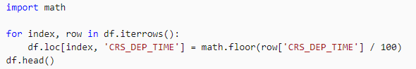

- Confirm that the numbers in the CRS_DEP_TIME column now fall in the range 0 to 23:

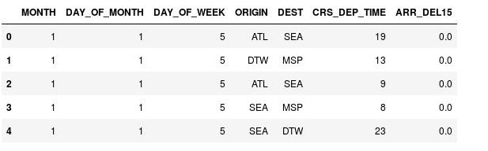

- The DataFrame with indicator columns

- Now use the following statements to generate indicator columns from the ORIGIN and DEST columns:

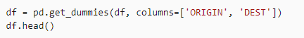
- Examine the resulting DataFrame and observe that the ORIGIN and DEST columns were replaced with columns corresponding to the airport codes present in the original columns. The new columns have 1s and 0s indicating whether a given flight originated at or was destined for the corresponding airport.

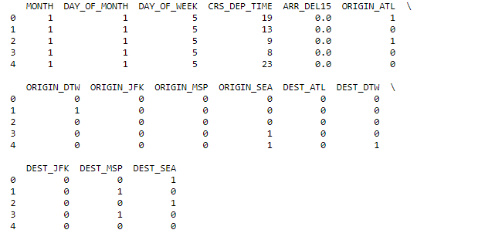

- Build machine learning model

- To create a machine learning model, we need two datasets: one for training and one for testing.
- To test the accuracy, we have divided the dataframe into training set and test set (80% and 20%) using random_state.

For that enter and execute the following statements:

from sklearn.model_selection import train_test_split
train_x, test_x, train_y, test_y = train_test_split(df.drop('ARR_DEL15', axis=1), df['ARR_DEL15'], test_size=0.2, random_state=42)

- The first statement imports scikit-learn's train_test_split helper function.
- The second line uses the function to split the DataFrame into a training set containing 80% of the original data, and a test set containing the remaining 20%.
- The random_state parameter seeds the random-number generator used to do the splitting, while the first and second parameters are DataFrames containing the feature columns and the label column.
- train_test_split returns four DataFrames. Use the following command to display the number of rows and columns in the DataFrame containing the feature columns used for training and testing:

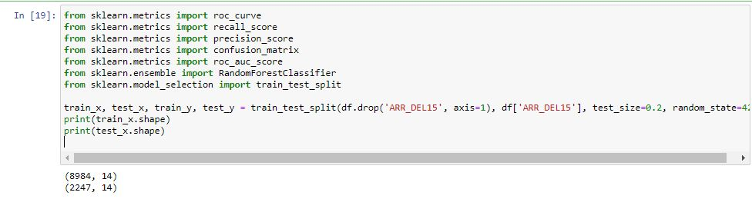

- Random Forest Classifier

1) Execute the following code in a new cell to create a RandomForestClassifier object and train it by calling the fit method:

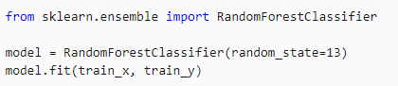

The output shows the parameters used in the classifier, including n_estimators, which specifies the number of trees in each decision-tree forest, and max_depth, which specifies the maximum depth of the decision trees. The values shown are the defaults, but you can override any of them when creating the RandomForestClassifier object.

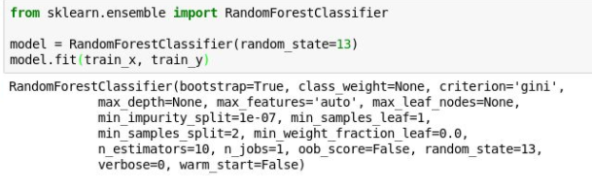
Fig: Training model

2) Now call the predict method to test the model using the values in test_x, followed by the score method to determine the mean accuracy of the model:

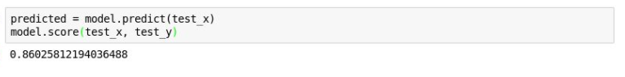
Fig: Testing model

The accuracy we got using random forest classifier is 86%.

- AUC Score (Area under the Receiver operating Characteristic Curve)

- Let's dig a little deeper and determine how accurate the model really is that is, how adapt it is at determining whether a flight will arrive on time by using ROC AUC (Area Under Receiver Operating Characteristic Curve).
- ROC AUC it is one of the most important evaluation metrics for checking any classification model’s performance.

Run the following code to generate a set of prediction probabilities from the test data:

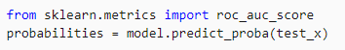

Now use the following statement to generate an ROC AUC score from the probabilities using scikit-learn's roc_auc_score method:

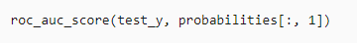

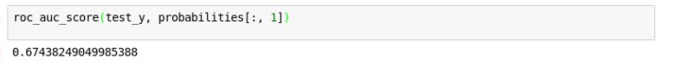

The score we got using ROC AUC is about 67%.

- Score method reflects how many of the items in the test set in the model are predicted correctly. This score of 67% due to the dataset as it contains more information about flights arriving on time that about flights that will be late. So, for accurate results it will be better to predict the flight that arrives on time than to predict whether the flight will be delayed.
- ROC AUC considers and gives a precise value of how likely it is that a forecast of on-time or late will be correct.

- Precision score:

- Generated a confusion matrix also known as an error matrix. The confusion matrix quantifies the number of times each answer was classified correctly or incorrectly.
- Once the confusion matrix is generated, we can predict the accuracy percentage. We used precision_score package in python to find the accuracy.

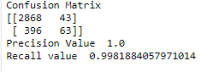
Fig (1) - Precision_Recall: Shows the confusion matrix, Precision & Recall value.

- Future Implementations:

- We have tried to predict the flight delays using the weather reports and considering the weather for next six months and predict the flight delays and cancellations, but the weather dataset was difficult to pull out because it was not free from dark-sky.API
- Mixing up AI in this machine learning Model and training the data helps in faster conclusions and predictions.
- Implementing other classifiers on this dataset and identifying the best suitable classifier for this dataset.
- This model helps us to predict if the flight we have booked is likely to get delayed by knowing this we can select a different flight that could save us time as well as money.

- Source Code:

import numpy as np
import pandas as pd
import math
from sklearn.metrics import roc_curve
from sklearn.metrics import recall_score
from sklearn.metrics import precision_score
from sklearn.metrics import confusion_matrix
from sklearn.metrics import roc_auc_score
from sklearn.ensemble import RandomForestClassifier
from sklearn.model_selection import train_test_split
from datetime import datetime
import matplotlib.pyplot as plt
import seaborn as sns

# Understanding the data
df = pd.read_csv(“C:\Users\MRC\Desktop\FINAL”)
df.head()
df.shape
df.isnull().values.any()
df.isnull().sum()

# Removing null values
df = df.drop('Unnamed: 25', axis=1)
print(df.isnull().sum())

df = df[["MONTH", "DAY_OF_MONTH", "DAY_OF_WEEK", "ORIGIN", "DEST", "CRS_DEP_TIME", "ARR_DEL15"]]
print(df.isnull().sum())

print(df[df.isnull().values.any(axis=1)].head())

# Filling null coulmn values
df = df.fillna({'ARR_DEL15': 1})
print(df.iloc[177:185])
print(df.head())

for index, row in df.iterrows():
df.loc[index, 'CRS_DEP_TIME'] = math.floor(row['CRS_DEP_TIME'] / 100)
print(df.head())

df = pd.get_dummies(df, columns=['ORIGIN', 'DEST'])
print(df.head())

# Data splitting into train and test
train_x, test_x, train_y, test_y = train_test_split(df.drop('ARR_DEL15', axis=1), df['ARR_DEL15'], test_size=0.2, random_state=42)
print(train_x.shape)
print(test_x.shape)
model = RandomForestClassifier(random_state=13)
model.fit(train_x, train_y)
predicted = model.predict(test_x)
model.score(test_x, test_y)

probabilities = model.predict_proba(test_x)
roc_auc_score(test_y, probabilities[:, 1])

# Building confusion matrix based on the false and true positive values
confusion_matrix(test_y, predicted)
print('Confusion Matrix')
print(confusion_matrix(test_y, predicted))

train_predictions = model.predict(train_x)
print('Precision Value ',precision_score(train_y, train_predictions))
print('Recall value ',recall_score(train_y, train_predictions))

sns.set()

fpr, tpr, _ = roc_curve(test_y, probabilities[:, 1])
plt.plot(fpr, tpr)
plt.plot([0, 1], [0, 1], color='grey', lw=1, linestyle='--')
plt.xlabel('False Positive Rate')
plt.ylabel('True Positive Rate')
plt.show()

# A function which changes the input date,time,origin and destination into numerical values for passing it to the model
def predict_delay(departure_date_time, origin, destination):

try:
departure_date_time_parsed = datetime.strptime(departure_date_time, '%d/%m/%Y %H:%M:%S')
except ValueError as e:
return 'Error parsing date/time - {}'.format(e)

month = departure_date_time_parsed.month
day = departure_date_time_parsed.day
day_of_week = departure_date_time_parsed.isoweekday()
hour = departure_date_time_parsed.hour
origin = origin.upper()
destination = destination.upper()

input = [{'MONTH': month,
'DAY': day,
'DAY_OF_WEEK': day_of_week,
'CRS_DEP_TIME': hour,
'ORIGIN_ATL': 1 if origin == 'ATL' else 0,
'ORIGIN_DTW': 1 if origin == 'DTW' else 0,
'ORIGIN_JFK': 1 if origin == 'JFK' else 0,
'ORIGIN_MSP': 1 if origin == 'MSP' else 0,
'ORIGIN_SEA': 1 if origin == 'SEA' else 0,
'DEST_ATL': 1 if destination == 'ATL' else 0,
'DEST_DTW': 1 if destination == 'DTW' else 0,
'DEST_JFK': 1 if destination == 'JFK' else 0,
'DEST_MSP': 1 if destination == 'MSP' else 0,
'DEST_SEA': 1 if destination == 'SEA' else 0 }]

return model.predict_proba(pd.DataFrame(input))[0][0]

print(predict_delay('16/11/2020 13:30:00', 'MSP', 'JFK'))

# Histogram generation for origin MSP to Destination JFK between days Nov 16 to Nov 22

labels = ('Nov 16', 'Nov 17', 'Nov 18', 'Nov 19', 'Nov 20', 'Nov 21', 'Nov 22')
values = (predict_delay('16/11/2020 13:30:00', 'MSP', 'JFK'),
predict_delay('17/11/2020 13:30:00', 'MSP', 'JFK'),
predict_delay('18/11/2020 13:30:00', 'MSP', 'JFK'),
predict_delay('19/11/2020 13:30:00', 'MSP', 'JFK'),
predict_delay('20/11/2020 13:30:00', 'MSP', 'JFK'),
predict_delay('21/11/2020 13:30:00', 'MSP', 'JFK'),
predict_delay('22/11/2020 13:30:00', 'MSP', 'JFK'))
alabels = np.arange(len(labels))

plt.bar(alabels, values, align='center', alpha=0.5)
plt.xticks(alabels, labels)
plt.ylabel('Probability of On-Time Arrival')
plt.ylim((0.0, 1.0))
plt.show()

- Visualize Output of Model

First, we have to install the library for draw a plot of ROC Curve.
For that, execute following statements:

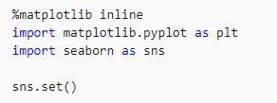

After installing library, to draw a plot of ROC curve for the machine-learning model we have to execute following code:

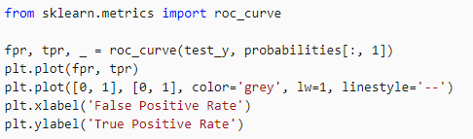

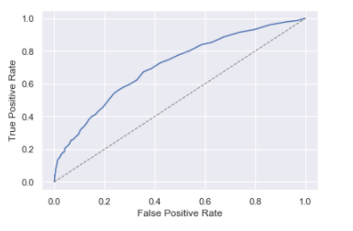

The dotted line in the middle of the graph represents a 50-50 chance of obtaining a correct answer. The blue curve represents the accuracy of your model.

- We have predicted the delay of flights for 7 days from Nov 16 to Nov 22 with the scale of 0.0 to 1.0 .
Input parameters: 16/11/2020 13:30:00', ‘MSP(Minneapolis−Saint Paul International Airport)', ‘JFK(John F. Kennedy International Airport)')
- We can do it for different flights and different airports (Source and destination) and we can estimate the flight delays.

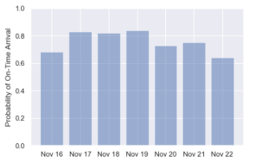

Fig - Flight_probability_prediction: Final output for one airport from one origin to destination

- References

- https://pandas.pydata.org/pandas-docs/stable/reference/api/pandas.DataFrame.fillna.html
- https://machinelearningmastery.com/roc-curves-and-precision-recall-curves-for-classification-in-python/
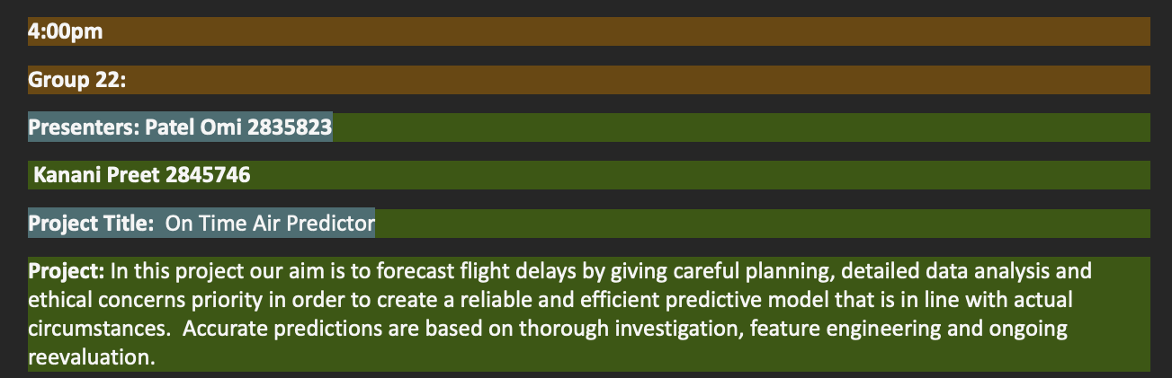
- https://scikit-learn.org/stable/modules/generated/sklearn.ensemble.RandomForestClassifier.html

