ANALYSTLAB AFRICA | DATA ANALYTICS INTERNSHIP | WEEK 3
Validation Evidence
Healthcare Operations & Financial Intelligence Dashboard
Prepared by Safrah Omisanya | October 2026
This document shows how the dashboard numbers were checked against the source files, how the filters were tested, and which discrepancies were found and corrected.

1. Independent verification of calculations
Each value was recalculated outside Power BI, directly from the raw CSV files.
Calculation | Dashboard | Independent result | Tool | Outcome
Total encounters | 27,891 | 27,891 | Excel: COUNTA | Match
Total claim cost | $101.5M | $101,514,375.52 | Excel: SUM | Match
Coverage rate | 30.6% | 30.6% ($31,097,506.99 divided by $101,514,375.52) | Excel: ratio of sums | Match
Unique patients | 974 | 974 | Python (pandas) | Match
Zero-coverage encounters | 48.7% | 13,586 of 27,891 = 48.7% | Python (pandas) | Match
Procedures and average cost | 47,701 and $2,212 | 47,701 and $2,212.06 | Python (pandas) | Match

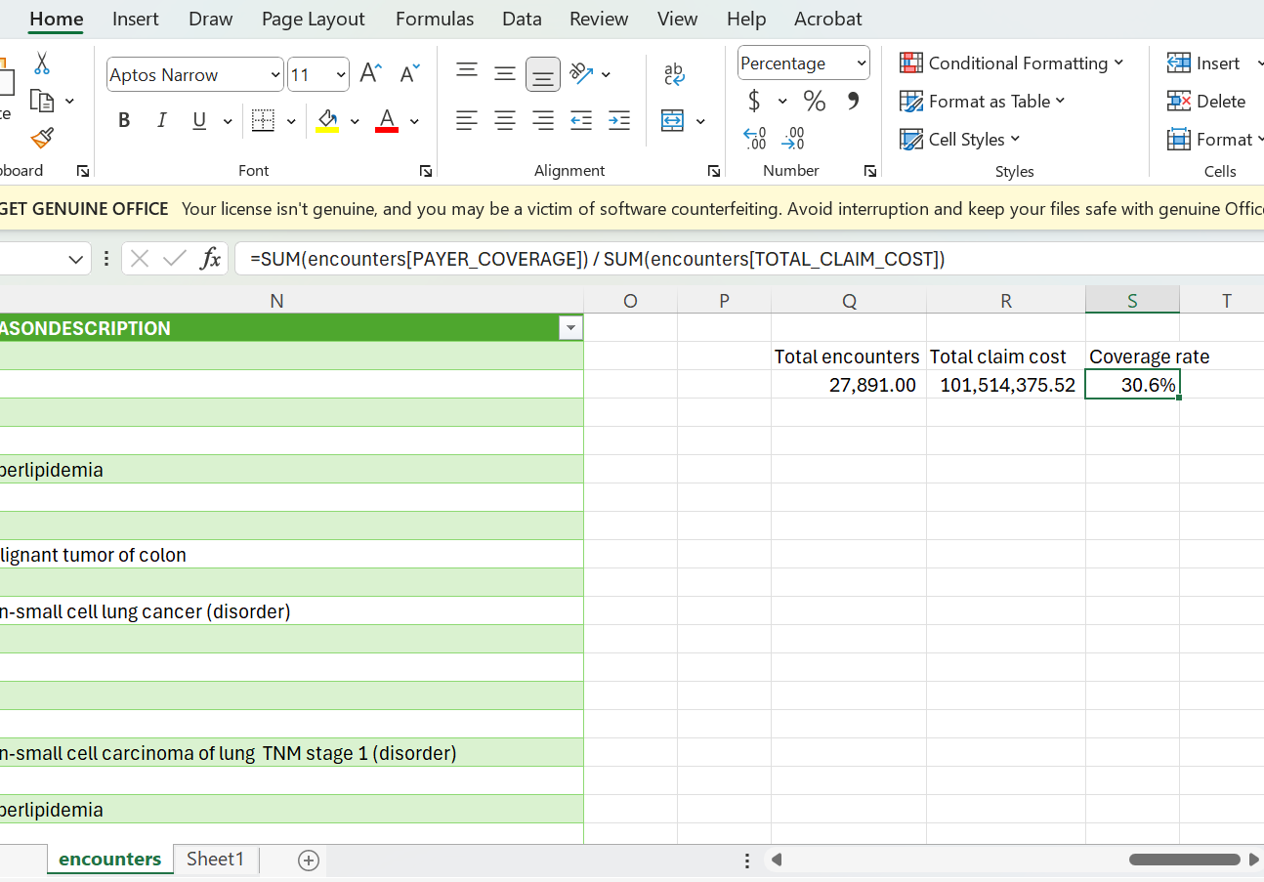
Figure 1. Excel check using the raw encounters file (27,891; 101,514,375.52; 30.6%).

2. Do totals change correctly when filters are applied?
Slicers were set one at a time on the Overview page and the cards were compared with values recalculated from the raw data.
Slicer setting | Measure | Expected (from raw data) | Dashboard
Year = 2021 | Encounters / patients | 3,530 / 649 | Match
 | Claim cost / coverage rate / zero coverage | $9.2M / 31.2% / 45.3% | Match
Class = emergency | Encounters / patients | 2,322 / 465 | Match
 | Claim cost / coverage rate / zero coverage | $10.8M / 30.2% / 32.7% | Match
Payer = Medicare | Encounters / coverage rate | 11,371 / 78.0% | Match
Screenshots of each test are kept in the evidence folder (test1_year2021.png, test2_emergency.png, test3_medicare.png).

3. Discrepancies investigated and corrected
Discrepancy found | Cause | Fix and result
Start times were one hour later than the file (10:26 instead of 09:26Z) | Power Query converted UTC text to local time | Time zone removed without shifting. Times now match the source.
Cards showed "28K" and "$4K" | Automatic abbreviation on cards | Display measures with full number formats. The values were unchanged.
Payer slicer listed long ID codes and Medicare could not be selected | Slicer used encounters[PAYER] (an ID) instead of payers[NAME] | Slicer rebuilt on payers[NAME]. The Medicare test then matched.
Procedure charts listed items like "Encounter for check up" | The chart used encounters[DESCRIPTION] instead of procedures[DESCRIPTION] | Field switched. Top procedures now match the raw data.
Highest-cost chart showed only 2 bars | Top 10 was chosen before the minimum-volume filter, removing most rows | Replaced with the Avg Cost (min 30) measure. The chart shows 10 bars.
Quarter and year axes were out of order | Charts were sorted by value | Sorted by period, ascending.

4. Metrics that could be misleading
- Coverage rate by payer: about 0% for Humana, Anthem, Aetna, UnitedHealthcare and Cigna looks like a recording gap. The overall 30.6% and 48.7% zero-coverage figures therefore understate what payers paid.
- Uncovered cost ($70.4M): claim cost minus recorded coverage. It includes the no-insurance group ($49.3M) and is not what patients paid.
- Procedure BASE_COST: totals $105.5M, more than total claim cost, so it is a list price and must not be added to claims.
- Average procedure cost: distorted by rare procedures, so rankings require at least 30 occurrences.
- Over 24 hours: depends on the boundary. 75 encounters are strictly over 24 hours, but 1,077 last exactly 24 hours.
- 2022: a partial year (to 5 February), not a decline.
- Procedures per encounter (1.71): covers all encounters. Only 52.6% of encounters have a recorded procedure, so the average for encounters with procedures is higher.
- Single hospital: results cannot be benchmarked against other hospitals.

