# **HTML & CSS**

**Objective**

1. To learn CSS features.

1. Design and analyze a webpage by changing color of following code:

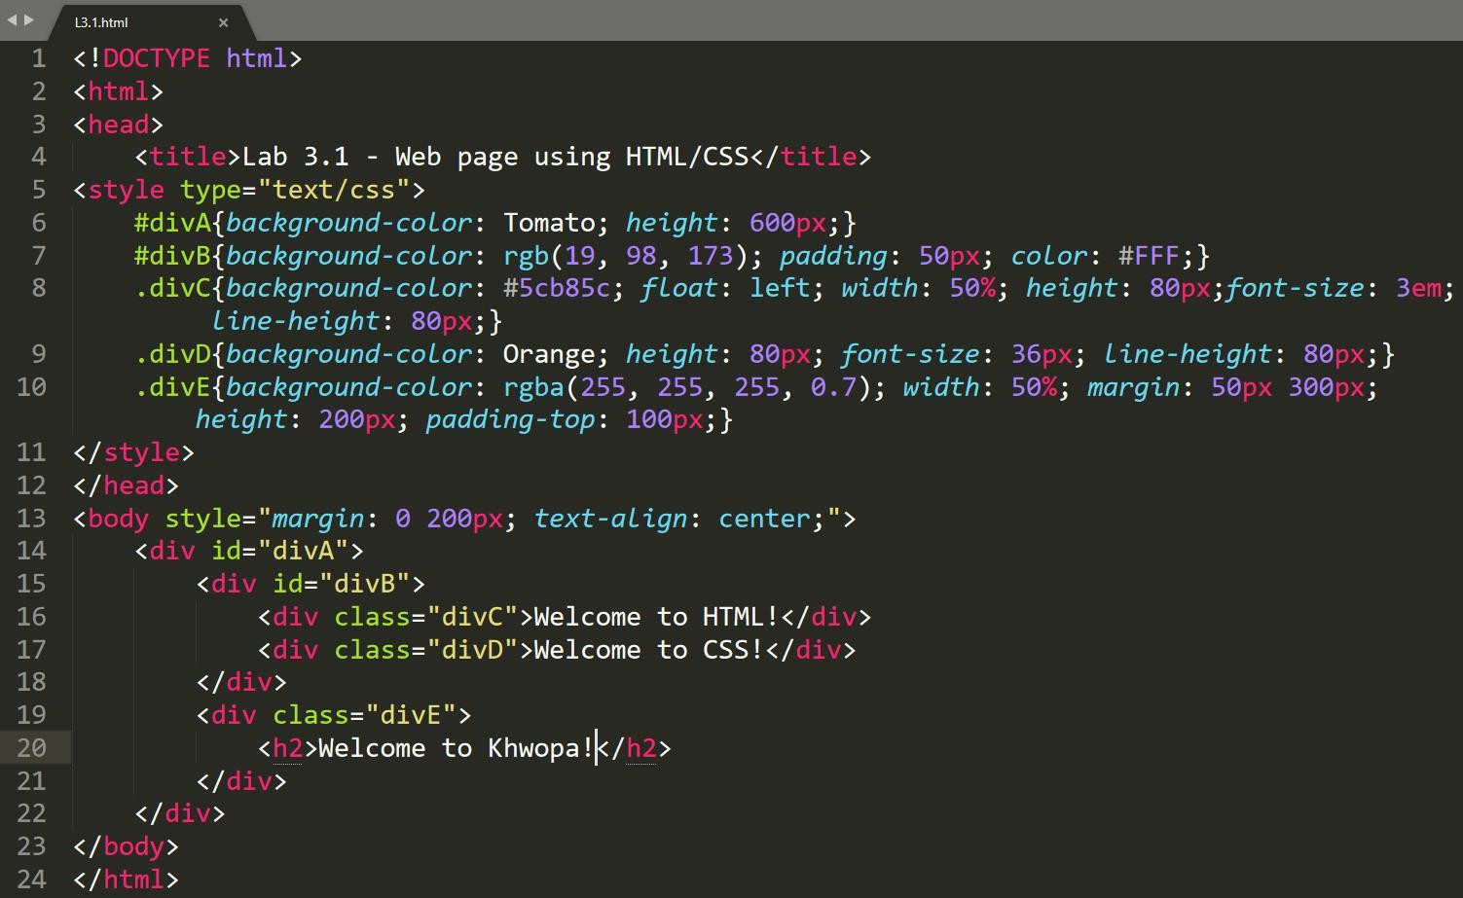

1. Write an HTML/CSS code to generate following output:

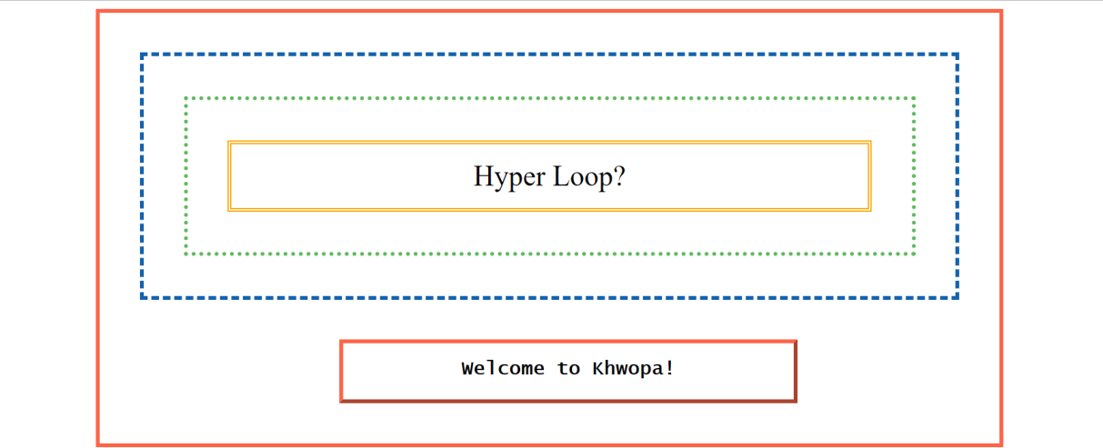

1. Write an HTML/CSS code to generate following output:

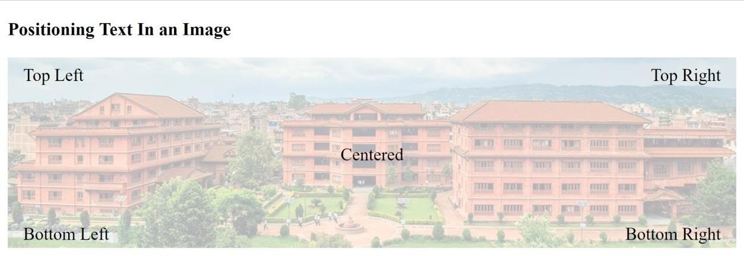

1. Generate the following output by considering following points:
   1. Greenish color on hover to the table row
   2. Font Family: sans-serif
   3. Apply background color #BEE5EB to even table row

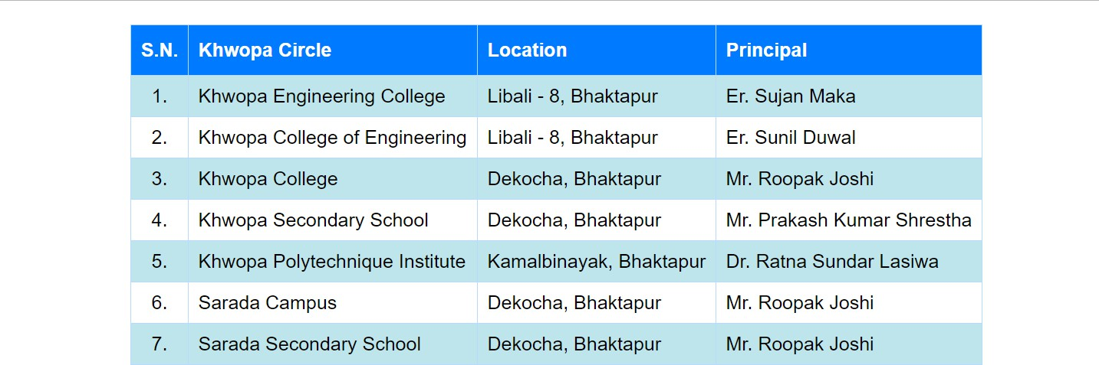

**Assignment**

Design a webpage by using HTML/CSS you learned in this lab.