# **HTML**

Objectives:

1. To learn basic HTML features.

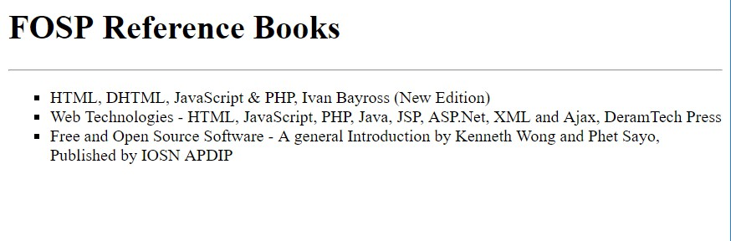

1. Type the following code in lab1_1.html page, run that page in browser and note & discuss the output.

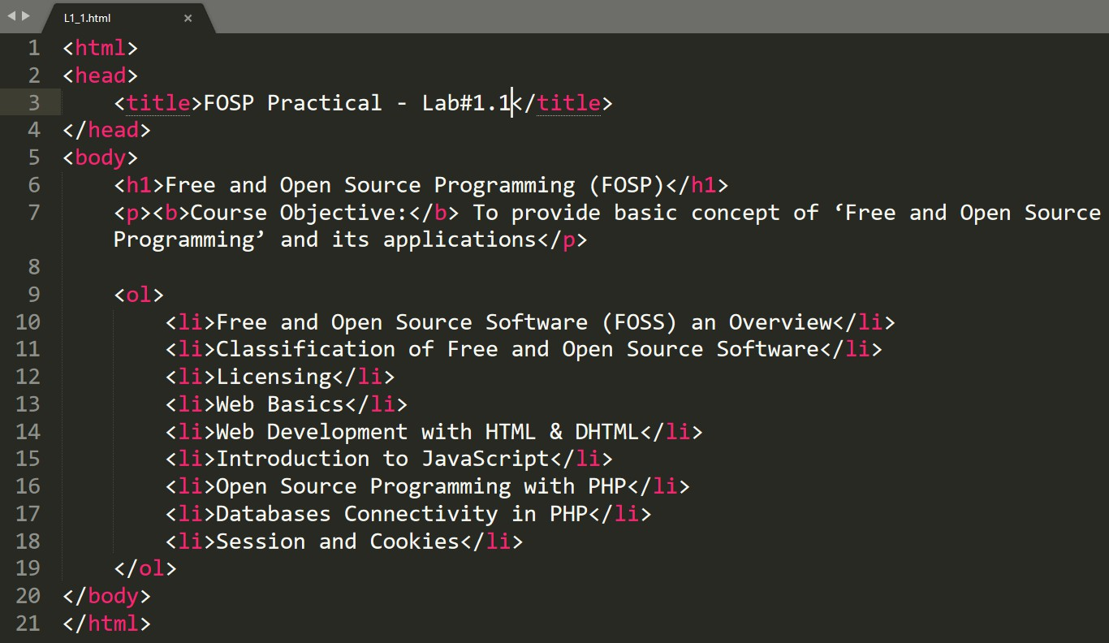

1. Display the given text in your web page:
2. Write an HTML markup to generate following output:



1. Implement following topics by searching on internet and show your output to your lab instructor:
   * Aligning the Headings
   * Working with Links
   * Creating a table
   * Change the text color
   * Text & Element Formatting