Calibrated Topology and Phase Diagnostics for Transcriptomic State Spaces
Author names, affiliations, corresponding author details and ORCID identifiers to be supplied by the authors
Keywords: persistent homology; transcriptomics; biological rhythms; surrogate calibration; circular statistics; reproducible analysis

Abstract
Persistent loops in transcriptomic sample spaces describe geometric recurrence, but do not by themselves identify rhythmic genes or biological oscillators. We developed OmicsTopology, an open-source workflow that separates first-homology (H1) detection under a fitted Gaussian reference, sensitivity to sample removal, association with experimental axes, and gene-level circular-phase diagnostics. In a frozen evaluation of 60 simulated clouds, the method recovered the reference counts in all six single-loop and six balanced double-loop cases and returned no positive detections among 36 noncyclic controls. It undercounted all six unequal-strength double loops, and five of six sparse triple-loop cases had stable zero detections. Public transcriptome reanalyses showed strong time-associated geometry but no stable positive H1 detections under the selected settings. Matched ordering comparisons identified no general advantage for any method. In Arabidopsis, genes ranked by heat-control phase difference were enriched for published heat-responsive genes in a separate experiment (odds ratios, 3.72–4.90; adjusted q values, 4.43 × 10⁻⁹–8.43 × 10⁻⁹), while genotype-under-heat enrichment was unsupported. These results establish a reproducible hypothesis-generation workflow and quantify its failure modes; they do not validate an oscillator counter or a causal clock mechanism.

1 Introduction
Biological rhythms organize molecular processes across time, and transcriptomic measurements provide a high-dimensional view of their coordinated outputs. Analysis commonly begins by identifying genes with rhythmic expression, estimating phase and amplitude, or predicting the biological time associated with a sample. Experimental design, sampling density, biological replication, and waveform assumptions materially affect these tasks. [1] A complementary question concerns the geometry formed by entire samples: does a transcriptomic trajectory return toward previously occupied molecular states, and does this recurrence remain visible when examined across scales? Addressing that question requires a clear distinction between the behavior of individual transcripts and the shape of the collective measurement space.
Persistent homology describes topological features that appear and disappear as a scale parameter varies. [2, 3] Its first-homology summaries capture loop-like structure in a finite point cloud without requiring a predefined cyclic ordering. Stability theory relates perturbations of suitable inputs to changes in persistence diagrams, providing a mathematical foundation for interpreting multiscale structure. [4] More broadly, topological data analysis offers a language for examining shape in high-dimensional data. [5] Biological applications have illustrated how shape-based summaries can reveal structure that is difficult to express through a small collection of individual variables. [6] However, a stable mathematical summary and a validated biological interpretation remain separate achievements.
Existing rhythm-analysis methods establish several relevant but distinct comparison points. JTK_CYCLE uses rank-based comparisons to detect rhythmic components, while RAIN accommodates asymmetric rising and falling patterns. [7, 8] MetaCycle integrates established periodicity methods into a common analysis workflow. [9] Improved statistical calibration and empirical evaluations show that detection depends on signal strength, waveform, and the construction of the reference distribution. [10] These methods principally ask whether individual measurements exhibit rhythmic behavior against an ordered time coordinate. They do not directly estimate the number of persistent loops in the space formed by multigene sample vectors.
Topological approaches also have a substantial history in time-series analysis. Sliding-window embeddings relate periodic signals to loop-like point clouds, and their persistence depends on embedding parameters and signal properties. [11] SW1PerS exploits this relationship to quantify periodicity in expression trajectories, while TimeCycle develops a topology-inspired approach to detecting cycling transcripts. [12, 13] Phase inference and sample ordering provide another perspective: ZeitZeiger learns periodic predictors from high-dimensional measurements, and CYCLOPS reconstructs transcriptional ordering from collections of samples. [14, 15] These contributions motivate geometric analysis but also clarify why different methods should not be compared as interchangeable answers to one biological question.
A sample-space H1 detection is distinct from a rhythmic-gene call, a phase estimate, and a biological oscillator count. For an ideal product of independent circles, the first Betti number equals the number of circle factors. Yet measurements of a biological system need not preserve that product topology. An observation map can collapse separate processes, incomplete phase coverage can leave a trajectory open, and treatment or batch structure can dominate the chosen dissimilarity. Two persistent H1 features also do not establish a torus: multiple spaces can have the same first-homology rank. Assigning a topological feature to a specific physiological mechanism requires evidence beyond the persistence diagram.
Statistical interpretation introduces additional requirements. Confidence-set and bootstrap approaches for persistence diagrams explicitly state the sampling models and objects for which uncertainty is quantified. [16, 17] Persistence landscapes offer another route for incorporating topological summaries into statistical analysis. [18] A fitted surrogate reference addresses a different question: whether observed features are unusual relative to a specified generative comparison. Surrogate-data methodology makes the reference construction part of the hypothesis rather than an interchangeable technical detail. [19] Consequently, a maximum-surrogate score should not be described as a distribution-free guarantee or a confidence statement about the number of biological processes.
Here, OmicsTopology separates three outputs: detection of H1 features relative to a fitted Gaussian reference, agreement of those detections under sample removal, and association of expression distances with recorded design axes. A second diagnostic layer evaluates whether reliable harmonic phases exhibit a coordinated offset or predominantly gene-specific differences. The contribution is the explicit integration of established methods, auditable decision logic, and evaluation of where that logic succeeds or fails. In addition to frozen simulations and development reanalyses, external source studies test transfer, a matched geometric comparison tests ordering performance, and a separate heat experiment tests a gene-level consequence of the phase diagnostic. These analyses support geometric hypothesis generation while keeping evidence of biological mechanism distinct from reproducible software output.

2 Results

2.1 A staged workflow separates detection from interpretation
The workflow begins with a finite samples-by-features matrix and a declared preprocessing route (Figure 1). After removing constant features and standardizing columns, the H1 protocol computes correlation dissimilarities in the retained feature space. Persistence is evaluated with the Ripser engine through its Python implementation. [20, 21] The general two-condition software workflow additionally supports a shared principal-component representation, but that visualization route is distinct from the full-feature geometry used in the present count protocol. Principal-component analysis can summarize variation effectively, yet truncating its representation changes the geometry available to a downstream topological calculation. [22]
For each observed H1 bar, the protocol asks whether its normalized lifetime exceeds the distribution of the maximum lifetime in fitted surrogate clouds. Testing against a maximum reference permits two similarly persistent bars to be retained together. The procedure does not require one observed bar to dominate every other bar by a specified ratio. This matters because a large ratio between the two longest bars is a criterion for dominance of one feature, rather than a general criterion for the existence of several features. Full-cloud candidates subsequently pass through a separate resampling stage, which can return a stable count, stable zero detection, or an unresolved result.
The final workflow branch describes experimental coordinates without allowing those labels to determine the H1 count. A circular time coordinate yields an expression-distance association; a categorical treatment yields a coding-invariant between-category comparison. Phase fits and matched-distance contrasts then describe how the recorded axes relate to expression geometry. Figure 1 therefore provides an interpretation map as well as a software map: a detected feature, a robust detection, an axis association, and an independent biological oscillator occupy different evidential levels. The API preserves these distinctions in separate output fields, including an explicit withheld-count value.

2.2 Frozen simulations recover balanced loops and expose incomplete counts
The frozen evaluation contains ten generator families with six independently seeded clouds per family. Six families are noncyclic controls (Gaussian noise, ramp, clusters, branch, open arc, and drift); four have positive generator ranks (one, two balanced, two unequal-strength, and three sparse cycles). Configuration and algorithm digest were fixed before scoring, and evaluation seeds were kept separate from development seeds. This is an internally frozen evaluation, not external preregistration or an independently conducted benchmark. [23]
All six single-cycle clouds receive a stable count of one, and all six balanced double-cycle clouds receive a stable count of two (Figure 2c). This shows that similarly persistent bars can both pass the maximum-surrogate reference without requiring one bar to dominate another. None of the 36 noncyclic clouds receives an accepted positive count; the Wilson 95% interval for this observed proportion is 0%–9.64%. [24] The result describes these specified generators and does not estimate a universal false-positive rate for transcriptomic data.
The positive cases also expose limits. All six unequal-strength double-cycle clouds are reported as one feature. In the sparse triple-cycle family, five clouds receive stable zero detections and one is unresolved. Thus, 18 of 24 positive-generator clouds receive a positive detection, but only 12 of 24 recover the generator reference rank. Across all 60 clouds, 59 receive an answer and 11 of those answers differ from the generator rank. These proportions depend on the chosen generator mixture and are not population estimates of sensitivity or accuracy.
A cutoff-sensitivity analysis recalculates answer coverage and generator-rank disagreement across alternative stability-agreement thresholds using the same scored records. The reported decision retains the frozen 0.75 threshold; the alternative thresholds are descriptive and were not used to tune the evaluation. Stable output fields and explicit abstention make uncertainty visible, but do not make stable counts complete.
The successful balanced cases therefore define only a limited operating range. A stable count is the number of H1 features detected under the selected geometry and reference, not a guarantee that every latent factor has been recovered. The contrast between balanced and unequal loops shows that recovery depends on relative signal strength as well as resampling stability.

2.3 Circular diagnostics distinguish coordinated shifts from gene-specific dispersion
Thirty additional simulations evaluate five second-axis scenarios, with six seeds per family. The inert scenarios receive no resolved axis effect, common-phase scenarios receive phase modulation, and gene-specific phase scenarios receive shape change (Figure 3b). Independently varying phases and discrete noncyclic shifts both receive a strong-axis-effect label in all six cases. A categorical perturbation can separate sample clouds strongly without introducing another cyclic coordinate; the coding-invariant design matrix in Figure 3a makes that distinction explicit.
The circular decomposition explains the distinction between phase scenarios. Phases near opposite ends of an angular coordinate can be close on the circle, making arithmetic subtraction inappropriate for offsets and residuals. Circular statistics instead represent directions by unit vectors and quantify their concentration. [25] OmicsTopology estimates gene-specific reference phases, block offsets, and wrapped residuals, then measures agreement among genes around each block offset. A common offset is interpreted only when enough genes have reliable harmonic fits and agree about a nonzero shift. Concentration of block means alone is insufficient.
The resulting common-shift and gene-specific shares summarize circular dispersion among reliably fitted features. They are not fractions of total transcriptomic variance, proportions of rhythmic genes, or probabilities of a biological mechanism. Likewise, the operational shape-change label refers here to predominantly gene-specific phase differences; it does not establish arbitrary waveform remodeling. The simulation results validate discrimination among these declared scenarios. More complex changes involving amplitude, harmonics, transient responses, or heterogeneous periods remain outside that validation and require additional models.

2.4 Numerical provenance connects inference to reproducible output
The software retains the information needed to audit an analysis rather than reporting a final integer alone (Figure 4). Source accessions, processed-file hashes, sample identities, transformations, selected feature identifiers, random seeds, and an algorithm digest connect public measurements to scored records. Per-cloud persistence spectra, surrogate maxima, reduced-cloud candidate counts, axis associations, and phase summaries expose intermediate evidence. The record distinguishes a stable zero, a positive detection, and an unresolved candidate.
The command-line comparison route and the full-feature v2 inference API are separate analysis paths. The former supports shared-principal-component summaries; the latter defines the calibrated H1 protocol evaluated here. Regeneration scripts and editable vector figures document their inputs and outputs. These capabilities support scrutiny without implying a graphical interface, automatic biological certification, or equivalence between the two geometric representations.

2.5 Yeast metabolic-cycle data yield an unresolved candidate
GSE3431 provides a source study not used in the earlier development corpus. The original experiment characterized temporally organized expression during the yeast metabolic cycle. [26] Its processed series contains 36 ordered samples across three successive cycles. The accession is available through the Gene Expression Omnibus, which also supplies the sample metadata needed to trace the released measurements. [27] For this reanalysis, the processed values are retained without another logarithmic transformation, and 1,000 variable features define the primary expression geometry. The source study is held out from parameter fitting, but its known biological context remains available and the analysis is retrospective.
The full cloud contains one candidate H1 feature, and association with the recorded circular coordinate is strong, with Mantel r = 0.811 (Figure S1a). However, only four of eight reduced clouds recover the candidate count. The resulting agreement of 0.50 falls below the frozen 0.75 threshold, so the final output is unresolved (Figure S1b). The 500-feature sensitivity analysis is also unresolved, whereas all 9,335 varying features yield no accepted H1 detection. These outcomes show that strong temporal association and a candidate persistence bar need not produce a robust count.
The biological and statistical sampling units matter. Three successive cycles in one continuous culture are not three independent cultures. Row removal measures sensitivity to geometric coverage, not reproducibility across biological replicates, and no time-series permutation p-value is assigned. The unresolved result neither negates the metabolic program established by the original study nor supplies an independently confirmed topological positive; it records that the present protocol did not meet its own stability requirement.
Feature selection also changes the geometry under study. Selecting highly variable features emphasizes one part of the measured transcriptome, whereas retaining all varying features includes additional patterns and measurement variation. Neither choice is justified by whether it produces a visually appealing loop. The primary and sensitivity analyses are therefore reported together, with their selection settings available in the evidence records.

2.6 Heat-associated phase dispersion does not demonstrate cycle loss
GSE158444 is the development case and contains total and translating RNA measurements under control conditions and one-hour heat treatment. The original study established time-dependent priorities in the translating RNA pool during heat stress. [28] The present analysis asks a narrower geometric question: whether treatment-associated separation resembles a coordinated phase displacement among reliable harmonic features or predominantly gene-specific phase differences. Within the first 24 hours, each RNA fraction contributes 47 retained libraries, comprising 23 control and 24 heat-treated libraries across eight sampling hours. The fractions belong to one source study and are not independent replications.
Treatment distance associations are r = 0.986 for total RNA and r = 0.985 for translating RNA (Figure S2b). Among 582 reliably phased features from the 1,000 selected features, the common-shift component accounts for 2.42% of circular phase dispersion and the gene-specific component for 97.58% (Figure S2a). For translating RNA, 689 features are reliably phased; common and gene-specific components account for 0.90% and 99.10%, respectively (Figure S2a). Both fractions receive the operational shape-change label. Thus, within the analyzed feature sets, a single coherent phase offset does not summarize most of the fitted treatment-associated phase differences.
Topology yields a different and more limited statement. Total RNA receives stable zero detections in both control and heat conditions. Translating RNA receives an unresolved control result and a stable zero heat result. Consequently, these analyses do not establish a treatment-induced change in H1 count. They cannot support the claim that heat destroys a transcriptomic loop or abolishes the circadian program. Strong treatment separation is compatible with several changes in molecular state, including shifts in abundance and gene-specific timing, and the present diagnostics do not assign a unique causal mechanism.
The two RNA fractions are complementary measurements from one source experiment, so their agreement is within-study consistency rather than independent validation. Phase shares apply only to the reliably fitted, selected features; they do not support inference about all expressed genes.

2.7 External source studies reveal transfer limits and provide matched comparisons
Two additional source studies extend evaluation beyond the development data: hourly mouse-liver profiles from GSE11923 and Arabidopsis whole-leaf, mesophyll, and vasculature profiles under long and short days from GSE50438. The original studies establish the sampling context and known rhythm biology. [29, 30] The mouse matrix contains 48 arrays; the plant study contributes six 12-array subsets from one 72-array experiment. These six subsets are related strata of one study, not six independent replications. Features are selected by variance without using timestamps, and all topology settings remain those of the frozen v2 protocol.
Across the seven matrices, time-associated geometry is strong: descriptive circular Mantel r is 0.750 for mouse liver and 0.835–0.899 for plant subsets (Figure 5c). Nevertheless, all seven yield zero full-cloud candidates and stable zero detections, with agreement in all eight reduced clouds. This result demonstrates transfer of a conservative decision rule, but supplies no externally confirmed positive H1 detection. It also identifies an important sensitivity limitation: known temporal organization can remain visible in distances while failing the fitted reference criterion. The result does not negate rhythmic expression in the source experiments.
A common ordering task compares the longest H1 representative walk with PCA angle, fitted-circle PCA angle, classical multidimensional scaling, Isomap, Laplacian eigenmaps, and a deterministic nearest-neighbor tour with 2-opt improvement (Figure 5a). Isomap and Laplacian eigenmaps provide established nonlinear geometric baselines. [31, 32] All receive the same selected samples and features; distance-based approaches receive the same correlation dissimilarity. Time is withheld during fitting and used only to score cyclic succession. The H1 walk is examined descriptively even when its bar does not pass the reference test; it is not presented as an accepted topological detection.
Mouse-liver succession is 0.545 for the H1 walk, compared with 0.271–0.604 for full-coverage baselines. However, the H1 walk visits only 11 of 48 arrays, so its score is conditional on restricted support. Plant H1 walks score 0.900–1.000 while visiting 58.3%–83.3% of arrays; most baselines score 1.000 while visiting every array. Supporting Information reports scores restricted to H1-walk vertices, full-support scores, coverage, mean circular step, and fitting time. These descriptive comparisons establish neither general superiority nor population-level accuracy. The demonstrated software contribution is calibrated detection with explicit abstention, not universally improved sample ordering.

2.8 Phase-dispersion candidates show external heat-program association
The phase diagnostic motivates a gene-level hypothesis: features with large heat-associated phase differences may be enriched for heat-responsive expression in a separate experiment. Among reliably fitted features, the top 20% by absolute wrapped heat-control phase difference comprise 117 of 582 total-RNA genes and 138 of 689 translating-RNA genes. Candidate selection uses GSE158444 before matching to external gene tables. GSE116004 supplies a separate temperature and clock-mutant experiment from the same research group, with published contrasts for cca1 lhy and prr7 prr9 backgrounds. [33] This is cross-experiment support, not replication by an independent laboratory.
After identifier matching, 116 candidates among 573 total-RNA genes and 137 among 685 translating-RNA genes are evaluable. External heat response is defined as an absolute log2 fold change of at least one and a published false-discovery rate below 0.05 for 37 °C versus 22 °C. One-sided Fisher tests compare candidates with other reliably fitted, mapped genes. The four odds ratios are 4.90 and 4.04 for total RNA and 4.49 and 3.72 for translating RNA; Benjamini–Hochberg adjusted q values range from 4.43 × 10⁻⁹ to 8.43 × 10⁻⁹ (Figure 6a). [34] The phase-difference ranking is therefore associated with a heat-responsive gene program across experiments.
The analysis does not establish clock specificity. Exploratory enrichment for mutant-versus-wild-type differential expression under heat gives odds ratios of 0.70–1.71 and adjusted q = 0.870 in all four tests (Figure 6b); these contrasts are not genotype-by-temperature interaction tests. The external sampling times do not validate phase shifts, and coexpression limits interpretation of gene-set p-values as independent replication. Acute abundance responses can also affect a fitted harmonic phase. The supported result is a cross-experiment association with heat-responsive expression; a causal clock-resetting mechanism and treatment-induced cycle loss remain unestablished.

3 Discussion

3.1 A practical role for topology alongside rhythm analysis
The framework addresses an interpretation problem in molecular-state analysis: outputs that appear to describe a cycle answer different questions. A rhythmic transcript can coexist with an open sample trajectory, while a closed trajectory does not identify the molecular components that generate it. Likewise, a circular sample order does not establish the number of independent latent coordinates. Gene-level rhythm tests, periodic predictors, sample ordering, and sample-space persistence are complementary analyses. The present results show how reporting unresolved topology alongside axis and phase diagnostics can prevent one output from being mistaken for another.
SW1PerS and TimeCycle analyze transcript trajectories, whereas the H1 protocol analyzes distances among multigene sample vectors. The targets are complementary: a higher sample-cloud persistence score does not imply better gene-level rhythmicity detection. The matched ordering comparison evaluates a shared geometric task and does not replace dedicated benchmarks of transcript rhythmicity or supervised phase prediction.

3.2 Surrogate detection and stability quantify different uncertainties
The maximum-reference procedure avoids requiring one signal bar to dominate another and compares each observed bar with the same type of surrogate maximum. The Gaussian covariance is estimated from the dataset under examination, so the resulting tail scores are conditional, model-based comparisons rather than exact randomization p-values under a known exchangeable null. Heterogeneous subpopulations, heavy tails, nonlinear dependence, and temporal structure may not be represented adequately. More surrogate draws improve Monte Carlo resolution but cannot correct a misspecified reference.
Resampling evaluates whether detections persist under the implemented removal of observations; it does not establish complete recovery. A weak circle may be missed in both the full cloud and most reduced clouds. A candidate may also depend on observations that bridge a sparsely sampled region, as in the unresolved yeast case. Agreement is not the probability that a reported count is biologically correct. Reduced clouds overlap, so the Wilson interval summarizes the observed agreement procedure and is not an independent-trial confidence interval for an underlying manifold.
Coverage remains a central limitation. A product of cyclic coordinates requires observations across coordinate combinations, while unequal signal strengths or an observation map can obscure one factor. More features alone cannot guarantee recovery. Independent experimental series and perturbations designed to distinguish hypothesized factors would provide stronger biological evidence than repeated removal of rows from one dataset.

3.3 Design association requires explicit exchangeability
Distance association is useful because it links a high-dimensional geometry to an interpretable coordinate. The Mantel statistic supplies a familiar correlation between pairwise dissimilarities. [35] Its interpretation nonetheless depends on the design and the allowable randomization; known problems arise when structured dependencies are ignored. [36] Pairwise distances share observations, so treating distance entries as independently exchangeable is inappropriate. OmicsTopology permutes sample identities jointly across rows and columns, with optional restrictions on the sample exchanges. The statistic remains descriptive when the experimental design does not justify those exchanges.
Chronological measurements, repeated subjects, and matched sampling hours require defensible exchangeability assumptions. General permutation principles make this dependence explicit. [37] If a restricted scheme leaves the reference distances unchanged, the software withholds its p-value. Monte Carlo tails use the plus-one convention. [38] These choices do not turn association into a test of latent independence.

3.4 Reproducibility supports scrutiny rather than biological certification
The released workflow retains numerical records, settings, selected feature identifiers, sample identities, source hashes, and an algorithm digest. These records let readers distinguish verification of committed summaries from regeneration from public source matrices. Versioned evidence also prevents historical plots from silently inheriting claims made for the corrected protocol; earlier outputs remain labeled as historical and are excluded from current validation claims.
The evidence has clear limits. The noncyclic simulation set contains 36 clouds, and the real analyses yield no stable positive H1 detection under the selected settings. The matched baselines do not establish a general ordering advantage. The heat-response extension supports a cross-experiment gene-set association, but clock specificity, phase replication, and causal regulation remain unresolved. OmicsTopology is therefore best supported as a reproducible analysis and hypothesis-generation framework; claims about oscillator counts or biological mechanisms require additional evidence.

4 Conclusion
OmicsTopology integrates surrogate-calibrated H1 detection, resampling sensitivity, experimental-axis association, and circular phase diagnostics in a reproducible workflow. Frozen simulations recover single and balanced double loops but expose undercounting of unequal and sparse structures. Public transcriptome reanalyses show time-associated geometry without stable positive H1 detections under the selected settings, and matched ordering comparisons show no general advantage. A phase-difference ranking is associated with heat-responsive expression in a separate Arabidopsis experiment. Together, these results support auditable hypothesis generation while defining the limits of geometric evidence for biological oscillators and causal mechanisms.

5 Experimental Section

5.1 Software and expression geometry
The analyzed implementation is OmicsTopology version 0.2.0 at source revision 13b1955c8a01c56e2c10c5578c395cdbb09f84d1. NumPy and SciPy provide the numerical infrastructure. [40, 41] Inputs must be finite two-dimensional matrices. Constant columns are removed, and remaining columns are centered and divided by their sample standard deviations. Correlation dissimilarities are calculated between sample vectors; the corresponding Vietoris–Rips filtration uses coefficients in the field with two elements. Ripser is explicitly selected for the reported analyses, and backend failure raises an error. A truncated built-in filtration is not substituted for the calibrated analysis. H1 lifetimes are divided by the square root of half the mean squared entries of the dissimilarity matrix, using the same convention for observed and surrogate clouds.

5.2 Gaussian reference and resampling decision
A singular-value decomposition retaining all numerically nonzero components of the standardized matrix supplies feature loadings and principal-score standard deviations. Independent Gaussian scores with these standard deviations are projected through the retained loadings to reconstruct feature-space surrogate matrices. Every reconstruction is standardized again and passed through the same dissimilarity and persistence calculation as the observations. This reconstruction matters because substituting principal scores preserves Euclidean geometry under suitable rotations but does not generally preserve correlation dissimilarity between sample vectors. Each draw contributes its maximum normalized H1 lifetime, or zero when no H1 bar is present.
For each observed lifetime, the tail score equals one plus the number of surrogate maxima at least as large as that lifetime, divided by one plus the number of surrogate draws. Lifetimes with scores at most 0.05 contribute to the candidate count. The frozen evaluation uses 99 full-cloud draws, eight reduced clouds, 39 independently generated surrogate draws per reduced cloud, and a retention fraction of 0.9. Each reduced cloud refits its own reference. A count is accepted when at least 75% of completed reduced clouds agree with the full-cloud candidate count. With insufficient agreement or no informative reduced clouds, the count is withheld. API defaults use 199 full-cloud draws and twelve reduced clouds; reported numerical records retain the evaluation settings rather than inheriting unstated defaults.
When independent units are supplied, the procedure retains complete units during subsampling. Otherwise it removes rows, optionally within declared strata, and the result is a geometric sensitivity analysis. The output status counted denotes a stable positive detection, no_cycle denotes stable zero detection under this analysis, and unresolved denotes a withheld count. The retained field name n_cycles is an API convention and does not change the stated interpretation as detected H1 features. Wilson intervals summarize the implemented agreement proportion with the dependence caveat given above.

5.3 Axis representation and circular phase decomposition
Periodic coordinates are converted to angles using the declared period. Categorical axes use zero distance for equal labels and unit distance for unequal labels, avoiding arbitrary numeric order. Expression-distance association is the Pearson correlation between the upper-triangular entries of the expression and coordinate dissimilarity matrices. Permutation p-values are omitted by default. Where specified, sample labels are exchanged jointly across matrix rows and columns, optionally within declared strata; a degenerate exchange scheme returns no p-value.
For phase diagnostics, each feature is regressed on an intercept, cosine, and sine within each fit block. Blocks require at least six observations and a full-rank harmonic design. Features must have harmonic explained variance of at least 0.2 in every block, and at least three features must pass. Phases follow from the fitted cosine and sine coefficients. Circular means define reference phases and block offsets; phase residuals are wrapped around the circle. The mean of one minus the cosine of angular deviations defines circular dispersion. The common share is one minus the ratio of residual to total dispersion, clipped to the unit interval; its complement is the gene-specific share.
Phase modulation requires common share and gene coherence of at least 0.8, with a maximum pairwise block offset of at least 0.1 radians. Predominantly gene-specific dispersion can produce shape_change; strong axis association uses an r threshold of 0.5. These labels are operational descriptions. Matched-phase contrasts compare distances between samples sharing phase but differing in the second-axis label against all different-phase pairs. Ratio and absolute-difference intervals are computed separately. Optional bootstrap draws retain supplied units or resample rows within fit blocks for phase uncertainty. Raw-row intervals remain descriptive for temporally dependent observations, and none of the phase shares is a linear expression-variance decomposition.

5.4 Simulation design and source-study preprocessing
The frozen plan specifies six evaluation seeds for each of ten topology families and five axis families, with development seeds excluded. Generator settings, latent reference ranks, spectra, surrogate maxima, and reduced-cloud counts are retained in benchmark/v2/validation.json. The generator rank is a latent reference, not a guarantee that the finite observed cloud resolves the corresponding manifold. Each cloud has 96 features. Single-cycle and noncyclic families contain 48 samples; the two-cycle and three-cycle families contain 64. Double-cycle samples form an eight-by-eight phase grid, with the second factor scaled to 0.35 in the unequal-strength family. Triple-cycle samples use four phases per factor on a four-by-four-by-four grid. Except for the direct Gaussian control, latent coordinates are projected through Gaussian feature loadings and receive additive Gaussian noise with standard deviation 0.12. Axis scenarios contain 48 samples and 96 features, with twelve time phases in each of four blocks; the common-offset schedule is 0, 0.25, 0.50, and 0.75 radians. The released generators specify the remaining shifts and loadings exactly. Risk-versus-coverage summaries reuse those scored records without changing the frozen reported threshold. The complete generator implementations and seed schedules accompany the plan, allowing the exact mixtures and sampling regimes to be regenerated rather than inferred from representative pictures.
For GSE3431, sample metadata establish the submitted T1–T36 order and the phase schedule. Released processed expression values are used directly; no additional log transform is applied. The primary route retains the 1,000 most variable features, with 500-feature and all-varying-feature sensitivity analyses. The analysis does not treat successive metabolic cycles as independent biological units and assigns no time-series permutation p-value. This study is held out from fitting the reported procedure, while GSE158444 remains the development source study.
For each GSE158444 RNA fraction, libraries in the first 24 hours are retained. Counts are converted to counts per million, features with at least one count per million in at least 20% of retained libraries are kept, and values are transformed by log2 of counts per million plus one. The 1,000 most variable features within each fraction define its analysis matrix. Available libraries yield 23 control and 24 heat samples in each fraction; missing libraries are not fabricated. Treatment-label exchanges, when evaluated, are restricted within sampling hour, with the remaining exchangeability assumption stated explicitly. Topology of each arm and phase diagnostics across arms are calculated separately. Source hashes, selected identifiers, and matrix digests are preserved in the real-validation record.

5.5 External studies, common-input comparison, and gene-set extension
GSE11923 MAS5 intensities and GSE50438 released positive GC-RMA intensities are transformed as log2(maximum(value, 0) + 1). Within each matrix, the 1,000 highest-variance finite, nonconstant features are retained, with source-order tie handling. The extension is retrospective. An initial GSE50438 scale assumption was corrected after inspecting its numerical range and initial analysis; this amendment prevents describing the study as untouched prespecified external validation. Source-file digests and numerical environments accompany the final regenerated records. The primary core algorithm and its frozen thresholds are unchanged.
All seven ordering methods use the same standardized selected matrix. PCA and fitted-circle PCA use its first two score coordinates; the circle fit retains its estimated center when computing angles. Classical MDS uses the squared correlation dissimilarity. Isomap and Laplacian eigenmaps use six neighbors and precomputed correlation dissimilarities, with spectral random state zero. Implementations use scikit-learn where applicable. [42] The tour starts at sample zero, chooses the nearest unvisited vertex with deterministic ties, and applies improving 2-opt swaps. Fitting time includes embedding or decomposition but excludes common matrix preprocessing. Method settings are fixed, without clock-score tuning.
External phases are reduced modulo 24 hours before cyclic scoring. Succession is the fraction of steps that stay at the current observed phase or advance to the next observed phase, taking the better traversal direction and including the closing step. Its phase levels are defined on the visited support, so partial-walk scores require coverage and common-support comparisons. No inferential p-values are assigned to ordering scores. For gene-level support, reliable harmonic fits require explained variance of at least 0.2 in both discovery conditions; candidates are the top ceiling(20% × reliable count) by absolute wrapped phase difference. Gene identifiers are matched exactly to published GSE116004 contrast tables. The mapped reliable genes define the background, and published contrast false-discovery rates are used without refitting their original differential-expression models.

5.6 Statistical Analysis
The topology benchmark contains 60 seeded clouds, with six per generator; the axis benchmark contains 30 scenarios, with six per family. Seeded clouds are computational replicates, not biological replicates. The yeast reanalysis contains 36 chronological observations from one culture series. Each Arabidopsis fraction contains 47 libraries, with per-arm sample counts as reported above; the two fractions are one study. The H1 selection threshold is 0.05 against the fitted surrogate maximum and the stability threshold is 0.75. No additional false-discovery correction is asserted for these model-based scores, and no inferential gene-level rhythmicity calls are made from the phase filter. Agreement and detection summaries are reported as counts and proportions, with Wilson intervals where specified. Distance associations and phase shares are descriptive; no significance stars or unsupported independent-time-series p-values are used in the principal figures.
Four primary one-sided Fisher enrichment tests for external heat response are adjusted as one Benjamini–Hochberg family; four exploratory genotype-under-heat tests are adjusted separately. Figure 6 intervals are descriptive 95% log-odds Wald intervals and do not account for gene dependence. Fisher tails are independently checked against hypergeometric survival probabilities. Coexpressed genes are not independent biological replicates, and a nonsignificant genotype enrichment does not establish clock independence.

5.7 Reproducibility and version control
The repository provides a one-command verification route, optional regeneration of the full synthetic study, and optional download-to-results reproduction of the public-source analyses. The reference records include Python and package versions, source and derived-data hashes, and the frozen algorithm digest. A Python 3.12 reference dependency set and container recipe accompany the workflow. Historical version-1 numerical records are retained unchanged and use explicitly named legacy modules for their reproduction. The configured continuous-integration workflow checks historical records and a version-2 smoke analysis; cross-platform bitwise identity is not asserted. Numerical evidence in this manuscript refers to the fixed analyzed source revision rather than the moving repository homepage.

Acknowledgements
Funding sources and grant numbers must be supplied by the authors before submission.

Author Contributions
The authors must supply and approve the contributor roles and final author list before submission.

Conflict of Interest
The authors must confirm the conflict-of-interest declaration before submission.

Data Availability Statement
Source expression data are available through GEO accessions GSE3431, GSE158444, GSE11923, GSE50438, and GSE116004. Core software and original v2 records are available at https://github.com/omixcore/OmicsTopology, with the analyzed inference core fixed at commit 13b1955c8a01c56e2c10c5578c395cdbb09f84d1. The accompanying evidence bundle supplies extension scripts, settings, source hashes, selected identifiers, numerical records, CSV tables, and editable figures. Public source matrices are downloaded from GEO rather than redistributed. An archival release DOI has not been assigned.

References
[1] M. E. Hughes, K. C. Abruzzi, R. Allada, R. Anafi, A. B. Arpat, G. Asher, et al. Guidelines for Genome-Scale Analysis of Biological Rhythms. Journal of Biological Rhythms 2017, 32(5), 380–393. https://doi.org/10.1177/0748730417728663
[2] H. Edelsbrunner, D. Letscher, A. Zomorodian. Topological Persistence and Simplification. Discrete & Computational Geometry 2002, 28(4), 511–533. https://doi.org/10.1007/s00454-002-2885-2
[3] A. Zomorodian, G. Carlsson. Computing Persistent Homology. Discrete & Computational Geometry 2005, 33(2), 249–274. https://doi.org/10.1007/s00454-004-1146-y
[4] D. Cohen-Steiner, H. Edelsbrunner, J. Harer. Stability of Persistence Diagrams. Discrete & Computational Geometry 2007, 37(1), 103–120. https://doi.org/10.1007/s00454-006-1276-5
[5] G. Carlsson. Topology and data. Bulletin of the American Mathematical Society 2009, 46(2), 255–308. https://doi.org/10.1090/s0273-0979-09-01249-x
[6] P. Y. Lum, G. Singh, A. Lehman, T. Ishkanov, M. Vejdemo-Johansson, M. Alagappan, et al. Extracting insights from the shape of complex data using topology. Scientific Reports 2013, 3(1), 1236. https://doi.org/10.1038/srep01236
[7] M. E. Hughes, J. B. Hogenesch, K. Kornacker. JTK_CYCLE: An Efficient Nonparametric Algorithm for Detecting Rhythmic Components in Genome-Scale Data Sets. Journal of Biological Rhythms 2010, 25(5), 372–380. https://doi.org/10.1177/0748730410379711
[8] P. F. Thaben, P. O. Westermark. Detecting Rhythms in Time Series with RAIN. Journal of Biological Rhythms 2014, 29(6), 391–400. https://doi.org/10.1177/0748730414553029
[9] G. Wu, R. C. Anafi, M. E. Hughes, K. Kornacker, J. B. Hogenesch. MetaCycle: an integrated R package to evaluate periodicity in large scale data. Bioinformatics 2016, 32(21), 3351–3353. https://doi.org/10.1093/bioinformatics/btw405
[10] A. L. Hutchison, M. Maienschein-Cline, A. H. Chiang, S. M. A. Tabei, H. Gudjonson, N. Bahroos, et al. Improved Statistical Methods Enable Greater Sensitivity in Rhythm Detection for Genome-Wide Data. PLOS Computational Biology 2015, 11(3), e1004094. https://doi.org/10.1371/journal.pcbi.1004094
[11] J. A. Perea, J. Harer. Sliding Windows and Persistence: An Application of Topological Methods to Signal Analysis. Foundations of Computational Mathematics 2015, 15(3), 799–838. https://doi.org/10.1007/s10208-014-9206-z
[12] J. A. Perea, A. Deckard, S. B. Haase, J. Harer. SW1PerS: Sliding windows and 1-persistence scoring; discovering periodicity in gene expression time series data. BMC Bioinformatics 2015, 16(1), 257. https://doi.org/10.1186/s12859-015-0645-6
[13] E. Ness-Cohn, R. Braun. TimeCycle: topology inspired method for the detection of cycling transcripts in circadian time-series data. Bioinformatics 2021, 37(23), 4405–4413. https://doi.org/10.1093/bioinformatics/btab476
[14] J. J. Hughey, T. Hastie, A. J. Butte. ZeitZeiger: supervised learning for high-dimensional data from an oscillatory system. Nucleic Acids Research 2016, 44(8), e80. https://doi.org/10.1093/nar/gkw030
[15] R. C. Anafi, L. J. Francey, J. B. Hogenesch, J. Kim. CYCLOPS reveals human transcriptional rhythms in health and disease. Proceedings of the National Academy of Sciences 2017, 114(20), 5312–5317. https://doi.org/10.1073/pnas.1619320114
[16] B. T. Fasy, F. Lecci, A. Rinaldo, L. Wasserman, S. Balakrishnan, A. Singh. Confidence sets for persistence diagrams. The Annals of Statistics 2014, 42(6), 2301–2339. https://doi.org/10.1214/14-aos1252
[17] F. Chazal, B. T. Fasy, F. Lecci, A. Rinaldo, A. Singh, L. Wasserman. On the Bootstrap for Persistence Diagrams and Landscapes. arXiv 2013, 1311.0376. https://doi.org/10.48550/arXiv.1311.0376
[18] P. Bubenik. Statistical Topological Data Analysis using Persistence Landscapes. Journal of Machine Learning Research 2015, 16(3), 77–102. https://jmlr.org/papers/v16/bubenik15a.html
[19] J. Theiler, S. Eubank, A. Longtin, B. Galdrikian, J. D. Farmer. Testing for nonlinearity in time series: the method of surrogate data. Physica D: Nonlinear Phenomena 1992, 58(1-4), 77–94. https://doi.org/10.1016/0167-2789(92)90102-s
[20] U. Bauer. Ripser: efficient computation of Vietoris–Rips persistence barcodes. Journal of Applied and Computational Topology 2021, 5(3), 391–423. https://doi.org/10.1007/s41468-021-00071-5
[21] C. Tralie, N. Saul, R. Bar-On. Ripser.py: A Lean Persistent Homology Library for Python. Journal of Open Source Software 2018, 3(29), 925. https://doi.org/10.21105/joss.00925
[22] I. T. Jolliffe, J. Cadima. Principal component analysis: a review and recent developments. Philosophical Transactions of the Royal Society A: Mathematical, Physical and Engineering Sciences 2016, 374(2065), 20150202. https://doi.org/10.1098/rsta.2015.0202
[23] A. L. Boulesteix, S. Lauer, M. J. A. Eugster. A Plea for Neutral Comparison Studies in Computational Sciences. PLoS ONE 2013, 8(4), e61562. https://doi.org/10.1371/journal.pone.0061562
[24] E. B. Wilson. Probable Inference, the Law of Succession, and Statistical Inference. Journal of the American Statistical Association 1927, 22(158), 209–212. https://doi.org/10.1080/01621459.1927.10502953
[25] P. Berens. CircStat: A MATLAB Toolbox for Circular Statistics. Journal of Statistical Software 2009, 31(10), 1–21. https://doi.org/10.18637/jss.v031.i10
[26] B. P. Tu, A. Kudlicki, M. Rowicka, S. L. McKnight. Logic of the Yeast Metabolic Cycle: Temporal Compartmentalization of Cellular Processes. Science 2005, 310(5751), 1152–1158. https://doi.org/10.1126/science.1120499
[27] R. Edgar, M. Domrachev, A. E. Lash. Gene Expression Omnibus: NCBI gene expression and hybridization array data repository. Nucleic Acids Research 2002, 30(1), 207–210. https://doi.org/10.1093/nar/30.1.207
[28] T. Bonnot, D. H. Nagel. Time of the day prioritizes the pool of translating mRNAs in response to heat stress. The Plant Cell 2021, 33(7), 2164–2182. https://doi.org/10.1093/plcell/koab113
[29] M. E. Hughes, L. DiTacchio, K. R. Hayes, C. Vollmers, S. Pulivarthy, J. E. Baggs, et al. Harmonics of Circadian Gene Transcription in Mammals. PLoS Genetics 2009, 5(4), e1000442. https://doi.org/10.1371/journal.pgen.1000442
[30] M. Endo, H. Shimizu, M. F. Nohales, T. Araki, S. A. Kay. Tissue-specific clocks in Arabidopsis show asymmetric coupling. Nature 2014, 515, 419–422. https://doi.org/10.1038/nature13919
[31] J. B. Tenenbaum, V. de Silva, J. C. Langford. A Global Geometric Framework for Nonlinear Dimensionality Reduction. Science 2000, 290, 2319–2323. https://doi.org/10.1126/science.290.5500.2319
[32] M. Belkin, P. Niyogi. Laplacian Eigenmaps for Dimensionality Reduction and Data Representation. Neural Computation 2003, 15(6), 1373–1396. https://doi.org/10.1162/089976603321780317
[33] E. J. Blair, T. Bonnot, M. Hummel, E. Hay, J. M. Marzolino, I. A. Quijada, D. H. Nagel. Contribution of time of day and the circadian clock to the heat stress responsive transcriptome in Arabidopsis. Scientific Reports 2019, 9, 4814. https://doi.org/10.1038/s41598-019-41234-w
[34] Y. Benjamini, Y. Hochberg. Controlling the False Discovery Rate: A Practical and Powerful Approach to Multiple Testing. Journal of the Royal Statistical Society: Series B 1995, 57(1), 289–300. https://doi.org/10.1111/j.2517-6161.1995.tb02031.x
[35] N. Mantel. The Detection of Disease Clustering and a Generalized Regression Approach. Cancer Research 1967, 27(2_Part_1), 209–220. https://aacrjournals.org/cancerres/article/27/2_Part_1/209/476508/The-Detection-of-Disease-Clustering-and-a
[36] G. Guillot, F. Rousset. Dismantling the Mantel tests. Methods in Ecology and Evolution 2013, 4(4), 336–344. https://doi.org/10.1111/2041-210x.12018
[37] A. M. Winkler, G. R. Ridgway, M. A. Webster, S. M. Smith, T. E. Nichols. Permutation inference for the general linear model. NeuroImage 2014, 92, 381–397. https://doi.org/10.1016/j.neuroimage.2014.01.060
[38] B. Phipson, G. K. Smyth. Permutation P-values Should Never Be Zero: Calculating Exact P-values When Permutations Are Randomly Drawn. Statistical Applications in Genetics and Molecular Biology 2010, 9(1), Article 39. https://doi.org/10.2202/1544-6115.1585
[39] M. D. Wilkinson, M. Dumontier, I. J. Aalbersberg, G. Appleton, M. Axton, A. Baak, et al. The FAIR Guiding Principles for scientific data management and stewardship. Scientific Data 2016, 3(1), 160018. https://doi.org/10.1038/sdata.2016.18
[40] C. R. Harris, K. J. Millman, S. J. van der Walt, R. Gommers, P. Virtanen, D. Cournapeau, et al. Array programming with NumPy. Nature 2020, 585(7825), 357–362. https://doi.org/10.1038/s41586-020-2649-2
[41] P. Virtanen, R. Gommers, T. E. Oliphant, M. Haberland, T. Reddy, D. Cournapeau, et al. SciPy 1.0: fundamental algorithms for scientific computing in Python. Nature Methods 2020, 17(3), 261–272. https://doi.org/10.1038/s41592-019-0686-2
[42] F. Pedregosa, G. Varoquaux, A. Gramfort, V. Michel, B. Thirion, O. Grisel, et al. Scikit-learn: Machine Learning in Python. Journal of Machine Learning Research 2011, 12, 2825–2830. https://jmlr.org/papers/v12/pedregosa11a.html

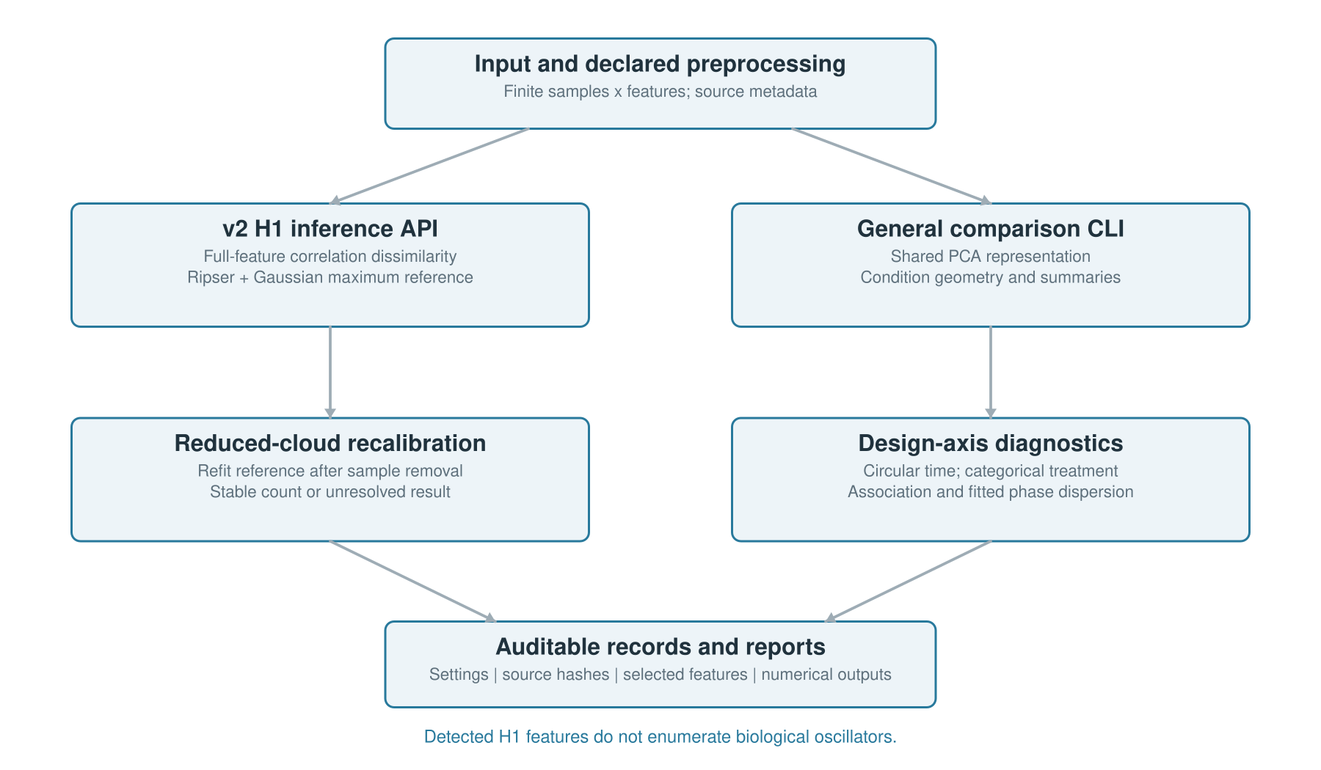
Figure 1. Analysis architecture. A declared samples-by-features matrix feeds two distinct routes: the full-feature v2 H1 inference API and the general comparison CLI using a shared principal-component representation. Resampling recalibrates the H1 reference after sample removal; axis diagnostics report associations and circular phase dispersion separately. Numerical records link inputs and settings to reports. The schematic describes implemented software paths, not a graphical interface.

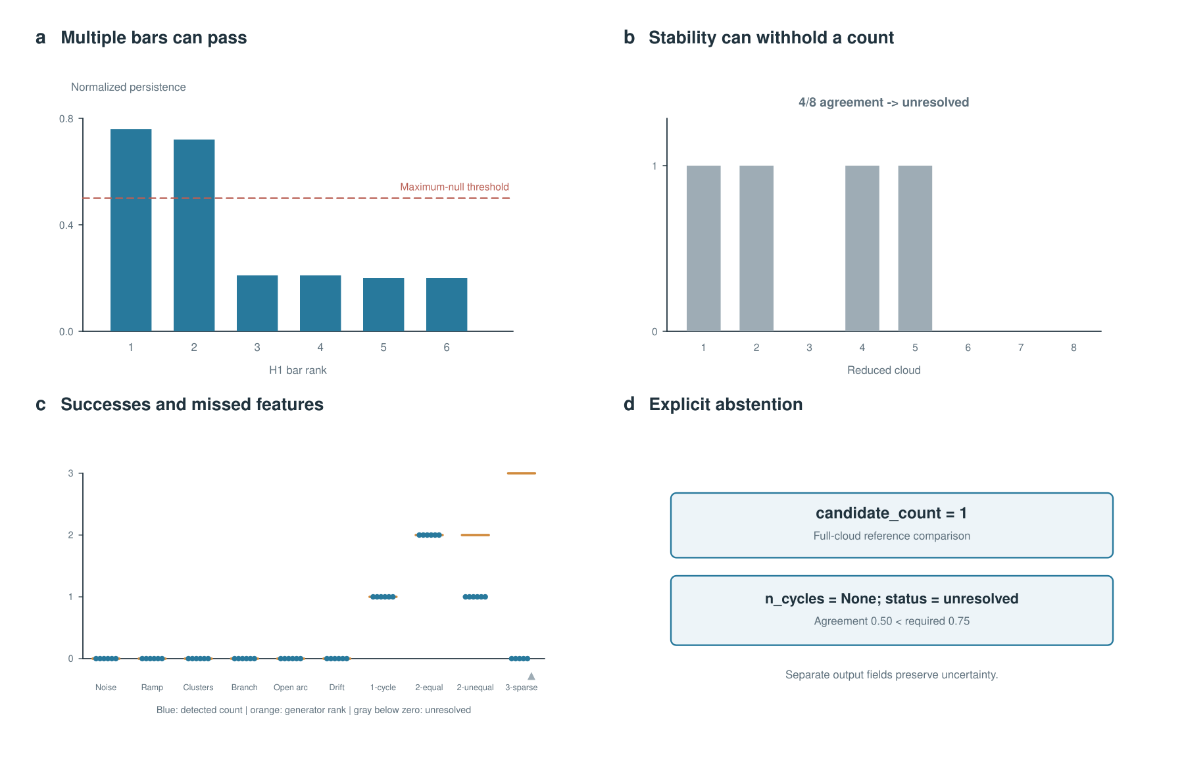
Figure 2. Calibrated H1 detection and abstention. (a) Two bars in a balanced two-loop simulation pass the maximum-surrogate threshold. (b) In the yeast analysis, a full-cloud candidate is recovered in four of eight reduced clouds, below the frozen 0.75 agreement threshold. (c) Stable counts across the 60 frozen simulation clouds; gray marks below zero indicate unresolved results. (d) Separate candidate and final-count fields preserve the unresolved status. Stable detection does not guarantee count completeness.

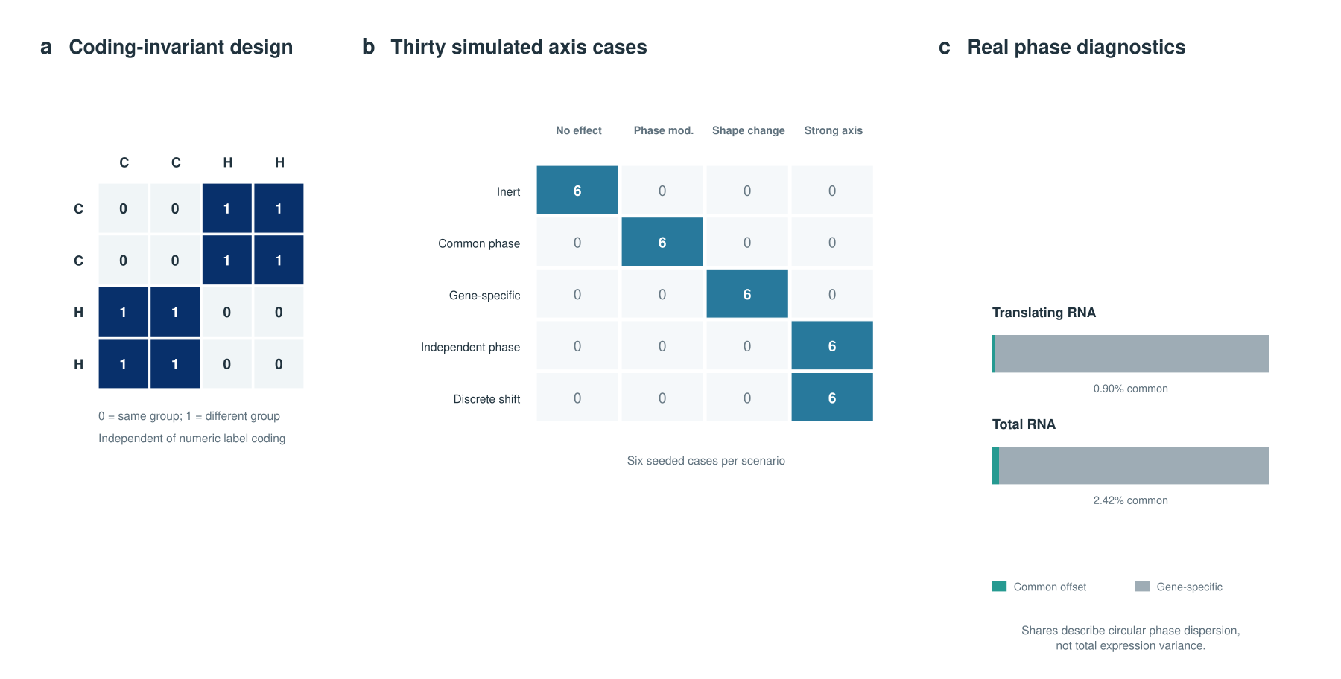
Figure 3. Axis-aware phase diagnostics. (a) A categorical distance matrix assigns zero to samples in the same condition and one to samples in different conditions, independent of numeric label coding. (b) Thirty simulated axis cases, six per scenario, show operational classifications; independent phases and discrete shifts both receive a strong-effect label. (c) Common-offset and gene-specific shares of circular dispersion among reliably fitted total- and translating-RNA features. The shares are not total expression variance or probabilities of a mechanism.

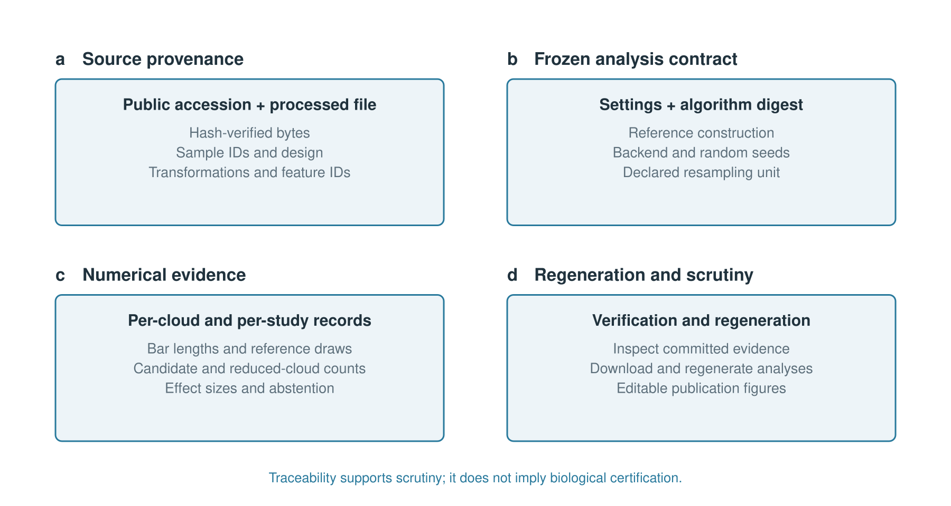
Figure 4. Numerical provenance and reproducibility. Source hashes and sample metadata, frozen settings and an algorithm digest, scored intermediate records, and regeneration scripts form four audit components. This schematic summarizes implemented records and workflows; traceability supports scrutiny but does not imply independent replication or automatic biological validation.

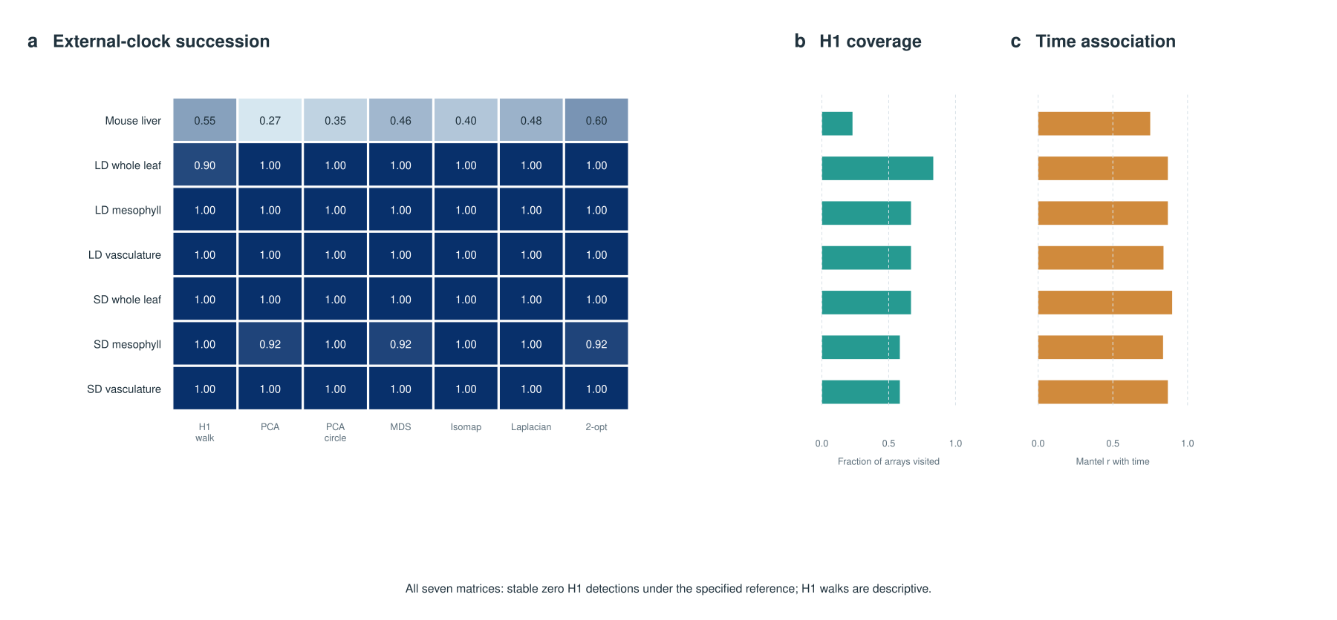
Figure 5. External source evaluation and common-input ordering comparison. (a) Cyclic-succession scores for seven geometric ordering methods on seven matrices from two source studies. H1 walks are descriptive representatives, including when bars do not pass calibrated detection. (b) Fraction of arrays visited by each H1 walk; the other methods visit all arrays. (c) Descriptive circular Mantel association with time. All seven matrices have zero accepted full-cloud candidates and stable zero detections under the selected settings. Partial-support scores require coverage and common-support context; the six plant subsets come from one study.

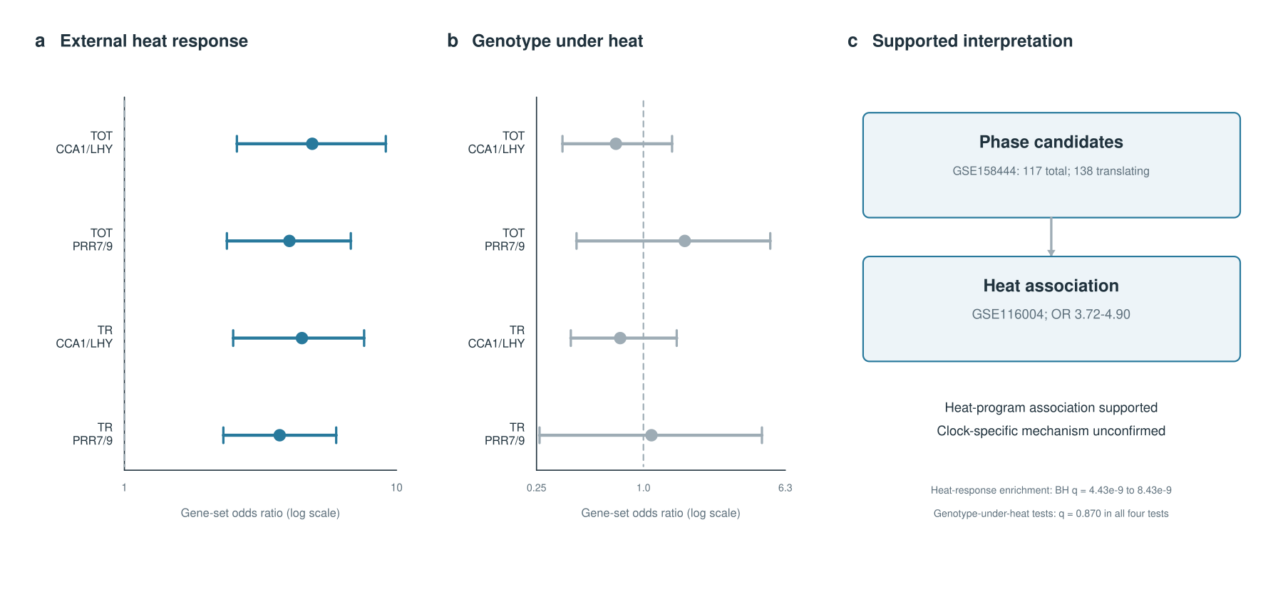
Figure 6. Cross-experiment evidence for a heat-program association. (a) Enrichment of top phase-difference candidates for published heat-responsive genes in GSE116004 using four primary one-sided Fisher tests. Odds ratios range from 3.72 to 4.90, with adjusted q values from 4.43 × 10⁻⁹ to 8.43 × 10⁻⁹. (b) Exploratory enrichment for genotype differences under heat is unsupported (all adjusted q = 0.870); these contrasts are not interaction tests. Points show odds ratios and bars descriptive 95% log-odds Wald intervals that do not account for gene dependence. (c) The evidence supports a heat-program association; phase replication and a clock-specific causal mechanism remain unestablished. Both source experiments share a research group.

Table of Contents
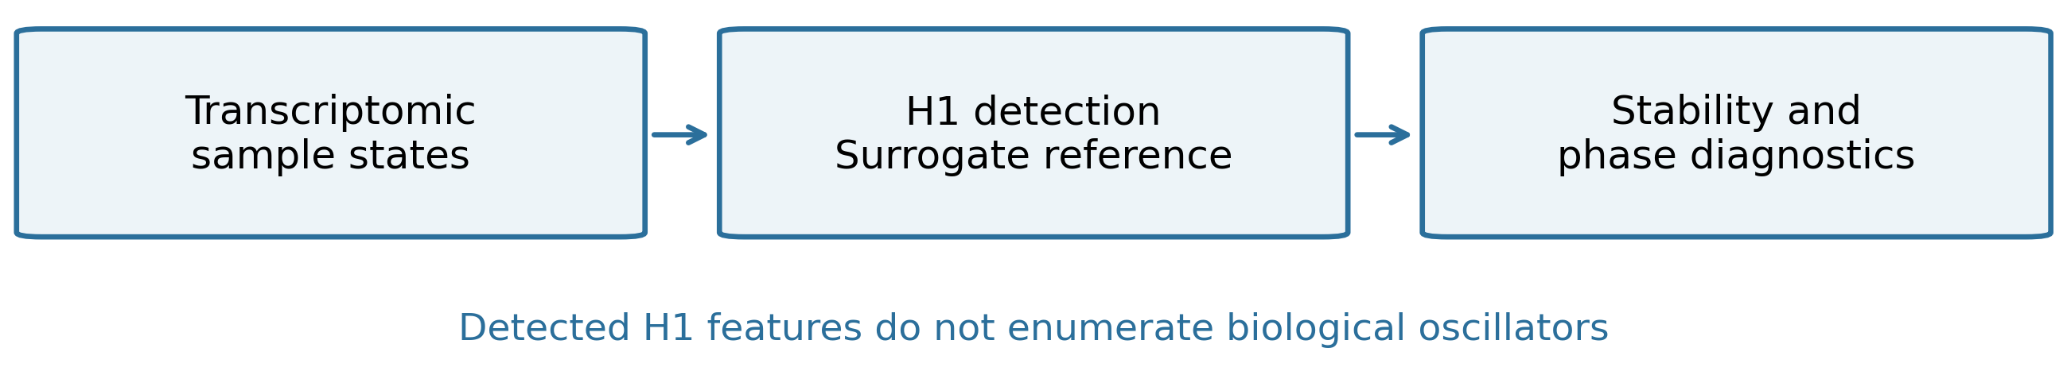
OmicsTopology links calibrated loop detection, resampling sensitivity, and circular phase diagnostics in an auditable workflow. Simulations and external transcriptomic studies expose recovery limits and separate geometry from biological interpretation. Matched comparisons and cross-experiment heat-response evidence support reproducible hypothesis generation while leaving oscillator identification and causal clock mechanisms for targeted experimental validation.

