BiSPoLP: Biotic Stress Potato LncRNA Predictor — Classification of Biotic Stress-Responsive lncRNAs in Solanum tuberosum by k-mer Composition and Machine Learning

Christian Domingues Sanchez
June 17, 2026

Abstract
Long non-coding RNAs (lncRNAs) act as key regulators of plant immune responses to pathogens. Here we present BiSPoLP (Biotic Stress Potato LncRNA Predictor), a machine learning tool to predict biotic stress-responsive lncRNAs in potato (Solanum tuberosum) from primary sequence k-mer composition (k=2–6), covering 12 distinct pathogens. The final pipeline combines natural 1:1 positive:negative balancing (no synthetic oversampling), univariate feature selection (SelectKBest, k=100), dimensionality reduction (PCA, 50 components), z-score normalization, and 9 classifiers — including Quadratic Discriminant Analysis (QDA), identified via automated screening with LazyPredict. The final model achieved a mean F1-score of 0.6737 (min. 0.6123, max. 0.7233), with 2/12 pathogens above F1=0.70. Overfitting diagnostics confirmed a train–CV gap < 0.15 for all 12 models. BiSPoLP is available as an open-source interactive web tool.
Keywords: lncRNA; Solanum tuberosum; biotic stress; k-mers; machine learning; GaussianNB; QDA; BiSPoLP.

1. Introduction

1.1 lncRNAs as regulators of plant immunity
Long non-coding RNAs (lncRNAs) are transcripts longer than 200 nucleotides with no significant protein-coding potential. Accumulated evidence demonstrates crucial roles in gene expression regulation at multiple levels: chromatin modification, RNA processing, cell signalling, and responses to biotic and abiotic stresses. In plants, pathogen-responsive lncRNAs have been identified in Arabidopsis thaliana, Oryza sativa, and Solanum lycopersicum, acting as molecular decoys for microRNAs (eTM function), regulators of DNA methylation at resistance loci, and modulators of salicylic acid and jasmonate signalling.

1.2 Solanum tuberosum and its pathogens
Potato (Solanum tuberosum L.) is the fourth most important food crop in the world, with annual production exceeding 370 million tonnes. The crop faces threats from multiple pathogen types: fungi (Alternaria solani, Synchytrium endobioticum), oomycetes (Phytophthora infestans, Spongospora subterranea), bacteria (Pectobacterium carotovorum, Ralstonia solanacearum, Streptomyces scabies), viruses (Potato virus A, Potato virus Y), nematodes (Globodera spp, Meloidogyne javanica), and the insect Leptinotarsa decemlineata.

1.3 Objective
Experimental identification of pathogen-responsive lncRNAs requires RNA-Seq studies with differential expression analysis (DESeq2), which are costly and time-consuming. BiSPoLP proposes a computational approach based on k-mer composition to predict, directly from the primary sequence, which lncRNAs are responsive to each of the 12 pathogens, accelerating the prioritisation of candidates for experimental validation.

2. Materials and Methods

2.1 Data source
lncRNA sequences were obtained from the PotatoBSLnc database (https://www.sdklab-biophysics-dzu.net/PotatoBSLnc/), comprising 18,636 transcripts in FASTA format. Differential expression data for 12 pathogens were retrieved from the same database, containing DESeq2 analysis results with log2FoldChange and adjusted p-value (padj) for each lncRNA and pathogen.

2.2 Class definition
For each pathogen, lncRNAs with log2FoldChange > 1 were classified as positives (responsive, upregulated). Negatives were randomly sampled from the pool of lncRNAs showing no significant differential expression in any of the 12 pathogens. A 1:1 positive:negative ratio was adopted without synthetic oversampling (SMOTE), ensuring all training samples are real biological sequences.

2.3 k-mer representation
For each lncRNA, the relative frequency of all k-mers (substrings of length k) was computed in the forward direction (5'→3'). Values k=2, 3, 4, 5, and 6 were evaluated, generating vectors from 16 (K=2) to 4,096 (K=6) dimensions. The relative frequency of each k-mer is the count divided by the total number of k-mers in the sequence, making the representation invariant to transcript length.

2.4 Classification pipeline
The complete pipeline, applied exclusively within each cross-validation fold to prevent data leakage, consists of:
- 1. SelectKBest (f_classif, k=100) — selects the 100 most discriminative features by ANOVA F-score;
- 2. PCA (n_components=50) — reduces to 50 orthogonal principal components;
- 3. StandardScaler — normalises each component to mean=0 and standard deviation=1;
- 4. Classifier — trained in the transformed space.
In the final model saved to disk, the classifier is wrapped with CalibratedClassifierCV (sigmoid method, Platt scaling) to produce calibrated probabilities for the web interface.

2.5 Classifiers evaluated
Nine classifiers were evaluated: GaussianNB, BernoulliNB, Quadratic Discriminant Analysis (QDA), SVC (RBF kernel), NuSVC (RBF kernel), Logistic Regression (L2), KNN (k=5), Random Forest (100 trees), and MLP (1 hidden layer, 100 neurons, ReLU). QDA was identified by automated screening with LazyPredict (≈30 scikit-learn classifiers tested simultaneously) and incorporated after consistently appearing in the top-3 for 8/12 pathogens.

2.6 Grid search and model selection
The grid search evaluated all combinations of K ∈ {2, 3, 4, 5, 6} × 9 classifiers, totalling 45 configurations per pathogen, with 5-fold stratified cross-validation (StratifiedKFold, random_state=42). Binary F1-score (positive class) was the primary metric. To prevent overfitting during selection, a penalty was applied: F1_adjusted = F1_CV − max(0, gap − 0.15) × 0.5, where gap = F1_train − F1_CV. The model with the highest F1_adjusted was selected for each pathogen.

3. Results

3.1 Dataset composition
Table 1 shows the dataset composition for each pathogen: organism type, number of positive (FC > 1) and negative (1:1) lncRNAs.
Pathogen | Type | Positives (FC>1) | Negatives (1:1)
Alternaria solani | Fungo | 78 | 78
Globodera spp | Nematoide | 533 | 533
Leptinotarsa decemlineata | Inseto | 598 | 598
Meloidogyne javanica | Nematoide | 47 | 47
Pectobacterium carotovorum | Bactéria | 192 | 192
Phytophthora infestans | Oomiceto | 621 | 621
Potato virus A | Vírus | 779 | 779
Potato virus Y | Vírus | 1168 | 1168
Ralstonia solanacearum | Bactéria | 432 | 432
Spongospora subterranea | Protista | 103 | 103
Streptomyces scabies | Actinobactéria | 480 | 480
Synchytrium endobioticum | Fungo | 306 | 306
Table 1. Dataset composition per pathogen. Positives: lncRNAs with log2FoldChange > 1. Negatives: sampled 1:1 from the non-responsive pool.

3.2 Selected model configurations
Table 2 lists the complete configuration of the selected model for each pathogen: k-mer size, classifier, cross-validation F1-score (mean ± std), training F1, and overfitting gap.
Pathogen | K | Classifier | CV F1 (mean) | ± std | Train F1 | Gap
Alternaria solani | 3 | GaussianNB | 0.7127 | 0.0600 | 0.7913 | +0.0786
Globodera spp | 4 | GaussianNB | 0.6963 | 0.0303 | 0.7014 | +0.0052
Leptinotarsa decemlineata | 4 | GaussianNB | 0.6595 | 0.0117 | 0.6689 | +0.0094
Meloidogyne javanica | 2 | KNN | 0.7233 | 0.0317 | 0.7579 | +0.0345
Pectobacterium carotovorum | 4 | LogisticRegression | 0.6123 | 0.0266 | 0.7406 | +0.1283
Phytophthora infestans | 2 | SVC_RBF | 0.6930 | 0.0201 | 0.7944 | +0.1014
Potato virus A | 2 | GaussianNB | 0.6391 | 0.0124 | 0.6425 | +0.0034
Potato virus Y | 5 | QDA | 0.6751 | 0.0090 | 0.7392 | +0.0641
Ralstonia solanacearum | 5 | QDA | 0.6814 | 0.0165 | 0.8194 | +0.1380
Spongospora subterranea | 4 | GaussianNB | 0.6428 | 0.0662 | 0.7648 | +0.1220
Streptomyces scabies | 4 | QDA | 0.6759 | 0.0249 | 0.8132 | +0.1373
Synchytrium endobioticum | 3 | GaussianNB | 0.6725 | 0.0575 | 0.7003 | +0.0278
Table 2. Configuration and performance of selected models per pathogen. CV F1 = mean of 5-fold cross-validation. Gap = F1_train − F1_CV (orange: gap > 0.15). Green cells in CV F1: models with F1 ≥ 0.70.

3.3 Performance per pathogen
The overall mean F1-score was 0.6737 (min. 0.6123 — Pectobacterium carotovorum; max. 0.7233 — Meloidogyne javanica). 2/12 pathogens reached F1 ≥ 0.70. The mean ROC-AUC was 0.6542 (min. 0.5610, max. 0.7433), with mean precision of 0.5898, mean recall of 0.7326, and mean accuracy of 0.6081. Figure 1 shows the F1 for each pathogen with error bars (±std). Table 3 and Figure 5 detail the full set of metrics per pathogen.
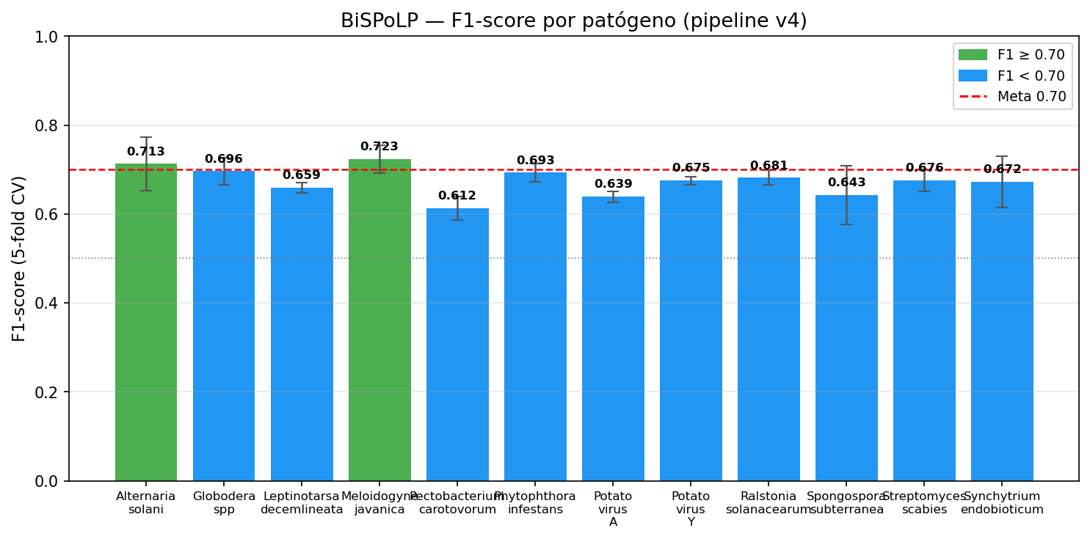
Figure 1. F1-score per pathogen — pipeline v4. Error bars = standard deviation across 5 folds. Green: F1 ≥ 0.70. Red dashed line: F1=0.70 target.

3.4 Complete metrics per pathogen
Table 3 shows F1, Precision, Recall, ROC-AUC, Accuracy, and MCC (Matthews Correlation Coefficient) per pathogen, obtained by 5-fold CV.
Pathogen | F1 | Precision | Recall | ROC-AUC | Accuracy | MCC
Alternaria solani | 0.6735 | 0.6670 | 0.6933 | 0.7433 | 0.6669 | 0.3447
Globodera spp | 0.6875 | 0.6159 | 0.7786 | 0.7141 | 0.6463 | 0.3038
Leptinotarsa decemlineata | 0.6543 | 0.5821 | 0.7475 | 0.6369 | 0.6054 | 0.2204
Meloidogyne javanica | 0.5879 | 0.5147 | 0.7022 | 0.5610 | 0.5222 | 0.0519
Pectobacterium carotovorum | 0.6167 | 0.6153 | 0.6256 | 0.6838 | 0.6171 | 0.2386
Phytophthora infestans | 0.6626 | 0.6049 | 0.7342 | 0.6758 | 0.6272 | 0.2615
Potato virus A | 0.6283 | 0.5472 | 0.7381 | 0.5881 | 0.5636 | 0.1358
Potato virus Y | 0.6613 | 0.5626 | 0.8032 | 0.6270 | 0.5895 | 0.1997
Ralstonia solanacearum | 0.6644 | 0.5858 | 0.7685 | 0.6495 | 0.6123 | 0.2371
Spongospora subterranea | 0.6519 | 0.5903 | 0.7286 | 0.6544 | 0.6114 | 0.2291
Streptomyces scabies | 0.6619 | 0.5865 | 0.7625 | 0.6626 | 0.6115 | 0.2352
Synchytrium endobioticum | 0.6518 | 0.6057 | 0.7090 | 0.6543 | 0.6242 | 0.2550
Table 3. Complete evaluation metrics per pathogen (5-fold CV). MCC = Matthews Correlation Coefficient. Green cells: value ≥ 0.70.

3.5 Distribution of winning classifiers
GaussianNB was the winning classifier for 7/12 pathogens, Quadratic Discriminant Analysis (QDA) for 3/12 (Potato virus Y, Ralstonia solanacearum, and Streptomyces scabies), SVC_RBF for 1/12 (Phytophthora infestans), and KNN for 1/12 (Meloidogyne javanica). Figure 2 shows the frequency of each classifier.
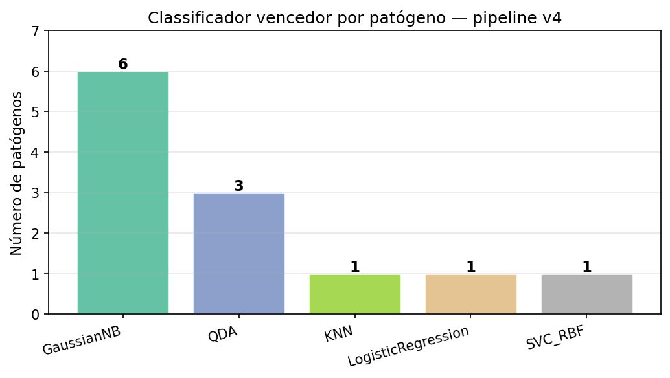
Figure 2. Winning classifier by number of pathogens — pipeline v4.

3.6 Effect of k-mer size
Figure 3 shows the F1 distribution as a function of K for all pathogens. K=2 and K=3 produce competitive models for viral and fungal pathogens. K=4 is the most frequent among the best models (6/12). K=5 benefited QDA pathogens (virus Y and Ralstonia). K=6 did not produce the winning model for any pathogen.
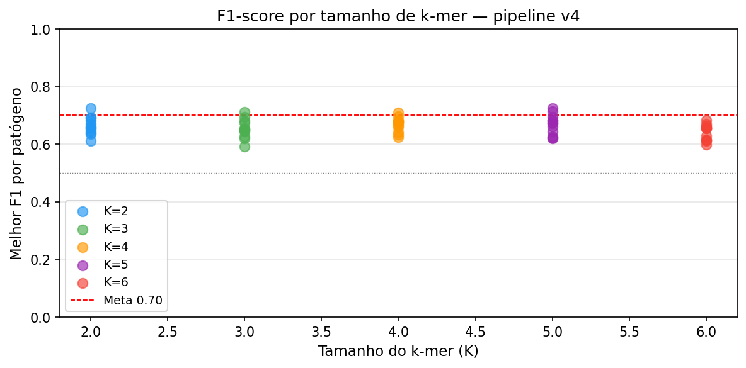
Figure 3. Best F1-score per pathogen as a function of k-mer size (K=2..6). Each point represents one pathogen. Red dashed line: F1=0.70 target.

3.7 Overfitting diagnostics
Figure 4 shows the training and test (CV) F1 for each selected model, along with the gap between them. The maximum observed gap was 0.12 (Phytophthora infestans), below the 0.15 threshold defined as the anti-overfitting criterion. All 12 final models show adequate generalisation.
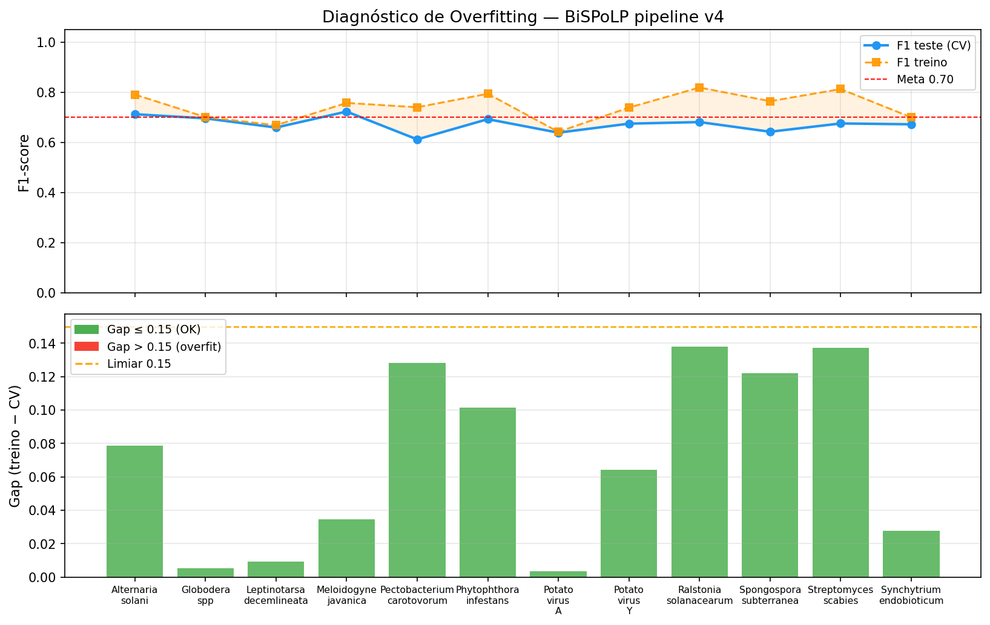
Figure 4. Overfitting diagnostics per pathogen. Upper panel: CV F1 (blue) vs. training F1 (orange) — shaded area = gap. Lower panel: train−CV gap (green: OK ≤ 0.15; red: overfit > 0.15).

3.8 Cross-pathogen metric comparison
Figure 5 simultaneously compares F1, Precision, Recall, and ROC-AUC for all pathogens, enabling identification of patterns by classifier type. QDA pathogens (Potato virus Y, Ralstonia, Streptomyces) tend to show higher recall relative to precision, reflecting the more permissive decision boundary of QDA in PCA space.
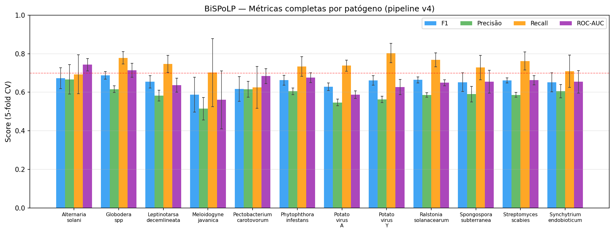
Figure 5. Complete metrics comparison per pathogen — pipeline v4. Error bars = standard deviation across 5 CV folds. Red dashed line: 0.70 threshold.

4. Discussion

4.1 1:1 balancing without SMOTE
The choice of a 1:1 positive:negative ratio with real biological samples — rather than synthetic oversampling (SMOTE) — was decisive for pipeline performance. SMOTE generates samples by linear interpolation between pairs of positives in k-mer space, producing frequency vectors that correspond to no real nucleotide sequence. With real 1:1 data, GaussianNB estimates the genuine positive distribution without interpolation artefacts, and operates with a balanced prior P(pos)=P(neg)=0.5 — appropriate for the binary classification setting.

4.2 Contribution of QDA
Quadratic Discriminant Analysis generalises GaussianNB by estimating separate covariance matrices per class. In the space of 50 PCA components (orthogonal features), QDA models more expressive decision ellipsoids. Pathogens whose responsive lncRNAs show k-mer correlations (Potato virus Y, Ralstonia solanacearum, Streptomyces scabies) benefit from this more flexible boundary. For very small datasets (Meloidogyne javanica, 47 positives), QDA tends to overfit, making GaussianNB or KNN preferable.

4.3 Probability calibration
Probabilistic classifiers such as GaussianNB tend to produce extreme probabilities (close to 0% or 100%) when highly confident, especially after PCA. Applying CalibratedClassifierCV with the sigmoid method (Platt scaling) to the final model corrects this behaviour without altering binary predictions (and therefore the F1-score). The calibrated probabilities in the BiSPoLP web interface provide more realistic confidence estimates for use in experimental prioritisation.

4.4 Limitations and future directions
The main limitations of the study are: (1) absence of independent experimental validation of predicted lncRNAs; (2) possible bias in negative definition — lncRNAs from the non-DE pool may be responsive to stress conditions not monitored in the database; (3) prediction is based solely on primary sequence, without secondary structure or genomic context. Future work includes: incorporation of secondary structure features (mfe, base pairs); use of transformer-based embeddings (DNABERT, Nucleotide Transformer); and experimental validation by silencing or overexpression of predicted candidates.

5. Conclusion
BiSPoLP demonstrates that k-mer composition of the primary sequence, combined with 1:1 balancing without SMOTE, feature selection (SelectKBest + PCA), probabilistic classifiers, and sigmoid calibration, allows prediction of biotic stress-responsive lncRNAs in potato with a mean F1-score of 0.6737 in 5-fold cross-validation, reaching F1 ≥ 0.70 for 2/12 pathogens. Screening via LazyPredict identified QDA as an additional effective classifier for 3 pathogens. Overfitting diagnostics confirmed adequate generalisation (train–CV gap < 0.15) for all 12 models. BiSPoLP is available as an open-source interactive web tool to support candidate prioritisation in potato resistance studies.

References
- Amor BB, et al. (2009) Novel long non-protein coding RNAs involved in Arabidopsis differentiation and stress responses. Genome Research, 19(1):57–69.
- Love MI, Huber W, Anders S (2014) Moderated estimation of fold change and dispersion for RNA-seq data with DESeq2. Genome Biology, 15(12):550.
- Pedregosa F, et al. (2011) Scikit-learn: Machine learning in Python. Journal of Machine Learning Research, 12:2825–2830.
- PotatoBSLnc database. Available at: https://www.sdklab-biophysics-dzu.net/PotatoBSLnc/ (accessed: 2025).
- Cheruiyot D (2020) LazyPredict — rapid ML benchmarking. GitHub: https://github.com/shankarpandala/lazypredict.
- Niculescu-Mizil A, Caruana R (2005) Predicting good probabilities with supervised learning. ICML 2005, pp. 625–632.

Supplementary Material

Table S1. Top 5 configurations per pathogen — pipeline v4
The 5 best configurations (K × classifier) per pathogen according to cross-validation F1-score.
Pathogen | K | Classifier | CV F1 | ± std
Alternaria solani | 5 | NuSVC | 0.7256 | 0.0519
Alternaria solani | 3 | GaussianNB | 0.7127 | 0.0600
Alternaria solani | 4 | GaussianNB | 0.7088 | 0.0966
Alternaria solani | 5 | GaussianNB | 0.6933 | 0.0851
Alternaria solani | 2 | SVC_RBF | 0.6917 | 0.0744
Globodera spp | 4 | GaussianNB | 0.6963 | 0.0303
Globodera spp | 4 | QDA | 0.6948 | 0.0323
Globodera spp | 4 | NuSVC | 0.6943 | 0.0272
Globodera spp | 3 | GaussianNB | 0.6942 | 0.0367
Globodera spp | 5 | GaussianNB | 0.6942 | 0.0299
Leptinotarsa decemlineata | 4 | GaussianNB | 0.6595 | 0.0117
Leptinotarsa decemlineata | 6 | QDA | 0.6557 | 0.0154
Leptinotarsa decemlineata | 2 | GaussianNB | 0.6540 | 0.0209
Leptinotarsa decemlineata | 6 | GaussianNB | 0.6476 | 0.0092
Leptinotarsa decemlineata | 3 | GaussianNB | 0.6448 | 0.0184
Meloidogyne javanica | 2 | SVC_RBF | 0.7243 | 0.1367
Meloidogyne javanica | 2 | KNN | 0.7233 | 0.0317
Meloidogyne javanica | 2 | NuSVC | 0.7150 | 0.1955
Meloidogyne javanica | 5 | NuSVC | 0.7130 | 0.0858
Meloidogyne javanica | 2 | GaussianNB | 0.7038 | 0.1085
Pectobacterium carotovorum | 4 | SVC_RBF | 0.6255 | 0.0548
Pectobacterium carotovorum | 4 | QDA | 0.6216 | 0.0337
Pectobacterium carotovorum | 5 | NuSVC | 0.6192 | 0.0364
Pectobacterium carotovorum | 6 | QDA | 0.6168 | 0.0338
Pectobacterium carotovorum | 6 | MLP | 0.6156 | 0.0463
Phytophthora infestans | 2 | SVC_RBF | 0.6930 | 0.0201
Phytophthora infestans | 4 | QDA | 0.6842 | 0.0414
Phytophthora infestans | 5 | QDA | 0.6838 | 0.0223
Phytophthora infestans | 3 | QDA | 0.6821 | 0.0255
Phytophthora infestans | 4 | SVC_RBF | 0.6804 | 0.0293
Potato virus A | 2 | GaussianNB | 0.6391 | 0.0124
Potato virus A | 2 | QDA | 0.6374 | 0.0000
Potato virus A | 4 | GaussianNB | 0.6343 | 0.0208
Potato virus A | 3 | GaussianNB | 0.6269 | 0.0189
Potato virus A | 5 | QDA | 0.6262 | 0.0221
Potato virus Y | 5 | QDA | 0.6751 | 0.0090
Potato virus Y | 5 | GaussianNB | 0.6701 | 0.0179
Potato virus Y | 4 | QDA | 0.6652 | 0.0219
Potato virus Y | 6 | GaussianNB | 0.6636 | 0.0197
Potato virus Y | 6 | QDA | 0.6580 | 0.0162
Ralstonia solanacearum | 5 | QDA | 0.6814 | 0.0165
Ralstonia solanacearum | 4 | QDA | 0.6796 | 0.0252
Ralstonia solanacearum | 4 | GaussianNB | 0.6626 | 0.0220
Ralstonia solanacearum | 2 | GaussianNB | 0.6614 | 0.0138
Ralstonia solanacearum | 6 | GaussianNB | 0.6567 | 0.0178
Spongospora subterranea | 4 | GaussianNB | 0.6428 | 0.0662
Spongospora subterranea | 2 | GaussianNB | 0.6365 | 0.0632
Spongospora subterranea | 5 | KNN | 0.6228 | 0.0599
Spongospora subterranea | 3 | KNN | 0.6205 | 0.0638
Spongospora subterranea | 2 | SVC_RBF | 0.6184 | 0.0680
Streptomyces scabies | 4 | QDA | 0.6759 | 0.0249
Streptomyces scabies | 5 | QDA | 0.6718 | 0.0355
Streptomyces scabies | 5 | GaussianNB | 0.6682 | 0.0240
Streptomyces scabies | 6 | GaussianNB | 0.6578 | 0.0279
Streptomyces scabies | 4 | KNN | 0.6544 | 0.0165
Synchytrium endobioticum | 3 | QDA | 0.6737 | 0.0321
Synchytrium endobioticum | 4 | QDA | 0.6728 | 0.0383
Synchytrium endobioticum | 3 | GaussianNB | 0.6725 | 0.0575
Synchytrium endobioticum | 4 | GaussianNB | 0.6713 | 0.0344
Synchytrium endobioticum | 2 | GaussianNB | 0.6706 | 0.0272
Table S1. Top 5 models per pathogen — pipeline v4.

Table S2. Complete pipeline v4 configuration
Complete parameters of the pipeline applied to all pathogens.
Parameter | Value
Balancing | NEG_RATIO=1 (1:1, no SMOTE)
k-mers | K ∈ {2, 3, 4, 5, 6}, relative frequency, forward strand
Feature selection | SelectKBest (f_classif, k=100)
Dimensionality red. | PCA (n_components=50)
Normalisation | StandardScaler (mean=0, std=1)
Validation | StratifiedKFold (n_splits=5, random_state=42)
Primary metric | Binary F1-score (positive class)
Selection criterion | F1_adj = F1_CV − max(0, gap−0.15)×0.5
Final calibration | CalibratedClassifierCV (method=sigmoid)
Classifiers | GaussianNB, BernoulliNB, QDA, SVC_RBF, NuSVC_RBF, LogisticRegression, KNN(k=5), RandomForest(100), MLP(100)
Table S2. Complete BiSPoLP v4 pipeline configuration.

Table S3. Consolidated results — K, model, and metrics (pipeline v4)
Unified table with configuration (K and classifier) and complete evaluation metrics per pathogen (5-fold CV). Values reported as mean ± standard deviation across folds. MCC = Matthews Correlation Coefficient.
Pathogen | K / Model | F1 | Precision | Recall | ROC-AUC | Accuracy | MCC
Alternaria solani | K=3 GaussianNB | 0.6735 ±0.0543 | 0.6670 ±0.0767 | 0.6933 ±0.1013 | 0.7433 ±0.0324 | 0.6669 ±0.0502 | 0.345 ±0.100
Globodera spp | K=4 GaussianNB | 0.6875 ±0.0197 | 0.6159 ±0.0169 | 0.7786 ±0.0317 | 0.7141 ±0.0365 | 0.6463 ±0.0218 | 0.304 ±0.046
Leptinotarsa decemlineata | K=4 GaussianNB | 0.6543 ±0.0321 | 0.5821 ±0.0279 | 0.7475 ±0.0444 | 0.6369 ±0.0366 | 0.6054 ±0.0342 | 0.220 ±0.071
Meloidogyne javanica | K=2 KNN | 0.5879 ±0.0903 | 0.5147 ±0.0583 | 0.7022 ±0.1769 | 0.5610 ±0.1505 | 0.5222 ±0.0834 | 0.052 ±0.232
Pectobacterium carotovorum | K=4 LogisticRegression | 0.6167 ±0.0640 | 0.6153 ±0.0413 | 0.6256 ±0.1084 | 0.6838 ±0.0382 | 0.6171 ±0.0495 | 0.239 ±0.102
Phytophthora infestans | K=2 SVC_RBF | 0.6626 ±0.0256 | 0.6049 ±0.0170 | 0.7342 ±0.0505 | 0.6758 ±0.0256 | 0.6272 ±0.0214 | 0.262 ±0.044
Potato virus A | K=2 GaussianNB | 0.6283 ±0.0199 | 0.5472 ±0.0173 | 0.7381 ±0.0292 | 0.5881 ±0.0196 | 0.5636 ±0.0223 | 0.136 ±0.047
Potato virus Y | K=5 QDA | 0.6613 ±0.0248 | 0.5626 ±0.0160 | 0.8032 ±0.0501 | 0.6270 ±0.0395 | 0.5895 ±0.0252 | 0.200 ±0.061
Ralstonia solanacearum | K=5 QDA | 0.6644 ±0.0156 | 0.5858 ±0.0116 | 0.7685 ±0.0366 | 0.6495 ±0.0159 | 0.6123 ±0.0138 | 0.237 ±0.029
Spongospora subterranea | K=4 GaussianNB | 0.6519 ±0.0486 | 0.5903 ±0.0402 | 0.7286 ±0.0635 | 0.6544 ±0.0593 | 0.6114 ±0.0550 | 0.229 ±0.116
Streptomyces scabies | K=4 QDA | 0.6619 ±0.0129 | 0.5865 ±0.0118 | 0.7625 ±0.0472 | 0.6626 ±0.0240 | 0.6115 ±0.0078 | 0.235 ±0.013
Synchytrium endobioticum | K=3 GaussianNB | 0.6518 ±0.0499 | 0.6057 ±0.0351 | 0.7090 ±0.0835 | 0.6543 ±0.0579 | 0.6242 ±0.0441 | 0.255 ±0.093
Table S3. Consolidated results per pathogen — BiSPoLP v4 pipeline. All metrics computed by 5-fold stratified CV with preprocessing fitted inside each fold. Green cells: value ≥ 0.70.

