
DEPARTMENT OF COMPUTER ENGINEERING AND TECHNOLOGY
MINI PROJECT REPORT
Computer Networks Laboratory (CSE20110)
Laboratory Continuous Assessment 3

Network Packet Analyzer
A Flask and Scapy Based Packet Analysis Dashboard

Submitted by
Sr. No. | Student Name | PRN
1 | Omkar Jadhav | 1262252367
2 | Rushikesh Patil | 1262253398
3 | Anshuman Shelke | 1262242950
4 | Avani Sarda | 1262242084

Group No.: 01 Panel: J Batch: j2
Third Year B.Tech. Computer Engineering and Technology
Under the guidance of: Faculty name to be added
Academic Year 2026–2027 | Submission date:

CERTIFICATE
This is to certify that the mini-project entitled “Network Packet Analyzer” has been carried out by the students listed below of Third Year B.Tech. Computer Engineering and Technology, under my guidance during academic year 2026–2027.
Student Name | PRN
Omkar Jadhav | 1262252367
Rushikesh Patil | 1262253398
Anshuman Shelke | 1262242950
Avani Sarda | 1262242084

The report is submitted towards the mini-project component of Laboratory Continuous Assessment 3 for the Computer Networks Laboratory course.
Faculty Signature: __________________________
Faculty Name:
Date: ____________________ Place: Pune

Acknowledgement
The group acknowledges the guidance and assistance received during development of the Network Packet Analyzer Dashboard. The project involved Python, Flask, Scapy, browser-based technologies, and packet-capture data. The group also acknowledges the technical documentation and software resources consulted. Faculty and other contributors should be named only where their assistance was actually received.

Abstract
Network communication transfers information in packets containing addressing, protocol, port, and size information. Inspecting these details manually can be time-consuming. The Network Packet Analyzer is a local web dashboard developed to examine captured network traffic and view protocol statistics. Python and Scapy read and dissect packet-capture data; Flask serves the application and API routes; HTML, CSS, and JavaScript implement the dashboard; and Chart.js visualizes protocol and traffic statistics. Developed features include offline PCAP analysis, searchable packet tables, packet-level inspection with decoded fields and raw hexadecimal data, live capture on supported interfaces, analytics, heuristic security alerts, and report-export options. The sample DNS capture processed during development contained 38 packets and 3,706 bytes, with all 38 packets identified as DNS. A live diagnostic also captured 105 packets in 15 seconds on the confirmed Wi-Fi interface. Results depend on the capture source and the capabilities of the selected interface. Export functions that previously produced an error must be retested in the final installed version.
Keywords: Network Packet Analyzer, Scapy, Flask, Packet Capture, Protocol Analysis

Table of Contents
- 1. Introduction and Project Objectives
- 2. Proposed Design and Requirements
- 3. Implementation and Technical Working
- 4. Testing and Results
- 5. Discussion and Conclusion
- 6. References
- 7. AI Usage Declaration
- 8. Appendices

1. Introduction and Project Objectives

1.1 Introduction and Background
A computer network transfers information in packets. Packet headers contain information required to deliver data, including source and destination addresses and protocol-specific fields. A packet analyzer reads captured traffic and decodes supported protocol layers so a user can inspect communication. Packet-capture tools are useful in network education and troubleshooting because they expose packet-level details that are not normally visible in ordinary applications.
This project uses Scapy to read and dissect packets, Flask to provide a local web application, and a browser-based dashboard to display packet summaries and details. Scapy supports packet manipulation and protocol dissection [1]. Flask provides the web framework used to serve the application [2]. Wireshark documentation describes packet-capture and protocol-analysis concepts relevant to validation [3].

1.2 Problem Statement
Reviewing packets directly from raw capture files or command-line output can be inconvenient for users who need a quick overview of traffic. This project addresses that problem by providing a dashboard that summarizes captured packets, displays protocol distribution, allows packet-table searching and filtering, and supports packet-field inspection.

1.3 Scope
- Read a packet-capture file and display its packets.
- Show packet counts, captured bytes, detected protocols, addresses, ports when available, and packet sizes.
- Search and filter packet rows by text, protocol, source address, or destination address.
- Inspect supported packet layers and fields, including raw hexadecimal data.
- Attempt live capture on interfaces supported by the operating system, capture driver, permissions, and traffic visibility.
- Display traffic analytics and heuristic security alerts.
- Export packet and report data where the corresponding feature is enabled.

1.4 Objectives
ID | Objective | Verification method
O1 | Load and parse a valid PCAP file. | Open captures/dns.cap and compare its packet count.
O2 | Summarize packet count, bytes, and protocols. | Compare dashboard totals with parsed capture summary.
O3 | Search packet rows. | Search for a known IP or protocol and verify matching rows.
O4 | Inspect packet fields and layers. | Select a packet and review decoded fields and raw bytes.
O5 | Capture live packets on a supported interface. | Generate authorized traffic while capture is running.
O6 | Export packet and report data. | Download each enabled export and open the result.
O7 | Display analytics and heuristic alerts. | Generate traffic and observe charts and alerts.

2. Proposed Design and Requirements

2.1 Architecture and Network Topology
The application uses a local client–server architecture. The browser acts as the dashboard client. Flask receives HTTP requests, performs analysis, and returns HTML or JSON. Scapy reads a PCAP file or captures packets from a supported interface. JavaScript updates tables and charts in the browser.
Component | Responsibility
Packet source | PCAP file or supported live network interface.
Scapy | Reads, captures, and dissects packets.
Flask backend | Serves dashboard, manages capture state, and exposes data routes.
HTML/CSS/JavaScript | Displays controls, packet tables, charts, filters, and inspector.
Chart.js | Renders protocol and traffic visualizations.
Export handlers | Generate available packet and report files.

2.2 Tools and System Requirements
Tool / resource | Version / specification | Purpose
Python | Python 3.14.2 reported in development environment | Application logic and packet analysis.
Flask | Installed in project virtual environment; record exact version | Local web server and routes.
Scapy | Installed in project virtual environment; record exact version | PCAP parsing, live capture, protocol dissection.
Npcap | Installed on Windows; record exact version | Windows packet-capture driver.
HTML/CSS/JavaScript | Browser technologies | Dashboard layout and interaction.
Chart.js | Loaded from CDN in dashboard | Charts.
openpyxl | Required if Excel export is enabled | Excel workbook and chart generation.
Operating system | Windows | Execution environment.

Record exact library and Npcap versions from the final machine; do not guess version numbers.

2.3 Addressing and Protocol Selection
This is a packet-analysis application rather than a fixed-addressing network configuration project. It observes addresses and protocols present in a supplied PCAP or visible on a selected live interface. The Flask development server was configured to listen on 127.0.0.1:5000.
Device / interface | IP / prefix | Gateway | Role
Dashboard host | 127.0.0.1 | Not applicable | Local Flask dashboard on port 5000.
Wi-Fi adapter | Dynamically assigned; insert verified value if required | Assigned by network | Primary live capture interface; confirmed working.
Npcap loopback | Loopback traffic | Not applicable | Captures supported local host traffic.
Hyper-V / WSL adapters | Depends on virtual network configuration | Depends on configuration | Capture traffic visible on relevant virtual path.
WAN Miniports / TAP / Ethernet | Depends on adapter and connection status | Depends on configuration | May be disconnected or may not expose useful traffic.

3. Implementation and Technical Working

3.1 Methodology
Development proceeded incrementally. The initial Flask dashboard and offline PCAP reader were implemented first, followed by live capture, packet inspection, analytics, heuristic alerts, and report-export controls. Interface diagnostics used Scapy's interface list and Windows Get-NetAdapter output. The Wi-Fi adapter was confirmed as a working live-capture interface; packet visibility varied across other adapters.

3.2 Configuration and Code Implementation
The main source file is app.py. It initializes Flask, locates the sample capture, loads Scapy packet layers, computes summaries, manages live capture state, and exposes routes for dashboard data and exports. The template templates/index.html contains the dashboard interface and JavaScript. The stylesheet static/css/style.css defines visual presentation. The sample capture is stored at captures/dns.cap.
File / component | Responsibility
app.py | Flask routes, PCAP analysis, packet summaries, live capture, APIs, exports.
templates/index.html | Dashboard sections, tables, charts, controls, packet inspector, client-side updates.
static/css/style.css | Layout, colors, responsive behavior, styling.
captures/dns.cap | Sample offline packet capture for DNS analysis.
Npcap | Windows packet-capture support for supported interfaces.

3.3 Protocols and Technical Working
For offline analysis, Scapy reads packets from captures/dns.cap and iterates through captured frames. For each packet, the application extracts available fields such as timestamp, source and destination IP addresses, protocol, source and destination ports, and packet length. Not all fields exist in every packet; unavailable fields may be represented as N/A.
For live capture, Scapy's asynchronous capture listens on the selected interface and passes packets to a callback. The callback updates counters and retains recent packet details. Flask endpoints return capture status and recent packets to the browser, which updates counters and charts.
The application identifies common protocols such as TCP, UDP, DNS, ICMP, IPv4, and IPv6 when those layers are present and supported by the decoder. DNS commonly uses UDP or TCP, and its presence is identified from decoded packet layers.
Security monitoring uses heuristic thresholds for patterns such as traffic spikes and repeated TCP connection attempts. These alerts are intended for demonstration and triage; they are not proof of malicious activity and can produce false positives.

3.4 Execution Procedure
- Install Python, Flask, Scapy, and Npcap; keep the project in NetworkPacketAnalyzer.
- Ensure captures/dns.cap exists and is a valid PCAP file.
- Open PowerShell and change to the project directory.
- Activate the environment with .\venv\Scripts\Activate.ps1.
- Run python -m py_compile app.py to check syntax.
- Run python app.py. If live capture requires elevated permissions, run PowerShell as Administrator.
- Open http://127.0.0.1:5000 in a browser.
- Inspect the offline capture; select a supported live interface, start capture, and generate authorized traffic.
- Stop capture and open exported files to verify their contents.

4. Testing and Results

4.1 Test Plan
The table distinguishes verified development observations from tests that must be repeated against the final packaged version. Pending tests should not be reported as passed until the group repeats them and records evidence.
Test ID | Test and input | Expected result | Observed result / status
T1 | Load captures/dns.cap | PCAP loads and packets are summarized. | 38 packets and 3,706 bytes; all 38 identified as DNS. PASS for sample.
T2 | Protocol distribution | Chart reflects parsed protocol counts. | DNS only: 38 packets. PASS for sample.
T3 | Search/filter packet table | Only matching rows remain visible. | Feature implemented; attach final screenshot. Retest/evidence pending.
T4 | Open packet inspector | Decoded layers, fields, and raw hex appear. | User confirmed packet inspection worked. PASS in development.
T5 | Live capture on Wi-Fi | Generated traffic appears in capture. | Diagnostic captured 105 packets in 15 seconds on Wi-Fi. PASS in that run.
T6 | Capture on other adapters | Results depend on status, traffic path, and driver. | Results varied; some short tests returned zero packets. PARTIAL / environment-dependent.
T7 | Analytics charts | Charts update with captured traffic. | User confirmed analytics worked. Attach final screenshot.
T8 | Security alerts | Configured heuristic patterns create alerts when thresholds are met. | User confirmed monitoring worked; record test conditions.
T9 | Packet CSV export | CSV downloads and opens correctly. | An Internal Server Error was reported earlier; retest latest fix.
T10 | Security CSV / Excel report | Exports contain expected details/charts. | Retest latest endpoints before claiming success.
T11 | HTML analysis report | Report downloads and opens. | Verify installed version and retain evidence.

4.2 Results and Execution Evidence
The sample DNS capture contained 38 packets and 3,706 bytes, and all 38 packets were identified as DNS. During one live diagnostic, the selected Wi-Fi interface captured 105 packets over 15 seconds while normal network traffic was generated. This is a single observation, not a throughput benchmark or proof of capture completeness.
Other interfaces did not all capture packets during short tests. The Windows adapter list included WAN Miniports, a TAP adapter, Hyper-V/WSL virtual adapters, Wi-Fi, Ethernet, and loopback. An interface appearing in Scapy does not guarantee that it is active or that the desired traffic is visible. Zero packets over five seconds is inconclusive if no traffic traverses the interface.

4.3 Objective Achievement
Objective | Evidence | Outcome
O1 | T1 | Achieved for sample DNS PCAP.
O2 | T1–T2 | Achieved for sample capture.
O3 | T3 | Implemented; final evidence should be captured.
O4 | T4 | Achieved in development based on user testing.
O5 | T5–T6 | Partially achieved: confirmed on Wi-Fi; other interfaces depend on environment.
O6 | T9–T11 | Pending final retest due to previously reported CSV error.
O7 | T7–T8 | Reported working in development; include final screenshots and conditions.

5. Discussion and Conclusion

5.1 Discussion and Comparative Analysis
Compared with command-line-only inspection, the dashboard places packet summaries, tables, charts, and packet details in one browser interface. Offline PCAP analysis is repeatable and was validated using the 38-packet DNS sample. Live capture depends more strongly on operating-system configuration, Npcap support, permissions, interface state, and traffic routing. Wireshark provides a broader protocol-analysis feature set; this project focuses on a small, understandable web-based educational dashboard. No performance comparison was measured, so no speed or completeness advantage is claimed.

5.2 Advantages and Applications
- Visual overview of packet counts, byte totals, and protocol distribution.
- Packet fields can be inspected without relying only on command-line output.
- Repeatable offline analysis from a PCAP file.
- Demonstrates integration of packet parsing, a Flask web service, JavaScript, and charts.
- Useful for introductory networking labs, authorized troubleshooting, and packet-structure demonstrations.

5.3 Limitations
- Live capture is limited to traffic visible on the selected interface and supported by the OS/Npcap.
- Some virtual, VPN, WAN Miniport, or disconnected adapters may expose no useful traffic under tested conditions.
- The live packet buffer is bounded; analytics based on retained packets do not represent all traffic indefinitely.
- Protocol identification depends on decoded layers and captured information.
- Heuristic alerts may produce false positives and false negatives; they are not a replacement for a dedicated IDS.
- Exports must be retested in the final environment because a packet CSV error occurred during development.
- The application is intended for local educational use and is not demonstrated as a hardened production monitoring service.

5.4 Challenges and Troubleshooting
Issue | Diagnosis | Correction / verification
Some interfaces captured zero packets. | Adapters may be disconnected, virtual, idle, or not expose expected traffic. | Mapped Scapy interfaces to Windows adapters; Wi-Fi capture confirmed. Short zero-packet tests are inconclusive.
Wrong interface selected. | Scapy interface order did not match physical-adapter priority. | Selected the Wi-Fi NPF GUID confirmed by diagnostic capture.
Packet CSV Internal Server Error. | Earlier version may have passed fields outside the CSV column list; confirm with Flask traceback if it recurs. | A corrected export version was supplied; retest and record evidence.
Live capture permission issue. | Windows permissions or Npcap setup can affect access. | Run terminal as Administrator when needed and verify adapter status.

5.5 Future Scope
- Add automated regression tests for Flask routes and export endpoints.
- Add safe PCAP upload and explicit file selection.
- Add interface capability checks and clearer diagnostics.
- Improve TCP connection tracking and distinguish heuristic warnings from confirmed events.
- Add configurable thresholds and alert acknowledgements.
- Add authentication and access controls before exposing beyond localhost.

5.6 Conclusion
The Network Packet Analyzer demonstrates a local web-based approach to packet analysis using Python, Scapy, and Flask. The sample DNS capture provided a repeatable offline result of 38 packets and 3,706 bytes, with all packets classified as DNS. Development also demonstrated live capture on Wi-Fi, packet-level inspection, charts, and heuristic security monitoring. Interface availability and packet visibility differed across Windows adapters, so live-capture results must be interpreted in the context of interface state and traffic routing. The project meets its main educational goals for offline inspection and supported live capture. Final packet and security report exports should be retested and documented before submission.

6. References
[1] Scapy Project, “Scapy Documentation.” Available: https://scapy.readthedocs.io/ (accessed 23 October 2026).
[2] Pallets Projects, “Flask Documentation.” Available: https://flask.palletsprojects.com/ (accessed 23 October 2026).
[3] Wireshark Foundation, “Wireshark User’s Guide.” Available: https://www.wireshark.org/docs/wsug_html_chunked/ (accessed 23 October 2026).
[4] Npcap Project, “Npcap User’s Guide.” Available: https://npcap.com/guide/ (accessed 23 October 2026).
Keep only references actually consulted by the group. Verify documentation details and access dates before submission.

7. AI Usage Declaration
AI assistance was used to help organize and edit report wording, explain technical concepts, and prepare draft descriptions of implementation and testing. The group must review each section, verify it against the actual source code and test evidence, and correct statements that do not match the final implementation. The group remains responsible for the submitted report and results. Amend this declaration to reflect the actual tools and extent of assistance used.
Declaration: We take responsibility for the accuracy of this report and understand the submitted implementation and results. Sources and assistance used have been acknowledged.
Student Name | PRN | Signature
Omkar Jadhav | 1262252367
Rushikesh Patil | 1262253398
Anshuman Shelke | 12 — verify complete PRN
Avani Sarda | PRN to be added

8. Appendices

Appendix A — Code and Configuration
Include final tested versions of app.py, templates/index.html, and static/css/style.css. Create requirements.txt from the actual virtual environment using python -m pip freeze > requirements.txt. Do not include credentials or private tokens.

Appendix B — Additional Evidence
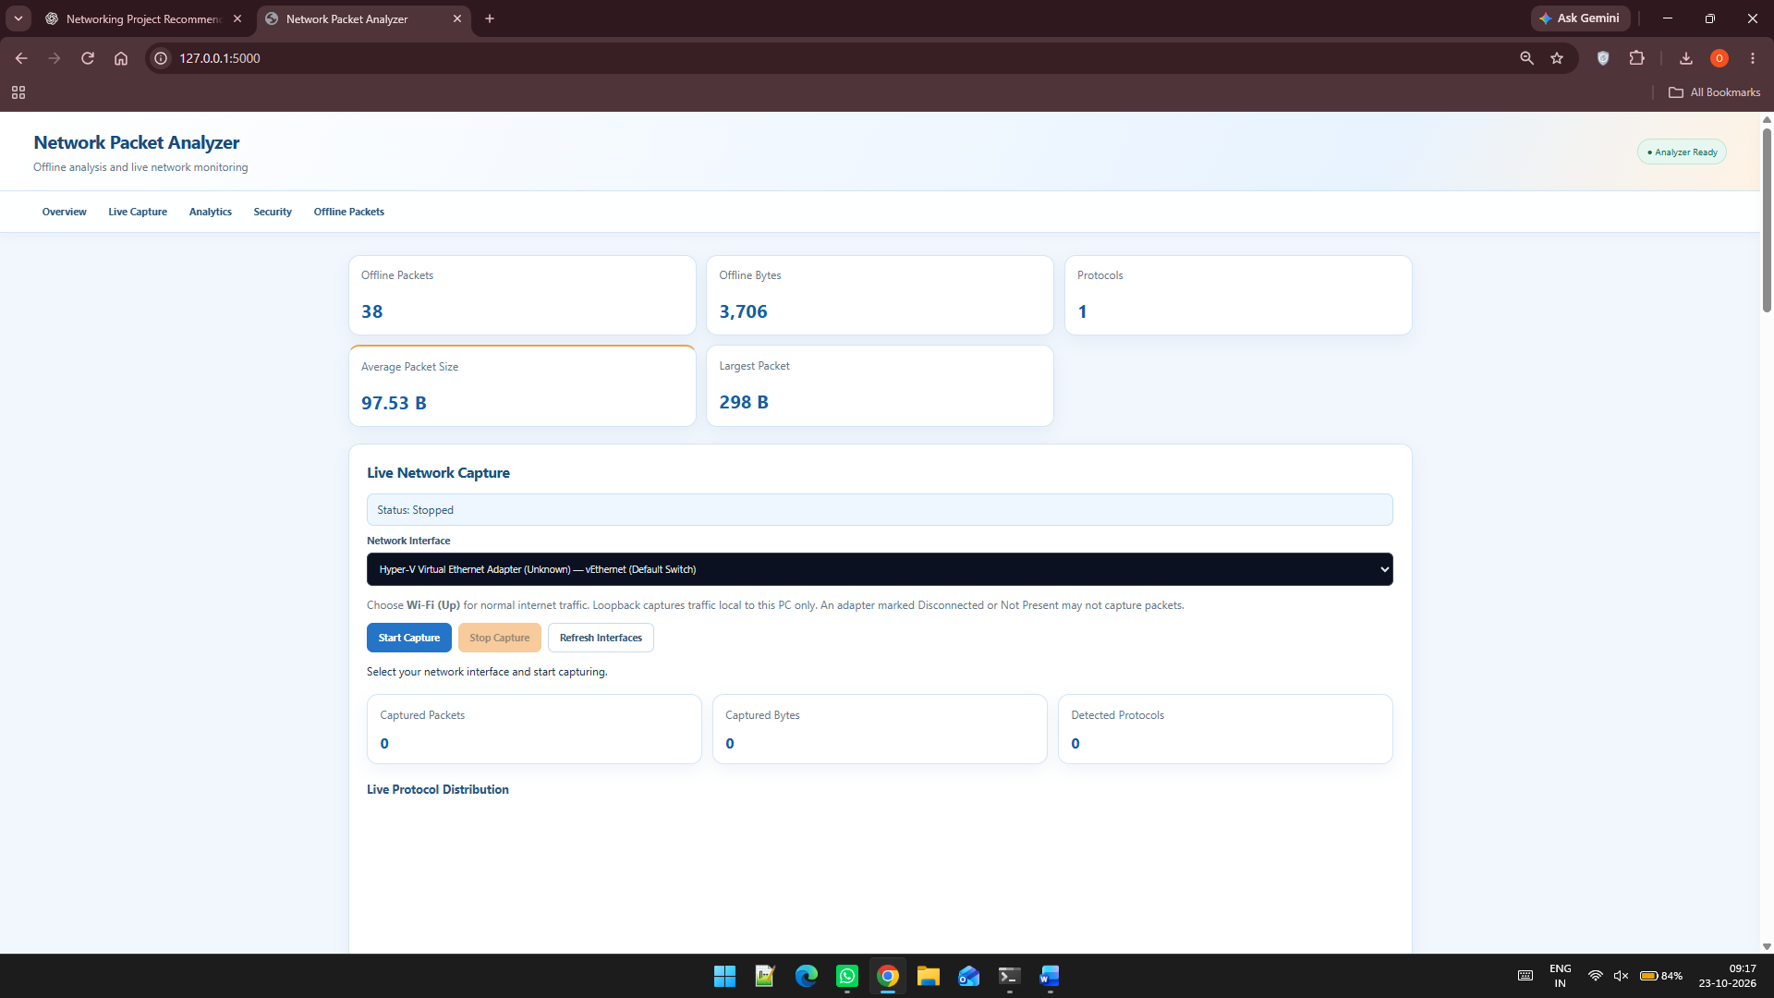
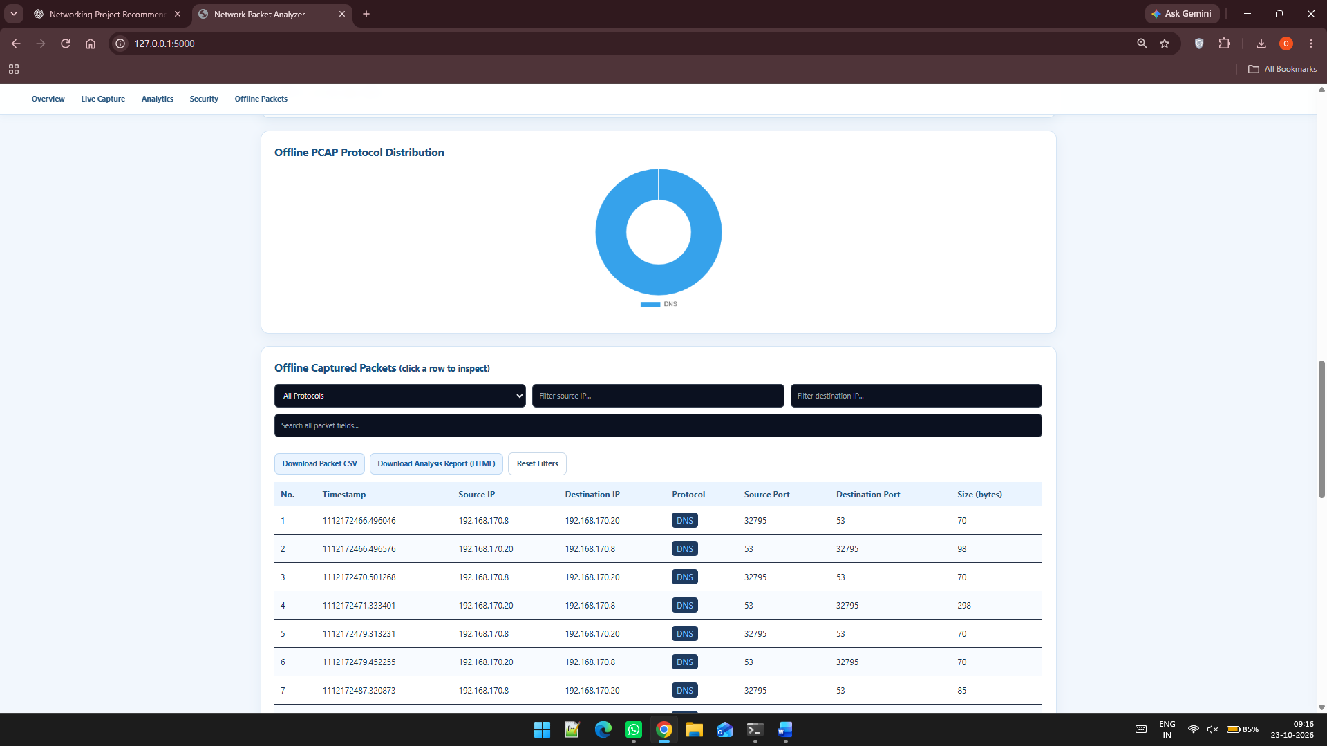
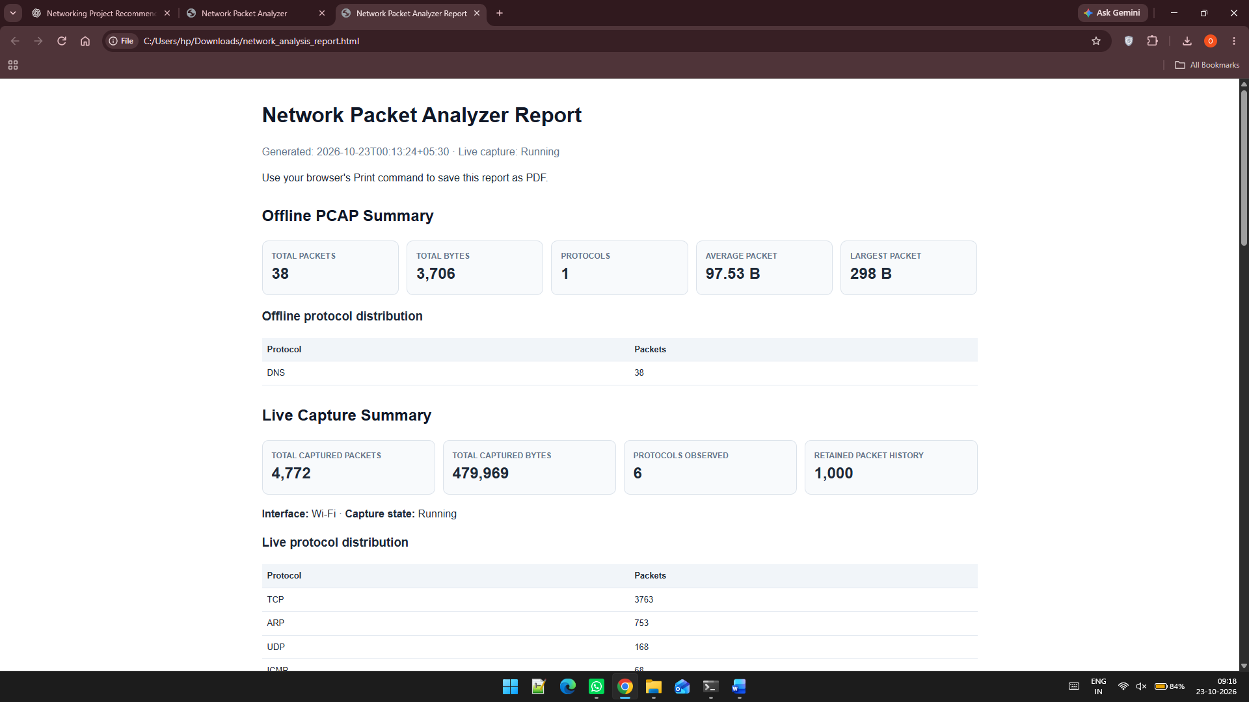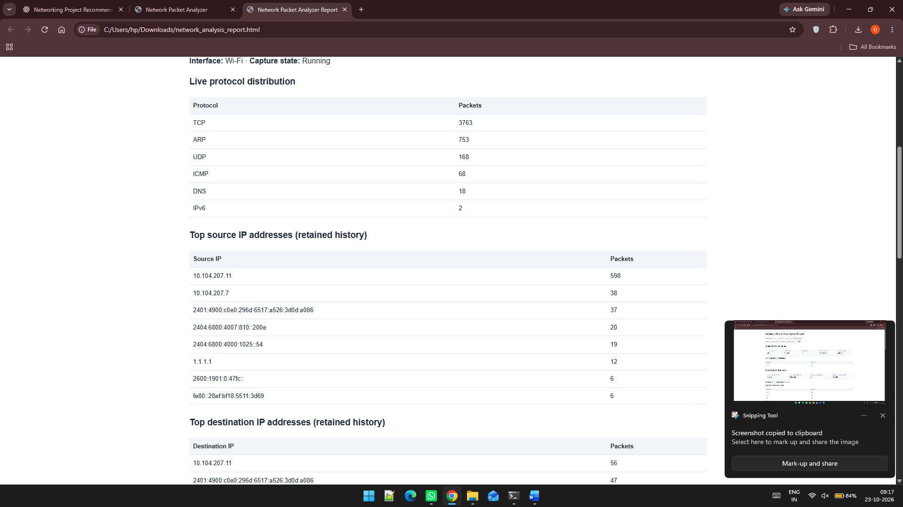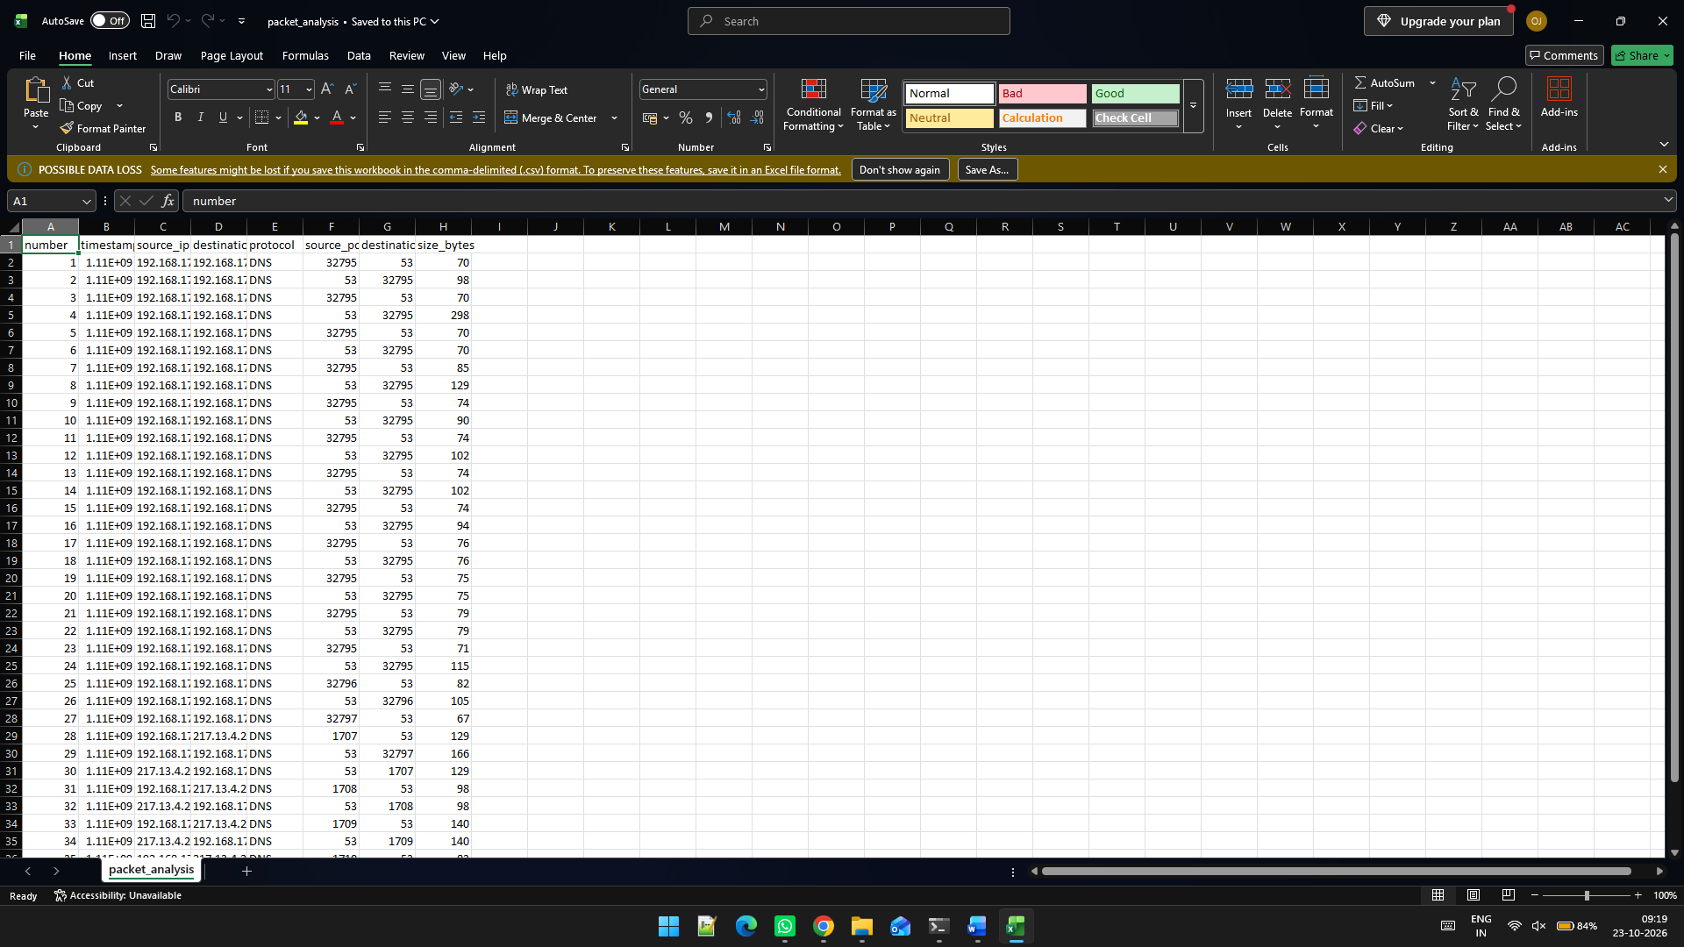

Appendix C — Individual Contributions
Exact individual contributions were not supplied. Complete the table according to the work each student actually performed.
Student name and PRN | Work completed | Evidence / deliverable
Omkar Jadhav — 1262252367 | Analytics, Security & Integration | Source files / tests / report sections
Rushikesh Patil — 1262253398 | Packet Capture & Protocol Analysis | Source files / tests / report sections
Anshuman Shelke — 1262242950 | Research, Planning & Architecture | Source files / tests / report sections
Avani Sarda — 1262242084 | Documentation | Source files / tests / report sections

